**SCREEN SHOTS:**

**After Running Spring Boot Successfully I can check this through localhost home page displayed**.

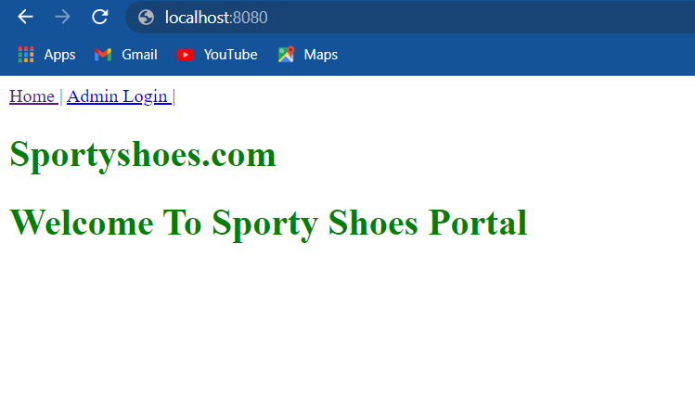

**Admin can login Through this page.**

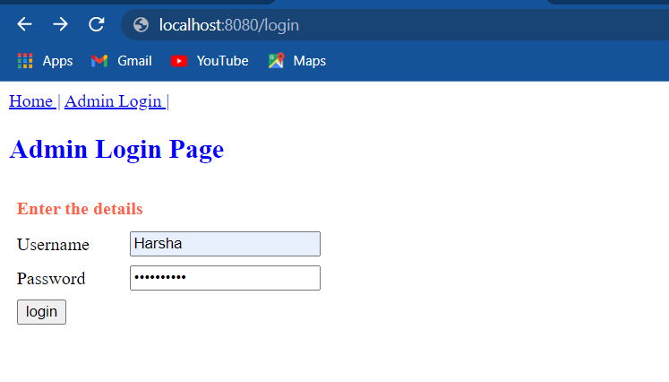

**After login Admin Process will be displayed here we can see list of categories, list of users and products list and also admin can change password and also we can logout.**

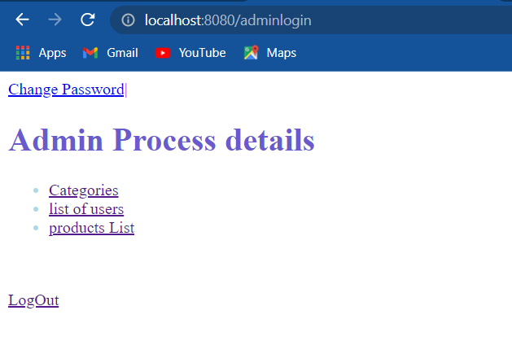

**If admin wants to change password**

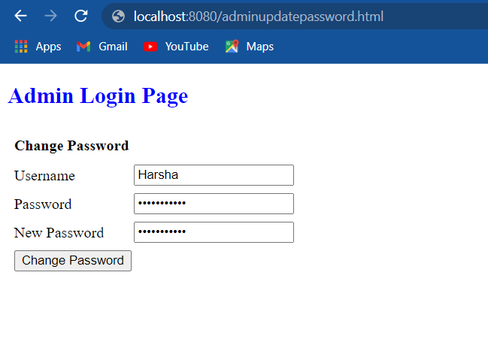

**After it will redirect to this page.**



**After clicking categoies empty list will be displayed by clicking new category link I can insert category**

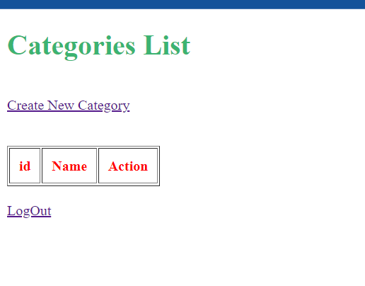

**After that through this I can insert category name and automatically CategoryID will be inserted**

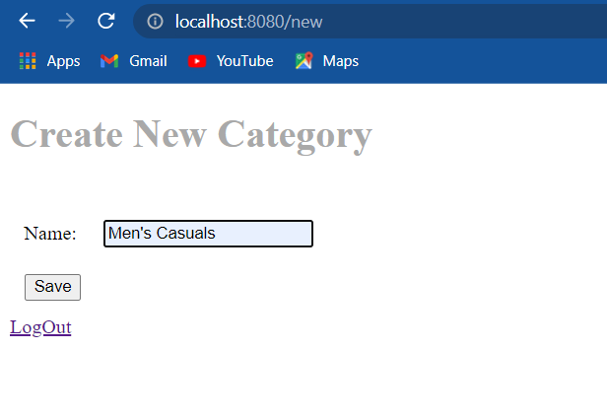

**Here we can see all category lists**

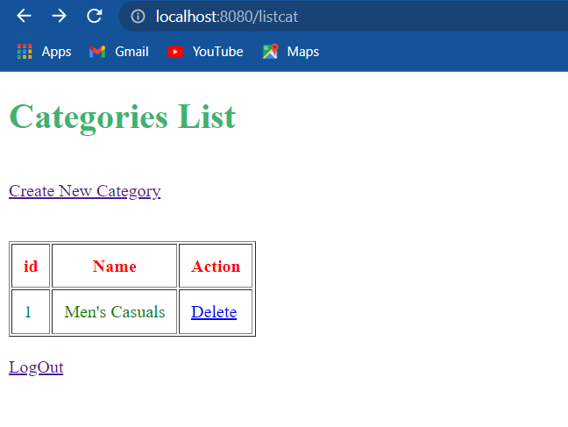

**I can delete that while clicking delete link and we can see in URL locolhost:8080/delete/1**

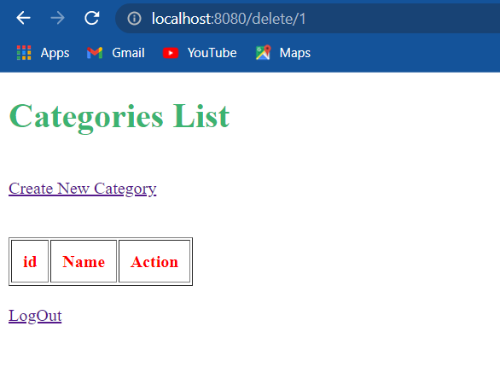

**Similarly I have tried to insert more categories here**

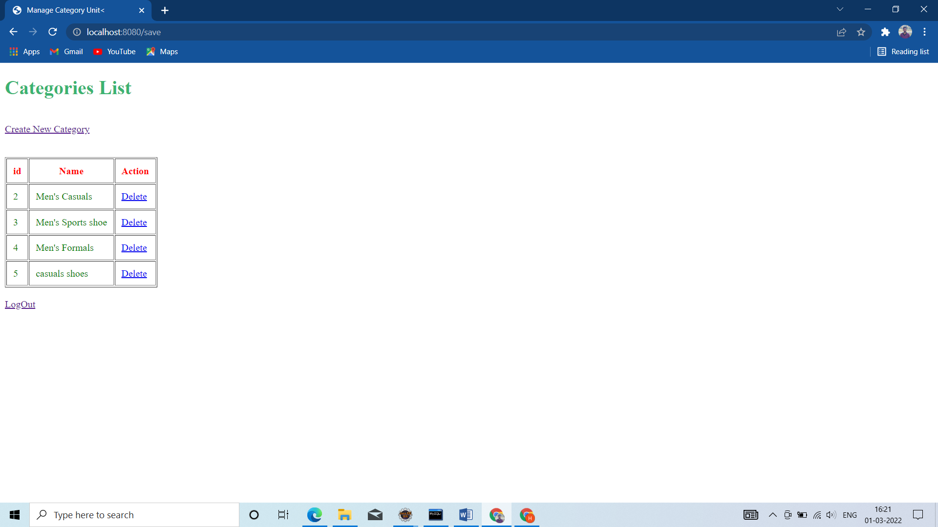

**Now I can check product list link**



**Because I not inserted anything it displaying empty table here using create product link I can add new products**

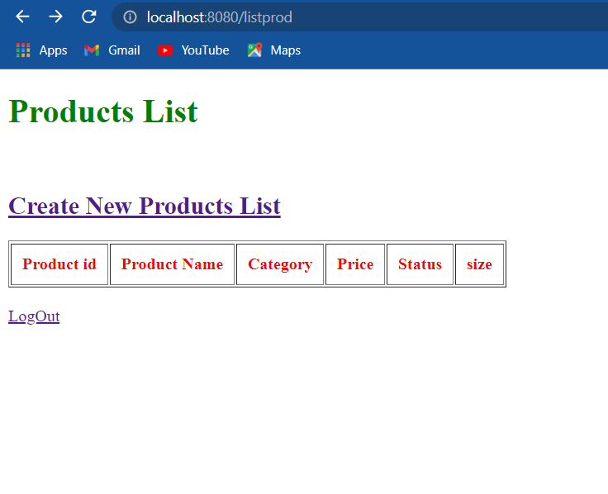

**List to enter new products.**

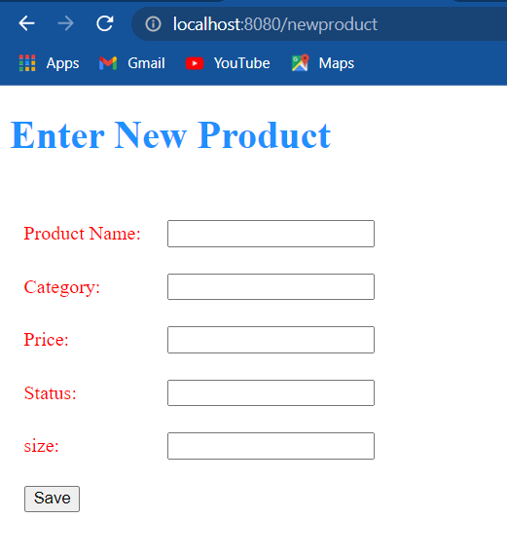

**Am trying to insert few data’s here that are available and not available products**

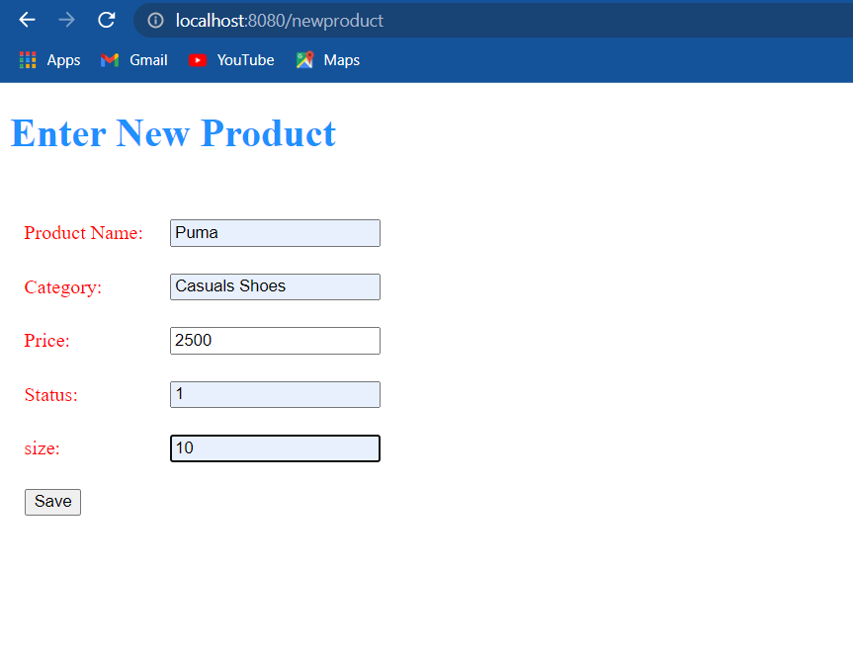

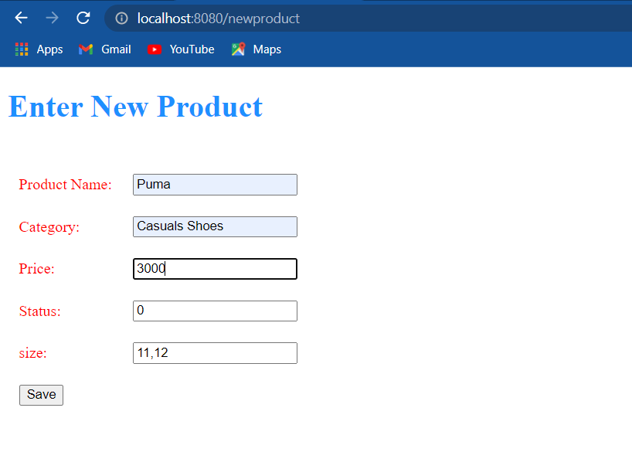

**After saving the data we can see here now we can book the order based on status availability**

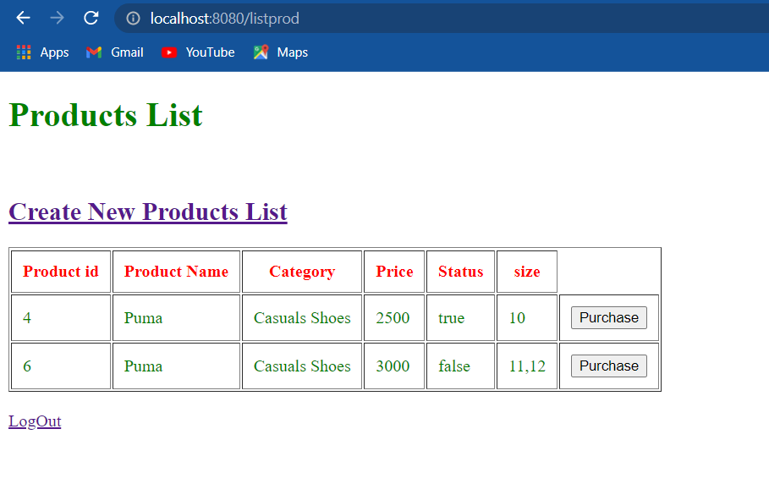

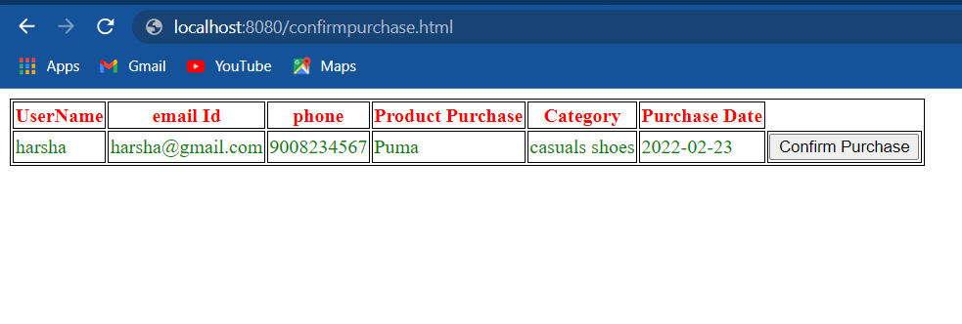

**Using second link we can see the users who are purchased shoes**



**Here we can see users but here I am purchased only one show one item is displaying if we have more then we can search user by ID by clicking Search User link**

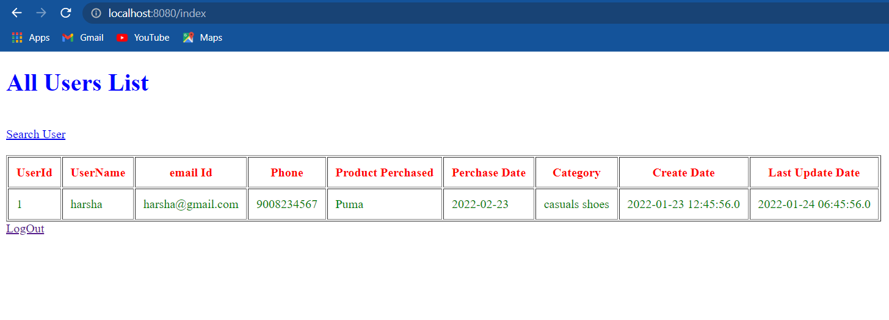

**After we can click logout it will redirect to login page**

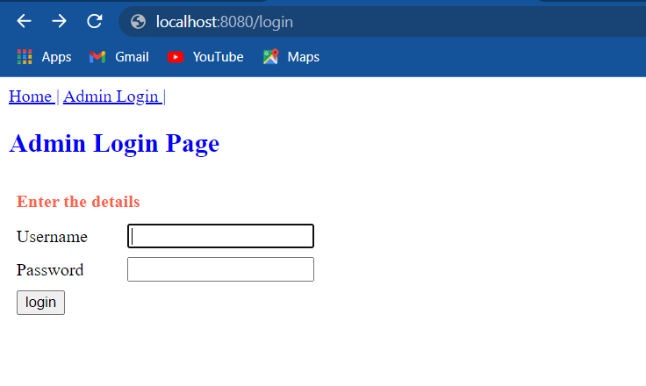

**If am trying to enter wrong password**

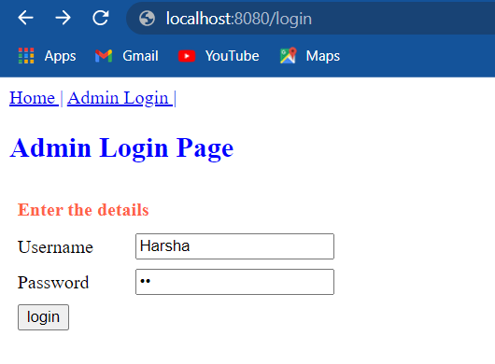

**It will display invalid message and also we can return to login page**

