**SCREEN SHOTS:**

**After running Spring boot app we can check this in localhos**t:8080

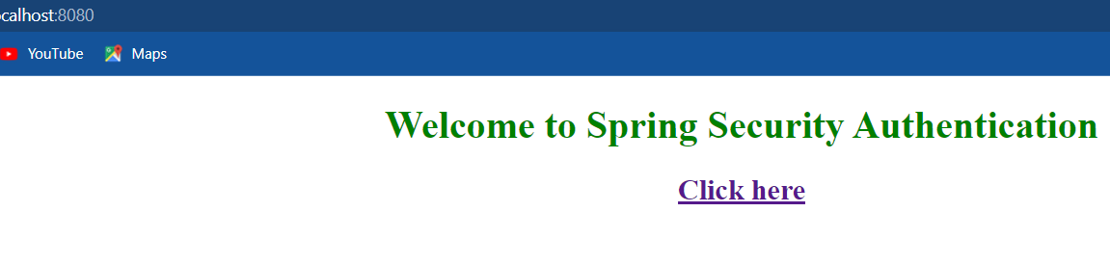

**After clicking the link login page will displayed as shown here.**

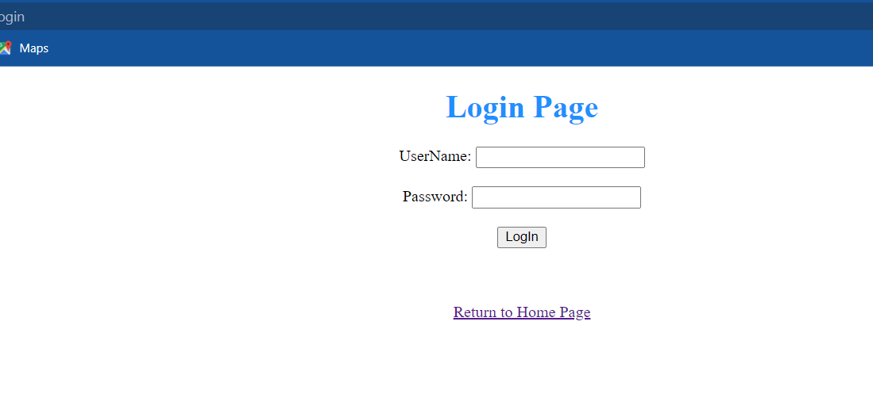

**Entering the Valid details**.

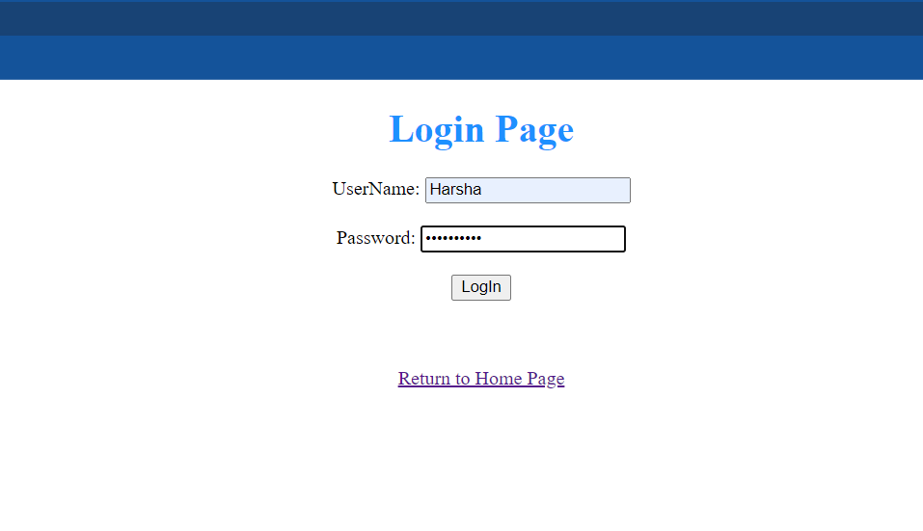

**If the values are correct dashboard will displayed**



**After clicking logout button it will redirect to /login page**

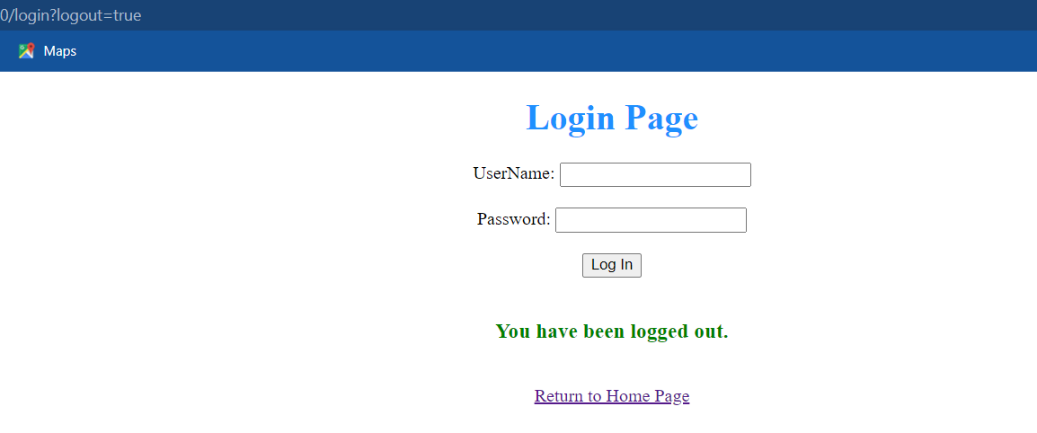

**If user enter invalid details.**

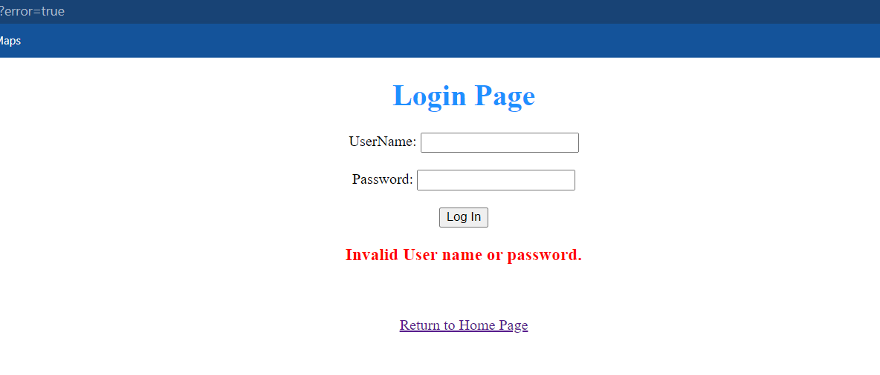

**User can return to home page.**

