**SCREEN SHOTS:**

**After running the junit this has appeared**.

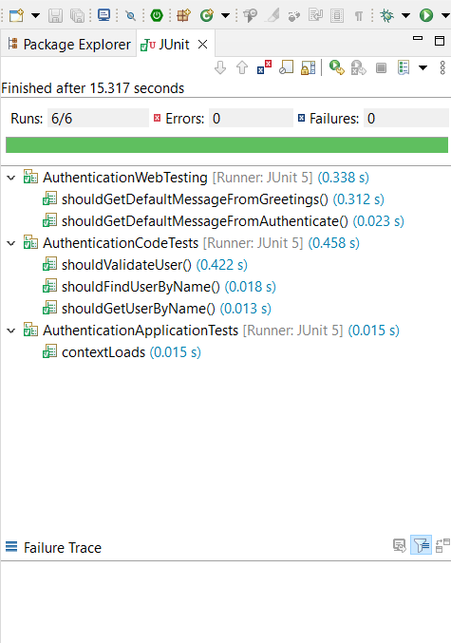

**In localhost:8080 this welcome page will display.**

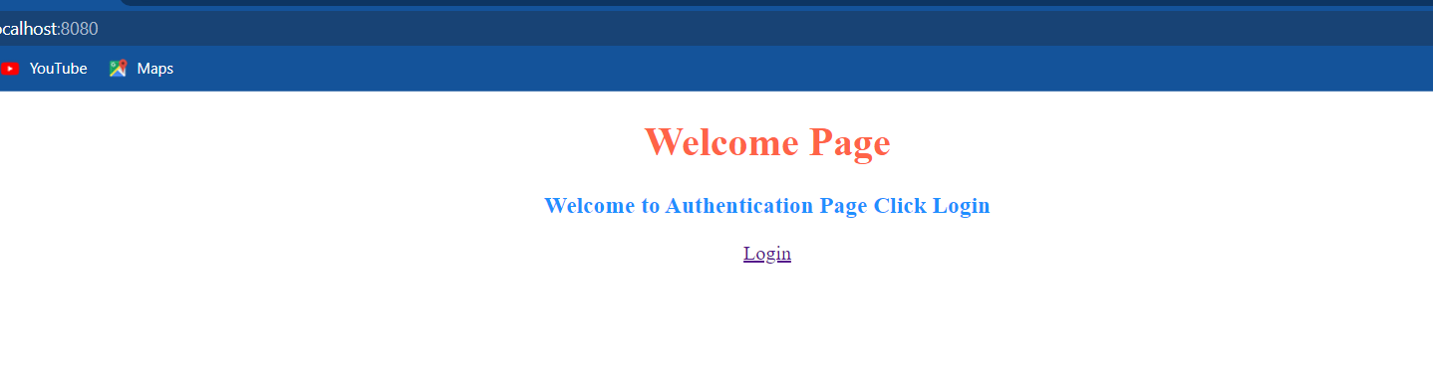

**After clicking login link above this form will appears user can authenticate here.**

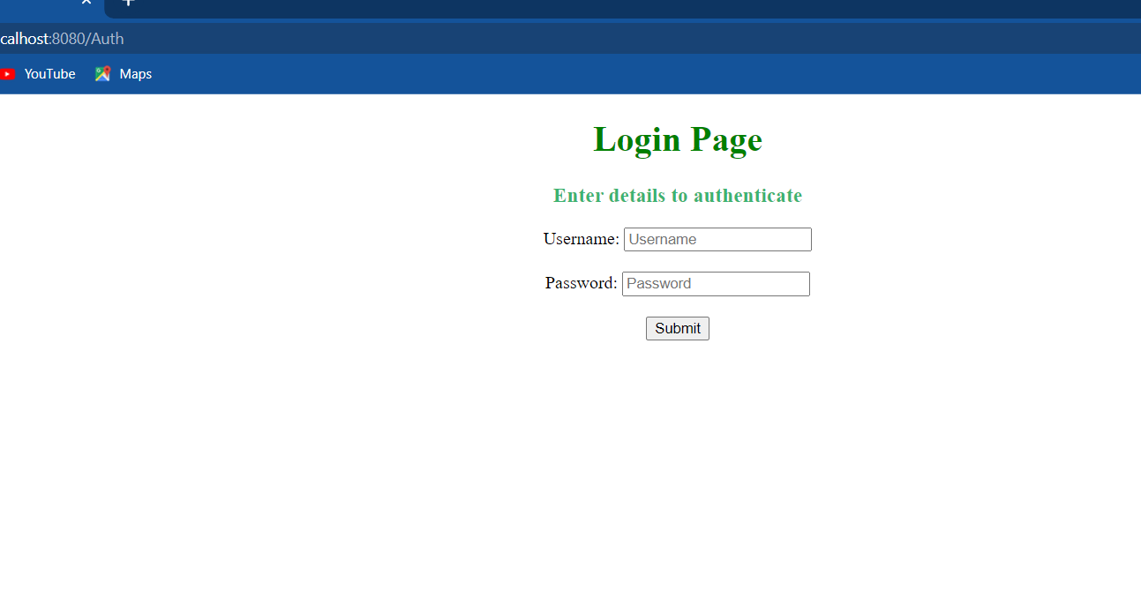

**Entering the required details.**

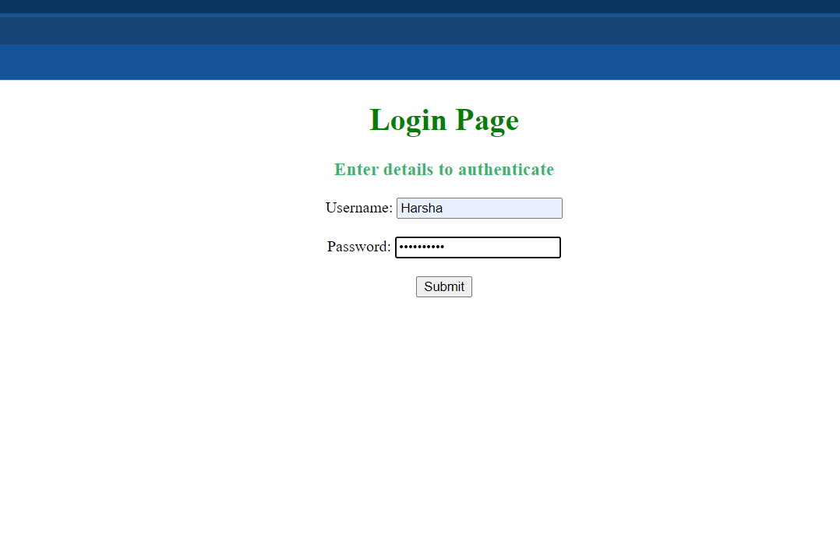

**If we enter valid password this will display.**

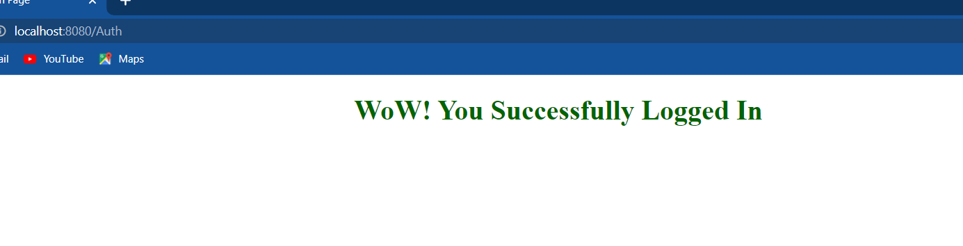

**Trying to enter wrong password.**

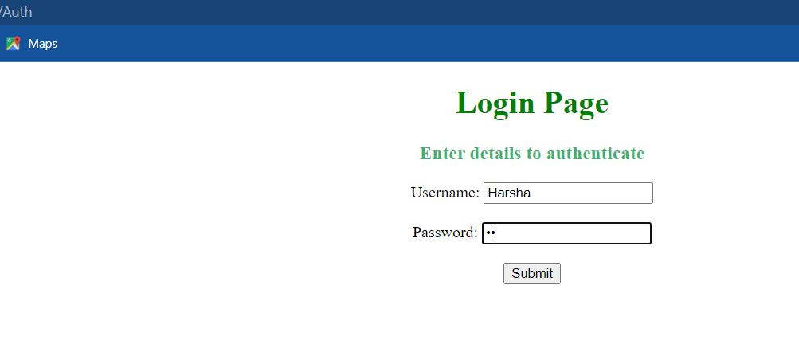

**if its wrong.**

