**SCREEN SHOTS:**

**After running in local host this will display**

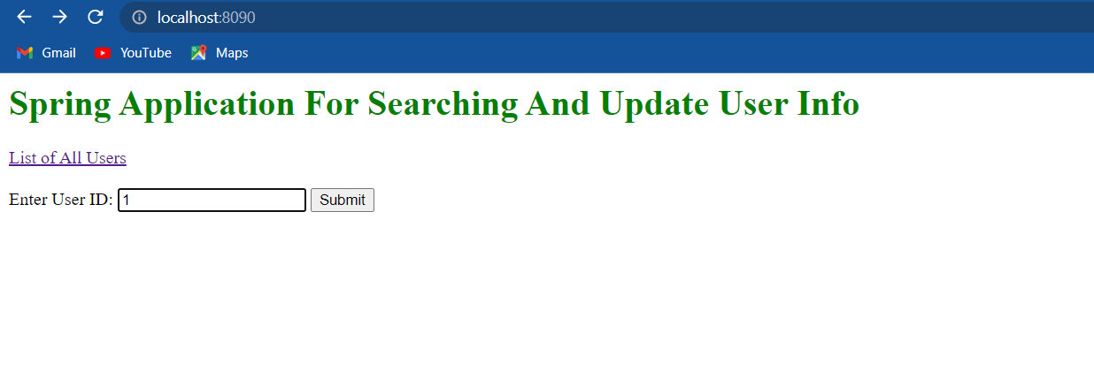

**if we not have that id in data base it display user not found.**

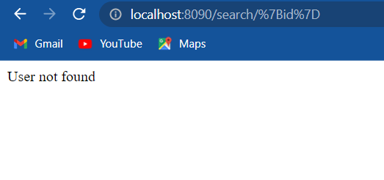

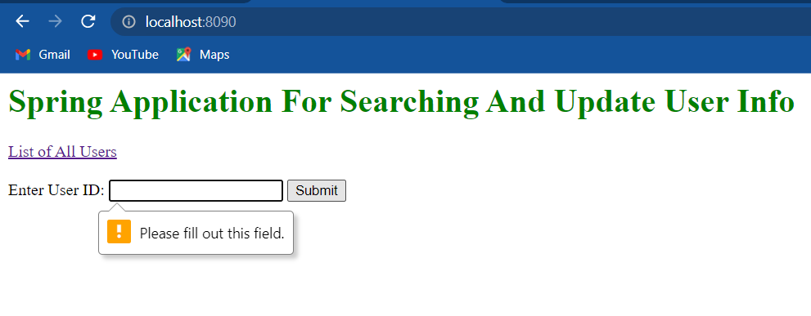

**If user trying to give random name that is not integer**

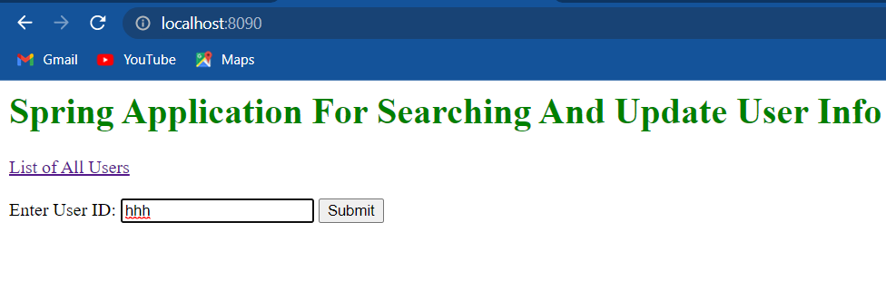

**This will display after clicking submit button**

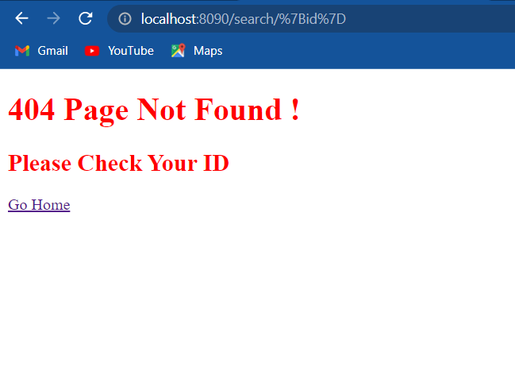

**after inserting data in database**

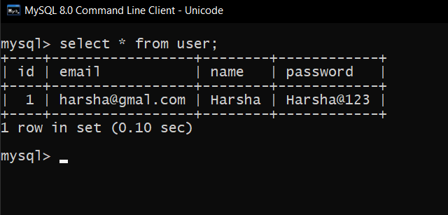

**After clicking go home this will display now we can give ID 1.**



**This will be searched after clicking submit.**

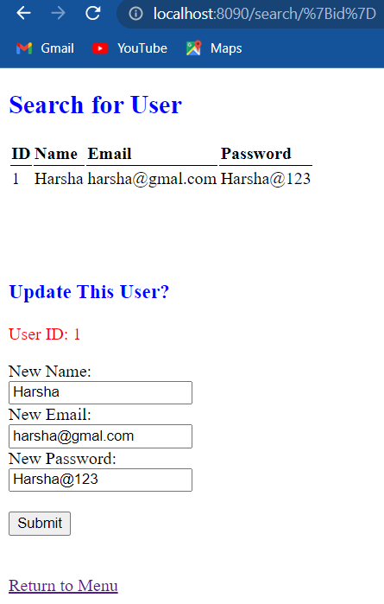

**User trying to update the details with ID 1.**

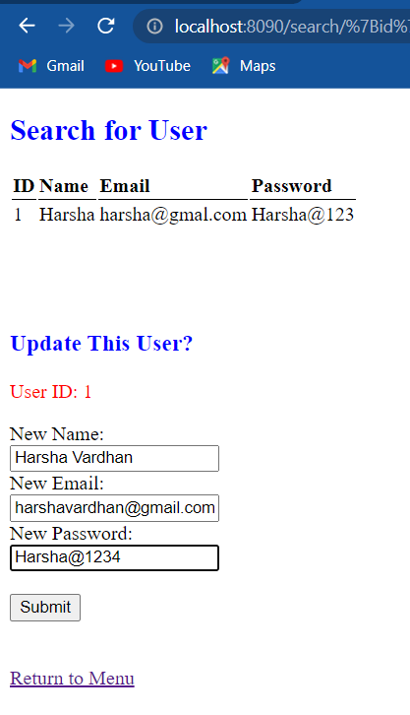

**After clicking submit button it will be updated.**

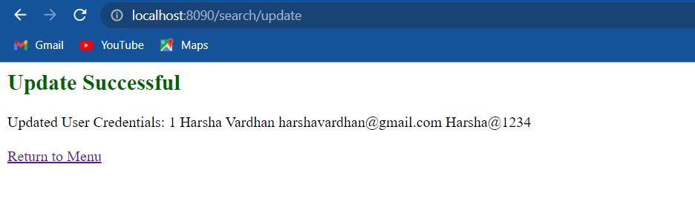



**After clicking list of user list this will display.**

