ScreenShot:

Home Page of FlyAway Website: Include options for Booking Flight, Admin Login, Customer Login.

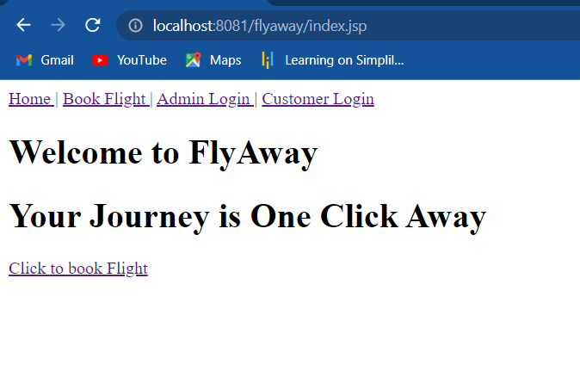

When a new customer wants to Book a Flight (Navbar does not change). He is provided with a form to enter journey details.

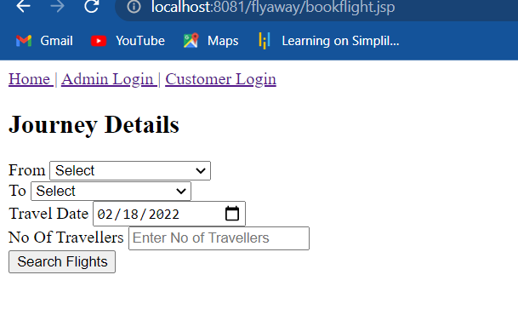

Customer enter journey details here From: Mumbai, To: Delhi, Travel Date: 20-02-2022 No of passengers: 3.

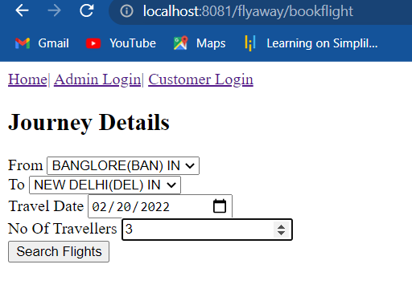

If flights are available from the provided source to Destination, User will be directed to Flight details page where they will see all the flights available for the given date/day.

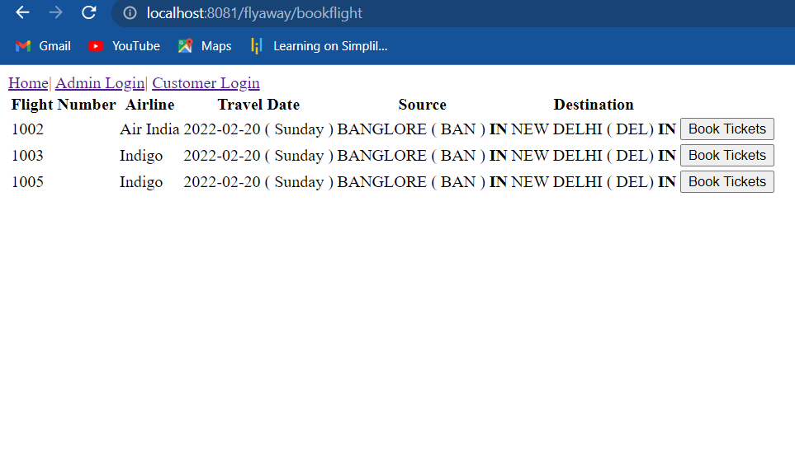

We can see for Sunday 3 flights are present from Banglore(BON) to New Delhi(DEL).

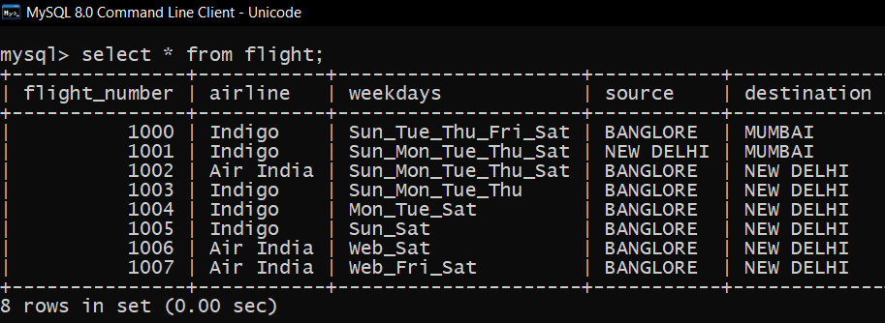

Suppose User entered date as 24-02-2022 which is Thursday then he will be shown only flights which are available for Thurdays.

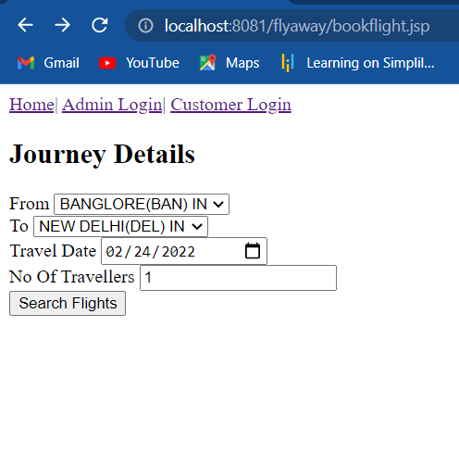

We can see here only two flights are present for Thursday.

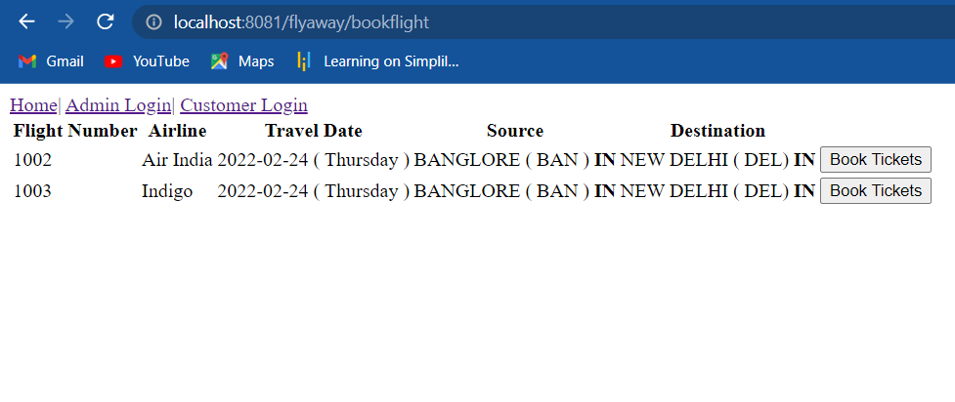

We can see here only two flights are present for Thursday.

****

If User enters details in the form for which flight is not available in the database

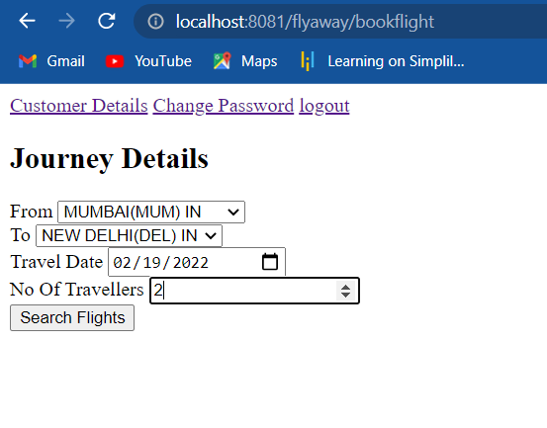

User gets a message as There are no Flights for those details.

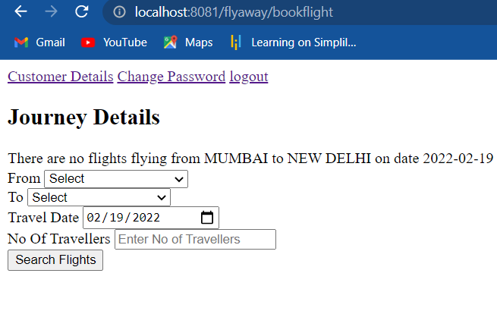

If the user enters correct details in the Journey details form, All the flights available for that day is shown.



User will be shown all the Flights available from banglore to new Delhi on Sunday. User can select any airline from the list and compare their fares by clicking on (Book Tickets).



If user selects an airline from the list (here 1005). User will be directed to fare details page where all the different classes are shown with fares. (User can book tickets on any class of their choice).

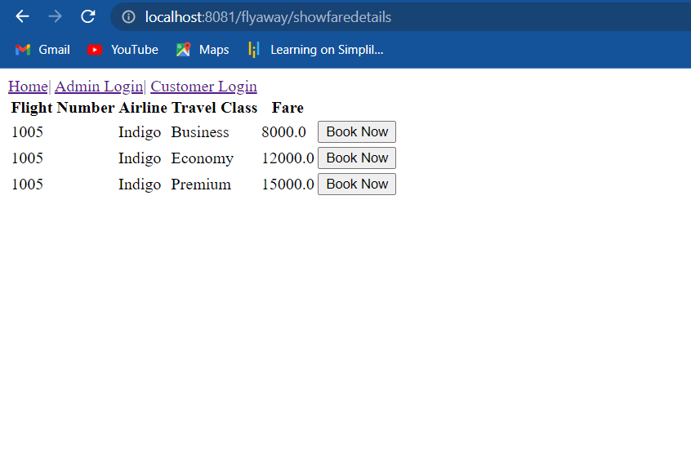

If the user is a new customer, then after selecting a fare they will be redirected to Register page where they should enter their valid details, If the user is already existing customer then they can use Login in existing account option to directly login to their account.

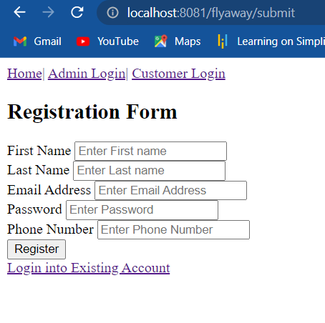

After entering user details if the details are valid then they are redirected to Booking details page where they will see all their booking related details after confirming details, they can click on confirm Booking. (Notice navbar changed after login or register).

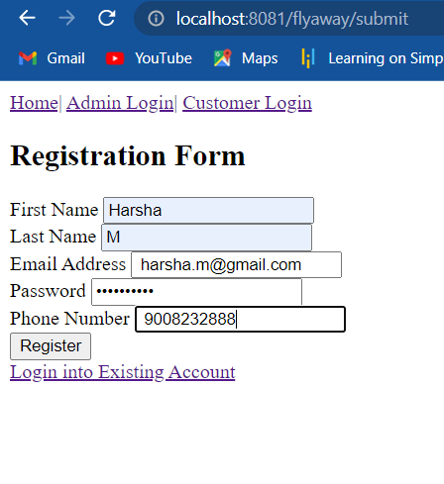

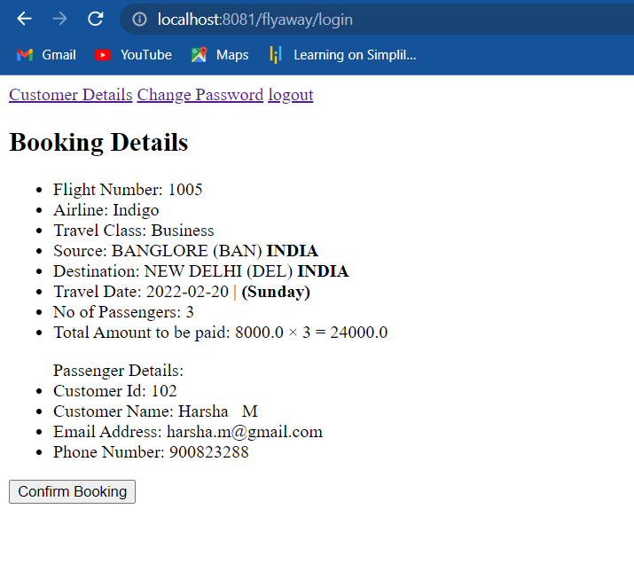

After Confirming booking details, user will be forwarded to payment form where they need to enter payment details like Card Name and Card Number. They can also recheck the amount to be paid, And confirm payment

v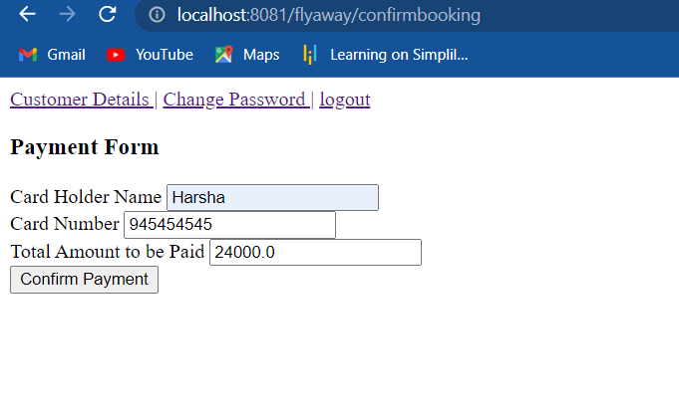

After confirming payment user will be forwarded to Ticket details page where they can see all the details of their journey and payment. At this step the journey details are stored in the database. User can also print their tickets with print ticket button.

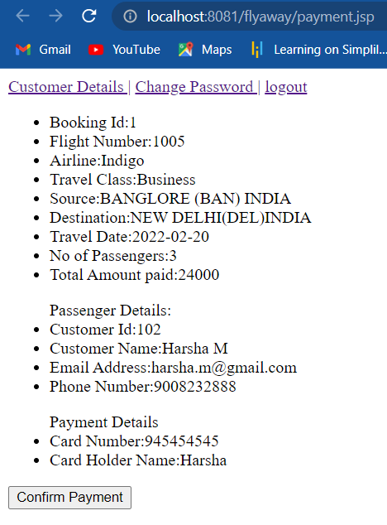

We can also confirm in the database the booking details are stored here.

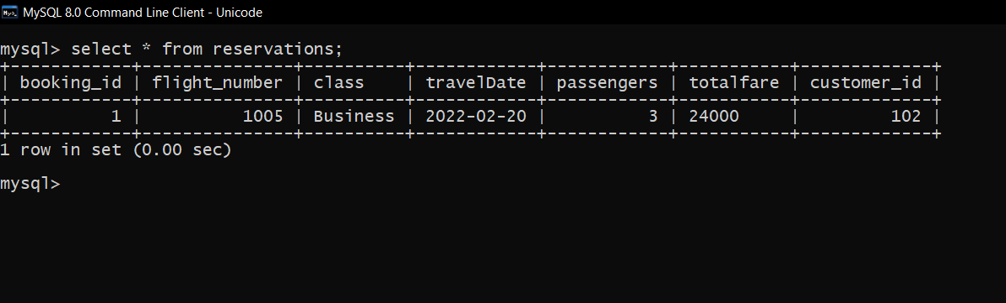

Next If the user is already logged in and want to book a new journey (Notice Navbar changed). (In this case user will not be asked to register again as they are already logged in).



If valid details are entered. User will be shown all the Flights available from Mumbai to Delhi on Sunday. User can select any airline from the list and compare their fares by clicking on (Book Tickets).



We confirm from the database only 2 flights are available for Thursday from banglore to new delhi.



If user selects an airline from the list (here 1003). User will be directed to fare details page where all the different classes are shown with fares. (User can book tickets on any class of their choice).

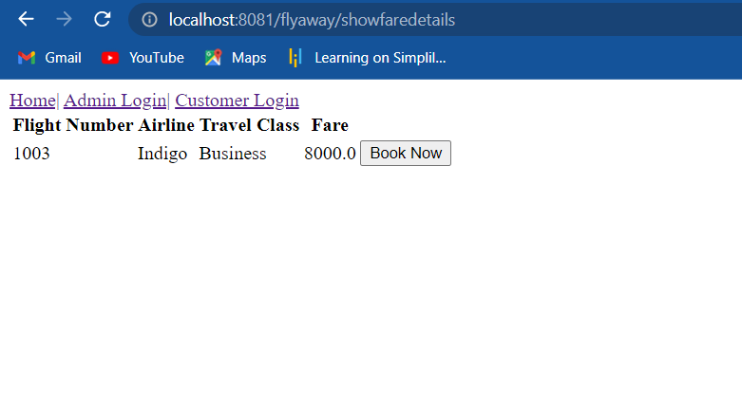

If the user is already logged in then they are forwarded directly to Booking details page where they will see all their booking related details after confirming details, they can click on confirm Booking.



If user wants to login through existing account he can click link

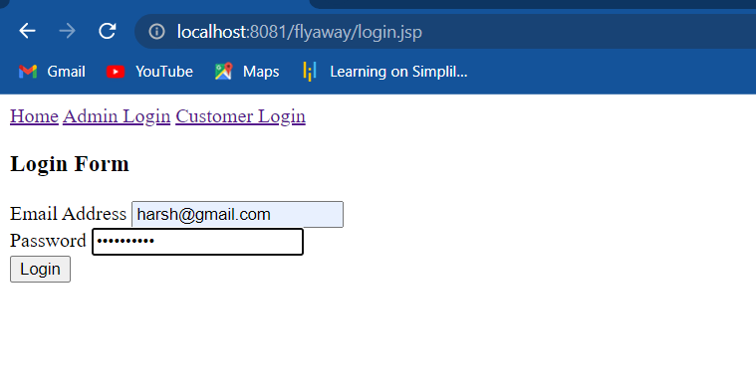

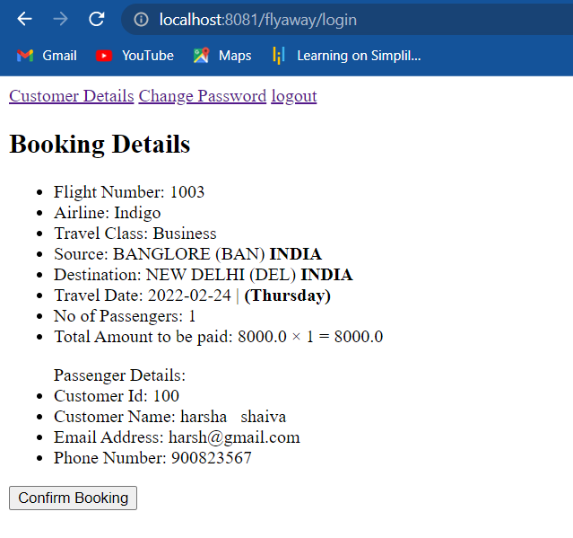

After Confirming booking details, user will be forwarded to payment form where they need to enter payment details like Card Name and Card Number. They can also recheck the amount to be paid, And confirm payment.

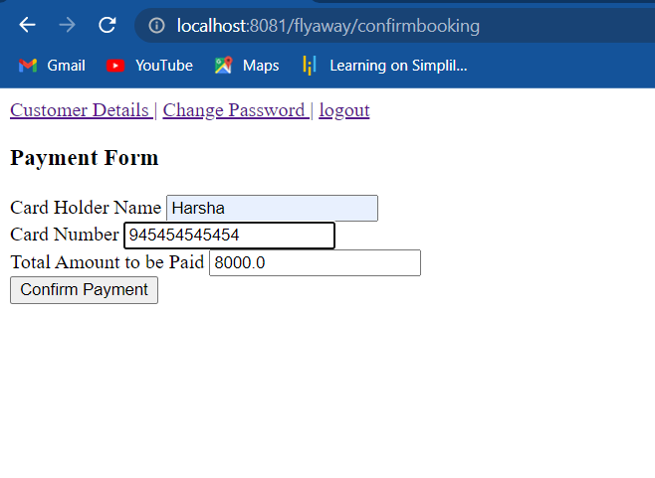

After confirming payment user will be forwarded to Ticket details page where they can print their tick

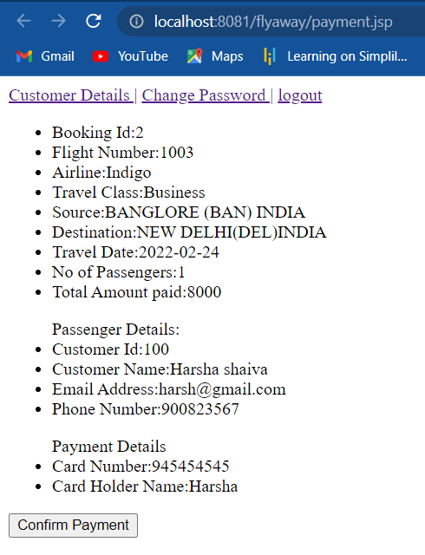

We can also confirm from the database new booking details are present for the same user 3008.

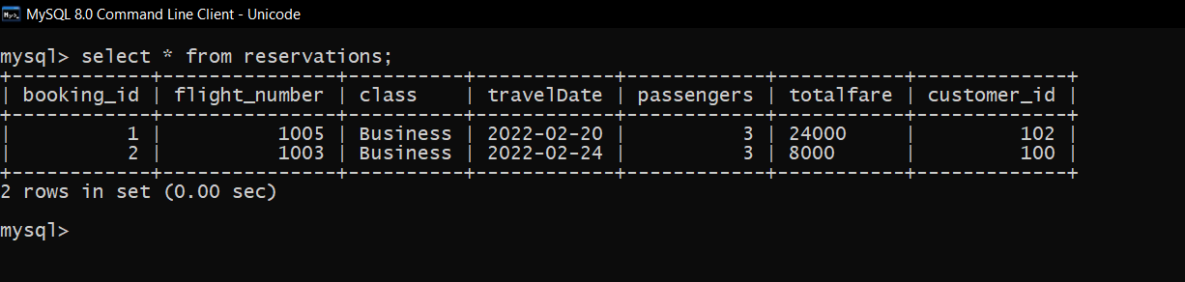

User also has the option to change password if they wishes to.

If the user selects Logout option they are redirected to Home page. (Notice navbar changed now).



If the user selects Customer Login from the navbar then they will be forwarded to Login form where the customer will enter their email address and password.

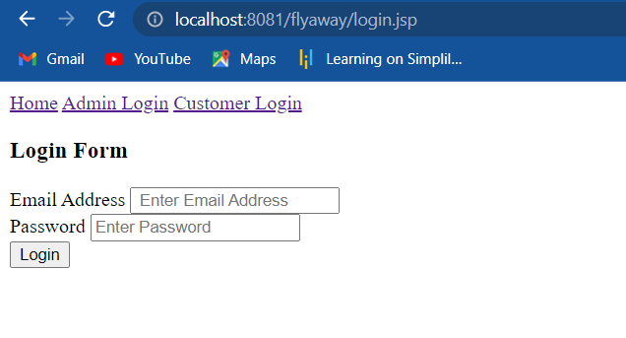



Updating password

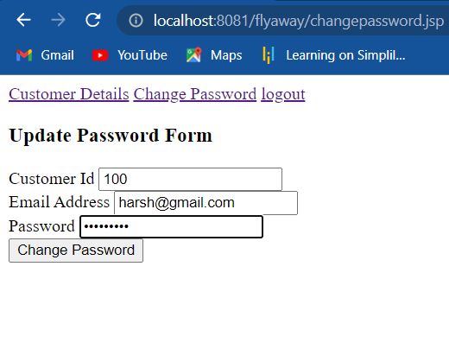

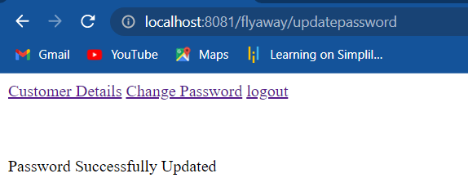

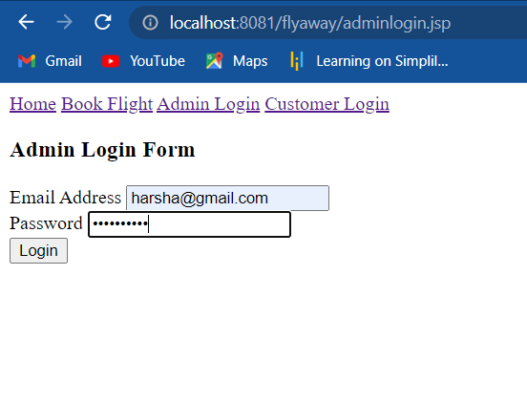

When Admin enters correct details then they are forwarded to Admin details page where they can see All the flight details and options to add flight and change password.

