**CSD2206 Term Project**

**Harsha Vardhan Gannamuneni**

**C0931034**

**Term 01**

**Contents**

Company Overview and Product 2

Company Name 2

Company Description 2

Product 2

Product Attribute 3

Customer Invoice 4

Entity Relationship Diagrams 5

Many to Many Relationship (Not Resolved) 5

Many to Many Relationship (Resolved) 6

Relational Model & Business Rules 7

# **Company Overview and Product**

## Company Name

HumidCare

## Company Description

At HumidCare Solutions, we specialize in providing top-of-the-line dehumidifiers to transform your living spaces into comfortable, moisture-free environments. With a commitment to innovation and customer satisfaction, we offer a curated selection of cutting-edge solutions designed to address a variety of humidity-related concerns.

Explore our online platform to discover a range of high-performance dehumidifiers meticulously chosen to suit your specific needs. From combating mold and mildew to improving indoor air quality, HumidCare Solutions is your trusted partner in creating healthier and more comfortable living spaces.

We take pride in offering not just products, but solutions that make a meaningful impact on your daily life. Our user-friendly website ensures a seamless shopping experience, providing detailed product information and expert guidance to help you make informed decisions.

At HumidCare Solutions, customer satisfaction is our priority. Our dedicated team is ready to assist you every step of the way, ensuring that you receive not only a quality dehumidifier but also unparalleled service. Take the first step towards a drier, more comfortable environment – choose HumidCare Solutions for all your dehumidification needs.

## Product

Dehumidifiers

## Product Attribute

* Product Code – Primary Key
* Model Number
* Brand
* Type
* Serial Number
* Description
* Size
* Weight
* Color
* Height
* Width
* Price

|  |  |  |  |  |
| --- | --- | --- | --- | --- |
| **Customer Invoice** | | HumidCare 371 Main Street Ottawa, ON N7L 4T3 Canada 545-558-8520 | | |
|
|
|
|
| Customer ID: | #1920 | Order ID: | | 3948 |
| Customer Name: | L. Mason | Order Date: | 02-03-2024 | |
| Customer Address: | 1234 Kellman Street Toronto, ON J7P 4F5 Canada | Associate ID: | 443 | |
|  | Associate Name: | M. Jon | |
|  |  |  | |

|  |
| --- |
|  |

|  |  |  |  |  |  |  |
| --- | --- | --- | --- | --- | --- | --- |
| Product Code | Model | Brand | Description | Qty | Unit Price | Total Price |
| L324 | DH3009 | Dehumify | Efficient Moisture Removal | 2 | 59.9 | 119.8 |
| K859 | DH4678 | Dehumify | Quiet Operation Technology | 3 | 159.5 | 478.5 |
| P7389 | FK2532 | FanHum | Space-saving Design | 1 | 34.99 | 34.99 |
| P7340 | FK2598 | FanHum | Space-saving Design | 1 | 36.99 | 36.99 |
| P7391 | FK2267 | FanHum | Max Space Design | 2 | 134.99 | 269.98 |
|  |  |  |  |  |  |  |
|  |  |  |  | Sub-total | | 389.78 |
|  |  |  |  | Tax | | 62.205 |
|  |  |  |  | Invoice Total | | 451.985 |

# **Entity Relationship Diagrams**

## Many to Many Relationship (Not Resolved)

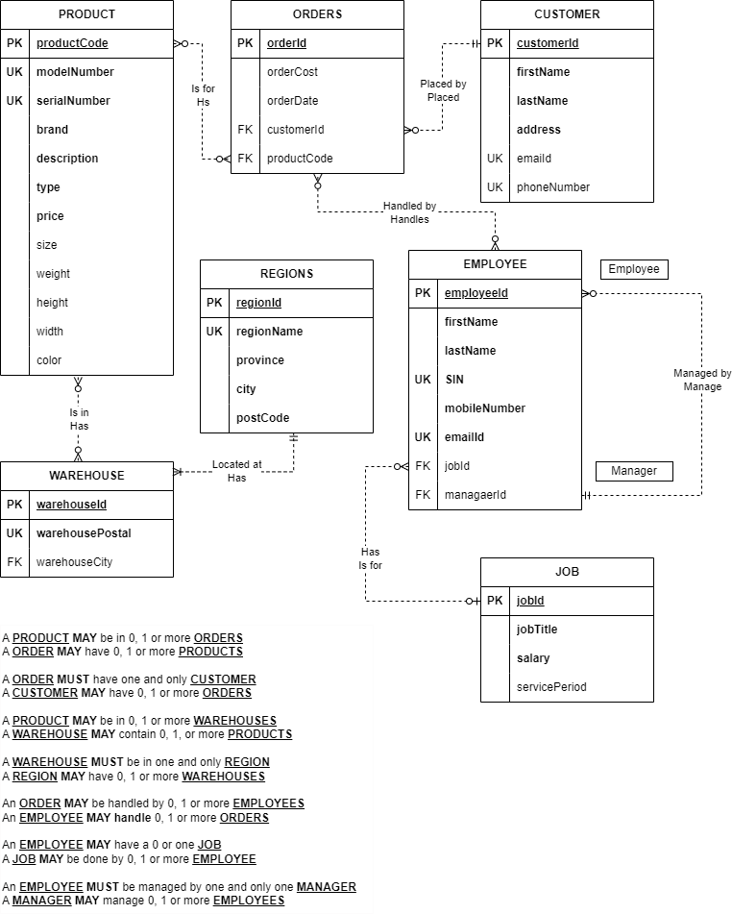

## Many to Many Relationship (Resolved)

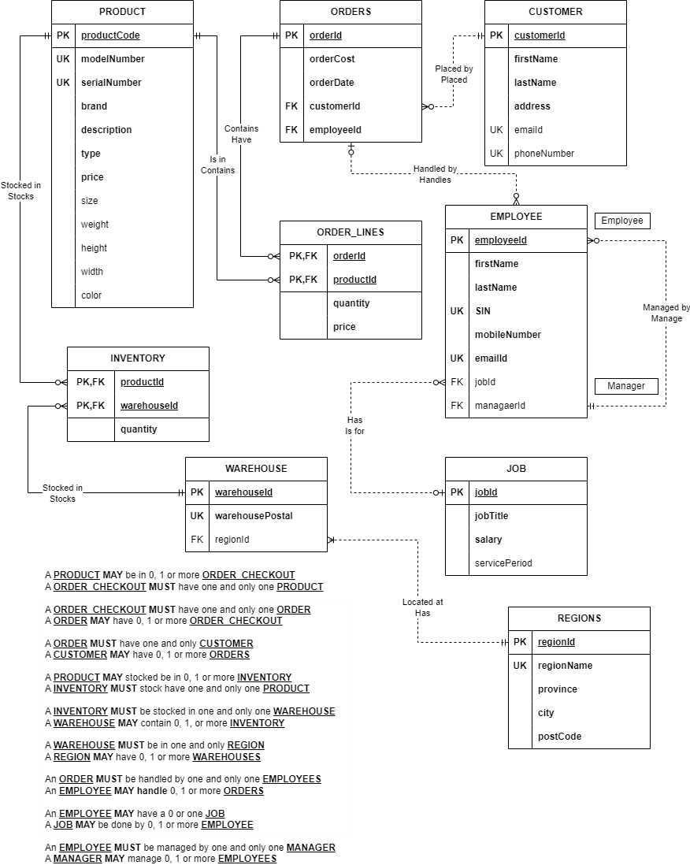

# **Relational Model & Business Rules**

|  |  |  |  |  |
| --- | --- | --- | --- | --- |
| **PRODUCTS** | | | | |
| **KEY** | **OPTIONALITY** | **COLUMN NAME** | **DATA TYPE** | **LENGTH** |
| PK | * | productCode | integer |  |
| UK | * | modelNumber | varchar | 30 |
| UK | * | serialNumber | varchar | 30 |
|  | * | brand | varchar | 20 |
|  | * | description | varchar | 100 |
|  | * | type | varchar | 20 |
|  | * | price | decimal | 10,2 |
|  | O | size | decimal | 10,2 |
|  | O | weight | decimal | 10,2 |
|  | O | height | decimal | 10,2 |
|  | O | width | decimal | 10,2 |
|  | O | color | varchar | 10 |

|  |  |  |  |  |
| --- | --- | --- | --- | --- |
| **ORDERS** | | | | |
| **KEY** | **OPTIONALITY** | **COLUMN NAME** | **DATA TYPE** | **LENGTH** |
| PK | * | orderId | integer |  |
|  | * | orderCost | decimal | 10,2 |
|  | * | orderDate | date |  |
| FK | * | customerId | integer |  |
| FK | * | employeeId | integer |  |

|  |  |  |  |  |
| --- | --- | --- | --- | --- |
| **ORDER_LINES** | | | | |
| **KEY** | **OPTIONALITY** | **COLUMN NAME** | **DATA TYPE** | **LENGTH** |
| PK,FK | * | orderId | integer |  |
| PK,FK | * | productId | integer |  |
|  | * | quantity | decimal | 10,2 |
|  | * | price | decimal | 10,2 |

|  |  |  |  |  |
| --- | --- | --- | --- | --- |
| **CUSTOMER** | | | | |
| **KEY** | **OPTIONALITY** | **COLUMN NAME** | **DATA TYPE** | **LENGTH** |
| PK | * | customerId | integer |  |
|  | * | firstName | varchar | 30 |
|  | * | lastName | varchar | 30 |
|  | * | address | varchar | 50 |
| UK | O | emailId | varchar | 20 |
| UK | O | phoneNumber | varchar | 10 |

|  |  |  |  |  |
| --- | --- | --- | --- | --- |
| **EMPLOYEE** | | | | |
| **KEY** | **OPTIONALITY** | **COLUMN NAME** | **DATA TYPE** | **LENGTH** |
| PK | * | employeeId | integer |  |
|  | * | firstName | varchar | 30 |
|  | * | lastName | varchar | 30 |
| UK | * | SIN | integer | 10 |
|  | * | mobileNumber | varchar | 10 |
| UK | * | emailId | varchar | 20 |
| FK | O | jobId | integer |  |
| FK | O | managerId | integer |  |

|  |  |  |  |  |
| --- | --- | --- | --- | --- |
| **JOB** | | | | |
| **KEY** | **OPTIONALITY** | **COLUMN NAME** | **DATA TYPE** | **LENGTH** |
| PK | * | jobId | integer |  |
|  | * | jobTitle | varchar | 30 |
|  | * | salary | decimal | 10,2 |
|  | O | servicePeriod | decimal | 60,2 |

|  |  |  |  |  |
| --- | --- | --- | --- | --- |
| **INVENTORY** | | | | |
| **KEY** | **OPTIONALITY** | **COLUMN NAME** | **DATA TYPE** | **LENGTH** |
| PK,FK | * | productId | integer |  |
| PK,FK | * | warehouseId | integer |  |
|  | * | quantity | decimal | 10,2 |

|  |  |  |  |  |
| --- | --- | --- | --- | --- |
| **WAREHOUSE** | | | | |
| **KEY** | **OPTIONALITY** | **COLUMN NAME** | **DATA TYPE** | **LENGTH** |
| PK | * | warehouseId | integer |  |
| UK | * | warehousePostal | varchar | 20 |
| FK | O | regionId | varchar | 20 |

|  |  |  |  |  |
| --- | --- | --- | --- | --- |
| **REGIONS** | | | | |
| **KEY** | **OPTIONALITY** | **COLUMN NAME** | **DATA TYPE** | **LENGTH** |
| PK | * | regionId | varchar | 20 |
| UK | * | regionName | varchar | 20 |
|  | * | province | varchar | 20 |
|  | * | city | varchar | 20 |
|  | * | postCode | varchar | 20 |

PRODUCTS(**productCode**, modelNumber, serialNumber, brand, description, type, price, size, weight, height, width, color)

ORDERS(**orderId**, orderCost, orderDate, customerId, employeeId)

FK customerId 🡪 CUSTOMER

FK employeeId 🡪 EMPLOYEE

ORDER_LINES(**orderId**, **productId**, quantity, price)

FK orderId 🡪 ORDERS

FK productid 🡪 PRODUCTS

CUSTOMER(**customerId**, firstName, lastName, address, emailId, phoneNumber)

EMPLOYEE(**employeeId**, firstName, lastName, SIN, mobileNumber, emailId, jobId, managerId)

FK jobId 🡪 JOB

FK managerId 🡪 EMPLOYEE

JOB(**jobId**, jobTitle, salary, servicePeriod)

INVENTORY(**productid**, **warehouseId**, quantity)

FK productid 🡪 PRODUCTS

FK warehouseId 🡪 WAREHOUSE

WAREHOUSE(**warehouseId**, warehousePostal, regionId)

FK regionId 🡪 REGIONS

REGIONS(**regionId**, regionName, province, city, postCode)

**Auto-generated columns:** Automatically generated unique identifier for each record with respect to their table.

**PRODUCTS**: productCode

**ORDERS**: orderId

**CUSTOMER**: customerId

**EMPLOYEE**: employeeId

**JOB**: jobId

**WAREHOUSE**: warehouseId

**REGIONS**: regionId

**Restrictions to column values.**

**JOB:** salary, default to 20,000

**JOB:** salary, ranges between 20,000 to 1,50,000