**PHASE 4**

**DEVELOPMENT PART 2**

**Steps:**

* We continue to build the analysis by creating visualizations and building a predictive model.
* Using Visualization libraries to create histograms, scatter plots, and correlation matrices.
* Here we Build a predictive model such as logistic regression and random forest.
* Using these models to determine water potability based on water quality parameters.

**# IMPORTING PACKAGES**

import pandas as pd

import seaborn as sns

import matplotlib.pyplot as plt

from sklearn.preprocessing import StandardScaler

from sklearn.model_selection import train_test_split

from sklearn.metrics import accuracy_score, classification_report, confusion_matrix

**#Visualization using Seaborn**

**#Histogram**

Value = analysis['Hardness'].mean()

plt.figure(figsize=(12,6))

plt.subplot(1,2,1)

plt.hist(analysis['Hardness'],bins=30,color='blue',alpha=0.7)

plt.axvline(Value, color='red', linestyle='dashed', linewidth=2)

plt.title('Hardness Analysis')

plt.xlabel('Hardness')

plt.ylabel('Data')

**#Output**

**#Hardness**

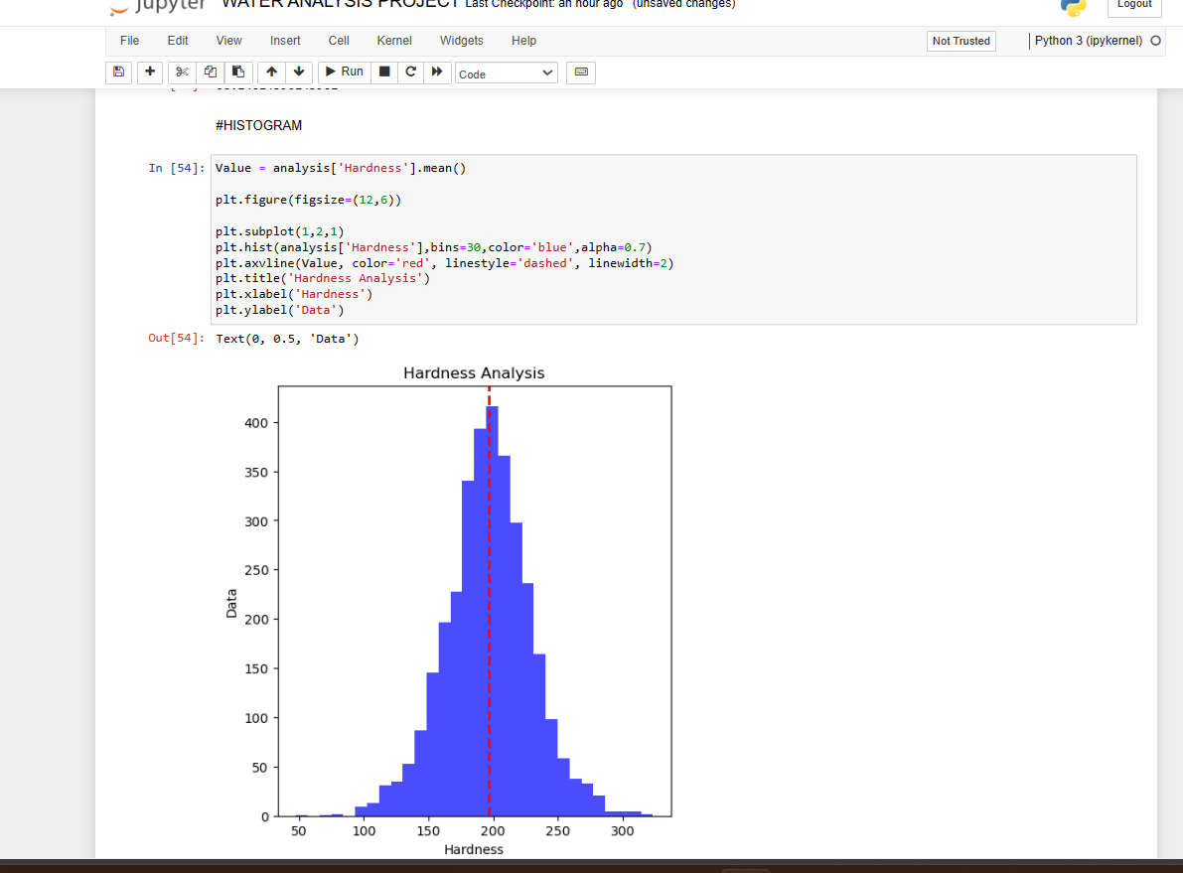

**#Solids**

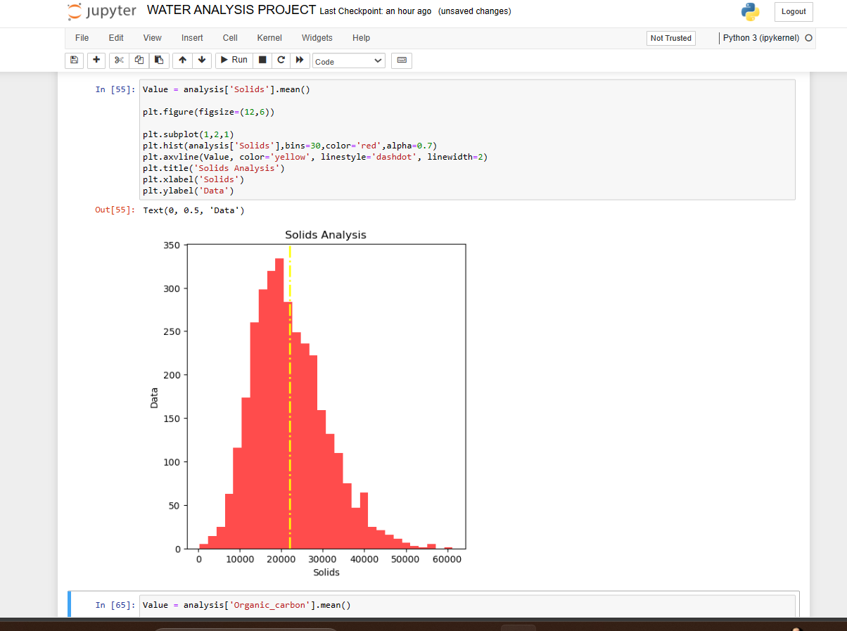

**#Organic carbon**

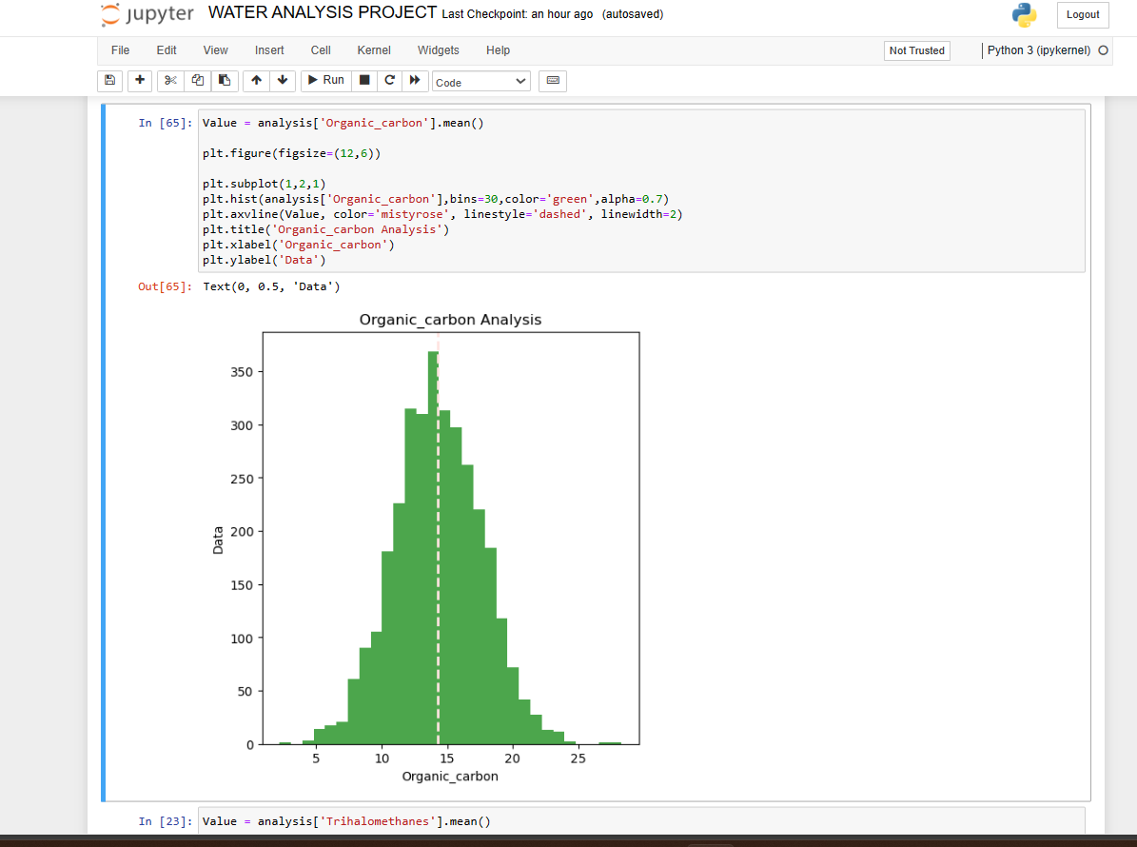

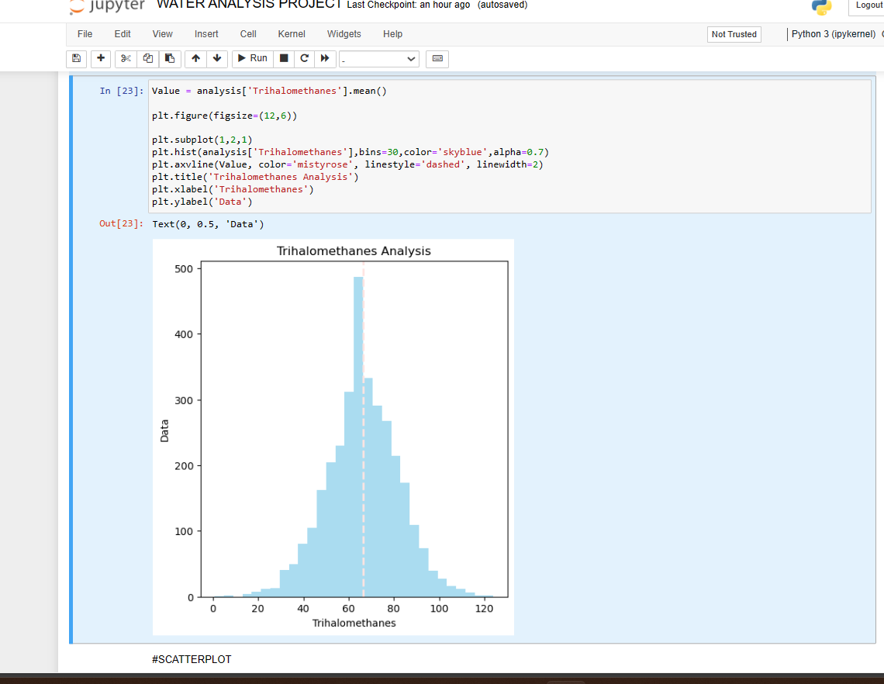**#Trihalomethanes**

**#Scatterplots**

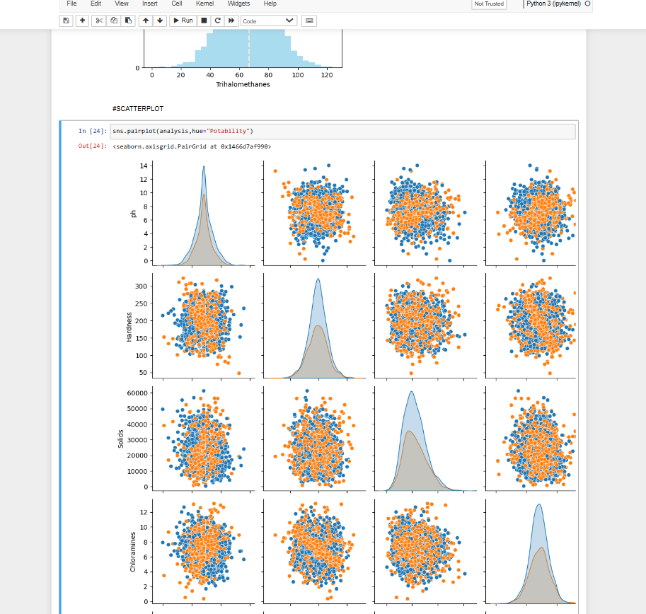

sns.pairplot(analysis,hue="Potability")

**#PH**

sns.scatterplot(analysis['Hardness'])

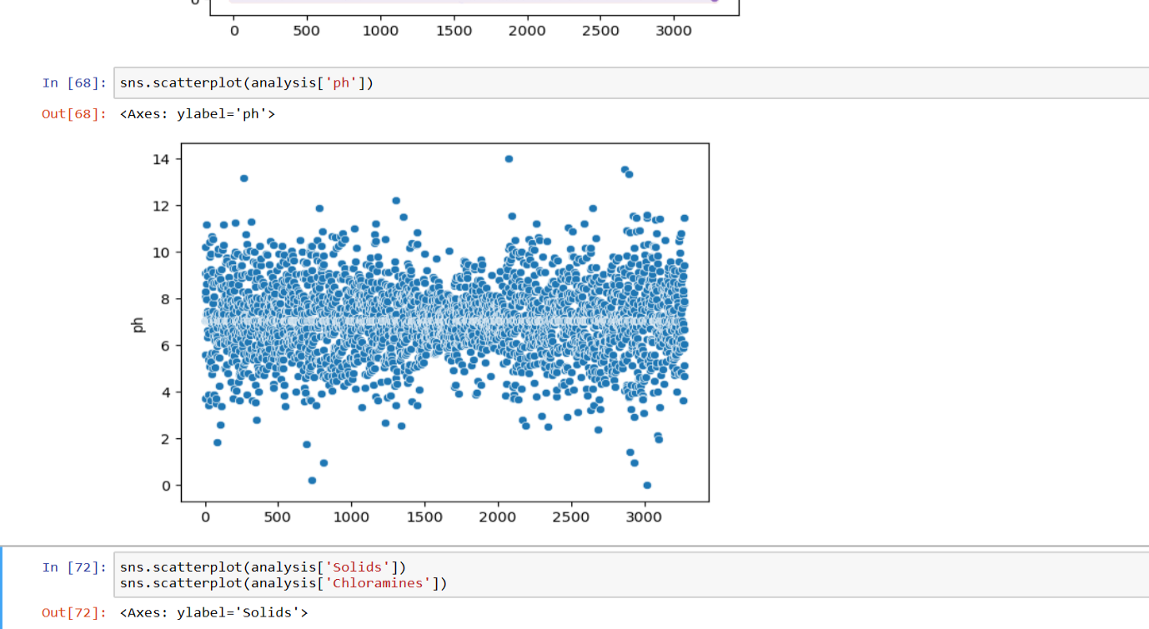

**#Hardness**

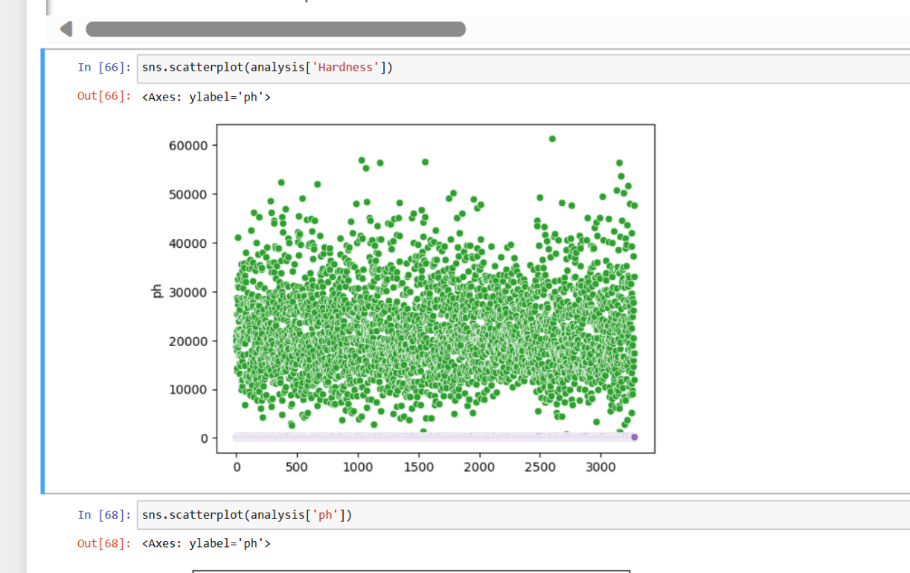

**#Solids**

**#Chloramines**

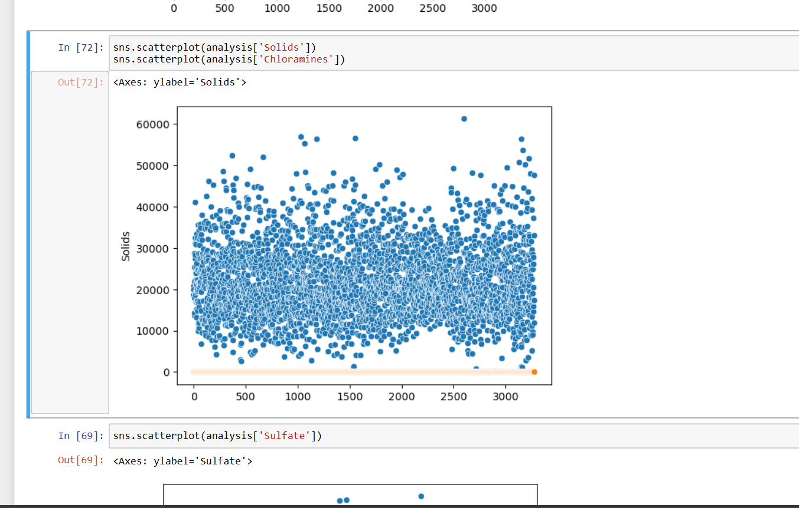

**#Sulfates**

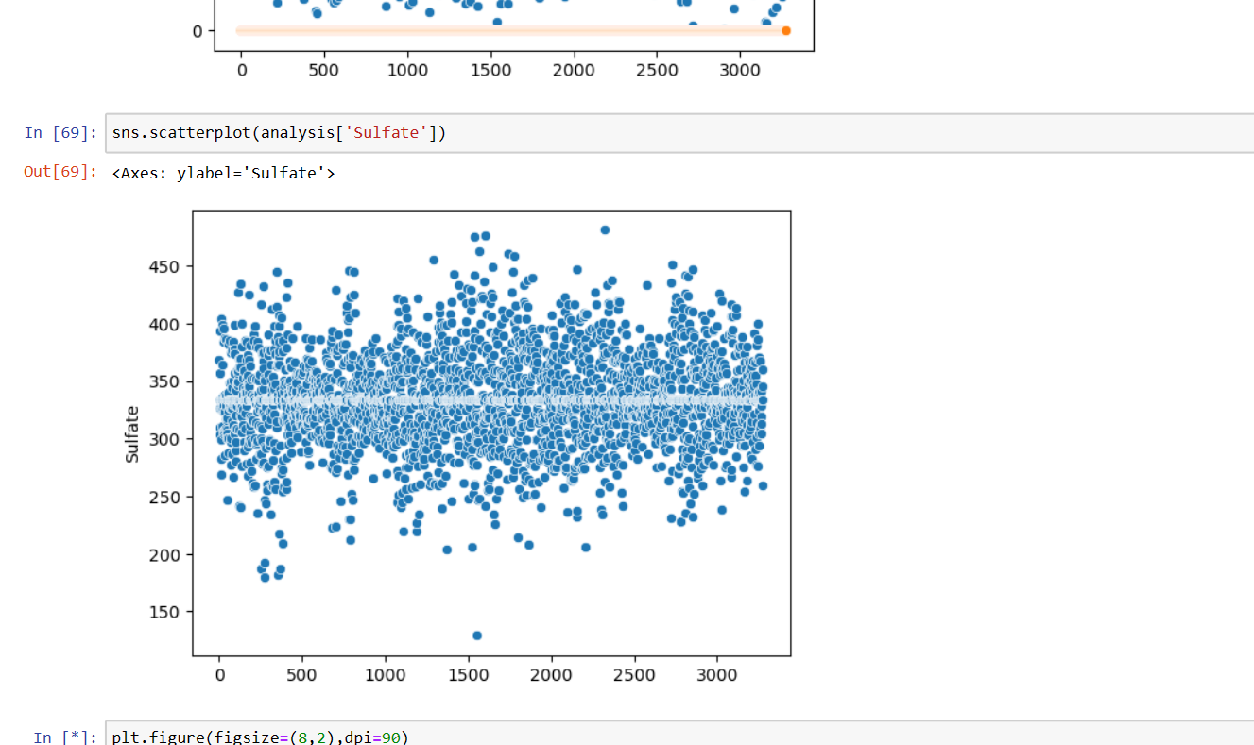

plt.figure(figsize=(8,2),dpi=90)

sns.scatterplot(x='Organic_carbon',y='Trihalomethanes',data=analysis,hue='Turbidity',style='Conductivity')

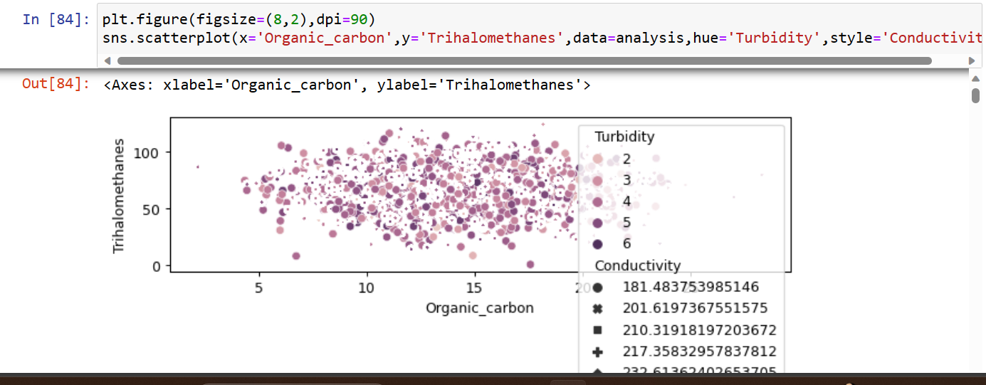

**#Correlation Matrices**

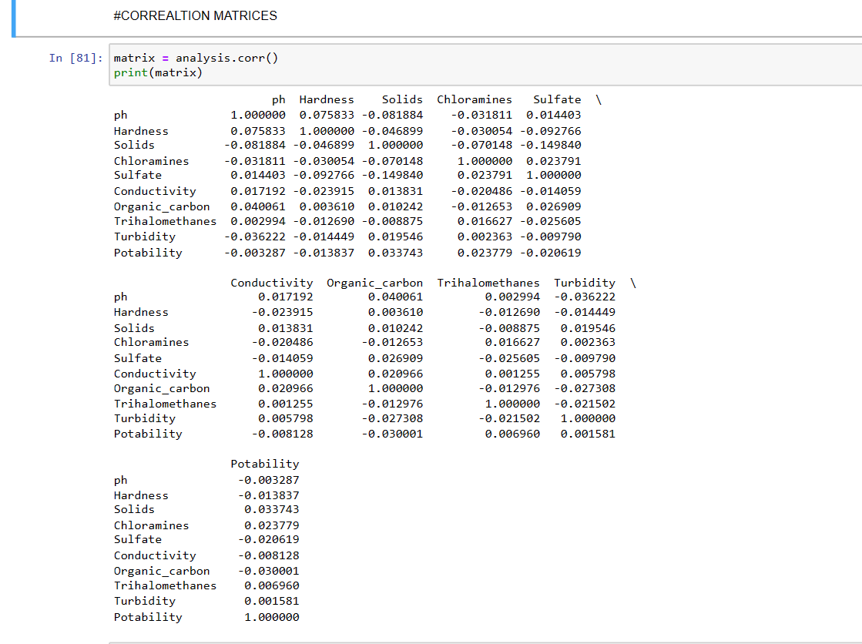

**#Logistic Regression**

from sklearn.linear_model import LogisticRegression

model_lr = LogisticRegression()

model_lr.fit(x_train,y_train)

pred_lr = model_lr.predict(x_test)

accuracy_score_lr = accuracy_score(y_test,pred_lr)

accuracy_score_lr*100

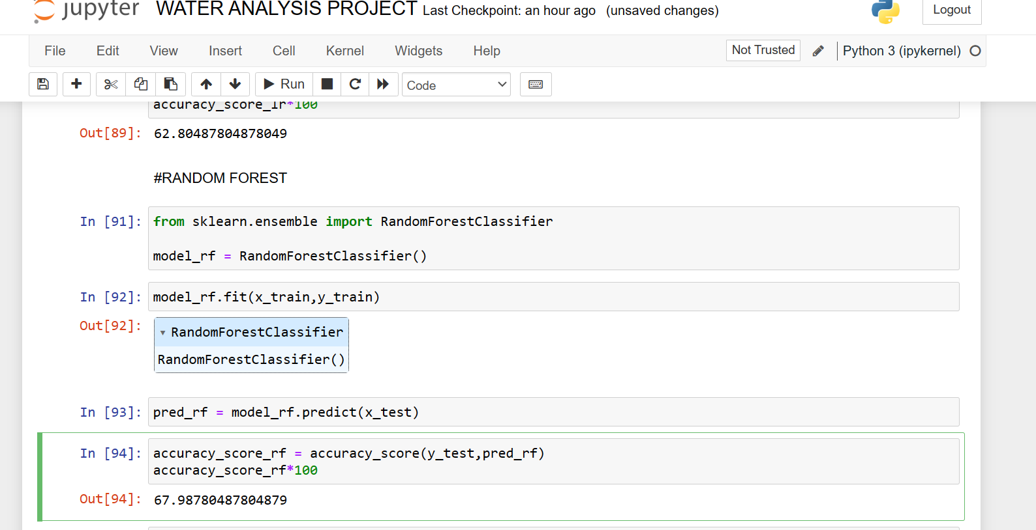

**#Output**

**67.98780487804879**

**#Random Forest**

from sklearn.ensemble import RandomForestClassifier

model_rf = RandomForestClassifier()

model_rf.fit(x_train,y_train)

pred_rf = model_rf.predict(x_test)

accuracy_score_rf = accuracy_score(y_test,pred_rf)

accuracy_score_rf*100

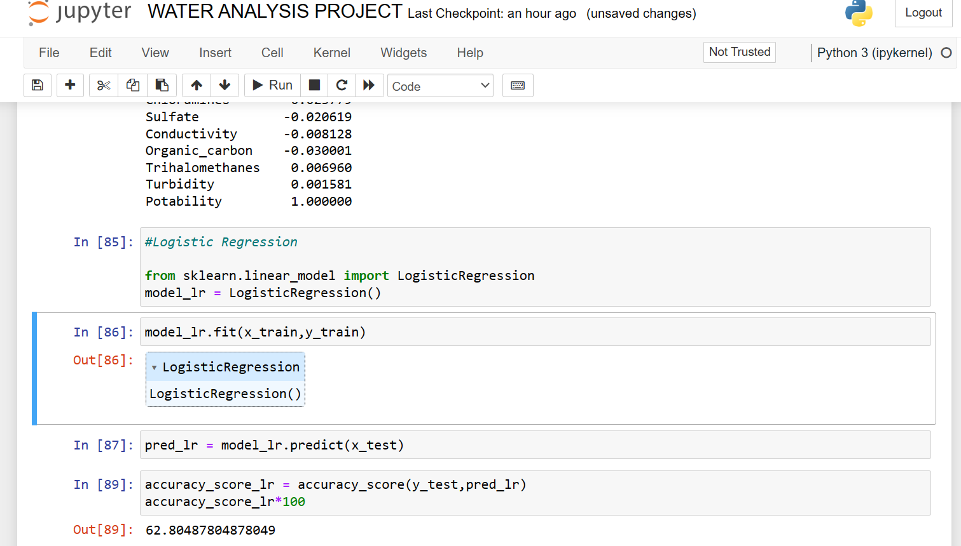

**#Output**

**62.80487804878049**

In this WATER QUALITY ANALYSIS, we represent various Histogram, Scatterplots and Correlation Matrices, Then we use machine learning models Logistic Regression and Random Forest.