**PHASE 5**

**PROJECT DOCUMENTATION & SUBMISSION**

**Project’s Objective:**

* In this project involves analyzing water quality data regulatory standards and determine water potability based on various parameters.
* This project includes defining analysis objectives, collecting water quality data, designing relevant visualizations, and building a predictive model.

**Design Thinking:**

* We continue to build the analysis by creating visualizations and building a predictive model.
* Using Visualization libraries to create histograms, scatter plots, and correlation matrices.
* Here we Build a predictive model such as logistic regression and random forest.

**Development Phases:**

* In this part we will begin building our project by loading and preprocessing the dataset.
* Preprocessing the data and performing exploratory data analysis for the given water quality analysis test.
* Handling missing values and outliers by isnull methods in python.
* Using these models to determine water potability based on water quality parameters.

**DATA PREPROCESSING:**

* We selected Support Vector Machine algorithm.
* In this part we will begin building our project by loading and preprocessing the dataset.
* Preprocessing the data and performing exploratory data analysis for the given water quality analysis test.
* Handling missing values and outliers by isnull methods in python.

**EXPLORATORY DATA ANALYSIS:**

Using Visualization libraries to create histograms, scatter plots, and correlation matrices.

**# IMPORTING PACKAGES**

import numpy as np

import pandas as pd

import seaborn as sns

import matplotlib.pyplot as plt

from sklearn.preprocessing import StandardScaler

from sklearn.model_selection import train_test_split

from sklearn.metrics import accuracy_score, classification_report, confusion_matrix

**#Displaying Datasets**

analysis = pd.read_csv('water_potability[1].csv')

analysis.head()

**#Output**

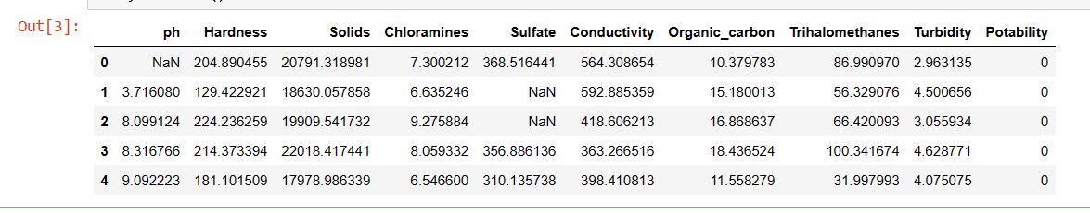

**Data Visualization**

**#Heatmap visualization**

plt.figure(figsize = (12,8))

sns.heatmap(analysis.isnull())

sns.heatmap(analysis.isnull())

plt.figure(figsize = (12,8))

sns.heatmap(analysis.corr(),annot= True)

**#Output 1**

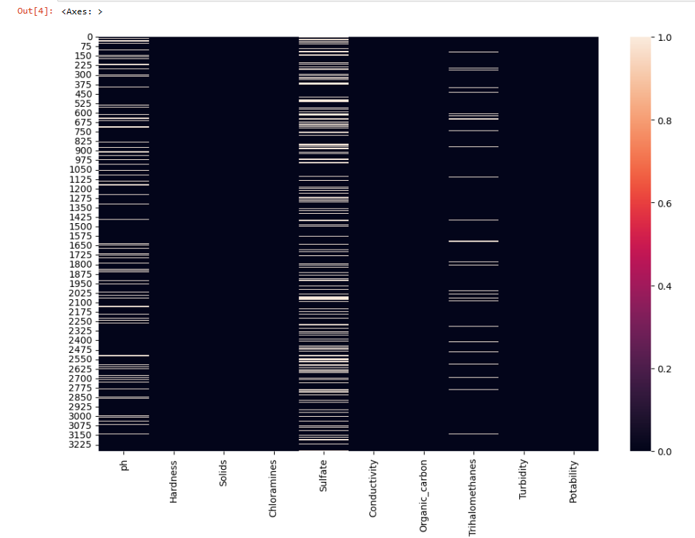

**#Output 2**

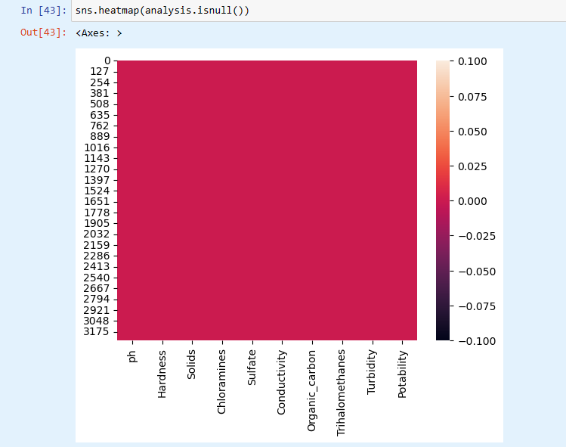

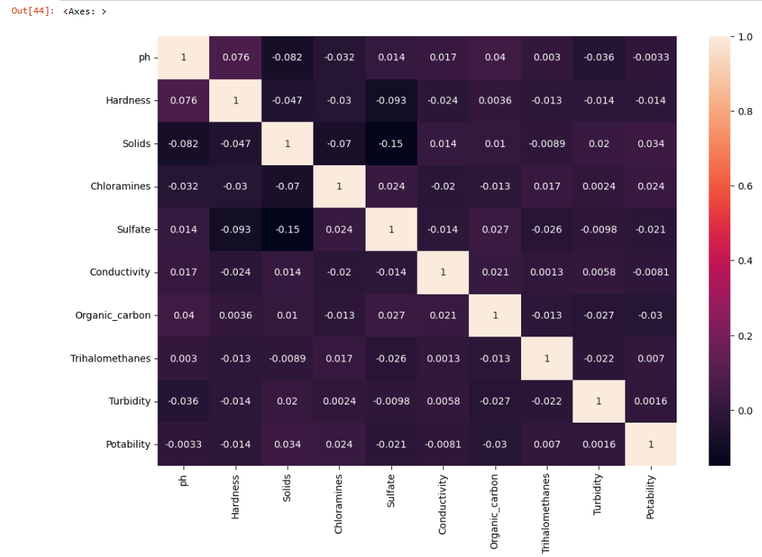

**#Pairplots**

sns.pairplot(analysis, hue="ph")

**#Output**

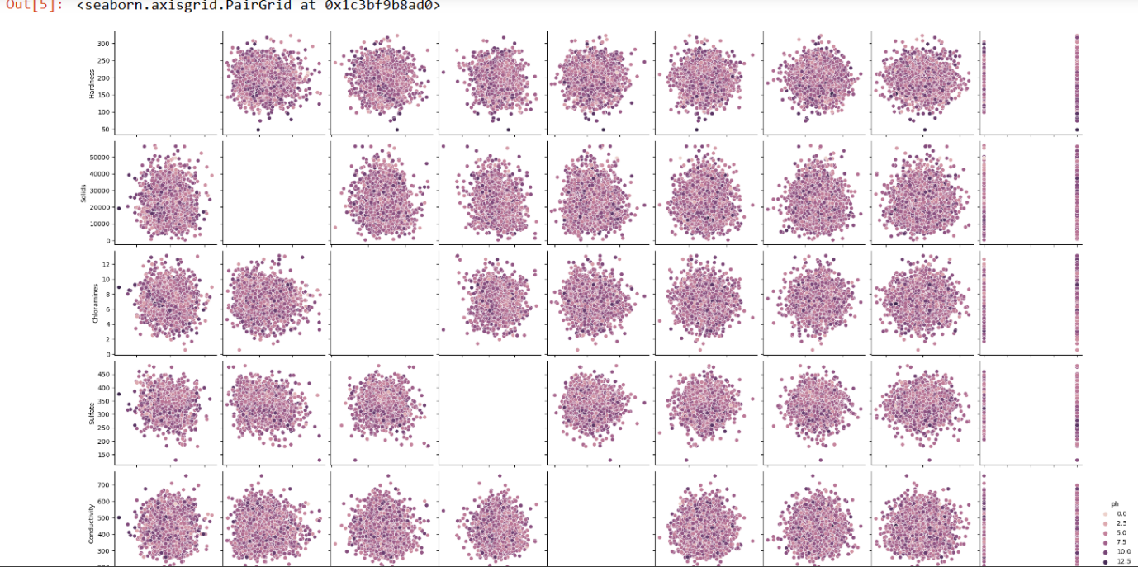

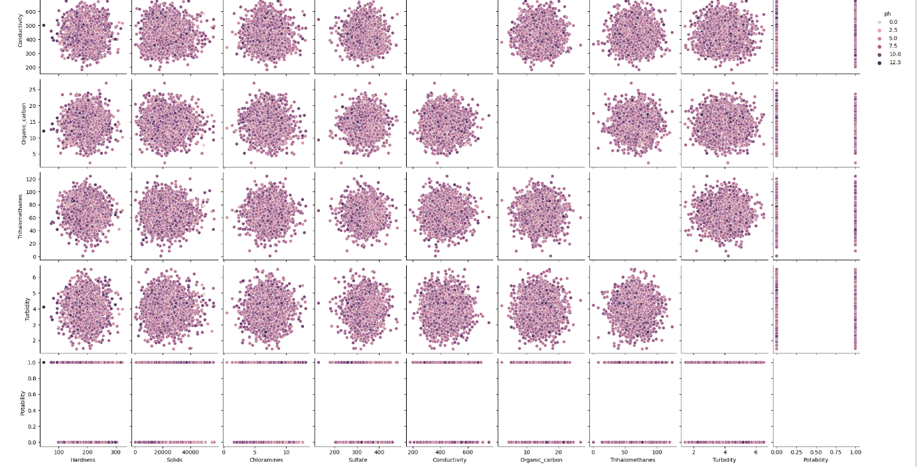

**#Barplots**

analysis.isnull().mean().plot.bar(figsize = (10,6))

plt.xlabel('Features')

plt.ylabel('Percentage')

**#Output**

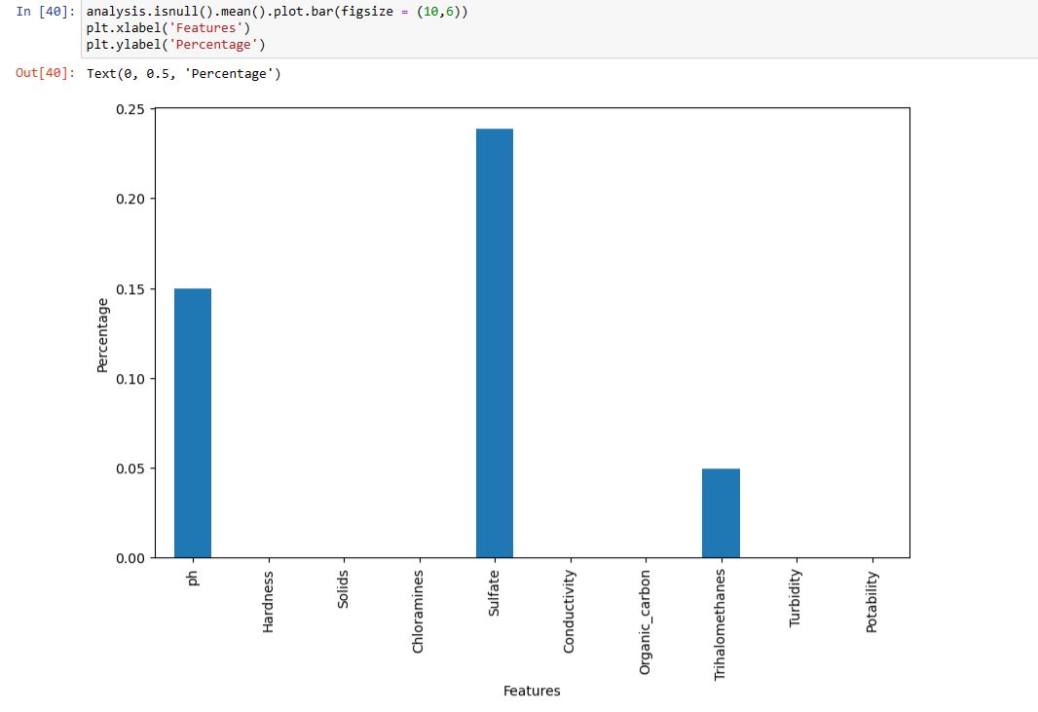

**#Handling Missing Values**

analysis['ph'] = analysis['ph'].fillna(analysis['ph'].mean())

analysis['Sulfate'] = analysis['Sulfate'].fillna(analysis['Sulfate'].mean())

analysis['Trihalomethanes'] = analysis['Trihalomethanes'].fillna(analysis['Trihalomethanes'].mean())

analysis.isnull().sum()

**#Output**

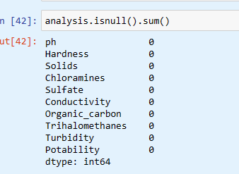

x = analysis.drop("Potability",axis = 1)

y = analysis['Potability']

x.shape, y.shape

scaler = StandardScaler()

x = scaler.fit_transform(x)

x

x_train,x_test,y_train,y_test = train_test_split(x,y,test_size = 0.2)

x_train.shape, x_test.shape

**#Support Vector Machine**

from sklearn.svm import SVC

model_svm = SVC(kernel='rbf')

model_svm.fit(x_train,y_train)

pred_svm = model_svm.predict(x_test)

accuracy_score_svm = accuracy_score(y_test,pred_svm)

accuracy_score_svm*100

**#Output**

**68.14024390243902**

**#Histogram**

Value = analysis['Hardness'].mean()

plt.figure(figsize=(12,6))

plt.subplot(1,2,1)

plt.hist(analysis['Hardness'],bins=30,color='blue',alpha=0.7)

plt.axvline(Value, color='red', linestyle='dashed', linewidth=2)

plt.title('Hardness Analysis')

plt.xlabel('Hardness')

plt.ylabel('Data')

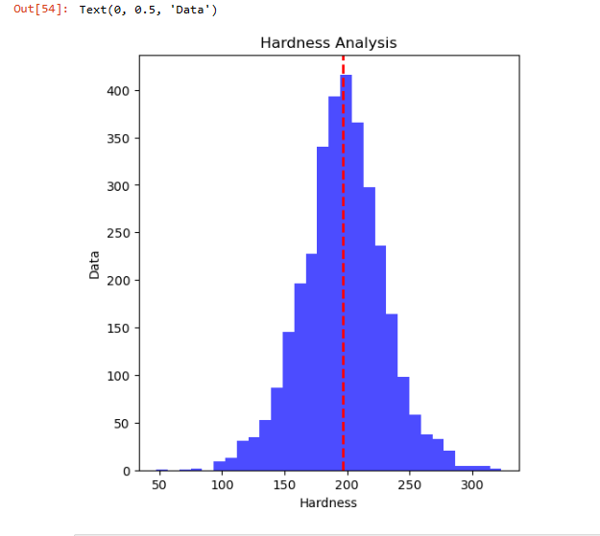

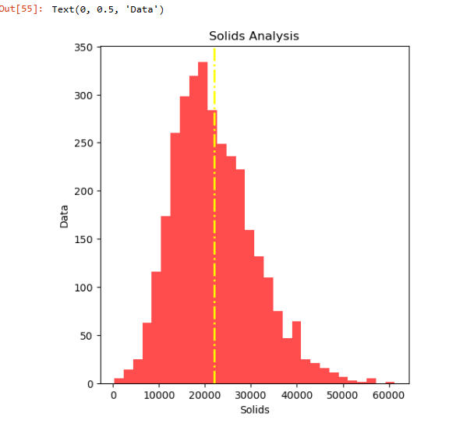

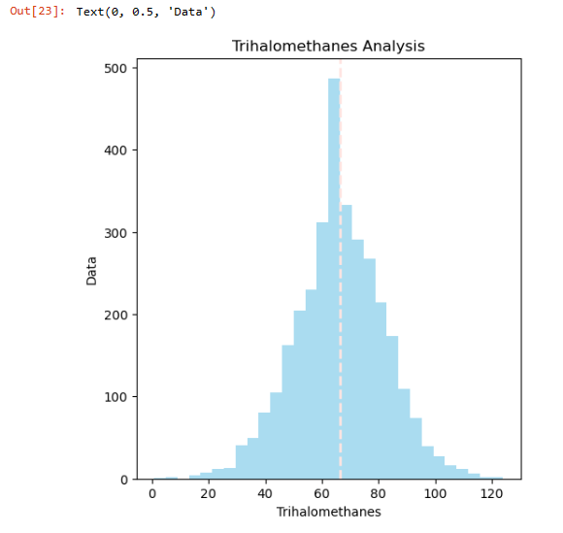

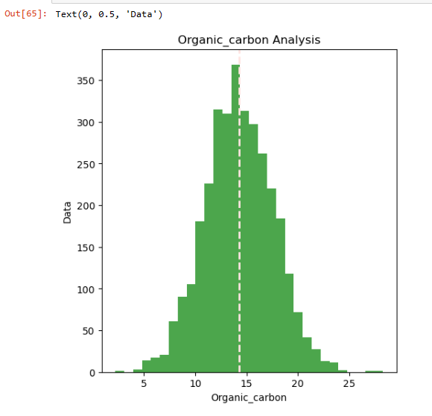

sns.pairplot(analysis,hue="Potability")

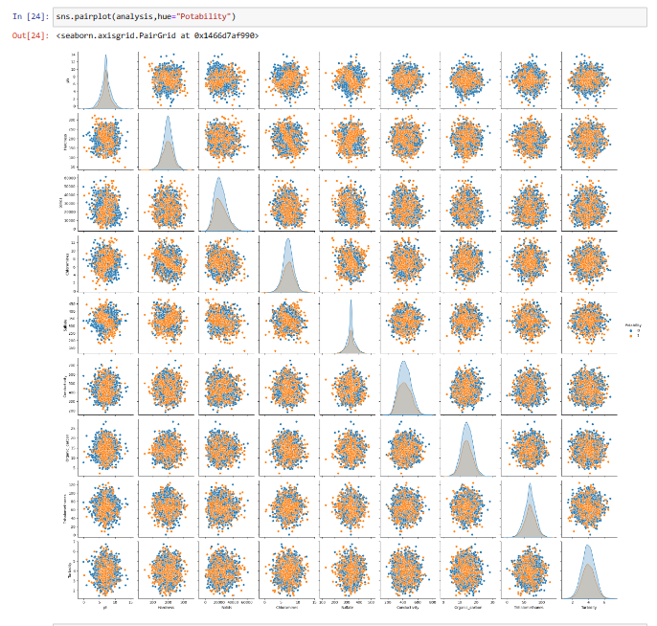

**#ScatterPlots**

sns.scatterplot(analysis['Hardness'])

sns.scatterplot(analysis['ph'])

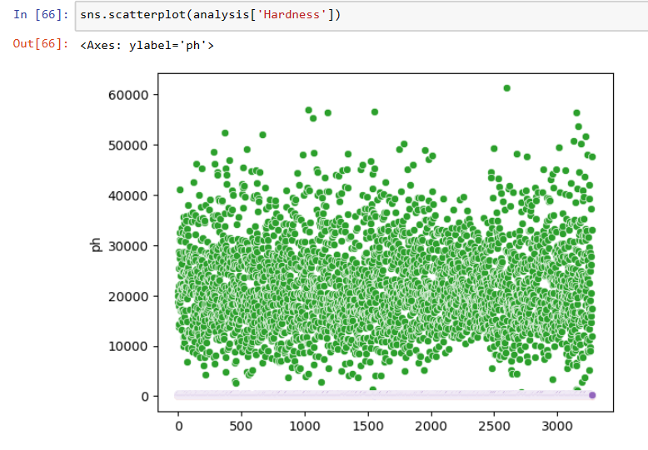

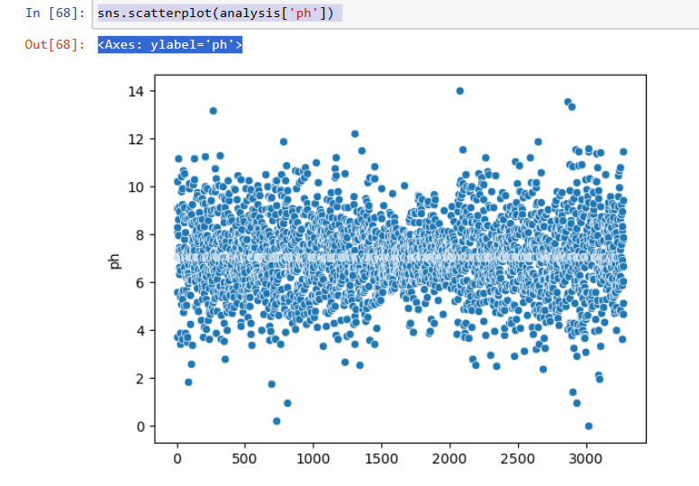

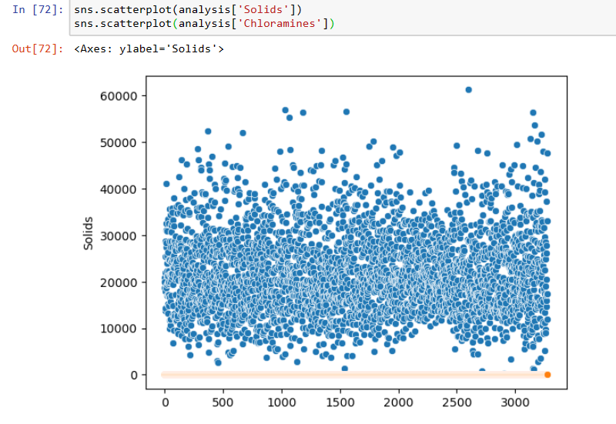

plt.figure(figsize=(8,2),dpi=90)

sns.scatterplot(x='Organic_carbon',y='Trihalomethanes',data=analysis,hue='Turbidity',style='Conductivity')

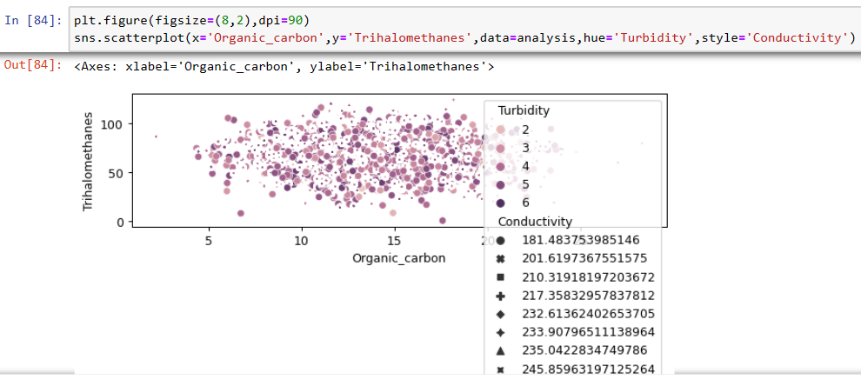

**#Corelation Matrices**

matrix = analysis.corr()

print(matrix)

**#Output**

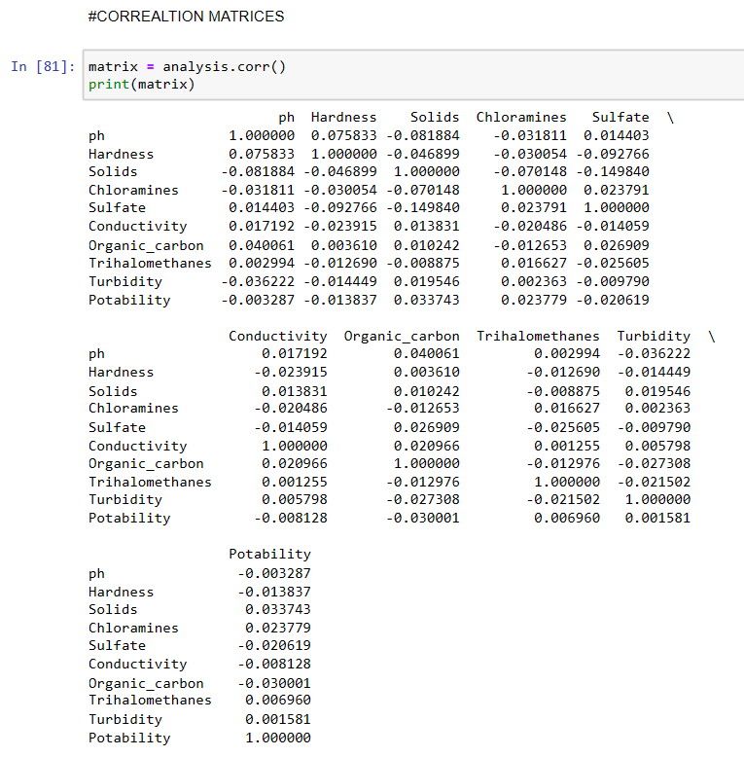

**PREDICTIVE MODELING**

**#Logistic Regression**

from sklearn.linear_model import LogisticRegression

model_lr = LogisticRegression()

model_lr.fit(x_train,y_train)

pred_lr = model_lr.predict(x_test)

accuracy_score_lr = accuracy_score(y_test,pred_lr)

accuracy_score_lr*100

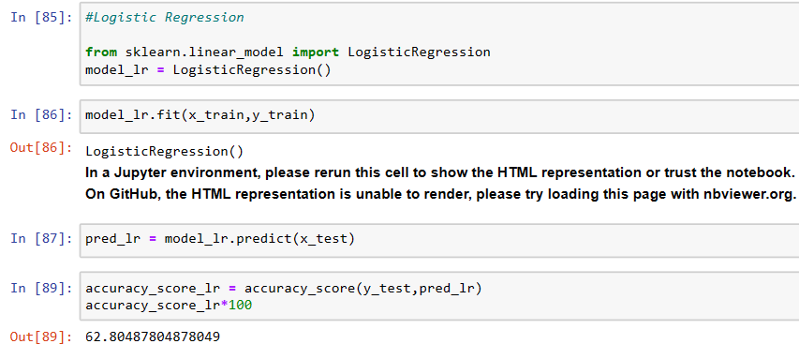

**#Predictive Analysis Logistic Regression**

**62.80487804878049**

**#Random Forest**

from sklearn.ensemble import RandomForestClassifier

model_rf = RandomForestClassifier()

model_rf.fit(x_train,y_train)

pred_rf = model_rf.predict(x_test)

accuracy_score_rf = accuracy_score(y_test,pred_rf)

accuracy_score_rf*100

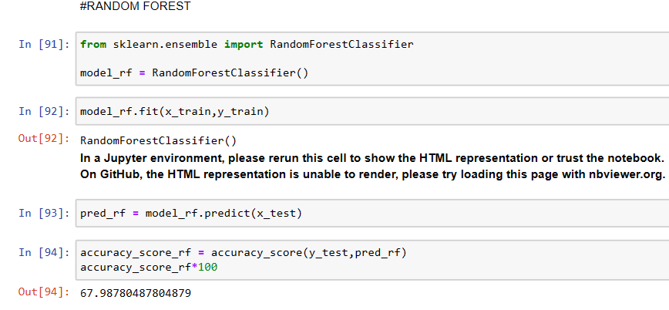

**#Predictive Analysis Random Forest**

**67.98780487804879**