
21ECC222L – ANALOG AND LINEAR INTEGRATED CIRCUITS LABORATORY

Mini Project Report
on

TWO WAY INTERCOM

Submitted by
N. DURGA PRANEETHA (RA2411004010213)
G. HARSHA VARDHAN (RA2411004010218)

Semester: IV
Academic Year: 2025–26
Course: 21ECC222L – Analog and Linear Electronic Circuits Laboratory

Under the supervision of
Dr. SRINATH R
Assistant Professor (Selection Grade), Department of ECE

Department of Electronics and Communication Engineering
SRM Institute of Science and Technology
SRM Nagar, Kattankulathur – 603203, Chengalpet District, Tamil Nadu
APRIL / MAY 2026


DEPARTMENT OF ECE
College of Engineering and Technology, SRM IST
SRM Nagar, Kattankulathur – 603203, Chengalpet District, Tamil Nadu

BONAFIDE CERTIFICATE
This document certifies that the project report titled TWO WAY INTERCOM represents the genuine work undertaken by N. DURGA PRANEETHA (RA2411004010213) and G. HARSHA VARDHAN (RA2411004010218) from the Department of Electronics and Communication Engineering. This project is submitted in fulfilment of the course 21ECC222L – Analog and Linear Electronic Circuits Laboratory, as part of the IV Semester in the B. Tech in Electronics and Communication Engineering program for the academic year 2025-26. The student(s) has/have conducted this work under my supervision and guidance. All materials sourced from external references have been appropriately acknowledged.

DATE: | LAB INSTRUCTOR

RUBRICS FOR EVALUATING THE MINI PROJECT WORK
Particulars | Possible Marks | Assigned Marks
Project Proposal | 10
Circuit/System Design | 10
PCB Prototype | 20
SPICE Simulation | 20
Project Report | 10
Poster | 10
Presentation Slides | 10
Viva Voce | 10
Total Marks | 100

Name / Sign / Stamp with date

ABSTRACT
This project implements a simple two-way intercom system for half-duplex communication using an LM386 audio amplifier. The system allows two users to communicate through speakers and microphones by toggling an SPDT (Single Pole Double Throw) switch. The LM386 amplifies microphone signals to drive a speaker for clear audio output. The design uses basic analog components — resistors, capacitors, electret microphones, and 8Ω speakers — and can be easily constructed on a breadboard. The project demonstrates core concepts in analog audio amplification, signal switching, and real-time audio routing using minimal components.
1. INTRODUCTION
1.1. Background and Motivation for the Project
Communication is a fundamental requirement in daily life, and localized, wired intercom systems offer a secure and cost-effective means of short-range voice communication. Unlike wireless systems that require complex RF circuitry or internet infrastructure, a wired intercom based on analog components is simple, reliable, and easy to build.
This project was motivated by the desire to understand the practical aspects of audio amplification and signal routing using the LM386, a widely used low-voltage audio power amplifier IC. The project provides a hands-on learning experience in analog circuit design and serves as an excellent foundation for understanding audio communication electronics.
1.2. Importance of the Project Topic
Analog communication systems remain highly relevant in embedded electronics, consumer devices, and industrial automation. The LM386, designed for low-power applications, is frequently used in portable audio equipment, hearing aids, AM-FM radios, and intercoms. Understanding how to design and build circuits around the LM386 equips students with practical skills in signal amplification, gain control, and noise suppression — all of which are critical in modern electronics engineering.
1.3. Overview of the Project Topic
The two-way intercom system consists of two identical units, each containing an electret microphone and a small speaker. A single-pole double-throw (SPDT) switch controls which microphone is active at any given time, enabling half-duplex communication. When one user activates the switch, their microphone signal is routed through the LM386 amplifier and played through the other user's speaker. Passive components such as resistors and capacitors are used to bias the microphone, control gain, and filter noise.
1.4. Objectives of the Project
- Design and implement a basic two-way audio communication system using the LM386 IC.
- Implement half-duplex switching using an SPDT switch to alternate between two communication endpoints.
- Amplify microphone input signals to an adequate level for speaker output using the LM386.
- Demonstrate clear, stable, and noise-free audio communication between two users.
- Develop hands-on experience in analog circuit design, breadboard prototyping, and component selection.
2. CIRCUIT / SYSTEM DESIGN AND ARCHITECTURE
The two-way intercom project is built around the LM386 low-voltage audio power amplifier. The system uses a single LM386 IC to amplify the microphone input from either of two users, depending on the position of the SPDT toggle switch. The overall architecture is straightforward and involves three main stages: microphone input selection, audio amplification, and speaker output.
2.1. System Block Diagram
The block diagram consists of two microphones (Microphone 1 and Microphone 2), an SPDT input switch (SW1), an LM386 audio amplifier stage, and two speakers. The SPDT switch selects which microphone is active, routing its signal to the amplifier, which then drives both speakers for audio output. The signal flow is: Microphone → SPDT Switch (SW1) → LM386 Audio Amplifier → Speakers.
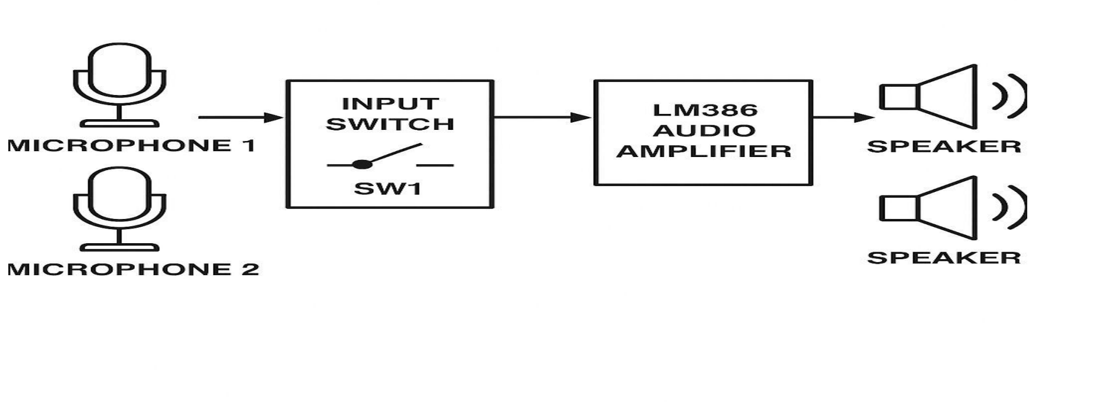
2.2. Components Used

S.No | Component | Value / Specification | Qty
1 | LM386 Audio Amplifier IC | Low-voltage, 8-pin DIP | 1
2 | Electret Microphone | Condenser type | 2
3 | Speaker | 8Ω, 0.5W | 2
4 | SPDT Toggle Switch (SW1) | Single Pole Double Throw | 1
5 | Resistor R1 | 10kΩ | 1
6 | Resistor R2 | 4.7kΩ | 1
7 | Resistor R3 | 10kΩ (pull-up bias) | 1
8 | Capacitor C1 | 10µF electrolytic | 1
9 | Capacitor C2 | 0.1µF ceramic | 1
10 | Capacitor C3 | 10µF electrolytic | 1
11 | Capacitor C4 | 0.1µF ceramic | 1
12 | Power Supply | +5V DC | 1
13 | Breadboard and connecting wires | General purpose | As reqd.

2.3. Circuit Description
The system consists of two identical microphone-speaker sets. Each electret microphone is powered through a 10kΩ pull-up resistor (R3) connected to +5V, which provides the necessary bias voltage for the condenser element. The SPDT switch SW1 selects the active microphone. The selected microphone output is AC-coupled through capacitor C2 (0.1µF) to remove the DC bias, then fed into the non-inverting input (pin 3) of the LM386 through a 4.7kΩ resistor R2.
The LM386 is powered by a +5V supply connected to pin 6, with pin 4 (ground) and pin 7 (bypass) decoupled using a 10µF capacitor C3 to prevent oscillations. The output at pin 5 is coupled through a 10µF electrolytic capacitor C1 to the speaker, blocking DC and allowing only the amplified audio signal to pass. A Zobel network consisting of R1 (10kΩ) and C4 (0.1µF) is placed at the output to ensure stability and suppress high-frequency oscillations. In its default configuration, the LM386 provides a voltage gain of 20 (26 dB).
2.4. Circuit Diagram

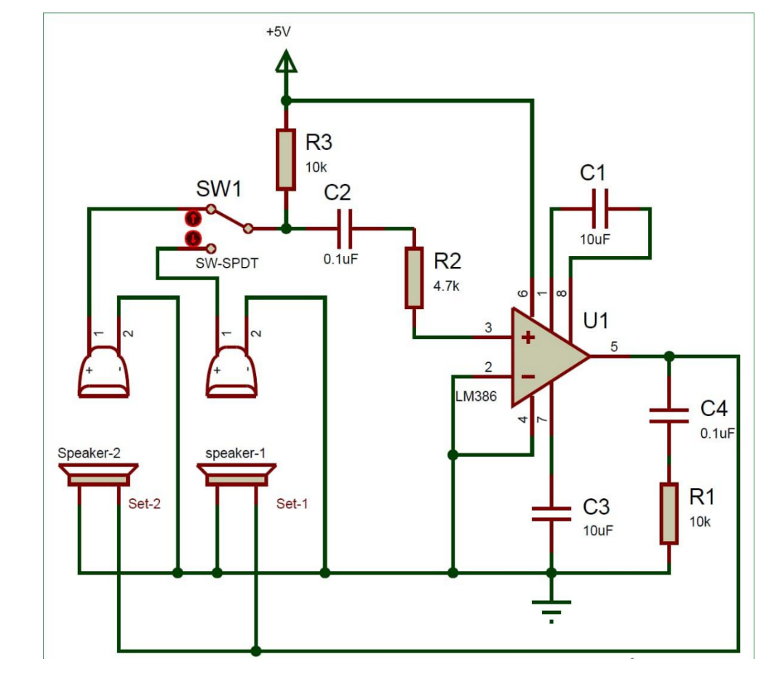

3. LITERATURE SURVEY
The following references were surveyed to understand the design and implementation of a two-way intercom system using the LM386 audio amplifier:
Sl.No | Title | Author | Journal & Year | Inference
1 | LM386 Audio Amplifier Datasheet | Texas Instruments | TI Datasheet, 2020 | Provides comprehensive specifications of the LM386 IC including gain settings, frequency response, and suitability for low-voltage audio applications.
2 | Two-Way Intercom using LM386 | Circuit Digest Team | Circuit Digest, 2021 | Presents a practical approach to designing a simple intercom circuit using LM386 with SPDT switch for half-duplex communication.
3 | Audio Amplifier Design Basics | AAC Editorial Team | All About Circuits, 2019 | Outlines foundational knowledge on audio amplifier topologies, feedback mechanisms, gain control, and the influence of component values on signal amplification.
4 | Practical Electronics for Inventors | Paul Scherz, Simon Monk | McGraw-Hill, 2016 | Offers in-depth explanation of analog electronics with specific sections dedicated to audio amplification and practical LM386 circuit designs.
5 | LM386 Application Note | National Semiconductor | TI Archive, 2012 | Focuses on optimizing LM386 circuits including stability improvements, noise suppression techniques, and gain control customization.
6 | Simple Audio Amplifier Using LM386 | Electronics Hub Team | Electronicshub.org, 2020 | Explains step-by-step methods to construct a basic LM386 amplifier with practical tips for voltage regulation and speaker compatibility.
7 | DIY Intercom with LM386 | John Doe (Contributor) | Instructables, 2018 | Demonstrates the implementation of a two-way intercom using LM386 and a toggle switch, promoting breadboard-level design.
8 | Analog Audio Design | EEWeb Team | EEWeb Articles, 2019 | Explores analog audio signal processing and design optimization techniques relevant for audio communication systems like intercoms.
9 | Real-Time Help with LM386 | TI Engineers | TI E2E Forum, 2021 | Compiles expert responses regarding real-world LM386 circuit problems, offering insights into debugging and gain tuning.
4. SIMULATION AND ANALYSIS
4.1. Simulation Environment
The two-way intercom circuit was simulated using Proteus software for schematic capture and verified using SPICE-based simulation tools. The simulation environment allowed verification of circuit connectivity, component values, and signal amplification behaviour before hardware prototyping on a breadboard.
4.2. Simulation Setup
The microphone was modelled as an AC voltage source with an amplitude of approximately 5mV (typical electret microphone output) at a frequency of 1kHz to represent a human voice signal. The LM386 was configured in its default gain setting (gain = 20) with the standard external components as described in Section 2. The SPDT switch was set to select Microphone 1 (Set-1) during simulation.
4.3. Key Simulation Results
- The LM386 amplified the 5mV input signal to approximately 100mV at its output, confirming a voltage gain of 20 (26 dB) in the default configuration.
- The output waveform was a clean, amplified sinusoid with no visible distortion at the nominal input level, confirming linear operation within the supply voltage range.
- The output coupling capacitor C1 (10µF) correctly blocked DC offset, allowing only the audio signal to reach the speaker.
- The Zobel network (R1 and C4) was verified to suppress high-frequency ringing at the amplifier output.
- The decoupling capacitor C3 at the bypass pin (pin 7) was confirmed to eliminate oscillations and stabilize the bias point.
5. RESULTS AND DISCUSSION
5.1. Practical Results
The two-way intercom system was successfully assembled on a breadboard and tested under real conditions. The following results were observed:
- Microphone signals from both Set-1 and Set-2 were successfully amplified by the LM386, producing clear and audible audio at the respective speakers.
- Toggling the SPDT switch (SW1) seamlessly switched the active microphone, enabling smooth half-duplex communication between two users.
- The audio output was stable with minimal background noise, confirming that the decoupling and Zobel network components were functioning as designed.
- Communication was tested across a physical distance of approximately 3–5 metres with satisfactory audio clarity.
5.2. Observations and Discussion
The LM386, despite being a low-power IC operable between 4V and 12V, delivered sufficient gain to clearly amplify electret microphone signals without additional pre-amplification. The default gain of 20 was adequate for short-range intercom applications. Some minor humming was observed at the speaker output, attributed to insufficient shielding of the microphone wires. This was mitigated partially by keeping the wiring compact on the breadboard.
The half-duplex nature of the communication — where only one party can speak at a time — was found to be practical for short announcements and inter-room communication scenarios. For applications requiring simultaneous bidirectional communication (full-duplex), a more complex design with separate amplifier paths and acoustic echo cancellation would be necessary.
5.3. Limitations
- The system operates in half-duplex mode only; simultaneous two-way communication is not supported.
- Performance degrades over longer wire lengths due to signal attenuation and electromagnetic interference.
- The default LM386 gain of 20 may be insufficient for very quiet speakers; higher gain (up to 200) can be configured using external components between pins 1 and 8.
- Breadboard construction introduces parasitic capacitance and inductance that may cause minor audio instability.
6. CONCLUSION
The two-way intercom system was successfully designed, simulated, and implemented using the LM386 audio power amplifier and basic passive components. The project demonstrates the core principles of analog audio amplification, signal switching using an SPDT switch, and real-time audio routing for half-duplex communication.
The LM386 IC proved to be an excellent choice for this application due to its simplicity, low power consumption, and sufficient gain for short-range intercom use. The project provided valuable hands-on experience in analog circuit design, breadboard prototyping, and the practical challenges of audio signal amplification.
Future enhancements could include: (a) increasing the gain using an external capacitor between LM386 pins 1 and 8 for improved microphone sensitivity, (b) implementing full-duplex communication using two separate LM386 amplifier stages, (c) adding a PCB design for a more robust and permanent circuit, and (d) incorporating a push-to-talk button instead of a toggle switch for improved user experience.
REFERENCES
- Texas Instruments, LM386 Low Voltage Audio Power Amplifier Datasheet, 2020. [Online]. Available: www.ti.com
- Circuit Digest Team, "Two-Way Intercom Circuit using LM386," Circuit Digest, 2021. [Online]. Available: www.circuitdigest.com
- AAC Editorial Team, "Audio Amplifier Design Basics," All About Circuits, 2019. [Online]. Available: www.allaboutcircuits.com
- P. Scherz and S. Monk, Practical Electronics for Inventors, 4th ed., New York, NY: McGraw-Hill, 2016.
- National Semiconductor, Application Note: LM386 Audio Amplifier, Texas Instruments, 2012. [Online]. Available: www.ti.com
- Electronics Hub Team, "Simple Audio Amplifier Using LM386," Electronicshub.org, 2020. [Online]. Available: www.electronicshub.org
- J. Doe, "DIY Intercom Using LM386 and SPDT," Instructables, 2018. [Online]. Available: www.instructables.com
- EEWeb Team, "Analog Audio Design Guide," EEWeb Technical Articles, 2019. [Online]. Available: www.eeweb.com
- Texas Instruments, "TI E2E Support Forums," TI E2E Community, 2021. [Online]. Available: https://e2e.ti.com
- Maker Pro, "Beginner Intercom Design Using LM386," Maker.pro, 2022. [Online]. Available: www.maker.pro
APPENDIX
CONTRIBUTIONS TO THE PROJECT WORK

S.No | Phase | Description | Responsibility*
1. | Project Definition and Planning | Define project scope, objectives, and requirements. Assess feasibility. Create a project plan. | N.Durga Praneetha
2. | Conceptual Design and Ideation | Brainstorm and create a conceptual design. Explore different approaches and architectures. | G.Harsha Vardhan
3. | Detailed Design and Component Selection | Select specific components. Create detailed schematics, layout designs, and circuit diagrams. | G.Harsaha Vardhan
4. | Simulation and Testing | Simulate the circuit using software tools. Validate the design. | N.Durga Praneetha
5. | PCB Design and Layout (If applicable) | Design the PCB layout using software tools. Ensure signal integrity. | G.Harsaha Vardhan
6. | Prototyping and Fabrication (If applicable) | Build a physical prototype. Verify it matches the design specifications. | N.Durga Praneetha
7. | Integration and Assembly | Integrate all hardware components. Assemble the complete system. | G.Harsha Vardhan
8. | Functional Testing and Debugging | Thoroughly test the integrated system. Debug hardware issues. | G.Harsha Vardhan
9. | Documentation and Reporting | Maintain detailed documentation including design files, schematics, and project reports. | N.Durga Praneetha
10. | Presentation Slides/Posters | Prepare the presentation slides and posters for demonstration. | N.Durga Praneetha
11. | Demonstration | Showcase the project to peers and instructors. Explain design choices and demonstrate. | All members in team

