HIGH-AVAILABILITY E-COMMERCE DATABASE
Azure SQL Database with Failover Group and Private Endpoint
Project ID: 24CC3046-P012

S. no | Name | ID no | ROLE
1 | Koritala Bhavana | 2400030596 | DNS and Security Connectivity
2 | Devabhaktuni Monika Mithra | 2400031564 | Testing & Presentation
3 | Kagitha Prem Siddhartha | 2400031606 | Networking & Private Endpoint
4 | Balaga Harsha Vardhan Naidu | 2400031652 | Azure Database & Failover
 | Dr. Surya kiran chebrolu | Mentor

KL University | Department of Computer Science and Engineering
Odd Semester 2026–2027

1. Abstract
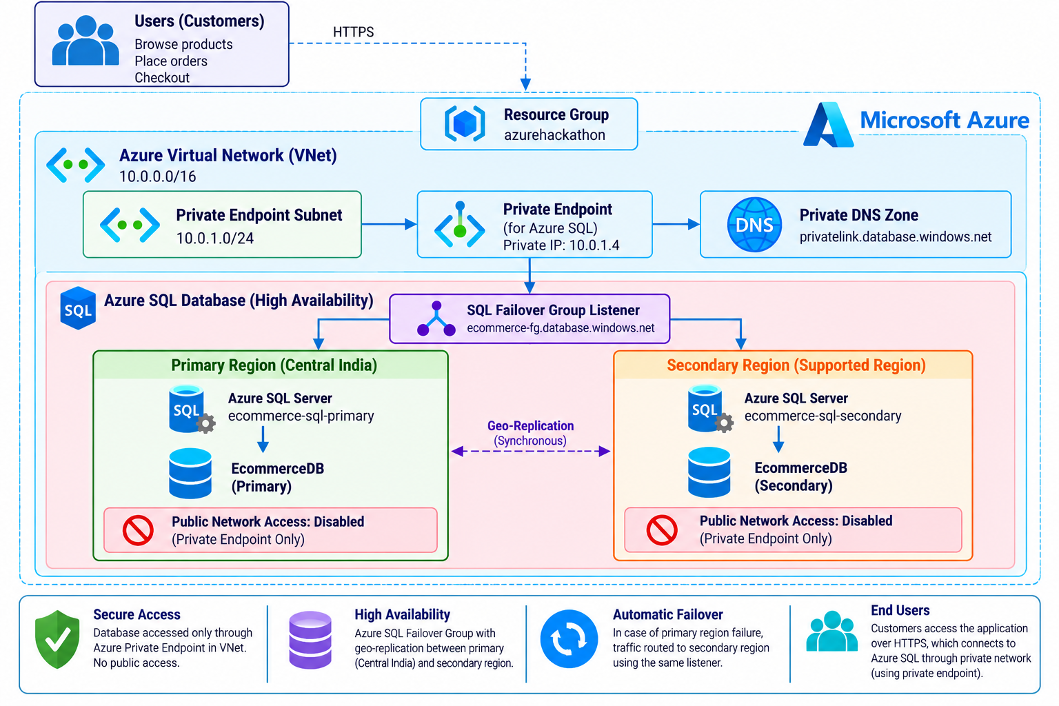This project presents a high-availability e-commerce database architecture using Azure SQL Database. The solution is designed to keep an e-commerce database available across a regional failure by using a primary Azure SQL Server in Central India and a secondary Azure SQL Server in Korea Central. The two servers are connected through an Azure SQL Failover Group, providing a logical failover mechanism and a listener endpoint for application connectivity. Private Endpoints and Virtual Networks are used to reduce exposure of the database to the public internet.
The implemented environment is hosted in the Azure resource group 'azurehackathon'. The primary database is named EcommerceDB and uses a General Purpose, provisioned, Gen5 configuration with 2 vCores. Public network access is disabled on the primary SQL server, and an approved private endpoint is configured. The project also includes the corresponding secondary SQL server and private networking resources.

2. Problem Statement
E-commerce systems depend on continuous access to customer, product, order and transaction data. A database outage caused by regional infrastructure failure, maintenance or connectivity problems can interrupt application operations and affect users. At the same time, exposing a production database through a public network increases the attack surface.
The project therefore addresses two core requirements: (1) provide cross-region database availability and failover capability, and (2) provide controlled private connectivity to Azure SQL.

3. Objectives
- Deploy a primary Azure SQL Server in Central India.
- Deploy a secondary Azure SQL Server in Korea Central.
- Create EcommerceDB as the project database.
- Configure an Azure SQL Failover Group named ecommerce-fog.
- Use the Failover Group to associate the primary and secondary servers.
- Create private networking resources and private endpoints for database connectivity.
- Disable public network access on the SQL server.
- Verify the deployed resources and document the configuration with Azure Portal evidence.

4. Implemented Architecture

5. Azure Resources Implemented
- Resource group: azurehackathon.
- Primary SQL server: ecommerce-sql-primary, Central India.
- Secondary SQL server: ecommerce-sql-secondary, Korea Central.
- SQL database: EcommerceDB.
- Failover Group: ecommerce-fog.
- Primary private endpoint: ecommerce-sql-private-endpoint.
- Secondary private endpoint: ecommerce-sql-secondary-private-endpoint.
- Primary VNet: ecommerce-vnet.
- Secondary VNet: ecommerce-vnet-secondary.
- Private DNS configuration for private SQL connectivity was part of the networking design.
- Public network access is disabled for the SQL server; access is intended through approved private endpoint connections.

6. Database Configuration
EcommerceDB is deployed on the primary Azure SQL Server in Central India. The database overview shows the database is online and configured under the General Purpose service tier with Gen5 and 2 vCores. The database is associated with the ecommerce-sql-primary server.
Property | Project Configuration
Database | EcommerceDB
Primary server | ecommerce-sql-primary
Primary region | Central India
Secondary server | ecommerce-sql-secondary
Secondary region | Korea Central
Pricing tier | General Purpose
Compute | Provisioned
Generation | Gen5
vCores | 2

7. High Availability and Failover Group
The core high-availability component is the Azure SQL Failover Group named ecommerce-fog. The Azure Portal confirms ecommerce-sql-primary as the Primary server and ecommerce-sql-secondary as the Secondary server. The failover policy shown in the project is Customer managed.
- Primary: ecommerce-sql-primary (Central India).
- Secondary: ecommerce-sql-secondary (Korea Central).
- Failover Group: ecommerce-fog.
- Database count displayed by Azure: 1/1.
- Failover policy: Customer managed.
- The Failover Group provides a logical endpoint that applications can use instead of hard-coding the current primary server.

8. Network and Private Access Design
The project uses an Azure Virtual Network to provide the private networking foundation. The primary VNet shown in the Azure Portal is named ecommerce-vnet and uses address space 10.0.0.0/16. A subnet is configured within the VNet, and private endpoints are used to connect the VNet to the Azure SQL resources.
The primary SQL Server networking configuration explicitly shows Public network access set to Disabled. The Private Access page shows an approved private endpoint connection. This ensures that the intended access path is through the private endpoint rather than an internet-facing SQL endpoint.

9. Security Configuration
- Public network access is disabled on the SQL server.
- Private Endpoint connections are used for private connectivity.
- The private endpoint connection shown in the Portal is Approved.
- Private DNS is used as part of the private connectivity design so that SQL private endpoint names can resolve correctly.
- Database authentication credentials should be kept confidential and must not be included in screenshots or reports.

10. Testing and Verification
The implementation was verified through the Azure Portal. The evidence confirms resource creation, database availability, private endpoint approval, disabled public network access, VNet configuration and Failover Group association.
Test / Verification | Expected Result | Evidence
Resource deployment | Project resources visible in azurehackathon | Figure 1
Primary SQL server | ecommerce-sql-primary available in Central India | Figure 2
Database | EcommerceDB online with General Purpose / Gen5 / 2 vCores | Figure 3
Public access | Disabled | Figure 4
Private endpoint | Connection state Approved | Figure 5
VNet | ecommerce-vnet with 10.0.0.0/16 | Figure 6
Subnet | 10.0.0.0/24 default subnet shown | Figure 7
Failover Group | ecommerce-fog contains primary and secondary | Figure 8
Regional roles | Central India Primary; Korea Central Secondary | Figure 9

11. Important Project Scope Note
An Azure Virtual Machine was not implemented in the final environment. Therefore, the VM is not presented as a completed component or as evidence of end-to-end VM-to-SQL connectivity. Testing in this report is limited to the Azure resources and Portal configuration that were actually deployed and verified.

12. Limitations and Future Enhancement
- A dedicated Azure VM-based test environment was not included in the final implementation.
- The report does not claim VM-based connectivity testing.
- A future extension could use a controlled test host inside the VNet to perform DNS resolution and SQL connectivity tests.
- Additional monitoring and alerting can be expanded if required for a production deployment.

13. Conclusion
The project demonstrates a high-availability Azure SQL architecture for an e-commerce workload. The solution combines a primary SQL server in Central India, a secondary SQL server in Korea Central, the ecommerce-fog Failover Group, private endpoints, Virtual Network connectivity and disabled public access. The Azure Portal evidence confirms that the principal database, regional servers, failover configuration and private access components were deployed.
The resulting architecture provides a foundation for resilient e-commerce database operations while reducing direct public exposure of the database. The design can be extended later with a dedicated test host and more advanced monitoring, but those components are intentionally not represented as implemented in this report.

Appendix A — Azure Portal Evidence
The following screenshots are included as implementation evidence. Each figure is labelled according to the configuration or resource it verifies.
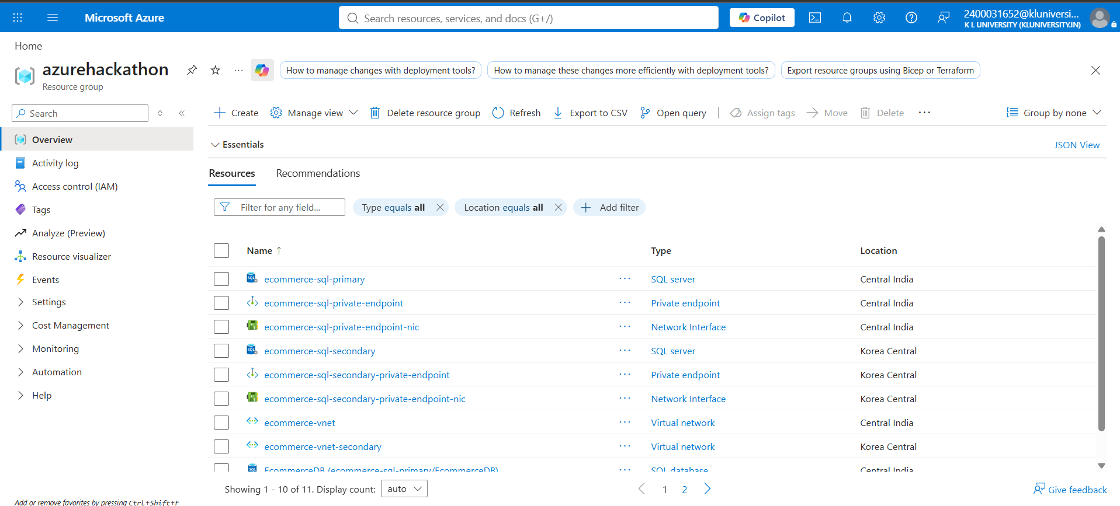
Figure 1. Azure resource group showing the deployed e-commerce SQL architecture resources.

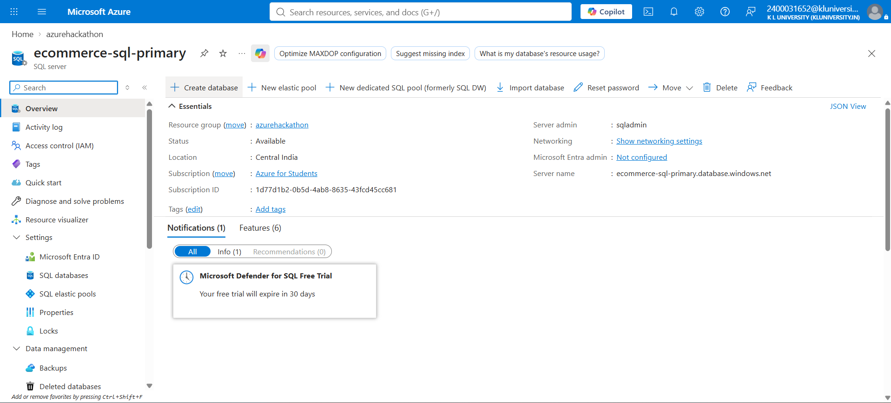
Figure 2. Primary Azure SQL Server overview: ecommerce-sql-primary in Central India.

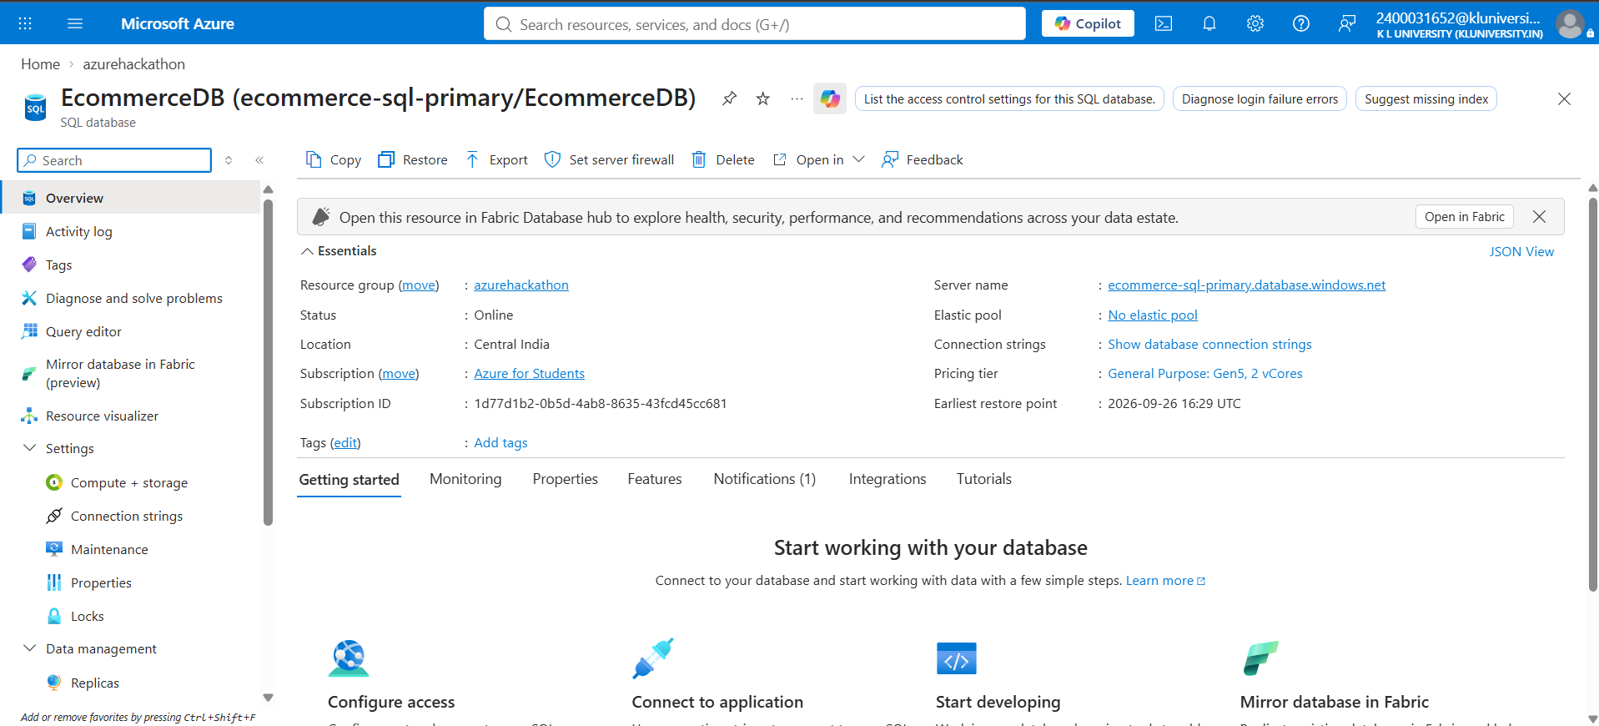
Figure 3. EcommerceDB overview showing the General Purpose, Gen5, 2-vCore configuration.

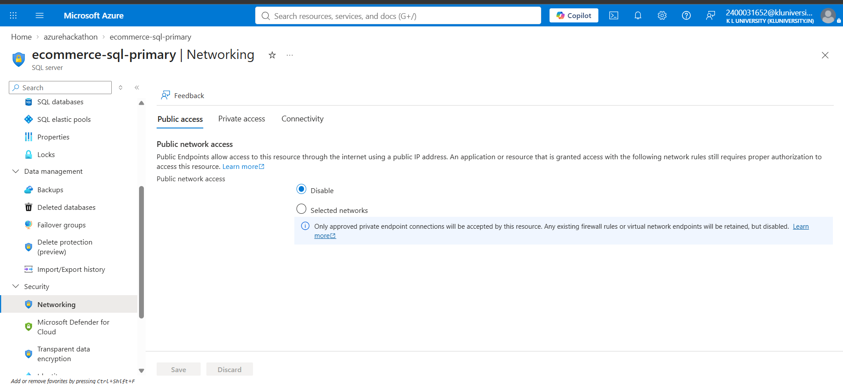
Figure 4. Primary SQL Server networking: Public network access is disabled.

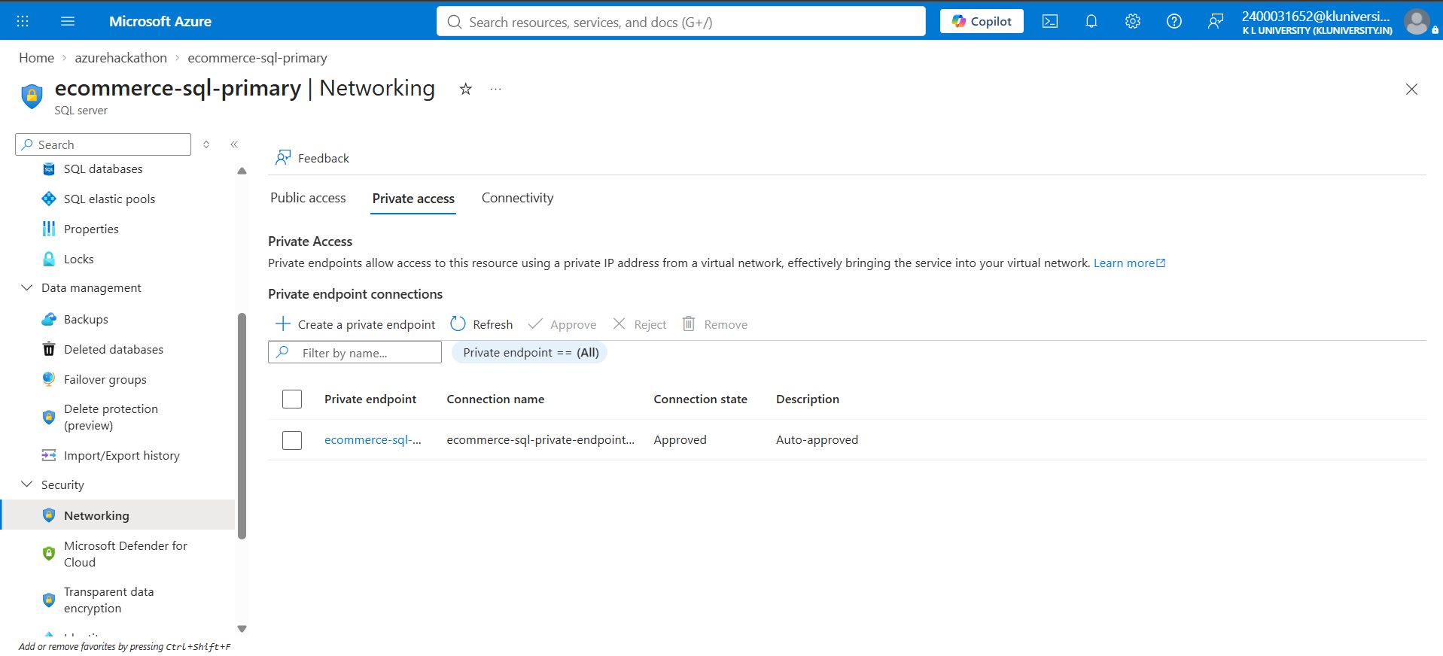
Figure 5. Primary SQL Server private access showing an approved private endpoint connection.

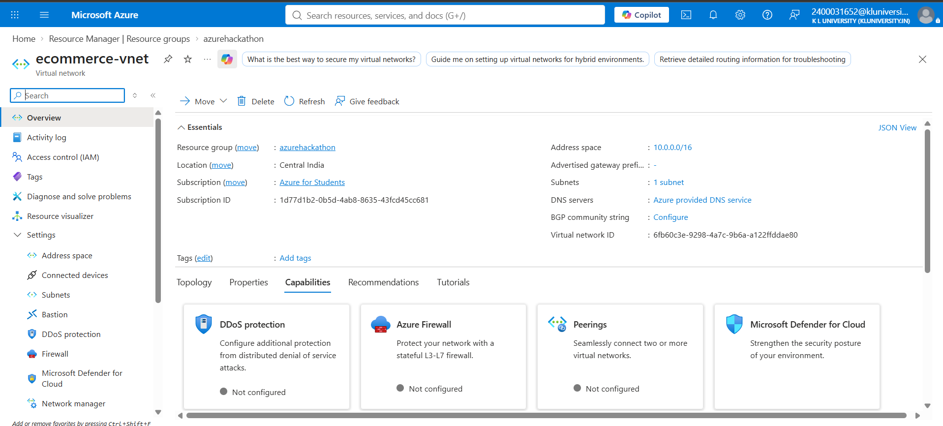
Figure 6. ecommerce-vnet overview showing the 10.0.0.0/16 address space.

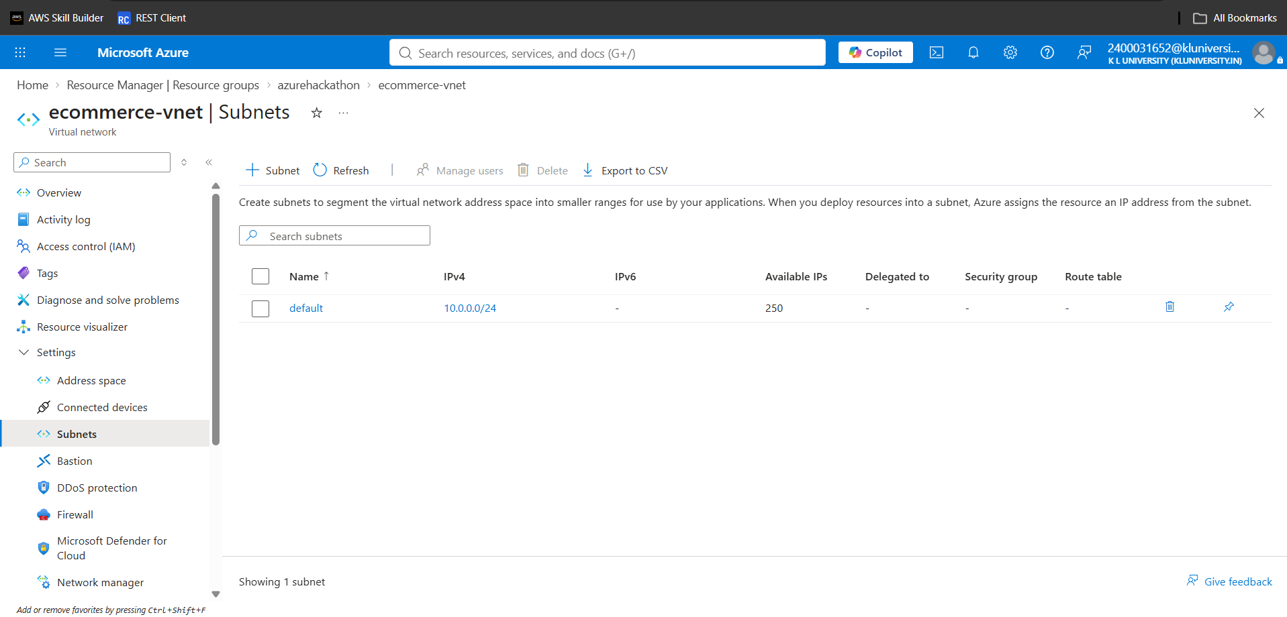
Figure 7. ecommerce-vnet subnet configuration showing the default 10.0.0.0/24 subnet.

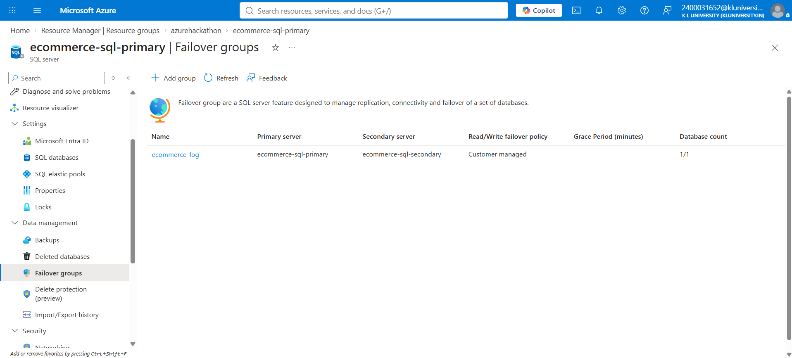
Figure 8. Failover Group list showing ecommerce-fog with primary and secondary SQL servers.

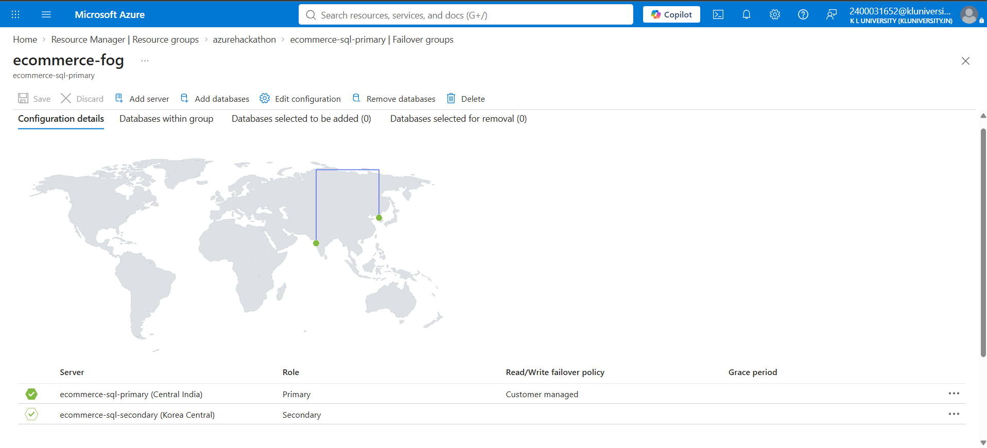
Figure 9. ecommerce-fog configuration showing Central India as Primary and Korea Central as Secondary.

