Introduction

This document has been created to discuss the process for:
PC Wipe Process

Sommaire

Introduction 1
Sommaire 1
Application 1
Warning 1
Process to wipe Desktops and Laptops 1
Document Control 5

Introduction

Startup de computer
Browse the programs and get all applications that are not part of the CORELOAD. Forward the user’s SSO and application list to Cyril Mourrain.

Application

The following open Source product has been selected for the PC wipe process for GE – “Darik's Boot and Nuke (DBAN) version 2.2.7”

Website: http://dban.sourceforge.net/

Warning

- On Laptop using a SD Card Reader, you will have to disable this drive in the BIOS.
- This Software is using a QWERTY keyboard.

Process to wipe Desktops and Laptops

- Start up the PC selecting the CD-rom/DVD/USB drive as the active drive, by hitting the ‘F12’ key at bootup. Alternatively, you can adjust the BIOS to have the CD/DVD perform as the 1st boot device.

- After selecting the CD drive, Darik’s Boot & Nuke would start to run. Press ‘Enter’ to start the program in ‘Interactive mode’. The following screens would appear:
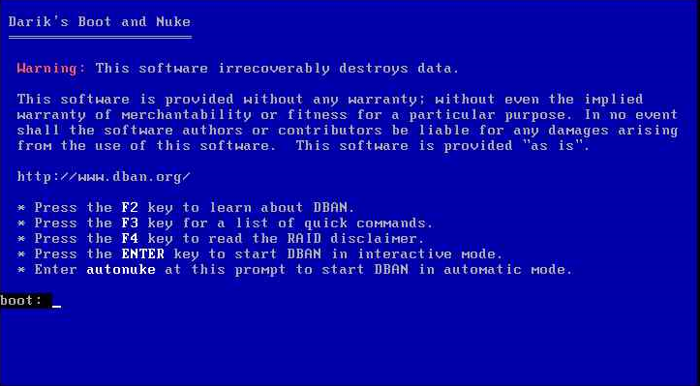

- Next, select the Hard disks to wipe (example here is taking for a virtual machine). You should see 2 partitions with one hard disk if it was a Win XP, or one partition if it was a win 7. Use Keys ‘Up’ or ‘Down’ to move and ‘Space’ to select the drives. ‘Wipe’ would appear beside the Partitions to clean.

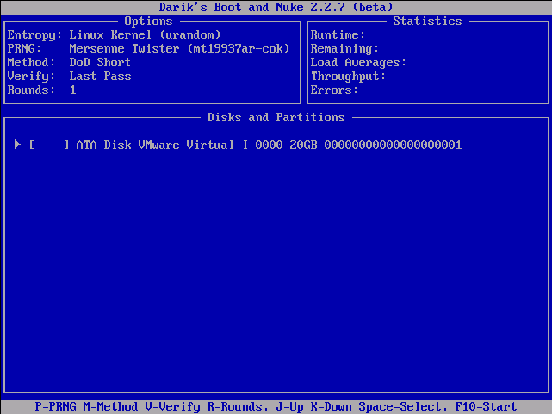

- Choose the PRNG method by pressing ‘P’ Key. Select ISAAC method using Keys ‘Up’ or ‘Down’ to move and ‘Space’ to select this PRNG.

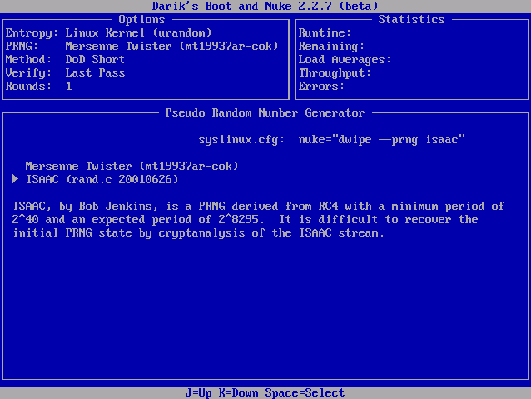

- You’ll return to the main screen. Next choose the Method for Wiping by hitting the ‘M’ key. In the new screen, select the “DoD 5220.22-M” by moving to this line and pressing ‘Space’

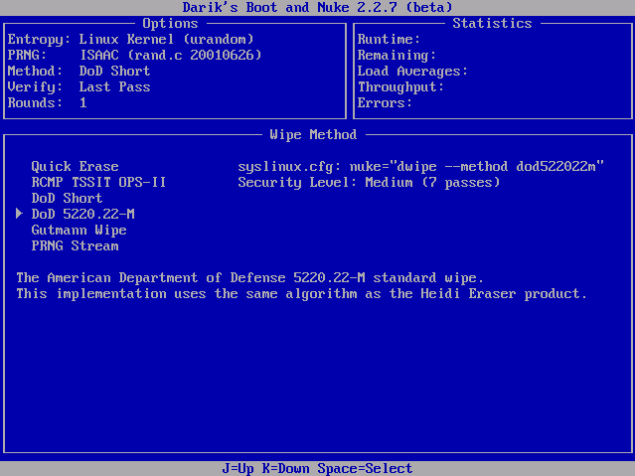

- Next choose the number of rounds to wipe the disk by hitting the ‘R’ key. Enter ‘7’ for the number of rounds

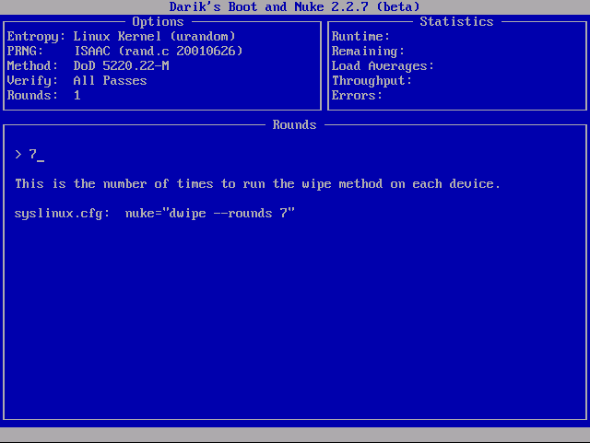

- Select the “Verification mode” by using the ‘V’ Key. Choose Verify All Passes

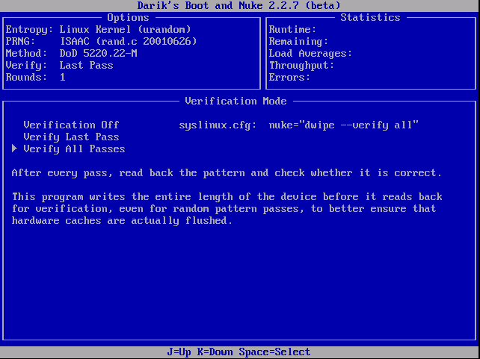

- Confirm the options selected by looking at the ‘Options’ selection and the disks to wipe. Press ‘F10’ to start the wipe process

- Program starts to execute. You should see the following
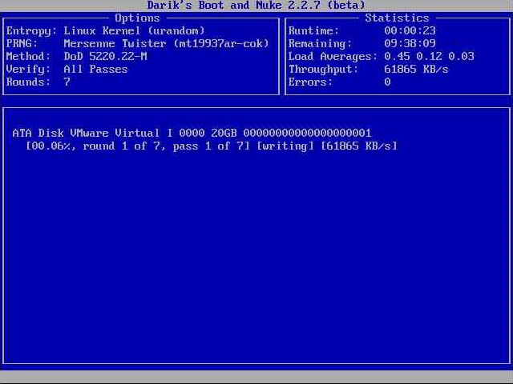

- On completion, the following message appears (ignore the error message Saving log to floppy disk… a floppy disk in DOS format was not found. This occurs because there is no floppy in the A:\ drive if available)

- If the “DBAN Succeeded” message appears, it means the wipe was successful. If not, the disk may have faults and should be trashed physically.

Document Control
Date | Change | Name
08/06/2013 | Document created | Thibaut LAURENT
13/03/14 | Updated | Diguidia Diakite

