Apply-IT #2, Beyond the Book

# Part 1: What-If Analysis with Data Tables

All Around Vision Care sets a goal for each office to expand its services each year. It establishes a percentage growth rate but uses an adjustment factor for each city to recognize differences in its markets. You have been asked to build a one-variable data table that tests several overall growth percentages to see the effect on the revenues forecast. You also will build a two-variable data table for Boston where you’ll illustrate revenues if both the growth percentage and its adjustment factor are changed.

1. Open the worksheet ***Revenues***
2. Trace dependent cells for cell H4 to see how the overall growth rate affects the 4 year revenues forecast in cell H18. *Hint: click “Trace Dependents” in the Formula Tab | Formula Auditing group 3 times.* Click “Remove Arrows” after you have completed your evaluation.
3. One-Variable Data Table
   1. You would like to evaluate growth rates between **1.00%** and **3.00%**. Interpolate the data to fill in the cells A26:A32. These percentages represent possible overall growth rates to replace the current value in cell H4. Your goal is to explore various growth rates using a constant amount of increase from 1.5% to 4%, rather than a constant percentage increase. *Interpolating from a Starting Value to an Ending Value EX9-23*
   2. Set up your one-variable data table by creating a reference to the four-year revenue forecast in cell B24. Make the number bold. *EX 8-3* [*Working with Data Tables*](javascript://)*. Helpful website:*  <https://www.excel-easy.com/examples/data-tables.html>
   3. Create a data table that shows revenues if the overall growth rate is set to the percentages shown in cells A25:A33. Format the results to improve readability.
   4. Use Conditional Formatting to highlight the Overall Growth Rate AND the corresponding Revenue Forecast on your one-variable data table, dependent on what is entered into cell H4. For instance, if you enter 4.00% in cell H4, cells A33 and B33 should be highlighted.
4. Two-Variable Data Table
   1. Next, create a data table with the result in cells F24:I31 that shows Boston Four-Year Total revenues when the overall growth rate and Boston’s adjusted growth factor are varied.
   2. Use Conditional Formatting to highlight the row, Column and intersection for Overall Growth Rate, the Boston Adjustment Factor AND the corresponding Revenue Forecast on your two-variable data table, dependent on what is entered into cells H4 and H6. For instance, if you enter 2.25% in cell H4 and 1.75 in H6, Row 29 and Column H in your data table should be highlighted.
5. Save your file now and often!

# PART 2: What-If Analyses with Solver

Michael Abbas is a manager at the Daybreak movie theater. One of his jobs is to create the weekly work schedule for the movie ushers. The theater employs 15 ushers—13 are full­time and two are part­time. The theater needs eight ushers to work each weekday, 11 on Saturday, and 10 on Sunday. Michael is currently working on the usher schedule for the second week in August. Michael tries to accommodate all time off requests while maintaining the required staff. He has been developing a workbook to automatically generate the work schedule. The workbook already contains the names of the ushers and their time off requests. He asks you to determine which ushers will be working which days. Complete the following:

1. The numbers 0 and 1 will indicate which shifts each employee is working. For example, 0 indicates an employee is not working that day, whereas 1 indicates that employee is scheduled to work.

In the Schedule worksheet, in the range D5:J19, enter 0 in each cell to indicate that you have not yet scheduled any shift for any employee.

1. In the range K5:K19, enter formulas to calculate the total number of shifts for each employee.
2. In the range L5:L19, calculate the total number of hours worked by each employee. Each shift is eight hours.
3. In the range D21:J21, enter the number of shifts required per day. The theater requires seven shifts on weekdays, 10 shifts on Saturday, and 11 shifts on Sunday.
4. In the range D22:J22, enter a formula that calculates the total number of shifts actually scheduled for the employees on each day.
5. In the range D23:J23, enter a formula to subtract the attendants required value from the attendants actually scheduled value. A negative number indicates that not enough employees have been scheduled to cover the day’s shifts.
6. In cell D25, calculate the total shortfall in shifts by entering a formula to total the values in the range D23:J23.
7. Create a Solver model that sets the value of cell D25 to 0 (indicating that all shifts are covered) by changing the values in the range D5:J19 under the following constraints:
   1. Add a binary constraint to force every value in the range D5:J19 to be either a 0 or a 1.
   2. Add a constraint to limit the total hours worked by each full­time employee to less than or equal to 40.
   3. Add a constraint to limit the total hours worked by each part­time employee to less than or equal to 24.
   4. Add a constraint to require that the difference values in the range D23:J23 all equal 0.
   5. Based on the entries in the range C5:C19, add constraints so that employees are not scheduled to work shifts on days when they are unavailable to work.
8. Run the Solver model using the Evolutionary method. (Note that Solver might take a minute to arrive at a solution.) Confirm that the schedule generated by Solver fulfills all of the requirements—all shifts are covered each day, no employee works more hours than allowed by his or her full­ or part­time status, and no employee works on a requested day off.

# Part 3: Business Intelligence with Power Query & Power Pivot

Joan Amari is a sales executive for Yummy Frozen Yogurt, a chain of frozen yogurt stores. Joan is responsible for overseeing 20 franchises in California. Joan wants to compare average customers per day at the franchises over the past three years and determine whether factors such as location, date, and weather play a significant role in the volume of customer traffic. She has data that contains over 21,000 records from the daily sales in the 20 stores from the past three years.

1. Use Power Query to access the **Support_EX_10_Yogurt** Access database, creating a **connection only** to the *Sales* and *Stores* tables into the workbook’s Data Model.
2. You would like to create a Column with the abbreviation for monthly sales, using the first 3 characters such as Jan, Feb, Mar. Complete this using 2 steps:
   1. Within Power Query, add a new Column to the **Sales** table using the **Date** command on the ribbon to display the name of the month (January, February, March).
   2. Add another Column using the **Extract** command to insert the first 3 characters of the month (Jan, Feb, Mar). Rename this Column **Month Abbreviation.**
3. Open Power Pivot to view the Data Model in Diagram View.
   1. Create a relationship between the Sales and Stores table through the Store ID field.
   2. In the Sales table, create a hierarchy named **Calendar** containing the *Year* and *Month Abbreviation* fields. Return to the workbook.
4. Go to the Datasets worksheet and review the fields in your dataset. Joan wants to analyze the **average** number of customers served by the Yummy Frozen Yogurt by *Temperature, Rainfall* and *Month*. Create 3 Pivot Charts to analyze these categories. Use the **Staging Worksheet** to create your Pivot Tables and charts.
   1. Create 3 different types of charts (i.e.: not all clustered Column) to evaluate *Temperature, Rainfall* and *Calendar.*
   2. The *Calendar* chart must use a hierarchy drilled down into the **2021** Year category to the level of **month**
   3. *Temperature* chart must use a scatter chart to analyze the relationship between average high temperature and average number of customers. Because PivotCharts cannot be created as scatter charts, you need to create your pivot table first. Then, copy the data and use Paste Link to paste the copied cells. Use the copied cells to create your scatter chart.

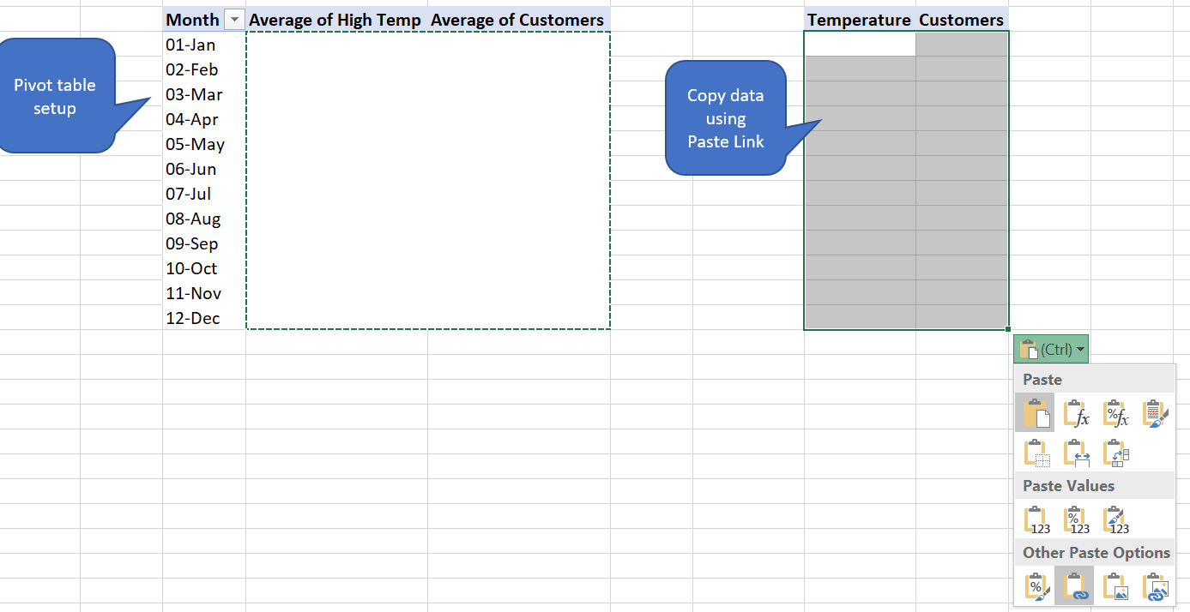

* 1. Use best practices for chart making,



* 1. Move your 3 pivot charts to the **Sales Report** worksheet, in the highlighted sections.

1. Joan wants to view the charts on the Sales Report worksheet filtered by city. Create a slicer in the Sales Report worksheet that is connected to all 3 charts. Put the slicer in cells **B4:I13** using an appropriate number of Columns. Use the City slicer to show results for the Malibu store only.

# Part 4: Grade Calculator with Power Query & Functions

Have you ever tried to copy your gradebook from Blackboard into Excel, but when you did you got one unwieldly Column that seemed impossible to turn into a gradebook? Getting raw data that is in a format unsuitable for analysis is typical, and it’s important to learn skills to ‘clean’ the data for your needs.

In this assignment you will create a grade calculator in Excel using PowerQuery and formulas to transform your raw data. The calculator will show each assignment completed during the semester and will calculate a current grade. Create formulas robust enough for any of your classmates to use. Use can also this calculator in other classes to track your grades from the Blackboard gradebook. Your goal is to calculate your % Grade. *Please note these are not the same percentages/points as described in the syllabus. The grade you calculate here will be close to your final grade but will not exactly match Blackboard.*



1. In Blackboard, go to **My Grades**.
   1. Click on the **ALL** tab to see all of your grades.
   2. Sort by **Course Order**
   3. Highlight the word **Item** in the upper left Column and continue to highlight all of your SAM assignments. Do not include anything else except for the SAM assignments. Skip the Final Grade and Extra Credit Total, etc. columns Copy your highlighted data using Ctrl+C.

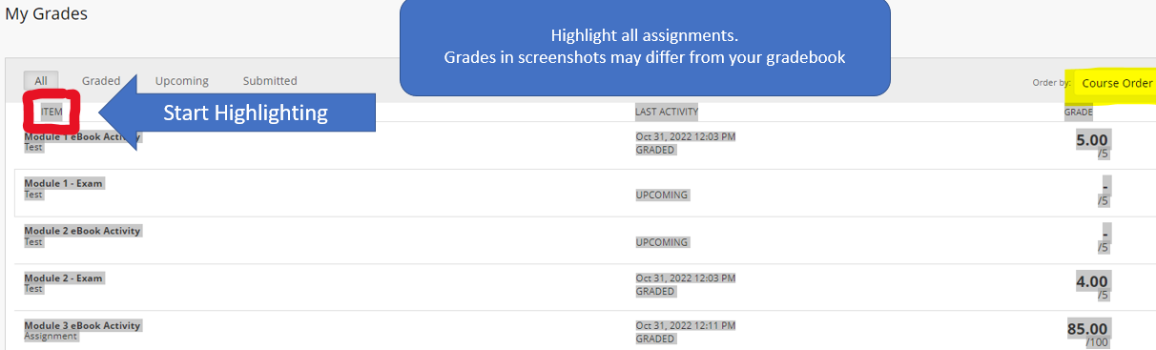

1. Paste your data into **Column A** of the **My Grades** worksheet.

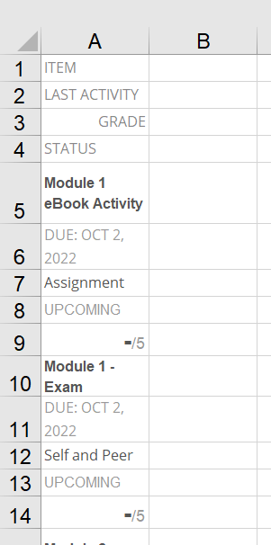

1. Next we need to clean up your data. Load the data into Power Query using **Get & Transform Data**. Check the box in the **Create Table** wizard that says **My table has headers.**
2. Remove the first 3 rows after the header using the **Remove Top Rows** command. NOTE: *Your grade values may be different from mine.*
3. Use the **Remove Alternate Rows** command to keep every 3 rows, starting with the 2nd row. Delete blank rows if needed.

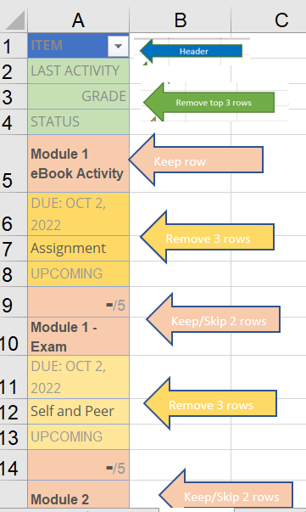

*Hint: if you removed the wrong rows, delete your step as shown below and try again*.

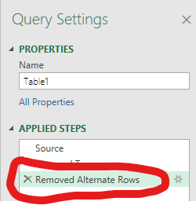

1. Load your data to a new worksheet by creating a table. Name the table **MyGradesTbl**. Rename the worksheet **Grade Calculator**. As you work on this problem, you may want to freeze your top row so when you scroll you can see the Column labels.

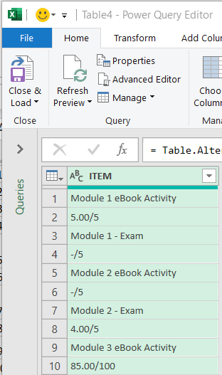

1. We need to move all your grades to Column B in the correct row, but copying them one-by-one is not efficient. Let’s have Excel do the work for us.
   1. Type **Assignment** in cell **A1**. Type **Grade** in cell **B1**.
   2. Let’s copy only the grades to Column B. Notice that all of the grades are in odd rows. How can we ask Excel to check if the row number is odd, & if so, copy the assignment value from Column A into Column B? Create a formula using the IF statement to return the current row’s assignment value from Column A if the row is ODD. Return a blank in the cell if the row is not ODD. Use the functions IF, ISODD & ROW to solve this puzzle.

* ISODD function returns TRUE if the argument number is odd, or FALSE if the number is even. Example: =ISODD(1) returns TRUE
* ROW() function returns the row number of the reference.   
  Example: =ROW(A1) returns the number 1
* *Hint: start your formula in B2 with* =IF(ISODD(

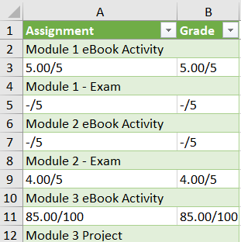

* 1. We need values in Column B, not formulas. Remove the formulas by using Copy / **Paste Values** to remove the formulas. Remove any extra Columns you may have used to accomplish this step, so that you only have Column A and Column B in your table. *Copying Formats with Paste Special Ex 2-11c*
  2. Move all of the grades in Column B up one row.

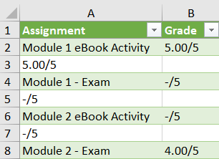

* 1. Delete the rows where the cells in Column B are blank. Don’t delete one row at a time; imagine instead of 30+ rows you had thousands. Harness your Excel knowledge to complete this task. *Hint: filter to show only the rows you want to delete*

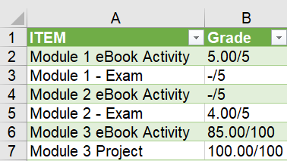

1. Use Flash Fill to create Columns **C *My Score*** and **D *Points Available*** using the data in Column B.
   1. The number before the / is your score on the assignment. Any item that does not have a grade will have a dash in front of the / symbol. (ie: -/5)
   2. The number after the / is the Points Available (ie: -/5)
   3. If you have any cells in Column D with a dash and the note ***needs grading,*** replace the dash with the correct point value.

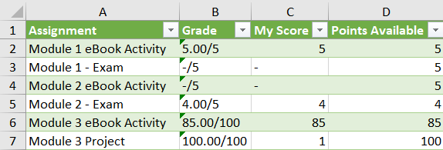

1. Use a formula to calculate the denominator for your % Grade formula



We need to figure out which cells are extra credit and which assignments we have not completed, and therefore will not be used for the denominator of our percent grade. In cell **E1**, type **Add to Denominator.** In Column E, use a formula to indicate how many points for graded assignments should count toward the grade bases, leaving blank any assignment that you didn’t complete or are extra credit. There are many ways to solve this problem.   
  
Here is one way: If both of the statements below are true, return the points available from the current row, otherwise insert a blank into the cell. *Exploring Logical Functions EX7-5*

* 1. If the **Points Available** are more than 5, the assignment is a not extra credit and should be counted in the denominator.
  2. If **My Score** is less or equal to than 200, you have completed the assignment and the assignment should be counted in the denominator.
  3. For any assignment you decided not to complete, change the My Score for that assignment to 0 in Column C. In this example I decided not to complete the Module 5 eBook Activity.

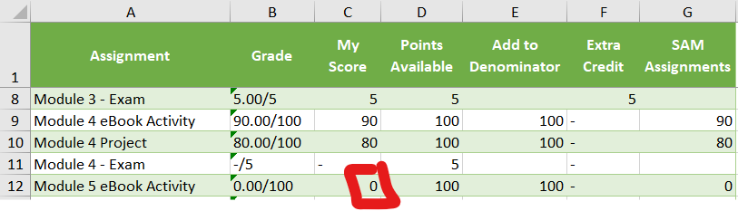

1. Use a formula to determine if you earned 5 points of Extra Credit. Any extra credit assignment where you earned less than 90% of 5 points doesn’t meet the criteria to earn points and should receive a 0. Put your results in Column **F** and label the Column **Extra Credit**. (ie: a score of 4.8 should return 5 points). *Exploring Logical Functions EX7-5*

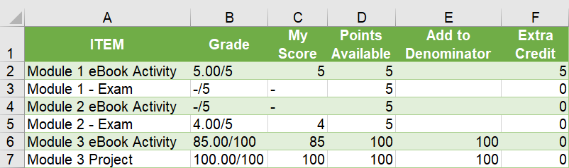

1. Add a **Total Row** to your table using the **Table Design** option checkbox**.** Choose to SUM for **Add to Denominator** and **Extra Credit** Columns. *Your Totals may be different from mine. Note: You will not have Apply-It and Participation scores in your table.*

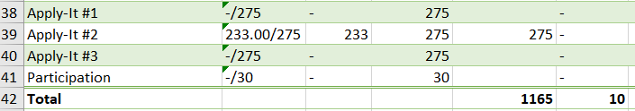

1. In order to drop your two lowest SAM scores, we need a column showing just SAM assignments you have completed or decided to receive a 0 on.
   1. Type **SAM Assignments** in cell G1.
   2. SAM assignments are all worth 100 points, so create a formula to copy any assignment’s **My Score** where **Points Available** = 100. Return a dash if the criteria is not met.

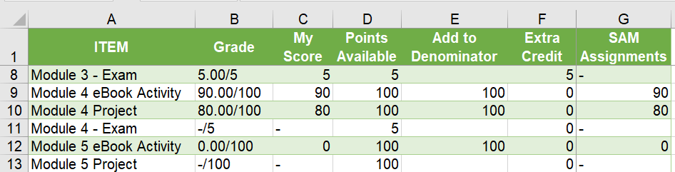

1. Create a formula **C42** to calculate the total points you have earned from all assignments except extra credit. To calculate your adjusted Total **My Score**:
   1. Add all of your points in the **My Score** Column where the **Points Available** are not extra credit (worth 5 points). *Hint: Calculating Conditional Sums with SUMIF EX 7-6b*
   2. Subtract your two lowest scores from **SAM Assignments** in column G. You must use a formula to determine these values to get full credit. *Hint: Google Excel’s SMALL function to learn how to use this formula. Note: You will not have Apply-It Scores in your table. You also will not include participation.*

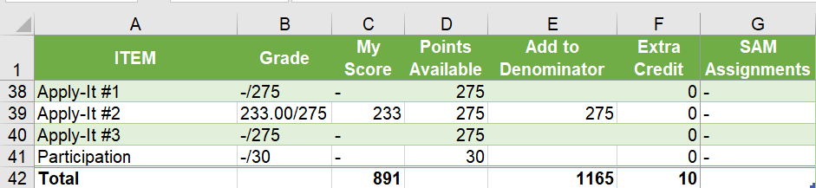

1. Type **My % Grade** into cell **I1** and **My Letter Grade** in cell **J1**. Calculate your percentage grade in **I2** using your Totals in row 42. Add your **My Score** and **Extra Credit**, then divide the result by your **Denominator**. Your denominator must be reduced by 200 points since you dropped your 2 lowest SAM scores.
2. In cell **J2**, use the most efficient formula to determine your grade letter based on the table below.   
   *Hint: you will need to build a table for your lookup_array and return_array arguments somewhere on your worksheet.*

|  |  |
| --- | --- |
| **Grade** | **Percentage** |
| A | 95-100% |
| A- | 90-94% |
| B+ | 86-89% |
| B | 85% |
| B- | 80-84% |
| C+ | 76-79% |
| C | 75% |
| F | below 75% |
|  |  |

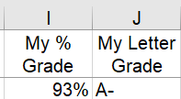

1. Test your grade calculator to see if your formulas are robust by creating various scenarios. What if you score a 4.8 on an Exam? How about 3 points? What if you earn 0 points on Module 6 Activity? Is your **Grade** still accurate for all these scenarios? *Please note these are not the same percentages/points as described in the syllabus. The grade you calculate here will be close to your final grade but will not exactly match Blackboard.*

# COMPLETED ASSIGNMENT

When you finish the assignment take a moment to feel a sense of accomplishment; this was not an easy assignment! Submit your finished workbook to Blackboard.