### Part 1: Welch Home Appliance Repair

Stefan Welch is the owner of Welch HomeAppliance Repair in Trenton, New Jersey. Stefan wants to use Excel to record data from his service calls to calculate the total charge on each service call and the total charges from all service calls within a given period. Unfortunately, the workbook he has created contains several errors. He has asked you to fix the errors and complete the workbook. Complete the following:

1. Go to the **Call Sheet** worksheet.
2. Use the **TODAY** function to insert today’s date in cell **C2**. *Hint: EX 3-5f Date and Time Functions found in Module 3*
3. You want to remove all suffixes, prefixes and middle initials from the customers’ names in column A. Use **FlashFill** to populate column **B** with first and last names only. *Hint*: *EX 1-15 Using Flash Fill found in Module 1* and *Advanced FlashFill video by Susan*
4. Insert blank cells in the range **A7:A63**, shifting the other cells to the right.
5. In cell **A7**, enter **Cust ID** as the label. The customer ID is a combination of the customer’s rate code from column Q and the customer’s last name, with 2 dashes added as shown in the example for Jensen. In cell **A8**, enter **123-adq-Jensen** as the customer ID for Patricia Jensen. Use **Flash Fill** to enter in the remaining customer IDs in the column.
6. Resize the columns of the **Call Sheet** worksheet so that all of the column labels and the cell contents are completely displayed. Use column widths that are visually appealing and practical. Use Autofit where appropriate to speed up this task. *Hint*: *EX 1-8a* [*Setting a Column Width*](javascript://)
7. There is a problem with the some of the customer ZIP codes. New Jersey ZIP codes begin with a 0, and these leading zeros are not showing up in the contact information. In the **Correct Zip** column create the correct zip codes using FlashFill. Do not fix this problem by changing the format in a way that masks the lack of zero in front of some zip codes. After you have fixed the problem, ensure all numbers in the **Correct Zip** column have the same format so they are justified similarly. After filling in the **Correct Zip** column, delete the **Zip** column to avoid confusion. *Hint: filter the* ***Zip*** *column to show all the zip codes that need to be fixed, then use Flash Fill. EX 1-7e Displaying Numbers as Text*
8. The formula in cell **L8** that calculates the total number of billable hours for the first customer is not correct. Instead of showing the number of hours, it displays the value as a fraction of a day. Fix this problem by revising the formula. *Hint*: *EX 3-3 Calculating with Dates and Times*
9. Copy the formula you entered for cell **L8** to calculate the total billable hours for the rest of the entries in column L.
10. Insert two new rows above row 5.
11. In cell **A5**, enter the label **Total Hours**. In cell **B5**, enter a function to calculate the total number of hours from all of the service calls.
12. In cell **A6**, type “Most Common Service Charge”. In cell B6, calculate the most common service charge from column O. Increase the width of column A to accommodate the long label. *EX 3-5c Measures of Central Tendency*
13. In column Q, use the Quick Analysis tool to calculate the running total of the Service Charges. Change the label in Q9 to **Service Charge Running Total**. Change the width of the column to 16 and **wrap the text** so the words don’t spill over into column R. *EX 3-8* [*Calculating Running Totals with the Quick Analysis Tool*](javascript://)
14. Use the Quick Analysis tool to create a chart like the one below showing how many service calls were answered per city. Create the chart in a new worksheet. Color Trenton’s column a unique color (your choice). *EX 4-3b* [*Charting with the Quick Analysis Tool*](javascript://)This graph will be used for informing and persuasion rather than analysis, so apply the concepts learned in Module 4’s best practices for storytelling:
    1. Title the chart “Service Calls per City”, and move the title to the left
    2. Create a subtitle “Trenton accounts for 30% of our calls”. Match the color of **30%** with the same color as the column.
    3. Remove the grid lines
    4. Remove the vertical axis
    5. Add data labels to each column
    6. Hide all the field buttons (ie: Count of City)
    7. Rename your worksheet **Call graph** (points deducted if worksheet isn’t named correctly)

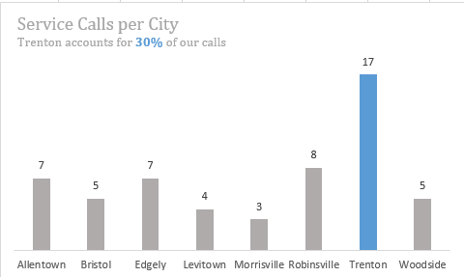

1. Format the **Call Sheet** worksheet for printing.
   1. Change the print area to the range A1:F65.
   2. Set the page layout of the worksheet so that all columns in the print range fit on one page.
   3. Select row 9 as the print titles to be repeated on each page. *EX 2-14* [*Formatting a Worksheet for Printing*](javascript://)
   4. Create footer as shown in the yellow highlighted screenshot below (no yellow highlight needed for your footer)

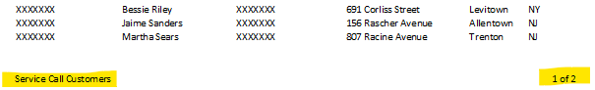

1. Save the workbook using the quick key Ctrl-S before moving to the next section (best practice is to save often!!).

### Part 2: Biology Grades

Daivi Emani teaches biology and life sciences at Milford College in White Plains, New York. She wants to use Excel to track the test scores and calculate final averages for the students in her Biology 221 class. She has already entered the homework, quiz, and final exam scores for her students. Daivi doesn’t have to scroll through the complete class roster to find a particular student. You will build formulas that will look up information on a particular student based on that student’s ID and populate the Student Lookup cells in columns M:U.

1. In cell **L6**, enter the student ID **602-1-99** for Lawrence Fujita.
2. In cell **M6**, create a **XLOOKUP** function that uses the student ID from cell **L6** to look up the exact matching student ID in column C and return the Student Data to cells M6:U6. If the Student ID is not found, return the words *Incorrect Student ID* in cell M6. Use Cell References to create this formula.



1. Test the **XLOOKUP** function by adding different student IDs in cell **L6** to confirm that you can retrieve the record for any student in class based on his or her student ID. Finish this step before you begin step 4 or you will have trouble using cell references for the arguments in your XLOOKUP function.
2. In cell **M7**, create a new **XLOOKUP** function that looks up the student ID from cell **L7** and returns the data from the Student Data list. This time, create named ranges for the *lookup_array* and the *return_array XLOOKUP* arguments. Include the error message from Step 2 if the Student ID is inaccurate.
3. Test the **XLOOKUP** function in cell **M7** by changing the **Student ID** in cell **L7**.



1. Manuel Harmon was not able to take the final exam because of car trouble. Manuel wants to know what grade he needs on the final to get an A in the class. A Class Average (cell **I24**) of 92.0 will give Manuel an A for the course. Use **Goal Seek** to determine what grade Manuel would need on the final (cell **H24**) to get an A for the course.   
   *EX 3-13b* [*Using Goal Seek*](javascript://)
2. Save the workbook before moving to the next section.

### Part 3: Orthographic

Jacek in the Human Resources department of Orthographic has tracked the hiring process for new recruits, from the initial application stage, through the interview stages, and culminating in a final offer of employment. Review the **Applications** worksheet. Jacek wants specific information about hires to the IT department with base salaries greater than $70,000 or from the Marketing department with base salaries greater than $60,000. Go to the **IT and Marketing Hires** worksheet and create an advanced filter. *EX 6-9e* [*Applying an Advanced Filter*](javascript://)

1. Create a criteria range for an Advanced Filter in cells A4:B6 on the **IT and Marketing Hires** worksheet.
2. Create an Advanced Filter using the information in the **Applications** worksheet, copying the records that meet the criteria to cell **D4** of the **IT and Marketing Hires** worksheet.

### Part 4: Stem Mentors

**STEM Mentors** Robert Harshaw is an Events Coordinator for STEM Mentors, a company specializing in education software for High School STEM teachers. Every July, the company sponsors a conference to showcase its wares and provide informative speakers and workshops on technology in science and math education. After the conference, Robert compiles results from a survey to acts a guide for the next conference. You’ll help Robert generate a dashboard about the conference responses. In the Survey Results worksheet, the answers to seven survey questions have been entered in an Excel table named Survey. The responses for the first four questions are the letters a through d, which represent responses from “very satisfied” to “very dissatisfied.” The text of the survey questions is on the Survey Questions worksheet.

1. In the **Survey Results** worksheet, in the **Workshops** column **I**, use a LOOKUP function with **structured references** and **named ranges** to display text regarding attendee satisfaction for **Q1**. Look up answers to Q1 responses from column B [Survey Results worksheet] in the **Survey Lookup** data set A5:B8 found on the **Lookup Tables** worksheet. For instance, Survey001 answered “a” for Q1, so we want to display “Very Satisfied” in cell I6.

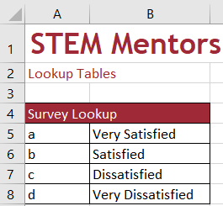

1. Repeat step 1 for the **Speakers** column **J,** using the answers for **Q2** in column C [Survey Results worksheet] to determine attendee satisfaction. For instance, Survey001 answered “b” for Q2, so we want to display “Satisfied” in cell J6. Use the appropriate named ranges for this LOOKUP formula.
2. In the **School** column **K**, display the type of school of each attendee (Public, Private, Online, or Tutor) by inserting a LOOKUP function to look up values in the **Q5** field from the **School Lookup** data set found on the **Lookup Tables** worksheet. For instance, Survey001 answered “c” for Q5, so we want to display “Online”.

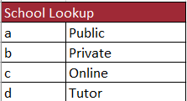

1. In the **Prior Conferences** column **L**, indicate the number of conferences previously attended (0, 1, 2, and 3+) by inserting a Lookup Function to look up of the values in the **Q6** field using the **Conference Lookup** data set found on the **Lookup Tables** worksheet. For instance, Survey001 answered “0” for Q6, so we want to display “0”.

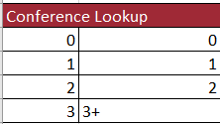

1. On the **Report** worksheet, do the following:
   1. In cell **B10**, use the **COUNTIF** function to count the number of records in the **Return** field from the Survey table that equal “will return.” Use a formula that you can copy to efficiently solve steps b-d, including using table references. *EX 7-6a* [*Conditional Counting with COUNTIF*](javascript://)
   2. In cell **B11**, use the COUNTIF function to count the number of records in the **Return** field from the Survey table that equal “will not return.”
   3. In the range **B14:B17**, use the COUNTIF function to count the number of records of the **School** field in the Survey table that equal Public, Private, Online, and Tutor.
   4. In the range **B20:B23**, use the COUNTIF function to count the number of records in the **Prior Conferences** field of the Survey table that equal 0, 1, 2, and 3+.
2. Robert would like to analyze what factors might contribute to a person deciding against returning to next year’s conference by reviewing workshop and speaker satisfaction by create 2 pivot charts.  
   1. From the Survey table on the Survey Results worksheet, create a PivotChart, placing it in cell A4 of the PivotTables worksheet. *EX 7-13a* [*Creating a PivotChart*](javascript://)
      1. Use the **Workshops** and **Return,** and **ID** fields to create the pivot chart shown below. Display the table associated with this chart. Be sure to reorder the column categories in the order shown and replicate the formatting. *EX 4-6a Comparing Column Chart Subtypes*
      2. Name the PivotTable **workshop pivot**.
      3. Move the chart to the **Report** worksheet to cover range **E7:I17**

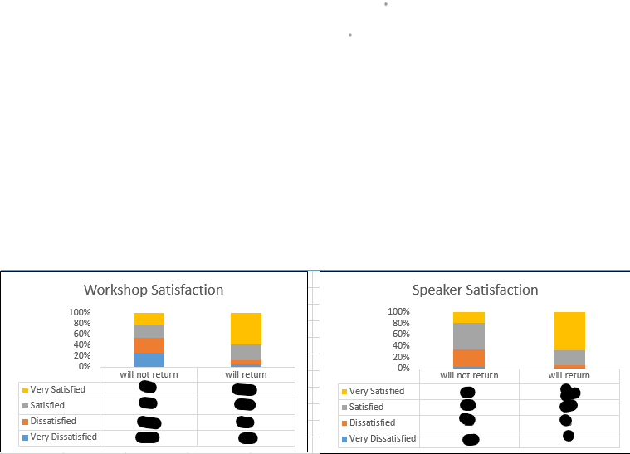

* 1. Create another pivot chart using the **Survey** table, placing it in cell A10 on the **PivotTables** worksheet.   
     1. Use the **Speakers**, **Return** and **ID** fields to create the PivotChart shown below.
     2. Name the PivotTable **speaker pivot**
     3. Place the PivotChart in the range K7:O17 on the Report worksheet



1. Click the first PivotChart to select it and then create a **slicer** for the **School** field.
   1. Move and resize the slicer to cover the range **E2:O5**
   2. Arrange the buttons in **4** columns.
   3. Connect the slicer to both PivotTables in the workbook.
2. Use the School slicer to filter the PivotCharts to show only the summaries of the **public school** attendees**.**

Save the workbook and upload it to Blackboard. Find the submission link in Modules | Apply-It where you downloaded the start file.