New Perspectives Excel 365/2021 | Module 7: SAM Project 1a

# Valerian State College

## SUMMARIZING YOUR DATA WITH PIVOTTABLES

### GETTING STARTED

* Save the file **NP_EX365_2021_7a_*FirstLastName*_1.xlsx** as **NP_EX365_2021_7a_*FirstLastName*_2.xlsx**

Edit the file name by changing “1” to “2”.

If you do not see the **.xlsx** file extension, do not type it. The file extension will be added for you automatically.

* With the file **NP_EX365_2021_7a_*FirstLastName*_2.xlsx** open, ensure that your first and last name is displayed in cell B6 of the Documentation worksheet.

If cell B6 does not display your name, delete the file and download a new copy.

### PROJECT STEPS

1. Lael Masterson works in the Student Activities Office at Valerian State College in Illinois. Lael has started compiling information on students who are interested in helping run student organizations at Valerian State, and she needs your help completing the workbook.  
   Switch to the *Student Representatives* worksheet. In cell E2, enter a formula using the **HLOOKUP** function as follows to determine a student's potential base hourly rate (which is based on the number of years of post-secondary education):
   1. Use a structured reference to look up the value in the Post-Secondary Years column. Retrieve the value in the **2**nd row of the table in the range **P13:U14**, using an absolute reference. Because base hourly rate is tiered based on the number of years of education, find an approximate match.
   2. Fill the formula into the range E3:E31, if necessary.
2. Student organizations sometimes require transportation for off-campus activities, and school policy requires students to be over 23 years old to serve as transport.  
   Lael wants to determine how many of the active students will be eligible to transport other group members. In cell J2, enter a formula using the **IF** function and structured references as follows to determine if Kay Colbert can serve as authorized transport:
   1. The function should use a reference to the value in the Age column to determine if the student's age is **greater than 23**, and should return the text **Yes** if true and **No** if false.
   2. Fill the formula into the range J3:J31, if necessary.
3. To be eligible for the leadership training program offered by the office, a student must have at least 2 years of post-secondary education or have gone through the organization finance training.   
   In cell K2 enter a formula using the **IF** and **OR** functions and structured references as follows to determine if Kay Colbert can join the leadership training program:
   1. The IF function should determine if the value in the student's Post-Secondary Years column is **greater than or equal to 2** OR if the value in the student's finance certified status is **"Yes"**, returning the text **Yes** if a student meets one or both of those criteria or the text **No** if a student meets neither of those criteria.
   2. Fill the formula into the range K3:K31, if necessary.
4. Experienced students may serve as mentors if they are at least age 21 and have at least 3 years of post-secondary education. In cell L2, enter a formula using the **IF** and **AND** functions and structured references as follows to determine if Kay Colbert is eligible to serve as a mentor:
   1. The IF function should determine if the value in the Age column is **greater than or equal to 21** AND the value in the student's Post-Secondary Years column is **greater than or equal to 3**, and should return the text **Yes** if a student meets both of those criteria or the text **No** if a student meets none or only one of those criteria.
   2. Fill the formula into the range L3:L31, if necessary.
5. Lael is always on the lookout for students who might be interested in running for office in student groups.  
   In cell M2, enter a formula using a nested **IF** function and structured references as follows to determine first if a student has already been elected to office in a student group, and if not, whether that student meets the qualifications to run in the future:
   1. If the value in the Elected column is equal to the text **"Yes"**, the formula should display **Elected** as the text.
   2. Otherwise, the formula should determine if the value in the Finance Certified column is equal to the text **"Yes"** and return the text **Yes** if true And **No** if false.
6. Students who work with student organizations are also considered for employment at the Student Activities Office. Students with more than 4 years of post-secondary education are qualified for more complex Tier 2 jobs.  
   In cell N1, enter the text **Tier** as the column heading.
7. In cell N2, enter a formula using the **IF** function and structured references as follows to determine which work tier Kay Colbert is qualified for:
   1. The IF function should determine if the value in the Post-Secondary Years column is **greater than or equal to 4**, and return the value **2** if true or the value **1** if false.
   2. Fill the formula into the range N3:N31, if necessary.
8. Lael wants a quick way to look up students by their Student ID.  
   In cell Q3, nest the existing VLOOKUP function in an **IFERROR** function. If the VLOOKUP function returns an error result, the text **Invalid Student ID** should display.
9. Lael wants to determine several totals and averages for active students.  
   In cell Q8, enter a formula using the **COUNTIF** function and structured references to count the number of students who have been elected to offices in student organizations.
10. In cell R8, enter a formula using the **AVERAGEIF** function and structured references to determine the average number of post-secondary years for students who have been elected.
11. In cell R9, enter a formula using the **AVERAGE** function and structured references to determine the average number of years of post-secondary education of all students as shown in the Post-Secondary Years column.
12. Switch to the *Academic Groups* worksheet. In cell A14, use the **INDEX** function and structured references to display the value in the first row and first column of the AcademicGroups table.
13. In cell A17, use the **SUMIF** function and structured references to display the total membership in 2026 for groups with at least **40** members.
14. Lael is also planning for student groups that the office will be working with in the coming year. She decides to create a PivotTable to better manipulate and filter the student group data.  
    Switch to the *Academic PivotTable* worksheet, then create a PivotTable in cell A1 based on the AcademicGroups table. Update the PivotTable as follows so that it matches Final Figure 2:
    1. Change the PivotTable name to: **AcademicPivotTable**
    2. Add the Activities field and the Group Name field (in that order) to the Rows area.
    3. Add the 2024, 2025, and 2026 fields (in that order) to the Values area.
    4. Change the display of subtotals to **Show all Subtotals at Top of Group**.
    5. Change the report layout to **Show in Outline Form**.
    6. Update the Sum of 2024 field in the Values area to display the name **2024 Membership** with the Number number format with 0 decimal places.
    7. Update the Sum of 2025 field in the Values area to display the name **2025 Membership** with the Number number format with 0 decimal places.
    8. Update the Sum of 2026 field in the Values area to display the name **2026 Membership** with the Number number format with 0 decimal places.
15. Lael wants to summarize data for all student groups in a PivotTable. To do so, she must first update the AllGroups table.  
    Switch to the *All Groups* worksheet then edit the record for the Astronomy Society to use **76** as the 2026 field value.
16. Switch to the *All Groups PivotTable* worksheet. Refresh the PivotTable data, then verify that the 2026 Membership value for the Astronomy Society in row 6 reflects the change you made in the previous step.
17. Apply the **Light Blue, Pivot Style Medium 2** PivotTable style to the PivotTable.
18. Add the Office field to the Filters area of the Pivot Table. Filter the table so that only organizations with private offices are visible.
19. Filter the PivotTable as follows:
    1. Create a Slicer based on the **Activities** field value.
    2. Resize the slicer so that it has a height of **2.2"** and a width of **3.2"**.
    3. Move the slicer so that its upper-left corner appears within cell F3 and its lower-right corner appears within cell J14.
    4. Use the slicer to filter the PivotTable so that only Fraternal groups are visible.
20. Lael also wants to summarize membership data for all organizations using a PivotChart to help determine which groups are showing the most interest from students.  
    Switch to the *Activities PivotTable* worksheet. Based on the PivotTable on the *Activities PivotTable* worksheet, insert a PivotChart using the **Clustered Column** chart type and format it as follows:
    1. Resize and reposition the PivotChart so that the upper-left corner is located within cell F3 and the lower-right corner is located within cell O19.
    2. Add the chart title **Membership by Type** to the PivotChart using the Above Chart option.
    3. Filter the PivotChart so that only the membership data for groups with educational, field, and fraternal activities in each type of group displays in the chart. (This filter may be automatically applied when you create the table.)

Your workbook should look like the Final Figures on the following pages. Save your changes, close the workbook, and then exit Excel. Follow the directions on the website to submit your completed project.

### Final Figure 1: Student Representatives Worksheet

Microsoft product screenshot reprinted with permission from Microsoft Incorporated. Copyright © 2020 Cengage Learning. All Rights Reserved.

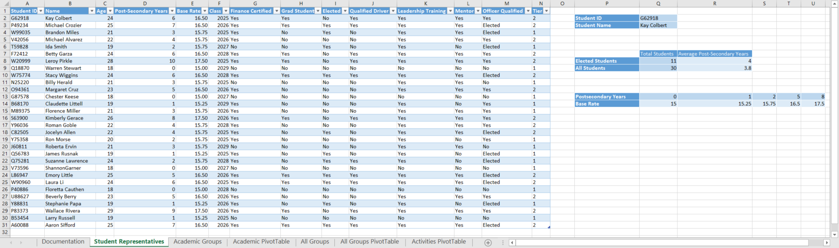

### Final Figure 2: Academic Groups Worksheet

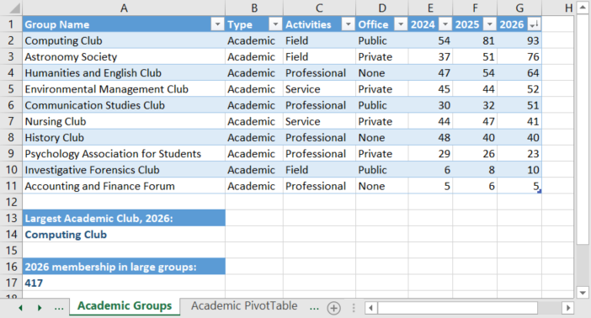

### Final Figure 3: Academic PivotTable Worksheet

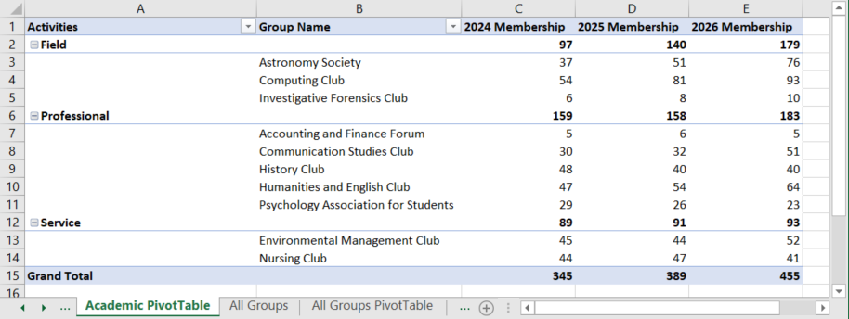

### Final Figure 4: All Groups Worksheet

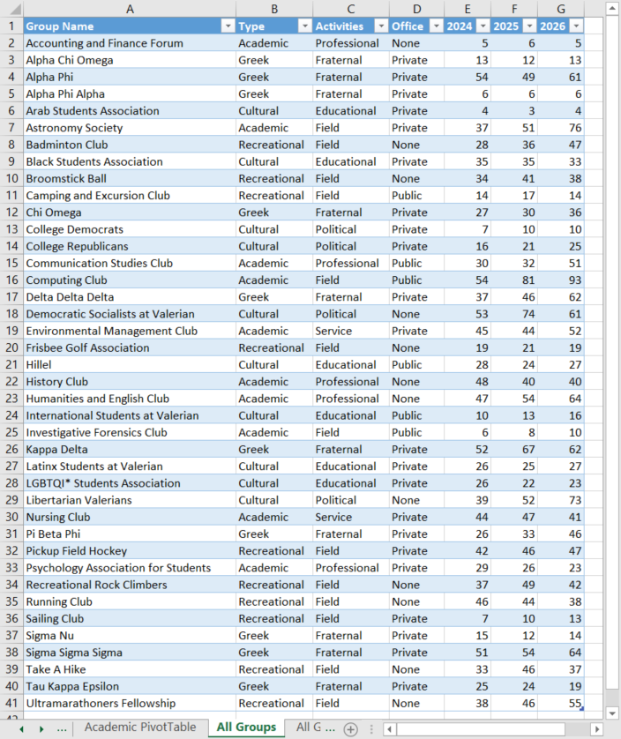

### Final Figure 5: All Groups PivotTable Worksheet

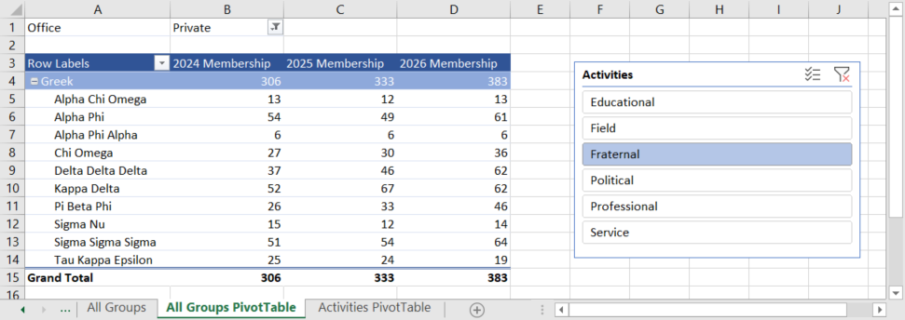

### Final Figure 6: Activities PivotTable Worksheet

