**EMOTION RECOGNITION AND DETECTION**

**OBJECTIVE**

The main goal of this project is to develop a model which will detect and recognize the facial expression of the person. Based on his/her facial expression we can detect their emotions and how they are feeling in that situation.

**ABSTRACT**

Human emotions are natural expressions that people tend to make naturally, instead of any conscious effort that is accompanied by the reflexing of facial muscles. Some of the common emotions are Happy, sad, surprised, anger and stable (normal) which a human face can make according to the different situations one may find itself in. We present the software which detects and recognizes faces as well as tells a lot more about that person which could be used to get feedback from customers or to know if a person needs motivation. The objective of the project is to be an affordable and efficient product. Artificial Intelligence & Digital image processing technology used to make the system in python. As the system also recognizes the identity card, this is a simple feature wherein the camera installed is trained in such way that it firstly focuses on the card and recognizes its shape and color.

**EXISTING SYSTEM**

The existing system has unable to find out the facial expression. It’s not supporting the machine learning (ML), artificial intelligence (AI).here database only capturing the data only management the data base. The existing system to totally failures the capturing Images to identifying the facial emotion expression.

**Disadvantages**

* No accurate results
* Not possible to find the facial expression.
* Loss the data base.

**PROPOSED SYSTEM**

The proposed system in which there is a thought for an better face expression recognition technique which is based on the region of interesting to let the convolution neutral networks (CNN) with transfer learning focus only on those areas which are associated with that particular expression which the human face makes. The given training data, it also identifies the relationship between the different areas which are helpful in intensifying the accuracy, thereby making it reliable of the predicted targets. In test stage, we investigated recognition. Identify the test image directly; implemented decision fusion strategy on areas. Emotions are natural expressions that people tend to make naturally, instead of any conscious effort that is accompanied by the refluxing of facial muscles. Some of the common emotions are Happy, sad, surprised, anger, stable (normal) which a human face can make according to the different situations one may find itself in. This is a proposed method to find the emotions of a person.

**BLOCK DIAGRAM:**

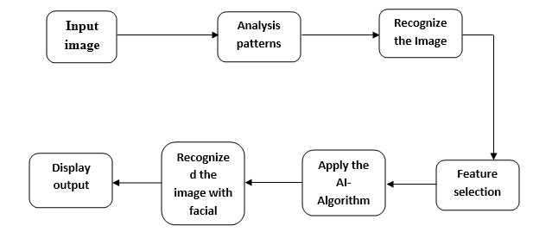

**Advantages**

* Time saving
* Find the facial expression
* Accurate results

**SYSTEM REQUIREMENTS**

# H/W System Configuration:

# Processor - I3/Intel Processor

* RAM - 4GB (min)
* Hard Disk - 160GB
* Key Board - Standard Windows Keyboard
* Mouse - Two or Three Button Mouse
* Monitor - SVGA

**S/W System Configuration:**

Operating System : Windows 10

Scripts : JavaScript, Jquery.

Server side Script : Python

IDE : PyCharm, Anaconda.

Packages : Open CV, Tensor Flow, Keras, NumPy, Pandas

**LEARNING OUTCOMES:**

* Scope of Real Time Application Scenarios
* Objective of the project
* How Internet Works
* What is a search engine and how browser can work?
* What type of technology versions are used?
* Use of HTML, and CSS on UI Designs
* Data Parsing Front-End to Back-End
* Working Procedure
* Introduction to basic technologies used for
* How project works.
* Input and Output modules
* Practical exposure to
  + Hardware and software tools.
  + Solution providing for real time problems
  + Working with team/ individual
  + Work on Creative ideas
* Frame work use
* Datasets properties
* Deep learning algorithms.
* What is sentiment analysis
* Data preprocessing techniques
* What is word embedding models
* What is CNN and NN.