BRD
(Business Requirement Document)

Project Description

This project is an online collaboration platform where one can communicate with others. In this we develop chat forums and blogs for NIIT students and Alumni. The Students and Alumni can register and login in this website. Students can create their profile, edit their profile, view events, view bulletins, view job opportunities, make friends, create chat forums and write messages in the blog.
Alumni can also do all the activities stated for the students and apart from that he can post job opportunities also.
Admin has the authority to accept/reject student or alumni registration and to accept/reject chat forums created by user. He can also edit or delete the blog contents.
SuperAdmin who can authorize the employee of NIIT as admin.

Users

Internal and External Users

sno | Internal Users
1 | Super admin
2 | Admin
3 | Employee

sno | External Users
1 | Alumni
2 | Student

Key Assumptions and Constraints

sno | Assumptions and Constraints
1 | The speed of the website depends on the speed of the internet.
2 | The total no of students added in the alumni is based on the size of the database.

USECASE DIAGRAM FOR SUPERADMIN

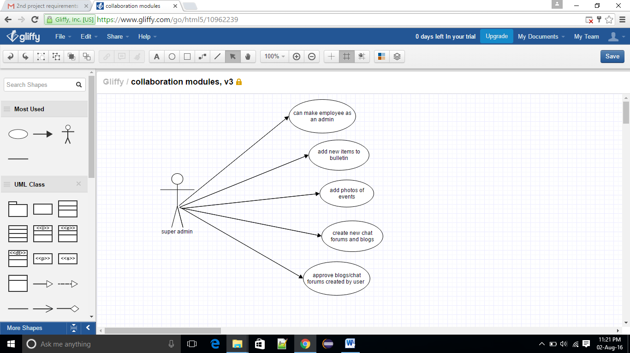

USE-CASE DIAGRAM FOR ADMIN

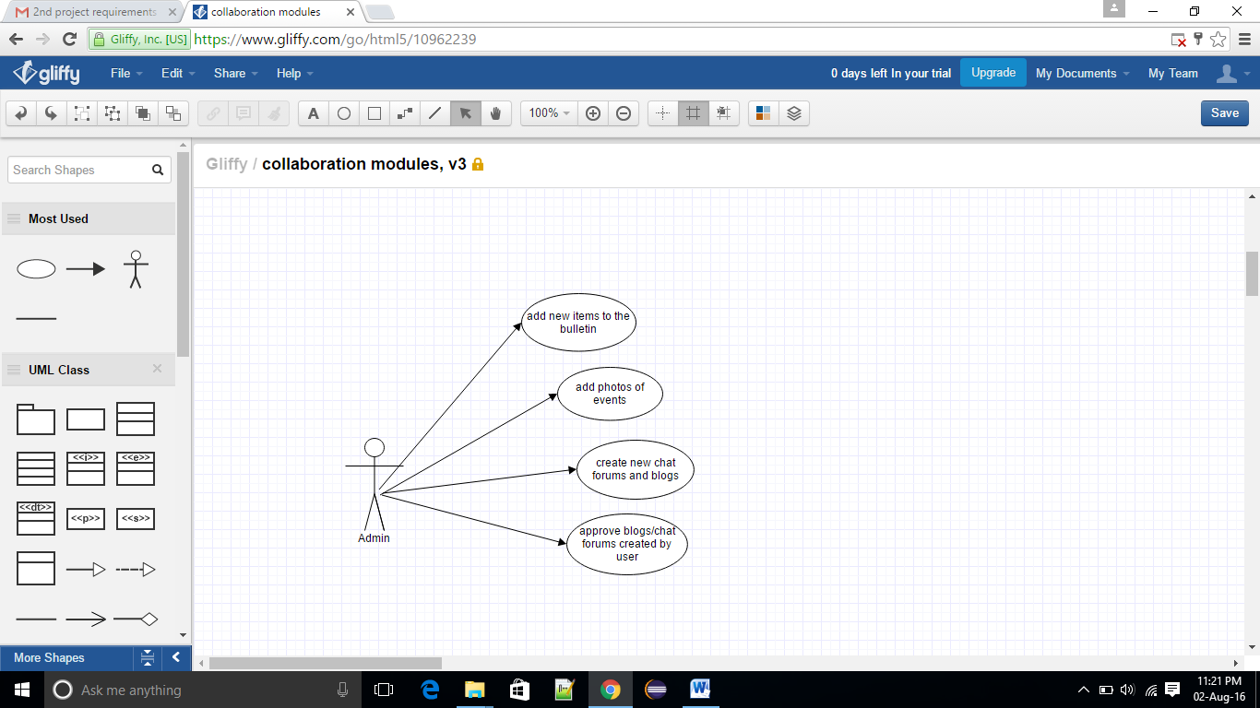

USECASE DIAGRAM FOR USER/ALUMNI

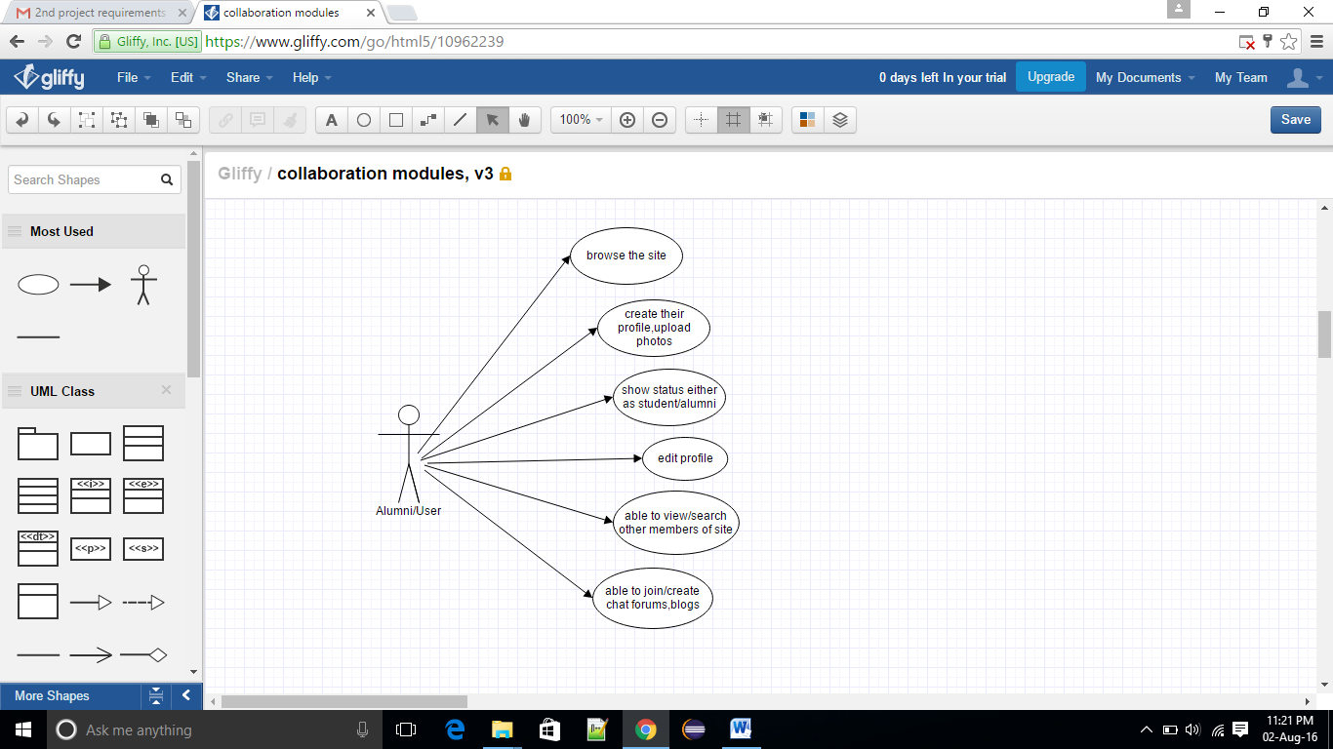

Design Template

- Required Modules
It has 2 main modules
- Admin
- User

Submodules involved
- Profile
- Events
- Job
- Bulletin
- Blog
- Chat Forum
- Make Friends
- Security

- Required Tables
- User_details
- Role
- User_role
- Event
- Job
- Blog
- User_friend
- Chat

- List of tables

Table 1 : User_details

Sno. | Field Name | Type | Length | Null | Description
1 | Id | Varchar2 | 20 | No | Primary
2 | Name | Varchar2 | 20 | No
3 | Password | Varchar2 | 20 | No
4 | Mobile | Varchar2 | 15 | No
5 | Email | Varchar2 | 30 | No
6 | Address | Varchar2 | 50 | No
7 | Gender | Varchar2 | 20 | No
8 | Enabled | Boolean | 1 | No
9 | Status | char | 1 | No | N,A,R(N-New,A-Approved,R-Rejected)
10 | Reason | Varchar2 | 50

Table 2 : Role

Sno. | Field Name | Type | Length | Null | Description
1 | Id | Varchar2 | 20 | No | Primary key
2 | Name | Varchar2 | 20 | No

Table 3 : User_role

Sno. | Field Name | Type | Length | Null | Description
1 | Id | Varchar2 | 20 | No
2 | User_id | Varchar2 | 20 | No
3 | Role_id | Varchar2 | 20 | No

Table 4 : Event

Sno. | Field Name | Type | Length | Null | Description
1 | Id | Varchar2 | 20 | No | Primary key
2 | Name | Varchar2 | 20 | No
3 | Date_time | Date | - | No
4 | Venue | Varchar2 | 20 | No
5 | Description | Varchar2 | 500 | No

Table 5 : Job

Sno. | Field Name | Type | Length | Null | Description
1 | Id | Varchar2 | 20 | No | Primary key
2 | Title | Varchar2 | 20 | No
3 | Description | Varchar2 | 500 | No
4 | Date_time | Date | - | No
5 | Qualification | Varchar2 | 20 | No
6 | Status | char | 1 | No | O,C(O-open,C-closed)

Table 6 : Blog

Sno. | Field Name | Type | Length | Null | Description
1 | Id | Varchar2 | 20 | No | Primary key
2 | Title | Varchar2 | 20 | No
3 | Description | Varchar2 | 500 | No
4 | User_id | Varchar2 | 20 | No
5 | Date_time | Date | - | No
6 | Status | Char | 1 | No
7 | Reason | Varchar2 | 20 | No

Table 7 : User_friend

Sno. | Field Name | Type | Length | Null | Description
1 | Id | Int | 20 | No
2 | User_id | Varchar2 | 20 | No
3 | Friend_id | Varchar2 | 20 | No

Table 8 : Chat

Sno. | Field Name | Type | Length | Null | Description
1 | ID | Int | 20 | No | Primary key
2 | User_id | Varchar2 | 20 | No
3 | Friend_id | Varchar2 | 20 | No
4 | Message | Varchar2 | 500 | No
5 | Date_time | Date | - | No

