ROAD ACCIDENT
DATA ANALYSIS SYSTEM

A project report submitted as part of academic requirements for the python course.
2nd year | B. Tech | Computer Science and Engineering
PROJECT TEAM DETAILS
S. No. | Team member | Roll number | Role
1. | Kalikiri Harsha Bindu | 25102A040178 | Frontened Development
2. | Munnam Sri Hari Vardhan Reddy | 25102A040145 | Data Analysis and Visualization
3. | Kasu Gowthami | 25102A040173 | Database Management
4. | Anneboyina Venkta Sai Charan | 25102A040156 | Backend Development

UNDER THE GUIDANCE OF
Mr. Mohammad Vali

Department of computer science and engineering
Mohan Babu University
Tirupati, Andhra Pradesh
ACADEMIC YEAR: 2026

TABLE OF CONTENTS

1. Abstract 2
2. Project Overview 2
3. Problem Statement 3
4. Objectives of the Project 3
5. Existing System 4
6. Proposed System 5
7. Hardware and Software Requirements 6
8. Technologies Used 7
9. System Architecture 9
10. System Working Flow 10
11. Database Design Overview 11
12. Database Structure and Data Dictionary 12
13. Landing Page and Login Module 13
14. Dashboard Module and Overview Section 13
15. Trends and Location Analysis Modules 14
16. Severity Analysis and Records Management Modules 15
17. Profile Management and Data Export Module 16
18. Frontend Implementation 17
19. Backend Implementation 18
20. Database Integration and CSV Export 19
21. System Execution and Deployment 20
22. Output Screens 22
23. Dashboard Output Screens 24
24. Severity, Records and Profile Output Screens 27
25. Software Testing 29
26. Test Cases and Results 30
27. Conclusion and Future Enhancements 31

1. ABSTRACT
Road accidents are one of the major public safety concerns, resulting in injuries, loss of lives, and damage to property. Analyzing accident-related information is important for understanding accident patterns and identifying areas that require attention.
The Road Accident Data Analysis System is a web-based application developed to organize, analyze, and visualize road accident data across India, with a focus on Andhra Pradesh. The system is developed using Python Flask for backend operations, HTML, CSS, and JavaScript for the user interface, and MySQL for database management.
The application provides an interactive dashboard through which users can explore accident information for different years from 2011 to 2026. It includes sections for viewing overall accident summaries, yearly and monthly trends, location-based information, accident severity, and vehicle-related records. Users can also search and filter accident records and download records in CSV format.
The system includes a landing page, login functionality, dashboard access, profile management, and light and dark theme options. These features provide an organized interface for accessing and exploring the available accident records.
The main aim of this project is to make accident data easier to access, understand, and analyze through a centralized web-based platform. The system can help users observe accident trends and gain insights from the available data. The analysis is limited to the records stored in the database and does not independently predict future accidents.

2. PROJECT OVERVIEW
The Road Accident Data Analysis System is a web-based application designed to organize, manage, and analyze road accident records. It provides a centralized platform where users can explore accident-related information through an interactive dashboard.
The application focuses on road accident data across India, particularly Andhra Pradesh. Users can select different years between 2011 and 2026 to explore the available records and understand accident-related patterns.
The system is developed using Python Flask as the backend framework, MySQL as the database management system, and HTML, CSS, and JavaScript for frontend development.

2.1 Main Components
The project consists of the following major components:
- Landing Page: Provides the initial interface and introduces the application.
- Login Module: Allows users to access the dashboard through the login interface.
- Dashboard: Displays summarized accident information and analytical visualizations.
- Trends Analysis: Helps users explore accident patterns over different time periods.
- Location Analysis: Displays accident-related information based on available locations.
- Severity Analysis: Provides information about accident severity categories.
- Records Management: Allows users to search, filter, and view accident records.
- Profile Management: Provides options to view and update profile information.
- Data Export: Allows users to download accident records in CSV format.

2.2 Main Purpose
The main purpose of this system is to make road accident information easier to access, explore, and understand. By presenting stored records in an organized dashboard, the application helps users examine accident trends and gain insights from the available data.

3. PROBLEM STATEMENT
Road accidents generate large amounts of information related to accident dates, locations, vehicles, road conditions, and severity. Organizing and understanding this information is important for analyzing accident patterns and improving awareness of road safety.
However, accessing and analyzing accident records can become difficult when the information is stored in separate records or presented without proper visualization. Users may face difficulties in comparing accident information across different years, identifying location-based patterns, and understanding accident severity.
The absence of a centralized and interactive platform can also make searching, filtering, and retrieving specific accident records less convenient.
To address these challenges, the Road Accident Data Analysis System is developed as a web-based application that provides a structured platform for exploring available accident records.

3.1 Identified Problems
- Difficulty in accessing and organizing accident-related information.
- Difficulty in comparing accident records across different years.
- Lack of a centralized dashboard for exploring accident information.
- Difficulty in understanding accident patterns based on locations and severity.
- Time-consuming process of searching for specific accident records.
- Need for a convenient way to download filtered accident information.

3.2 Proposed Solution
The proposed system provides an interactive web application that stores and displays accident records using a MySQL database and Flask backend.
It offers dashboard visualizations, year-based filtering, location and severity analysis, record searching, and CSV export functionality. This helps users explore the available information in a more organized and convenient manner.

4. OBJECTIVES OF THE PROJECT
The main objective of the Road Accident Data Analysis System is to develop a web-based platform that allows users to access, manage, and analyze road accident records through an interactive dashboard.
The specific objectives of the project are:

4.1 Primary Objectives
- Centralized Data Management: To organize and maintain road accident records using a MySQL database.
- Interactive Dashboard: To provide a user-friendly dashboard for displaying accident summaries and analytical information.
- Year-Wise Analysis: To allow users to explore accident records for different years from 2011 to 2026.
- Trend Analysis: To present accident-related trends through visualizations for easier understanding.
- Location-Based Analysis: To display accident information based on the available geographical locations.
- Severity Analysis: To help users examine accident records according to their severity categories.
- Record Searching and Filtering: To provide options for searching, filtering, and viewing individual accident records.
- Data Export: To allow users to download selected-year or all available accident records in CSV format.
- User Profile Management: To provide login and profile management functionality.
- Theme Customization: To support light and dark dashboard themes for improved user interface flexibility.

4.2 Expected Outcome
The expected outcome is a functional web-based application that presents available road accident information in an organized and understandable format. It aims to make accident data exploration, comparison, and retrieval more convenient for users.

5. EXISTING SYSTEM
In the existing approach, road accident information may be maintained in separate datasets, spreadsheets, reports, or database records. Users who want to understand accident patterns may need to collect and examine information from different sources.
Analyzing large amounts of accident-related information manually can be time-consuming. Comparing records across different years, identifying location-based patterns, and examining accident severity may also require additional effort.
When information is not presented through an interactive interface, users may find it difficult to quickly understand the available records.

5.1 Limitations of the Existing System
The following are some general limitations of traditional data management and analysis approaches:
- Scattered Information: Accident records may be maintained in different files or sources.
- Manual Analysis: Examining large datasets manually can require considerable time and effort.
- Limited Visualization: Data presented mainly in tabular form may be difficult to interpret.
- Difficult Comparison: Comparing accident information across multiple years may require additional processing.
- Searching Difficulties: Finding specific accident records can be inconvenient without proper search and filtering options.
- Data Retrieval: Downloading selected records may require manual data extraction.

5.2 Need for an Improved System
A centralized web-based application can make accident information easier to access and explore. An interactive dashboard with search, filtering, visualizations, and export options can improve the convenience of analyzing stored accident records.
The proposed Road Accident Data Analysis System addresses these needs by providing a structured interface for exploring available road accident information.

6. PROPOSED SYSTEM
The proposed Road Accident Data Analysis System is a web-based application developed to provide a centralized platform for accessing, managing, and analyzing road accident records.
The application uses Python Flask to handle server-side operations and MySQL to store and retrieve accident-related information. The frontend is developed using HTML, CSS, and JavaScript to provide an interactive and user-friendly interface.
Users can access the application through a landing page and login interface. After successful login, they can navigate to the dashboard and explore the available accident information.
The dashboard provides different sections for analyzing accident summaries, yearly and monthly trends, location-based information, accident severity, and individual records.

6.1 Features of the Proposed System
- Centralized Database: Stores and manages available accident records using MySQL.
- Interactive Dashboard: Displays accident summaries and visual representations of stored information.
- Year Selection: Allows users to explore accident records for different years from 2011 to 2026.
- Trend Analysis: Provides options to examine accident patterns over time.
- Location Analysis: Displays accident information based on available locations.
- Severity Analysis: Organizes accident information according to severity categories.
- Record Management: Supports searching, filtering, and viewing accident records.
- CSV Export: Allows users to download records for a selected year or all available years.
- User Profile: Provides profile viewing and updating functionality.
- Theme Options: Supports both light and dark themes.

6.2 Advantages of the Proposed System
- Provides a centralized interface for accident data exploration.
- Makes year-wise accident analysis convenient.
- Presents information through dashboard visualizations.
- Simplifies searching and filtering of accident records.
- Supports downloading records in CSV format.
- Provides an organized and user-friendly interface.

6.3 Expected Result
The proposed system provides a convenient way to explore and understand the road accident records stored in the database. It helps users examine available accident information through an interactive web-based dashboard.

7. HARDWARE AND SOFTWARE REQUIREMENTS
The Road Accident Data Analysis System is a web-based application that requires a computer system with suitable hardware and software configurations for development and execution.

7.1 Hardware Requirements
The following hardware components are recommended for running and developing the application:
Component | Requirement
Processor | Intel Core i3 or equivalent and above
RAM | 4 GB minimum
Storage | 2 GB or more available space
System | Desktop or Laptop
Display | Standard monitor or laptop display
Network | Internet connection for downloading dependencies and accessing online resources

Note: These are suggested requirements, not experimentally verified minimum specifications.

7.2 Software Requirements
Software | Purpose
Operating System | Windows
Programming Language | Python
Backend Framework | Flask
Frontend Technologies | HTML, CSS, JavaScript
Database | MySQL
Code Editor | Visual Studio Code
Web Browser | Google Chrome or Microsoft Edge
Database Tool | MySQL Workbench / MySQL Command Line Client
Version Control | Git and GitHub

7.3 Development Environment
The application is developed and executed in a local development environment. Python and Flask are used to run the web application, while MySQL manages the accident records. The application can be accessed through a web browser using the local server address.
Local Application URL: http://127.0.0.1:5000

8. TECHNOLOGIES USED
The Road Accident Data Analysis System is developed using different programming languages, frameworks, and tools. Each technology performs a specific role in building and running the application.

8.1 Python
Python is a high-level, interpreted programming language known for its simple syntax and readability. It is used in this project to implement backend functionality and process accident-related information.
Python handles application logic, database operations, user requests, and communication between the frontend and database.
Uses of Python in the Project:
- Handles backend application logic.
- Processes user requests.
- Retrieves accident records from the database.
- Supports data filtering and analysis.
- Generates responses for dashboard requests.

8.2 Flask
Flask is a lightweight web framework for Python used to develop web applications. It provides routing functionality and handles communication between the frontend and backend.
In this project, Flask manages different application routes, user login sessions, dashboard access, database interactions, and API responses.
Uses of Flask in the Project:
- Provides routes for different application pages.
- Handles login and logout operations.
- Manages user sessions.
- Connects frontend requests with backend operations.
- Provides dashboard data through API endpoints.
- Supports CSV record downloads.

8.3 HTML (HyperText Markup Language)
HTML is the standard markup language used to create the structure of web pages. It defines elements such as headings, forms, buttons, tables, navigation menus, and content sections.
Uses in the Project:
- Creates the structure of the landing page and login page.
- Defines dashboard sections and navigation elements.
- Creates forms for user input.
- Displays accident records in tables.
- Organizes profile and account settings.

8.4 CSS (Cascading Style Sheets)
CSS is used to control the appearance and layout of web pages. It helps improve the visual design and user experience of the application.
Uses in the Project:
- Styles the landing page and dashboard.
- Controls colors, fonts, spacing, and layouts.
- Provides light and dark theme designs.
- Improves the appearance of buttons, forms, and tables.
- Supports responsive layout adjustments.

8.5 JavaScript
JavaScript is a scripting language used to make web pages interactive. It handles client-side interactions and communicates with backend APIs.
Uses in the Project:
- Handles dashboard interactions.
- Supports year selection and filtering.
- Sends requests to backend API endpoints.
- Updates displayed dashboard information.
- Supports theme selection and persistence.

8.6 MySQL
MySQL is a relational database management system used to store and manage structured information.
In this project, MySQL is used to maintain road accident records and provide the data required by the dashboard.
Uses in the Project:
- Stores accident-related records.
- Organizes information using database tables.
- Retrieves records based on user requests.
- Supports filtering and summary queries.
- Provides data to the Flask application.

9. SYSTEM ARCHITECTURE
The system architecture describes the overall structure of the Road Accident Data Analysis System and explains how different components interact with each other.
The application follows a web-based client-server architecture. It consists of three major layers: the presentation layer, application layer, and database layer.

9.1 Presentation Layer (Frontend)
The presentation layer provides the user interface through which users interact with the application. It is developed using HTML, CSS, and JavaScript.
It includes the landing page, login page, dashboard, navigation menu, data tables, charts, and profile section.

9.2 Application Layer (Backend)
The application layer is developed using Python Flask. It handles user requests, manages login sessions, performs application logic, communicates with the database, and returns the required information to the frontend.

9.3 Database Layer
The database layer uses MySQL to store and manage road accident records. It processes database queries received through the backend and returns the requested information.

9.4 Working of the Architecture
- The user opens the application through a web browser.
- The frontend displays the landing page and login interface.
- After successful login, the user accesses the dashboard.
- Flask receives requests from the frontend.
- The backend communicates with the MySQL database to retrieve the required records.
- MySQL returns the requested information to Flask.
- Flask sends the response to the frontend.
- The dashboard displays the information through tables and visualizations.
This architecture separates the user interface, application logic, and database management, making the application easier to organize and maintain.

10. SYSTEM WORKING FLOW
The working flow of the Road Accident Data Analysis System describes the sequence of operations performed when a user interacts with the application.
The system follows a structured workflow that begins with opening the application and ends with displaying the requested accident information.

10.1 Steps Involved in System Working
- Application Access: The user opens the application using a web browser.
- Landing Page: The system displays the landing page with basic information about the application.
- User Login: The user enters the required login details through the login interface.
- Session Management: Flask processes the login request and manages the user session.
- Dashboard Access: After successful login, the user is redirected to the dashboard.
- Year Selection: The user selects the required year to explore accident information.
- Data Request: The frontend sends a request to the Flask backend.
- Database Interaction: Flask executes the required queries on the MySQL database.
- Data Processing: The backend prepares the requested accident summaries and records.
- Data Display: The frontend displays the retrieved information through dashboard visualizations and tables.
- Additional Operations: Users can explore different dashboard sections, filter records, update profile information, and download CSV files.
- Logout: The user can log out of the application, which clears the active session.

10.2 Workflow Outcome
The workflow provides a systematic connection between the user interface, backend application, and database. It allows users to access and explore the available road accident records through a single web-based platform.

11. DATABASE DESIGN OVERVIEW
Database design is an important part of the Road Accident Data Analysis System. It provides a structured way to store, organize, retrieve, and manage road accident information.
The project uses MySQL as its relational database management system. The database is named road_accident_db and is connected to the Flask backend for performing database operations.
The database stores accident-related information that is used by the dashboard to display summaries, trends, location-based details, severity information, and individual accident records.

11.1 Database Objectives
The main objectives of the database are:
- To store road accident records in an organized manner.
- To maintain structured information for retrieval and analysis.
- To support year-wise accident data filtering.
- To provide data for dashboard visualizations.
- To support searching and retrieving individual records.
- To maintain available location-related information.

11.2 Database Tables
The project database contains the following known tables:
S.No. | Table Name | General Purpose
1 | accidents | Accident-related records
2 | accidents_backup | Backup records
3 | accidents_backup_new | Additional backup records
4 | locations | Location-related information
5 | locations_backup | Backup location records

Note: The exact columns, primary keys, foreign keys, and relationships must be documented after verifying the final database schema.

11.3 Database Connectivity
The Flask application establishes a connection with the MySQL database using its database connection configuration.
When a user requests accident information, the backend executes the required SQL queries and retrieves the matching records. The retrieved information is then processed and returned to the frontend for display.
The database connection helps the application perform operations such as data retrieval, filtering, and record export.

12. DATABASE STRUCTURE AND DATA DICTIONARY
The database structure defines how road accident information is organized and stored in the MySQL database. The Road Accident Data Analysis System uses the database named road_accident_db to manage accident-related records.
The database consists of accident-related tables and location-related tables. These tables help the application retrieve and display the information required for dashboard analysis.

12.1 Data Dictionary
A data dictionary describes the fields available in a database table, including their names, data types, and purposes.
The following section provides space to document the actual database fields after verifying the table structure.

12.2 Accident Table Structure
Table Name: accidents
S.No. | Column Name | Data Type | Description
1 | accident_id | INT (Primary Key, AUTO_INCREMENT) | Unique ID for each accident record
2 | accident_date | DATE (NOT NULL) | Date on which the accident occurred
3 | accident_time | TIME | Time at which the accident occurred
4 | location | VARCHAR(255) | Name or address of the accident location
5 | location_id | INT (Foreign Key) | References the locations table to link the accident to a location
6 | vehicle_type | VARCHAR(50) | Type of vehicle involved in the accident
7 | severity | VARCHAR(30) | Severity level of the accident (e.g., Fatal, Serious, Minor)
8 | deaths | INT (Default 0) | Number of deaths caused in the accident
9 | injuries | INT (Default 0) | Number of people injured in the accident
10 | weather | VARCHAR(50) | Weather condition at the time of the accident
11 | road_name | VARCHAR(255)
  Name of the road where the accident took place

12.3 Location Table Structure
Table Name: locations
S.No. | Column Name | Data Type | Description
1 | location_id | INT (Primary Key, AUTO_INCREMENT) | Unique ID for each location record
2 | region | VARCHAR(100) (NOT NULL) | Name of the region or area where the accidents are recorded
3 | road_name | VARCHAR(255) | Name of the road associated with the location

12.4 Database Relationships
The relationship between the accident and location tables must be documented based on the actual primary key and foreign key definitions in the MySQL database.
Primary Key: accidents.accident_id and locations.location_id
Foreign Key: accidents.location_id REFERENCES locations.location_id
Relationship Type: One-to-Many (1:N)

13. LANDING PAGE AND LOGIN MODULE
The Road Accident Data Analysis System includes a landing page and login module to provide an organized entry point for users.

13.1 Landing Page
The landing page is the first interface displayed when a user opens the application. It introduces the Road Accident Data Analysis System and provides information about its purpose and available functionality.
The landing page acts as the starting point for accessing the application. Users can navigate from this page to the login interface.
Main Features:
- Introduces the application.
- Displays the project name and basic information.
- Provides navigation to the login page.
- Uses a consistent visual design.

13.2 Login Module
The login module provides an interface for users to enter their login details before accessing the dashboard.
The application uses Flask to process login requests and manage user sessions. After successful login, the user is redirected to the dashboard.
Main Features:
- Provides a login form.
- Accepts the required user details.
- Processes login requests through Flask.
- Maintains the active login session.
- Provides access to the dashboard after successful login.

13.3 Session Management
Flask session management is used to maintain the user's login state while navigating through the application. Protected pages and dashboard data requests check the login session before providing access.
The logout functionality clears the active session and redirects the user to the landing page.

14. DASHBOARD MODULE AND OVERVIEW SECTION
The dashboard is the main component of the Road Accident Data Analysis System. It provides a centralized interface for viewing and exploring road accident information stored in the MySQL database.
After successful login, users are redirected to the dashboard, where they can access different sections of the application through the navigation menu.

14.1 Dashboard Module
The dashboard is developed using HTML, CSS, JavaScript, and Flask. It communicates with the backend through API requests to retrieve the required accident information.
Main Features:
- Displays the main accident analysis interface.
- Provides navigation between different dashboard sections.
- Supports year selection from 2011 to 2026.
- Retrieves accident information through the Flask API.
- Supports light and dark themes.
- Provides access to records and profile sections.

14.2 Overview Section
The Overview section provides a summarized view of the available road accident information.
It helps users understand the general accident statistics for the selected year through summary information and visual representations.
Main Features:
- Displays accident summary information.
- Provides an overall view of the selected year's data.
- Presents important accident-related statistics.
- Helps users quickly understand the available records.

14.3 Dashboard Navigation
The dashboard includes the following major sections:
- Overview
- Trends
- Locations
- Severity
- Records
Users can navigate between these sections to explore different aspects of the available accident information.

15. TRENDS AND LOCATION ANALYSIS MODULES
The Road Accident Data Analysis System provides separate sections for exploring accident trends and location-based information. These modules help users examine the available accident records from different perspectives.

15.1 Trends Analysis Module
The Trends section provides visual representations of accident information over different time periods. It helps users explore changes in accident occurrences based on the available records.
The module retrieves information from the backend and displays it through dashboard visualizations.
Main Features:
- Displays year-wise accident information.
- Supports monthly accident trend analysis.
- Helps users observe changes in accident occurrences over time.
- Provides visual representations for easier understanding.
- Updates the displayed information based on the selected year.

15.2 Location Analysis Module
The Locations section provides information about road accidents based on the locations available in the database.
It helps users explore how accident records are distributed across different geographical locations.
Main Features:
- Displays location-based accident information.
- Helps compare accident records across available locations.
- Provides summarized information for location analysis.
- Supports understanding of geographical patterns in the stored records.

15.3 Importance of These Modules
The Trends and Locations modules make it easier to explore accident information without manually examining every individual record. They provide organized visual summaries that help users understand time-based and location-based patterns.

16. SEVERITY ANALYSIS AND RECORDS MANAGEMENT MODULES
The Road Accident Data Analysis System includes Severity Analysis and Records Management sections to help users explore accident information in detail.

16.1 Severity Analysis Module
The Severity section provides information about accident records based on their severity categories.
It helps users understand the distribution of accident records among the available severity levels.
Main Features:
- Displays accident information according to severity categories.
- Provides summarized severity-related statistics.
- Presents severity information through visualizations.
- Helps users compare the available severity categories.

16.2 Records Management Module
The Records section provides access to individual road accident records stored in the database.
Users can view available accident details and use the provided search and filtering options to find specific records.
Main Features:
- Displays individual accident records in tabular format.
- Supports searching for accident information.
- Provides filtering options for available records.
- Displays details such as date, location, road, vehicle, and severity where available.
- Supports year-based record selection.
- Provides options to download accident records in CSV format.

16.3 Importance of These Modules
The Severity and Records modules provide detailed access to stored accident information. Severity analysis helps users examine accident classifications, while the Records section makes it easier to retrieve and examine individual records.

17. PROFILE MANAGEMENT AND DATA EXPORT MODULE
The Road Accident Data Analysis System provides profile management and data export functionalities to improve user convenience and application usability.

17.1 Profile Management Module
The Profile Management module allows users to view and update their profile information through the application.
The system displays the currently logged-in user's profile details and provides an option to update the available information.
Main Features:
- Displays the current user's profile information.
- Shows the user's name and email address.
- Provides an option to update profile details.
- Includes account settings.
- Provides a logout option.

17.2 Data Export Module
The Data Export module allows users to download accident records from the application in CSV format.
The system provides options to download records for a selected year or download all available records.
Main Features:
- Downloads records for a selected year.
- Supports downloading all available accident records.
- Generates CSV files for downloaded information.
- Makes exported records available for further analysis using spreadsheet applications.

17.3 Logout Functionality
The application provides a logout option within the account settings area. When the user logs out, the Flask session is cleared and the application redirects the user to the landing page.

17.4 Importance of These Features
Profile management provides users with control over their displayed account information, while CSV export makes accident records easier to access outside the application for additional analysis.

18. FRONTEND IMPLEMENTATION
The frontend is an important part of the Road Accident Data Analysis System because it provides the interface through which users interact with the application.
The frontend is developed using HTML, CSS, and JavaScript. These technologies work together to create an interactive and user-friendly web application.

18.1 HTML Implementation
HTML is used to create the structure of the application's web pages.
It defines the different elements displayed in the application, including:
- Landing page content.
- Login forms and input fields.
- Dashboard navigation menu.
- Dashboard sections.
- Data tables and buttons.
- User profile interface.

18.2 CSS Implementation
CSS is used to control the visual appearance and layout of the application.
It provides styling for:
- Page layouts and navigation.
- Colors, fonts, and spacing.
- Dashboard cards and data tables.
- Buttons and form elements.
- Light and dark theme designs.
- Responsive layout adjustments.

18.3 JavaScript Implementation
JavaScript is used to handle user interactions and dynamic frontend operations.
It supports:
- Dashboard navigation.
- Year selection and filtering.
- Communication with Flask API endpoints.
- Dynamic updating of dashboard information.
- Theme selection and persistence.
- Interactive elements within the application.

18.4 Frontend and Backend Communication
The frontend communicates with the Flask backend through HTTP requests. JavaScript sends requests to the required API endpoints, receives the returned information, and updates the dashboard interface.
This communication allows the application to display information retrieved from the MySQL database without requiring users to interact directly with the database.

19. BACKEND IMPLEMENTATION
The backend of the Road Accident Data Analysis System is developed using Python and the Flask framework. It handles user requests, manages application sessions, communicates with the MySQL database, processes accident-related information, and sends the required data to the frontend.

1. Flask Application
Flask is used to create the web application and manage different URL routes. The main backend logic is maintained in the app.py file.

2. Database Connection
The backend connects to the MySQL database named road_accident_db using the get_db_connection() function. This function establishes the database connection required to retrieve and manage accident records.

3. Main Backend Routes
The application contains the following important routes:
- Home Route (/): Displays the landing page.
- Login Route (/login): Handles the login form and creates a user session.
- Dashboard Route (/dashboard): Provides access to the dashboard after login.
- Logout Route (/logout): Clears the active session and redirects the user.
- Profile Route (/update_profile): Updates the current user's profile details.
- Dashboard API (/api/dashboard): Retrieves accident summaries and grouped information from the database for the selected year.
- Download Route (/download_records): Exports accident records as CSV files for the selected year or all available years.

4. Session Management
Flask sessions are used to maintain the login state of the user. Protected pages and dashboard API requests check whether the user is logged in before providing access.

5. Data Processing
The backend receives the selected year and other request parameters, validates the year between 2011 and 2026, retrieves the required information from MySQL, and returns the results to the frontend in JSON format.

Conclusion
The backend acts as the connection between the frontend and the MySQL database. It manages application routes, user sessions, data retrieval, and CSV export functionality.

20. DATABASE INTEGRATION AND CSV EXPORT
The Road Accident Data Analysis System uses MySQL as its database management system. The database stores accident-related records that are accessed by the Flask backend to display information on the dashboard.

1. MySQL Database Integration
The application connects to the MySQL database named road_accident_db through the database connection function available in app.py.
The backend executes SQL queries to retrieve accident records and generate summaries required by different dashboard sections.

2. Retrieving Accident Records
When a user selects a year, the frontend sends a request to the Flask backend. The backend validates the selected year and retrieves the corresponding information from MySQL.
The retrieved information is used to display:
- Accident summaries.
- Monthly and time-based trends.
- Location-wise information.
- Vehicle-related information.
- Accident severity details.
- Individual accident records.

3. CSV Export Functionality
The system provides an option to download accident records in CSV format.
Two download options are available:
- Download Selected Year: Downloads records belonging to the selected year.
- Download All Records: Downloads all available accident records.

4. Benefits of Database Integration
- Centralized storage of accident records.
- Easy retrieval of information.
- Supports year-wise analysis.
- Helps display updated dashboard information.
- Allows records to be downloaded for further analysis.

Conclusion
MySQL integration and CSV export make the system useful for storing, retrieving, viewing, and downloading road accident information through a single web application.

21. SYSTEM EXECUTION AND DEPLOYMENT
The Road Accident Data Analysis System is developed as a web-based application using Python Flask and MySQL. The application can be executed locally on a computer by following the required setup steps.

1. Project Setup
The project source code is maintained in a GitHub repository. The project folder contains the Flask application, HTML templates, static resources, database-related files, and configuration requirements.

2. Database Setup
The MySQL database named road_accident_db must be created and configured before running the application.
The provided SQL database backup can be imported into MySQL to restore the required tables and records.

3. Installing Dependencies
Python and the required Python packages must be installed on the system. The dependencies listed in the requirements.txt file can be installed using pip.

4. Running the Application
The application is started by opening the project folder in the terminal and executing the following command:
python app.py
After successful execution, the Flask development server starts locally.

5. Accessing the Application
The application can be accessed through a web browser using the following local address:
http://127.0.0.1:5000
The user can open the landing page, proceed to login, and access the dashboard.

6. Deployment Status
The current application is configured for local execution using the Flask development server. It can be accessed on the computer where the application and database are configured. Hosting on a public server can be considered as a future enhancement.

Conclusion
The execution process allows users and project team members to run and test the application locally after configuring Python, Flask, and MySQL.

22. OUTPUT SCREENS

1. LANDING PAGE
The landing page is the first interface displayed when a user opens the Road Accident Data Analysis System. It introduces the purpose of the application and provides navigation to the login page.
The page is designed with a simple and user-friendly layout to help users understand the main purpose of the system.
Main Features:
- Introduction to the Road Accident Data Analysis System.
- Brief information about the application.
- Navigation to the login page.
- User-friendly interface.
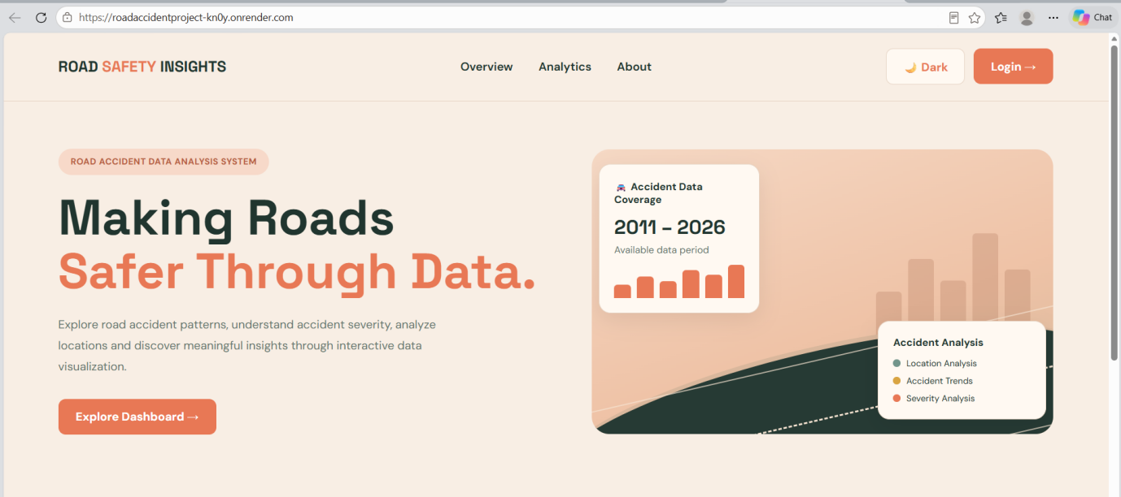
Fig 1.1 : Landing page
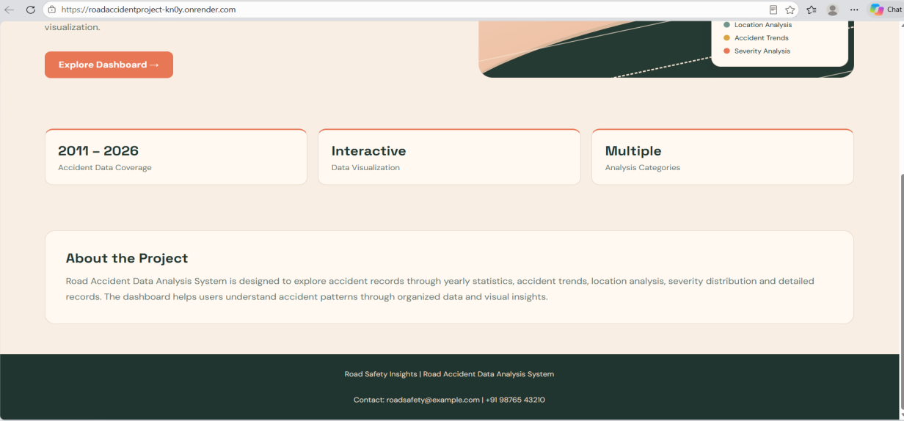
Fig 1.2: feature card, about, contact details display on landing page

LOGIN PAGE

The login page provides an interface for users to enter their login details before accessing the dashboard.
After the login process is completed, the application creates a session and allows access to the dashboard.
Main Features:
- User login form.
- Input fields for required login details.
- Login button.
- Navigation to the dashboard after successful login.

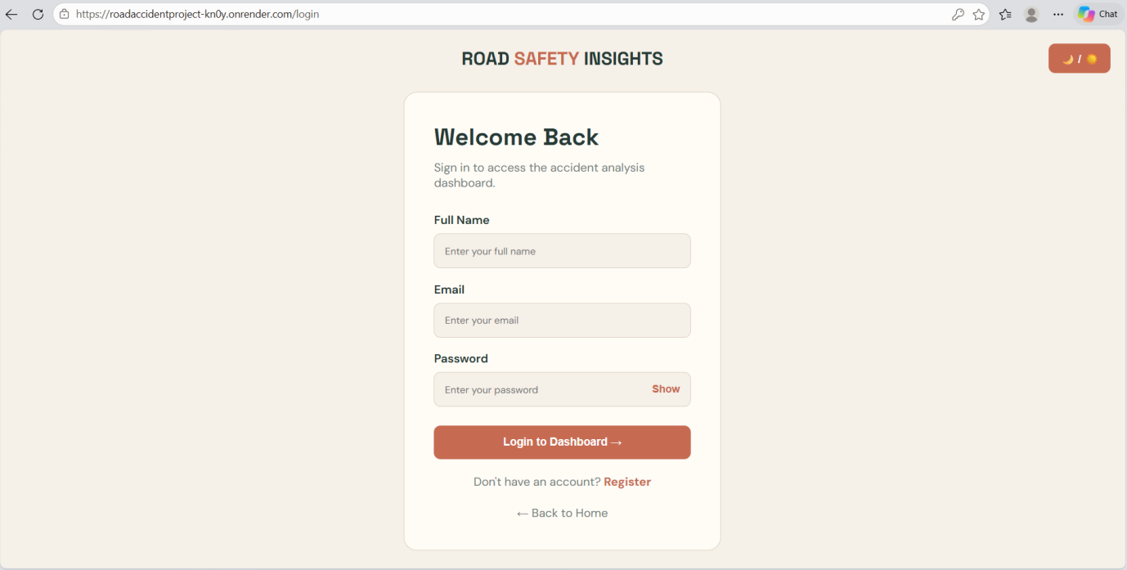
Fig 2: Login page

23. DASHBOARD OUTPUT SCREENS

1. DASHBOARD OVERVIEW
The dashboard overview provides a summary of the road accident information available in the system. It presents important information through summary cards, charts, and visual elements.
Users can select a year to view the corresponding accident information.
Main Features:
- Summary of accident-related information.
- Year selection from 2011 to 2026.
- Visual representation of accident data.
- Navigation to different dashboard sections.

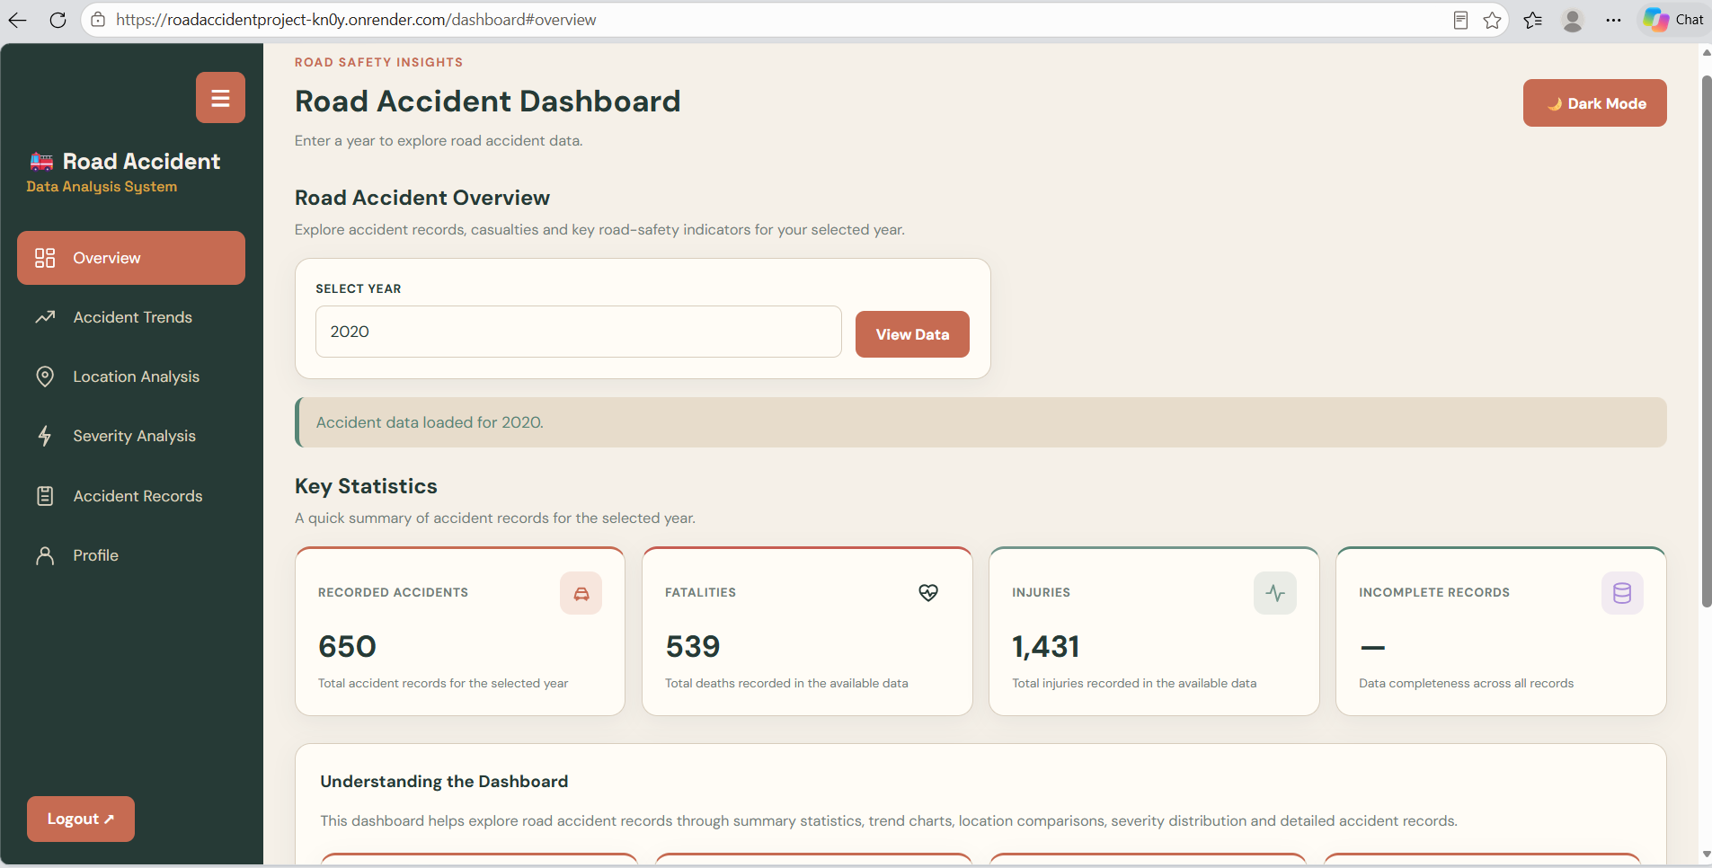
Fig 3: Dashboard overview

2. TRENDS ANALYSIS
The trends section displays accident-related patterns using graphical representations. It helps users understand how accident records vary across different months and time periods.
Main Features:
- Monthly accident trends.
- Time-based analysis where data is available.
- Graphical representation of accident patterns.

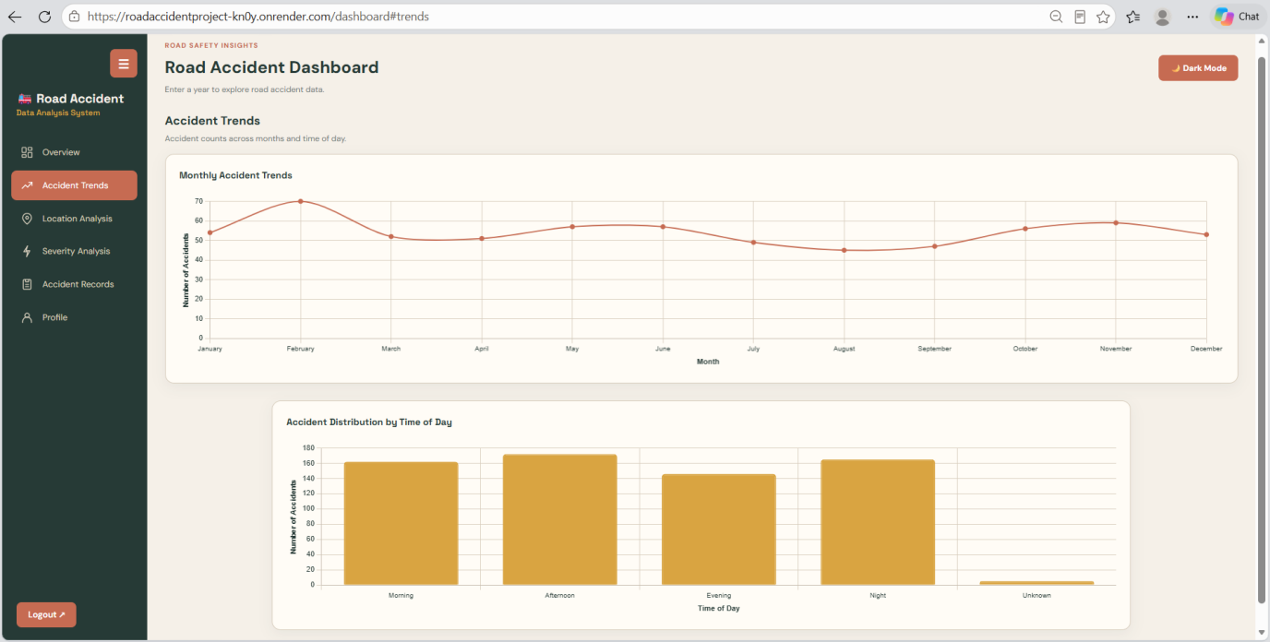
Fig 4: Trends analysis

3. LOCATION ANALYSIS
The location analysis section presents accident information based on the locations available in the database. It helps users compare accident records across different areas.
Main Features:
- Location-wise accident information.
- Comparison of available locations.
- Graphical representation of location-based records.

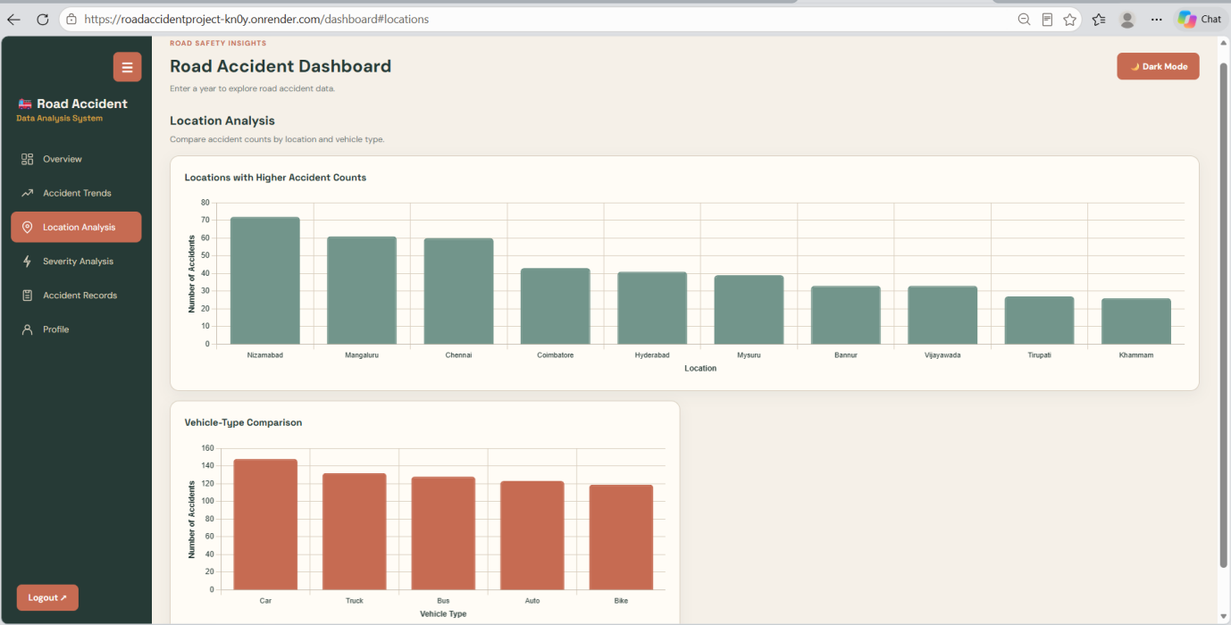
Fig 5: Location analysis

24. SEVERITY, RECORDS AND PROFILE OUTPUT SCREENS

1. SEVERITY ANALYSIS
The severity analysis section presents accident records according to the severity categories available in the database. It uses visual representations to help users understand the distribution of accident severity.
Main Features:
- Severity-wise accident information.
- Graphical representation of severity categories.
- Comparison of available severity records.

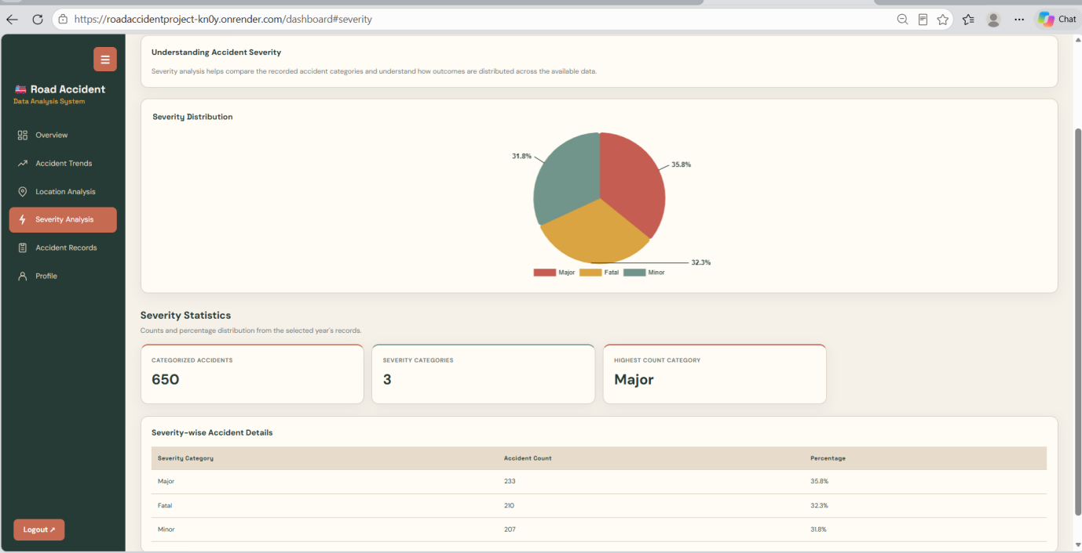
Fig 6: Severity analysis

2. ACCIDENT RECORDS
The records section displays individual accident entries stored in the database. Users can view the available details and use the search and filtering options to find specific records.
Main Features:
- Display of accident records in tabular format.
- Search and filtering functionality.
- Year-wise record selection.
- CSV download options for selected-year and all records.

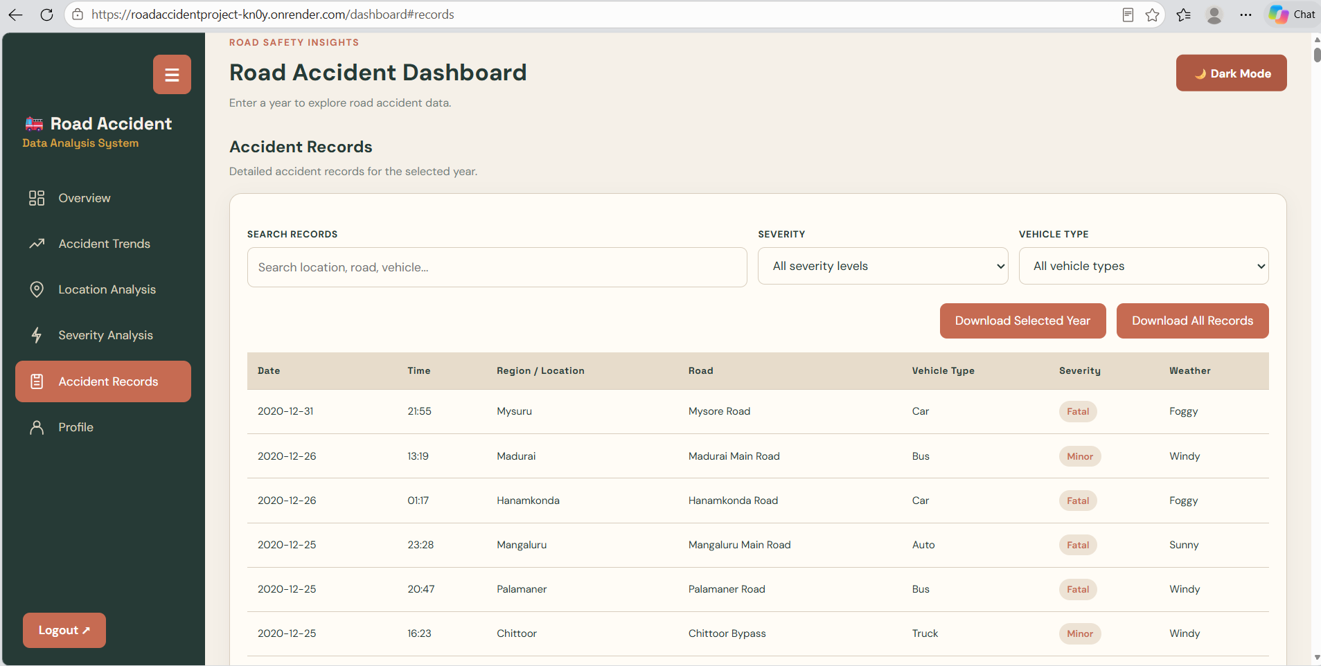
Fig 7: Accident records

3. PROFILE AND ACCOUNT SETTINGS
The profile section allows the currently logged-in user to view and update their profile information. Account settings also provide options for changing the dashboard theme and logging out.
Main Features:
- Display of current user's name and email.
- Profile update functionality.
- Light and dark theme options.
- Logout option.

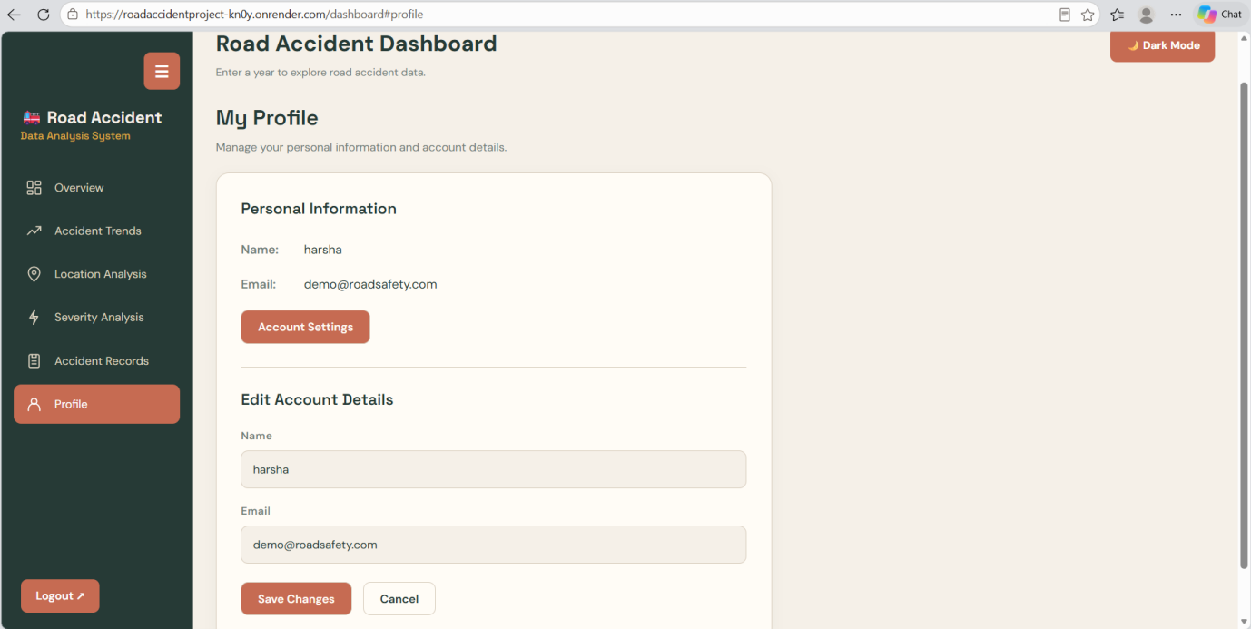
Fig 8: Profile and account settings

25. SOFTWARE TESTING
Software testing is an important phase in the development of the Road Accident Data Analysis System. It is performed to check whether the application functions according to the specified requirements.
The main purpose of testing is to identify errors, verify individual features, and ensure that the frontend, backend, and database work together correctly.

1. Functional Testing
Functional testing is performed to verify whether each feature of the application works as expected.
The following functionalities are checked:
- Landing page navigation.
- Login and logout functionality.
- Dashboard access after login.
- Year selection and dashboard data retrieval.
- Trends, locations, and severity sections.
- Search and filtering of accident records.
- Profile update functionality.
- CSV download for selected-year and all records.
- Light and dark theme selection.

2. Integration Testing
Integration testing checks the interaction between the frontend, Flask backend, and MySQL database.
It verifies whether user requests are processed correctly and the required information is retrieved from the database and displayed on the dashboard.

3. User Interface Testing
User interface testing checks the appearance and usability of the application.
It includes checking page navigation, buttons, forms, charts, tables, theme selection, and overall layout.

4. Database Testing
Database testing verifies whether the application can connect to MySQL and retrieve the required accident records correctly.

Conclusion
Testing helps verify the major functionalities of the Road Accident Data Analysis System and improves the reliability and usability of the application.

26. TEST CASES AND RESULTS
Test cases are prepared to verify the major functionalities of the Road Accident Data Analysis System. Each test case includes the functionality being tested, the expected result, and the actual result.

1. TEST CASE TABLE
Test Case ID | Functionality Tested | Expected Result | Actual Result
TC01 | Landing Page | Landing page should load successfully. | Landing page loaded successfully.
TC02 | Login | User should be able to access the dashboard after successful login. | User was able to access the dashboard after successful login.
TC03 | Dashboard Access | Dashboard should display after login. | Dashboard was displayed after login.
TC04 | Year Selection | Data for the selected year should be displayed. | Data for the selected year was displayed.
TC05 | Trends Section | Available trend information should be displayed. | Trend information was displayed.
TC06 | Location Section | Location-wise information should be displayed. | Location-wise information was displayed.
TC07 | Severity Section | Severity-related information should be displayed. | Severity-related information was displayed.
TC08 | Search and Filter | Matching accident records should be displayed. | Matching accident records were displayed.
TC09 | CSV Export | Selected-year and all-record CSV downloads should work. | Selected-year and all-record CSV files were downloaded successfully
TC10 | Profile Update | Updated profile information should be displayed. | Updated profile information was displayed.
TC11 | Theme Selection | Light and dark themes should be applied. | Light and dark themes were applied successfully.
TC12 | Logout | User session should be cleared and landing page displayed. | User session was cleared and the landing page was displayed.

2. TESTING RESULTS
The application is tested by checking its main modules, including login, dashboard navigation, database integration, accident record retrieval, profile management, theme selection, and CSV export.
The actual result of each test case is recorded after execution. Any errors identified during testing are corrected and the corresponding functionality is tested again.

3. OVERALL TESTING SUMMARY
The testing process helps verify the working of the major modules and the interaction between the frontend, backend, and database.

27. CONCLUSION AND FUTURE ENHANCEMENTS

1. CONCLUSION
The Road Accident Data Analysis System is a web-based application developed to organize, retrieve, and analyze road accident information through an interactive dashboard.
The system is developed using Python, Flask, HTML, CSS, JavaScript, and MySQL. It provides different modules such as landing page, login, dashboard overview, trends analysis, location analysis, severity analysis, accident records, profile management, and CSV export.
The application supports year-wise analysis for the period 2011 to 2026 using the records available in its database. Users can explore accident-related information through charts, tables, search options, and filtering features.
The project demonstrates how web technologies and database management can be combined to make accident information easier to access and understand.

2. FUTURE ENHANCEMENTS
The following features can be considered for future development:
- Real-Time Accident Data: Integration with reliable external data sources to obtain updated accident information.
- Interactive Maps: Display accident locations on maps for better geographical understanding.
- Predictive Analysis: Apply machine learning techniques to study accident patterns and estimate possible risk trends.
- Advanced Filtering: Add more filtering options based on district, vehicle type, road type, and severity.
- Improved Data Visualization: Introduce additional charts and interactive visualizations.
- Cloud Deployment: Host the application on a cloud platform so authorized users can access it online.
- Expanded Data Coverage: Include more verified accident records and additional geographical regions.

3. FINAL REMARKS
This project provides a foundation for understanding road accident patterns through organized data and visual analysis. With reliable data sources and further improvements, the system can be extended into a more comprehensive road safety analysis platform.

REFERENCES
The following official technical documentation and development resources were referred to during the development of the Road Accident Data Analysis System.
- Python Official Documentation – https://docs.python.org/3/
- Flask Web Framework Documentation – https://flask.palletsprojects.com/
- MySQL Official Documentation – https://dev.mysql.com/doc/
- MySQL Connector/Python Documentation – https://dev.mysql.com/doc/connector-python/en/
- Python Random Module Documentation – https://docs.python.org/3/library/random.html
- Python CSV Module Documentation – https://docs.python.org/3/library/csv.html
- Python JSON Module Documentation – https://docs.python.org/3/library/json.html
- Python Date and Time Documentation – https://docs.python.org/3/library/datetime.html
- HTML Documentation – MDN Web Docs – https://developer.mozilla.org/en-US/docs/Web/HTML
- CSS Documentation – MDN Web Docs – https://developer.mozilla.org/en-US/docs/Web/CSS
- JavaScript Documentation – MDN Web Docs – https://developer.mozilla.org/en-US/docs/Web/JavaScript
- Chart.js Documentation – https://www.chartjs.org/docs/latest/
- Git Official Documentation – https://git-scm.com/doc
- GitHub Documentation – https://docs.github.com/
- Visual Studio Code Documentation – https://code.visualstudio.com/docs/
- MySQL Workbench Documentation – https://dev.mysql.com/doc/workbench/en/
- Flask API Documentation – https://flask.palletsprojects.com/en/stable/api/
Dataset Note:
The accident records used in this project are synthetically generated using Python for academic and demonstration purposes. The dataset does not represent verified official road accident statistics and was not directly collected from government databases.

