DESIGN PROJECT – I · SEMESTER III
CryptoGuard
A Measured Password and File-Security Workbench
A project report submitted in partial fulfilment of the requirements of
Design Project – I (Semester III) for the degree of
BACHELOR OF TECHNOLOGY
with specialisation in Cyber Security
Submitted by
Malepati Sree Harsha
Register No. 23CU0340018
DISC
HINDUSTAN INSTITUTE OF TECHNOLOGY AND SCIENCE
(Deemed to be University)
Padur, Kelambakkam, Chennai – 603 103
Academic Year 2024–25

DECLARATION
I, Malepati Sree Harsha (Register No. 23CU0340018), hereby declare that the project report entitled “CryptoGuard: A Measured Password and File-Security Workbench”, submitted as Design Project – I in Semester III of the Bachelor of Technology programme with specialisation in Cyber Security, DISC, Hindustan Institute of Technology and Science, during the academic year 2024–25, is a record of my own work.
Where the work of others has been used, it is acknowledged and cited in the references. All experiments were performed on systems I own, using bundled or synthetic data, and no third-party system was tested without authorization.

Place: Chennai
Date: ____________
Malepati Sree Harsha
Register No. 23CU0340018

ACKNOWLEDGEMENT
I thank the faculty of DISC, Hindustan Institute of Technology and Science, for the course structure, laboratory facilities and feedback that shaped this design project, and the institution for the opportunity to work on an applied security problem.
I also acknowledge the open-source communities behind Python, Flask, scikit-learn, the cryptography library, OpenSSL, John the Ripper, Wireshark/TShark, Suricata, Nmap and OWASP ZAP, whose tools and documentation made this work possible. Finally, I thank my family and friends for their support.
Malepati Sree Harsha

ABSTRACT
Password-strength meters usually convert a password into a crack-time estimate using a guess rate that the tool simply assumes. In practice the rate an attacker achieves depends far more on how the server stores the password than on a few extra characters typed by the user. This project, CryptoGuard, is a local, privacy-preserving web workbench that makes these trade-offs measurable. It combines (i) an explainable password-strength analyser, (ii) cryptographically secure password and passphrase generation, (iii) authenticated file encryption with AES-256-GCM and PBKDF2-HMAC-SHA256 key derivation, (iv) file-integrity digests and hash-format identification, (v) a bounded John the Ripper demonstration on bundled sample hashes, and (vi) a novel measured key-derivation benchmark that times MD5, SHA-1, SHA-256, PBKDF2 (200,000 and 600,000 iterations) and scrypt on the host and expresses each scheme's cost as an equivalent number of extra password characters.
The system is implemented in Python (Flask) with a responsive single-page interface, packaged as a non-root Docker container, and hardened with a strict Content-Security-Policy, OWASP security headers, request-ID logging that never records request bodies, JSON error handling and per-client rate limits. Evaluation on the Docker image shows that one CPU core computes about 3,516,182 MD5 guesses per second but only 15.2 PBKDF2-600k guesses per second, a 231,328-fold slowdown worth about 2.71 extra random characters from a 95-symbol alphabet. John the Ripper recovered 8 of 9 bundled weak hashes from a 16-word list. All 14 automated tests pass, and non-KDF endpoints answer with a median latency under 5 ms at more than 1,500 requests per second. The work shows that storage-side choices deserve the same visibility as user-side password rules, and it provides a reproducible way to demonstrate this in a classroom or interview.
Keywords: password security, key derivation function, PBKDF2, scrypt, AES-GCM, authenticated encryption, John the Ripper, secure web application, Flask, Docker

CONTENTS
Declaration ii
Acknowledgement iii
Abstract iv
List of Figures vii
List of Tables viii
Chapter 1 Introduction 1
1.1 Background 1
1.2 Motivation 1
1.3 Problem Statement 1
1.4 Objectives 2
1.5 Scope and Ethics 2
1.6 Organisation of the Report 2
Chapter 2 Literature Survey 3
2.1 Password Strength Estimation 3
2.2 Password Storage and Key Derivation 3
2.3 Authenticated File Encryption 3
2.4 Existing Tools 3
2.5 Research Gap 4
Chapter 3 System Requirements Specification 5
3.1 Functional Requirements 5
3.2 Non-Functional Requirements 5
3.3 Hardware and Software Requirements 6
3.4 Feasibility 6
Chapter 4 System Design 7
4.1 Architecture 7
4.2 Data Flow Diagrams 7
4.3 UML Diagrams 8
4.4 Deployment Design 10
4.5 Encrypted Envelope Format 11
Chapter 5 Methodology and Implementation 12
5.1 Technology Stack and Justification 12
5.2 Stage 1 — Project Skeleton and API 12
5.3 Stage 2 — Explainable Password Analysis 12
5.4 Stage 3 — Secure Secret Generation 13
5.5 Stage 4 — Authenticated Encryption 13
5.6 Stage 5 — Integrity and Hash Identification 14
5.7 Stage 6 — Bounded John the Ripper Demonstration 14
5.8 Stage 7 — Measured KDF Benchmark (Novel Component) 15
5.9 Stage 8 — HTTP Hardening, Logging and Rate Limiting 16
5.10 Stage 9 — User Interface 16
5.11 Stage 10 — Packaging and Continuous Integration 16
5.12 Secure Coding Practices Applied 17
Chapter 6 Testing and Validation 18
6.1 Test Strategy 18
6.2 Automated Test Cases 18
6.3 Functional, Usability and Performance Checks 19
6.4 Security Testing Notes 19
Chapter 7 Results and Discussion 21
7.1 Working System 21
7.2 Measured KDF Cost 22
7.3 Strength Analyser Behaviour 24
7.4 Performance 25
7.5 Usability on Mobile 26
7.6 Limitations 26
Chapter 8 Conclusion and Future Scope 27
8.1 Conclusion 27
8.2 Future Scope 27
References 28
Appendix A Installation and User Manual 29
Appendix B Demonstration Script 30
Appendix C API Reference 31
Appendix D Repository Structure 32

LIST OF FIGURES
Figure 4.1 Layered architecture of CryptoGuard 7
Figure 4.2 DFD level 0 (context diagram) 8
Figure 4.3 DFD level 1 8
Figure 4.4 Use-case diagram 9
Figure 4.5 Sequence diagram for AES-256-GCM file encryption 9
Figure 4.6 Class and module diagram 10
Figure 4.7 Activity diagram of password-strength analysis 10
Figure 4.8 Deployment diagram 11
Figure 7.1 CryptoGuard landing view 21
Figure 7.2 Live password analysis with checks and crack-time scenarios 21
Figure 7.3 AES-256-GCM encryption producing a .cguard envelope 22
Figure 7.4 John the Ripper cracking 8 of 9 bundled sample hashes 22
Figure 7.5 Guesses per second per scheme (log scale) 23
Figure 7.6 Benchmark rendered in the user interface 24
Figure 7.7 Latency per endpoint (p50 and p95) 25
Figure 7.8 Layout at 390 px width 26

LIST OF TABLES
Table 2.1 Comparison of existing tools with CryptoGuard 3
Table 3.1 Functional requirements 5
Table 3.2 Non-functional requirements and how they are verified 5
Table 3.3 Hardware and software requirements 6
Table 4.1 Fields of the .cguard envelope 11
Table 5.1 Technology choices 12
Listing 5.2 Password strength analysis (cryptoguard/crypto_core.py) 12
Listing 5.3 Key derivation and AES-256-GCM (cryptoguard/crypto_core.py) 13
Listing 5.4 John the Ripper adapter, beginning (cryptoguard/tools.py) 14
Listing 5.5 Benchmark core (cryptoguard/kdf_bench.py) 15
Listing 5.6 Rate-limiting decorator (cryptoguard/web_security.py) 16
Table 6.1 Test levels used 18
Table 6.2 Automated test cases and results 18
Table 6.3 Functional and non-functional checks 19
Table 7.1 Measured guess rates (Linux aarch64, Python 3.12.16, one core) 23
Table 7.2 Load-test results against the Docker container (100 requests, 8 workers per endpoint) 25

CHAPTER 1
INTRODUCTION

1.1 Background
Passwords remain the dominant authentication mechanism on the web, and credential theft is a consistent leading cause of breaches. Two independent decisions determine how well a password resists an attacker who has stolen a password database: the user's choice of password, and the service's choice of how to store it. Users receive constant advice about the first (length, character classes, uniqueness); the second is invisible to them.
Cryptography offers well-understood building blocks for the second decision. Slow, salted key-derivation functions (KDFs) such as PBKDF2 [2], [4] and memory-hard functions such as scrypt [5] and Argon2 [11] deliberately make each guess expensive. Authenticated encryption modes such as AES-GCM [3] protect both the confidentiality and the integrity of files. These ideas are standard in industry guidance [1], [9] but are rarely made tangible to the people who must choose or audit them.

1.2 Motivation
Most strength meters display a single crack time such as “centuries” without stating the attacker model behind it. Research shows such estimates are often poorly aligned with real cracking behaviour [6], [7], [15], and that users' perceptions of password strength differ from reality [12]. The guess rate hidden inside the estimate can vary by five or more orders of magnitude depending on the storage scheme. A student or developer therefore cannot tell from a typical meter whether a password is weak, or whether the system storing it is weak.
A second motivation is privacy. Many online password checkers and file-encryption websites require the user to send secrets to a third-party server. An educational tool for security hygiene should itself demonstrate good hygiene: process data locally and never log it.

1.3 Problem Statement
To design and implement a local, secure web application that lets a user evaluate passwords, generate strong secrets, encrypt and verify files, and observe real password cracking, while quantifying with measurements on the host machine how much the server-side password storage scheme changes an attacker's guessing speed, expressed in a unit users already understand: password characters.

1.4 Objectives
- Implement an explainable password-strength analyser that reports entropy, policy checks, detected weaknesses and crack-time scenarios with their assumptions stated.
- Generate passwords and passphrases with an operating-system CSPRNG (Python secrets).
- Provide authenticated encryption of files and text using AES-256-GCM with PBKDF2-HMAC-SHA256 key derivation and a self-describing, downloadable envelope.
- Compute integrity digests (SHA-256, SHA-1, MD5) and identify hash formats using hashid and built-in rules.
- Demonstrate dictionary attacks safely with John the Ripper restricted to bundled sample hashes.
- Design and evaluate a measured KDF benchmark that converts each storage scheme's cost into equivalent password characters.
- Apply secure-coding practice: input validation, security headers, safe logging, error handling and rate limiting, verified by automated tests.
- Package the system reproducibly with Docker and continuous integration, and evaluate functionality, security and performance.

1.5 Scope and Ethics
CryptoGuard is an educational, single-user tool that runs on the user's own machine and binds only to the loopback interface. It is not a password manager or a production encryption service, and it has not been independently audited. The cracking demonstration accepts no user input: it only reads the sample hash file and word list shipped with the repository. No experiment in this report involved third-party systems or real user credentials.

1.6 Organisation of the Report
Chapter 2 surveys existing tools and literature and identifies the research gap. Chapter 3 specifies requirements. Chapter 4 presents the system design with architecture, data-flow and UML diagrams. Chapter 5 describes the implementation stage by stage. Chapter 6 covers testing and validation. Chapter 7 presents results and discussion, and Chapter 8 concludes with future scope. Appendices contain the installation guide, demonstration script, API reference and repository structure.

CHAPTER 2
LITERATURE SURVEY

2.1 Password Strength Estimation
Early strength measures counted character classes and multiplied length by log2 of the alphabet size, an approach popularised by older NIST guidance. Weir et al. [8] showed, by attacking large leaked password sets, that such entropy scores are a poor predictor of resistance to real attacks. Kelley et al. [15] measured strength by simulating cracking algorithms and found policy-based scores disagree with guess numbers. Bonneau [6] analysed 70 million passwords and proposed guessing-based metrics. Wheeler's zxcvbn [7] estimates guess numbers by matching dictionary words, keyboard patterns, dates and l33t substitutions, and is deployed widely. Ur et al. [12] found that users misjudge which passwords are strong.
Current NIST guidance (SP 800-63B [1]) moved away from composition rules toward length, blocklists of compromised passwords, and rate limiting, and requires verifiers to store passwords with a salted, iterated one-way KDF.

2.2 Password Storage and Key Derivation
PBKDF2 [2], [4] applies an HMAC many times so that each guess costs a configurable number of iterations. OWASP's Password Storage Cheat Sheet [9] recommends at least 600,000 iterations for PBKDF2-HMAC-SHA256, or a memory-hard function. scrypt [5] adds a large memory requirement to resist GPU and ASIC parallelism; Argon2 [11], winner of the Password Hashing Competition, generalises this design. Fast general-purpose hashes (MD5, SHA-1, SHA-256) are unsuitable for passwords because they are optimised for speed.

2.3 Authenticated File Encryption
Galois/Counter Mode [3] provides confidentiality and a 128-bit authentication tag. Decryption fails if the ciphertext, nonce or key is wrong, which prevents silent acceptance of tampered data. GCM requires a unique nonce per key; deriving a fresh key per file from a random salt, as in this project, keeps nonce reuse risk negligible.

2.4 Existing Tools
Table 2.1: Comparison of existing tools with CryptoGuard
Tool / approach | What it does well | Limitation addressed here
Browser / password-manager meters (e.g. zxcvbn [7]) | Realistic pattern-aware estimates | Assume one attacker speed; storage scheme invisible
Online password checkers | Convenient | Send secrets to a third party; no stated model
John the Ripper [10] / Hashcat | Real cracking power | Expert CLI tools; not connected to strength feedback
7-Zip, VeraCrypt (AES) | Strong, audited encryption | Separate tools; parameters hidden from learners
NIST / OWASP guidance [1], [9] | Authoritative parameters | Text only; no way to observe the effect
CryptoGuard (this work) | Local, explainable, integrated | Measures KDF cost on the host in password-character units

2.5 Research Gap
The surveyed work treats the attacker's guess rate either as a fixed assumption (meters) or as a property of attack hardware (cracking tools). No widely used educational tool lets a learner (a) measure, on their own hardware, how storage schemes change the guess rate, and (b) compare that change in the same unit as user-side advice. This project addresses that gap with a small, reproducible benchmark and an integrated, local workbench. The contribution is deliberately modest: it is an engineering and educational contribution, not a new cryptographic primitive or a new strength estimator.

CHAPTER 3
SYSTEM REQUIREMENTS SPECIFICATION

3.1 Functional Requirements
Table 3.1: Functional requirements
ID | Requirement | Endpoint / module
FR-1 | Analyse a password (≤ 256 chars) and return score, label, entropy, checks, issues and crack-time scenarios | POST /api/analyze
FR-2 | Generate a password (12–64 chars, optional symbols) or passphrase (4–8 words) using a CSPRNG | GET /api/generate
FR-3 | Encrypt text or a file (≤ 8 MB) with AES-256-GCM and return a .cguard envelope | POST /api/encrypt
FR-4 | Decrypt an envelope with the passphrase; reject wrong keys or tampered data | POST /api/decrypt
FR-5 | Compute SHA-256, SHA-1 and MD5 digests of text or a file | POST /api/integrity
FR-6 | Identify the probable format of a pasted hash | POST /api/identify
FR-7 | Run John the Ripper on bundled sample hashes only and report cracked passwords | GET /api/john
FR-8 | Measure hash/KDF cost on the host and convert it to equivalent characters | POST /api/kdf-bench
FR-9 | Report installed tool status and OpenSSL details | GET /api/tools, /api/openssl
FR-10 | Export or print a report of the current analysis | Browser UI

3.2 Non-Functional Requirements
Table 3.2: Non-functional requirements and how they are verified
ID | Category | Requirement | Verification
NFR-1 | Privacy | No user input is written to disk or logs | Code review; logs contain method/path/status only
NFR-2 | Security | CSP, X-Frame-Options, nosniff, Referrer-Policy on every response | tests/test_security.py
NFR-3 | Security | Bounded input sizes; rate limits on expensive endpoints | Validation tests; 429 test
NFR-4 | Performance | Non-KDF endpoints p95 < 50 ms on a laptop | scripts/loadtest.py (Table 7.3)
NFR-5 | Usability | Usable from 320 px to desktop widths; 44 px touch targets | Screenshots at 390 px
NFR-6 | Portability | One-command start on any OS with Docker | docker compose up
NFR-7 | Reliability | Container health check; graceful degradation if a tool is missing | HEALTHCHECK; tool-status API
NFR-8 | Maintainability | Modular code, automated tests, CI on every push | GitHub Actions workflow

3.3 Hardware and Software Requirements
Table 3.3: Hardware and software requirements
Item | Minimum | Used in this work
Processor | Any 64-bit x86 or ARM CPU | Apple Silicon (arm64)
Memory | 4 GB RAM | 8 GB+
Operating system | Windows 10+, macOS 12+, or Linux | macOS; container runs Debian (python:3.12-slim)
Runtime | Docker Desktop 4.x, or Python 3.9+ | Docker 29; Python 3.12 in container
Libraries | Flask ≥ 3.0, cryptography ≥ 42, hashID | As pinned in requirements.txt
Security tools | John the Ripper, OpenSSL (in image) | John (Debian package), OpenSSL 3.5.7 9 Jun 2026
Browser | Any modern browser | Chromium, Safari

3.4 Feasibility
- Technical: all components are mature open-source libraries; the cryptography is delegated to OpenSSL via the cryptography package rather than implemented by hand.
- Economic: zero licence cost; runs on a student laptop.
- Operational: a single docker compose up command starts the system; a macOS double-click launcher is included.
- Legal and ethical: no third-party systems are contacted; the cracking demonstration only uses bundled synthetic hashes.

CHAPTER 4
SYSTEM DESIGN

4.1 Architecture
CryptoGuard follows a layered architecture (Figure 4.1). The presentation layer is a single self-contained HTML page. The API layer is a Flask application whose cross-cutting security concerns live in web_security.py. The domain layer contains pure-Python modules with no web dependencies (so they can be unit-tested directly), and the tool layer wraps external programs behind bounded subprocess calls.
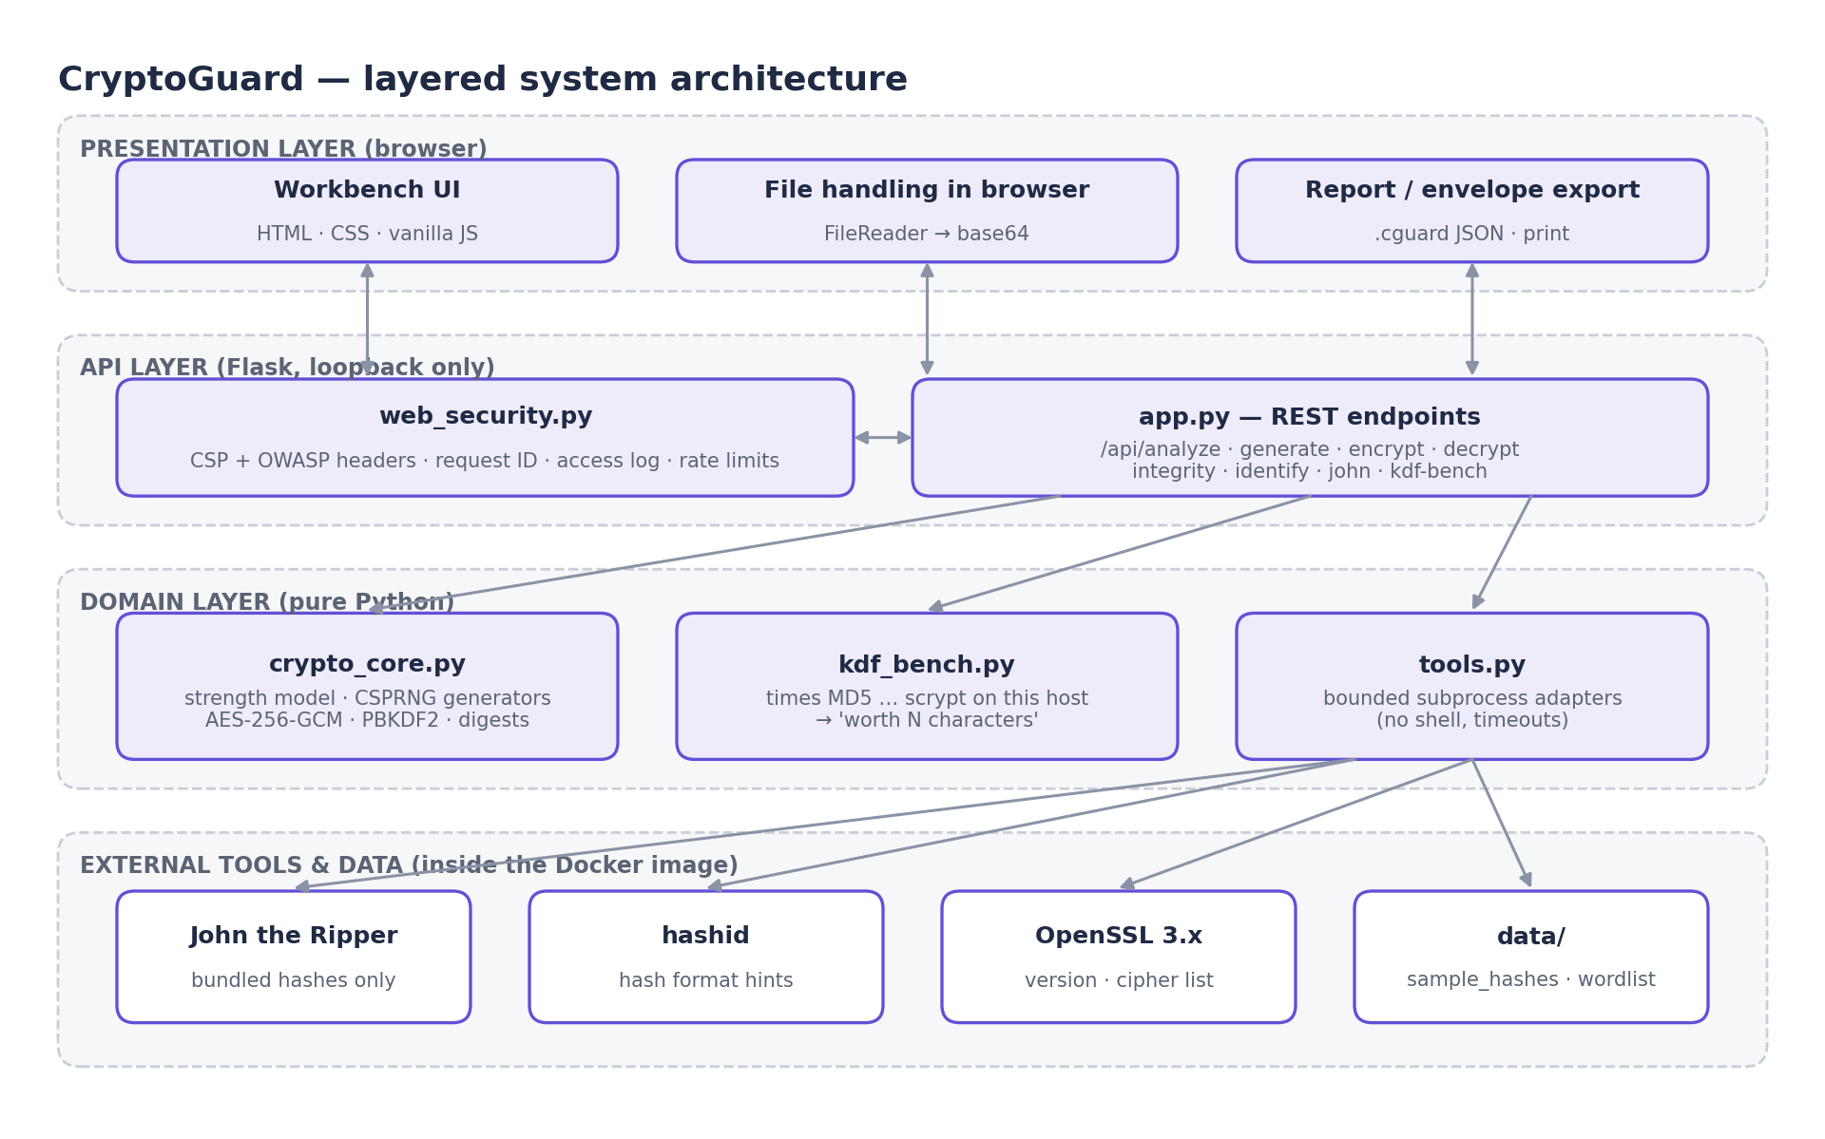
Figure 4.1: Layered architecture of CryptoGuard

4.2 Data Flow Diagrams
The context diagram (Figure 4.2) shows the system boundary: the only external entities are the user, the locally installed tools and the bundled sample data. The level-1 diagram (Figure 4.3) decomposes the system into six processes. No process writes user input to persistent storage.
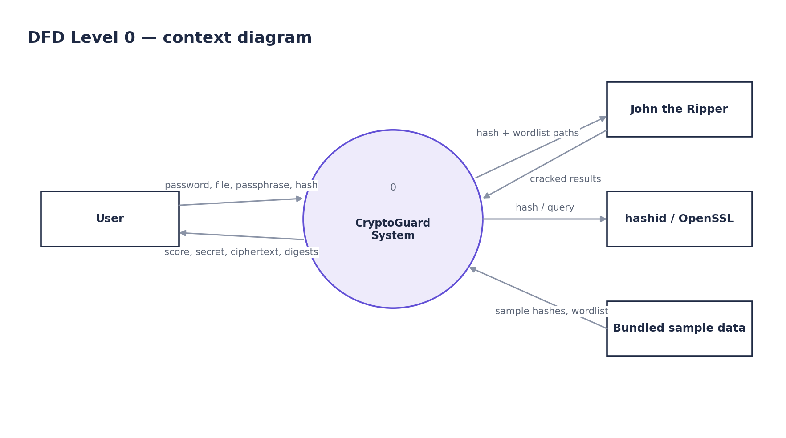
Figure 4.2: DFD level 0 (context diagram)
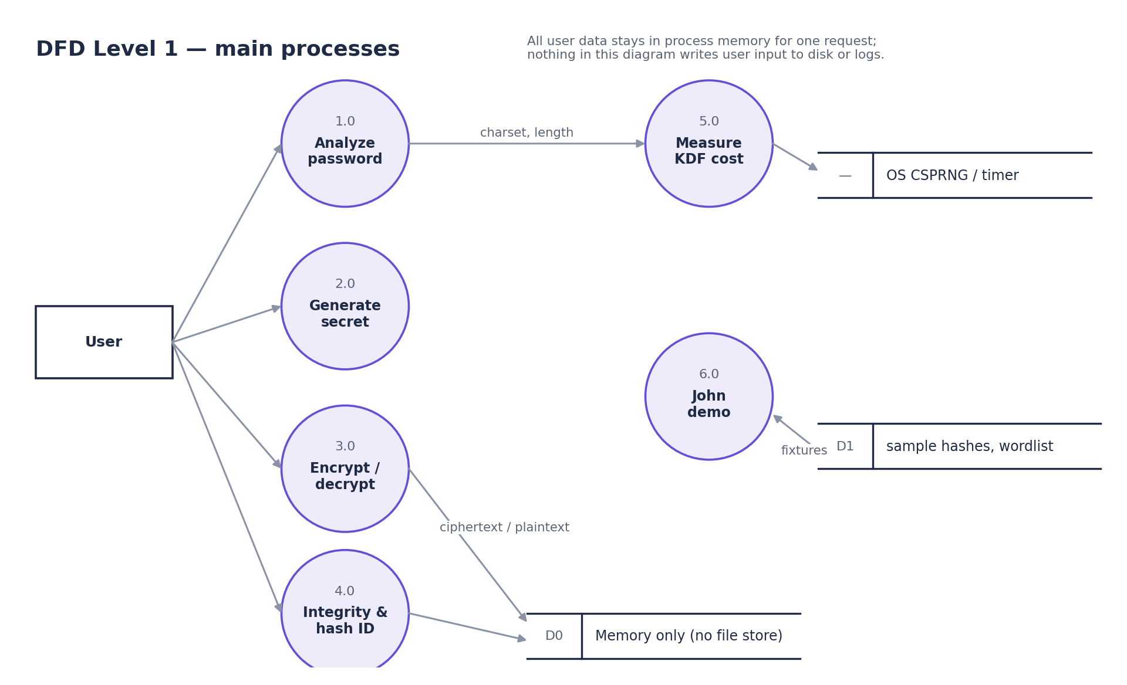
Figure 4.3: DFD level 1

4.3 UML Diagrams
Figure 4.4 shows the use cases for the two actors. Figure 4.5 traces the most security-sensitive interaction, encrypting a file, through every layer. Figure 4.6 shows the module structure, and Figure 4.7 the activity flow of the strength analyser.
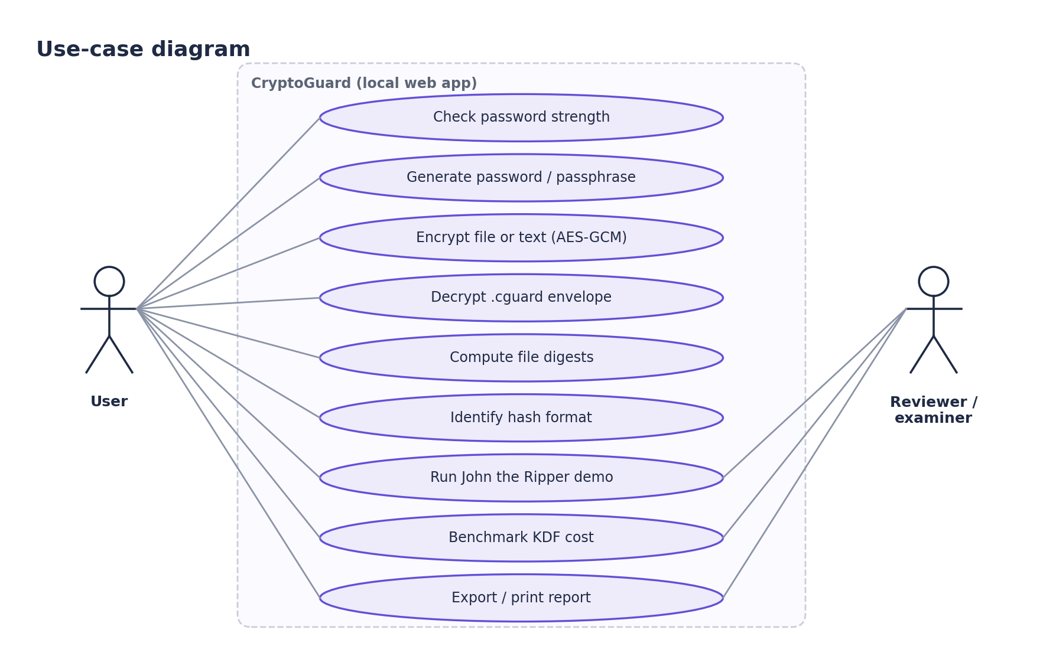
Figure 4.4: Use-case diagram
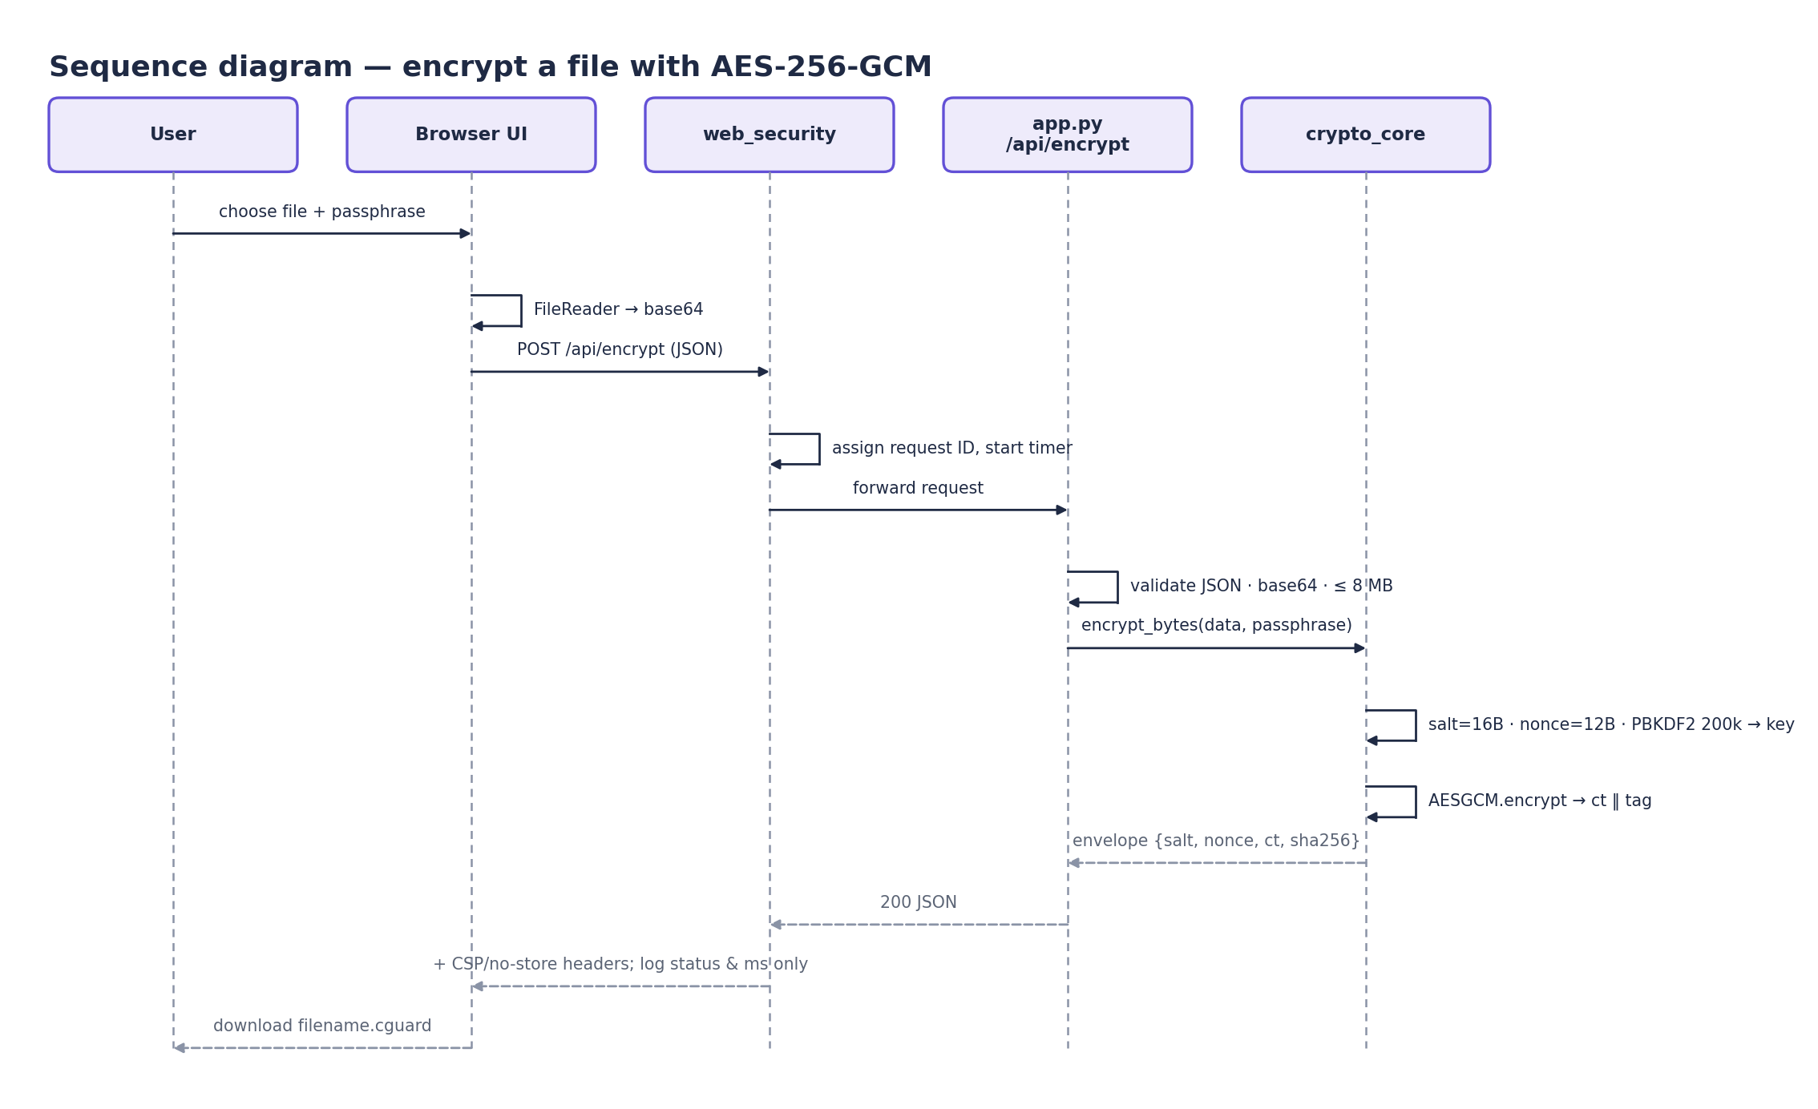
Figure 4.5: Sequence diagram for AES-256-GCM file encryption
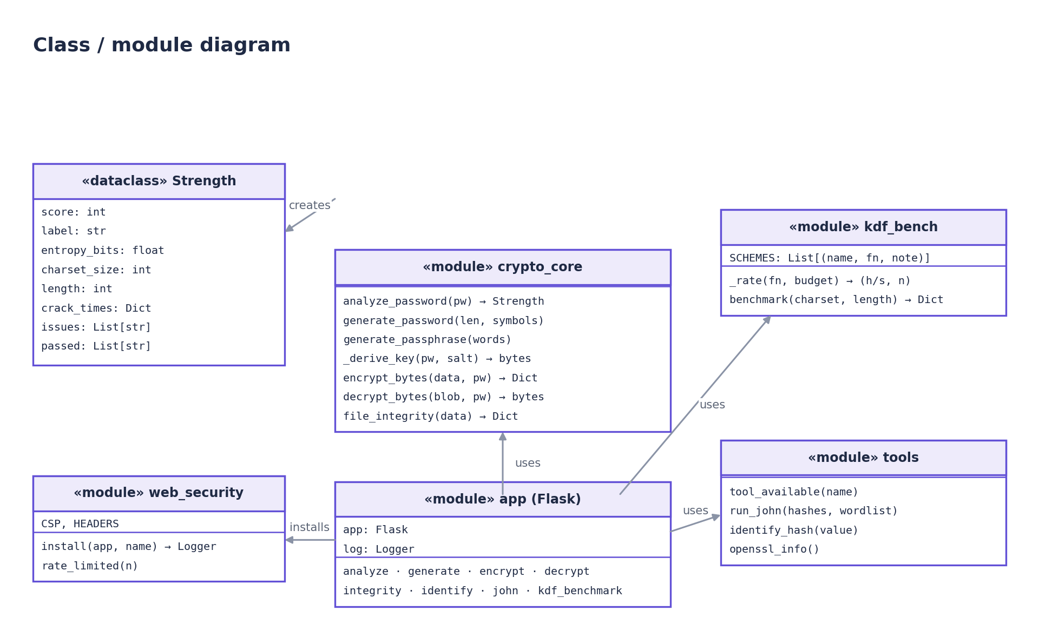
Figure 4.6: Class and module diagram
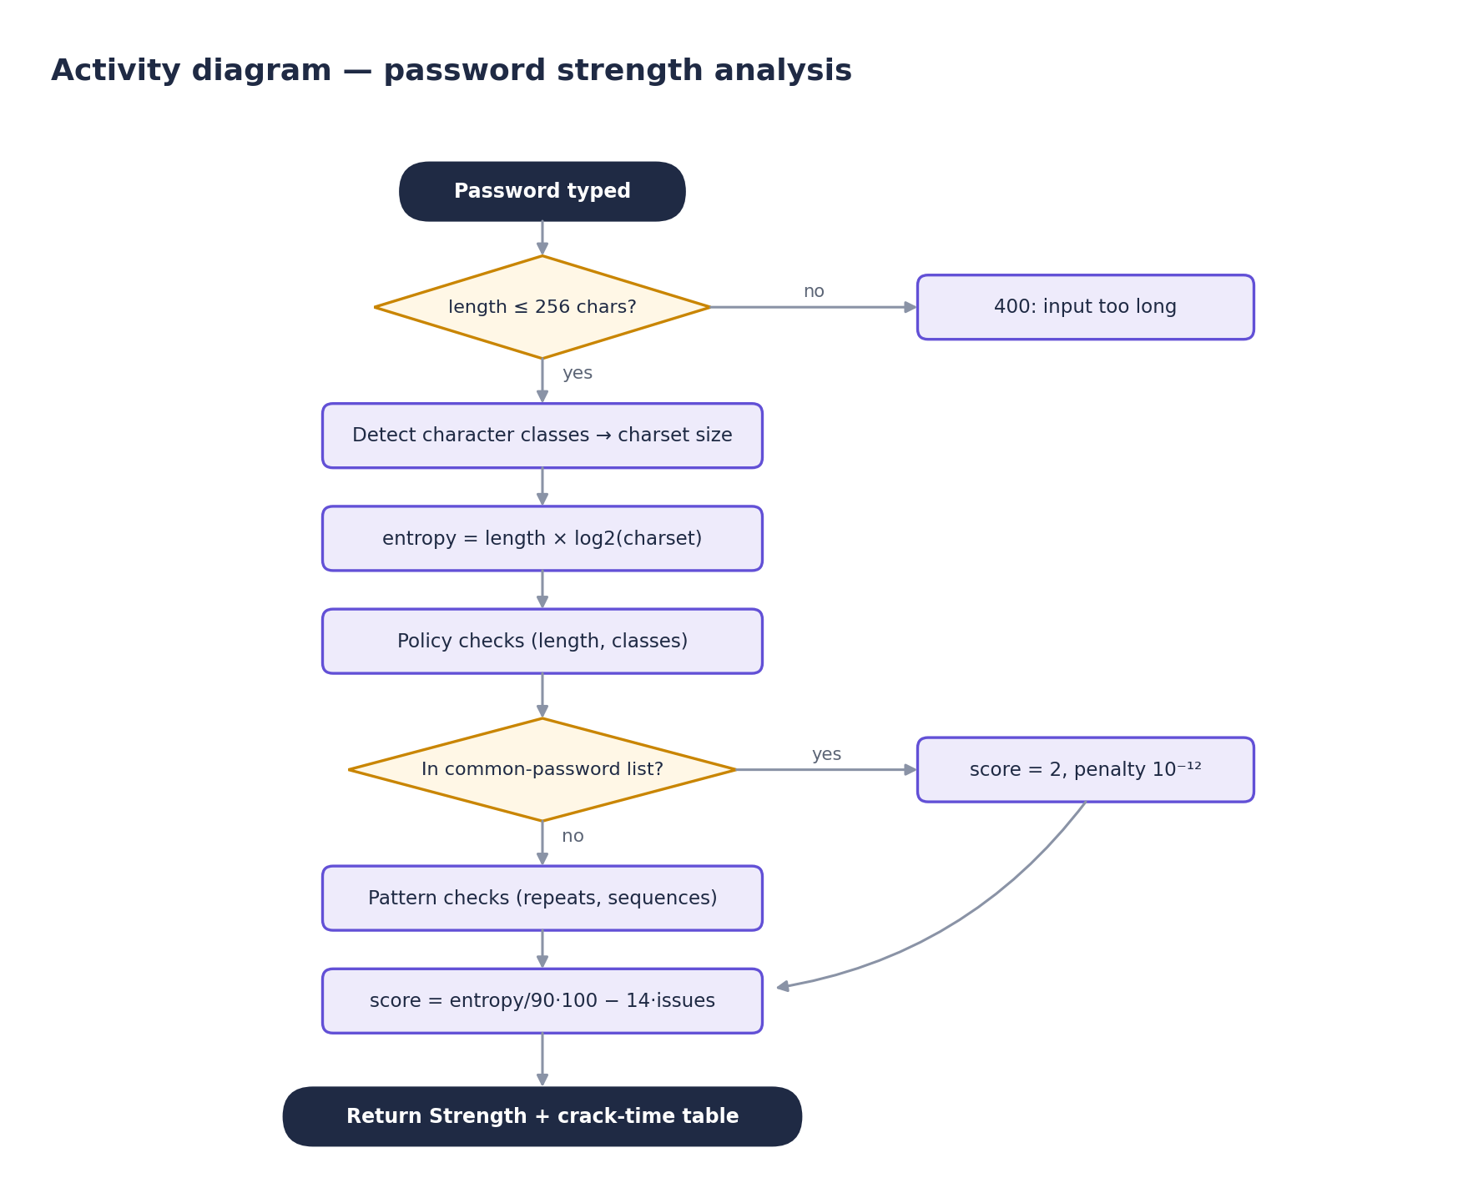
Figure 4.7: Activity diagram of password-strength analysis

4.4 Deployment Design
The application runs in one container built from python:3.12-slim (Figure 4.8). The container runs as an unprivileged user (uid 10001), publishes its port only on 127.0.0.1, has a health check, and mounts no volumes, so nothing a user uploads can persist.
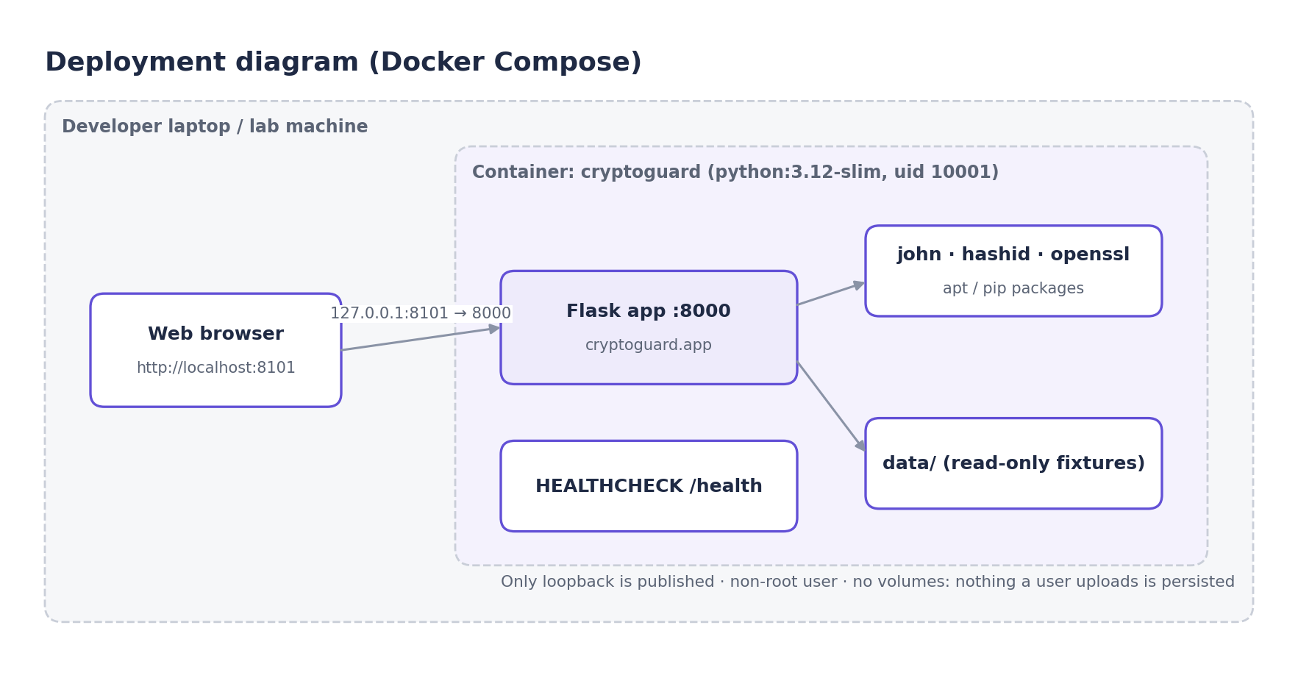
Figure 4.8: Deployment diagram

4.5 Encrypted Envelope Format
Table 4.1: Fields of the .cguard envelope
Field | Content | Secret?
ciphertext_b64 | base64(salt[16] ‖ nonce[12] ‖ ciphertext ‖ GCM tag[16]) | No (protected by key)
algorithm / kdf | "AES-256-GCM" / "PBKDF2-HMAC-SHA256 (200,000 iters)" | No
salt_hex, nonce_hex | Random per encryption (os.urandom) | No — safe to store
sha256 | Digest of the plaintext, for integrity checks after decryption | No
filename, size | Original name (≤ 120 chars) and length | No
passphrase | Never stored in the envelope or on the server | Yes

CHAPTER 5
METHODOLOGY AND IMPLEMENTATION

5.1 Technology Stack and Justification
Table 5.1: Technology choices
Technology | Role | Why this and not something heavier
Python 3.12 | Backend language | Readable; first-class security libraries
Flask 3 | HTTP API | Minimal; every route visible in one file; no ORM needed (no database)
cryptography (OpenSSL) | AES-GCM, PBKDF2, scrypt | Vetted primitives; never hand-rolled crypto
secrets / hashlib | CSPRNG, digests | Standard library; no extra dependency
John the Ripper, hashid, OpenSSL CLI | Real security tooling | Industry tools, wrapped safely
Vanilla HTML/CSS/JS | User interface | No build step; one file; strict CSP possible
Docker + Compose | Packaging | Identical toolchain on every machine
pytest + GitHub Actions | Testing and CI | Fast tests on every push

Deliberately absent: a database (nothing must persist), a JavaScript framework (would complicate the CSP and add a build chain) and user accounts (single-user loopback tool). Each omission removes an attack surface.

5.2 Stage 1 — Project Skeleton and API
What: a Flask app that serves the UI and a /health endpoint, with a _body() helper that accepts only JSON objects. Why: every later feature needs a validated request path. How: all endpoints return JSON errors with HTTP 400 for malformed input instead of raising exceptions, and the request size is capped by MAX_CONTENT_LENGTH.

5.3 Stage 2 — Explainable Password Analysis
What: analyze_password() estimates entropy as length × log2(charset), applies policy checks, detects common passwords, repeats and keyboard sequences, and converts the keyspace into crack-time scenarios at four stated guess rates. Why: the user should see why a score was given and which assumptions sit behind each time. How: every rule contributes either to issues or passed, and the UI lists both.
Listing 5.2: Password strength analysis (cryptoguard/crypto_core.py)
def analyze_password(pw: str) -> Strength:
length = len(pw)
charset = 0
if re.search(r"[a-z]", pw):
charset += 26
if re.search(r"[A-Z]", pw):
charset += 26
if re.search(r"\d", pw):
charset += 10
if re.search(r"[^A-Za-z0-9]", pw):
charset += 33
charset = max(charset, 1)
entropy = length * math.log2(charset) if length else 0.0
issues, passed = [], []
(passed if length >= 12 else issues).append(
"at least 12 characters" if length >= 12 else f"too short ({length} chars) — use 12+")
for name, rx in [("lowercase", r"[a-z]"), ("uppercase", r"[A-Z]"),
("a digit", r"\d"), ("a symbol", r"[^A-Za-z0-9]")]:
(passed if re.search(rx, pw) else issues).append(
f"contains {name}" if re.search(rx, pw) else f"add {name}")
if pw.lower() in COMMON:
issues.append("appears in common-password lists")
else:
passed.append("not a known common password")
if re.search(r"(.)\1{2,}", pw):
issues.append("repeated characters (e.g. aaaa)")
if re.search(r"(?:0123|1234|2345|3456|4567|5678|6789|abcd|qwer)", pw.lower()):
issues.append("predictable sequence (e.g. 1234, qwer)")
# Effective guesses ~ half the keyspace; penalise detected weaknesses.
penalty = 1.0
if pw.lower() in COMMON:
penalty = 1e-12
guesses = (charset ** length) / 2 * penalty if length else 1
crack_times = {k: _human_time(guesses / rate) for k, rate in _GUESS_RATES.items()}
score = max(0, min(100, int(entropy / 90 * 100) - 14 * (len(issues))))
if pw.lower() in COMMON:
score = 2
label = (["Very weak", "Weak", "Fair", "Strong", "Very strong"]
[min(4, score // 20)])
return Strength(score, label, round(entropy, 1), charset, length,
crack_times, issues, passed)

5.4 Stage 3 — Secure Secret Generation
Passwords and passphrases are drawn with secrets.choice, which uses the operating system's CSPRNG. The ordinary random module is predictable from its outputs and must never be used for secrets. Inputs are bounded (12–64 characters, 4–8 words) at the API.

5.5 Stage 4 — Authenticated Encryption
What: encrypt_bytes() derives a 256-bit key with PBKDF2-HMAC-SHA256 (200,000 iterations) from the passphrase and a fresh 16-byte salt, then encrypts with AES-GCM under a fresh 12-byte nonce. Why: GCM gives integrity as well as confidentiality, so a modified envelope or wrong passphrase is rejected rather than decrypted to garbage. How: salt and nonce are prepended to the ciphertext; both are public values. Decryption errors return a single generic message so that the API does not reveal why decryption failed.
Listing 5.3: Key derivation and AES-256-GCM (cryptoguard/crypto_core.py)
def _derive_key(password: str, salt: bytes) -> bytes:
kdf = PBKDF2HMAC(algorithm=hashes.SHA256(), length=32, salt=salt, iterations=200_000)
return kdf.derive(password.encode())
def encrypt_bytes(data: bytes, password: str) -> Dict:
salt = os.urandom(16)
nonce = os.urandom(12)
key = _derive_key(password, salt)
ct = AESGCM(key).encrypt(nonce, data, None)
blob = salt + nonce + ct
return {
"ciphertext_b64": base64.b64encode(blob).decode(),
"algorithm": "AES-256-GCM",
"kdf": "PBKDF2-HMAC-SHA256 (200,000 iters)",
"salt_hex": salt.hex(),
"nonce_hex": nonce.hex(),
"sha256": hashlib.sha256(data).hexdigest(),
"size": len(data),
}
def decrypt_bytes(blob_b64: str, password: str) -> bytes:
blob = base64.b64decode(blob_b64)
salt, nonce, ct = blob[:16], blob[16:28], blob[28:]
key = _derive_key(password, salt)
return AESGCM(key).decrypt(nonce, ct, None)

5.6 Stage 5 — Integrity and Hash Identification
File digests are computed with hashlib. Hash identification combines a small set of regular expressions (MD5/NTLM, SHA-1, SHA-256, SHA-512, bcrypt, md5crypt, sha512crypt, Argon2) with the hashid tool when installed, so the feature degrades gracefully outside Docker.

5.7 Stage 6 — Bounded John the Ripper Demonstration
What: a wrapper runs john --wordlist and john --show on the bundled md5crypt sample file. Why: seeing a weak hash fall in seconds teaches more than any meter. How: the endpoint accepts no parameters; file paths are constants; subprocesses use argument lists (no shell) and timeouts; the pot file is cleared so each demonstration is fresh.
Listing 5.4: John the Ripper adapter, beginning (cryptoguard/tools.py)
def run_john(hashes_path: str, wordlist_path: str, fmt: str = None) -> Dict:
"""Crack bundled md5crypt sample hashes with John (format auto-detected).
Core John stores results in the default pot (~/.john/john.pot); we clear it
first so the demo always shows a fresh crack.
"""
if not tool_available("john"):
return {"available": False, "note": "John the Ripper not installed in this environment."}
# Core John stores results in <home>/.john/john.pot and resolves <home> from
# the password database (not always $HOME). Resolve it the same way, set HOME
# to match, and clear the pot so every demo run is a fresh crack.
try:
import pwd as _pwd
home = _pwd.getpwuid(os.getuid()).pw_dir
except Exception:
home = os.path.expanduser("~")
env = {**os.environ, "HOME": home}
pot = os.path.join(home, ".john", "john.pot")
try:
os.makedirs(os.path.dirname(pot), exist_ok=True)
if os.path.exists(pot):
os.remove(pot)
except OSError:
pass
cmd = ["john", "--wordlist=%s" % wordlist_path]
show = ["john", "--show"]
if fmt:
cmd.append("--format=%s" % fmt)
show.append("--format=%s" % fmt)
try:
run = subprocess.run([*cmd, hashes_path], capture_output=True, text=True, timeout=60, env=env)
shown = subprocess.run([*show, hashes_path], capture_output=True, text=True, timeout=30, env=env)
except (subprocess.TimeoutExpired, OSError) as exc:
return {"available": True, "error": str(exc)}
# … (trimmed; see repository for the full function)

5.8 Stage 7 — Measured KDF Benchmark (Novel Component)
What: kdf_bench.benchmark() times six schemes on the running machine for about 0.15 s each and reports guesses per second. Why: it replaces an assumed attacker speed with a measured one, and isolates the effect of the storage scheme. How: for a password model with alphabet size c and length n, the keyspace is cⁿ. If scheme S runs at r_S guesses/s and MD5 at r_MD5, the slowdown is k = r_MD5 / r_S. Because each extra random character multiplies the keyspace by c, the slowdown is equivalent to log(k) / log(c) extra characters. The password itself is used only to choose c and n; it is never hashed or logged.
Listing 5.5: Benchmark core (cryptoguard/kdf_bench.py)
def _rate(fn: Callable[[bytes], bytes], budget_s: float) -> Tuple[float, int]:
"""Return (hashes per second, samples) by timing fn for about budget_s."""
count = 0
start = time.perf_counter()
elapsed = 0.0
while elapsed < budget_s or count < 2:
fn(b"candidate-%d" % count)
count += 1
elapsed = time.perf_counter() - start
return count / elapsed, count
def benchmark(charset_size: int = 95, length: int = 10, budget_s: float = 0.15) -> Dict:
if not 1 <= charset_size <= 256 or not 1 <= length <= 128:
raise ValueError("charset_size must be 1-256 and length 1-128")
keyspace_log10 = length * math.log10(charset_size)
rows = []
for name, fn, note in SCHEMES:
rate, samples = _rate(fn, budget_s)
rows.append({"scheme": name, "note": note,
"hashes_per_second": round(rate, 1), "samples": samples})
base = rows[0]["hashes_per_second"]
for row in rows:
slowdown = base / row["hashes_per_second"]
seconds_log10 = keyspace_log10 - math.log10(row["hashes_per_second"])
row["slowdown_vs_md5"] = round(slowdown, 1)
row["extra_chars_equivalent"] = round(math.log(slowdown) / math.log(charset_size), 2) if charset_size > 1 else 0.0
row["exhaust_keyspace"] = _human(10 ** seconds_log10) if seconds_log10 < 300 else f"10^{seconds_log10:.0f} seconds"
return {
"machine": f"{platform.system()} {platform.machine()}, Python {platform.python_version()}, one core",
"password_model": {"charset_size": charset_size, "length": length,
"keyspace": f"{charset_size}^{length} ≈ 10^{keyspace_log10:.1f}"},
"results": rows,
"caveat": "Measured on this machine with hashlib; GPU/ASIC attackers are much faster on fast hashes. Compare ratios, not absolute times.",
}

5.9 Stage 8 — HTTP Hardening, Logging and Rate Limiting
web_security.install() adds OWASP-recommended headers [14] to every response: a Content-Security-Policy restricted to the app's own origin, frame-ancestors 'none' and X-Frame-Options: DENY against clickjacking, nosniff, no-referrer and a restrictive Permissions-Policy. API responses are marked Cache-Control: no-store. Each request receives an ID (a client-supplied ID is accepted only if it matches [A-Za-z0-9-]{1,64}, preventing log injection), and one log line records method, path, status and duration, never the body. Unhandled exceptions are logged server-side and return a generic 500 with the request ID. The rate_limited(n) decorator implements a per-client sliding window and returns HTTP 429 with Retry-After.
Listing 5.6: Rate-limiting decorator (cryptoguard/web_security.py)
def rate_limited(per_minute: int):
"""Allow at most ``per_minute`` calls per client address for this endpoint."""
def decorator(view):
@wraps(view)
def wrapper(*args, **kwargs):
key = (view.__name__, request.remote_addr or "?")
now = time.monotonic()
with _lock:
window = _hits[key]
while window and now - window[0] > 60:
window.popleft()
if len(window) >= per_minute:
retry = int(60 - (now - window[0])) + 1
response = jsonify({"error": "rate limit reached; try again shortly",
"retry_after_s": retry})
response.status_code = 429
response.headers["Retry-After"] = str(retry)
return response
window.append(now)
return view(*args, **kwargs)
return wrapper
return decorator

5.10 Stage 9 — User Interface
The interface is one HTML file with tabbed tools, live analysis as the user types (debounced at 180 ms), drag-and-drop file handling in browser memory, and a results table for the benchmark. All server-provided strings are HTML-escaped before insertion. At widths below 720 px the benchmark table collapses to one card per scheme, and buttons grow to a 44 px minimum touch target.

5.11 Stage 10 — Packaging and Continuous Integration
The Dockerfile installs John the Ripper and OpenSSL, creates an unprivileged user, and defines a health check; Compose binds the port to 127.0.0.1:8101. A GitHub Actions workflow installs dependencies and runs the test suite on every push and pull request.

5.12 Secure Coding Practices Applied
- Validate type, length and range of every input; reject non-object JSON bodies.
- Use vetted primitives (AES-GCM, PBKDF2, scrypt from OpenSSL) and a CSPRNG; no custom cryptography.
- Fail closed on authentication-tag mismatch; return non-specific error messages.
- Call external tools with argument lists, constant paths and timeouts; never through a shell.
- Never log request bodies; sanitise request IDs before logging.
- Apply defence-in-depth headers and per-client rate limits on CPU-expensive endpoints.
- Run the container as non-root with only the loopback port published.

CHAPTER 6
TESTING AND VALIDATION

6.1 Test Strategy
Table 6.1: Test levels used
Level | Purpose | Tooling
Unit | Pure functions in crypto_core, tools and kdf_bench | pytest
Integration | HTTP routes end-to-end through Flask's test client | pytest + Flask test client
Security | Headers, input bounds, log-injection guard, rate limits, error format | pytest (tests/test_security.py)
Functional / UI | Real browser flows on the Docker build, including real tools | Playwright-driven Chromium; screenshots
Performance | Throughput and latency under concurrent load | scripts/loadtest.py (thread pool, stdlib only)

6.2 Automated Test Cases
Table 6.2 lists the automated test cases with the pytest function that implements each. The suite was executed on 14 tests with the result 14 passed, 0 failed.
Table 6.2: Automated test cases and results
ID | Type | Scenario | Expected result | Actual (test function)
TC-01 | Unit | Weak vs strong password scoring | "password" < 10; random 16-char > 80 and > 80 bits | PASS (test_weak_vs_strong)
TC-02 | Unit | AES-GCM round trip and wrong key | Plaintext restored; wrong key raises | PASS (test_encrypt_roundtrip_and_tamper)
TC-03 | Unit | Generator length and digest size | 20 chars; passphrase has '-'; SHA-256 = 64 hex | PASS (test_generator_and_integrity)
TC-04 | Unit | Built-in hash identification | MD5 sample recognised | PASS (test_hash_identify_builtin)
TC-05 | Integration | API health, analyse, encrypt → decrypt | 200 responses; decrypted text matches | PASS (test_api_endpoints)
TC-06 | Security | Oversized and malformed inputs | HTTP 400 for 257-char password, bad base64, out-of-range generator | PASS (test_api_rejects_bad_input_and_bounds_generator)
TC-07 | Integration | File envelope keeps filename and decrypts | Algorithm AES-256-GCM; bytes restored | PASS (test_cguard_envelope_includes_filename_and_decrypts)
TC-08 | Unit | KDF benchmark ordering | MD5 > 1000× PBKDF2-200k; 200k > 600k; 600k worth > 2 chars | PASS (test_kdf_benchmark_orders_schemes_by_cost)
TC-09 | Security | KDF endpoint validation | HTTP 400 for 300-char password and non-JSON body | PASS (test_kdf_endpoint_validates_input)
TC-10 | Security | Security headers on page and API | CSP default-src 'self', frame-ancestors 'none', DENY, nosniff, no-referrer | PASS (test_security_headers_on_page_and_api)
TC-11 | Security | API responses not cached | Cache-Control: no-store | PASS (test_api_responses_are_not_cached)
TC-12 | Security | Request-ID log-injection guard | Safe ID echoed; forged ID replaced by 12-char token | PASS (test_request_id_is_echoed_only_when_safe)
TC-13 | Security | Unknown API route | JSON 404 body | PASS (test_unknown_api_route_returns_json_error)
TC-14 | Security | Rate limit on John endpoint | 7th call within a minute returns 429 | PASS (test_expensive_endpoint_is_rate_limited)

6.3 Functional, Usability and Performance Checks
Table 6.3: Functional and non-functional checks
ID | Type | Scenario | Expected result | Actual
TC-15 | Functional | Live strength meter on typing | Score ring, checks and bars update | PASS (Fig. 7.2)
TC-16 | Functional | Encrypt text in UI and download envelope | Envelope JSON shown; download offered | PASS (Fig. 7.3)
TC-17 | Functional | John demo in Docker | Cracked list shown (8/9) | PASS (Fig. 7.4)
TC-18 | Functional | KDF benchmark in UI | Table with 6 schemes and char equivalents | PASS (Fig. 7.5)
TC-19 | Usability | Layout at 390 px width | No horizontal scroll; controls ≥ 44 px | PASS (Fig. 7.6)
TC-20 | Performance | Load test, 100 requests × 4 endpoints | 0 errors; p95 < 50 ms except KDF-bound encrypt | PASS (Table 7.3)

6.4 Security Testing Notes
Beyond the automated checks, the following were verified by inspection: the John endpoint takes no request data (so it cannot be pointed at other files); decryption errors return the same message for wrong passphrase and tampering; the access log contains no request bodies; the container user is uid 10001; and the only published port is on 127.0.0.1. The Content-Security-Policy was observed in practice: the browser automation tool used for screenshots was itself blocked from evaluating injected script until CSP bypass was enabled for that tool only.

CHAPTER 7
RESULTS AND DISCUSSION

7.1 Working System
Figures 7.1 to 7.6 show the system running from the Docker image with all external tools installed.
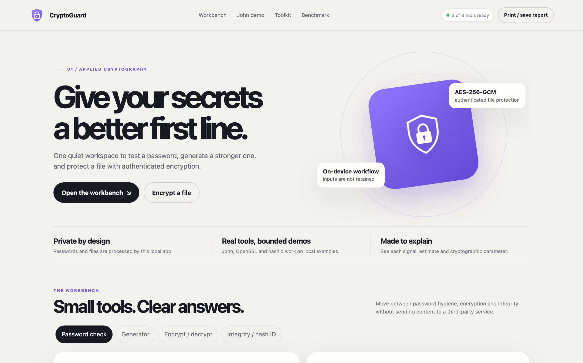
Figure 7.1: CryptoGuard landing view
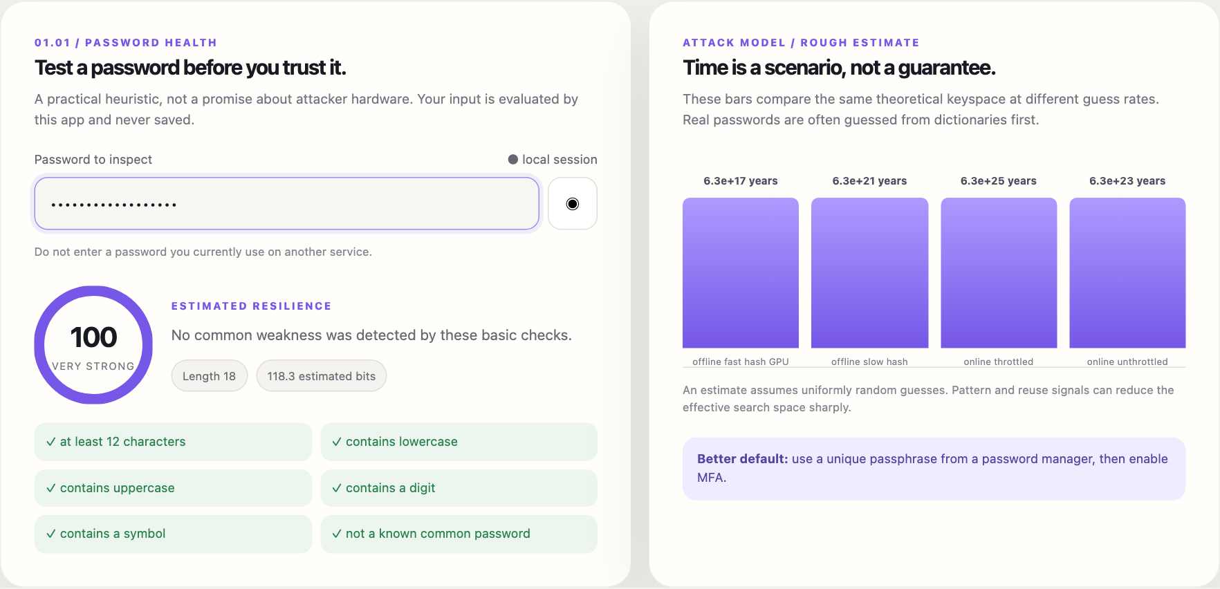
Figure 7.2: Live password analysis with checks and crack-time scenarios
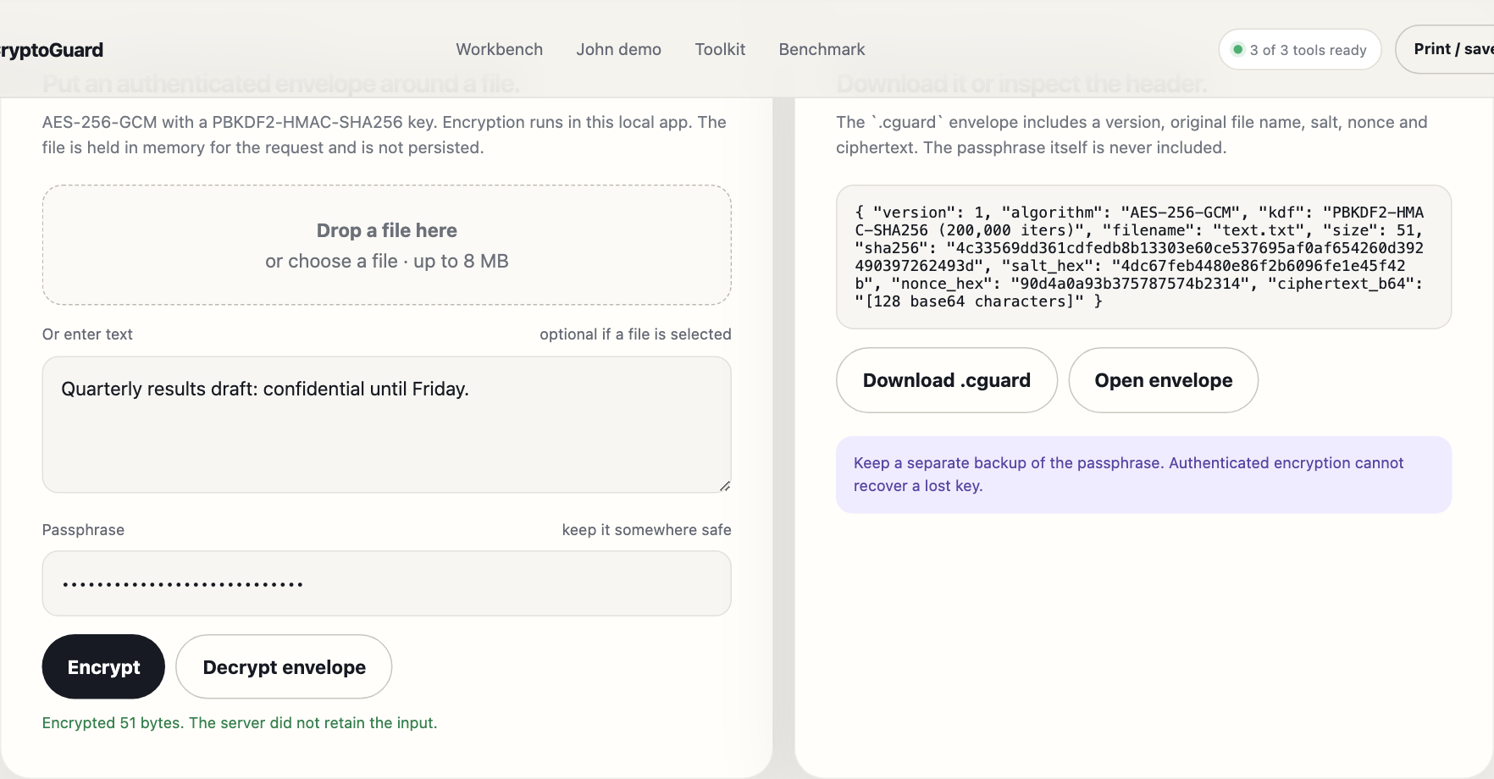
Figure 7.3: AES-256-GCM encryption producing a .cguard envelope
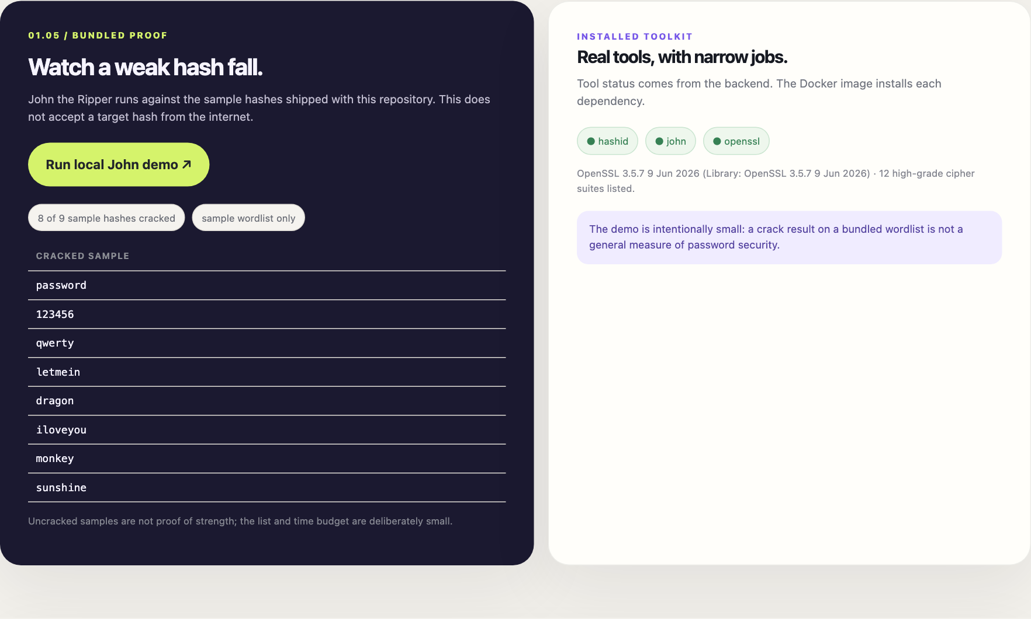
Figure 7.4: John the Ripper cracking 8 of 9 bundled sample hashes

7.2 Measured KDF Cost
Table 7.1 and Figure 7.7 give the benchmark measured inside the Docker image (Linux aarch64, Python 3.12.16, one core). The three fast hashes run at roughly 3.5–4.2 million guesses per second per core, and their relative order varies by a few tens of percent between runs (Python call overhead dominates at this speed). The KDFs are slower by four to five orders of magnitude.
Table 7.1: Measured guess rates (Linux aarch64, Python 3.12.16, one core)
Scheme | Guesses/s | Slowdown vs MD5 | Worth (chars, c = 95) | Note
MD5 (unsalted) | 3,516,182 | ≈ 1 | — | legacy fast hash; never use for passwords
SHA-1 (unsalted) | 4,160,727 | ≈ 1 | — | legacy fast hash
SHA-256 + salt | 3,834,116 | ≈ 1 | — | salted but still fast
PBKDF2-SHA256 200k | 45.7 | 76,940× | +2.47 | what CryptoGuard uses for file keys
PBKDF2-SHA256 600k | 15.2 | 231,328× | +2.71 | OWASP 2023 minimum for PBKDF2-SHA256
scrypt N=2^14 r=8 | 51.7 | 68,011× | +2.44 | memory-hard: 16 MiB per guess

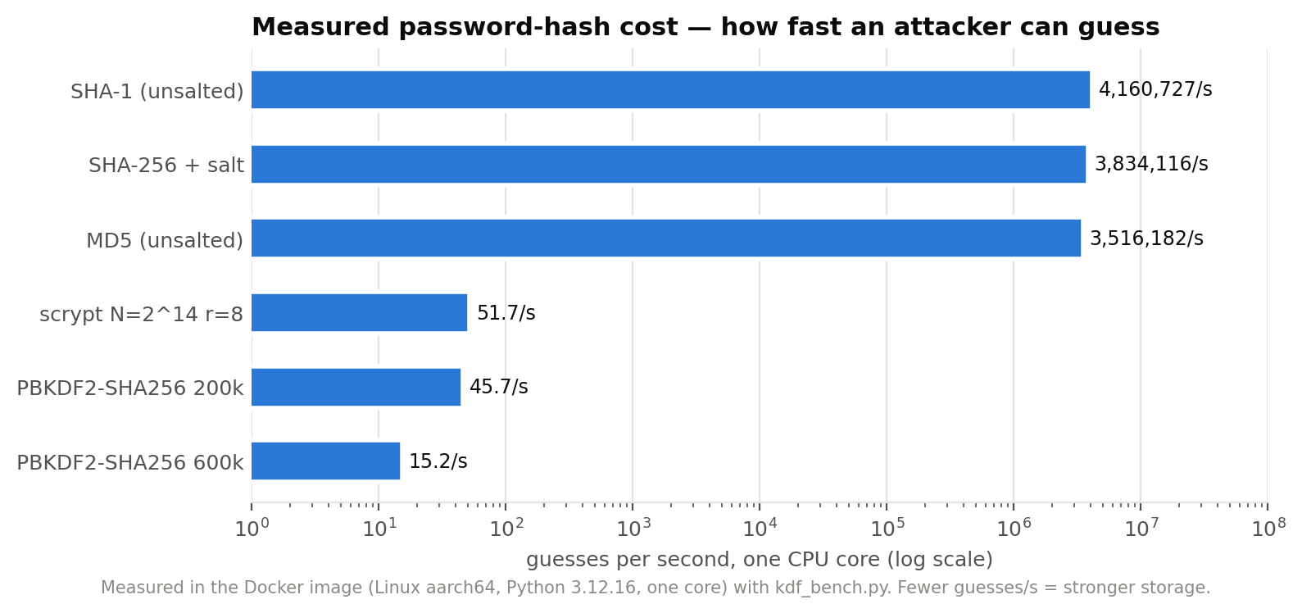
Figure 7.5: Guesses per second per scheme (log scale)
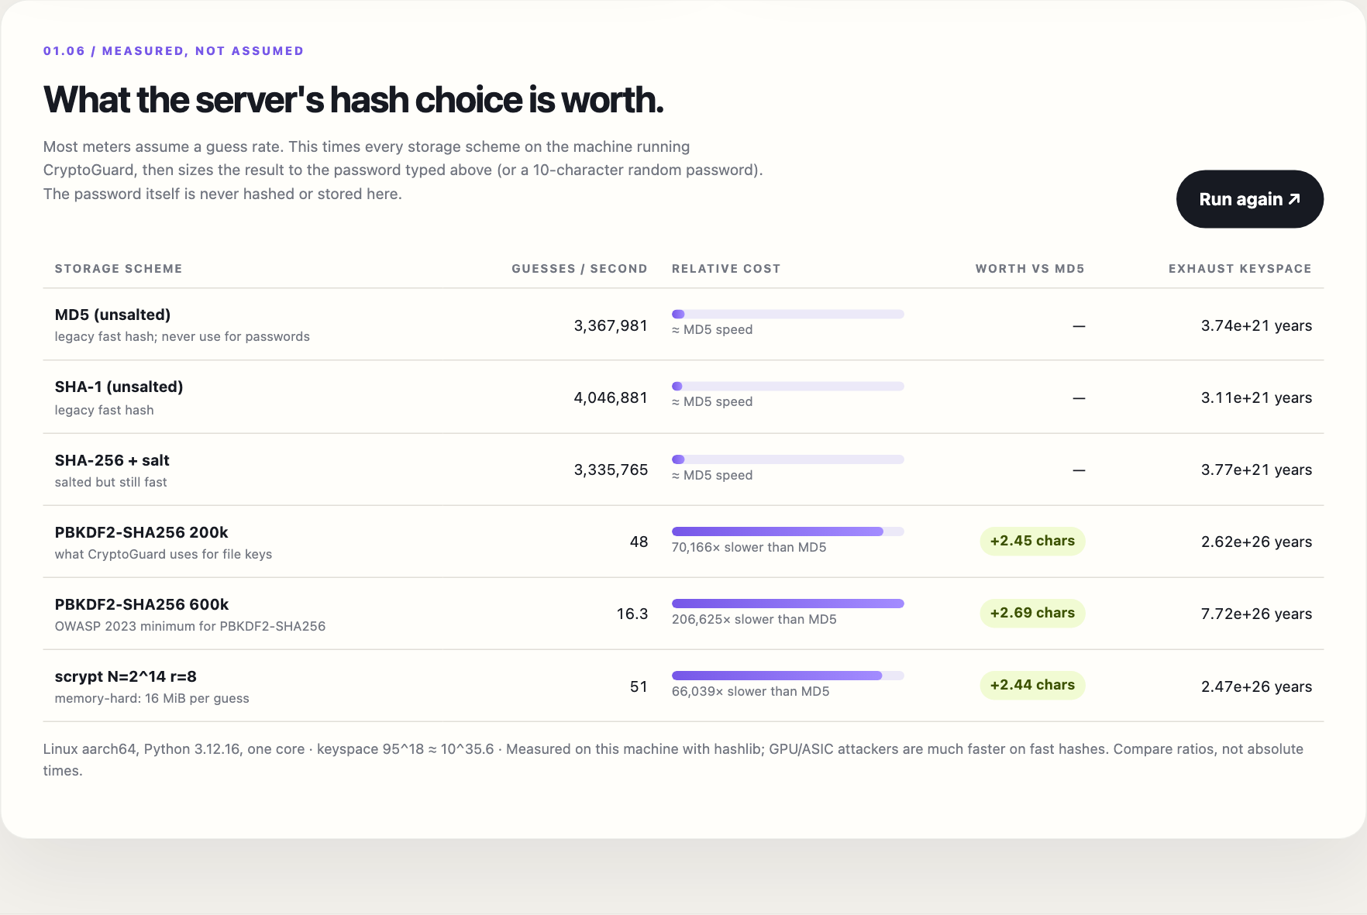
Figure 7.6: Benchmark rendered in the user interface
Interpretation. Moving from unsalted MD5 to PBKDF2-SHA256 with 600,000 iterations slows a single-core attacker by about 231,328×. For a password drawn uniformly from 95 printable characters, this equals 2.71 additional characters: the server's choice is worth roughly as much as the user typing three more random symbols, at no cost to the user. scrypt at N = 2¹⁴ is slightly faster per guess than PBKDF2-200k on one CPU core (51.7 vs 45.7 guesses/s), but its 16 MiB memory requirement is what limits GPU and ASIC parallelism [5]; a single-core CPU benchmark does not capture that advantage, which is an important limitation of this measurement.
The same benchmark on the development laptop's system Python (macOS, LibreSSL) gave lower absolute rates but the same ordering and similar character equivalents (+2.5 to +2.8), supporting the claim that the ratios are the robust result.

7.3 Strength Analyser Behaviour
The analyser scored the common password "password" at 2/100 (blocklisted), and "Tr0ub4dor&3-Horse!" at 100/100 with 118.3 estimated bits. The second result exposes a known weakness of charset-entropy estimators, discussed by Weir et al. [8] and addressed by zxcvbn [7]: a dictionary word with predictable l33t substitutions is far weaker than its character count suggests. This is reported as a limitation (Section 7.6) rather than hidden, and it is why the UI labels crack times as rough estimates.

7.4 Performance
Table 7.2: Load-test results against the Docker container (100 requests, 8 workers per endpoint)
Endpoint | Req/s | p50 ms | p95 ms | max ms | Errors
password analysis | 1,535 | 4.8 | 7.8 | 8.4 | 0
secret generation | 1,638 | 4.5 | 7.0 | 9.3 | 0
file integrity (1 KB) | 1,761 | 4.3 | 6.6 | 7.3 | 0
AES-GCM encrypt (1 KB, PBKDF2 200k) | 318 | 23.7 | 31.0 | 36.4 | 0

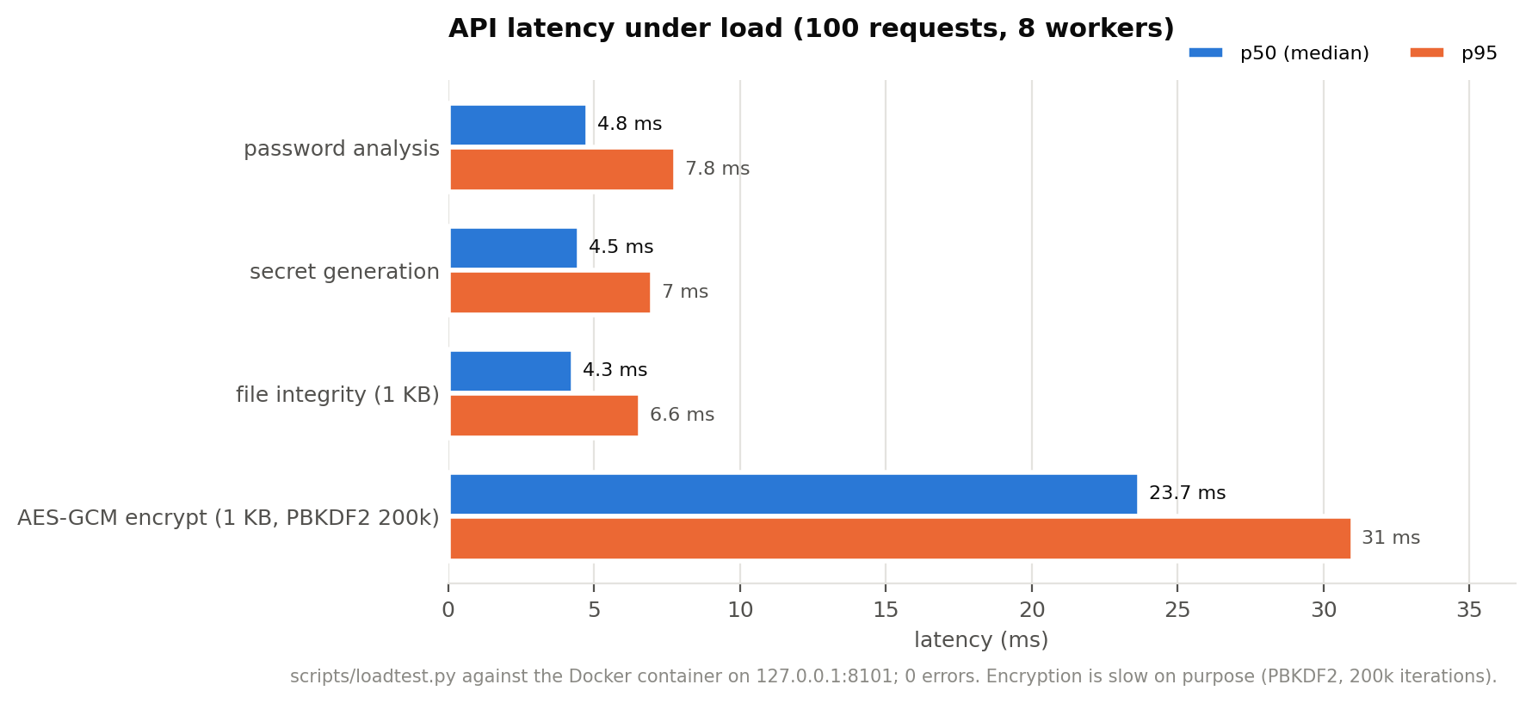
Figure 7.7: Latency per endpoint (p50 and p95)
All requests succeeded. The encryption endpoint is about five times slower than the others because PBKDF2 with 200,000 iterations runs on every request: this is the intended cost, and it is the same cost an attacker pays per guess. NFR-4 is met.

7.5 Usability on Mobile
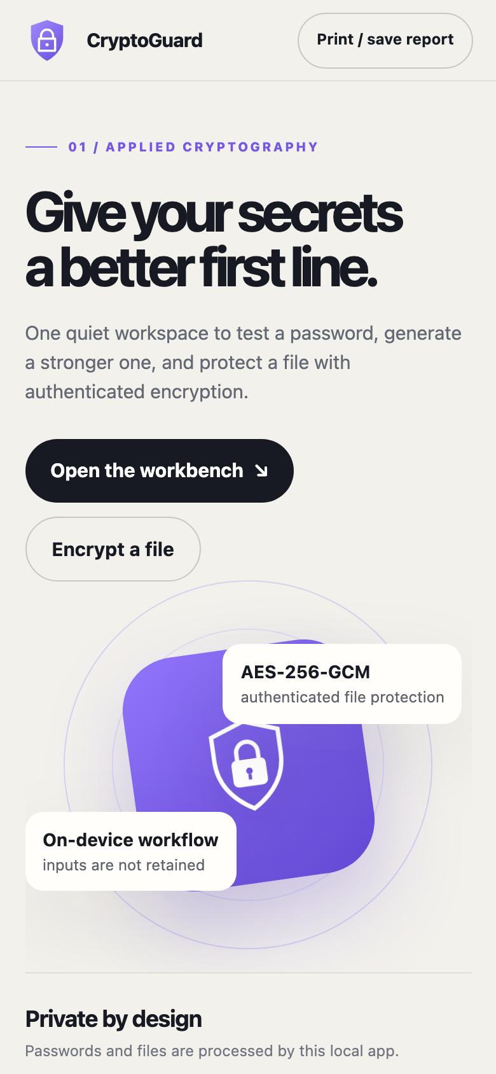
Figure 7.8: Layout at 390 px width

7.6 Limitations
- The strength score is a teaching heuristic, not a guess-number estimator; it over-rates dictionary words with l33t substitutions.
- The benchmark measures one CPU core in Python. It understates attacker speed on GPUs for fast hashes and does not capture scrypt's memory-hardness advantage.
- Argon2 and bcrypt are not benchmarked because they require additional libraries.
- The envelope format is versioned only implicitly; it has not been reviewed for interoperability.
- The application has no authentication and must stay on loopback; it has not had an independent security audit.

CHAPTER 8
CONCLUSION AND FUTURE SCOPE

8.1 Conclusion
CryptoGuard meets its objectives: it analyses, generates, encrypts, verifies and cracks within a single local, hardened application, and it adds a measured view of password storage that typical meters lack. The central finding is quantitative and reproducible: on the test machine, choosing PBKDF2-SHA256 with 600,000 iterations instead of MD5 slowed guessing by about 231,328×, equivalent to roughly 2.7 extra random password characters. All 14 automated tests pass, and the system performs well within its requirements.
As the first design project, it establishes the engineering foundations used in the later projects (PhishLens and ThreatScope): input validation, safe tool integration, honest evaluation, containerisation and continuous testing.

8.2 Future Scope
- Replace the heuristic with a guess-number estimator (zxcvbn-style pattern matching) and compare both against a public cracking benchmark.
- Add bcrypt and Argon2id to the benchmark and a GPU measurement with Hashcat to model attacker hardware.
- Check passwords against breach corpora with k-anonymity range queries, opt-in only.
- Define a versioned, documented envelope format with interoperability tests.
- Add an optional authenticated multi-user mode for classroom deployment.

REFERENCES
[1] P. A. Grassi, J. L. Fenton, E. M. Newton, R. A. Perlner, A. R. Regenscheid, W. E. Burr, J. P. Richer, N. B. Lefkovitz, J. M. Danker, Y.-Y. Choong, K. K. Greene and M. F. Theofanos, “Digital Identity Guidelines: Authentication and Lifecycle Management,” NIST Special Publication 800-63B, National Institute of Standards and Technology, 2017.
[2] M. S. Turan, E. Barker, W. Burr and L. Chen, “Recommendation for Password-Based Key Derivation, Part 1: Storage Applications,” NIST Special Publication 800-132, 2010.
[3] M. Dworkin, “Recommendation for Block Cipher Modes of Operation: Galois/Counter Mode (GCM) and GMAC,” NIST Special Publication 800-38D, 2007.
[4] K. Moriarty, B. Kaliski and A. Rusch, “PKCS #5: Password-Based Cryptography Specification Version 2.1,” IETF RFC 8018, 2017.
[5] C. Percival and S. Josefsson, “The scrypt Password-Based Key Derivation Function,” IETF RFC 7914, 2016.
[6] J. Bonneau, “The science of guessing: analyzing an anonymized corpus of 70 million passwords,” in Proc. IEEE Symposium on Security and Privacy, 2012, pp. 538–552.
[7] D. L. Wheeler, “zxcvbn: Low-budget password strength estimation,” in Proc. 25th USENIX Security Symposium, 2016, pp. 157–173.
[8] M. Weir, S. Aggarwal, M. Collins and H. Stern, “Testing metrics for password creation policies by attacking large sets of revealed passwords,” in Proc. 17th ACM Conference on Computer and Communications Security (CCS), 2010, pp. 162–175.
[9] OWASP Foundation, “Password Storage Cheat Sheet,” OWASP Cheat Sheet Series. [Online]. Available: https://cheatsheetseries.owasp.org/cheatsheets/Password_Storage_Cheat_Sheet.html
[10] Openwall, “John the Ripper password cracker.” [Online]. Available: https://www.openwall.com/john/
[11] A. Biryukov, D. Dinu and D. Khovratovich, “Argon2: new generation of memory-hard functions for password hashing and other applications,” in Proc. IEEE European Symposium on Security and Privacy (EuroS&P), 2016, pp. 292–302.
[12] B. Ur, J. Bees, S. M. Segreti, L. Bauer, N. Christin and L. F. Cranor, “Do users' perceptions of password security match reality?,” in Proc. ACM CHI Conference on Human Factors in Computing Systems, 2016, pp. 3748–3760.
[13] Python Cryptographic Authority, “cryptography” library documentation. [Online]. Available: https://cryptography.io/
[14] OWASP Foundation, “OWASP Secure Headers Project.” [Online]. Available: https://owasp.org/www-project-secure-headers/
[15] P. G. Kelley, S. Komanduri, M. L. Mazurek, R. Shay, T. Vidas, L. Bauer, N. Christin, L. F. Cranor and J. Lopez, “Guess again (and again and again): measuring password strength by simulating password-cracking algorithms,” in Proc. IEEE Symposium on Security and Privacy, 2012, pp. 523–537.

APPENDIX A: INSTALLATION AND USER MANUAL
- Install Docker Desktop and start it.
- Open a terminal in the project folder.
- Run docker compose up --build -d and open http://localhost:8101.
- Stop with docker compose down. On macOS you can instead double-click Start.command.
Listing A.1: Local development without Docker
python3 -m venv .venv
source .venv/bin/activate
python -m pip install -r requirements.txt
cp .env.example .env # optional
make test # run the test suite
make run # http://127.0.0.1:8000
python -m cryptoguard.kdf_bench # benchmark from the command line
python scripts/loadtest.py # needs the app running
Table A.2: Troubleshooting
Symptom | Cause and fix
John panel says not installed | Running outside Docker; use the container or install john
HTTP 429 on benchmark | Rate limit (6/min) reached; wait a minute
Port 8101 already in use | Stop the other process or change the port in docker-compose.yml
Decryption failed | Wrong passphrase or edited envelope; GCM rejects both by design

APPENDIX B: DEMONSTRATION SCRIPT
- Open the app and point out the tool-status pill (all tools ready in Docker) and the privacy promise.
- Type "password" — score near zero, blocklist issue shown. Then type a long random password — score rises; read out the four crack-time scenarios and their stated guess rates.
- Generate a 20-character password and a passphrase; explain CSPRNG vs random.
- Encrypt a short note with a passphrase; show salt, nonce and algorithm in the envelope; decrypt it; then change one character of the ciphertext and show decryption is refused.
- Run the John demo: weak sample hashes fall in seconds from a 16-word list.
- Run the KDF benchmark: MD5 vs PBKDF2-600k; read out the slowdown and the “+2.7 characters” result. Close with the key message: storage choices matter as much as password rules.

APPENDIX C: API REFERENCE
Table C.1: REST endpoints
Method and path | Input | Output
POST /api/analyze | {password} | score, label, entropy_bits, crack_times, issues, passed
GET /api/generate | type, length, symbols, words | {value}
POST /api/encrypt | {password, text | data_b64, filename} | envelope
POST /api/decrypt | {password, ciphertext_b64} | text, data_b64, sha256
POST /api/integrity | {text | data_b64} | sha256, sha1, md5, size
POST /api/identify | {hash} | builtin_guesses, hashid
GET /api/john | — | cracked, cracked_count, total
POST /api/kdf-bench | {password?} | machine, password_model, results[]
GET /api/tools, /api/openssl | — | tool availability; OpenSSL version and ciphers
GET /health | — | ok

APPENDIX D: REPOSITORY STRUCTURE
Listing D.1: Repository layout
├── .dockerignore
├── .env.example
├── .github/
│ └── workflows/
│ └── ci.yml
├── .gitignore
├── CHANGELOG.md
├── CONTRIBUTING.md
├── Dockerfile
├── LICENSE
├── Makefile
├── PROJECT_OVERVIEW.md
├── README.md
├── SECURITY.md
├── Start.command
├── cryptoguard/
│ ├── __init__.py
│ ├── app.py
│ ├── crypto_core.py
│ ├── data/
│ │ ├── sample_hashes.txt
│ │ └── wordlist.txt
│ ├── kdf_bench.py
│ ├── static/
│ │ └── index.html
│ ├── tools.py
│ └── web_security.py
├── docker-compose.yml
├── docs/
│ ├── README.md
│ ├── diagrams/ (10 images)
│ ├── index.html
│ └── screenshots/ (6 images)
├── requirements.txt
├── scripts/
│ └── loadtest.py
└── tests/
├── test_cryptoguard.py
└── test_security.py

