DESIGN PROJECT – III · SEMESTER V
ThreatScope
A Reproducible SOC Detection Lab with Ground-Truth Rule Evaluation
A project report submitted in partial fulfilment of the requirements of
Design Project – III (Semester V) for the degree of
BACHELOR OF TECHNOLOGY
with specialisation in Cyber Security
Submitted by
Malepati Sree Harsha
Register No. 23CU0340018
DISC
HINDUSTAN INSTITUTE OF TECHNOLOGY AND SCIENCE
(Deemed to be University)
Padur, Kelambakkam, Chennai – 603 103
Academic Year 2025–26

DECLARATION
I, Malepati Sree Harsha (Register No. 23CU0340018), hereby declare that the project report entitled “ThreatScope: A Reproducible SOC Detection Lab with Ground-Truth Rule Evaluation”, submitted as Design Project – III in Semester V of the Bachelor of Technology programme with specialisation in Cyber Security, DISC, Hindustan Institute of Technology and Science, during the academic year 2025–26, is a record of my own work.
Where the work of others has been used, it is acknowledged and cited in the references. All experiments were performed on systems I own, using bundled or synthetic data, and no third-party system was tested without authorization.

Place: Chennai
Date: ____________
Malepati Sree Harsha
Register No. 23CU0340018

ACKNOWLEDGEMENT
I thank the faculty of DISC, Hindustan Institute of Technology and Science, for the course structure, laboratory facilities and feedback that shaped this design project, and the institution for the opportunity to work on an applied security problem.
I also acknowledge the open-source communities behind Python, Flask, scikit-learn, the cryptography library, OpenSSL, John the Ripper, Wireshark/TShark, Suricata, Nmap and OWASP ZAP, whose tools and documentation made this work possible. Finally, I thank my family and friends for their support.
Malepati Sree Harsha

ABSTRACT
Security operations centres (SOCs) correlate authentication, firewall, web, endpoint and network evidence into alerts that analysts triage. Commercial and open-source SIEM platforms are powerful but heavy, and detection rules are often deployed without a reproducible measurement of how many incidents they catch or how much noise they produce. This project, ThreatScope, is a compact SOC lab that parses four log types and packet captures, applies five detection rules mapped to MITRE ATT&CK (brute force, anomalous valid-account login, network service scanning, large data egress and suspicious command execution), and presents alerts with evidence and response playbooks in an interactive console.
The lab integrates industry tools safely: TShark and Suricata analyse a bundled PCAP offline, while Nmap and OWASP ZAP run only against a demo container on an internal Docker network with no route out. The research contribution is a ground-truth benchmark: because the log generator injects known incidents into random benign noise, every alert can be scored as a true or false positive. Over 25 seeds the rules found all 150 injected incidents with 0 false positives, and threshold sweeps locate each rule's safe operating band (for example, brute-force thresholds of 3–16 failures per 120 s are exact on this data; 2 adds noise and 20 misses the attack). The system is hardened with a strict Content-Security-Policy, OWASP headers, audit logging, rate limits and optional bearer-token authentication, and is verified by 13 automated tests and load testing.
Keywords: security operations, SIEM, detection engineering, MITRE ATT&CK, intrusion detection, Suricata, TShark, Nmap, OWASP ZAP, ground-truth evaluation

CONTENTS
Declaration ii
Acknowledgement iii
Abstract iv
List of Figures vii
List of Tables viii
Chapter 1 Introduction 1
1.1 Background 1
1.2 Motivation 1
1.3 Problem Statement 1
1.4 Objectives 1
1.5 Scope and Ethics 2
1.6 Organisation of the Report 2
Chapter 2 Literature Survey 3
2.1 Intrusion Detection Foundations 3
2.2 SIEM, Log Management and Incident Response 3
2.3 Adversary Frameworks 3
2.4 Network and Web Assessment Tools 3
2.5 Comparison and Research Gap 3
Chapter 3 System Requirements Specification 5
3.1 Functional Requirements 5
3.2 Non-Functional Requirements 5
3.3 Hardware and Software Requirements 6
Chapter 4 System Design 7
4.1 Architecture 7
4.2 Data Flow Diagrams 8
4.3 UML Diagrams 9
4.4 Deployment and Network Isolation 10
4.5 Detection Rules 11
Chapter 5 Methodology and Implementation 12
5.1 Technology Stack 12
5.2 Stage 1 — Synthetic Telemetry with Known Incidents 12
5.3 Stage 2 — Parsers 12
5.4 Stage 3 — Sliding-Window Detection Rules 12
5.5 Stage 4 — Packet Analysis 13
5.6 Stage 5 — Isolated Active Tools 13
5.7 Stage 6 — Ground-Truth Benchmark (Novel Component) 13
5.8 Stage 7 — Analyst Console 14
5.9 Stage 8 — Platform Security 14
Chapter 6 Testing and Validation 16
6.1 Strategy 16
6.2 Automated Test Cases 16
6.3 Functional and Non-Functional Checks 17
Chapter 7 Results and Discussion 18
7.1 Analyst Console 18
7.2 Real Tool Integration 20
7.3 Ground-Truth Detection Quality 21
7.4 Threshold Sensitivity 22
7.5 Performance 23
7.6 Mobile Layout 24
7.7 Limitations 24
Chapter 8 Conclusion and Future Scope 26
8.1 Conclusion 26
8.2 Future Scope 26
References 27
Appendix A Installation and User Manual 28
Appendix B Demonstration Script 29
Appendix C API Reference 30
Appendix D Repository Structure 31

LIST OF FIGURES
Figure 4.1 Layered architecture of ThreatScope 7
Figure 4.2 DFD level 0 (context diagram) 8
Figure 4.3 DFD level 1 8
Figure 4.4 Use-case diagram 9
Figure 4.5 Sequence diagram for a dashboard replay 9
Figure 4.6 Class and module diagram 10
Figure 4.7 Activity diagram of the sliding-window brute-force rule 10
Figure 4.8 Deployment diagram with isolated lab network 11
Figure 7.1 SOC overview: 918 events, 6 alerts across 5 ATT&CK techniques 18
Figure 7.2 Alert triage with evidence and response playbook 19
Figure 7.3 Bundled synthetic evidence by source 19
Figure 7.4 TShark (62 packets) and Suricata (3 alerts) on the bundled PCAP 20
Figure 7.5 Nmap connect scan of the isolated demo target 20
Figure 7.6 OWASP ZAP spider and passive baseline 21
Figure 7.7 Detection-quality benchmark in the console 22
Figure 7.8 Precision and recall versus threshold 23
Figure 7.9 Latency per endpoint 24
Figure 7.10 Console at 390 px width 24

LIST OF TABLES
Table 2.1 Existing platforms compared with ThreatScope 3
Table 3.1 Functional requirements 5
Table 3.2 Non-functional requirements 5
Table 3.3 Hardware and software requirements 6
Table 4.1 Rules, ATT&CK mapping and logic 11
Table 5.1 Technology choices 12
Listing 5.2 Brute-force rule (threatscope/detect.py) 12
Listing 5.3 Benchmark scoring (threatscope/benchmark.py) 13
Listing 5.4 Optional token authentication (threatscope/app.py) 14
Table 6.1 Test levels 16
Table 6.2 Automated test cases and results 16
Table 6.3 Functional, safety, usability and performance checks 17
Table 7.1 ZAP passive findings on the demo target (16 alerts) 21
Table 7.2 Per-rule results over 25 seeds (default thresholds) 21
Table 7.3 Brute-force threshold sweep (failures per 120 s) 22
Table 7.4 Port-scan threshold sweep (distinct ports per 60 s) 22
Table 7.5 Load-test results (60 requests, 4 workers) 23

CHAPTER 1
INTRODUCTION

1.1 Background
A security operations centre collects logs from many sources, applies detection logic, and gives analysts alerts to investigate and respond to [3], [4]. Detection logic ranges from signatures on network traffic (Snort [6], Suricata [9]) and event correlation in SIEM platforms to anomaly models dating back to Denning's intrusion-detection model [5]. MITRE ATT&CK [1], [2] provides a shared vocabulary of adversary tactics and techniques, against which detections are now routinely mapped.

1.2 Motivation
For students, a production SIEM is difficult to study: it needs real telemetry, licences or substantial hardware, and its rules are hard to inspect. More fundamentally, detection rules are often tuned by intuition. Sommer and Paxson [7] argue that intrusion-detection evaluation suffers from a lack of ground truth and from evaluations that do not reflect operational conditions. A learning lab should make rules readable and should measure them.
Active tools such as Nmap and ZAP introduce a second concern: scanning systems without authorization is illegal and harmful. A teaching lab must make that impossible by construction, not just by policy.

1.3 Problem Statement
To build a reproducible, safe SOC lab that ingests multi-source logs and packet captures, raises ATT&CK-mapped alerts with evidence and playbooks, integrates real network-security tools without any possibility of scanning third parties, and evaluates every detection rule against ground truth, including its sensitivity to threshold choices.

1.4 Objectives
- Parse authentication, firewall, web and process logs into typed events; tolerate malformed lines.
- Implement five readable detection rules with sliding windows, mapped to MITRE ATT&CK, each with a response playbook.
- Analyse packet captures with TShark and Suricata offline.
- Run Nmap and OWASP ZAP only against an isolated demo target on an internal network.
- Build a ground-truth benchmark over many seeds and threshold sweeps for tunable rules.
- Provide an analyst console with KPIs, alert queue, evidence, playbooks, uploads and report export.
- Harden the platform (CSP, headers, audit logging, rate limits, optional token authentication) and test it.

1.5 Scope and Ethics
All bundled telemetry is synthetic and uses documentation address ranges (RFC 5737 [15]). Scan targets are constants in the backend; the scanner, ZAP and demo target share a Docker network declared internal: true, so even a modified request cannot reach the internet or the host LAN. Uploaded files are processed in memory or in temporary files that are deleted after analysis.

1.6 Organisation of the Report
Chapter 2 surveys SIEM and intrusion-detection work. Chapter 3 gives requirements, Chapter 4 the design, Chapter 5 the implementation, Chapter 6 testing, Chapter 7 results and Chapter 8 conclusions.

CHAPTER 2
LITERATURE SURVEY

2.1 Intrusion Detection Foundations
Denning [5] proposed modelling normal behaviour and flagging deviations. Signature systems such as Snort [6] and Bro/Zeek [8] match known patterns in traffic. Khraisat et al. [17] survey signature- and anomaly-based approaches and the datasets used to evaluate them. Sommer and Paxson [7] caution that anomaly detection in operational networks is hard to evaluate and that false positives are costly for analysts.

2.2 SIEM, Log Management and Incident Response
NIST SP 800-92 [4] describes log management infrastructure; NIST SP 800-61 [3] defines the incident-handling lifecycle (preparation, detection and analysis, containment, eradication and recovery, post-incident activity). Open-source platforms such as Wazuh [14] and vendor SIEMs implement these at scale. Sigma [13] provides a vendor-neutral rule format, encouraging detection-as-code.

2.3 Adversary Frameworks
MITRE ATT&CK [1], [2] catalogues tactics (the adversary's goal) and techniques (how it is achieved), e.g. T1110 Brute Force and T1046 Network Service Discovery. Mapping alerts to techniques helps coverage analysis and communication, though a mapping is not evidence that a detection is effective.

2.4 Network and Web Assessment Tools
TShark [10] is the command-line form of Wireshark. Suricata [9] is a multi-threaded IDS/IPS engine with a rule language and EVE JSON output. Nmap [11] performs host and service discovery. OWASP ZAP [12] is a web application scanner whose spider and passive scan inspect responses without attacking.

2.5 Comparison and Research Gap
Table 2.1: Existing platforms compared with ThreatScope
Platform | Strength | Limitation for learning / evaluation
Commercial SIEM | Scale, integrations | Cost, opacity; no ground truth for rules
Wazuh / Security Onion [14] | Open source, complete | Heavy deployment; real data needed
Snort / Suricata / Zeek [6], [8], [9] | Mature network detection | Network only; no cross-source correlation
Sigma [13] | Portable rule format | No bundled benchmark data
Public IDS datasets [17] | Labelled traffic | Often criticised as unrepresentative [7]
ThreatScope (this work) | Small, readable, safe | Ground-truth benchmark + threshold sweeps per rule

The gap is a learner-scale lab in which every rule ships with a reproducible, ground-truth measurement and a threshold-sensitivity analysis, alongside real tools that are isolated by design. The contribution is methodological and educational; the benchmark validates rules against the scenarios they were written for and does not estimate real-world detection rates.

CHAPTER 3
SYSTEM REQUIREMENTS SPECIFICATION

3.1 Functional Requirements
Table 3.1: Functional requirements
ID | Requirement | Endpoint / module
FR-1 | Parse auth, firewall, web and process log lines into typed events | detect.parse_*
FR-2 | Detect brute force (T1110) with a sliding window and tunable threshold | detect_brute_force
FR-3 | Detect anomalous internal→external login for one user (T1078) | detect_impossible_travel
FR-4 | Detect port scans by distinct ports per window (T1046) | detect_port_scan
FR-5 | Detect large data egress per source (T1041) | detect_exfil
FR-6 | Detect suspicious commands and web-shell parents (T1059) | detect_suspicious_process
FR-7 | Summarise alerts: severity counts, timeline, top entities, techniques | GET /api/dashboard
FR-8 | Analyse PCAPs with TShark and Suricata | nettools.tshark_summary / suricata_alerts
FR-9 | Ingest uploaded logs and PCAPs (≤ 8 files, ≤ 10 MB each) | POST /api/upload
FR-10 | Run Nmap and ZAP against the fixed demo target only | POST /api/nmap-demo, /api/zap-demo
FR-11 | Score rules against ground truth with threshold sweeps | GET /api/benchmark
FR-12 | Export / print the current report | Browser UI

3.2 Non-Functional Requirements
Table 3.2: Non-functional requirements
ID | Category | Requirement | Verification
NFR-1 | Safety | No scan can target anything but demo-target | Constant targets; internal network; test
NFR-2 | Security | CSP/OWASP headers; rate limits on scans and uploads | tests/test_security.py
NFR-3 | Security | Optional bearer-token authentication | test_optional_api_token
NFR-4 | Privacy | Uploaded evidence is never persisted | Code review; temp file deletion
NFR-5 | Accountability | Audit log of scans and auth failures | Log inspection
NFR-6 | Performance | Dashboard incl. TShark + Suricata p95 < 500 ms | scripts/loadtest.py
NFR-7 | Reproducibility | Deterministic fixtures and seeded benchmark | make evaluate / benchmark
NFR-8 | Usability | Responsive from 320 px; 44 px touch targets | Mobile screenshot

3.3 Hardware and Software Requirements
Table 3.3: Hardware and software requirements
Item | Minimum | Used
CPU / RAM | 64-bit, 8 GB RAM (ZAP needs ~1.5 GB) | Apple Silicon
Disk | ≈ 3 GB for images | —
Runtime | Docker Desktop with Compose | Docker 29
Tools in image | tshark, suricata, nmap, openssl | Debian packages
ZAP | ghcr.io/zaproxy/zaproxy:stable | Separate container

CHAPTER 4
SYSTEM DESIGN

4.1 Architecture
Parsing, detection, benchmarking and tool adapters are separate modules behind a Flask API (Figure 4.1). A false match can therefore be traced from the alert to the rule and the input lines that triggered it.
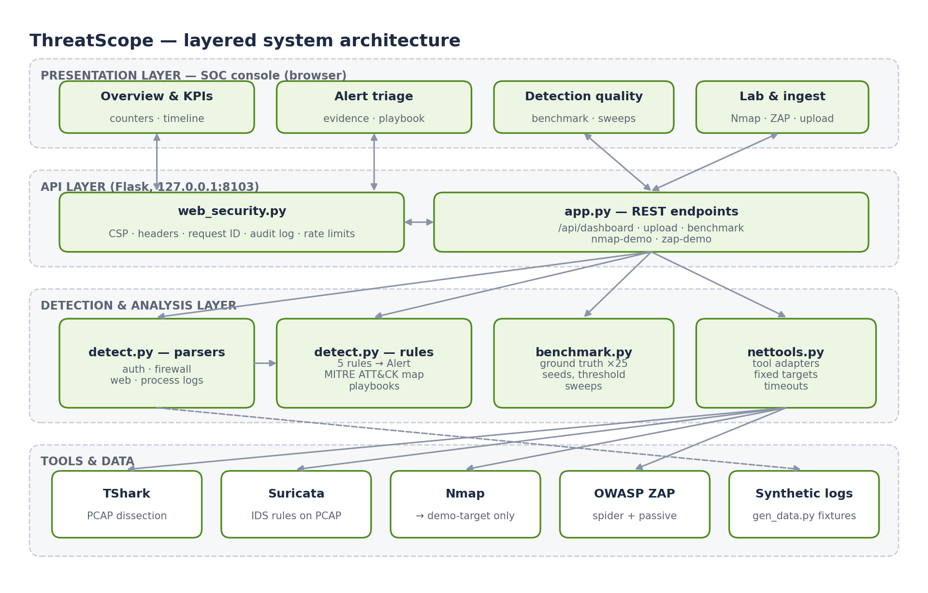
Figure 4.1: Layered architecture of ThreatScope

4.2 Data Flow Diagrams
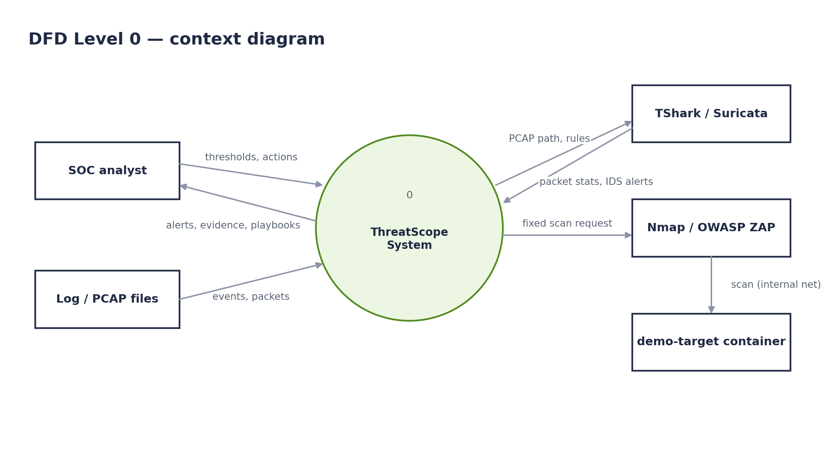
Figure 4.2: DFD level 0 (context diagram)
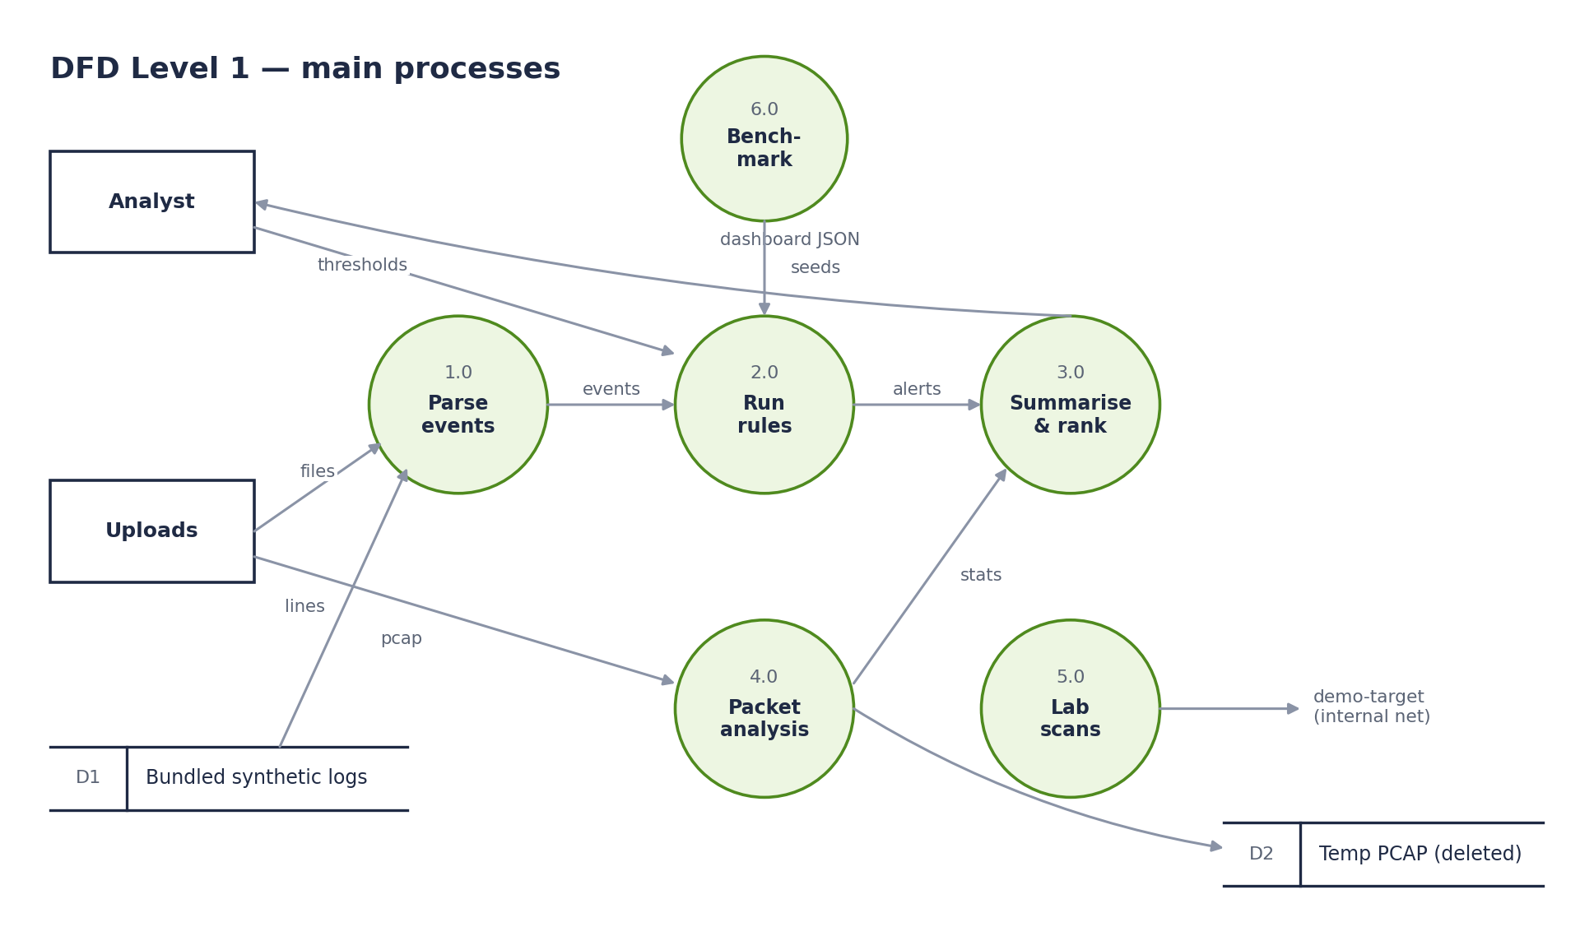
Figure 4.3: DFD level 1

4.3 UML Diagrams
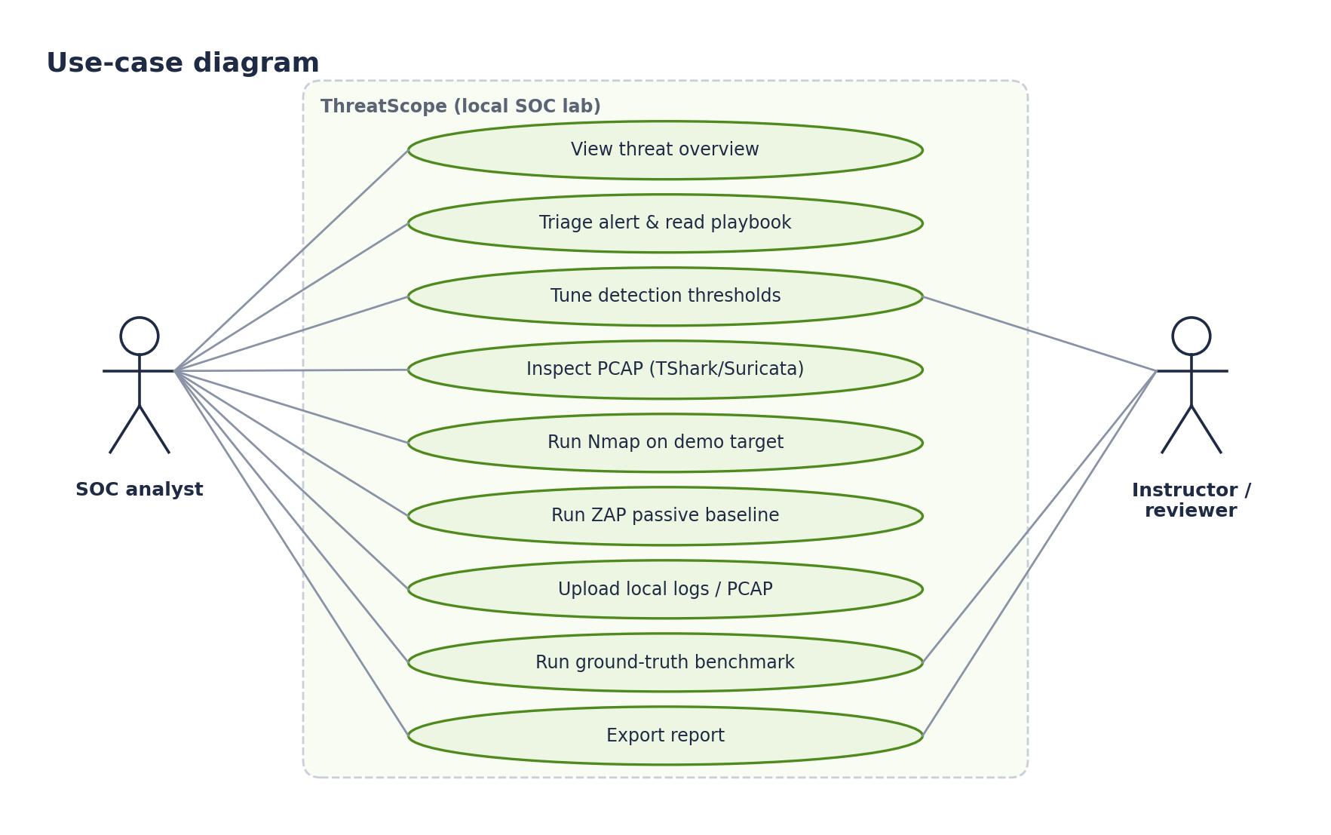
Figure 4.4: Use-case diagram
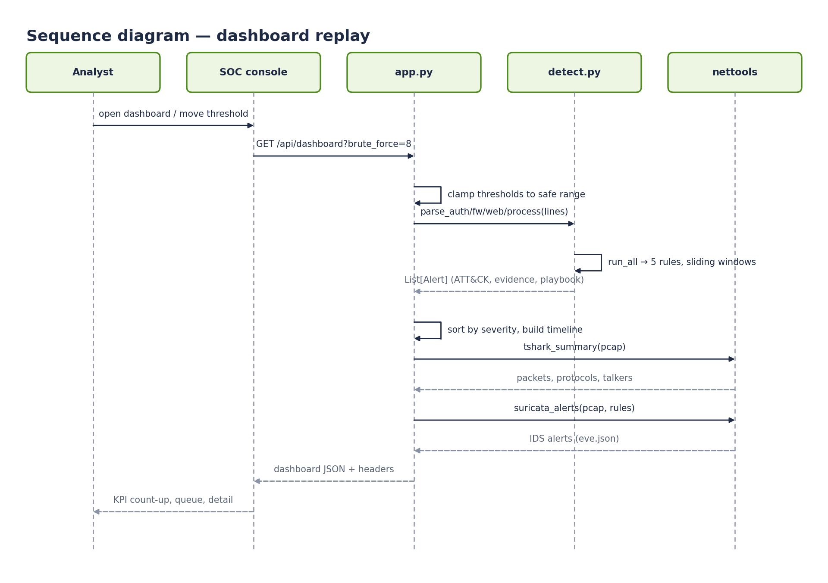
Figure 4.5: Sequence diagram for a dashboard replay
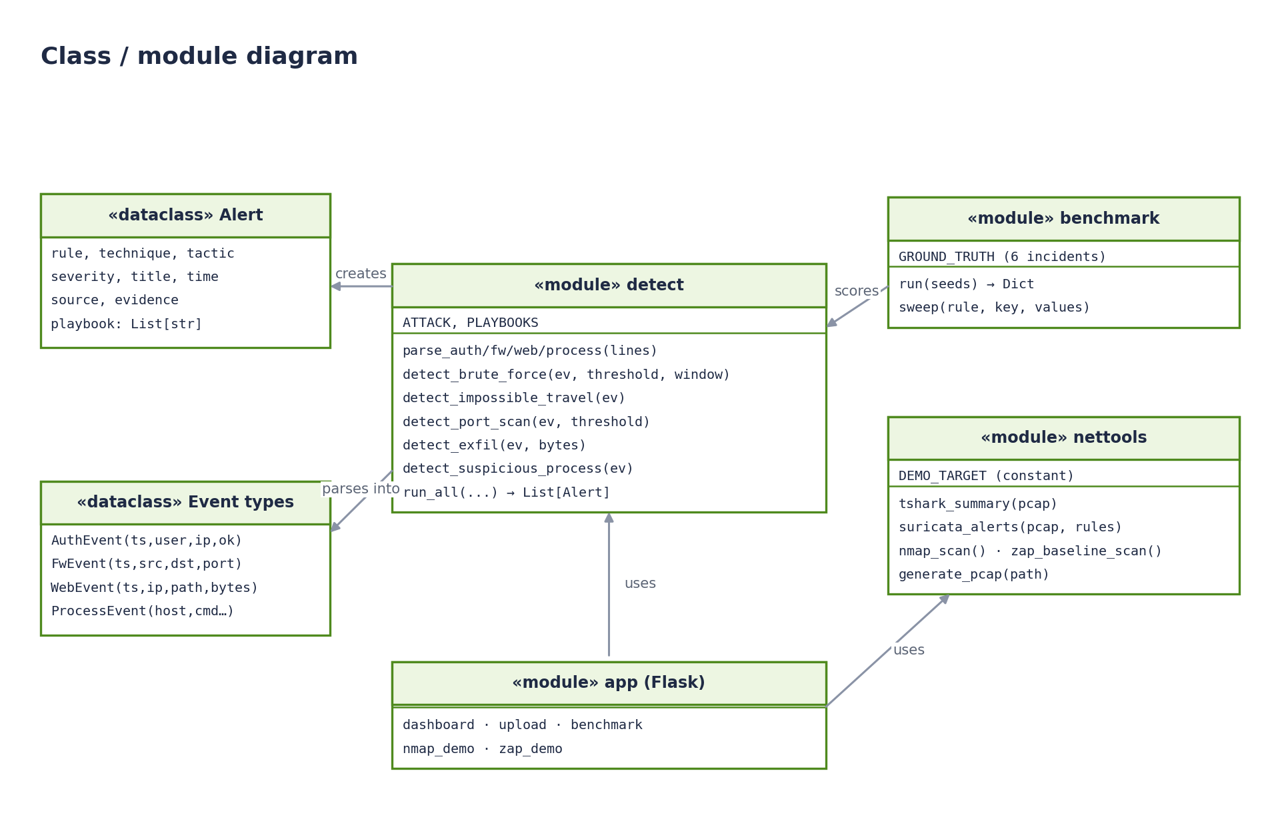
Figure 4.6: Class and module diagram
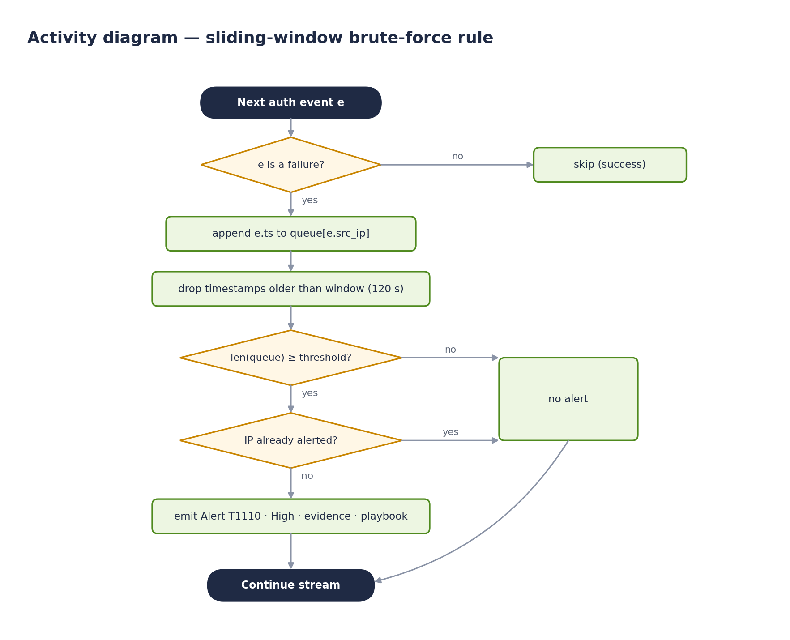
Figure 4.7: Activity diagram of the sliding-window brute-force rule

4.4 Deployment and Network Isolation
Three containers run under Compose (Figure 4.9). Only the dashboard joins the ordinary web bridge network, so that its loopback port mapping works; the demo target and ZAP exist only on lab, which is declared internal: true and has no route out. All containers use no-new-privileges and memory limits.
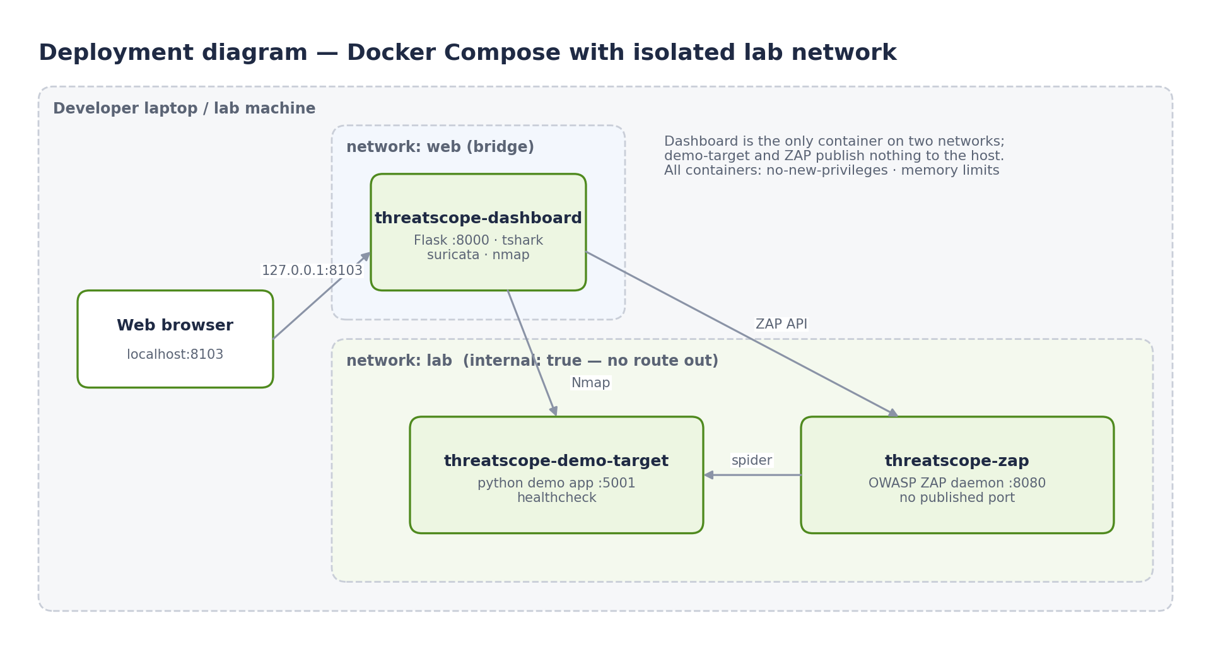
Figure 4.8: Deployment diagram with isolated lab network

4.5 Detection Rules
Table 4.1: Rules, ATT&CK mapping and logic
Rule | ATT&CK | Severity | Logic
brute_force_login | T1110 Brute Force | High | ≥ threshold (default 8) failures from one IP within 120 s
impossible_travel | T1078 Valid Accounts | High | Same user, successful logins from internal and external IPs within 600 s
port_scan | T1046 Network Service Discovery | Medium | ≥ threshold (default 15) distinct destination ports from one IP within 60 s
data_exfil | T1041 Exfiltration over C2 | Critical | ≥ 5 MB transferred by one source in the web log
suspicious_process | T1059 Command and Scripting Interpreter | High | Encoded PowerShell, curl/wget, reverse shells, or a shell spawned by a web server

CHAPTER 5
METHODOLOGY AND IMPLEMENTATION

5.1 Technology Stack
Table 5.1: Technology choices
Technology | Role | Justification
Python 3.12, Flask | API and detection engine | Readable rules; easy to test
TShark, Suricata | Packet analysis and IDS | Industry-standard, offline on PCAP
Nmap, OWASP ZAP | Active assessment (isolated) | Real tools; scope fixed by design
scapy | Deterministic PCAP generation | Reproducible teaching capture
Docker Compose | Isolation and packaging | Internal network enforces scope
Vanilla JS console | Analyst UI | No build chain; strict CSP
pytest, GitHub Actions | Quality | Rules tested on every push

5.2 Stage 1 — Synthetic Telemetry with Known Incidents
gen_data.py writes deterministic logs: 200 benign logins (15% failures), 300 firewall events, 250 web requests and 90 process events among internal hosts, plus injected incidents: 16 failed logins from 203.0.113.9, a login for bob from an internal then an external address, a 28-port scan from 198.51.100.7, 30 large exports by 10.0.0.23 and two suspicious commands. The bundled set holds 918 events (218 auth, 328 firewall, 280 web, 92 process).

5.3 Stage 2 — Parsers
Each parser applies one anchored regular expression per line and builds a typed dataclass; lines that do not match, or carry invalid timestamps, are skipped rather than crashing the pipeline. This tolerance is tested explicitly.

5.4 Stage 3 — Sliding-Window Detection Rules
Windowed rules keep a per-source deque of timestamps and drop entries older than the window on each event, so each event is processed in amortised O(1) time. An alert fires once per source to avoid alert storms. Every alert carries its ATT&CK technique and tactic, the evidence string and a playbook aligned with the NIST incident-handling lifecycle [3].
Listing 5.2: Brute-force rule (threatscope/detect.py)
def detect_brute_force(events: List[AuthEvent], threshold=8, window=120) -> List[Alert]:
fails: Dict[str, deque] = defaultdict(deque)
fired, alerts = set(), []
for e in events:
if e.ok:
continue
q = fails[e.src_ip]; q.append(e.ts)
while q and (e.ts - q[0]) > timedelta(seconds=window):
q.popleft()
if len(q) >= threshold and e.src_ip not in fired:
fired.add(e.src_ip)
alerts.append(_mk("brute_force_login", "T1110", "High", "Password brute force",
e.ts, e.src_ip, f"{len(q)} failed logins from {e.src_ip} within {window}s"))
return alerts

5.5 Stage 4 — Packet Analysis
A deterministic PCAP is generated with scapy (a 30-port SYN sweep and HTTP requests including /export/ paths to an external address). TShark summarises protocols, ports and talkers; Suricata runs two lab signatures with EVE JSON output. On the bundled capture TShark parsed 62 packets and Suricata raised 3 alerts.

5.6 Stage 5 — Isolated Active Tools
Nmap and ZAP adapters take no target argument: the target is the constant demo-target. The Compose file places the dashboard, ZAP and the demo target on an internal network, so the scope is enforced by the network as well as by the code. Nmap uses a TCP connect scan; ZAP runs a spider and a passive scan only, never an active attack.

5.7 Stage 6 — Ground-Truth Benchmark (Novel Component)
What: benchmark.py regenerates the logs with 25 different seeds (varying all benign noise), runs every rule, and labels each alert as a true positive if its (rule, source) pair is one of the six injected incidents, otherwise a false positive; missed incidents are false negatives. It then sweeps the brute-force and port-scan thresholds. Why: this turns rule tuning from intuition into measurement, in the spirit of detection-as-code. How: precision = TP/(TP+FP), recall = TP/(TP+FN), aggregated over seeds.
Listing 5.3: Benchmark scoring (threatscope/benchmark.py)
def _score(alerts) -> Dict[str, Dict[str, int]]:
found = {(a.rule, a.source) for a in alerts}
per_rule = {}
for rule in RULES:
truth = {s for r, s in GROUND_TRUTH if r == rule}
got = {s for r, s in found if r == rule}
per_rule[rule] = {"tp": len(truth & got), "fp": len(got - truth), "fn": len(truth - got)}
return per_rule
def run(seeds: int = 25) -> Dict:
totals = defaultdict(lambda: {"tp": 0, "fp": 0, "fn": 0})
for seed in range(1, seeds + 1):
auth, fw, web, proc = _events(seed)
for rule, c in _score(run_all(auth, fw, web, proc=proc)).items():
for k in c:
totals[rule][k] += c[k]
per_rule = []
for rule in RULES:
t = totals[rule]
p, r = _rates(t["tp"], t["fp"], t["fn"])
per_rule.append({"rule": rule, **t, "precision": p, "recall": r})
tp = sum(x["tp"] for x in per_rule); fp = sum(x["fp"] for x in per_rule)
fn = sum(x["fn"] for x in per_rule)
p, r = _rates(tp, fp, fn)
def sweep(rule: str, key: str, values: List[int]):
rows = []
for v in values:
agg = {"tp": 0, "fp": 0, "fn": 0}
for seed in range(1, seeds + 1):
auth, fw, web, proc = _events(seed)
c = _score(run_all(auth, fw, web, proc=proc, **{key: v}))[rule]
for k in agg:
agg[k] += c[k]
pp, rr = _rates(**agg)
# … (trimmed; see repository for the full function)

5.8 Stage 7 — Analyst Console
The console shows animated KPI counters, an hourly alert timeline, a severity-ordered queue, an evidence and playbook panel, top entities, ATT&CK coverage, replay controls for thresholds, packet-inspection results, the isolated scan lab, uploads and the detection-quality benchmark with threshold charts. The layout is responsive; below 720 px the sidebar becomes a scrollable tab strip and all controls are at least 44 px tall.

5.9 Stage 8 — Platform Security
The web_security layer provides CSP and OWASP headers, request IDs, body-free access logs, JSON errors and rate limits (Nmap 4/min, ZAP 2/min, uploads 20/min, benchmark 6/min); scans are written to an audit log. Optional bearer-token authentication protects every /api/ route when THREATSCOPE_API_TOKEN is set, using a constant-time comparison and logging failures without the token value. A Compose networking defect was also fixed: with the dashboard only on the internal network, Docker silently dropped its port mapping, so the console was unreachable; it now joins one extra non-internal network while the scan targets remain isolated.
Listing 5.4: Optional token authentication (threatscope/app.py)
@app.before_request
def _require_token():
"""Optional bearer-token authentication for every /api/ route.
Off by default (the dashboard binds to loopback for a single analyst). Set
THREATSCOPE_API_TOKEN to require ``Authorization: Bearer <token>``, e.g. when
the dashboard is shared on a lab network. The comparison is constant-time
and failed attempts are written to the audit log without the token value.
"""
expected = os.getenv("THREATSCOPE_API_TOKEN", "")
if not expected or not request.path.startswith("/api/"):
return None
supplied = request.headers.get("Authorization", "")
if hmac.compare_digest(supplied.encode(), f"Bearer {expected}".encode()):
return None
log.warning("rid=%s auth failure path=%s client=%s", getattr(g, "rid", "-"), request.path, request.remote_addr)
response = jsonify({"error": "authentication required"})
response.status_code = 401
response.headers["WWW-Authenticate"] = 'Bearer realm="threatscope"'
return response

CHAPTER 6
TESTING AND VALIDATION

6.1 Strategy
Table 6.1: Test levels
Level | Scope | Tool
Unit | Parsers and rules | pytest
Integration | API routes incl. uploads | Flask test client
Security | Scan scope, headers, auth, rate limits, log injection | pytest
Detection validation | Ground-truth benchmark, 25 seeds; threshold sweeps | benchmark.py
Functional | Real tools in Docker; browser flows | Playwright + screenshots
Performance | Throughput and latency | scripts/loadtest.py

6.2 Automated Test Cases
All 13 automated tests pass.
Table 6.2: Automated test cases and results
ID | Type | Scenario | Expected | Actual (test function)
TC-01 | Integration | Bundled fixtures parse and detect | All five rules fire on the fixture | PASS (test_bundled_log_fixtures_parse_and_detect)
TC-02 | Unit | Malformed rows | Skipped without exceptions | PASS (test_parsers_skip_malformed_rows)
TC-03 | Unit | Threshold changes | Higher thresholds suppress matches | PASS (test_detection_thresholds_change_expected_matches)
TC-04 | Security | Nmap target cannot be changed | Arbitrary targets rejected | PASS (test_nmap_rejects_arbitrary_targets)
TC-05 | Integration | Dashboard and local-only scan API | Summary, techniques; scans scoped | PASS (test_dashboard_and_local_only_scan_api)
TC-06 | Security | Uploads in memory; bad files rejected | Parsed counts; 400 for unsupported | PASS (test_upload_logs_is_in_memory_and_bad_files_are_rejected)
TC-07 | Validation | Ground-truth benchmark | All injected incidents, 0 FP; threshold 20 misses | PASS (test_benchmark_finds_every_injected_incident_without_noise_alerts)
TC-08 | Security | Security headers | CSP, DENY, nosniff, no-referrer | PASS (test_security_headers_on_page_and_api)
TC-09 | Security | API not cached | Cache-Control: no-store | PASS (test_api_responses_are_not_cached)
TC-10 | Security | Request-ID log-injection guard | Forged ID replaced | PASS (test_request_id_is_echoed_only_when_safe)
TC-11 | Security | Unknown API route | JSON 404 | PASS (test_unknown_api_route_returns_json_error)
TC-12 | Security | Rate limit on Nmap | 5th call within a minute → 429 | PASS (test_expensive_endpoint_is_rate_limited)
TC-13 | Security | Optional token authentication | 401 without/with wrong token; 200 with token; headers kept | PASS (test_optional_api_token)

6.3 Functional and Non-Functional Checks
Table 6.3: Functional, safety, usability and performance checks
ID | Type | Scenario | Expected | Actual
TC-14 | Functional | TShark on bundled PCAP (Docker) | 62 packets; TCP/HTTP split | PASS (Fig. 7.3)
TC-15 | Functional | Suricata on bundled PCAP | 3 alerts incl. export-path signature | PASS (Fig. 7.3)
TC-16 | Functional | Nmap demo scan | 1 open port on demo-target (5001/tcp) | PASS (Fig. 7.4)
TC-17 | Functional | ZAP spider + passive scan | 16 passive alerts, spider 100% | PASS (Fig. 7.5)
TC-18 | Safety | Lab network isolation | demo-target/ZAP publish no host ports; lab internal | PASS (compose config)
TC-19 | Usability | Console at 390 px | No horizontal overflow (was broken before fix) | PASS (Fig. 7.8)
TC-20 | Performance | Load test | 0 errors; dashboard p95 < 500 ms | PASS (Table 7.4)

CHAPTER 7
RESULTS AND DISCUSSION

7.1 Analyst Console
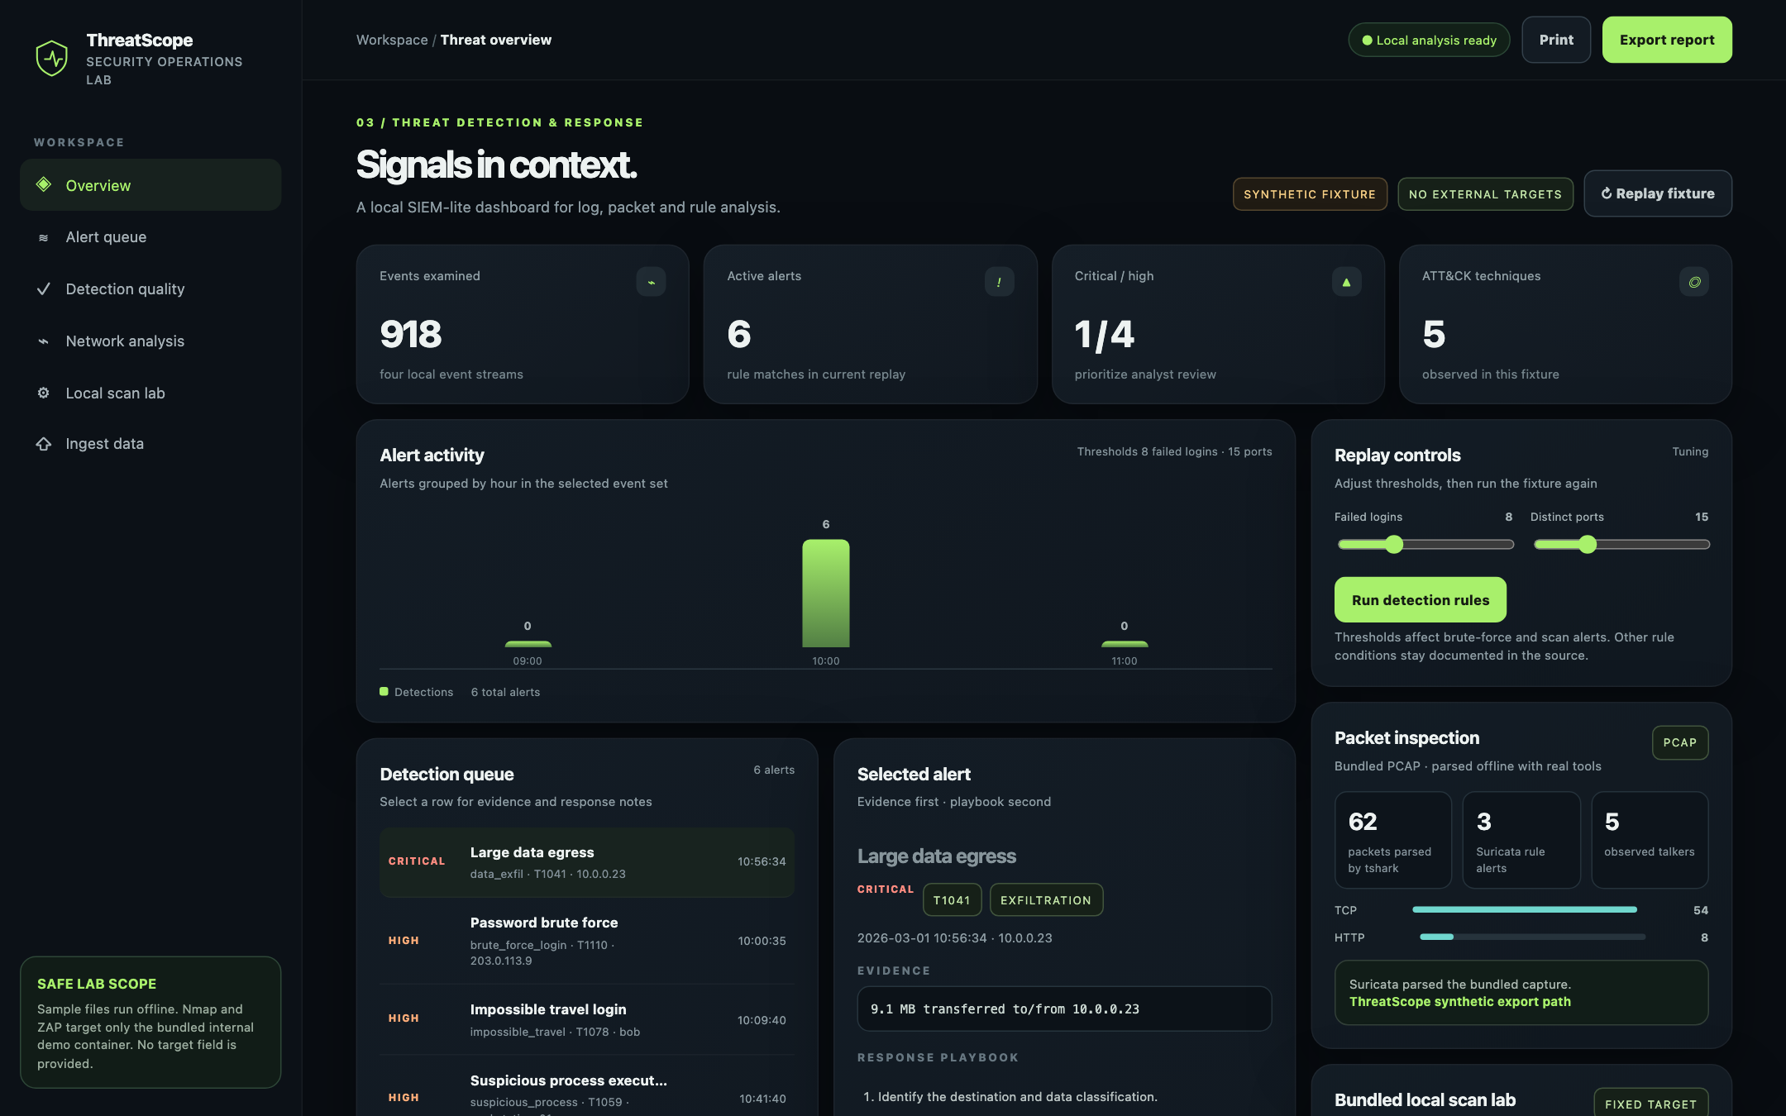
Figure 7.1: SOC overview: 918 events, 6 alerts across 5 ATT&CK techniques
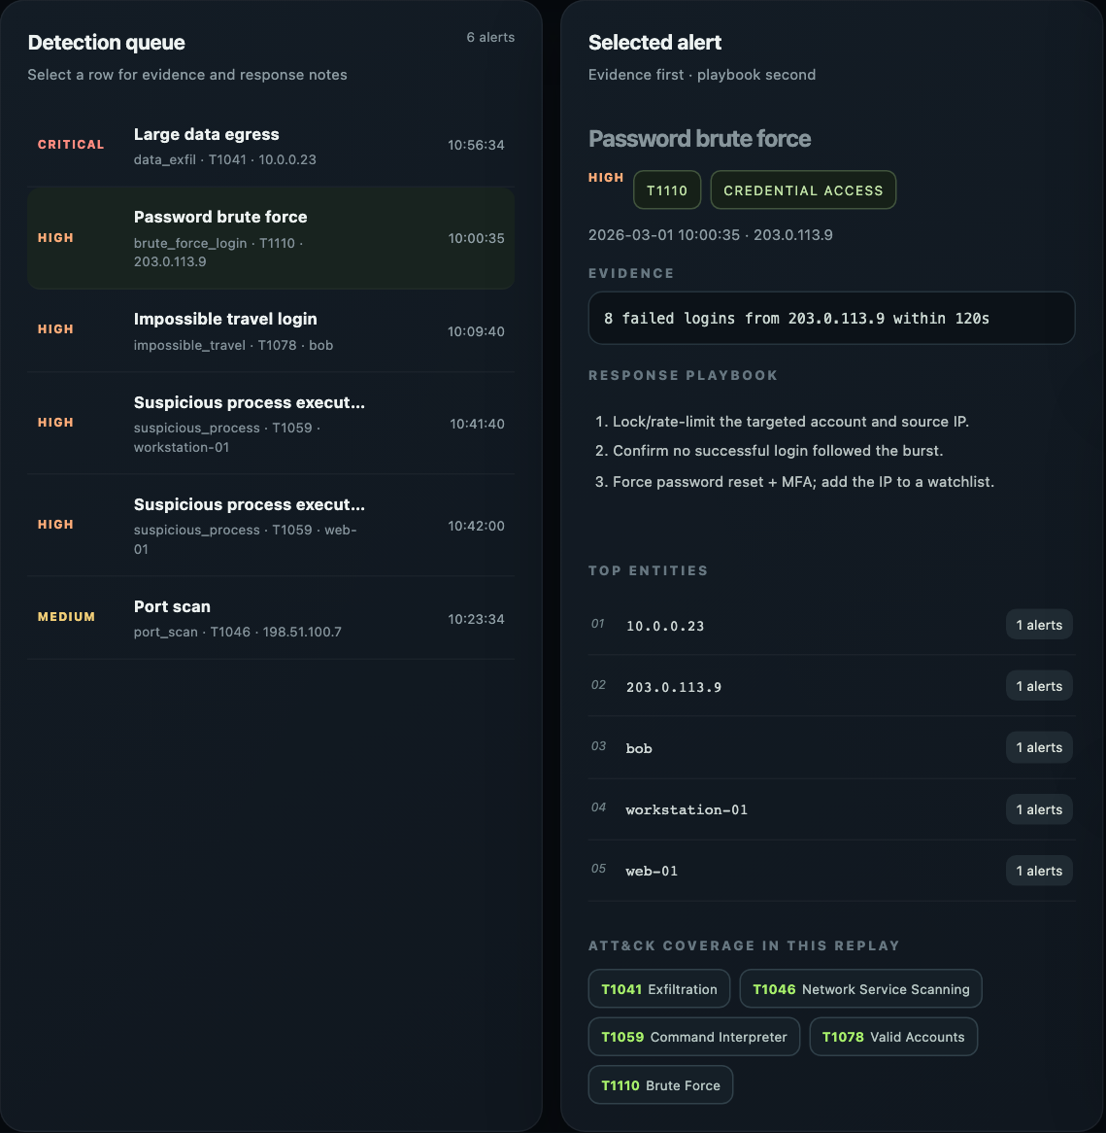
Figure 7.2: Alert triage with evidence and response playbook
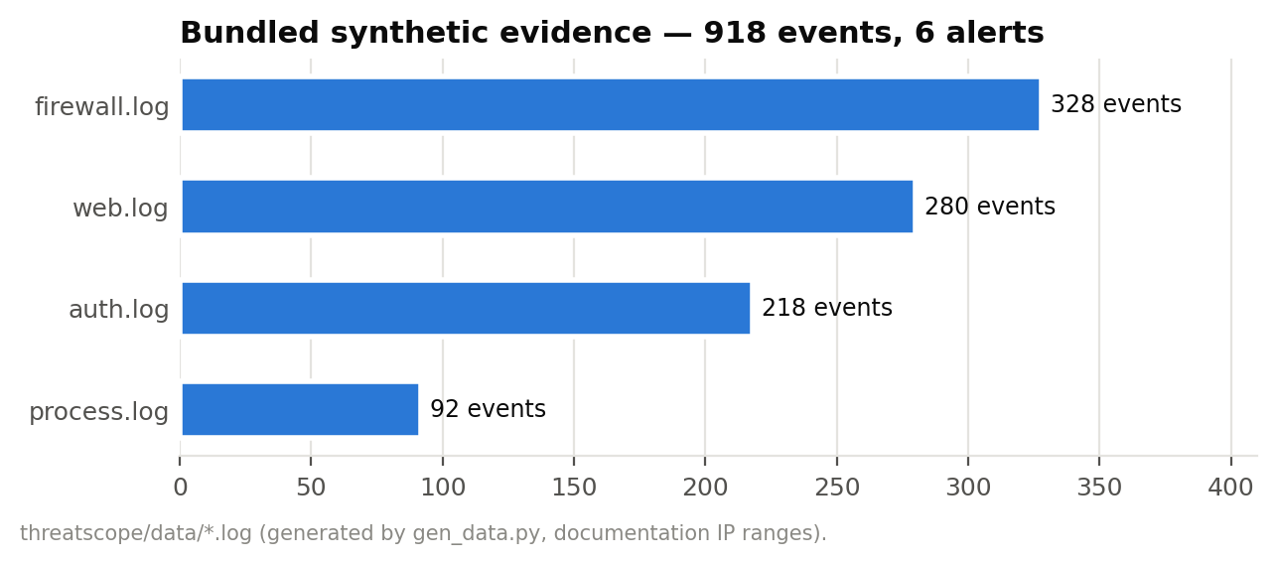
Figure 7.3: Bundled synthetic evidence by source

7.2 Real Tool Integration
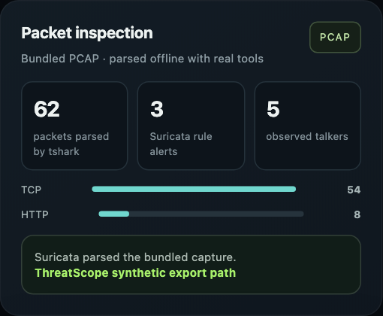
Figure 7.4: TShark (62 packets) and Suricata (3 alerts) on the bundled PCAP
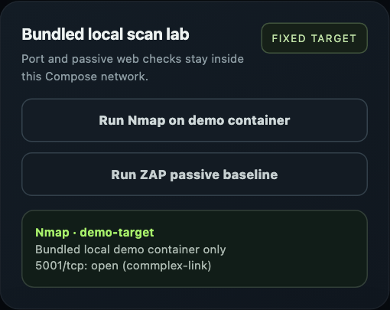
Figure 7.5: Nmap connect scan of the isolated demo target
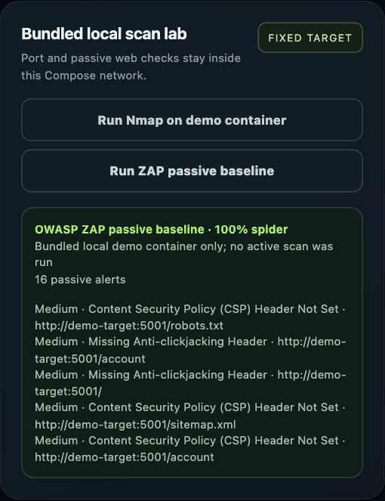
Figure 7.6: OWASP ZAP spider and passive baseline
Table 7.1: ZAP passive findings on the demo target (16 alerts)
Finding | Risk | Count
Content Security Policy (CSP) Header Not Set | Medium | 5
Missing Anti-clickjacking Header | Medium | 3
Server Leaks Version Information via "Server" HTTP Response Header Field | Low | 5
X-Content-Type-Options Header Missing | Low | 3

The demo target is deliberately unhardened. Every ZAP finding (missing CSP, missing anti-clickjacking header, version disclosure, missing nosniff) corresponds to a control that ThreatScope's own web_security layer applies, so the lab demonstrates both finding and fixing the issue.

7.3 Ground-Truth Detection Quality
Table 7.2: Per-rule results over 25 seeds (default thresholds)
Rule | TP | FP | FN | Precision | Recall
brute_force_login | 25 | 0 | 0 | 1.00 | 1.00
data_exfil | 25 | 0 | 0 | 1.00 | 1.00
impossible_travel | 25 | 0 | 0 | 1.00 | 1.00
port_scan | 25 | 0 | 0 | 1.00 | 1.00
suspicious_process | 50 | 0 | 0 | 1.00 | 1.00
All rules | 150 | 0 | 0 | 1.00 | 1.00

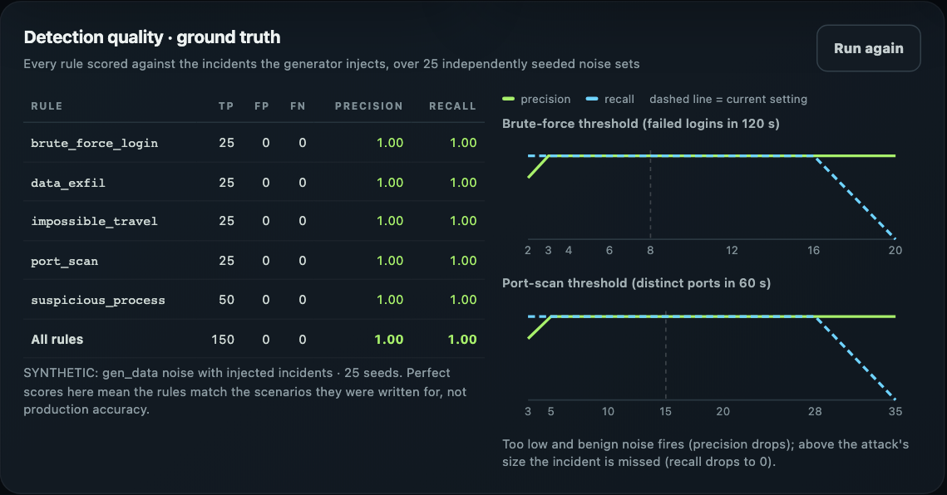
Figure 7.7: Detection-quality benchmark in the console
At default thresholds every injected incident was detected in every seed (150 TP) with no false positives. This shows the rules behave as designed on the scenarios they target; it is not evidence of real-world accuracy, because the benign noise is simple and the rules were written with these scenarios in mind [7].

7.4 Threshold Sensitivity
Table 7.3: Brute-force threshold sweep (failures per 120 s)
Threshold | FP | FN | Precision | Recall
2 | 9 | 0 | 0.73 | 1.00
3 | 0 | 0 | 1.00 | 1.00
4 | 0 | 0 | 1.00 | 1.00
6 | 0 | 0 | 1.00 | 1.00
8 | 0 | 0 | 1.00 | 1.00
12 | 0 | 0 | 1.00 | 1.00
16 | 0 | 0 | 1.00 | 1.00
20 | 0 | 25 | 1.00 | 0.00

Table 7.4: Port-scan threshold sweep (distinct ports per 60 s)
Threshold | FP | FN | Precision | Recall
3 | 9 | 0 | 0.73 | 1.00
5 | 0 | 0 | 1.00 | 1.00
10 | 0 | 0 | 1.00 | 1.00
15 | 0 | 0 | 1.00 | 1.00
20 | 0 | 0 | 1.00 | 1.00
28 | 0 | 0 | 1.00 | 1.00
35 | 0 | 25 | 1.00 | 0.00

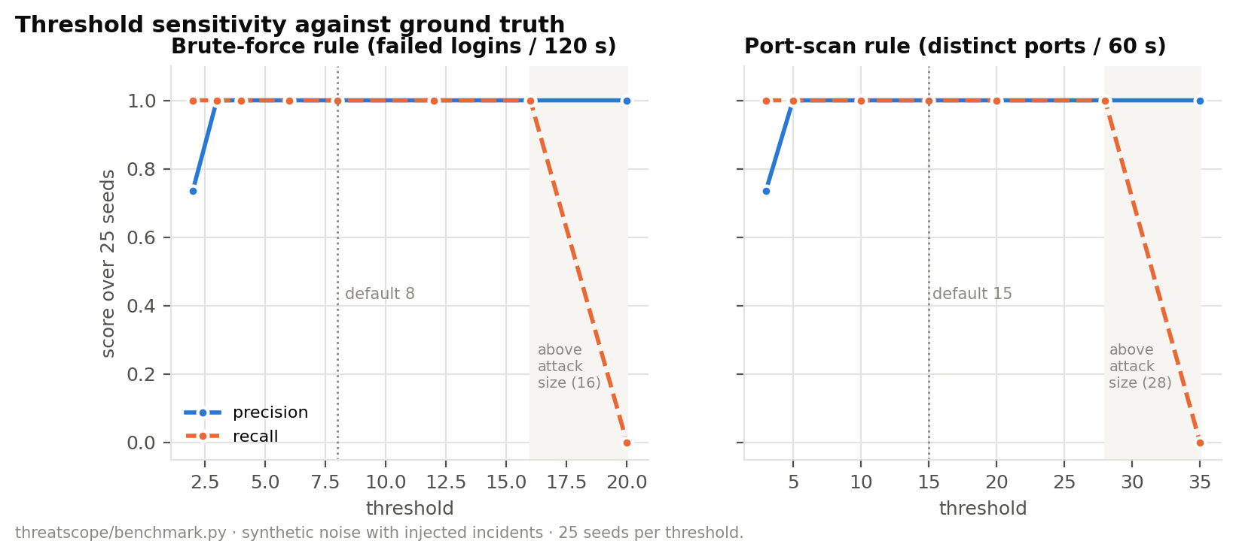
Figure 7.8: Precision and recall versus threshold
The sweeps reveal each rule's operating band. For brute force, a threshold of 2 produces 9 false positives over 25 seeds (benign users who mistype twice within two minutes), thresholds 3–16 are exact, and 20 exceeds the 16-failure attack so recall drops to 0. For port scans, 3 adds 9 false positives, 5–28 are exact, and 35 exceeds the 28-port sweep. The defaults (8 and 15) sit near the middle of these bands, which gives margin against noisier environments and slower attacks. Equally, the analysis shows that an attacker who stays below the threshold (e.g. 7 failures per window) evades the rule, an argument for layered detections.

7.5 Performance
Table 7.5: Load-test results (60 requests, 4 workers)
Endpoint | Req/s | p50 ms | p95 ms | max ms | Errors
full dashboard (918 events + tshark + Suricata) | 30 | 126.9 | 143.5 | 163.8 | 0
health check | 2,487 | 1.4 | 2.3 | 2.9 | 0

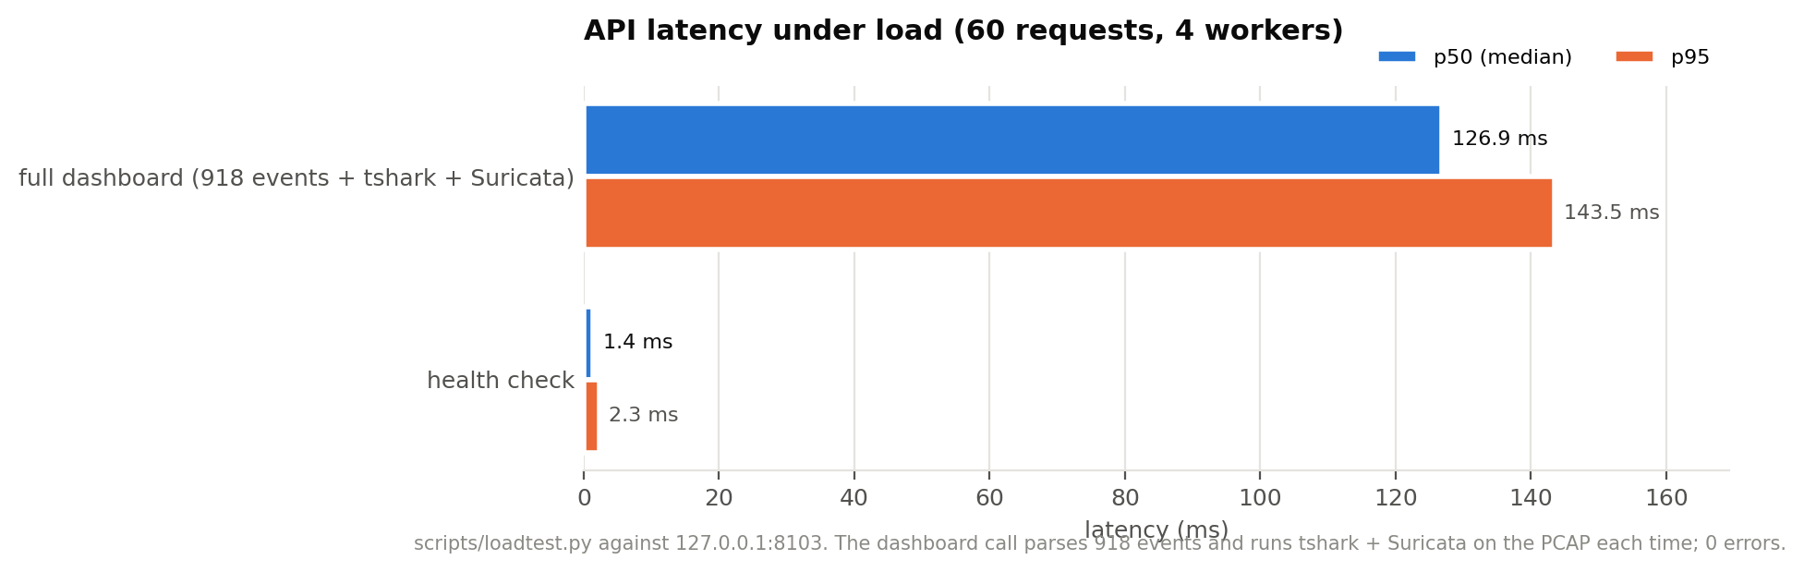
Figure 7.9: Latency per endpoint
The full dashboard call, which parses all 918 events, runs every rule and executes TShark and Suricata on the PCAP, has a median under 130 ms. Running the external tools dominates the cost; caching their output for the unchanged bundled PCAP would be an easy optimisation.

7.6 Mobile Layout
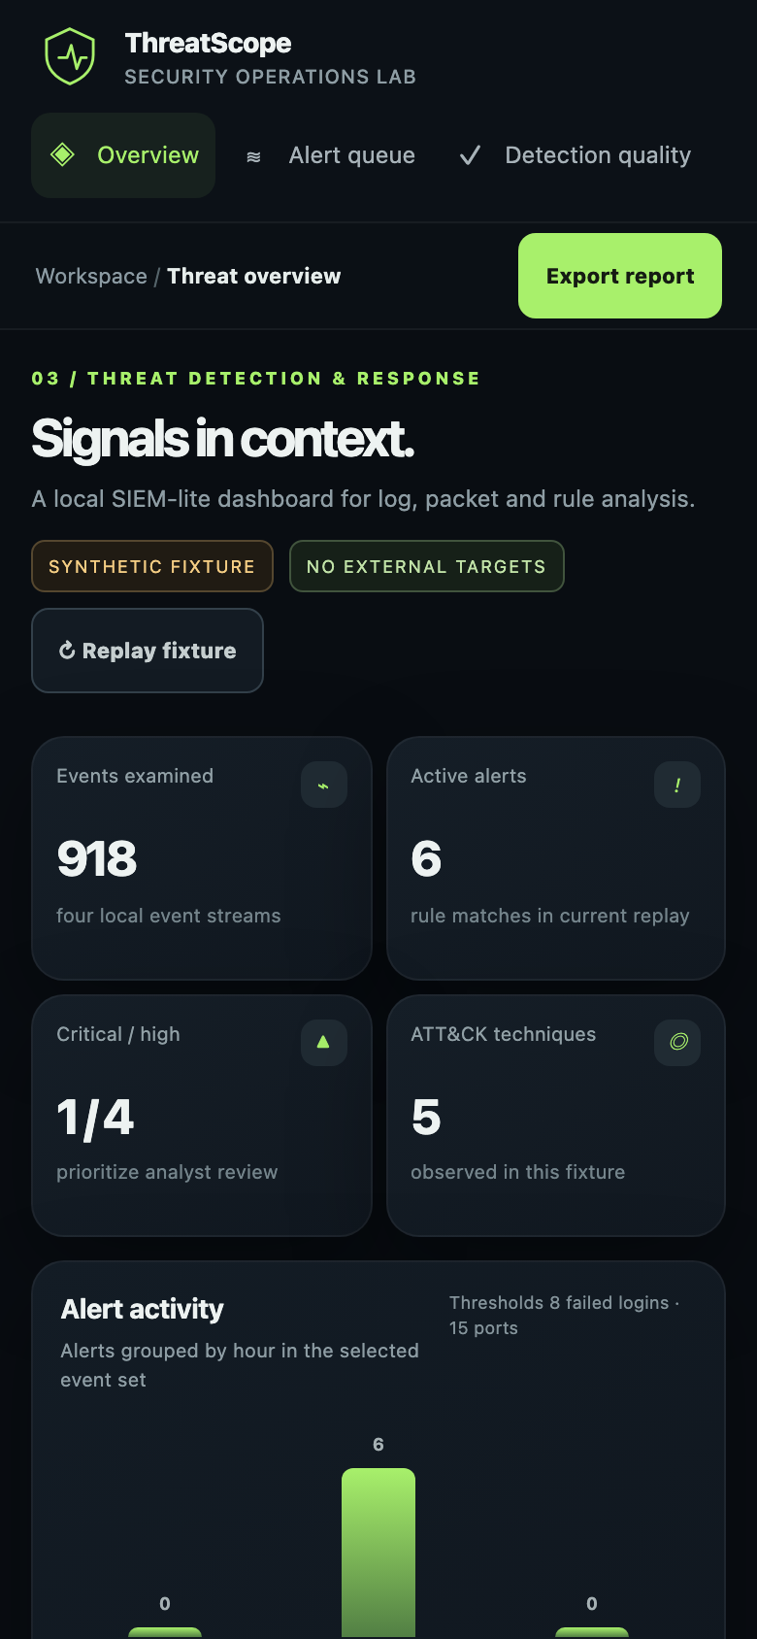
Figure 7.10: Console at 390 px width

7.7 Limitations
- Telemetry is synthetic and simple; perfect benchmark scores reflect that.
- Rules are hand-written, single-event-type detections; no cross-source correlation of one actor across logs yet.
- Impossible travel uses internal/external address change, not geolocation and velocity.
- Authentication is a single shared token; no user roles or per-analyst audit identity.
- Parsing a hostile PCAP exposes TShark/Suricata dissectors; mitigated by container isolation and limits, not eliminated.

CHAPTER 8
CONCLUSION AND FUTURE SCOPE

8.1 Conclusion
ThreatScope delivers a working, safe SOC lab: five ATT&CK-mapped rules over four log sources, real packet and web tooling isolated by design, an analyst console, and, as its research contribution, a ground-truth benchmark with threshold sweeps that makes each rule's behaviour measurable. On 25 seeds the rules detected all 150 injected incidents without false positives, and the sweeps located each rule's safe operating band. Testing also uncovered and fixed a networking defect that made the console unreachable. All 13 automated tests pass.
As the third design project it combines the foundations of the first two (secure tool integration in CryptoGuard; evaluation design and threat modelling in PhishLens) into a platform-scale system.

8.2 Future Scope
- Express rules in Sigma and test them with the same benchmark harness.
- Add cross-source correlation (scan → brute force → exfil by one actor) and alert scoring.
- Replay a licensed public dataset with labelled attacks for external validity.
- Per-analyst accounts with roles, and case management for alerts.
- Cache tool output and stream large uploads; add Zeek for protocol logs.

REFERENCES
[1] B. E. Strom, A. Applebaum, D. P. Miller, K. C. Nickels, A. G. Pennington and C. B. Thomas, “MITRE ATT&CK: Design and Philosophy,” The MITRE Corporation, Technical Report, 2018.
[2] The MITRE Corporation, “MITRE ATT&CK knowledge base.” [Online]. Available: https://attack.mitre.org/
[3] P. Cichonski, T. Millar, T. Grance and K. Scarfone, “Computer Security Incident Handling Guide,” NIST Special Publication 800-61 Rev. 2, 2012.
[4] K. Kent and M. Souppaya, “Guide to Computer Security Log Management,” NIST Special Publication 800-92, 2006.
[5] D. E. Denning, “An intrusion-detection model,” IEEE Transactions on Software Engineering, vol. SE-13, no. 2, pp. 222–232, 1987.
[6] M. Roesch, “Snort: lightweight intrusion detection for networks,” in Proc. 13th USENIX Systems Administration Conference (LISA), 1999, pp. 229–238.
[7] R. Sommer and V. Paxson, “Outside the closed world: on using machine learning for network intrusion detection,” in Proc. IEEE Symposium on Security and Privacy, 2010, pp. 305–316.
[8] V. Paxson, “Bro: a system for detecting network intruders in real-time,” Computer Networks, vol. 31, no. 23–24, pp. 2435–2463, 1999.
[9] Open Information Security Foundation (OISF), “Suricata User Guide.” [Online]. Available: https://docs.suricata.io/
[10] Wireshark Foundation, “tshark — Dump and analyze network traffic,” manual page. [Online]. Available: https://www.wireshark.org/docs/man-pages/tshark.html
[11] G. F. Lyon, Nmap Network Scanning: The Official Nmap Project Guide to Network Discovery and Security Scanning. Sunnyvale, CA, USA: Insecure.Com LLC, 2009.
[12] ZAP Project, “ZAP documentation.” [Online]. Available: https://www.zaproxy.org/docs/
[13] SigmaHQ, “Sigma — generic signature format for SIEM systems.” [Online]. Available: https://github.com/SigmaHQ/sigma
[14] Wazuh, Inc., “Wazuh documentation.” [Online]. Available: https://documentation.wazuh.com/
[15] J. Arkko, M. Cotton and L. Vegoda, “IPv4 Address Blocks Reserved for Documentation,” IETF RFC 5737, 2010.
[16] OWASP Foundation, “OWASP Secure Headers Project.” [Online]. Available: https://owasp.org/www-project-secure-headers/
[17] A. Khraisat, I. Gondal, P. Vamplew and J. Kamruzzaman, “Survey of intrusion detection systems: techniques, datasets and challenges,” Cybersecurity, vol. 2, art. 20, 2019.

APPENDIX A: INSTALLATION AND USER MANUAL
- Install Docker Desktop (allow ≈ 8 GB RAM).
- Run docker compose up --build -d in the project folder (first run downloads ZAP, ≈ 1.5 GB).
- Open http://localhost:8103.
- Optional: set THREATSCOPE_API_TOKEN in .env to require a token; the console will prompt for it.
- Stop with docker compose down.
Listing A.1: Developer commands
python3 -m venv .venv && source .venv/bin/activate
python -m pip install -r requirements.txt
make test # 13 tests
make evaluate # fixture rule counts
make benchmark # ground truth + sweeps
make run # http://127.0.0.1:8000 (tools show as unavailable outside Docker)
python scripts/loadtest.py
Table A.2: Troubleshooting
Symptom | Fix
Console unreachable on 8103 | Pull the latest compose file (web network fix); docker compose up -d
ZAP card unavailable | Wait for the ZAP container to become healthy, or set THREATSCOPE_ZAP_ENABLED=0
Token prompt appears | THREATSCOPE_API_TOKEN is set; enter it, or unset it for loopback use
429 on scans | Rate limits (Nmap 4/min, ZAP 2/min) working as designed

APPENDIX B: DEMONSTRATION SCRIPT
- Overview: KPIs count up; 918 events, 6 alerts, 5 techniques. State that the data are synthetic.
- Open the critical exfiltration alert: evidence, ATT&CK tag, playbook steps.
- Move the failed-login slider to 20 and replay: the brute-force alert disappears; explain thresholds.
- Packet inspection: TShark and Suricata results on the bundled PCAP.
- Run Nmap, then ZAP; explain the fixed target and the internal network.
- Run the detection-quality benchmark: 150 TP, 0 FP; read the threshold bands from the chart.
- Close on safety and on measured detection engineering.

APPENDIX C: API REFERENCE
Table C.1: REST endpoints
Method and path | Input | Output
GET /api/dashboard | brute_force, port_scan (query) | alerts, summary, timeline, techniques, pcap, suricata
POST /api/upload | multipart files[], thresholds | same shape as dashboard, label USER-UPLOADED
GET /api/benchmark | — | per_rule, overall, sweeps
POST /api/nmap-demo | — (target fixed) | ports, open_count
POST /api/zap-demo | — (target fixed) | alerts, alert_count, spider_percent
GET /health | — | ok (never requires a token)

APPENDIX D: REPOSITORY STRUCTURE
Listing D.1: Repository layout
├── .dockerignore
├── .env.example
├── .github/
│ └── workflows/
│ └── ci.yml
├── .gitignore
├── CHANGELOG.md
├── CONTRIBUTING.md
├── Dockerfile
├── LICENSE
├── Makefile
├── PROJECT_OVERVIEW.md
├── README.md
├── SECURITY.md
├── Start.command
├── docker-compose.yml
├── docs/
│ ├── README.md
│ ├── diagrams/ (11 images)
│ ├── index.html
│ └── screenshots/ (7 images)
├── requirements.txt
├── scripts/
│ └── loadtest.py
├── tests/
│ ├── test_security.py
│ └── test_threatscope.py
└── threatscope/
├── __init__.py
├── app.py
├── benchmark.py
├── data/
│ ├── auth.log
│ ├── firewall.log
│ ├── process.log
│ ├── sample-traffic.pcap
│ └── web.log
├── demo_target.py
├── detect.py
├── evaluate.py
├── gen_data.py
├── nettools.py
├── rules/
│ └── local-demo.rules
├── static/
│ └── index.html
└── web_security.py

