BHIMAVARAM DIGITALS
Digital Signage Platform
Technical Documentation

Prepared by: Harsha Vardhan Eudu
Organization: Bhimavaram Digitals
Version: v1.1
Date: 30 July 2026

PROPRIETARY & CONFIDENTIAL
This document and the system it describes are the intellectual property of the project owner. Unauthorized copying, distribution, or commercial use is prohibited.
Table of Contents
1. Executive Summary 1
2. System Overview & Architecture 1
2.1 System Overview 1
2.2 High-Level Architecture 1
2.3 Component Interaction 1
2.4 Design Decisions 1
3. Technology Stack 1
3.1 Player Application 1
3.2 Admin Dashboard 1
3.3 Backend Services 1
3.4 Media Infrastructure 1
4. Data Model 1
4.1 Firestore Collections 1
4.2 Document Structure 1
4.3 Data Relationships 1
5. Core Features & Functional Flow 1
5.1 Screen Pairing 1
5.2 Playlist Assignment & Playback 1
5.3 Rotation Handling 1
5.4 Analytics Logging 1
5.5 Boot Recovery 1
6. Security 1
6.1 Authentication 1
6.2 Firestore Security Rules 1
6.3 Current Security Limitations 1
7. Deployment & Infrastructure 1
7.1 Current Deployment 1
7.2 Target Hardware 1
7.3 OTA Update Strategy 1
8. Known Limitations & Technical Debt 1
9. Roadmap 1
10. Team & Contributions 1
Appendix 1
Repository Links 1
Glossary 1
License 1

1. Executive Summary

Bhimavaram Digitals is a cloud-based digital signage platform that lets a single administrator manage advertising content across a network of Android TV screens from one dashboard. It replaces manual, screen-by-screen updates with real-time synchronization: an operator builds a playlist once, assigns it to any screen, and the change appears on that display within seconds, without anyone visiting the physical location.
The platform is built around three components sharing a common Firebase backend — an Android TV player application, a web-based administration dashboard, and Firebase Firestore as the real-time data layer connecting them. Video and image assets are served from Cloudflare R2, which keeps bandwidth costs predictable as the number of screens grows.
The system is designed to support approximately 40 screens deployed across Bhimavaram, with an architecture intended to scale meaningfully beyond that number without a redesign. It is functionally comparable to commercial platforms such as EasySignage, built specifically to match the operating budget and technical needs of local businesses rather than an enterprise price point.
The core platform — screen pairing, playlist management, playback, and analytics — is complete and in active use. Remaining work is concentrated on operational tooling: over-the-air application updates, offline-device alerting, and dashboard scaling for larger fleets. These are addressed in Section 9, Roadmap.

2. System Overview & Architecture

2.1 System Overview
The platform is used by two distinct groups. Administrators interact with the system through the web dashboard to register screens, build playlists, and review analytics. The public interacts with the system only passively, as viewers of the content displayed on each screen — there is no end-user-facing app or account.
Every screen in the network runs the same player application and connects to a single shared Firestore project, so a change made once in the dashboard reaches every relevant screen without a manual push step. Adding a new screen to the network requires no code changes — only a one-time pairing code entered into the dashboard.

2.2 High-Level Architecture
At a high level, the platform has three tiers: an operator-facing dashboard, a real-time Firestore backend, and a fleet of player devices that render content. Media assets are stored outside Firestore entirely, in Cloudflare R2, since large video files are not practical to hold inside a document database. Figure 1 shows how these tiers connect and where each type of data flows.
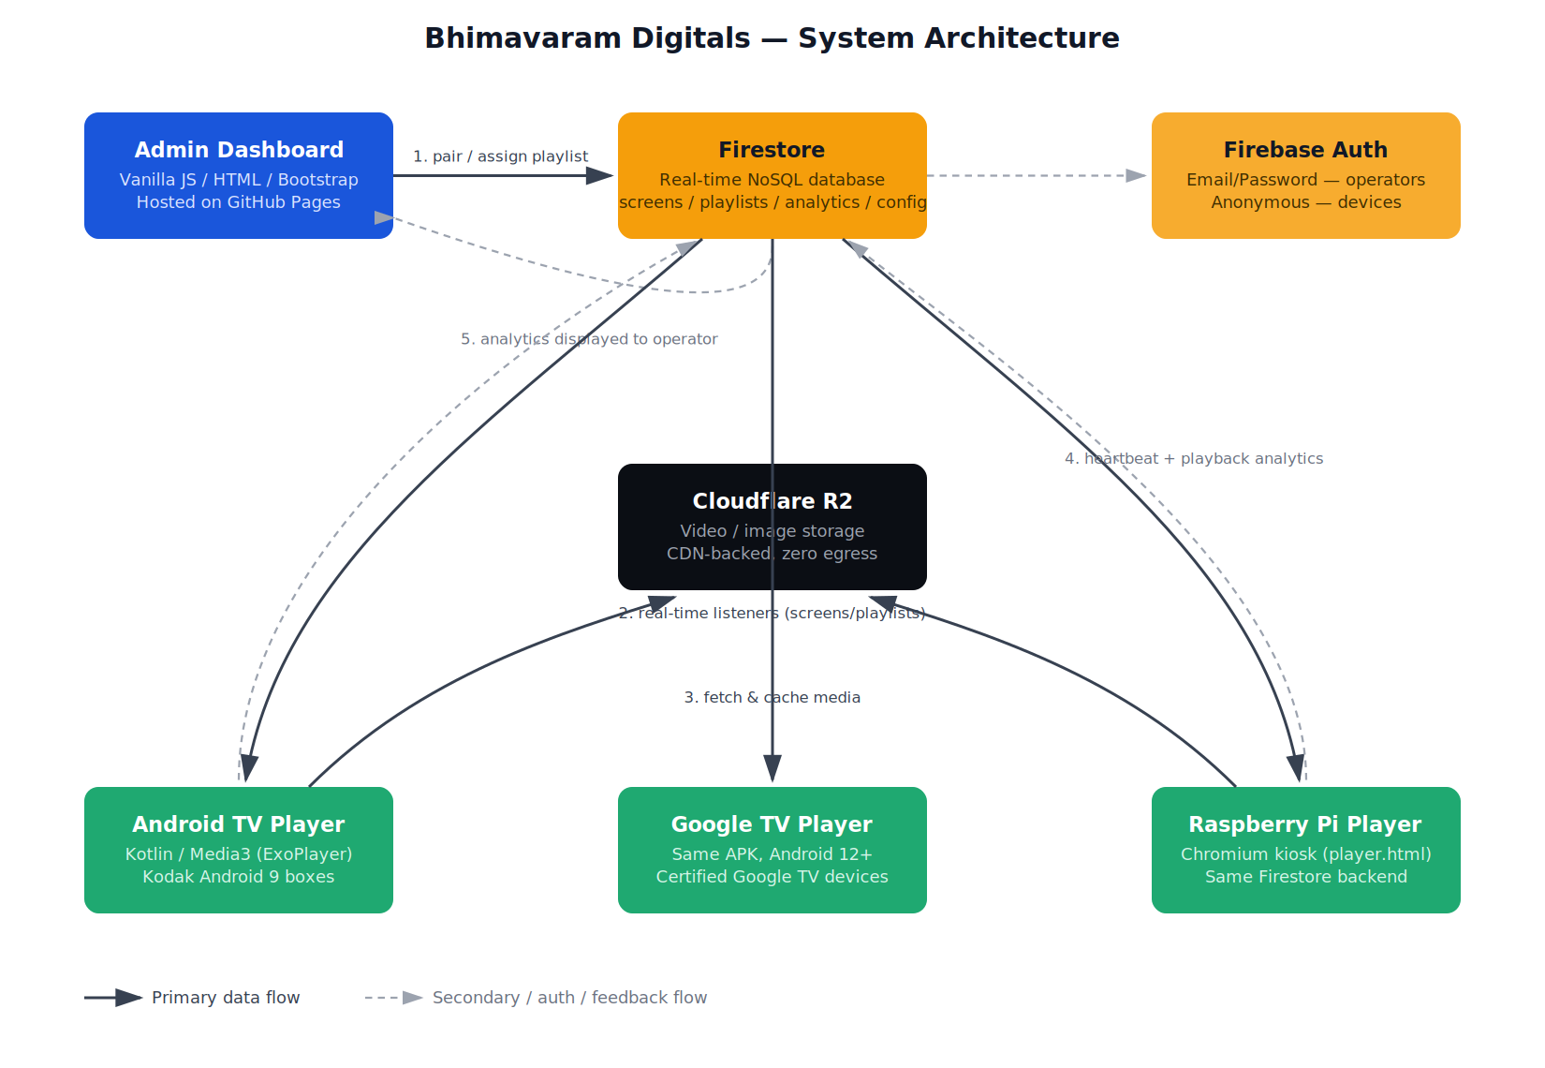
Figure 1 — High-level system architecture: data and media flow between the dashboard, Firestore, Cloudflare R2, and the player fleet.

2.3 Component Interaction
Two workflows account for most of the system's real-time behavior: pairing a new screen, and assigning it a playlist. Figure 2 walks through both in sequence, since a playlist assignment reuses the exact same Firestore listener that pairing establishes on first boot.
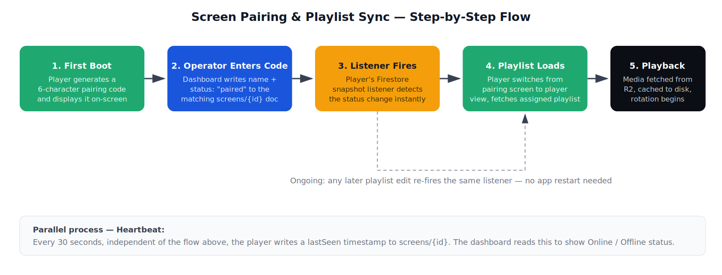
Figure 2 — Screen pairing and playlist synchronization flow, with the parallel heartbeat process that drives online/offline status.
A third workflow, boot recovery, is intentionally simpler and is covered in detail in Section 5.5.

2.4 Design Decisions
Firestore real-time listeners. Firestore's real-time listeners were chosen over a traditional polling REST API because they push updates to every connected device the moment a change is written, rather than waiting for the next poll interval. For a fleet of screens that should reflect content changes within seconds, this removes both the latency and the unnecessary network traffic that polling would add once the fleet grows past a handful of devices.
Anonymous authentication for devices. Player devices authenticate anonymously because they represent a screen, not a person — there is no user to log in, and requiring credentials on unattended hardware would only create an operational liability if a device were lost, reset, or physically swapped. Dashboard administrators, by contrast, authenticate with email and password, since dashboard access controls who can push content to public displays and needs to be tied to an accountable individual.
Cloudflare R2 for media storage. A signage network re-serves the same video files to every screen on every loop, so bandwidth cost scales directly with the number of screens. R2 was selected specifically because it charges no egress fees, keeping that cost flat as the fleet grows — a material difference from Firebase Storage or a comparable S3-compatible service at this scale.
Framework-free, modular dashboard. The dashboard is deliberately built without a frontend framework, split into small single-purpose modules (screens, playlists, analytics, auth) rather than one monolithic script. This keeps the build simple — no bundler, no build step — while still letting two people work on the codebase concurrently: UI changes stay confined to HTML and CSS, and logic changes stay confined to their own module file.
3. Technology Stack

3.1 Player Application
Technology | Purpose | Reason for Selection
Kotlin | Android application development | Official Android language with strong tooling and long-term support.
AndroidX Media3 (ExoPlayer) | Media playback | High-performance video playback with HLS support and Android TV optimization.
Coil | Image loading | Lightweight image loading with efficient memory caching.
Firebase Firestore SDK | Real-time synchronization | Delivers playlist and configuration changes to devices instantly.
Firebase Authentication SDK | Device authentication | Enables secure anonymous authentication with no user interaction required.

3.2 Admin Dashboard
Technology | Purpose | Reason for Selection
HTML5 / CSS3 | Interface structure and styling | Standard, dependency-free web foundation.
Vanilla JavaScript (ES6) | Application logic | Lightweight implementation with no framework or build-step overhead.
Bootstrap 5 | Responsive layout | Rapid development using reusable, well-tested UI components.
Firebase JavaScript SDK | Firebase integration | Provides Authentication and Firestore connectivity from the browser.

3.3 Backend Services
Technology | Purpose | Reason for Selection
Firebase Firestore | Cloud database | Real-time NoSQL database with automatic client synchronization.
Firebase Authentication | Authentication | Email/password for administrators; anonymous authentication for player devices.

3.4 Media Infrastructure
Technology | Purpose | Reason for Selection
Cloudflare R2 | Media storage | Zero egress fees, making repeated large-file delivery to many screens cost-effective.
yt-dlp | Video acquisition | Resolves supported online media into a playable HLS URL before playback.
FFmpeg | Media processing | Normalizes uploaded video into an Android-decoder-compatible format.
GitHub Pages | Dashboard hosting | Free, reliable static hosting for the dashboard build.
The stack was chosen to balance performance, scalability, and operating cost. Firestore removes the need for a dedicated backend server; Kotlin and Media3 give stable playback on constrained Android TV hardware; Cloudflare R2 removes bandwidth as a growth cost; and the dashboard's framework-free JavaScript keeps it simple to deploy, audit, and hand off.

4. Data Model

4.1 Firestore Collections
The platform stores all operational data in Firebase Cloud Firestore, a real-time NoSQL document database. Each top-level collection maps to one concern — screens, playlists, analytics, and application configuration — and every player and dashboard client subscribes only to the documents relevant to it, rather than polling for changes.
Collection: screens/{screenId}
Field | Type | Purpose
status | String | unpaired or paired — controls whether the player shows its pairing code or its content.
name | String | Operator-assigned label shown in the dashboard (e.g. "Mall Entrance").
currentPlaylist | String | Document ID reference to the assigned playlists/{playlistId}.
rotation | Number | Screen-level display rotation in degrees: 0, 90, 180, or 270.
lastSeen | Timestamp | Updated every 30 seconds by the player's heartbeat; drives online/offline status.
createdAt | Timestamp | Set once, on the device's first boot.
Collection: playlists/{playlistId}
Field | Type | Purpose
name | String | Playlist name shown in the dashboard.
items | Array | Ordered media items. Each item carries type, url, durationSeconds, resizeMode, rotation, and isLive.
createdAt | Timestamp | Set when the playlist is first saved.
Collection: analytics/{screenId}_{yyyyMMdd}/items/{urlEncoded}
Field | Type | Purpose
screenId | String | The screen that generated this playback event.
date | String | yyyyMMdd — matches the parent document's date partition.
url | String | The media URL played (also the source for the document ID, URL-encoded).
type | String | video, image, or web.
playCount | Number | Total plays, incremented atomically via FieldValue.increment(1).
totalSeconds | Number | Cumulative playback duration, incremented via FieldValue.increment().
lastPlayed | Timestamp | Server timestamp of the most recent play.
Collection: config/appVersion (supports the OTA update system — see Section 7.3)
Field | Type | Purpose
latestVersionCode | Number | The newest available versionCode; compared against the installed build on boot.
apkUrl | String | Cloudflare R2 URL of the current release APK.
releaseNotes | String | Short operator-facing description of the release.

4.2 Document Structure
Documents are organized as flat top-level collections, with one exception: analytics data is nested one level deeper, under an items subcollection keyed by day and screen. This is a deliberate partitioning choice — grouping a day's playback events under analytics/{screenId}_{yyyyMMdd}/items/ keeps each parent document small and each query scoped to a single day and, optionally, a single screen, rather than accumulating an unbounded array inside one ever-growing document.
screens
└── {screenId}
playlists
└── {playlistId}
analytics
└── {screenId}_{yyyyMMdd}
└── items
└── {urlEncoded}
config
└── appVersion

4.3 Data Relationships
screens, playlists, and analytics are related by reference rather than by nesting. A screen document stores a currentPlaylist field pointing at a playlist's document ID; every analytics entry stores a screenId field pointing back to the screen that generated it. This keeps each collection independently queryable — the dashboard can list all playlists without touching screens, and vice versa — while the player still joins the two client-side at runtime.
Screen ──currentPlaylist──▶ Playlist ──contains──▶ Media Items
Screen ──generates──▶ Analytics (grouped by screenId + date)
Config is read independently by every player and has no reference to screens.

5. Core Features & Functional Flow

5.1 Screen Pairing
On first boot, the player generates a six-character pairing code from a set of unambiguous characters and displays it fullscreen. The operator enters this code and a screen name into the dashboard, which looks up the matching screens/{screenId} document and updates its status to paired. The player's own Firestore listener on that same document detects the change within moments and switches from the pairing view into the player view — no reboot or manual refresh required on either side.

5.2 Playlist Assignment & Playback
Administrators create playlists in the dashboard and assign them to one or more screens by writing a playlist ID into that screen's currentPlaylist field. Every paired player is already listening to its own screen document, so it picks up the new playlist ID immediately, opens a second listener on that playlist, and begins playback. Each media item renders through the component appropriate to its type: video through Media3/ExoPlayer, images through Coil, and web content or YouTube through a WebView.

5.3 Rotation Handling
The platform supports rotation at two independent levels. Screen-level rotation rotates the entire display — used when a physical screen is mounted in portrait orientation. Item-level rotation rotates a single image or video within the playlist, independent of the screen's own orientation. Supporting both was necessary because source media (particularly phone-shot video) is not always captured in the same orientation as the screen it will play on.

5.4 Analytics Logging
The player tracks how long each playlist item actually played, not just how long it was scheduled for. When the player advances to the next item, it logs the previous item's real playback duration to Firestore, merging the update into that day's analytics document for the screen. This means a video interrupted by an error or an early advance is recorded with its true watched duration, not its nominal duration — giving the dashboard's playtime totals a reasonably accurate picture of what viewers actually saw.

5.5 Boot Recovery
To support unattended installations across the city, the player restarts itself automatically after any reboot — a power cut, a scheduled restart, or a firmware update. SignageBootReceiver listens for the system's BOOT_COMPLETED broadcast and starts BootLaunchService as a foreground service, which then launches the main player activity. Routing the relaunch through a foreground service is a deliberate workaround: Android 12 and later block background processes from starting an activity directly, and a foreground service is the supported exception to that restriction. Once running, the player re-authenticates with Firebase and resumes exactly the state its screen document indicates — paired and playing, or waiting to be paired.

6. Security

6.1 Authentication
The system uses two authentication methods, matched to two different trust levels. Player devices authenticate anonymously through Firebase Authentication, since they represent hardware rather than a person and require no login flow. Dashboard administrators authenticate with email and password, since dashboard access is what actually controls what the public sees on 40 physical screens, and therefore needs to be tied to an accountable, revocable identity.

6.2 Firestore Security Rules
Firestore denies all reads and writes by default; every collection needs an explicit rule granting the access it requires, and it is easy to miss one when adding a new collection. This happened once during development: the analytics collection initially had no rules of its own and silently rejected every write until the gap was identified and fixed. That experience is the reason security rules are now reviewed deliberately whenever a new collection is added to the schema, rather than only at initial project setup.
Cross-screen analytics queries use Firestore's collection group functionality to read across every screen's items subcollection in a single query. This required manually adding a composite index in the Firebase console — a one-time step that Firestore itself prompts for the first time such a query runs without one.

6.3 Current Security Limitations
The current implementation does not include request rate limiting, abuse prevention, or detailed audit logging of dashboard actions. These are acceptable gaps for the platform's current scale and trusted operator base, but are flagged here as planned hardening work as the system scales to more operators or a larger screen count.

7. Deployment & Infrastructure

7.1 Current Deployment
The dashboard is deployed as a static site on GitHub Pages, updated automatically on every push to the main branch with no build step. Android TV devices currently receive the player application via ADB sideload during installation and any subsequent manual update.

7.2 Target Hardware
The application is designed for Kodak Android 9 TV boxes as the primary target, with Google TV certified (Android 12+) devices supported on the same APK. Raspberry Pi installations run a separate Chromium kiosk web player against the same Firestore backend, since the native Android APK cannot run on standard Raspberry Pi OS.

7.3 OTA Update Strategy
An over-the-air update mechanism is in development to remove manual ADB sideloading from the update process entirely. The design uses Device Owner provisioning (established before any Google account is added to a device) together with Android's PackageInstaller Session API to allow silent, unattended installation. The config/appVersion Firestore document (Section 4.1) drives the process: each player compares its installed versionCode against latestVersionCode on boot, and if a newer release exists, downloads the APK from apkUrl and installs it without operator interaction.

8. Known Limitations & Technical Debt
The current implementation is appropriately scoped for a small-to-medium deployment and carries some known limitations worth tracking explicitly:
- Dashboard pagination — the screens and playlists tables render the full dataset on every update; this will not scale gracefully much past a few hundred screens.
- Offline alerting — there is no active notification when a screen goes offline; an operator must notice a stale lastSeen timestamp manually.
- YouTube URL expiry — HLS URLs resolved via yt-dlp expire after a period and are not currently refreshed automatically, requiring periodic re-resolution.
- YouTube Terms of Service exposure — playing YouTube-sourced content on unattended commercial displays carries ToS risk that has not yet been independently reviewed.
- Release signing — the release build pipeline (signing configuration, keystore management) is still being finalized to fully replace debug-build sideloading.

9. Roadmap
Planned work is prioritized around removing manual operational steps and preparing the platform to scale past its current fleet size:
- Complete the OTA application update system (Section 7.3).
- Add dashboard pagination for larger screen counts.
- Introduce offline-duration alerts for screens down longer than roughly 10 minutes.
- Support time-based playlist scheduling for automatic ad rotation by time of day.
- Support bulk playlist assignment across multiple screens at once.
- Add proactive media pre-caching on cold boot, replacing the current lazy, play-triggered cache.

10. Team & Contributions
The platform is built and maintained by a three-person team, with ownership deliberately separated by file and concern to avoid overlapping changes to the same code.
Harsha Vardhan Eudu — Project lead. Owns Android application development, Firebase/Firestore backend logic, and dashboard application logic (app.js and the modules/*.js files).
[Teammate — dashboard UI] — Owns dashboard interface and styling (Figma), working within the existing id and onclick attributes that the logic layer depends on.

Appendix

Repository Links
- Android Player Repository: https://github.com/harshacsit/signage_player.git
- Dashboard Repository: https://github.com/harshacsit/digitals-signage.git

Glossary
Term | Description
Firestore | Firebase's cloud-hosted NoSQL database used for real-time synchronization.
Firestore Listener | A real-time subscription that automatically receives document updates as they happen.
Media3 (ExoPlayer) | Google's Android library for high-performance media playback.
Cloudflare R2 | Object storage service used for hosting video and image assets.
Coil | Kotlin image-loading library optimized for Android.
ADB | Android Debug Bridge — used to install and manage applications on Android devices from a computer.
OTA | Over-the-air — an update delivered and installed remotely, without physical access to the device.
Kiosk mode | A locked-down device state that runs a single application fullscreen with no access to the system UI.

License
This project is the intellectual property of the project owner and is intended for educational, research, and startup development purposes.
All source code, documentation, designs, and related assets are proprietary. Unauthorized copying, modification, distribution, or commercial use of this project is prohibited without prior written permission from the project owner.
© 2026 Harsha Vardhan Eudu. All Rights Reserved.

