INDUSTRY INTERNSHIP REPORT
ON
CNAIP- DevOps via Azure

Yeshwantrao Chavan College of Engineering
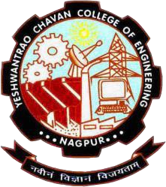
Bachelor of Technology in Information Technology

Session 2025-26
Industry: Cognizant Technology Solutions
(12/03/2026 to 11/07/2026)

Submitted By:

Harshad Arun Rakhunde (68)

Supervised By:

Faculty Supervisor
Dr. Ujwalla Gawande
Department of Information Technology
YCCE, Nagpur

Industry Supervisor
Mr. M Lawrance
CPO L&D GenC Training

Nagar Yuwak Shikshan Sanstha’s

Yeshwantrao Chavan College of Engineering,
(An Autonomous Institution Affiliated to Rashtrasant Tukdoji Maharaj Nagpur University, Nagpur)

NAGPUR - 441 110

