1. Internship Overview

1.1 Overview
The internship under the INTCIS26CNAIP DevOps via Azure domain at Cognizant offered a comprehensive and structured exposure to modern cloud computing technologies, security frameworks, and DevOps methodologies. It was carefully designed to bridge the gap between academic knowledge and industry expectations by providing practical experience with real-world tools, platforms, and workflows commonly used in enterprise environments.
The training program encompassed multiple core domains, including Microsoft Azure, scripting and automation, DevSecOps practices, python fundamentals, and containerization technologies such as Docker and Kubernetes. Equal emphasis was placed on both theoretical concepts and hands-on implementation, enabling a deeper understanding of how scalable, secure, and efficient cloud-based systems are designed, deployed, and managed.
The internship followed a structured learning approach supported by continuous assessments, practical exercises, and domain-specific modules. This not only strengthened technical proficiency but also enhanced analytical thinking, problem-solving capabilities, and adaptability to real-world scenarios. Exposure to industry-relevant practices such as infrastructure automation, monitoring, security integration, and platform engineering further contributed to a well-rounded skill set.
Overall, this structured internship program at Cognizant has served as a transformative professional and technical milestones, equipping me with the rigorous foundational knowledge and deep practical engineering skills required to operate effectively within modern cloud-native and high-velocity DevOps environments. This technical report presents a comprehensive, detailed account of the sequential training frameworks, architectural domains traversed, and programmatic work executed over the course of the engagement.
By analyzing the specific tools and infrastructure methodologies utilized—ranging from initial Linux server administration to advanced multi-tenant Kubernetes orchestration, automated continuous integration pipelines, and declarative infrastructure code—this documentation traces the strategic transformation from conceptual understanding to production-ready application deployment. Ultimately, the outcomes detailed within this report reflect not only the mastery of standalone technologies but also a holistic grasp of software reliability, engineering governance, and automated operational efficiency, establishing a strong professional baseline for my continued progression in the cloud engineering landscape.

1.2 Company Profile
Cognizant is a multinational technology company headquartered in Teaneck, New Jersey, USA with a strong global presence in over 40 countries and a workforce of more than 350,000 professionals.
The company provides services in:

    - Cloud Computing and Digital Transformation
    - Artificial Intelligence and Data Analytics
    - Cloud Security and Risk Management
    - Application Development and Maintenance
    - Consulting and Business Services

Cognizant helps organizations modernize their IT infrastructure and adopt cloud-based solutions for improved efficiency and innovation.

1.2.1 Vision, Mission, and Core Values

Cognizant’s vision is to empower organizations through technology and innovation to achieve sustainable growth in the digital era.

Its mission focuses on helping clients transform their business processes using advanced technologies such as cloud computing, AI, and automation.

The company operates on core values such as:

    - Work as one
    - Raise the bar
    - Dare to innovate
    - Do the right thing
    - Own it

These values are reflected in its work culture and training approach.

1.2.2 Cognizant in India

Cognizant has a strong presence in India with multiple delivery centres across major cities such as:
    - Pune
    - Bangalore
    - Mumbai
    - Hyderabad
    - Chennai
    - Kolkata

These centers play a key role in global service delivery, innovation, and training programs.

1.3 Objectives of the Internship

The internship was designed to bridge the gap between academic learning and practical industry experience. It acted as an application layer for core subjects such as cloud computing, software development, operating systems, and automation. The program focused on transitioning from an academic mindset to an industry-oriented approach cantered on efficiency and scalability.
The internship's objectives included:
- Developing a strong understanding of cloud-based technologies and DevOps practices for real-world application.
- Enhancing problem-solving abilities and logical thinking through hands-on implementation of automation and deployment workflows.
- Gaining exposure to professional work culture, corporate ethics, and structured project delivery methodologies.
- Applying theoretical knowledge of software development, version control, and system operations in a practical environment.
Understanding collaborative development, agile practices, and continuous integration and deployment processes.

1.4 Type of Work
- Cloud Infrastructure Management: Logged into the Azure Portal to create resource groups and successfully deploy virtual machines. This involved selecting operating systems, defining access credentials, and configuring instance details.
- CI/CD Pipeline Engineering: Implemented automated pipelines using Jenkins and Azure DevOps to reduce manual intervention. This included configuring pipeline stages for build, test, and deployment while monitoring execution logs.
- Version Control & Collaboration: Managed source code repositories using Git and GitHub. Performed essential operations such as commit, push, and pull, and managed parallel development through branching and merging.
- Network & Security Configuration: Defined security rules through Network Security Groups (NSGs) to control inbound and outbound traffic. Configured virtual networks (VNet) to enable secure communication between cloud resources.
- System Automation & Scripting: Utilized Linux command-line operations and shell scripting to automate repetitive system-level tasks. This involved file management and optimizing process efficiency through automated scripts.
- Performance Monitoring & Debugging: Tracked application, system, and deployment logs to identify and resolve configuration errors or performance bottlenecks. Monitored resource utilization, such as CPU and memory, to ensure system stability
2. Training overview

DevOps via Azure Basics
During the initial phase of my journey at Cognizant, from 12th March to 20th March, I underwent a comprehensive behavioral and holistic training program designed to build a strong professional foundation. This phase focused on developing essential workplace competencies such as effective communication, collaboration, adaptability, and understanding organizational values. Sessions on diversity and inclusion, professional ethics, and corporate communication helped me align with industry expectations and enhanced my ability to interact confidently in a professional environment.

Following this, I progressed to Stage 1 of my technical training, where I gained foundational knowledge in Linux, Shell Scripting, and Python. I learned key Linux commands, file system management, and process handling, which are crucial for working in cloud-based environments. In addition, I developed basic scripting skills to automate routine tasks and improved my programming understanding through Python, focusing on core concepts such as control structures, file handling, and simple problem-solving techniques.

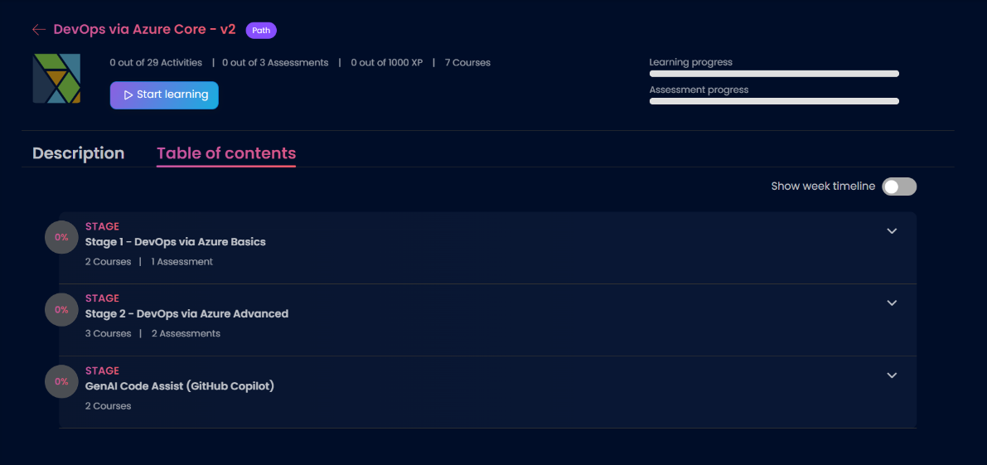
As part of my cloud learning path, I was introduced to Azure Fundamentals (AZ-900) and Azure Administrator concepts (AZ-104). This provided me with a strong understanding of cloud computing principles, including virtual machines, storage solutions, networking components, and resource management. I also explored identity management and basic security concepts, which are essential for maintaining secure and scalable cloud environments.
Image 2.1: DevOps via Azure

To reinforce my learning, I participated in Azure use-case-based lab sessions, where I gained hands-on experience in deploying and managing cloud resources. As shown in Image 2.1, which details the "DevOps via Azure Core - v2" learning path, my training was structured into distinct stages ranging from foundational basics to advanced GenAI code assistance with GitHub Copilot.
These practical sessions helped me understand real-world applications of theoretical concepts, such as provisioning virtual machines, configuring networks, and managing storage services. Overall, this initial phase effectively combined behavioural development with technical skill-building, laying a strong foundation for my continued growth in the Cloud domain.

Fundamental of Infra and Cloud

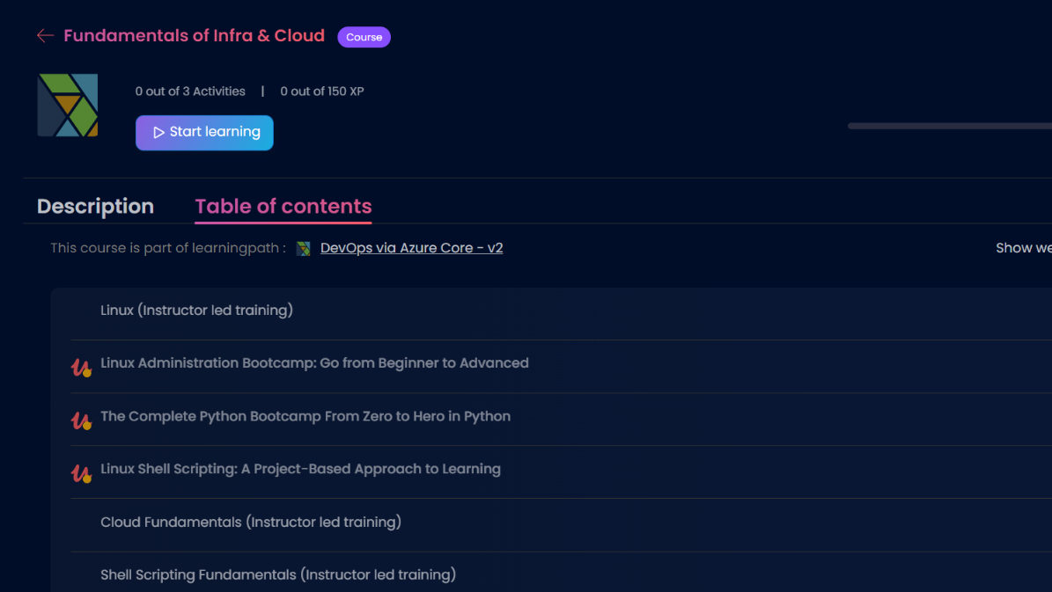
During the Stage 1 Track, a comprehensive understanding of Linux Fundamentals, Shell Scripting, and Python programming was developed, focusing on both theoretical concepts and practical implementation through hands-on exercises and mini tasks. These technologies form the backbone of modern cloud and DevOps environments, enabling efficient system management, automation, and application development.
Image 2.2: Stage 1 Overview

    - Linux Administration Bootcamp
Linux, a widely used open-source operating system, was studied to understand its architecture, file system hierarchy, and command-line interface. The training emphasized practical usage of essential commands such as ls, cd, pwd, cp, mv, and rm for file and directory management. Concepts such as file permissions, user and group management, and process handling were explored to understand system-level security and operations. Tools like top, ps, and kill were used to monitor and manage running processes. This provided a strong foundation for working in server environments, where Linux is predominantly used in cloud infrastructure and enterprise systems.
To gain deeper insights into real-world system operations, practical scenarios were implemented. Tasks such as organizing directories, modifying file permissions using chmod, and managing ownership using chown helped in understanding system administration. Additionally, the importance of environment variables and system configuration files was studied, highlighting how Linux systems are customized and managed efficiently. These activities demonstrated how command-line proficiency improves productivity and enables effective interaction with cloud-based virtual machines.

    - Linux Shell Scripting: A Project-Based Approach to Learning
Shell Scripting was introduced as a powerful method to automate repetitive tasks and streamline workflows in Linux environments. Scripts were created using basic constructs such as variables, loops, and conditional statements to perform dynamic operations. Practical implementations included automating file creation, performing scheduled backups, checking system health, and handling errors such as missing files or invalid inputs. Logging mechanisms were also incorporated to track script execution, which is a critical practice in real-world environments for monitoring and debugging. This module emphasized how automation reduces manual effort and increases operational efficiency in DevOps practices.
Further, advanced scripting concepts were applied through structured problem-solving tasks. Scripts were designed to handle edge cases, validate user inputs, and generate custom outputs based on conditions. Error handling techniques were implemented to improve script reliability and prevent unexpected failures. These activities provided a deeper understanding of how shell scripts are used in production environments for system maintenance, deployment automation, and monitoring.

    - The Complete Python Bootcamp: Zero to Hero in Python
Python programming was introduced as a versatile and high-level language widely used in automation, data processing, and backend development. The learning covered fundamental concepts such as variables, data types, control structures (loops and conditionals), functions, and file handling. Practical exercises included writing programs for file operations, implementing logic-based problems, and creating small automation utilities. Exception handling was also explored to manage runtime errors and improve program stability.
To strengthen practical understanding, integrated tasks combining Python with system operations were performed. These included automating file handling processes, reading and processing data, and executing system commands through Python scripts. This demonstrated how Python can be used alongside Linux and shell scripting to build efficient automation solutions.
Overall, this module provided a strong technical foundation by combining system administration, scripting, and programming skills. It highlighted the importance of command-line expertise, automation, and problem-solving in modern IT environments, and prepared for advanced applications in cloud computing and DevOps practices.

Azure Devops and Cloud Basics

Following the successful completion of the initial month of behavioral conditioning and foundational holistic training, a rigorous qualifier assessment was conducted. This checkpoint evaluated my technical aptitude, analytical problem-solving capabilities, and readiness for complex architectural tracks. Upon clearing this benchmark, I officially progressed into the highly specialized DevOps via Azure domain. From March 23rd onwards, structured technical training was undertaken as part of the official Cloud Batch at Cognizant. This advanced learning path was intentionally architected to transition our cohort from local system administration to enterprise-scale cloud engineering, combining rigorous conceptual methodologies with direct, hands-on environment provisioning.
The technical curriculum initiated with an extensive overview of DevOps services and modern software engineering philosophies. This module served to reframe how applications are built, tested, secured, and deployed in high-velocity business environments. The training introduced the core concepts of Continuous Integration and Continuous Deployment (CI/CD), infrastructure automation, and automated telemetry. Rather than treating development and operations as isolated silos, this overview demonstrated how they merge into a unified lifecycle. We explored the strategic importance of DevSecOps, focusing on "shift-left" security practices where vulnerability scanning, compliance checks, and secure code analysis are integrated directly into the early stages of the deployment pipeline. This foundational overview established a clear understanding of how automation reduces manual error, minimizes deployment risk, and accelerates time-to-market.
As Stage 1 progressed into its later weeks, the curriculum shifted its weight entirely toward a comprehensive, high-intensity deep dive into Microsoft Azure and fundamental cloud infrastructure. The training evolved from high-level overviews into granular architectural analysis, focusing deeply on how cloud platforms enable highly available, fault-tolerant, and on-demand resource distribution. This phase was designed to build complete technical fluency in Infrastructure as a Service (IaaS), ensuring that every theoretical cloud concept was backed by practical configuration experience within the Azure ecosystem.
A primary pillar of this Azure deep dive was computing resource management, centered around Azure Virtual Machines. I analyzed different VM sizing tiers, compute architectures, and pricing models to understand how to optimize workloads based on memory, CPU, and storage performance requirements. This computational training was directly integrated with a deep study of Azure Storage Services. I explored the mechanics of data persistence, studying the distinct use cases and performance traits of Azure Blob Storage, Azure Files, and Disk Storage. This included configuring data replication strategies—such as Locally Redundant Storage (LRS) and Geo-Redundant Storage (GRS)—to ensure business continuity and disaster recovery readiness for critical enterprise data.
The latter portion of Stage 1 placed a massive, non-negotiable emphasis on cloud networking and resource governance. I gained hands-on experience designing and implementing secure cloud boundaries using Azure Virtual Networks (VNets). This involved creating custom subnetting schemes, implementing public and private IP allocation, and writing granular security rules within Network Security Groups (NSGs) to control inbound and outbound traffic. To tie these components together, the training emphasized Azure’s hierarchical governance framework. I mastered the organization of cloud infrastructure across Management Groups, Subscriptions, and Resource Groups, while utilizing Azure Role-Based Access Control (RBAC) to enforce the principle of least privilege. This extensive deep dive provided an airtight technical foundation, ensuring a thorough command over cloud networking, data security, and resource lifecycles before advancing to complex container orchestration pipelines.

  - Microsoft Azure
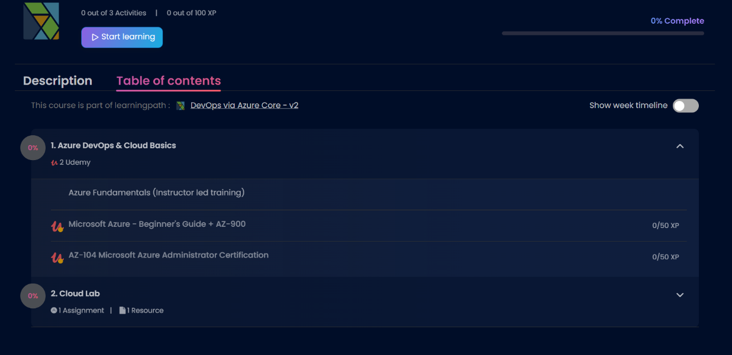
As part of the Cloud domain training as shown in image 2.3, I worked extensively with Microsoft Azure, a leading enterprise cloud computing platform that provides a comprehensive suite of services spanning computing, storage, networking, monitoring, and security. Azure enables organizations to deploy, optimize, and manage applications on a highly scalable and resilient infrastructure without the burden of maintaining physical on-premises hardware. The platform operates on a consumption-based, pay-as-you-go model and natively supports high availability, fault tolerance, and global geographic accessibility, making it an ideal foundation for modern distributed enterprise applications.
Image 2.3: Azure Fundamentals Modules
The training involved both deep architectural conceptualization and direct, command-line and portal-based implementation of core Azure services. One of the primary tasks performed was the strategic creation, configuration, and provisioning of Azure Virtual Machines (VMs). This hands-on activity provided an intimate look into Infrastructure as a Service (IaaS), where virtualized, multi-tenant computing resources are carved out and provisioned over the cloud. While working with these virtual instances, I explored a multitude of production configuration parameters, including operating system distribution selection, regional deployment strategies for latency mitigation, resource sizing tiers optimized for specific compute or memory workloads, and access management profiles. This provided critical technical insight into how cloud-based servers can be efficiently deployed, hardened, and maintained in complex enterprise environments.
Another cornerstone area covered during this intensive training was cloud networking through the engineering of Azure Virtual Networks (VNets). I learned how to systematically define private IP address spaces, partition environments into secure subnets, and configure Network Security Groups (NSGs) to enable isolated, rule-based communication between cloud resources. This exercise helped in understanding how Azure provides network isolation, routing control, and secure internet connectivity, which are critical aspects when architecting secure multi-tier cloud frameworks for corporate workloads.
Resource management and corporate governance were further enhanced through the deployment of tagging mechanisms. By programmatically assigning structured metadata tags to various Azure resources, I was able to categorize, group, and track assets based on parameters such as project name, deployment environment (Dev/QA/Prod), or cost-center ownership. This practice is widely utilized across the IT industry to manage large-scale cloud deployments, enabling automated cost tracking, financial accountability, strict corporate governance, and structured resource allocation.
Additionally, I performed end-to-end backup and restore operations for virtual machines, which highlighted the non-negotiable importance of disaster recovery and data protection strategies in enterprise cloud systems. By creating Recovery Services vaults, configuring automated backup retention policies, and executing simulated disaster restoration processes, I gained an industry-standard understanding of how organizations safeguard critical business data, minimize data loss (RPO), and ensure continuous business operations in the event of system failures or unexpected outages.

    - Microsoft Azure Fundamentals (AZ-900) Certification Training
The initial phase of formal technical validation centered around the Microsoft Azure Fundamentals (AZ-900) curriculum. This comprehensive training program on Udemy was designed to establish a verified, baseline understanding of cloud concepts and core platform mechanics.
- Architectural Mastery: The coursework provided a deep, formalized look into core cloud concepts, specifically distinguishing between Public, Private, and Hybrid cloud models, while evaluating the financial and operational trade-offs between Capital Expenditure (CapEx) and Operational Expenditure (OpEx).
- Core Service Mapping: It systematically structured my knowledge of Azure architectural components, detailing the relational hierarchy between Geographies, Regions, Availability Zones, and Resource Groups.
- Security, Privacy, and Compliance: A significant portion of the training focused on understanding cloud security baselines, covering tools like Azure Active Directory (now Microsoft Entra ID), the role of the Trust Center, compliance documentation, and the foundational Zero-Trust security model.
- Outcome: Successfully completing this certification preparation track formally solidified my understanding of cloud governance, pricing calculators, and SLA structures, establishing the theoretical framework necessary to speak the language of cloud architecture fluently.

    - Microsoft Azure Administrator (AZ-104) Certification Training
Following the foundational track, the curriculum immediately progressed into the advanced, highly technical Microsoft Azure Administrator (AZ-104) certification training course on Udemy. This intensive track transitioned from fundamental overviews to deep-dive system administration, engineering, and resource optimization.
- Identity and Governance Management: The advanced training focused heavily on configuring secure access control at an enterprise scale. This included implementing Microsoft Entra ID identities, managing self-service password reset (SSPR), configuring conditional access policies, and executing Azure Role-Based Access Control (RBAC) to enforce strict, least-privilege administrative boundaries.
- Hybrid Storage and Data Management: I analyzed advanced data management techniques, including the configuration of Azure Storage replication, managing secure access tokens (SAS), configuring network access to storage accounts, and utilizing tools like AzCopy and Azure Storage Explorer for secure, high-throughput data migration.
- Advanced Compute and Networking Configuration: This module went deep into automated compute deployments and complex network routing. I mastered the configuration of Azure Virtual Machine Scale Sets (VMSS) for automated elastic scaling, configured advanced VNet-to-VNet peering paths, managed custom routing tables (User Defined Routes), and implemented high-availability traffic distribution via Azure Load Balancers and Application Gateways.
- Outcome: The completion of this rigorous preparation course validated my capability to act as a production-ready Azure Administrator, ensuring I possess the technical skills required to monitor, scale, secure, and manage sophisticated, resilient cloud infrastructures in a live DevOps environment.

2.5 Qualifier Assessment
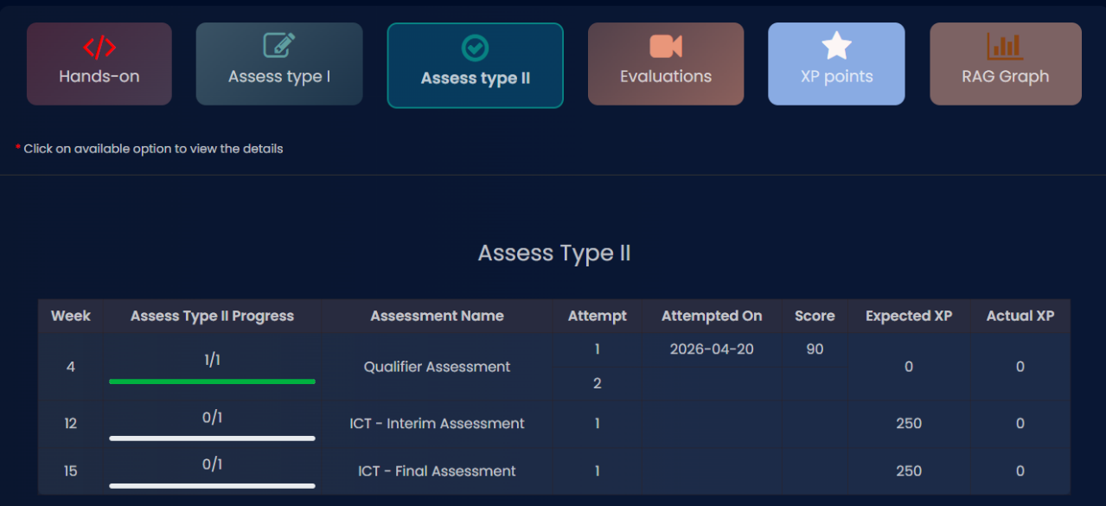
To systematically measure technical competency and ensure operational readiness before transitioning into deep cloud implementation, the training program incorporated structured evaluation checkpoints. Following the completion of the core preparatory courses, a mandatory milestone exam was administered to test our analytical and practical application of the concepts.
Image 2.4: Qualifier Assessment Score
As detailed in Image 2.4, this evaluation was conducted under the "Assess Type II" track as the official Qualifier Assessment. The examination served as a technical gatekeeper for the internship, establishing a strict performance benchmark where the minimum qualifying score was set at 70%. The assessment comprehensively tested my knowledge across system administration, foundational cloud architectures, and operational automation strategies.
I successfully cleared this milestone on my first attempt with a score of 90 out of 100, demonstrating a strong conceptual grasp and an ability to troubleshoot real-world technical scenarios. Securing a score well above the qualification threshold validated the effectiveness of my study methodology during the initial month of the Cloud Batch.

2.6 Devops via Azure Advanced
Upon demonstrating baseline technical proficiency in foundational cloud metrics and infrastructure provisioning, the learning roadmap smoothly transitioned into Stage 2: DevOps via Azure Advanced. While the previous phase concentrated heavily on isolated system administration and Cloud infrastructure as a service (IaaS), Stage 2 was engineered to elevate my technical skill set toward automated software delivery, configuration management, and end-to-end continuous integration and deployment pipelines.
This advanced module shifted the operational lens from manual server setup to enterprise-grade automation frameworks. The primary architectural objective of Stage 2 was to simulate a real-world engineering lifecycle where code flows seamlessly from a developer's machine through automated quality checking, building, deployment, and real-time production monitoring. By exploring a highly integrated ecosystem of industry-standard tools, I developed an understanding of how distinct infrastructure and engineering utilities collaborate to form resilient, self-healing, and high-velocity delivery pipelines.

2.6.1 Devops -Core
The initial, heavy technical pillar under this advanced track was DevOps – Core. This module provided a deep dive into the operational mechanics of the software development lifecycle, source control governance, automated build pipelines, immutable infrastructure configuration, and modern log aggregation. The specific domains and integrated technologies mastered during this phase included:
SDLC, Git Version Control, and Collaborative Workflows
The engineering track began with a foundational reinforcement of the Software Development Lifecycle (SDLC) alongside modern agile tracking using Jira and Confluence. I learned how project managers and engineering teams track operational velocity, assign tasks, and maintain cross-functional documentation. This project management layer was directly integrated with a deep dive into Git for version control. Through exhaustive practical tracking, I mastered source control mechanics, branch management strategies, conflict resolution, and collaborative code integration. This established a critical foundation, ensuring that all subsequent automated deployment pipelines were triggered by secure, structured version control events.
Automated Build Management with Maven and Gradle
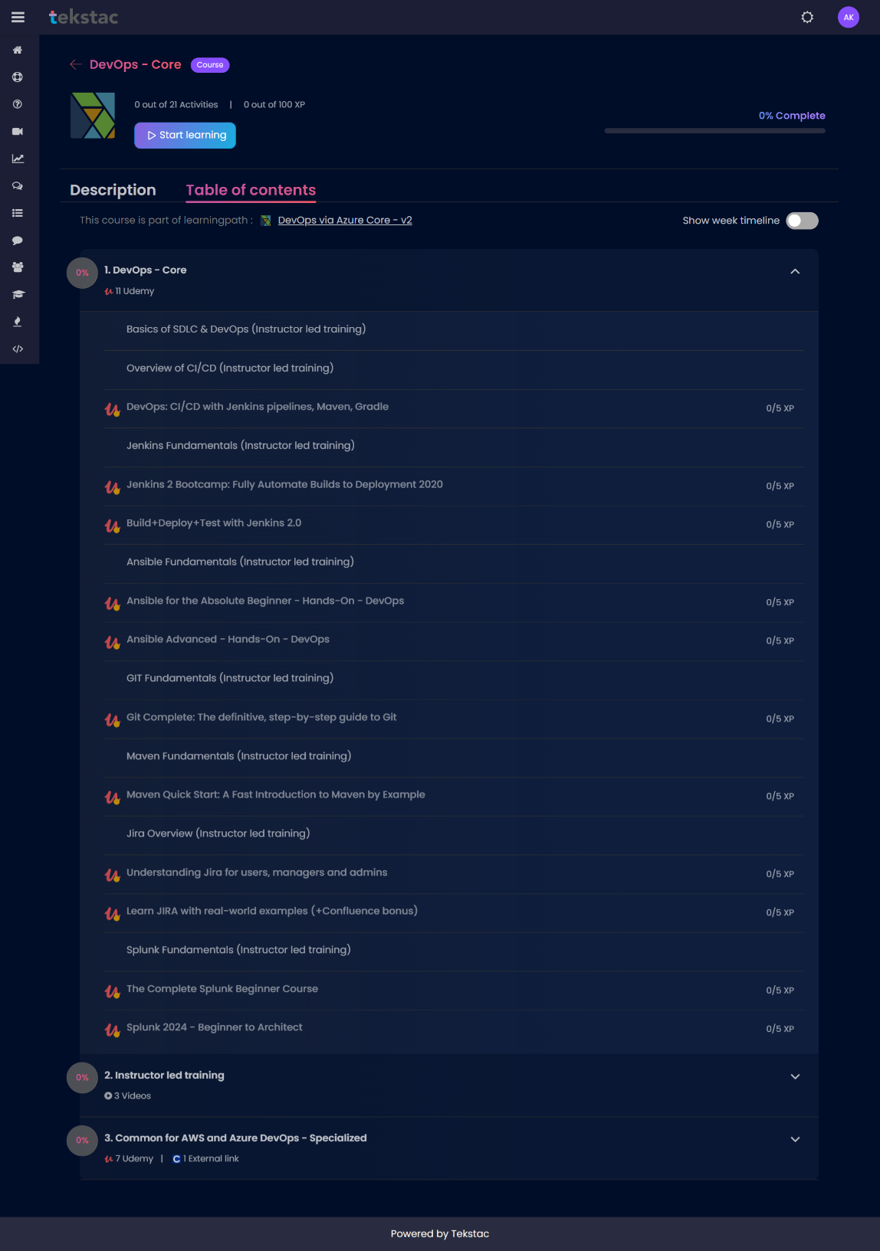
To eliminate manual compilation errors and handle complex application dependencies at scale, the training heavily incorporated automated build tools, focusing extensively on Maven and Gradle frameworks. I analyzed the internal architecture of project object model files, learning how to configure automated dependencies, manage plugins, compile source code, and run unit test suites programmatically. This module highlighted how modern applications are packaged into stable, deployable artifacts, serving as a non-negotiable step before injecting software into continuous deployment pipelines.
Image 2.5: DevOps Core Path

Continuous Integration and Deployment via Jenkins Pipelines
At the center of the core DevOps curriculum was an intensive focus on continuous integration and continuous deployment (CI/CD) utilizing Jenkins 2.0. The training evolved from basic Jenkins job creation into scripting advanced declarative and scripted Jenkins files. I gained practical exposure to designing multi-stage automation pipelines that automatically pull updated source code from Git, trigger Maven build scripts, execute automated test frameworks, and manage artifact archiving. This extensive training demonstrated how Jenkins serves as the central automation orchestrator, minimizing human intervention and accelerating deployment feedback loops.
Infrastructure Configuration and Management via Ansible
To address configuration drift and enforce consistency across large-scale server clusters, the module transitioned into automated configuration management using Ansible. Moving from foundational playbooks to advanced modular roles, I learned to write declarative YAML syntax to automate software installations, manage system configurations, and patch remote target environments over secure shell (SSH) connections. This experience highlighted the paradigm of Infrastructure as Code (IaC), demonstrating how entire server configurations can be versioned, audited, and deployed repeatably without manual system modifications.
Enterprise Telemetry, Observability, and Log Aggregation via Splunk
The final phase of the DevOps Core track focused on post-deployment operational health, utilizing Splunk as an enterprise observability platform. The training provided a comprehensive walkthrough of log forwarding, indexing, data parsing, and dashboard construction. I learned how to build complex search queries to parse distributed application logs, monitor system metrics in real time, and configure automated alerts to flag infrastructure anomalies or deployment failures.

2.6.2 Azure DevOps- Specialized
Following the automation and configuration baseline established in the initial phase of Stage 2, the technical curriculum advanced into immutable infrastructure engineering and distributed container systems. This segment transitioned from configuration management to structural infrastructure provisioning and microservices management, focusing on declarative orchestration engines and Site Reliability Engineering (SRE) paradigms.

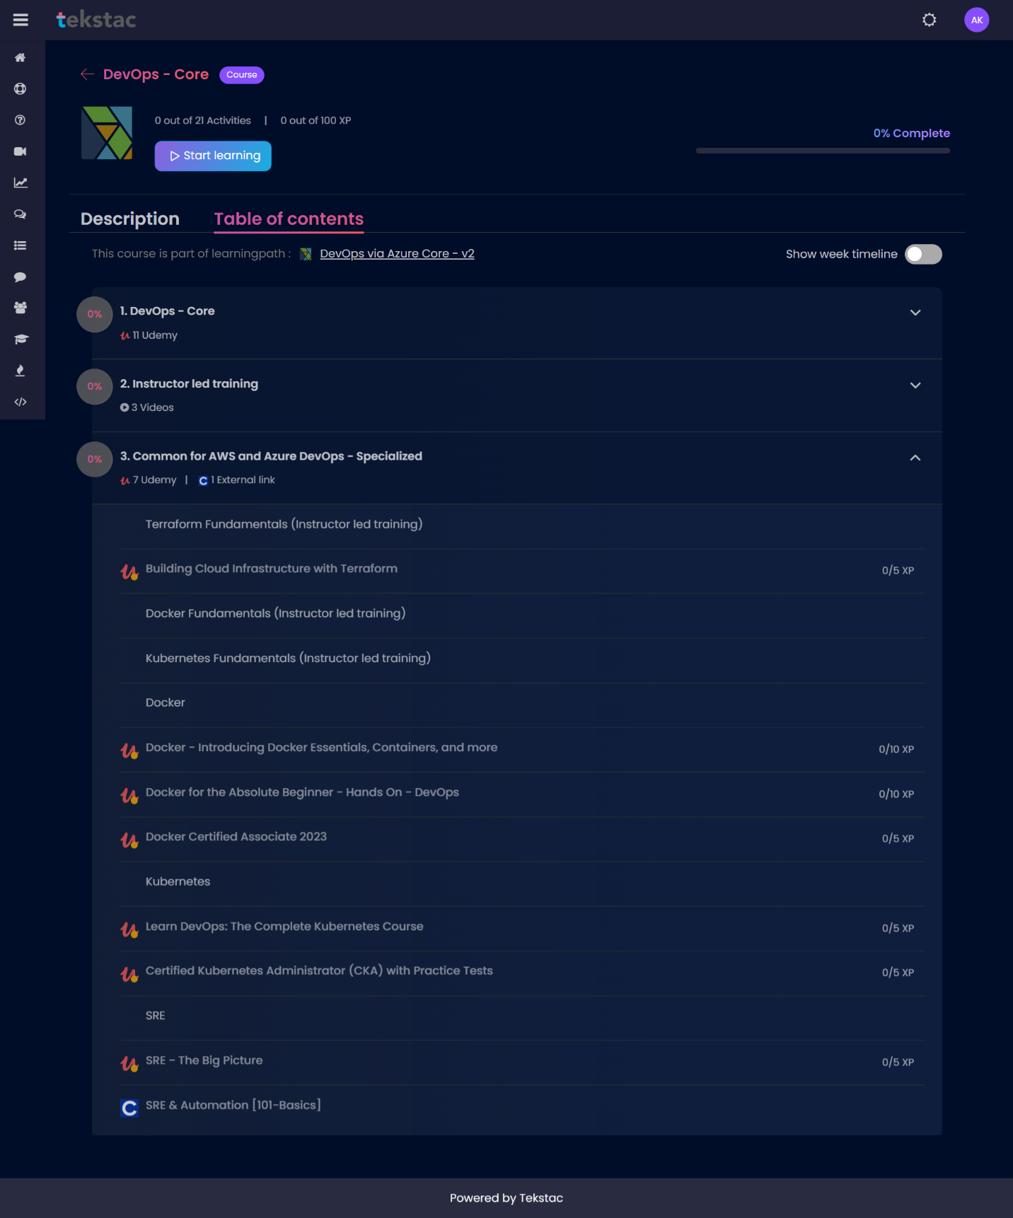
Image 2.6: Devops Specialized Path
As shown in image 2.6, second technical pillar under the advanced track focused heavily on treating infrastructure entirely as software, isolating runtime applications, managing automated cluster lifecycles, and establishing enterprise reliability metrics. The core frameworks and engineering modules mastered during this phase included:
Declarative Infrastructure as Code (IaC) via Terraform
The advanced infrastructure track began with a deep dive into Terraform as an open-source, cloud-agnostic provisioning engine. The training moved from foundational state mechanics to building complex cloud infrastructure using HashiCorp Configuration Language (HCL). I analyzed how Terraform maintains an architectural state file (terraform.tfstate) to track real-world resource mappings against declarative code configurations. Practical milestones involved writing modular Terraform scripts to provision scalable network components, security boundaries, and compute instances. This training highlighted how to automate immutable infrastructure deployments, execute dry-run planning phases, and manage predictable cloud infrastructure lifecycles without configuration drift.
Container Isolation, Image Optimization, and Runtime Management via Docker
To address application portability issues and eliminate local dependency mismatches, the module transitioned into containerization mechanics using Docker. The training spanned from absolute beginner building blocks to specialized enterprise-grade image optimization aligned with the Docker Certified Associate (DCA) curriculum. I gained hands-on experience writing optimized, multi-stage Dockerfiles to minimize attack surfaces and layer counts, managing local network topologies, and configuring persistent volume storage mounts. This module demonstrated how to package microservices with their explicit runtimes, ensuring absolute consistency from local developer workstations directly to production multi-tenant environments.
Enterprise Container Orchestration and Cluster Administration via Kubernetes
With microservices containerization established, the curriculum advanced into a comprehensive, production-scale deep dive into container orchestration utilizing Kubernetes. Structured closely around the Certified Kubernetes Administrator (CKA) curriculum, this module provided rigorous, hands-on exposure to cluster architecture, control plane mechanics, and worker node communication. I mastered the declarative deployment of core API primitives, including Pods, Deployments, ReplicaSets, and StatefulSets. Advanced laboratory simulations involved implementing high-availability ingress routing, managing network security policies, configuring dynamic persistent volume provisioning, and executing rolling, zero-downtime updates. This extensive training established the skill set required to automate the scaling, self-healing, and maintenance of distributed application clusters.

Site Reliability Engineering (SRE) Methodologies and High-Availability Systems
The final phase of this advanced DevOps core curriculum focused on the institutional practices of Site Reliability Engineering (SRE). Moving beyond basic automation, the module explored the strategic application of software engineering principles directly to infrastructure operations. I analyzed core SRE paradigms, including the calculation of Service Level Indicators (SLIs) and Service Level Objectives (SLOs), managing error budgets to balance deployment velocity against system stability, and identifying system dependencies to eradicate manual operational toil. This framework provided a holistic perspective on how modern engineering teams architect highly resilient, self-monitoring systems that can tolerate unexpected failures while maintaining optimal user availability.

3. Skills Acquired
During the internship at Cognizant, I gained a comprehensive set of technical and professional skills essential for modern IT infrastructure and cloud-native development. The program focused on transitioning from academic theory to industry-oriented application.
Technical Skills
- Cloud Computing and Microsoft Azure: Developed a strong foundation in cloud principles and gained hands-on experience in provisioning virtual machines, managing storage accounts, and configuring secure virtual networks.
- DevOps and Automation: Mastered the DevOps lifecycle and used tools like Jenkins and Azure DevOps to automate build and deployment processes, ensuring continuous delivery.
- Scripting and Version Control: Improved proficiency in Linux command-line operations, Shell scripting, and Python, while mastering version control using Git and GitHub for collaborative development.
- Containerization and Orchestration: Gained practical experience with Docker for application packaging and Kubernetes for automated scaling, management, and orchestration of containerized systems.
- Cloud Security and SRE: Learned to integrate security within the CI/CD pipeline and applied Site Reliability Engineering principles like monitoring and incident management to maintain system stability.
Professional and Behavioural Skills
- Corporate Communication: Enhanced professional interpersonal skills, including email etiquette and navigating organizational culture, through structured Behavioral and Holistic training.
- Analytical Thinking: Developed the ability to analyze complex technical problems and debug deployment failures by effectively utilizing system logs to identify root causes.
- Workplace Adaptability: Built confidence in handling real-world projects and adapting to new tools, technologies, and industry standards within a professional setting.

4. Challenges and Solutions:
A variety of technical and operational obstacles were encountered throughout the internship, each serving as a significant learning opportunity. One of the most prominent hurdles was navigating the complexity of cloud architecture, specifically regarding the interdependencies and resource management within the Azure ecosystem. This was successfully addressed through a combination of guided lab sessions and repetitive hands-on practice, which helped in developing the clarity needed to manage cloud-based virtual machines and networking components.

Furthermore, the implementation and configuration of CI/CD pipelines presented a steep learning curve, often resulting in errors during the integration of Jenkins, Git, and Azure. These difficulties were resolved by conducting detailed root-cause analysis through system logs and refining pipeline stages to ensure consistent deployment processes. This experience was instrumental in shifting from a purely academic mindset to a professional approach focused on identifying and solving real-time execution failures.

Finally, adapting to the command-line interface and mastering scripting logic for Linux and Python required substantial effort due to limited prior exposure. To overcome this, extra time was dedicated to experimenting with shell scripts for task automation and system monitoring. Additionally, initial difficulties in aligning with corporate communication standards and professional ethics were mitigated by participating in Behavioral and Holistic training sessions. These efforts ultimately resulted in a professional mindset focused on streamlining operations and ensuring system reliability.

As the technical track advanced into advanced cloud engineering, managing declarative state synchronization in Terraform and container communication within Kubernetes emerged as a significant hurdle. During lab simulations, minor discrepancies between written code and active cloud resources frequently triggered infrastructure drift or deployment errors. Similarly, establishing secure networking boundaries, ingress routing paths, and persistent volumes across distributed container clusters presented a steep learning curve. Overcoming these challenges required a rigorous application of command-line diagnostics and system log inspection. This intensive troubleshooting refined my ability to manage immutable architecture, ensuring that containerized microservices remain portable, isolated, and scalable under real-world production constraints.

Optimizing Distributed Monitoring Pipelines and Site Reliability Baselines The final operational obstacle centered around configuring centralized telemetry using Splunk and adapting to Site Reliability Engineering (SRE) paradigms. Gathering data from multiple distributed applications often led to formatting errors and log ingestion bottlenecks, making it difficult to construct accurate monitoring dashboards. Furthermore, learning to translate system data into actionable metrics—like Service Level Indicators (SLIs) and error budgets—demanded a major shift from reactive troubleshooting to proactive system engineering. I resolved these bottlenecks by mastering complex search queries, building custom log-parsing rules, and setting up automated alerts. This experience ultimately emphasized the value of deep system observability, teaching me how to eliminate operational inefficiencies and maintain high availability across modern corporate infrastructures.

5. Conclusion and Future Scope

The internship at Cognizant Technology Solutions, conducted at the Cognizant (SRZ) facility in Chennai, proved to be a highly enriching and multidimensional learning experience. It provided me with an opportunity to enhance my technical knowledge while gaining exposure to the real-world working environment of a global IT services organization. Cognizant is a leading technology partner that empowers clients to modernize technology and transform experiences, making this internship a valuable platform for industry-oriented learning. The structured training across various domains such as cloud computing, DevOps via Azure, version control with Git, and Linux scripting helped in building a strong foundation in modern software development and deployment practices. These training modules were designed to provide both conceptual clarity and practical understanding, enabling me to grasp how applications are developed, deployed, and maintained in real-world scenarios.

Another important aspect of the internship was understanding the importance of integrating automation with development processes through CI/CD pipelines and structured workflows. Learning about cloud architecture, resource management, and deployment best practices further strengthened my awareness of building reliable and efficient software systems. Simultaneously, the focus on behavioral standards and professional ethics helped in transitioning from an academic mindset to a corporate environment.

The internship has now been successfully completed and has played a crucial role in shaping my technical and professional skills. It has prepared me to take on future challenges in the field of cloud computing and DevOps, with a motivated interest in exploring advanced technologies such as containerization and orchestration to further enhance my capability to work on scalable systems.

6. Annexures

Annexure A: Internship Details

- Internship Period: January 2025 – June 2025
- Organization: Mark9 Pte Ltd
- Project Title: KUOK-SubCon

Annexure B: Figures Description

Figure No. | Title | Description
2.1 | DevOps via Azure | Displays the complete path of overall internship.
2.2 | Stage 1 Overview | Shows the list of courses to be completed
2.3 | Azure Fundamentals Modules | Training courses on AZ-900 and AZ-104
2.4 | Qualifier Assessment Score | Details marks scored in Qualifier assessment.
2.5 | DevOps Core Path | Displays courses listed in first module in stage 2.
2.6 | Devops Specialized Path | Displays courses focused on DevOps to be completed.

Annexure C: Tools and Technology Used

Tool/Technology | Purpose/Description
Azure Cloud Console | Manage Microsoft cloud resources and services.
Linux - Ubuntu | Open-source operating system powering modern servers
Python | Language for automation and development
Jenkins | Automation server for continuous integration pipelines
Ansible | Agentless configuration management and deployment tool
Git and GitHub | Version control system for collaborating on code
Maven | Build automation tool for Java projects
Jira | Agile project management and issue tracking
Splunk | Analyse and monitor machine-generated log data
Terraform | Infrastructure as code for cloud provisioning
Docker | Package applications into lightweight, portable containers
Kubernetes | Automate orchestration of containerized application deployments

