EXECUTIVE SUMMARY

The internship under the INTCIS26CNAIP DevOps via Azure domain at Cognizant offered a comprehensive and structured exposure to modern cloud computing technologies, security frameworks, and DevOps methodologies. It was carefully designed to bridge the gap between academic knowledge and industry expectations by providing practical experience with real-world tools, platforms, and workflows commonly used in enterprise environments.
The training program encompassed multiple core domains, including Microsoft Azure, scripting and automation, DevSecOps practices, python fundamentals, and containerization technologies such as Docker and Kubernetes. Equal emphasis was placed on both theoretical concepts and hands-on implementation, enabling a deeper understanding of how scalable, secure, and efficient cloud-based systems are designed, deployed, and managed.
The internship followed a structured learning approach supported by continuous assessments, practical exercises, and domain-specific modules. This not only strengthened technical proficiency but also enhanced analytical thinking, problem-solving capabilities, and adaptability to real-world scenarios. Exposure to industry-relevant practices such as infrastructure automation, monitoring, security integration, and platform engineering further contributed to a well-rounded skill set.

Overall, the internship served as a significant learning experience, equipping me with the foundational knowledge and practical skills required to operate effectively in modern cloud and DevOps environments. This report presents a detailed account of the training structure, domains covered, hands-on work performed, tools and technologies utilized, and the key outcomes achieved during the internship.

Internship Overview

1.1 Overview
This section describes the academic and professional backdrop of my internship with INTCIS26CNAIP DevOps via Azure domain at Cognizant. It discusses the objectives, relevance, training progression, tools used, and evaluation techniques. The internship was part of the academic program and was designed to provide structured, industry-relevant learning experiences in cloud computing and associated domains.
The internship began with an introduction to cloud fundamentals and progressed through organized training in technologies such as Microsoft Azure, scripting, DevSecOps, python fundamentals, and containerization using Docker and Kubernetes. The training also included cloud platform assessments to evaluate understanding and practical knowledge.
Cognizant is a global leader in cloud and digital transformation services, helping organizations modernize infrastructure and adopt cloud-native technologies for scalable and secure solutions.

This report explores each phase of the internship and provides insights into how the training combined theoretical concepts with practical exposure to real-world cloud technologies.

Company Profile

Cognizant is a multinational technology company headquartered in Teaneck, New Jersey,USA with a strong global presence in over 40 countries and a workforce of more than 350,000 professionals.
The company provides services in:

    - Cloud Computing and Digital Transformation
    - Artificial Intelligence and Data Analytics
    - Cloud Security and Risk Management
    - Application Development and Maintenance
    - Consulting and Business Services

Cognizant helps organizations modernize their IT infrastructure and adopt cloud-based solutions for improved efficiency and innovation.

1.2.1 Vision, Mission, and Core Values

Cognizant’s vision is to empower organizations through technology and innovation to achieve sustainable growth in the digital era.

Its mission focuses on helping clients transform their business processes using advanced technologies such as cloud computing, AI, and automation.

The company operates on core values such as:

    - Work as one
    - Raise the bar
    - Dare to innovate
    - Do the right thing
    - Own it

These values are reflected in its work culture and training approach.

1.2.2 Cognizant in India

Cognizant has a strong presence in India with multiple delivery centres across major cities such as:
    - Pune
    - Bangalore
    - Mumbai
    - Hyderabad
    - Chennai
    - Kolkata

These centres play a key role in global service delivery, innovation, and training programs.

1.3 Objectives of the Internship

The internship was designed to integrate academic learning with practical industry exposure in c computing, DevSecOps, and cybersecurity. It acted as an application layer for subjects related to IT infrastructure, networking, and system security.

The internship's objectives included:

- Understanding core Java programming concepts and object-oriented principles.
- Learning web development technologies such as HTML, CSS, and JavaScript.
- Gaining knowledge of automation testing using Selenium WebDriver.
- Improved problem-solving and analytical thinking skills.

1.4 Type of Work
- Automation Framework Engineering: Developed a Hybrid Automation Framework using the Page Object Model (POM) with Selenium WebDriver to automate web application testing and reduce manual effort.
- Test Management & Execution: Utilized TestNG for organizing test suites, implementing parallel execution, and generating detailed execution reports.
- Full-Stack & API Development: Built and validated REST APIs using Java, focusing on JSON data exchange, backend database integration, and basic security authentication.
- Build & Pipeline Management: Managed project dependencies and automated build lifecycles using Maven, while integrating scripts into CI/CD pipelines for continuous testing.
- Quality Assurance (QA): Performed end-to-end testing (STLC), including Unit Testing with JUnit, Performance Testing with JMeter, and comprehensive defect documentation.
- Requirement Analysis: Conducted requirement engineering by drafting SRS documents and translating business logic into technical test cases within an Agile/Scrum environment.

Training Component

2. Topics Covered

Stage 1: DevOps via Azure

During the initial phase of my journey at Cognizant, from 12th March to 20th March, I underwent a comprehensive behavioral and holistic training program designed to build a strong professional foundation. This phase focused on developing essential workplace competencies such as effective communication, collaboration, adaptability, and understanding organizational values. Sessions on diversity and inclusion, professional ethics, and corporate communication helped me align with industry expectations and enhanced my ability to interact confidently in a professional environment.

Following this, I progressed to Stage 1 of my technical training, where I gained foundational knowledge in Linux, Shell Scripting, and Python. I learned key Linux commands, file system management, and process handling, which are crucial for working in cloud-based environments. In addition, I developed basic scripting skills to automate routine tasks and improved my programming understanding through Python, focusing on core concepts such as control structures, file handling, and simple problem-solving techniques.

As part of my cloud learning path, I was introduced to Azure Fundamentals (AZ-900) and Azure Administrator concepts (AZ-104). This provided me with a strong understanding of cloud computing principles, including virtual machines, storage solutions, networking components, and resource management. I also explored identity management and basic security concepts, which are essential for maintaining secure and scalable cloud environments.

To reinforce my learning, I participated in Azure use-case-based lab sessions, where I gained hands-on experience in deploying and managing cloud resources. These practical sessions helped me understand real-world applications of theoretical concepts, such as provisioning virtual machines, configuring networks, and managing storage services.

Overall, this initial phase effectively combined behavioral development with technical skill-building, laying a strong foundation for my continued growth in the Cloud domain.

Linux, Shell Scripting and Python Fundamentals

During the Stage 1 Track, a comprehensive understanding of Linux Fundamentals, Shell Scripting, and Python programming was developed, focusing on both theoretical concepts and practical implementation through hands-on exercises and mini tasks. These technologies form the backbone of modern cloud and DevOps environments, enabling efficient system management, automation, and application development.
Linux, a widely used open-source operating system, was studied to understand its architecture, file system hierarchy, and command-line interface. The training emphasized practical usage of essential commands such as ls, cd, pwd, cp, mv, and rm for file and directory management. Concepts such as file permissions, user and group management, and process handling were explored to understand system-level security and operations. Tools like top, ps, and kill were used to monitor and manage running processes. This provided a strong foundation for working in server environments, where Linux is predominantly used in cloud infrastructure and enterprise systems.
To gain deeper insights into real-world system operations, practical scenarios were implemented. Tasks such as organizing directories, modifying file permissions using chmod, and managing ownership using chown helped in understanding system administration. Additionally, the importance of environment variables and system configuration files was studied, highlighting how Linux systems are customized and managed efficiently. These activities demonstrated how command-line proficiency improves productivity and enables effective interaction with cloud-based virtual machines.
Shell Scripting was introduced as a powerful method to automate repetitive tasks and streamline workflows in Linux environments. Scripts were created using basic constructs such as variables, loops, and conditional statements to perform dynamic operations. Practical implementations included automating file creation, performing scheduled backups, checking system health, and handling errors such as missing files or invalid inputs. Logging mechanisms were also incorporated to track script execution, which is a critical practice in real-world environments for monitoring and debugging. This module emphasized how automation reduces manual effort and increases operational efficiency in DevOps practices.
Further, advanced scripting concepts were applied through structured problem-solving tasks. Scripts were designed to handle edge cases, validate user inputs, and generate custom outputs based on conditions. Error handling techniques were implemented to improve script reliability and prevent unexpected failures. These activities provided a deeper understanding of how shell scripts are used in production environments for system maintenance, deployment automation, and monitoring.
Python programming was introduced as a versatile and high-level language widely used in automation, data processing, and backend development. The learning covered fundamental concepts such as variables, data types, control structures (loops and conditionals), functions, and file handling. Practical exercises included writing programs for file operations, implementing logic-based problems, and creating small automation utilities. Exception handling was also explored to manage runtime errors and improve program stability.
To strengthen practical understanding, integrated tasks combining Python with system operations were performed. These included automating file handling processes, reading and processing data, and executing system commands through Python scripts. This demonstrated how Python can be used alongside Linux and shell scripting to build efficient automation solutions.
Overall, this module provided a strong technical foundation by combining system administration, scripting, and programming skills. It highlighted the importance of command-line expertise, automation, and problem-solving in modern IT environments, and prepared for advanced applications in cloud computing and DevOps practices.

Software Development Life Cycle and Software Testing Life Cycle

During the course of the internship, significant hands-on experience was gained in understanding and applying the principles of the Software Development Life Cycle (SDLC) and Software Testing Life Cycle (STLC) through practical assignments and documentation activities. The primary task involved the preparation of a detailed Software Requirements Specification (SRS) document for a Generative AI Chatbot system. This document was developed following standard guidelines and included key sections such as introduction, scope, system features, external interface requirements, and non-functional requirements. The SRS helped in clearly defining the functional expectations of the system, including conversational capabilities, context management, API integrations, and administrative monitoring features. It also outlined system constraints such as performance requirements, scalability, and security considerations, thereby providing a structured foundation for system development.
In alignment with SDLC phases, the requirement analysis phase was addressed through the creation of the SRS document, while the design phase was reflected in the architectural understanding of chatbot functionalities such as natural language processing, session management, and integration with external services. Although full-scale development was not carried out, a conceptual understanding of system implementation and deployment strategies was established, particularly in cloud-based environments.
A major focus area of the internship was software testing, where STLC principles were applied extensively. Multiple test cases were designed and documented for different application modules such as comment management (Facebook-like system), tweet scheduling (Twitter-like system), profile update management (LinkedIn-like system), and banking operations including login validation and fund transfer scenarios. Each test case included detailed components such as test case ID, test scenario, preconditions, step-by-step execution procedures, test data, and expected results. These test cases ensured validation of both positive and negative scenarios, including error handling, invalid inputs, and system behavior under exceptional conditions such as network failure or insufficient balance.
The testing approach emphasized systematic validation of functionalities, ensuring that user actions such as adding, editing, and deleting content, scheduling posts, updating profiles, and performing financial transactions behaved as expected. The work also demonstrated an understanding of real-world testing practices by covering edge cases and ensuring reliability and robustness of applications. Through this process, practical exposure to manual testing techniques and structured test documentation was achieved.

Overall, this activity provided comprehensive exposure to both SDLC and STLC processes, highlighting the importance of requirement clarity, structured documentation, and rigorous testing in software development. It enhanced analytical thinking, attention to detail, and the ability to design and validate software systems effectively, preparing for real-world industry practices.

DevOps

During the internship, practical exposure to DevOps concepts and tools was gained through theoretical understanding, case study analysis, and hands-on activities. A detailed study of the DevOps lifecycle was carried out, covering all major phases including planning, coding, building, testing, release, deployment, operation, and monitoring. The DevOps phase diagram was implemented and understood as a continuous loop where each stage contributes to faster and more reliable software delivery. The planning phase focused on defining project goals, requirements, and workflows. In the coding phase, version control practices were introduced to manage and track source code efficiently. The build phase involved understanding how source code is converted into executable software using automated tools, followed by the testing phase where both manual and automated testing techniques are applied to identify and fix defects. The release and deployment stages ensured that applications are delivered to production environments smoothly, while the operate and monitor phases emphasized maintaining system performance and tracking real-time issues.
A major component of the DevOps learning was the study of Version Control Systems (VCS), which are essential for collaborative software development. The concept of tracking changes, maintaining version history, and enabling multiple developers to work simultaneously without conflicts was explored. Both Centralized Version Control Systems (CVCS) and Distributed Version Control Systems (DVCS) were studied, with a strong focus on Git as a distributed version control tool. Key features such as branching, merging, data integrity, and offline capabilities were understood. Practical knowledge of Git workflows was developed, including the stages of modifying files, adding them to the staging area, committing changes locally, and pushing them to remote repositories. Common Git commands such as git init, git clone, git add, git commit, git push, and git pull were learned and applied conceptually. The importance of the staging area in controlling and organizing changes before committing was also emphasized.
Additionally, the use of GitHub as a remote repository platform was studied for code storage, version tracking, and team collaboration. Concepts such as pull requests, issue tracking, and
repository management were explored, highlighting their importance in real-world software development environments. Git Bash was introduced as a command-line interface tool that provides a Linux-like environment on Windows, enabling efficient execution of Git commands and system operations.
A case study on Vodafone’s DevOps transformation was analyzed to understand real-world implementation. The study highlighted how Vodafone transitioned from a traditional, hardware-centric organization to a software-driven enterprise by adopting DevOps practices. Key challenges such as infrequent releases and fragmented development efforts were addressed through automation, collaboration, and continuous integration and delivery, resulting in improved efficiency and faster innovation.
As part of hands-on practice, Docker was introduced to understand containerization. A basic “Hello World” application was created by writing a Dockerfile based on Ubuntu, building a Docker image, and running it as a container. This demonstrated how applications can be packaged along with their dependencies and executed in isolated environments, ensuring consistency across different systems.
Overall, the DevOps activities provided a comprehensive understanding of modern software development practices, emphasizing automation, collaboration, version control, and continuous delivery. The experience enhanced knowledge of real-world development workflows and prepared for implementing DevOps principles in industry environments.

Stage 2: DevOps via Azure

After the successful completion of one month of Behavioural and Holistic training along with Stage 1, a qualifier assessment was conducted to evaluate my understanding and readiness for the next phase of learning. Based on this assessment, I progressed further in the DevOps via Azure domain. From 23rd March onwards, structured training was undertaken as part of the Cloud Batch at Cognizant, focusing on a wide range of industry-relevant technologies and practices. The learning path was designed to provide both conceptual understanding and practical exposure to modern cloud computing and DevOps ecosystems.
The training began with Microsoft Azure, where core cloud concepts such as virtual machines, storage services, networking, and resource management were studied. This provided a foundational understanding of how cloud platforms enable scalable, on-demand infrastructure and services. Following this, DevSecOps concepts were introduced, emphasizing the integration of security practices within the DevOps lifecycle. The importance of “shift-left” security, secure coding practices, and vulnerability management in continuous integration and continuous deployment pipelines was explored.
Shell scripting was also included as a core skill, enabling automation of repetitive tasks, system operations, and workflow management in cloud and Linux environments. This helped in improving efficiency and reducing manual intervention in routine processes.
The program also included multiple assessment checkpoints such as the Cloud Platform Assessment and Platform Assessment to evaluate understanding and practical application of concepts. Infrastructure-related topics focused on cloud architecture, resource provisioning, and infrastructure management strategies, reinforcing the concept of Infrastructure as a Service (IaaS). Cloud security fundamentals were introduced to address security challenges, including data protection, access control, and risk mitigation strategies.
A significant portion of the training was dedicated to Containers and Kubernetes, where containerization concepts were explored to understand application deployment in isolated environments. Kubernetes was studied as a container orchestration platform, enabling automated deployment, scaling, and management of containerized applications in distributed systems.
Overall, the Cloud Domain training provided comprehensive exposure to modern cloud technologies, DevOps practices, security integration, and container-based deployment strategies. The structured progression from foundational cloud concepts to advanced orchestration and security topics helped build a strong technical base. This experience enhanced practical understanding, problem-solving abilities, and readiness to work in real-world cloud computing environments.

Microsoft Azure

As part of the Cloud domain training, I worked extensively with Microsoft Azure, a leading cloud computing platform that provides a wide range of services including computing, storage, networking, monitoring, and security. Azure enables organizations to deploy and manage applications on a scalable and reliable infrastructure without the need for physical hardware. The platform follows a pay-as-you-go model and supports high availability, fault tolerance, and global accessibility, making it suitable for modern enterprise applications.
The training involved both conceptual understanding and practical implementation of core Azure services. One of the primary tasks performed was the creation and configuration of Virtual Machines (VMs). This activity helped in understanding Infrastructure as a Service (IaaS), where
virtualized computing resources are provisioned over the cloud. While working with virtual machines, I explored various configuration parameters such as operating system selection, region deployment, resource sizing, and access management. This provided insight into how cloud-based servers can be efficiently deployed and managed in real-world scenarios.
In addition to compute services, I worked on Azure Storage by creating and configuring storage accounts. This involved understanding different storage types such as Blob storage for unstructured data, File storage for shared access, and Disk storage for virtual machine persistence. I also configured storage settings related to access control, redundancy options, and performance tiers, which are essential for ensuring data durability, availability, and security in cloud environments.
Another important area covered during the training was networking through the creation of Virtual Networks (VNets). I learned how to define IP address spaces, create subnets, and enable secure communication between cloud resources. This exercise helped in understanding how Azure provides network isolation and secure connectivity, which are critical aspects in designing cloud architectures for enterprise applications.
Resource management was further enhanced through the use of tagging mechanisms. By assigning tags to various Azure resources, I was able to categorize and organize them based on different parameters such as project, environment, or ownership. This practice is widely used in industry to manage large-scale cloud deployments, enabling efficient cost tracking, governance, and resource allocation.
The training also included monitoring and performance management using Azure Monitor. Through this, I analyzed system metrics, viewed logs, and configured alerts to track the health and performance of deployed resources. This provided practical exposure to how cloud environments are continuously monitored to ensure reliability, detect anomalies, and maintain optimal performance.
Additionally, I performed backup and restore operations for virtual machines, which highlighted the importance of disaster recovery and data protection strategies in cloud systems. By configuring backup policies and testing restoration processes, I gained an understanding of how organizations safeguard critical data and ensure business continuity in case of failures or unexpected events.
Overall, the hands-on experience with Microsoft Azure significantly strengthened my understanding of cloud computing principles and their practical applications. The training enabled me to work with real cloud infrastructure, manage resources efficiently, and apply best practices related to scalability, security, monitoring, and recovery. This experience serves as a

DevSecOps

As part of the Cloud domain training, I was introduced to DevSecOps, an advanced software development approach that integrates security practices into the DevOps lifecycle. DevSecOps emphasizes the concept of “shifting security left,” meaning that security is incorporated from the initial stages of development rather than being treated as a final step. This approach ensures that applications are not only developed and deployed rapidly but are also secure, compliant, and resilient against potential threats.
The training began with an understanding of the DevOps lifecycle, which includes stages such as planning, coding, building, testing, releasing, deploying, operating, and monitoring. DevSecOps enhances this lifecycle by embedding automated security checks and validation mechanisms at each stage. This reduces vulnerabilities, improves code quality, and ensures continuous security throughout the software delivery pipeline.
One of the key practical tasks performed was the implementation of Continuous Integration and Continuous Deployment (CI/CD) pipelines. Through this task, I learned how code changes are automatically built, tested, and deployed using pipeline automation tools. The integration of security checks within the CI/CD process demonstrated how vulnerabilities can be detected early, thereby minimizing risks and reducing the cost of fixing issues at later stages.
Another significant hands-on activity involved working with Docker to create containerized applications. I developed a Dockerfile based on a base image and built Docker images, which were then executed as containers. This exercise provided insight into containerization, where applications and their dependencies are packaged together to ensure consistency across development, testing, and production environments. Containerization also plays a crucial role in modern DevSecOps practices due to its portability and scalability.
The training also covered Dynamic Application Security Testing (DAST), where I performed security testing on running applications to identify vulnerabilities such as injection flaws, cross-site scripting, and misconfigurations. This helped in understanding how real-time security testing is conducted to detect issues that may not be visible during static analysis.
In addition, I worked on Software Composition Analysis (SCA), which involves identifying and analyzing third-party libraries and dependencies used within an application. This task highlighted the importance of managing open-source components, as vulnerabilities in external libraries can significantly impact application security. By performing SCA, I learned how to detect outdated
or vulnerable dependencies and ensure compliance with security standards.
Another critical task involved Container Security Scanning, where Docker images were analyzed for vulnerabilities before deployment. This ensured that the containerized applications were free from known security risks and adhered to best practices in secure image creation and deployment. Furthermore, I explored Infrastructure as Code (IaC), which involves managing and provisioning infrastructure through code rather than manual processes. This approach improves consistency, reduces human error, and allows infrastructure configurations to be version-controlled and automated. Integrating security within IaC ensures that infrastructure deployments follow predefined security policies and compliance requirements.
Overall, the DevSecOps training provided a comprehensive understanding of how development, security, and operations are integrated into a unified workflow. The combination of theoretical concepts and hands-on tasks enabled me to understand the importance of automation, continuous monitoring, and proactive security practices. This experience has equipped me with the knowledge to build secure, scalable, and efficient software systems while adhering to modern industry standards and best practices.

Shell Scripting

As part of the Cloud domain training, I developed a strong foundation in Shell Scripting, which is widely used for automating system-level tasks and managing cloud operations efficiently. Shell scripting allows users to execute a sequence of commands in a structured manner, enabling automation, error handling, and logging within operating systems, particularly in Linux environments.
The training began with basic scripting tasks such as printing system information, listing files in directories, and reading file contents. These tasks helped in understanding command execution, file handling, and interaction with the operating system. I also created scripts to automatically generate multiple files, which demonstrated how repetitive tasks can be efficiently automated using scripting.
Further, I implemented file management operations such as automatic backup of files and handling file-related errors, including scenarios where files are not found. This provided practical exposure to conditional statements and control flow mechanisms in shell scripts.
Error handling was an important aspect of the training. I developed scripts to handle runtime errors such as division by zero and implemented custom error messages to improve script reliability and usability. In addition, I worked on logging mechanisms, where script outputs and operations were recorded both on the console and in log files. This is a critical practice in real-world systems for tracking execution and debugging issues.
The training also included integration with cloud services through scripting. I performed tasks such as listing and creating storage resources, uploading files, and managing virtual machines in Microsoft Azure using command-line interfaces. This provided practical exposure to cloud automation and resource management within a unified platform.
Advanced scripting concepts were applied through exception handling for cloud operations and structured logging of activities. Finally, I developed a complete automation script that combined cloud resource management, logging, and error handling into a single workflow. This demonstrated how shell scripting can be used to build robust and automated solutions for managing cloud infrastructure. Overall, the Shell Scripting training enhanced my ability to automate repetitive tasks, handle system and runtime errors, and integrate scripts with cloud platforms. This experience is essential for efficient system administration, DevOps practices, and cloud-based operations.

Cloud Platform Assessment

As part of the Cloud domain training, I performed a Cloud Platform Assessment to evaluate the readiness of systems and applications for cloud adoption. This assessment focused on analyzing business requirements, technical dependencies, security considerations, and overall system maturity to determine how effectively an organization can transition to a cloud-based environment.
The process began with Cloud Readiness and Strategy analysis, where I examined the existing infrastructure and identified key factors such as scalability requirements, cost considerations, and migration goals. This helped in understanding how organizations plan their transition to the cloud by aligning technical capabilities with business objectives.
Security and Compliance assessment was another critical component, where I evaluated potential risks, data protection requirements, and adherence to regulatory standards. This included understanding how cloud platforms ensure confidentiality, integrity, and availability of data

through proper security frameworks and policies.
I also analyzed Application Dependencies, identifying how different components of an application interact with each other and with external systems. This step is essential for planning cloud migration, as it ensures that all dependencies are properly managed and no critical functionality is disrupted during deployment.
The assessment further included evaluating Cloud Maturity, which involves determining the level of cloud adoption within an organization. This helped in categorizing systems based on their readiness and identifying areas that require improvement before full-scale cloud implementation.
Performance Monitoring was studied to understand how cloud environments track system health, resource utilization, and application performance. This included analyzing metrics, logs, and alerts to ensure that systems operate efficiently and meet expected performance standards.
Additionally, I explored various Security Tools used in cloud environments for vulnerability detection, threat analysis, and compliance monitoring. These tools play a vital role in maintaining secure and reliable cloud operations.
Overall, the Cloud Platform Assessment provided a structured approach to evaluating cloud adoption strategies and identifying gaps in infrastructure, security, and performance. This experience enhanced my ability to analyze real-world systems and recommend suitable cloud solutions based on organizational needs and technical feasibility.

Infrastructure

As part of the Cloud domain training, I gained an understanding of modern cloud infrastructure and its key components, focusing on how scalable, reliable, and efficient systems are designed and managed. Cloud infrastructure forms the backbone of application deployment, enabling organizations to deliver services with high availability and performance.
The training began with concepts of Load Balancing and Distributed Systems, where I learned how workloads are distributed across multiple servers to ensure optimal resource utilization and fault tolerance. Load balancing helps prevent system overload, while distributed systems allow applications to operate across multiple nodes, improving scalability and reliability.
I also studied Resilient Applications, which are designed to handle failures and continue functioning under adverse conditions. This included understanding strategies such as redundancy, failover mechanisms, and fault isolation. These concepts are essential for maintaining service availability in real-world cloud environments.

Another important area covered was Storage Systems, where I explored different types of storage solutions used in cloud computing, including block storage, object storage, and file storage. I learned how data is managed, stored, and retrieved efficiently while ensuring durability and accessibility.
The training further included Virtual Machines, Serverless Computing, and Auto Scaling. Virtual machines provide on-demand compute resources, while serverless computing allows applications to run without managing underlying infrastructure. Auto scaling ensures that resources are automatically adjusted based on demand, helping maintain performance while optimizing costs.
Overall, the Infrastructure training provided a comprehensive understanding of how cloud systems are designed to be scalable, resilient, and efficient. It enhanced my ability to understand system architecture, manage resources effectively, and apply best practices for building robust cloud-based applications.

Cloud Security

As part of the Cloud domain training, I studied fundamental cloud security concepts with a focus on protecting cloud environments, systems, and networks. Cloud security plays a vital role in safeguarding data, applications, and infrastructure from unauthorized access, threats, and vulnerabilities. The training included both conceptual understanding and practical scenarios related to security best practices and risk management.
The learning began with cloud security principles, where I explored how improperly configured storage resources, such as publicly accessible buckets, can result in data leaks. I learned to secure these resources by implementing strict access controls, Identity and Access Management (IAM) policies, and continuous monitoring. The Principle of Least Privilege was emphasized to ensure that users and services are granted only the permissions they strictly require. Multi-Factor Authentication (MFA) was also highlighted as an additional layer of protection against unauthorized access, along with the importance of explicit deny rules in access control strategies.
Network security concepts were covered to understand how data is protected during transmission across cloud environments. This included the use of encryption protocols for secure communication and identifying risks associated with unsecured or public networks. I also examined common attack techniques such as sniffing and spoofing, and how tools like Virtual Private Networks (VPNs) help secure data over untrusted connections.
The training further addressed personal and device security practices, including the creation of strong passwords and passphrases, enabling multi-factor authentication, and carefully managing application permissions. These measures help minimize the risk of account breaches and unauthorized data exposure.
Threat detection and response were key areas of focus, where I studied various attack methods such as phishing and vishing. I learned to identify indicators of compromise, including abnormal system behavior, reduced performance, and unauthorized configuration changes. Safe usage practices, such as scanning external devices before use, were also emphasized.
Additionally, I explored web and network safety practices, including verifying secure websites through HTTPS and avoiding suspicious or malicious domains. Understanding the distinction between public and private IP addresses helped in analyzing network traffic and identifying potential vulnerabilities.
The training also included the use of basic network diagnostic tools such as ping and netstat to monitor connectivity and detect unusual activities. I gained experience in investigating unknown processes by reviewing system logs, validating file origins, and utilizing threat detection mechanisms. Incident response techniques were also introduced, including identifying anomalies like unusual login attempts and applying corrective actions promptly.
Overall, the cloud security training provided a comprehensive understanding of securing cloud, network, and system environments. It enhanced my ability to detect threats, implement preventive controls, and maintain secure operations of applications and infrastructure in real-world scenarios.

Containers and Kubernetes

As part of the Cloud and DevOps training program, I gained practical experience in containerization and orchestration technologies through hands-on work with Docker and Kubernetes. This module emphasized how modern applications are efficiently packaged, deployed, and managed within scalable cloud ecosystems.
The learning journey began with core containerization concepts, where a basic application developed using Node.js or Python Flask was containerized. A Dockerfile was created to define the runtime environment, required dependencies, and execution workflow. The container image was then built and executed locally, demonstrating application isolation and portability across environments.
Subsequently, container image handling was explored by tagging images and uploading them to a registry such as Docker Hub. Retrieving and running these images on different systems highlighted the consistency and portability benefits of container-based deployment.
The focus then shifted to Kubernetes, where initial exposure involved deploying applications using Pods defined through YAML configuration files. This provided insight into how containers are orchestrated within a cluster. The application was later managed using Deployments, enabling replication, automatic recovery, and scalability. Scaling operations were performed to dynamically adjust replicas, ensuring reliability and availability.
To facilitate communication, Kubernetes Services such as NodePort and ClusterIP were used to expose the application, making it accessible externally. Deployment strategies like rolling updates and rollbacks were also implemented to achieve seamless updates and minimize downtime during releases.
Configuration management was handled through ConfigMaps and environment variables, allowing application settings to remain separate from code. Sensitive data, including credentials, was secured using Kubernetes Secrets, reinforcing secure development practices.
Persistent storage concepts were implemented using Persistent Volumes (PV) and Persistent Volume Claims (PVC), ensuring that application data remained intact even after container restarts, thereby supporting stateful workloads.
Troubleshooting and debugging skills were developed using Kubernetes command-line tools such as kubectl describe, logs, and exec, enabling efficient issue identification and resolution in running applications.
In addition, advanced topics such as Helm for package management, Horizontal Pod Autoscaling (HPA), multi-container Pod configurations, and Ingress-based routing were explored, providing a comprehensive view of production-grade Kubernetes environments.
Overall, this module delivered strong hands-on knowledge in deploying, managing, and scaling containerized applications, aligning closely with industry standards in cloud-native and DevOps practices.

Platform Engineering

As part of the Cloud and DevOps training, practical exposure in Platform Engineering concentrated on enhancing developer efficiency, ensuring workflow consistency, and enabling self-service infrastructure capabilities.
A “Golden Path” strategy was implemented to minimize microservice setup time by leveraging pre-configured templates, uniform project structures, and automated CI/CD pipelines. This facilitated rapid service creation with built-in logging, monitoring, and security features.
To address variations across teams, centralized CI/CD frameworks were introduced with reusable components for build, testing, and deployment stages, while still providing flexibility through configurable parameters.
Challenges such as low platform adoption were mitigated by improving tool usability, enhancing documentation, and increasing flexibility. A streamlined deployment approach was developed using containerization and orchestration tools like Docker, Kubernetes enabling end-to-end automation from code integration to deployment, thereby reducing manual effort for developers.
The concept of Platform as a Product was incorporated by defining measurable indicators such as adoption rate, deployment frequency, lead time, and developer experience. Continuous feedback mechanisms, including surveys and telemetry data, were used to drive ongoing platform improvements.
For self-service infrastructure, solutions were designed using Terraform and identity management systems, allowing developers to independently provision resources with minimal dependency on approvals. Resource utilization and cost efficiency were managed through quotas, budget notifications, and monitoring dashboards.
Additionally, concepts such as API Gateway and Service Mesh were studied to ensure secure and efficient communication between microservices, along with governance practices using Policy-as-Code to enforce security standards and cost controls.
Overall, this phase provided hands-on experience in designing scalable, automated, and developer-centric platforms within modern cloud ecosystems.

Site Reliability Engineering (SRE)

As part of the Cloud and DevOps training, practical sessions in Site Reliability Engineering (SRE) emphasized maintaining system stability, high availability, and optimal performance through monitoring, automation, and well-defined incident management strategies.
The learning process began with establishing Service Level Indicators (SLIs) and Service Level Objectives (SLOs) by evaluating application uptime and response latency. Key reliability metrics were assessed, and error budgets were determined using simulated failure scenarios, helping to understand acceptable limits of system downtime in real-world environments.
Incident management concepts were applied by developing a structured incident response workflow and preparing a detailed postmortem format that included problem description, impact analysis, root cause, and resolution steps. Root Cause Analysis (RCA) was carried out for situations such as application failures caused by excessive CPU utilization, enhancing analytical and troubleshooting capabilities.
System architecture principles were explored by designing resilient infrastructures with redundancy and failover capabilities, such as deploying multiple servers behind a load balancer. High availability was further ensured by configuring automatic service recovery mechanisms to handle unexpected failures.
Monitoring and observability were implemented using tools like Prometheus and Grafana, where critical system parameters such as CPU usage, memory consumption, and uptime were tracked and displayed through dashboards. Alert systems were configured based on predefined thresholds, enabling proactive identification of potential issues.
Performance and scalability were evaluated through load and stress testing by simulating concurrent user activity and analyzing system behavior under varying workloads. Based on these insights, both vertical and horizontal scaling approaches were considered to enhance system efficiency
Automation played a significant role, where repetitive operational tasks like log maintenance and service restarts were streamlined using scripting techniques. Furthermore, Infrastructure as Code (IaC) practices were implemented using tools like Terraform to provision and manage resources in a consistent and automated manner.
Overall, the SRE module offered valuable hands-on experience in reliability engineering practices, including monitoring, incident response, performance tuning, and automation, enabling the development of robust, scalable, and highly reliable systems.

Tools, Technologies, and Platforms
The internship emphasized practical exposure to tools and technologies widely used in the cloud computing and DevOps ecosystem.

The tools and technologies included:

    - Microsoft Azure: Enterprise cloud solutions and platform services
    - Scripting (Bash/Python basics): Used for automation and cloud operation
    - DevSecOps Tools & Concepts: CI/CD pipelines, automation, and secure development practices
    - Cloud Security Concepts: Identity and Access Management (IAM), data protection, and security policies
    - Docker: Containerization platform for application deployment
    - Kubernetes: Container orchestration for scalable applications
    - Cloud Platform Assessment Tools: Used for evaluating system performance, security, and architecture

These technologies helped in understanding how modern IT infrastructure is built, deployed, and secured in cloud environments

2.14 Week-wise Assessment and scores Earned
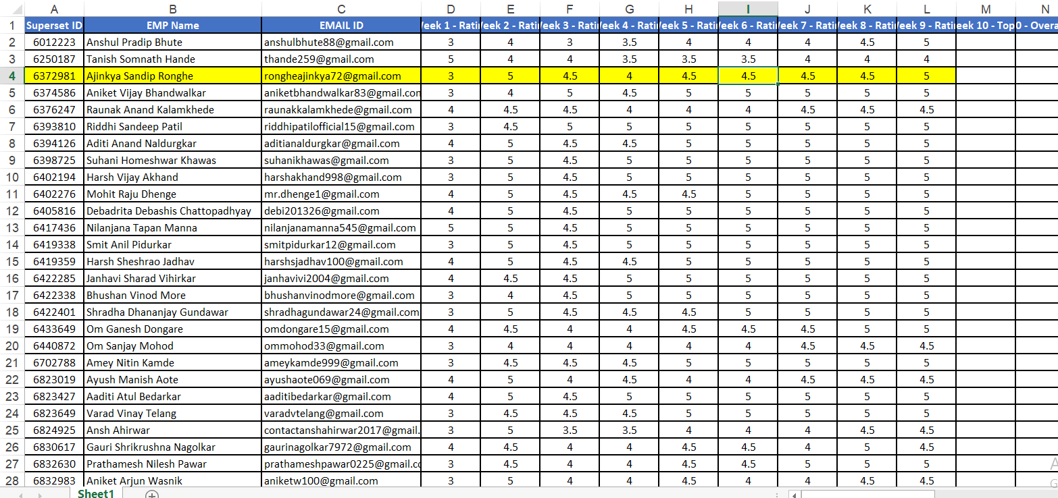

3. Project Component
3.1 Project Title
Hybrid UI–API Automation and Performance Testing Framework for ParaBank Application
3.2 Problem Statement
The ParaBank application lacks an integrated automation solution capable of validating UI functionality, API interactions, and system performance at scale. Manual testing is insufficient to ensure reliability due to frequent changes and complex user workflows.
Therefore, the challenge is to design and implement a Hybrid UI–API–Performance Automation Framework using Selenium, RestAssured, JMeter, TestNG, and Jenkins, enhanced with Selenium Grid and data-driven execution, to achieve continuous, repeatable, and scalable test coverage for the banking system.

3.3 Project Objectives

1. Automate End-to-End UI Functional Testing
To design a Selenium-based framework that validates major ParaBank workflows such as:
- User Registration
- Login and Logout
- Account Overview
- Fund Transfer
- Customer Profile Access
Ensuring accuracy, repeatability, and reduction in manual testing effort.

2. Implement API Automation for Backend Validation
To build RestAssured-based API test suites for:
- User details
- Account details
- Transactions
- Balance and customer services
Ensuring backend reliability and correctness independent of UI.

3. Conduct Performance & Load Testing
To use JMeter for:
- Testing API response times
- Identifying bottlenecks under heavy user load
- Generating HTML performance reports for analysis

4. Build a Unified Hybrid Automation Framework
To integrate UI, API, and Performance testing into a single maintainable framework with:
- Page Object Model (POM)
- Reusable components
- Data-driven testing (Excel)
- Modular architecture

5. Enable CI/CD Automation
To integrate the entire testing workflow with Jenkins so that:
- Test execution becomes automated
- Test results are available after every code update
- The team receives continuous quality feedback

6. Support Cross-Browser and Parallel Execution
Using Selenium Grid to:
- Execute tests across multiple browsers
- Run tests in parallel for faster feedback

3.4 Tools & Technologies

1. Programming & Automation
- Java – Core language for UI and API automation.
- Selenium WebDriver – UI automation framework.
- RestAssured – API testing automation.

2. Testing Frameworks
- Cucumber (BDD) – Feature files & step definitions.
- TestNG – Parallel execution & reporting.
- Page Object Model (POM) – Framework design pattern.

3. Performance Testing
- Apache JMeter – Load and stress testing.

4. Build & Dependency Management
- Maven – Project structure, dependencies, plugins.

5. Continuous Integration
- Jenkins – Automated pipeline for UI, API, and JMeter tests.

6. Selenium Grid
- For distributed & parallel test execution on multiple browsers.

7. Version Control
- Git & GitHub – Source code management.

8. Reporting Tools
- Allure Reports – UI/API test reporting.
- JMeter HTML Dashboard – Performance results.

9. Utilities
- Excel (Apache POI) – Data-driven testing.
- Properties Files – Environment configuration.

3.5 Implementation and Outcome
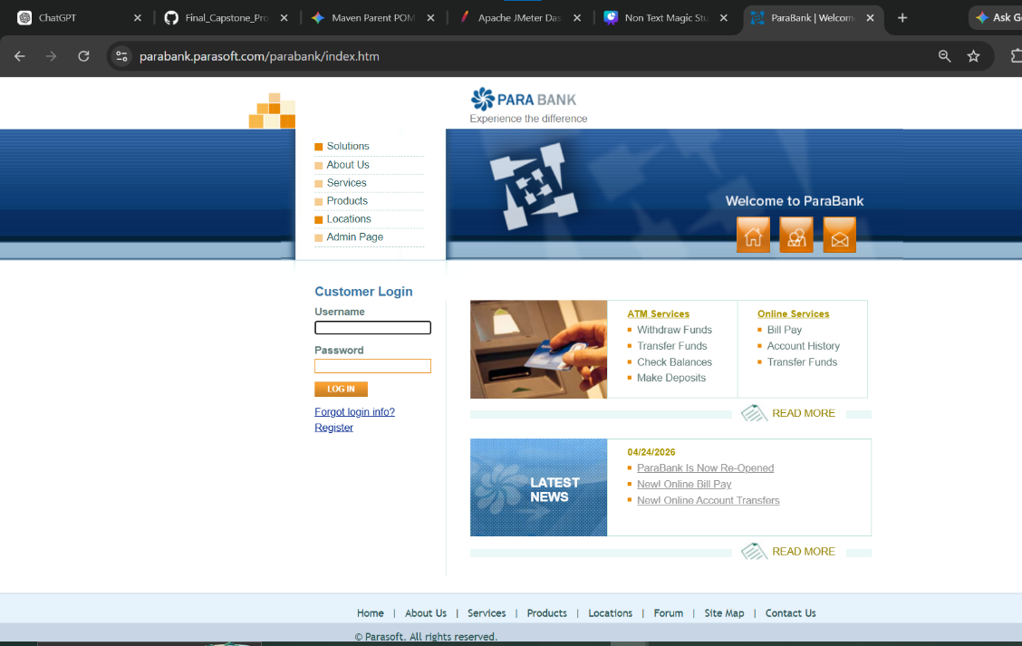
Fig1. Para Bank Website UI

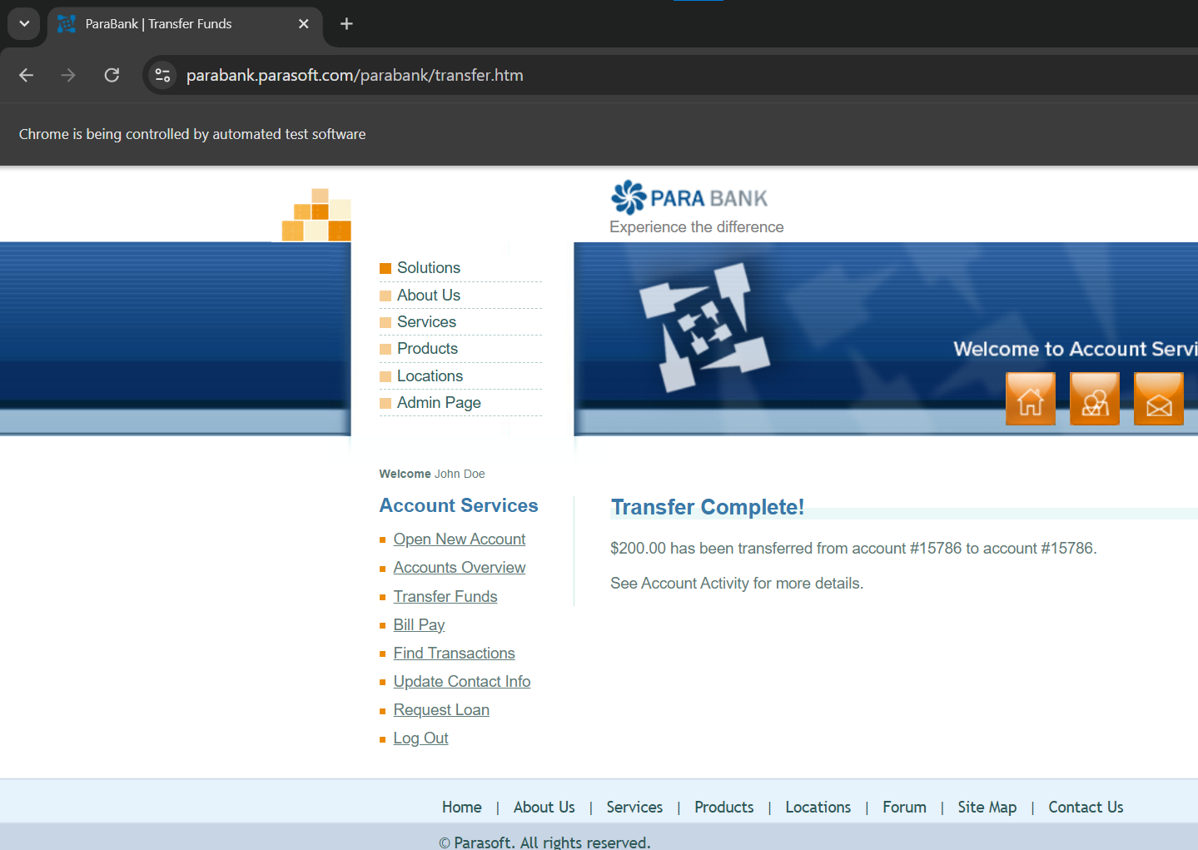
Fig2. UI Testing

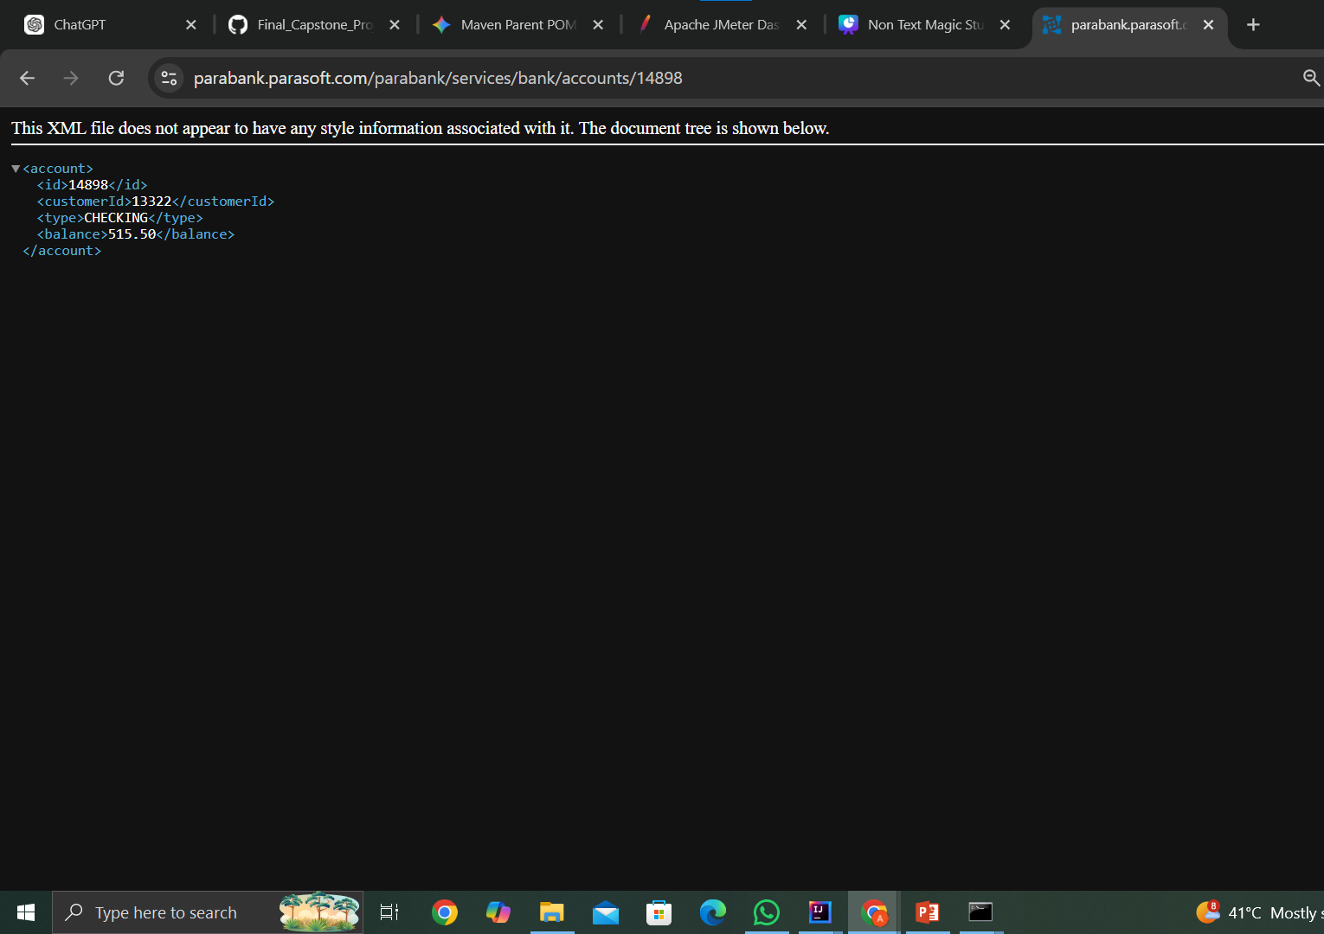

Fig3. API Testing

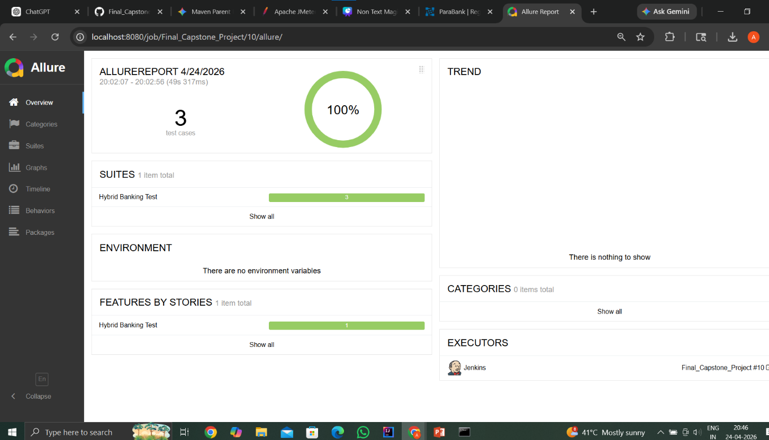
Fig 4. Allure Testing Report

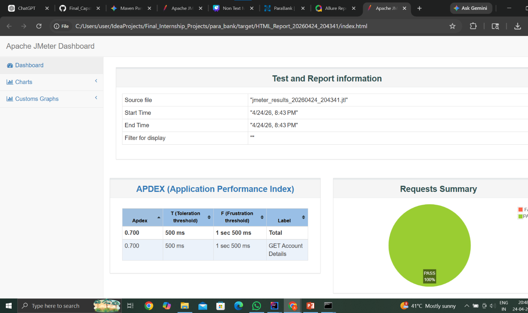
Fig 5. JMeter Report

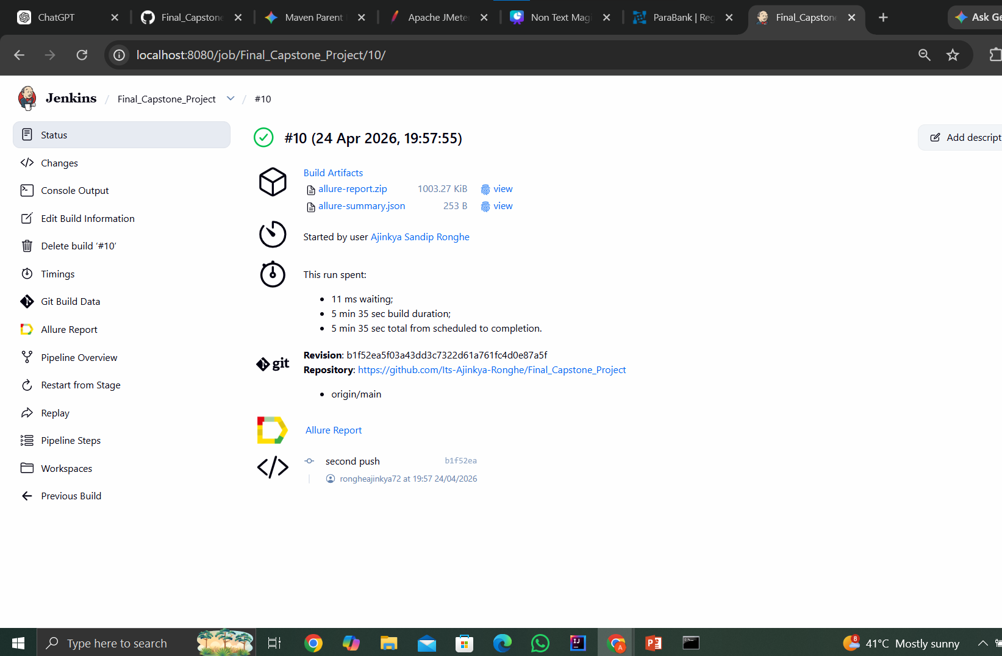
Fig 6. Jenkins CI/CD

4. Conclusion and Future Scope

The internship at Capgemini under the AIVS–Java track proved to be a highly enriching and multidimensional learning experience. It provided me with an opportunity to enhance my technical knowledge while gaining exposure to the real-world working environment of a global IT services and consulting organization. Capgemini is a leading technology partner that helps businesses transform through software engineering, AI, and digital solutions, making this internship a valuable platform for industry-oriented learning. The structured training across various domains such as Java programming, web development, automation testing using Selenium, API testing, and testing frameworks helped in building a strong foundation in modern software development and quality engineering practices. The training modules were designed to provide both conceptual clarity and practical understanding, enabling me to grasp how applications are developed, tested, and maintained in real-world scenarios.

Another important aspect of the internship was understanding the importance of integrating testing with development processes through automation and structured frameworks. Learning about testing methodologies and best practices further strengthened my awareness of building reliable and efficient software systems.

The internship has now been successfully completed and has played a crucial role in shaping my technical and professional skills. It has prepared me to take on future challenges in the field of software development and testing.

5. References
[1] Capgemini, "Quality Engineering and Assurance Services," Capgemini Global. [Online].
Available: https://www.capgemini.com/services/technology-operations/quality-engineering-and-assurance/
[2] Selenium Project, "Selenium WebDriver Documentation," Selenium.dev. [Online].
Available: https://www.selenium.dev/documentation/webdriver/
[3] Oracle, "Java SE Documentation – Language Basics and OOPs," Oracle Help Center. [Online].
Available: https://docs.oracle.com/javase/tutorial/java/concepts/
[4] TestNG, "TestNG Documentation – Testing Framework for Java," TestNG.org. [Online].
Available: https://testng.org/doc/documentation-main.html
[5] Cucumber, "Cucumber Documentation – BDD with Gherkin," Cucumber.io. [Online].
Available: https://cucumber.io/docs/cucumber/
[6] Apache Maven, "Maven – Project Management and Build Automation," Apache Software Foundation. [Online].
Available: https://maven.apache.org/guides/index.html
[7] Rest-Assured, "REST-Assured: Testing and Validating REST Services," Github. [Online].
Available: https://rest-assured.io/
[8] Jenkins, "Jenkins User Documentation – CI/CD Pipelines," Jenkins.io. [Online].
Available: https://www.jenkins.io/doc/
[9] DemoQA, "DemoQA - Practice Site for Automation," ToolsQA. [Online].
Available: https://demoqa.com/
[10] Atlassian, "Agile Coach: A Guide to Agile and Scrum," Atlassian. [Online].
Available: https://www.atlassian.com/agile

