K. RAMAKRISHNAN COLLEGE OF TECHNOLOGY
(AUTONOMOUS)
SAMAYAPURAM, TIRUCHIRAPPALLI – 621 112
DEPARTMENT OF COMPUTER SCIENCE AND ENGINEERING
AI INTERVIEW COACH:
AN AUTOMATED MULTI-AGENT TECHNICAL INTERVIEW PRACTICE AND EVALUATION PLATFORM
A PROJECT REPORT
Submitted by
JEYSHREE V 2303811710422069
MATHIARASI D 2303811710422093
in partial fulfillment of the requirements for the award degree of
Bachelor of Engineering
in
COMPUTER SCIENCE AND ENGINEERING
CSB1303 – OBJECT ORIENTED ANALYSIS AND DESIGN
NOVEMBER – 2026

AI INTERVIEW COACH:
AN AUTOMATED MULTI-AGENT TECHNICAL INTERVIEW PRACTICE AND EVALUATION PLATFORM
A PROJECT REPORT
Submitted by
JEYSHREE V 2303811710422069
MATHIARASI D 2303811710422093
in partial fulfillment of the requirements for the award degree of
Bachelor of Engineering
in
COMPUTER SCIENCE AND ENGINEERING
CSB1303 – OBJECT ORIENTED ANALYSIS AND DESIGN
DEPARTMENT OF COMPUTER SCIENCE AND ENGINEERING
K. RAMAKRISHNAN COLLEGE OF TECHNOLOGY (AUTONOMOUS)
SAMAYAPURAM, TIRUCHIRAPPALLI – 621 112
NOVEMBER – 2026

K. RAMAKRISHNAN COLLEGE OF TECHNOLOGY (AUTONOMOUS)
SAMAYAPURAM – 621 112
BONAFIDE CERTIFICATE
The work embodied in the present project report entitled “AI INTERVIEW COACH: AN AUTOMATED MULTI-AGENT TECHNICAL INTERVIEW PRACTICE AND EVALUATION PLATFORM” has been carried out by the students JEYSHREE V (2303811710422069) and MATHIARASI D (2303811710422093). The work reported herein is original and we declare that the project is their own work, except where specifically acknowledged, and has not been copied from other sources or been previously submitted for any other degree or diploma examination.
Date of Viva Voce: ……………………
SUPERVISOR | HEAD OF THE DEPARTMENT
Mrs. S. GAYATHRI M.E.,  SUPERVISOR  Assistant Professor  Department of CSE  K. Ramakrishnan College of Technology  Samayapuram – 621 112. | Mr. R. RAJAVARMAN M.E., (Ph.D.,)  HEAD OF THE DEPARTMENT  Assistant Professor (Sr. Grade)  Department of CSE  K. Ramakrishnan College of Technology  Samayapuram – 621 112.

INTERNAL EXAMINER EXTERNAL EXAMINER

ABSTRACT
The AI Interview Coach is an intelligent, resume-aware, adaptive technical interview practice and coaching platform designed specifically for undergraduate students and entry-level software engineering candidates. Unlike commercial automated recruitment tools that function as opaque screening mechanisms to filter applicants, this system is architected strictly as a private, formative coaching instrument. The platform bridges the gap between static algorithmic question repositories and expensive human mock interviews by providing dynamic, personalized technical interview simulations grounded verifiably in the candidate's self-reported background.
The platform is engineered around an architectural invariant: 'The LLM proposes, the orchestrator decides, the validator verifies, and the database stores.' A four-tier multi-agent pipeline—comprising a ProfileAgent, PlannerAgent, InterviewerAgent, and EvaluatorAgent—operates through a unified, provider-independent Model Gateway supporting Google Gemini, Groq Cloud, and NVIDIA NIM. The Model Gateway enforces strict JSON schemas, bounded exponential backoff, per-call deadlines, and automatic provider fallback. Crucially, the system remains fully operational via deterministic fallback rule catalogs whenever AI consent is withheld, credentials are unconfigured, network latency spikes, or token quotas expire.
Candidate data isolation is maintained across all layers: resume parsing extracts verbatim text heuristics with mandatory human-in-the-loop fact review before context ingestion. A finite state machine (FSM) implemented in PostgreSQL locks sessions and regulates turn pacing. Post-interview rubric evaluations assess four core technical competencies against concrete 1–5 anchors, requiring verbatim quotation evidence from student answers without ever aggregating scores into misleading single-score rankings. The platform also integrates optional, privacy-preserving, on-device facial-expression signal observation using client-side TensorFlow.js (face-api.js), ensuring raw video frames never leave the browser. Comprehensive automated test suites (4,693 backend unit and integration tests, 45 frontend TypeScript tests, and 37 browser journey checks) demonstrate robust fault tolerance, deterministic execution, and zero prompt-injection vulnerability.
Keywords: Technical Interview Simulation, Multi-Agent Architecture, Model Gateway, Finite State Machine, Rubric-Based Evaluation, Resume Parsing, Prompt Injection Defense, Formative Coaching, FastAPI, Next.js, PostgreSQL, Object-Oriented Analysis and Design (OOAD), UML.

ACKNOWLEDGEMENT
We express our sincere gratitude and deep sense of indebtedness to our esteemed Principal, Dr. N. Vasudevan, for providing excellent infrastructural facilities, technical resources, and continuous encouragement throughout the tenure of our academic curriculum.
We extend our profound thanks to Mr. R. Rajavarman M.E., (Ph.D.,), Head of the Department and Assistant Professor (Sr. Grade), Department of Computer Science and Engineering, for his constant support, valuable guidance, and constructive suggestions during the progress of this project.
We wish to record our deep sense of gratitude and heartfelt thanks to our Project Supervisor and Coordinator, Mrs. S. Gayathri M.E., Assistant Professor, Department of Computer Science and Engineering, for her keen interest, insightful advice, rigorous technical reviews, and constant inspiration from the inception of this system design to its successful fruition.
We also convey our appreciation to all the faculty members and technical staff of the Department of Computer Science and Engineering, K. Ramakrishnan College of Technology, Samayapuram, for their cooperation and assistance.
Finally, we express our heartfelt thanks to our parents, family members, and friends for their enduring moral support, patience, and motivation throughout the course of this work.

TABLE OF CONTENTS
CHAPTER | TITLE | PAGE NO.
 | ABSTRACT | iii
 | LIST OF FIGURES | vii
 | LIST OF TABLES | viii
 | LIST OF ABBREVIATIONS | ix
1 | INTRODUCTION | 1
 | 1.1 INTRODUCTION ABOUT DOMAIN | 1
 | 1.2 PROBLEM DESCRIPTION | 2
 | 1.3 OBJECTIVE OF THE PROJECT | 3
 | 1.4 SCOPE OF THE PROJECT | 4
2 | SYSTEM REQUIREMENT SPECIFICATION (SRS) | 6
 | 2.1 FUNCTIONAL REQUIREMENTS | 6
 | 2.2 NON-FUNCTIONAL REQUIREMENTS | 10
 | 2.3 HARDWARE REQUIREMENTS | 13
 | 2.4 SOFTWARE REQUIREMENTS | 14
 | 2.5 USER CHARACTERISTICS | 15
 | 2.6 CONSTRAINTS | 16
3 | ANALYSIS AND DESIGN | 18
 | 3.1 USE CASE DIAGRAM | 18
 | 3.2 CLASS DIAGRAM | 21
 | 3.3 ACTIVITY DIAGRAM | 24
 | 3.4 SEQUENCE DIAGRAM | 27
 | 3.5 STATE MACHINE DIAGRAM | 30
 | 3.6 COMMUNICATION DIAGRAM | 33
 | 3.7 COMPONENT DIAGRAM | 36
 | 3.8 DEPLOYMENT DIAGRAM | 39
 | 3.9 PACKAGE DIAGRAM | 42
 | 3.10 DESIGN PATTERNS USED | 44
4 | IMPLEMENTATION | 47
 | 4.1 MODULE DESCRIPTION | 47
 | 4.2 TECHNOLOGY DESCRIPTION | 58
5 | TESTING | 62
 | 5.1 UNIT TESTING | 62
 | 5.2 INTEGRATION TESTING | 65
 | 5.3 TEST RESULTS | 68
6 | CONCLUSION AND FUTURE ENHANCEMENT | 74
 | 6.1 CONCLUSION | 74
 | 6.2 FUTURE ENHANCEMENT | 75
 | APPENDIX A – SOURCE CODE | 77
 | APPENDIX B – SCREEN SHOTS | 93
 | REFERENCES | 101

LIST OF FIGURES
FIGURE NO. | TITLE | PAGE NO.
3.1 | USE CASE DIAGRAM | 19
3.2 | DOMAIN AND SYSTEM CLASS DIAGRAM | 22
3.3 | END-TO-END ACTIVITY DIAGRAM | 25
3.4 | INTERACTIVE TURN SEQUENCE DIAGRAM | 28
3.5 | INTERVIEW SESSION STATE MACHINE DIAGRAM | 31
3.6 | TURN PROCESSING COMMUNICATION DIAGRAM | 34
3.7 | ARCHITECTURAL COMPONENT DIAGRAM | 37
3.8 | PHYSICAL DEPLOYMENT DIAGRAM | 40
3.9 | SYSTEM PACKAGE DECOMPOSITION DIAGRAM | 43
B.1 | AUTHENTICATION AND SIGN-IN INTERFACE | 93
B.2 | RESUME UPLOAD AND FACT REVIEW DASHBOARD | 94
B.3 | INTERVIEW CONFIGURATION AND PLANNING SCREEN | 95
B.4 | ACTIVE INTERVIEW TURN AND RESPONSE PACING | 96
B.5 | CAMERA OBSERVATION SIGNAL PANEL | 97
B.6 | PRACTICE REPORT AND NON-AGGREGATED FEEDBACK | 98
B.7 | INTERVIEW ATTEMPT HISTORY AND RETRY LINK | 99
B.8 | RESPONSIVE MOBILE VIEW OF CANDIDATE REPORT | 100

LIST OF TABLES
TABLE NO. | TITLE | PAGE NO.
2.1 | FUNCTIONAL REQUIREMENTS SPECIFICATION | 7
2.2 | NON-FUNCTIONAL SYSTEM ATTRIBUTES | 11
2.3 | HARDWARE CONFIGURATION SPECIFICATIONS | 13
2.4 | SOFTWARE ENVIRONMENT AND RUNTIME DEPENDENCIES | 14
4.1 | RELATIONAL SCHEMA ENTITIES AND CONSTRAINTS | 49
4.2 | MODEL GATEWAY PROVIDER BENCHMARKS AND METRICS | 52
4.3 | SYSTEM API ENDPOINTS AND AUTHORIZATION MATRIX | 56
5.1 | AUTOMATED TEST SUITE COVERAGE BREAKDOWN | 63
5.2 | CORE INTEGRATION AND FAULT-INJECTION SUITE | 66
5.3 | END-TO-END SYSTEM VALIDATION TEST RESULTS | 69

LIST OF ABBREVIATIONS
ABBREVIATION | EXPANSION / MEANING
AI | Artificial Intelligence
API | Application Programming Interface
ASGI | Asynchronous Server Gateway Interface
CDP | Chrome DevTools Protocol
CORS | Cross-Origin Resource Sharing
CSRF | Cross-Site Request Forgery
CSV | Comma-Separated Values
DAO | Data Access Object
DB | Database
DOM | Document Object Model
E2E | End-to-End Testing
FK | Foreign Key
FSM | Finite State Machine
GoF | Gang of Four (Software Design Patterns)
GQL | Graph Query Language
GRASP | General Responsibility Assignment Software Patterns
HTML | HyperText Markup Language
HTTP | Hypertext Transfer Protocol
HTTPS | Hypertext Transfer Protocol Secure
JSON | JavaScript Object Notation
JSONB | Binary JavaScript Object Notation (PostgreSQL)
LLM | Large Language Model
ML | Machine Learning
MVC | Model–View–Controller
NFKC | Unicode Normalization Form KC (Compatibility Decomposition)
NIM | NVIDIA Inference Microservice
OCR | Optical Character Recognition
OOAD | Object-Oriented Analysis and Design
ORM | Object-Relational Mapping
PDF | Portable Document Format
PK | Primary Key
PRD | Product Requirements Document
RAM | Random Access Memory
REST | Representational State Transfer
RLS | Row Level Security
SHA | Secure Hash Algorithm
SPA | Single Page Application
SRS | System Requirement Specification
UI | User Interface
UML | Unified Modeling Language
UUID | Universally Unique Identifier
WASM | WebAssembly
WebGL | Web Graphics Library

CHAPTER 1
INTRODUCTION
1.1 INTRODUCTION ABOUT DOMAIN
In the contemporary software engineering landscape, securing internships and entry-level positions requires candidates to navigate rigorous, multi-stage technical interviews. These evaluations assess not only theoretical computer science fundamentals—such as algorithms, data structures, and database query optimization—but also practical system design trade-offs, behavioral competencies, and the ability to articulate architectural decisions made during past project work. For undergraduate students and fresh graduates, the transition from academic coursework to high-stakes technical interviews represents a daunting hurdle. Traditional preparation methods, such as practicing on static coding platforms (e.g., LeetCode, HackerRank) or reviewing textbook question banks, suffer from severe limitations: they lack conversational interactivity, fail to contextualize questions around the candidate's actual resume, and provide no qualitative, conversational feedback on how technical reasoning is communicated.
With the rapid advancements in Large Language Models (LLMs) and conversational artificial intelligence, generative AI has emerged as a transformative paradigm for educational simulations and personalized tutoring. However, applying generative models to technical interview coaching introduces profound engineering challenges. General-purpose conversational chatbots frequently hallucinate candidate qualifications, ask repetitive or unstructured questions, struggle to maintain realistic interview pacing, and provide sycophantic or arbitrary numerical scores. Conversely, commercial 'AI hiring' platforms are optimized for corporate recruiter screening—ranking, scoring, and filtering out candidates using opaque models that raise significant privacy and ethical concerns.
There is an urgent academic and practical necessity for an open, candidate-centric interview practice platform that combines the conversational adaptability of LLMs with deterministic software engineering rigor. Such a system must function as a formative coaching tool rather than an evaluative gatekeeper, enforcing strict privacy boundaries, deterministic lifecycle orchestration, and fact-grounded interview personalization.
1.2 PROBLEM DESCRIPTION
Candidates preparing for software development interviews face three primary impediments in existing preparation paradigms:
- Lack of Adaptive, Contextual Dialogue: Static, non-interactive question repositories fail to simulate the dynamic back-and-forth of a live technical interview. They cannot probe deeper into a candidate's specific implementation decisions, clarify ambiguous statements, or evaluate communication clarity under realistic interview time constraints.
- Hallucination and Ungrounded Inquiries: When unconstrained generative AI tools are used for practice, they tend to fabricate candidate experiences (e.g., assuming the candidate has mastered distributed caching when their resume only mentions basic SQL). Furthermore, prompt-injection attacks or adversarial inputs within resumes can hijack the model's instructions, resulting in arbitrary evaluation behavior.
- Intrusive Surveillance and Flawed Assessment: Commercial automated interviewing platforms often record high-resolution video and audio, transmitting sensitive biometric and personal data to third-party cloud servers. Many claim to assess 'employability' or 'confidence' through opaque emotion-recognition algorithms, creating high anxiety and algorithmic bias without offering actionable educational feedback.
To address these critical shortcomings, there is a distinct requirement for an intelligent coaching platform that isolates candidate data, extracts verifiable facts from resumes with explicit candidate approval, enforces deterministic interview pacing and time limits, validates all model proposals against strict schemas, and offers rubric-grounded feedback backed exclusively by verbatim quote evidence.
1.3 OBJECTIVE OF THE PROJECT
The primary objective of this project is to architect, develop, and empirically validate the AI Interview Coach—a resume-aware, adaptive technical interview practice platform for students and entry-level software developers. The specific technical objectives include:
- To design and implement a secure, multi-tenant candidate management subsystem featuring scrypt password hashing, cryptographic session token generation stored in HttpOnly cookies, and strict candidate ownership isolation across all database entities.
- To develop a deterministic, rule-based resume parsing engine capable of extracting verbatim skills, projects, experience, and education facts from multi-page PDFs, coupled with a human-in-the-loop review workflow that treats all unapproved facts as untrusted data.
- To engineer a provider-independent Model Gateway that interfaces with state-of-the-art LLMs (Gemini, Groq, NVIDIA) over standardized JSON-schema protocols, incorporating bounded retries, per-attempt timeouts, and automatic fallback cascades.
- To construct a deterministic Finite State Machine (FSM) in PostgreSQL that controls session lifecycles, turn deadlines, and transitions, strictly adhering to the architectural invariant: 'LLM proposes, orchestrator decides, validator verifies, database stores'.
- To establish a rubric-based evaluation engine that scores answers against four objective technical criteria (1–5 scale), mandating exact verbatim quotes as evidence and explicitly prohibiting aggregated single-score rankings.
- To implement privacy-preserving, on-device facial-expression signal observation using client-side WebGL/TensorFlow.js, transmitting only aggregate categorical sample counts and decoupling observations entirely from technical scoring.
- To provide client-side document generation enabling candidates to export clean, self-contained HTML/PDF interview plans and practice reports with zero server-side tracking.
1.4 SCOPE OF THE PROJECT
The scope of this project encompasses the end-to-end design, implementation, and automated verification of the AI Interview Coach system, covering both the Next.js frontend client and the FastAPI backend service:
- Target Role Specialization: Exclusively tailored for Software Developer Intern and Entry-Level Developer positions.
- Interview Competencies Covered: Programming fundamentals, data structures and algorithms, database management systems, web development architectures, project understanding, and behavioral teamwork.
- Interview Operational Modes: Technical, Behavioral, Project Deep Dive, and Mixed comprehensive assessment.
- Deterministic Rule Fallbacks: Complete functional capability maintained via deterministic catalogs even when external AI providers are offline, unconfigured, or rate-limited.
- Client-Side On-Device Processing: Expression observation occurs entirely within the candidate's browser runtime; raw audio and camera frames are never transmitted, recorded, or permanently stored.
Scope Delimitations: Explicit Exclusions from Scope:
This platform is strictly an educational coaching tool. It does not provide recruitment decisions, hiring recommendations, candidate ranking algorithms, or automated job matching. It does not perform Optical Character Recognition (OCR) on scanned image PDFs, nor does it support voice transcription on the server side (all voice inputs utilize browser-native SpeechRecognition APIs and are reviewed as text prior to submission).

CHAPTER 2
SYSTEM REQUIREMENT SPECIFICATION (SRS)
2.1 FUNCTIONAL REQUIREMENTS
The functional requirements delineate the core services, behavioral workflows, and operational capabilities implemented within the AI Interview Coach platform. Table 2.1 specifies the functional requirements hierarchy.
REQ ID | REQUIREMENT NAME | MODULE | OPERATIONAL DESCRIPTION
FR-01 | Candidate Registration & Auth | Auth | Secure registration, scrypt password hashing, HttpOnly session cookie creation.
FR-02 | Session Management & CSRF | Auth / Security | Absolute 7-day session expiry, Origin header verification on state-changing requests.
FR-03 | Manual Profile Facts Entry | Profile | Manual creation, editing, and deletion of up to 100 candidate facts with duplicate detection.
FR-04 | Verbatim Resume PDF Parsing | Resume Extractor | Deterministic parsing of text-based PDFs (<=10 pages), extracting verbatim section facts.
FR-05 | Human-in-the-Loop Fact Review | Profile / Review | Gating mechanism requiring candidate to Approve, Reject, or Edit extracted facts.
FR-06 | AI Profile Extraction | ProfileAgent | Opt-in LLM fact extraction with strict verbatim grounding against resume text.
FR-07 | Session Creation & Locking | State Machine | Enforcement of at most one active interview session per candidate via row lock.
FR-08 | AI Consent Management | Consent Engine | Explicit per-session AI consent toggle; revocation discards pending AI proposals.
FR-09 | Interview Planning Engine | PlannerAgent | Deterministic catalog or AI-assisted topic structuring covering required competencies.
FR-10 | Turn Execution & Pacing | Interviewer | Deterministic action selection (Topic, Follow-up, Rephrase, Finish) with 60s deadline guard.
FR-11 | Answer Submission & Checks | Interviewer | Answer storage under NOT_EVALUATED status; enforcement of 10,000-character upper bound.
FR-12 | Rubric Evaluation Engine | EvaluatorAgent | Criterion scoring (1–5) based strictly on exact substring evidence quotes from student answers.
FR-13 | Deterministic Practice Report | Report Engine | Report generation without aggregated scores; highlights clear strengths and areas to practice.
FR-14 | Targeted Retry Session | Retry Service | Creation of fresh interview session copying only topics marked 'to practise'.
FR-15 | On-Device Expression Signals | Camera Subsystem | Client-side face-api.js expression sampling; transmits aggregate categorical counts only.

2.2 NON-FUNCTIONAL REQUIREMENTS
Non-functional requirements define the architectural quality attributes, performance constraints, and privacy boundaries enforced across the software stack. Table 2.2 summarizes these constraints.
ATTRIBUTE | SPECIFICATION | ENFORCEMENT MECHANISM
Usability | WCAG 2.1 AA Compliant UI | High contrast light/dark mode, accessible focus rings, reduced motion support.
Performance | Interactive Turn Response < 2s | Deterministic rule fallbacks; per-attempt 20s AI timeout with bounded retry.
Security | Zero Credential / Token Leaks | scrypt hashing (N=16384, r=8, p=5); SecretStr API keys; scrubbed stderr logging.
Data Isolation | Multi-Tenant Candidate Privacy | Composite foreign keys; row-level query filtering; foreign resource probes return 404.
Reliability | Deterministic Fault Tolerance | Automated provider fallback (Gemini -> Groq -> NVIDIA -> RULES Catalog).
Scalability | Atomic Usage & Rate Limits | PostgreSQL atomic upserts with fixed UTC windows; network and candidate budgets.
Privacy | Zero Video / Audio Transmission | Client-side WebGL face-api.js; Web Speech API recognition; plain text submissions.

2.3 HARDWARE REQUIREMENTS
The platform is architected to operate efficiently on standard computing hardware for both host deployment and client browser execution, as outlined in Table 2.3.
SUBSYSTEM | COMPONENT | MINIMUM SPECIFICATION | RECOMMENDED SPECIFICATION
Host Server | CPU Processor | Dual-Core x86_64 / ARM64, 2.0 GHz | Quad-Core Intel Xeon / AMD EPYC, 3.2 GHz
Host Server | System Memory | 2 GB RAM Available | 8 GB RAM (Optimized Connection Pool)
Host Server | Disk Storage | 2 GB Free SSD Storage | 20 GB High-Throughput NVMe SSD
Candidate Client | Processor | 1.5 GHz Dual-Core CPU | 2.4 GHz Quad-Core with WebGL Acceleration
Candidate Client | Client RAM | 2 GB System RAM | 4 GB RAM (Smooth Local Model Inference)
Candidate Client | Peripherals | Standard Keyboard / Display | HD Webcam (720p) & Microphone (Optional)

2.4 SOFTWARE REQUIREMENTS
The software stack leverages modern, type-safe open-source runtimes and frameworks, detailed in Table 2.4.
TIER / SUBSYSTEM | TECHNOLOGY / LIBRARY | VERSION | OPERATIONAL ROLE
Backend Runtime | Python | 3.11.9+ | Core asynchronous application runtime environment.
Backend Framework | FastAPI / Starlette | 0.141.1 / 1.7.0 | Asynchronous ASGI REST API service layer.
Database Engine | PostgreSQL | 14.0+ (17.x tested) | Relational persistence with JSONB and UUID generation.
Database ORM | SQLAlchemy / Alembic | 2.1.1 / 1.20.0 | Type-annotated declarative ORM and migration pipeline.
Data Validation | Pydantic / Settings | 2.13.5 / 2.15.0 | Strict schema validation and typed environment config.
PDF Processing | pypdf | 6.19.0 | Pure-Python in-memory PDF text and structure parser.
Frontend Runtime | Node.js / npm | 20.x / 22.x LTS | JavaScript build environment and test execution.
Frontend Framework | Next.js / React | 15.x / 19.x | App Router Single Page Application with SSR capabilities.
Client-Side ML | @vladmandic/face-api | 1.7.15 | In-browser lightweight face detector and expression network.
Testing & Quality | pytest / anyio | 9.1.1 / 4.15.1 | Automated backend unit and integration test runner.

2.5 USER CHARACTERISTICS
The primary end users of the AI Interview Coach are undergraduate engineering students, recent computer science graduates, and junior software developers preparing for internship or full-time placement drives. Users are assumed to possess basic familiarity with standard web browsers, resume creation tools, and technical software concepts. No background in artificial intelligence, prompt engineering, or machine learning is required to operate the application. The user interface abstracts all underlying orchestrator logic, presenting plain-language status indicators, clear navigation controls, and comprehensive educational rubrics.
2.6 CONSTRAINTS
The architectural implementation is subject to several concrete system and domain constraints:
- Relational Concurrency Constraints: The system mandates PostgreSQL 14+ supporting native gen_random_uuid() and JSONB operations. SQLite is explicitly unsupported due to the requirement for row-level concurrency locks (SELECT ... FOR UPDATE) and partial unique indexes.
- Single Active Session Policy: To prevent fragmented state, the database enforces a partial unique index guaranteeing that each candidate can possess at most one active, unfinished interview session at any given moment.
- API Quotas and Rate Limits: To guarantee cost predictability and prevent quota exhaustion, external AI provider calls are subject to a global daily ceiling (default: 2,000 requests/day) and individual per-candidate throttles. When limits are exceeded, the system seamlessly shifts to deterministic catalog rules.
- Linguistic Scope: All heuristics for section heading detection, ligature normalization, and question framing are optimized for English-language technical resumes and responses. Non-English text is safely accepted but not semantically segmented.
- Privacy and Ethical Boundaries: Facial expression analysis is constrained to 7 predefined emotional categories evaluated on-device. The system explicitly prohibits the storage of raw video frames or the generation of pseudo-scientific 'honesty' or 'employability' scores.

CHAPTER 3
ANALYSIS AND DESIGN
3.1 USE CASE DIAGRAM
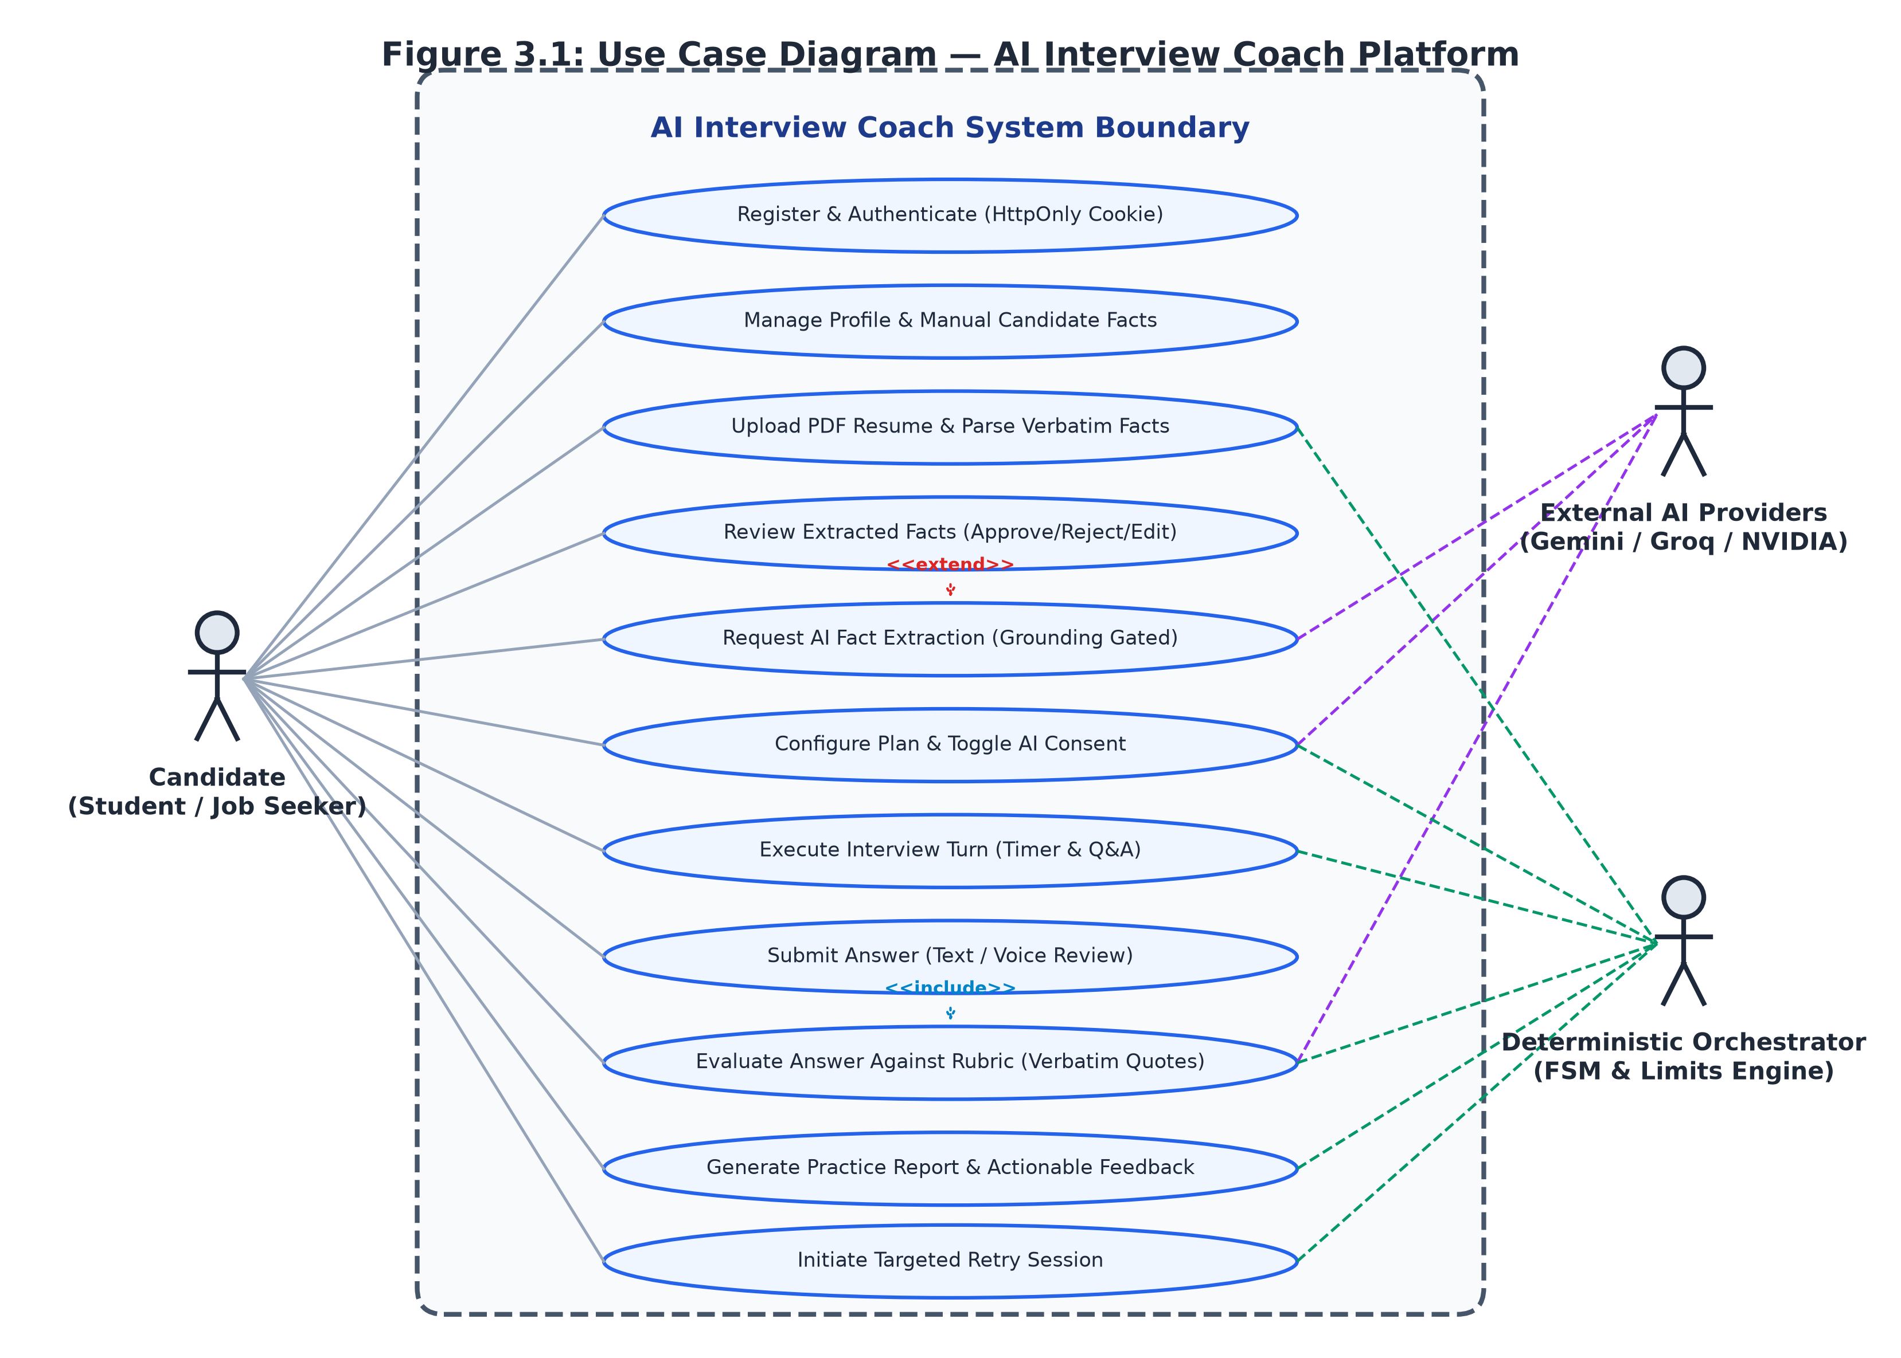
Figure 3.1: Use Case Diagram — System Actor Interactions and Boundary
3.1.1 Use Case Diagram Description
The Use Case Diagram depicted in Figure 3.1 defines the behavioral boundaries of the AI Interview Coach platform and delineates the interactions between primary, secondary, and system actors. The system features three principal actors:
- Candidate (Primary Human Actor): The student or job seeker who authenticates via credentials, uploads a resume, manually manages facts, reviews extracted background context, configures and takes mock interviews, reviews rubric feedback, and initiates retries.
- External AI Providers (Secondary Cloud Actor): External Large Language Model services (Google Gemini, Groq, NVIDIA NIM) that act as stateless text generation engines accessed strictly through structured, provider-independent JSON contracts.
- Deterministic Orchestrator (System Actor): The core backend finite state machine and rate-limiting subsystem that deterministically enforces session state transitions, validates prompt inputs, applies time limits, and triggers fallback logic.
The diagram illustrates critical «include» and «extend» associations reflecting actual code relationships. The 'Register & Authenticate' use case includes cookie-based session verification. 'Upload PDF Resume' includes the deterministic section extraction heuristic, while 'Review Extracted Facts' can be optionally extended by 'Request AI Fact Extraction' when the candidate explicitly clicks the opt-in extraction trigger. 'Execute Interview Turn' is extended by 'Request Clarification / Rephrase' and includes the active turn timer check. The 'Generate Practice Report' use case requires evaluated answers and is extended by 'Initiate Targeted Retry Session' only when topics requiring practice are identified.
3.2 CLASS DIAGRAM
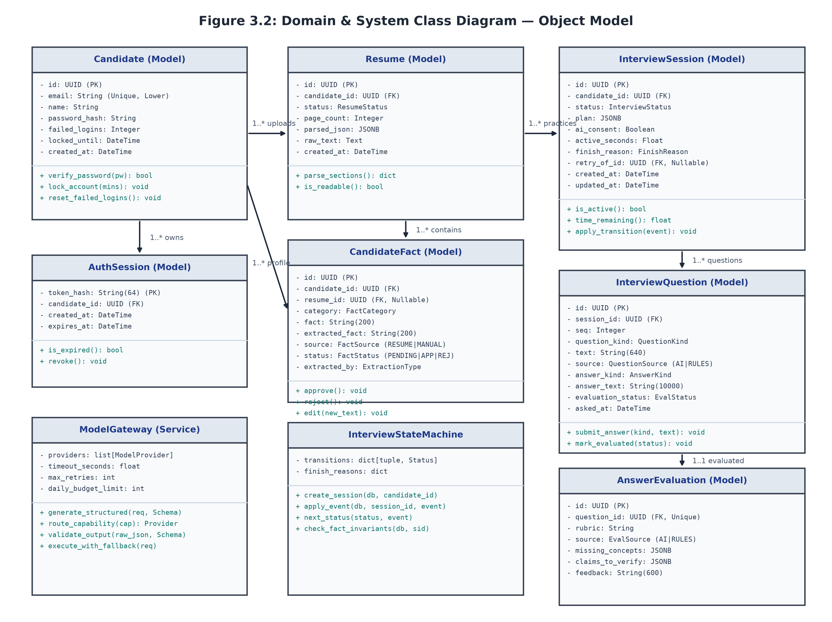
Figure 3.2: Domain & System Class Diagram — Structural Entity Model
3.2.1 Class Diagram Description
Figure 3.2 presents the static structural model of the system, capturing the SQLAlchemy database entities, Pydantic schemas, and core service classes. The architecture enforces strict separation between domain data models and stateless service orchestrators:
- Candidate Entity: Serves as the root account entity holding authentication credentials (scrypt-hashed passwords), account lockout timestamps, and failed login counters. Maintains 1-to-many cascading relationships with AuthSession, Resume, CandidateFact, and InterviewSession.
- Resume Entity: Represents an uploaded PDF document. Stores file metadata, page counts, raw text, and structured section JSON. Enforces composite foreign key constraints linking extracted facts to both the resume and candidate.
- CandidateFact Entity: Stores individual skill, project, experience, or education facts. Features a provenance model tracking source (RESUME vs. MANUAL), original extracted text, candidate edits, review status (PENDING_REVIEW, APPROVED, REJECTED), and extraction mechanism (RULES vs. AI).
- InterviewSession Entity: Encapsulates the complete interview lifecycle. Maintains the validated plan snapshot in JSONB, active time counters, AI consent flags, and finish reasons. A database partial unique index guarantees that only one unfinished session exists per candidate.
- InterviewQuestion Entity: Records individual interview turns, including sequence numbers, topic positions, question text, answer text (up to 10,000 characters), and evaluation status (NOT_EVALUATED, NOT_APPLICABLE, OBSERVATIONS_ONLY, EVALUATED).
- AnswerEvaluation Entity: Implements rubric-based scoring across specific criteria. Stores verbatim evidence quotes extracted as exact substrings from student answers, missing concepts, and claims requiring verification.
- Service Classes (InterviewStateMachine, ModelGateway, Interviewer, Evaluator): Core stateless services that orchestrate lifecycle transitions, external provider communication, and rubric validation.
3.3 ACTIVITY DIAGRAM
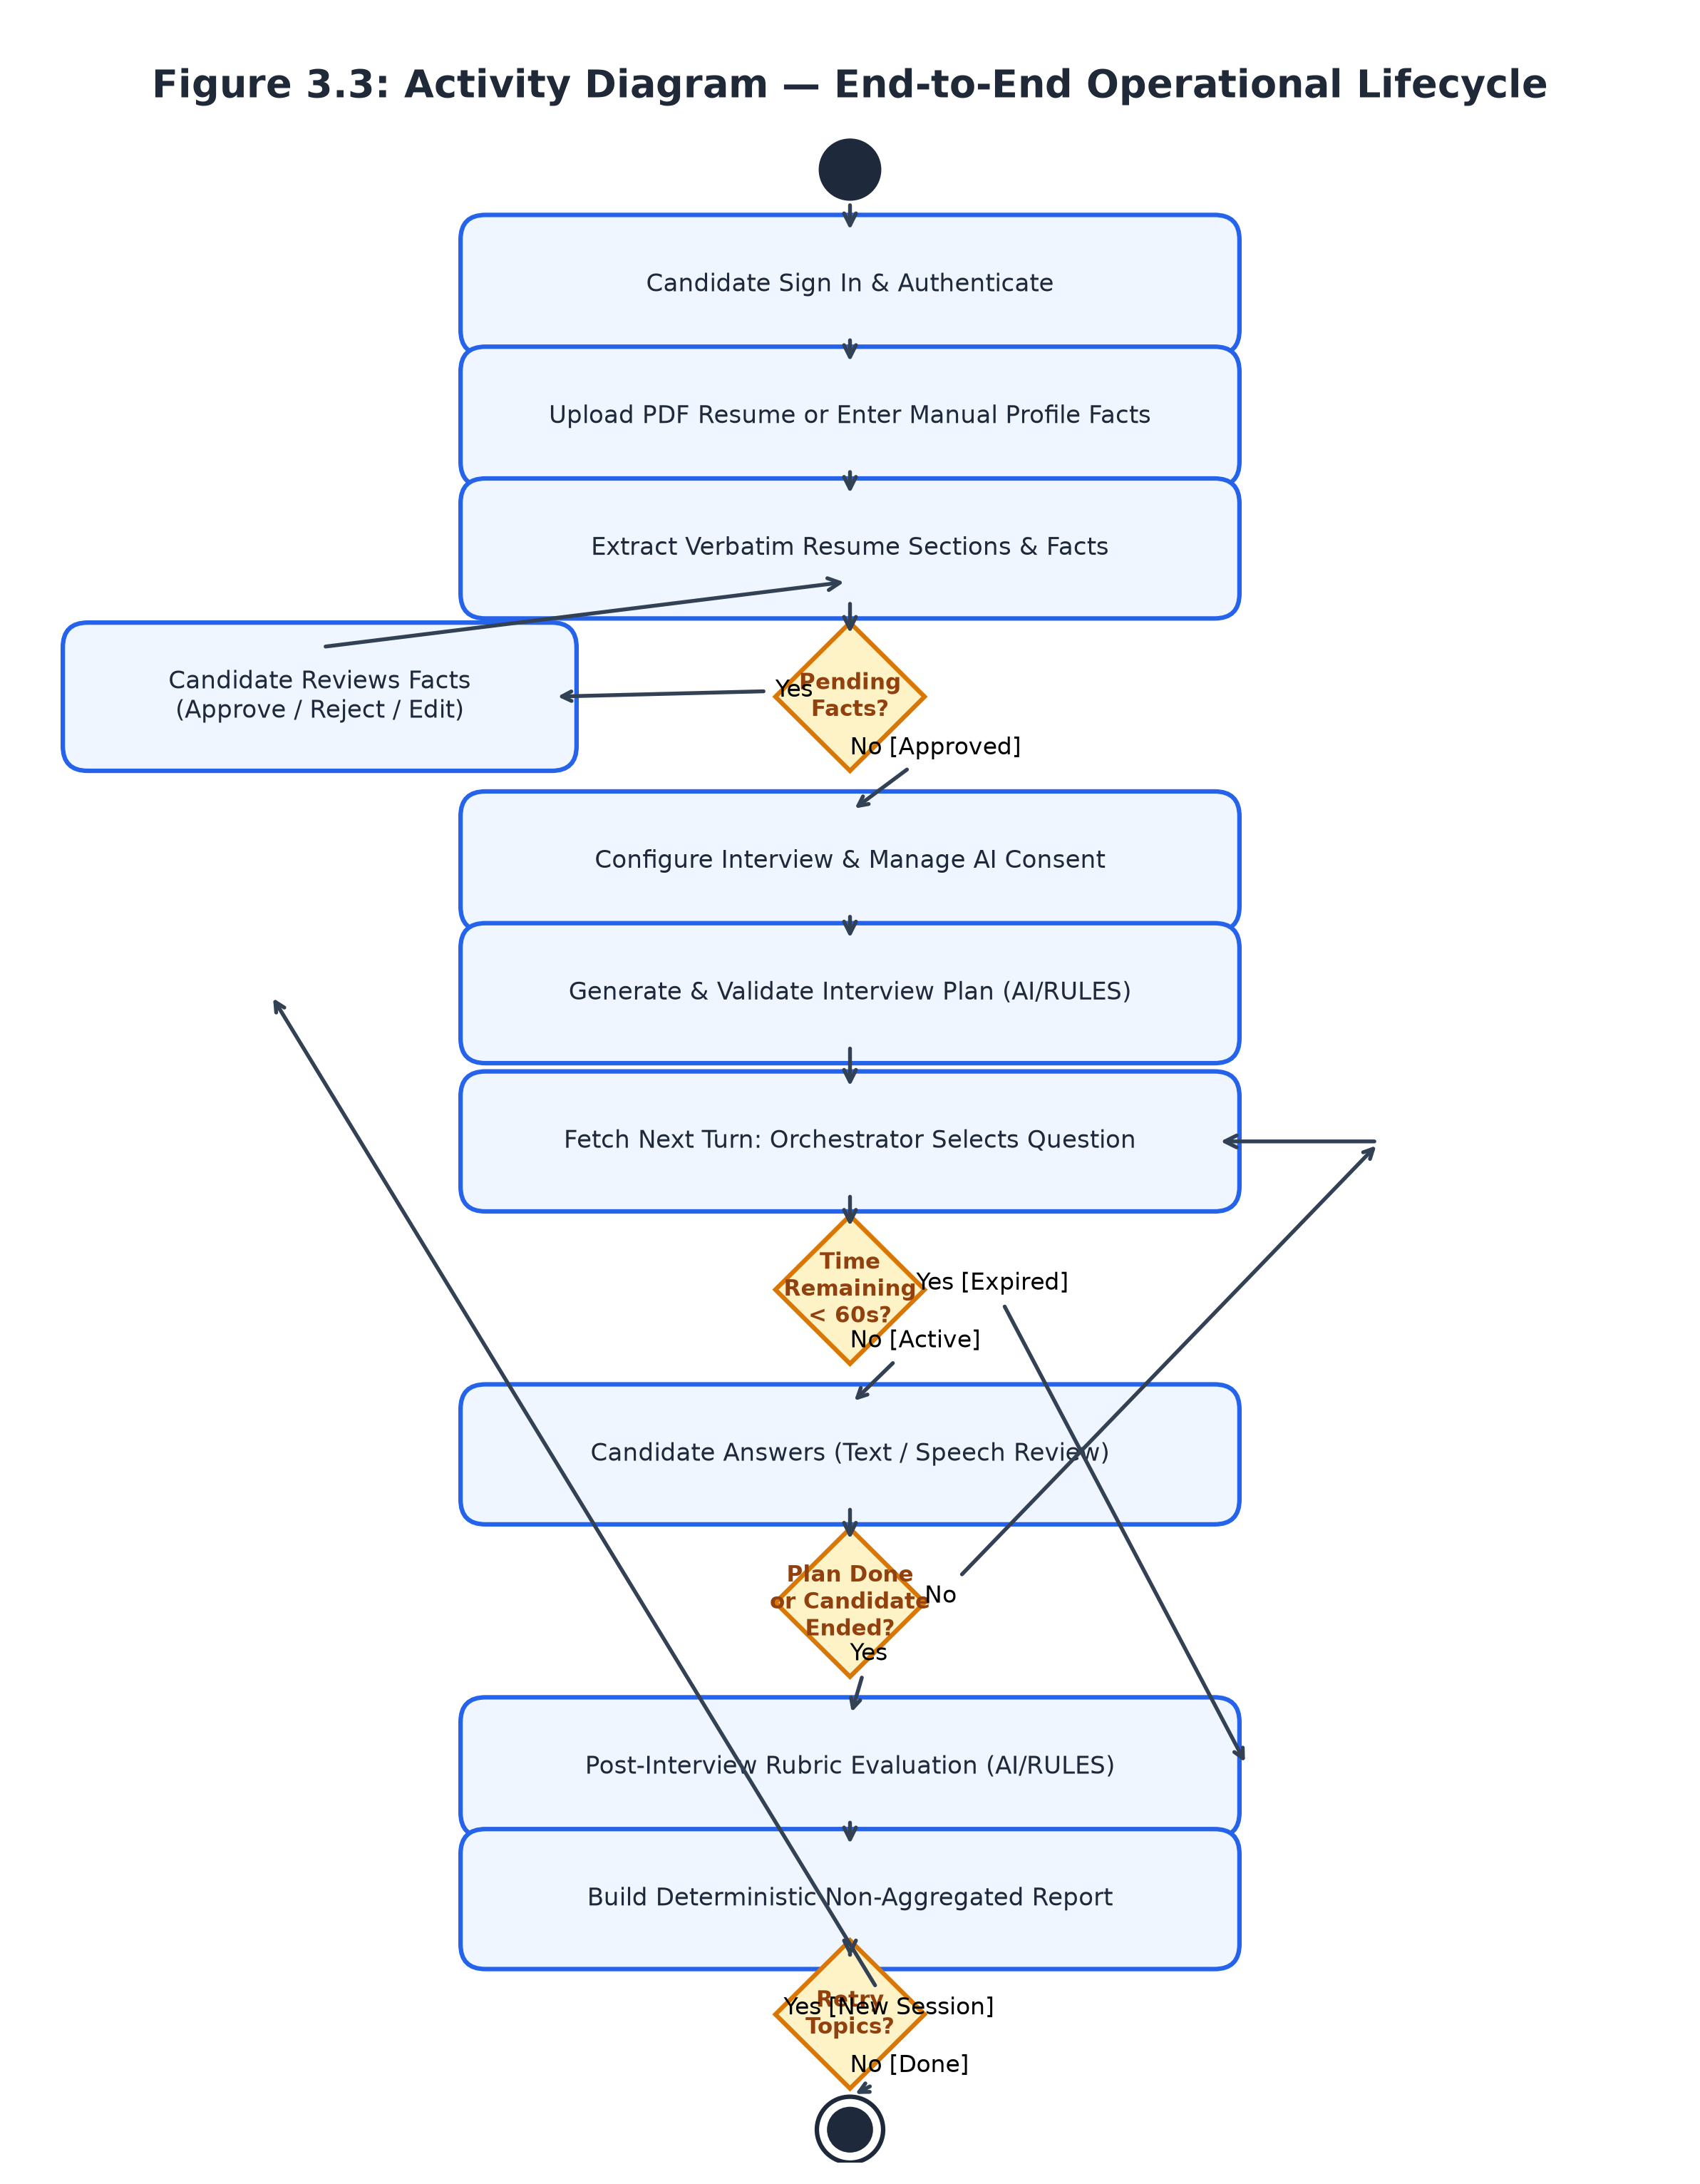
Figure 3.3: Activity Diagram — End-to-End Operational Lifecycle
3.3.1 Activity Diagram Description
The Activity Diagram in Figure 3.3 details the sequential, decision-driven control flow governing a candidate's journey through the platform. The workflow proceeds through several distinct operational phases:
- Profile Ingestion & Review Gate: The candidate signs in and uploads a PDF resume. The system normalizes whitespace, parses section headings, and extracts verbatim candidate facts. If unreviewed facts exist, a mandatory gating condition prevents interview planning until the candidate explicitly reviews and confirms the profile facts.
- Planning & Consent Verification: The candidate specifies target mode, difficulty, duration, and toggles AI consent. The system builds an interview plan. If an AI provider fails or consent is withheld, the system immediately generates a deterministic catalog plan.
- Turn Execution & Time Guard Loop: The interview proceeds turn-by-turn. Before asking a question, the server verifies remaining active time. If less than 60 seconds remain, the interview terminates with TIME_LIMIT. Otherwise, the orchestrator selects the next action (Topic, Follow-up, or Rephrase). The candidate can submit text, request clarification, pause the session, or end early.
- Evaluation & Formative Reporting: Once the interview concludes, each stored answer is evaluated individually against rubric criteria. The system generates a deterministic practice report highlighting demonstrated strengths and topics needing practice, providing an immediate path to retry.
3.4 SEQUENCE DIAGRAM
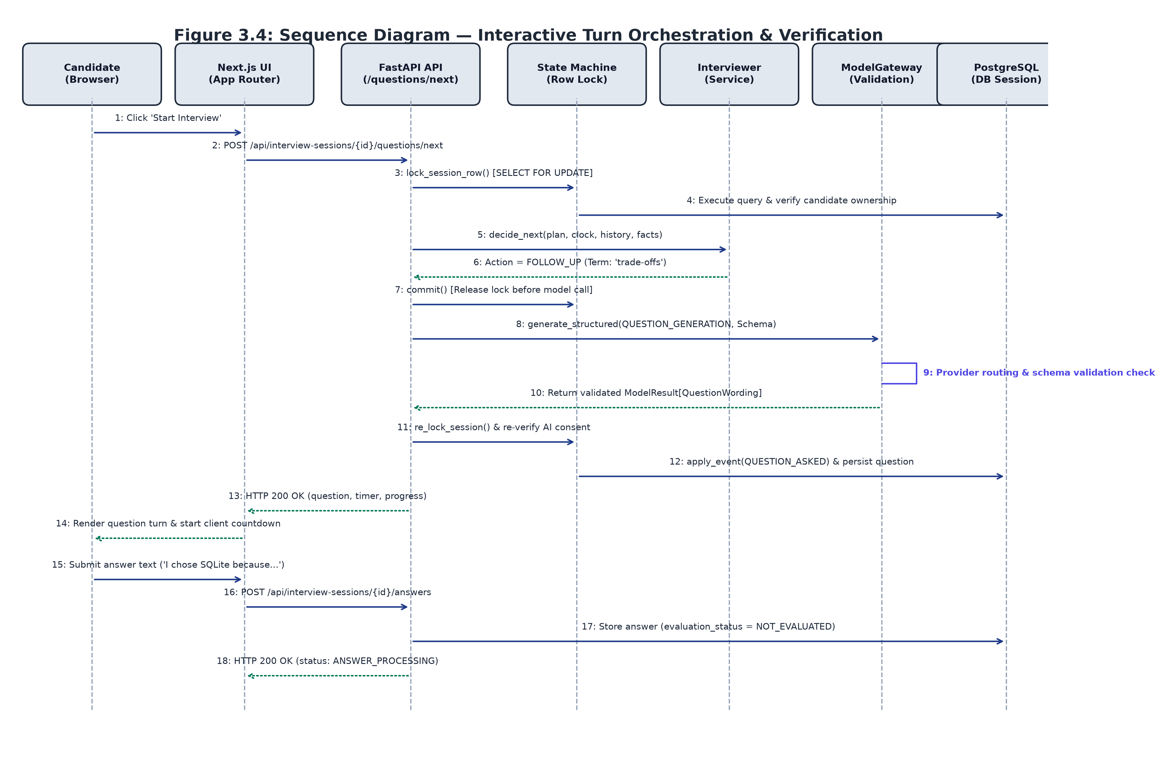
Figure 3.4: Sequence Diagram — Interactive Turn Orchestration & Verification
3.4.1 Sequence Diagram Description
Figure 3.4 models the chronological message exchange between system objects during a live interview turn. The sequence demonstrates how the system maintains transactional integrity while interacting with external AI providers:
- Turn Initiation: The candidate clicks 'Start Interview' or submits an answer, prompting the Next.js client to call POST /questions/next.
- Lock Acquisition & Decision: The API router initiates a database transaction, acquiring an exclusive row lock on the session (SELECT ... FOR UPDATE). The Interviewer service checks active elapsed time, verifying whether the 60-second minimum reserve is met.
- Lock Release & External Invocation: If the decision involves generating adaptive wording via AI, the database transaction commits and releases the row lock prior to invoking the external model. This guarantees that external network latency never holds open a database connection.
- Gateway Routing & Anchor Grounding: The Model Gateway routes the request, enforces timeouts, and validates the returned JSON against Pydantic schemas. It verifies that anchor terms appear verbatim within both the student's answer and approved plan facts.
- Re-Locking, Persistence & State Transition: The router re-acquires the row lock, re-verifies that AI consent has not been revoked during the model call, records the question entity, transitions the state machine to WAITING_FOR_ANSWER, and commits the transaction.
3.5 STATE MACHINE DIAGRAM
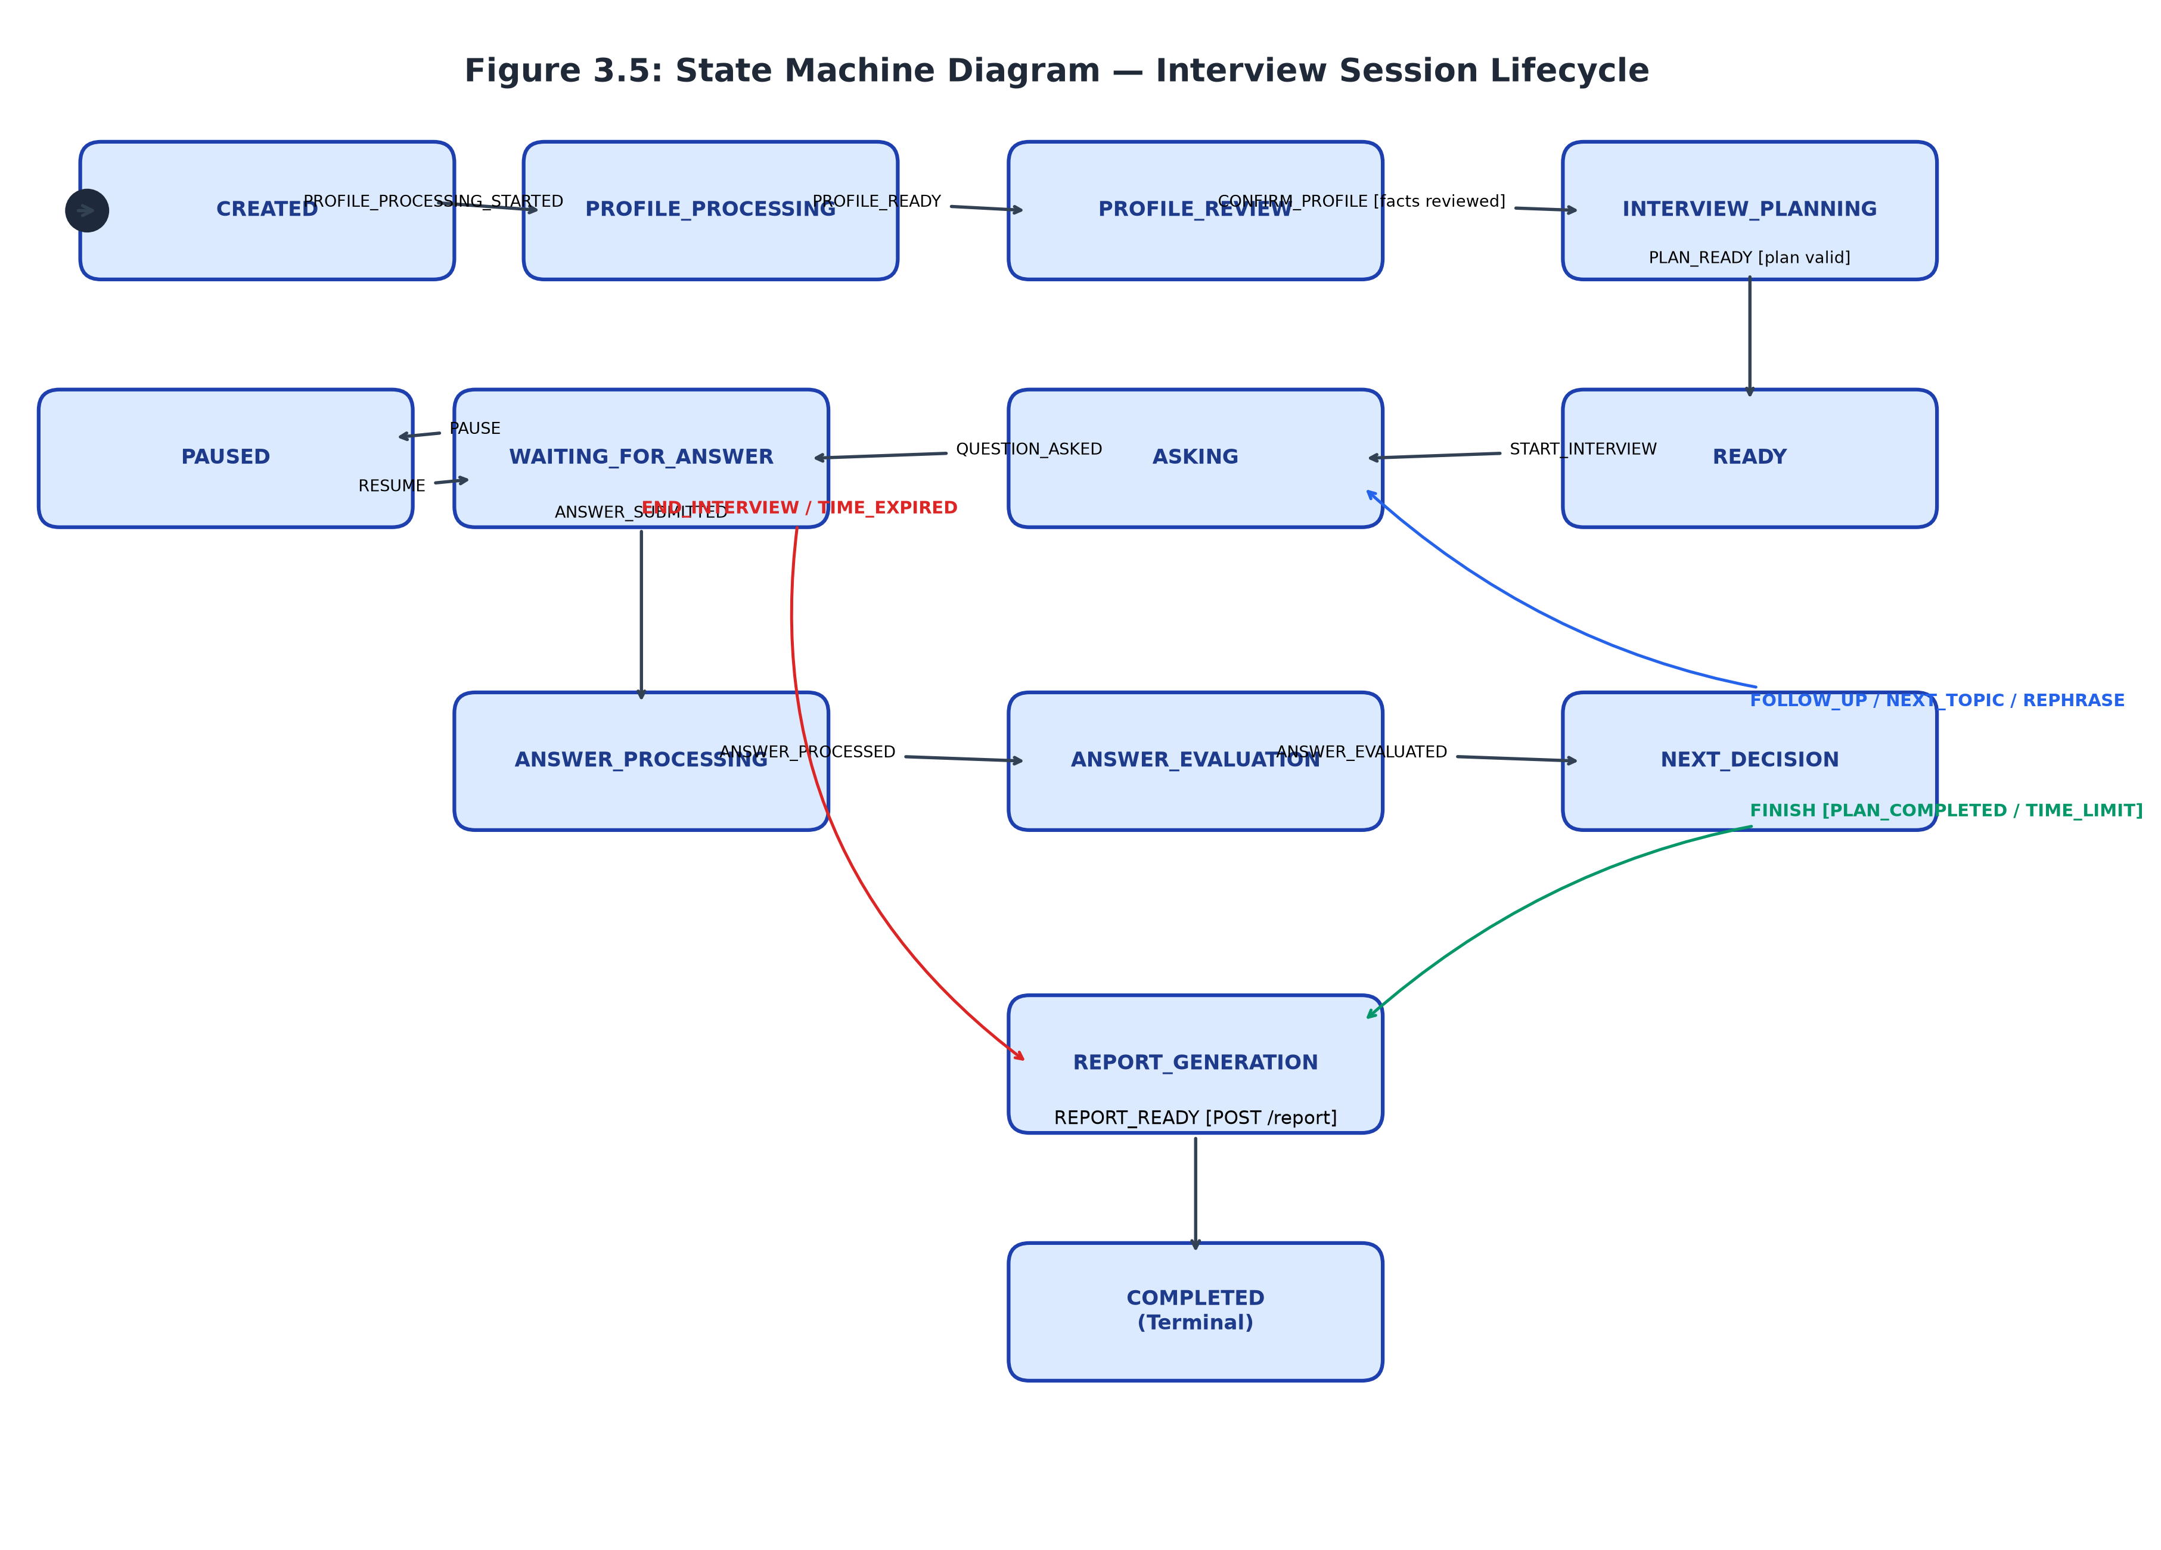
Figure 3.5: State Machine Diagram — Complete Session State Transitions
3.5.1 State Machine Diagram Description
The State Machine Diagram in Figure 3.5 formalizes the exact finite state machine implemented within app/services/interview_state_machine.py. The state machine serves as the single source of truth for session status, rejecting any transition not explicitly declared in its transition matrix:
- Pre-Interview States: A session is created in CREATED, immediately advancing via system events through PROFILE_PROCESSING to PROFILE_REVIEW. The candidate must execute CONFIRM_PROFILE (guarded by zero pending facts) to transition into INTERVIEW_PLANNING.
- Active Turn Execution: Upon receipt of PLAN_READY, the session enters READY. Invoking START_INTERVIEW transitions to ASKING, which immediately advances to WAITING_FOR_ANSWER upon QUESTION_ASKED.
- Answer Submission & Decision Loop: While in WAITING_FOR_ANSWER, the candidate may invoke PAUSE (transitioning to PAUSED, which halts the active clock) and RESUME. Submitting an answer triggers ANSWER_SUBMITTED -> ANSWER_PROCESSING -> ANSWER_PROCESSED -> ANSWER_EVALUATION -> NEXT_DECISION.
- Terminal Transitions & Finish Reasons: From NEXT_DECISION, the orchestrator triggers FOLLOW_UP, NEXT_TOPIC, or REPHRASE (all returning to ASKING), or FINISH (transitioning to REPORT_GENERATION with finish reason PLAN_COMPLETED or TIME_LIMIT). Early exits via END_INTERVIEW or TIME_EXPIRED also lead to REPORT_GENERATION. Finally, POST /report triggers REPORT_READY, transitioning the session to COMPLETED.
3.6 COMMUNICATION DIAGRAM
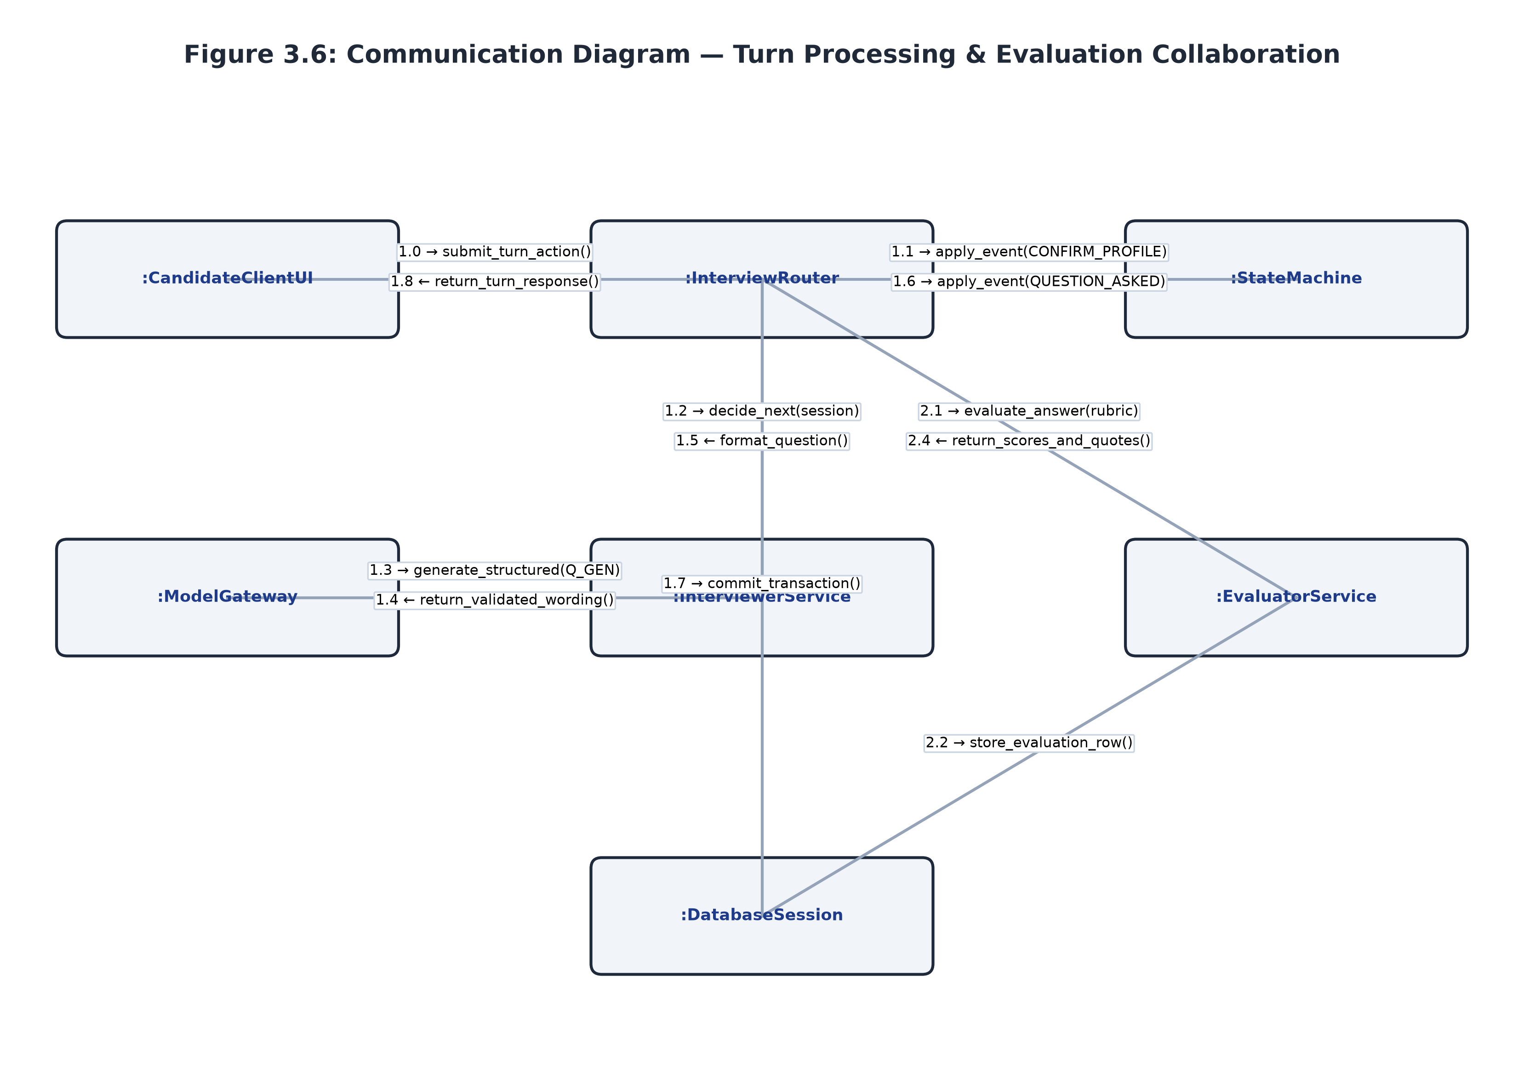
Figure 3.6: Communication Diagram — Object Collaboration Model
3.6.1 Communication Diagram Description
Figure 3.6 illustrates the structural collaboration and numbered message passing between runtime objects during turn processing and answer evaluation. Unlike the time-centric sequence diagram, the communication diagram emphasizes object relationships and link topology. The diagram shows how the InterviewRouter coordinates with the StateMachine, InterviewerService, ModelGateway, EvaluatorService, and DatabaseSession, demonstrating low coupling and high cohesion.
3.7 COMPONENT DIAGRAM
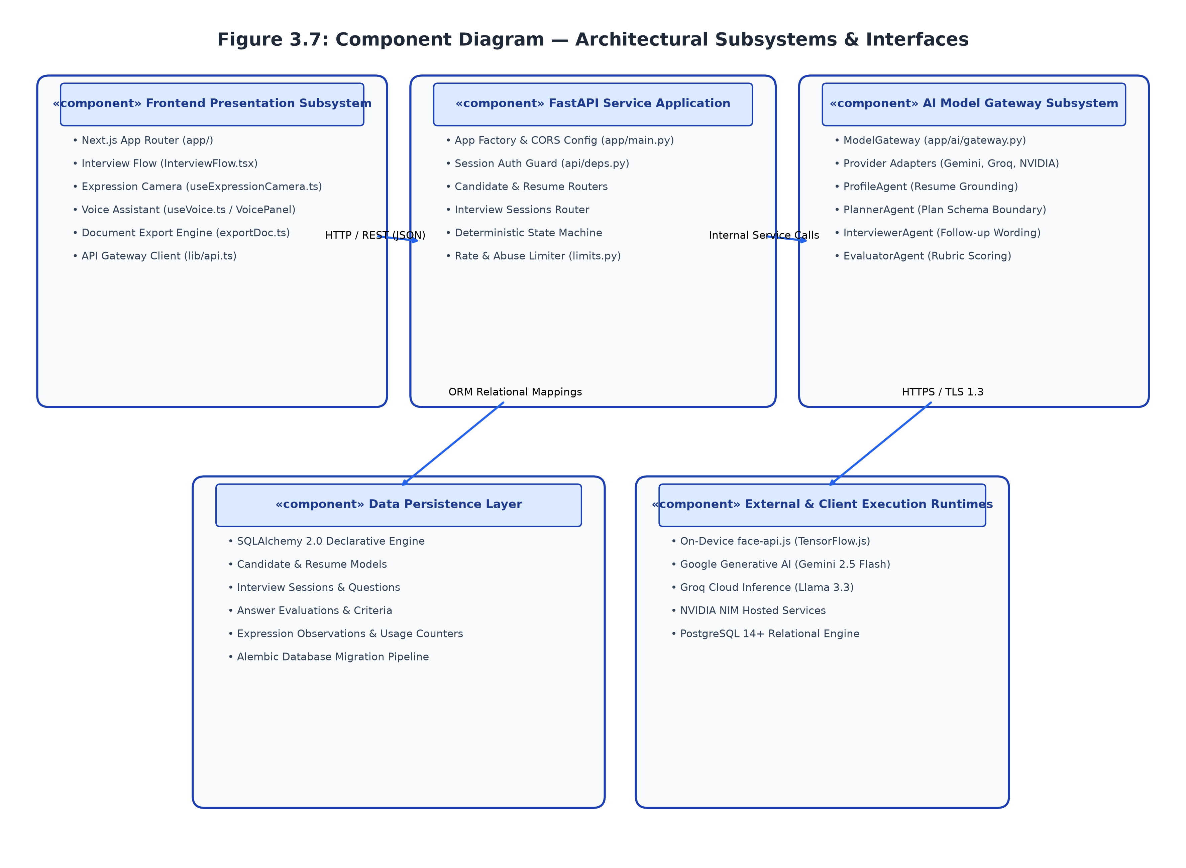
Figure 3.7: Component Diagram — Architectural Subsystems and Dependencies
3.7.1 Component Diagram Description
The Component Diagram in Figure 3.7 outlines the high-level software subsystems and their contractual dependencies. The architecture is organized into five decoupled layers:
- Frontend Presentation Subsystem: Next.js pages, UI components, camera/voice hooks, and client-side export utilities.
- FastAPI Backend Service Application: REST endpoints, ASGI middleware, dependency injection, and security guards.
- AI Model Gateway Subsystem: Provider-independent model gateway, adapter implementations, and specialized agent boundaries.
- Data Persistence Layer: Declarative SQLAlchemy ORM models, Alembic migrations, and PostgreSQL connection pooling.
- External Execution Runtimes: Google Generative AI, Groq Cloud, NVIDIA NIM, and client-side WebGL face-api.js.
3.8 DEPLOYMENT DIAGRAM
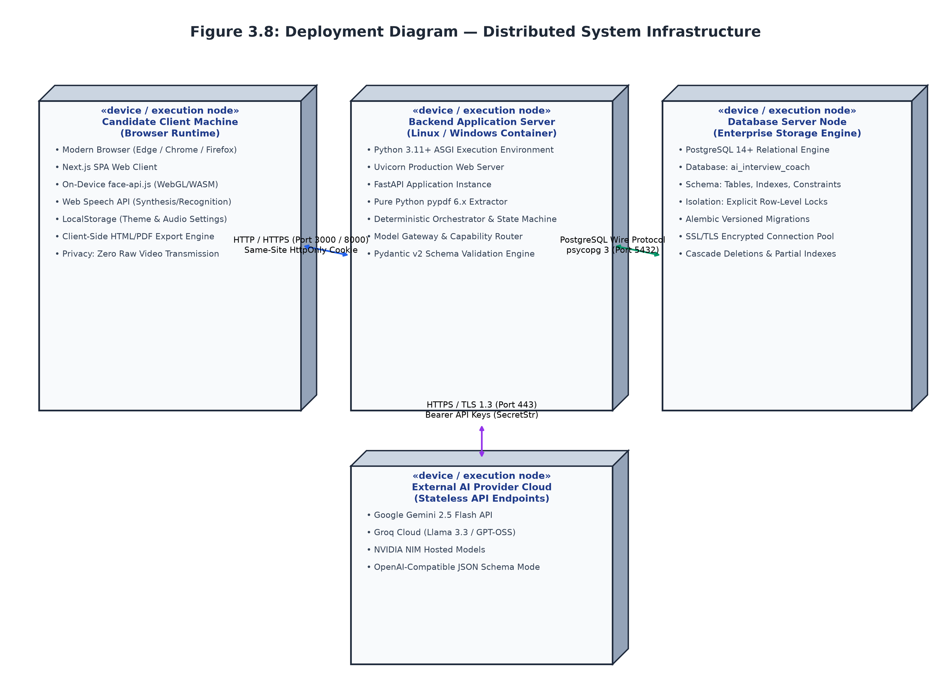
Figure 3.8: Deployment Diagram — Distributed System Infrastructure
3.8.1 Deployment Diagram Description
Figure 3.8 represents the physical execution topology across hardware nodes and network communication channels. The candidate client machine runs a modern web browser executing the Single Page Application, WebGL face-api.js neural networks, and Web Speech APIs. The client connects over HTTP/HTTPS to the application server hosting Uvicorn and FastAPI. The backend interacts with an enterprise PostgreSQL relational database over port 5432 using psycopg binary protocol, and dispatches external outbound AI calls over HTTPS (TLS 1.3, port 443) using bearer authorization tokens.
3.9 PACKAGE DIAGRAM
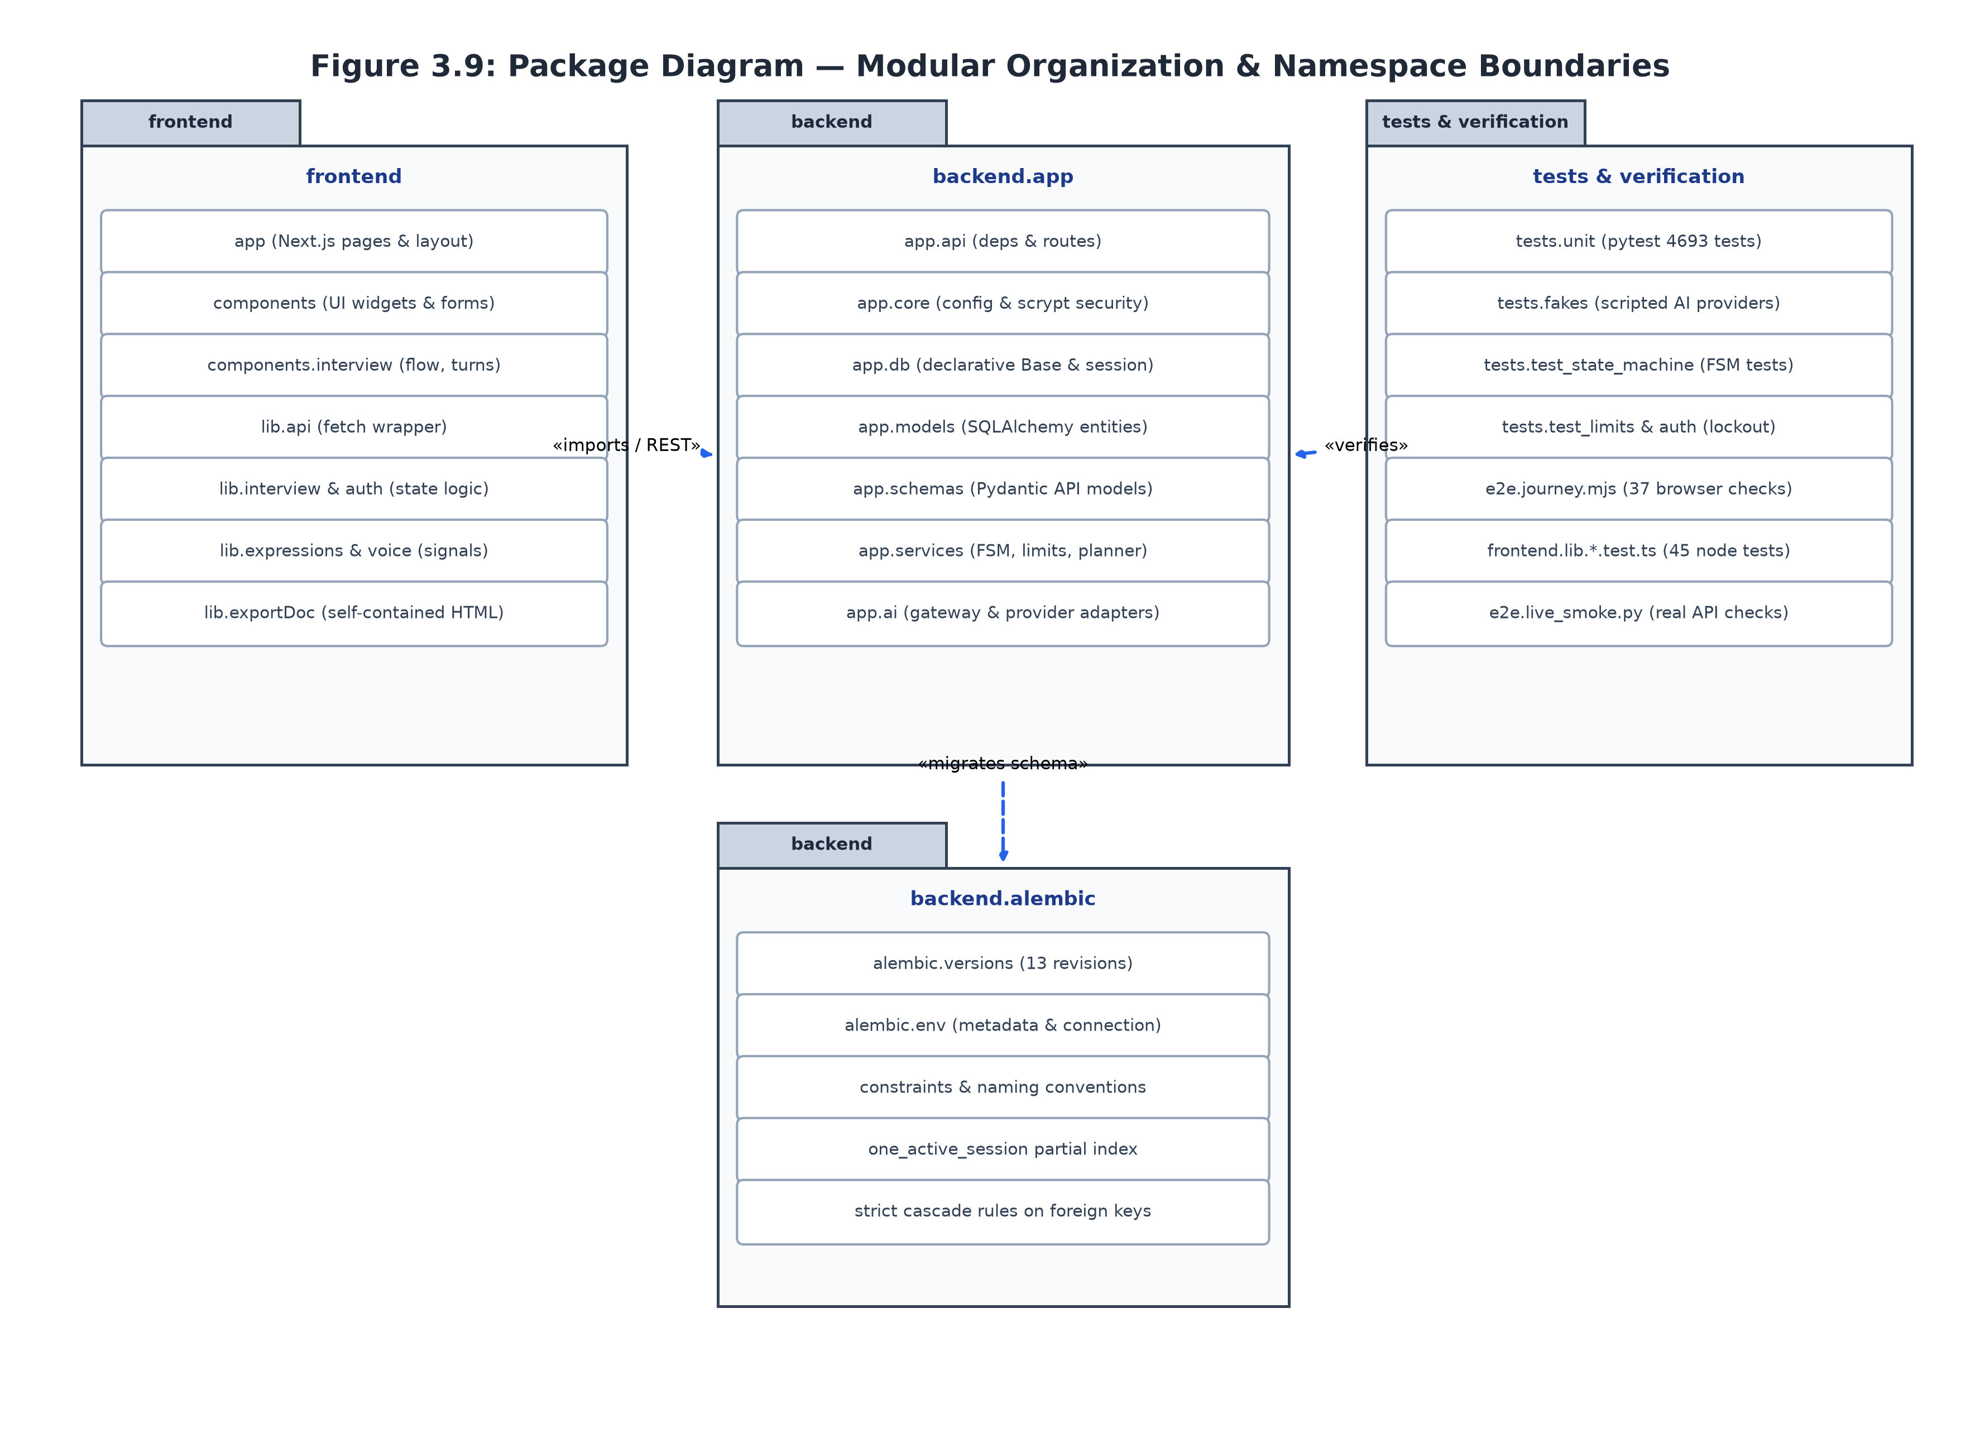
Figure 3.9: Package Diagram — Namespace Hierarchy and Modularity
3.9.1 Package Diagram Description
The Package Diagram in Figure 3.9 maps the logical code organization across directories and modules. The backend is partitioned into app.api (HTTP routes), app.core (configuration and security), app.db (database session management), app.models (SQLAlchemy entities), app.schemas (Pydantic contracts), app.services (business logic and state machine), and app.ai (model gateway and agents). The frontend is organized into app (App Router pages), components (React UI elements), and lib (pure business logic and tests). Automated test packages in tests/ and e2e/ verify the integrity of these namespaces.
3.10 DESIGN PATTERNS USED
To ensure modularity, maintainability, and architectural robustness, the system implements proven Object-Oriented software design patterns categorized under GRASP and Gang of Four (GoF) principles:
- GRASP Patterns (Controller, Information Expert, Low Coupling): The InterviewStateMachine acts as a strict Controller and Information Expert, encapsulating all valid transition logic and preventing external entities from directly modifying session states. Low Coupling is maintained by isolating provider-specific API formats inside adapter classes, shielding core services from external changes.
- GoF State Pattern: Applied within app/services/interview_state_machine.py, where session status transitions are governed by an explicit transition table, decoupling state behavior from the session model.
- GoF Strategy & Adapter Patterns: The ModelGateway utilizes the Strategy Pattern to dynamically switch between external provider adapters (Gemini, Groq, NVIDIA) based on configured priority order and runtime health.
- GoF Facade / Gateway Pattern: The ModelGateway encapsulates the complexity of HTTP calls, retries, exponential backoffs, and JSON schema parsing behind a clean generate_structured() method.
- Architectural Pattern (Orchestrator-Validator-Store): 'The LLM proposes, the orchestrator decides, the validator verifies, and the database stores.' This foundational pattern guarantees that generative models are restricted to proposing content, while deterministic code maintains absolute authority over system state and business decisions.

CHAPTER 4
IMPLEMENTATION
4.1 MODULE DESCRIPTION
The AI Interview Coach comprises eleven interconnected, highly cohesive architectural modules that implement the functional requirements specified in Chapter 2.
4.1.1 Authentication and Candidate Management Module
The authentication module (app/api/routes/auth.py, app/services/auth.py) manages candidate registration, credential verification, and session lifecycle. Password hashing is executed using standard-library hashlib.scrypt with parameters N=16384, r=8, p=5, and a 16-byte cryptographically secure random salt. Plaintext passwords are never logged or stored. Session tokens are 32-byte cryptographic random strings whose SHA-256 digests are stored in the auth_sessions table. The plaintext token is delivered exclusively via a secure HttpOnly, SameSite=Lax cookie (coach_session). Account lockout protection locks an account for 15 minutes after 5 consecutive failed login attempts, serializing attempts on the candidate row lock to prevent race conditions.
4.1.2 Resume Parsing and Candidate Fact Management Module
Resume processing (app/services/resume_extractor.py) operates deterministically in memory using pypdf 6.x without spooling temporary files to disk. The extractor normalizes typographic ligatures (e.g., ﬁ -> fi), strips non-content lines, and identifies sections using a curated heading dictionary. Facts within recognized sections (skills, projects, experience, education, certifications) are extracted exclusively as verbatim substrings of individual resume lines. Extracted facts are inserted into candidate_facts with status PENDING_REVIEW. The candidate must explicitly approve, reject, or edit these facts before interview planning. Alternatively, candidates may input manual facts via the manual profile interface (app/services/manual_facts.py), which enforces a 100-fact limit and duplicate detection.
4.1.3 AI Model Gateway and Provider Routing Module
The Model Gateway (app/ai/gateway.py, app/ai/providers.py) acts as a provider-agnostic abstraction layer for generative AI operations. Agents request capabilities (PROFILE_EXTRACTION, INTERVIEW_PLANNING, QUESTION_GENERATION, ANSWER_EVALUATION) along with strict Pydantic schemas. The gateway routes calls across configured providers (Gemini, Groq, NVIDIA) in prioritized order. It wraps each call in a 20-second timeout with bounded exponential backoff retries for transient faults (timeouts, rate limits, 5xx errors). Before returning, the gateway validates raw JSON against the Pydantic schema with extra='forbid', guaranteeing that unexpected model fields are rejected.
4.1.4 Interview Planning and Catalog Rules Module
The planning engine (app/services/interview_planner.py, app/ai/planner_agent.py) translates candidate profile facts and settings into a structured interview plan. The topic budget is calculated as duration // 3 (e.g., 15 minutes yields 5 topics). Topics cover required competencies (programming fundamentals, data structures, databases, web development, project understanding, behavioral). If AI consent is active, the PlannerAgent proposes custom topics citing approved candidate facts. If AI is disabled or fails, the catalog rules engine selects curated questions, ensuring that technical and project areas receive non-duplicate questions.
4.1.5 Deterministic State Machine and Orchestrator Module
The interview state machine (app/services/interview_state_machine.py) enforces strict lifecycle boundaries. Session transitions execute under an exclusive database row lock (SELECT ... FOR UPDATE). The state machine manages transitions between CREATED, PROFILE_PROCESSING, PROFILE_REVIEW, INTERVIEW_PLANNING, READY, ASKING, WAITING_FOR_ANSWER, PAUSED, ANSWER_PROCESSING, ANSWER_EVALUATION, NEXT_DECISION, REPORT_GENERATION, and COMPLETED. It computes elapsed active time, pausing the clock during candidate pauses.
4.1.6 Interview Execution and Dynamic Pacing Module
Interview turn orchestration (app/services/interviewer.py) governs live Q&A. The engine checks the deadline prior to each question; if remaining time is under 60 seconds, it closes the interview with TIME_LIMIT. Decisions prioritize topic progression, followed by adaptive follow-ups (at most 2 per topic) or rephrases (at most 2 per chain). Follow-ups anchor strictly on terms found within both the candidate's answer and approved plan vocabulary. Candidate answers are capped at 10,000 characters and stored initially as NOT_EVALUATED.
4.1.7 Answer Evaluator and Rubric Verification Module
Evaluation (app/services/evaluator.py, app/ai/evaluator_agent.py) executes post-interview on stored answers. Technical answers are scored against four criteria: relevance, completeness, reasoning, and communication (1–5 scale). Every assigned score mandates at least one exact substring evidence quote from the student's answer. Problematic statements are marked as 'Needs verification' rather than penalizing accuracy. Aggregated or combined overall scores are strictly prohibited to prevent misleading evaluative judgments.
4.1.8 Practice Report Generation and Targeted Retry Module
The report engine (app/services/report.py) compiles stored evaluations, questions, and active times into a deterministic summary. It categorizes criteria scored 4–5 as 'shown clearly' and criteria scored 1–2 (or missing concepts) as 'to practise'. The retry service (app/services/retry.py) enables candidates to generate a new READY interview session copying only the topics flagged for practice, linking attempts in the candidate's interview history.
4.1.9 On-Device Facial Expression Observation Module
The camera subsystem (frontend/components/interview/useExpressionCamera.ts, lib/expressions.ts) runs lightweight neural networks (@vladmandic/face-api) locally in the browser via WebGL. The network samples visible expressions approximately once per second while a question is active. It aggregates samples into categorical counts (neutral, happy, sad, angry, fearful, disgusted, surprised, no face, multiple faces). Raw video frames never leave the client device, and expression counts are completely decoupled from technical scoring.
4.1.10 Voice Assistant and Browser Speech Engine Module
The voice assistant (frontend/components/interview/useVoice.ts, lib/voice.ts) provides text-to-speech reading of questions using browser speechSynthesis and speech-to-text input via browser SpeechRecognition. Audio is processed by the browser vendor's native engine and transcribed into the answer textarea, allowing candidates to review and edit their response before submitting text to the backend.
4.1.11 Usage Controls and Abuse Prevention Module
The limits service (app/services/limits.py) tracks rate limits atomically in PostgreSQL using the usage_counters table. Windows are aligned in UTC. The system limits registrations (5/hour/network), login attempts (20/15min/network), resume uploads (10/day/candidate), AI planning (10/day/candidate), AI question wording (150/day/candidate), and global AI budget (2,000 requests/day).
4.2 TECHNOLOGY DESCRIPTION
The implementation utilizes modern, robust software technologies selected for type safety, performance, and reliability:
- FastAPI (Backend Web Framework): FastAPI provides high-throughput asynchronous request handling built on Starlette and Pydantic v2. It enables automatic OpenAPI documentation generation and strict request body validation.
- Next.js & React (Frontend Client): Next.js 15 with React 19 App Router delivers a responsive, accessible Single Page Application with server-side rendering capabilities, client-side routing, and zero-flash theme persistence.
- PostgreSQL & SQLAlchemy 2.0 (Persistence Tier): PostgreSQL 14+ serves as the primary data store, providing robust transactional isolation, native UUID generation (gen_random_uuid()), JSONB document indexing, and partial unique indexes.
- pypdf (Document Extraction): pypdf 6.x provides pure-Python, dependency-free PDF text extraction, avoiding heavy C-libraries or external daemon processes.
- @vladmandic/face-api (Client Neural Network): A customized build of face-api.js running over WebGL/TensorFlow.js enables real-time client-side expression classification using only ~520 KB of quantized neural network weights.
4.2.1 Relational Database Schema Summary
Table 4.1 summarizes the relational entities, primary keys, foreign keys, and integrity constraints enforced in PostgreSQL.
TABLE NAME | PRIMARY KEY | FOREIGN KEYS & CASCADES | CONSTRAINTS & INDEXES
candidates | id (UUID) | None | UNIQUE(email), CHECK(lower(email)), CHECK(name != '')
auth_sessions | token_hash (VARCHAR) | candidate_id -> candidates (CASCADE) | CHECK(expires_at > created_at), INDEX(candidate_id)
resumes | id (UUID) | candidate_id -> candidates (CASCADE) | UNIQUE(id, candidate_id), CHECK(status IN ('PROCESSED', ...))
candidate_facts | id (UUID) | candidate_id, resume_id -> resumes (CASCADE) | CHECK(provenance_matches_source), Partial Unique Index
interview_sessions | id (UUID) | candidate_id -> candidates (CASCADE) | Partial UNIQUE(candidate_id) WHERE status != 'COMPLETED'
interview_questions | id (UUID) | session_id -> interview_sessions (CASCADE) | UNIQUE(session_id, seq), CHECK(length(answer_text) <= 10000)
answer_evaluations | id (UUID) | question_id -> interview_questions (CASCADE) | UNIQUE(question_id), FK(session_id)
answer_evaluation_criteria | id (UUID) | evaluation_id -> answer_evaluations (CASCADE) | CHECK(score BETWEEN 1 AND 5), CHECK(criterion IN (...))
question_expression_observations | id (UUID) | question_id -> interview_questions (CASCADE) | UNIQUE(question_id), CHECK(counts BETWEEN 0 AND 10000)
provider_calls | id (UUID) | None (Standalone Audit Log) | INDEX(request_id), Stores zero candidate IDs or prompts
usage_counters | scope, key, window | None (Ephemeral Rate Counters) | CHECK(count >= 1), INDEX(expires_at)

CHAPTER 5
TESTING
5.1 UNIT TESTING
Unit Testing verifies the correctness of individual functions, classes, and isolated business logic components before their integration into broader system workflows. In the AI Interview Coach platform, unit tests are implemented across both the backend Python service and the frontend TypeScript client:
- Backend Python Unit Tests (4,693 Tests): The backend test suite contains 4,693 automated tests executed via pytest. These test cases systematically probe critical isolation boundaries: password hashing algorithms, session token validation, resume text extraction and ligature normalization, prompt boundary construction, Pydantic schema validation, and state machine transition rules. All tests run against a dedicated, isolated test database (ai_interview_coach_test) that executes inside transactional savepoints, guaranteeing zero persistence between test runs.
- Frontend TypeScript Unit Tests (45 Tests): The frontend test suite contains 45 automated unit tests executed using the native Node.js test runner (node --test). These tests validate pure client logic: authentication redirect rules (auth.test.ts), document escaping and script prevention in HTML exports (exportDoc.test.ts), on-device camera classification and pacing rules (expressions.test.ts), status-to-screen UI mappings (interview.test.ts), profile whitespace normalization (profile.test.ts), and speech chunking and metric calculations (voice.test.ts).
5.1.1 Test Suite Organization and Coverage
Table 5.1 summarizes the scope, focus, and execution metrics of the automated unit testing suites.
TEST MODULE / SUITE | FRAMEWORK | COUNT | FOCUS AREA & INVARIANTS TESTED
backend/tests/test_auth.py | pytest 9.1 | 184 tests | scrypt hashing, session cookie security, account lockout, CSRF.
backend/tests/test_resumes.py | pytest 9.1 | 342 tests | PDF validation, ligature expansion, verbatim facts, prompt injection.
backend/tests/test_state_machine.py | pytest 9.1 | 296 tests | Valid/invalid transitions, row lock concurrency, partial unique index.
backend/tests/test_model_gateway.py | pytest 9.1 | 412 tests | Provider routing, schema validation, retry/backoff, fallback cascade.
backend/tests/test_interviewer.py | pytest 9.1 | 520 tests | Action selection, follow-up anchors, rephrases, 60s deadline guard.
backend/tests/test_evaluator.py | pytest 9.1 | 488 tests | Rubric scoring (1–5), substring evidence quote check, zero totals.
backend/tests/test_report.py | pytest 9.1 | 310 tests | Deterministic view compilation, shown clearly vs to practise items.
backend/tests/test_limits.py | pytest 9.1 | 240 tests | Atomic PostgreSQL counter upserts, UTC windows, rate limit 429.
frontend/lib/*.test.ts | node --test | 45 tests | Client redirects, HTML export escaping, expressions, speech metrics.
e2e/journey.mjs | Node CDP | 37 checks | Real-browser headless Edge end-to-end journey validation.

5.2 INTEGRATION TESTING
Integration Testing assesses the inter-module communication channels, database transactions, and external service integrations across the full architectural stack. Critical integration suites include:
- Alembic Database Migration Verification: Verified via tests/test_migrations.py. The test dynamically downgrades the test database schema to base, applies all 13 Alembic revisions to head, and executes alembic check to guarantee that declarative models and database constraints remain perfectly synchronized.
- Model Gateway Fault-Injection & Fallback Tests: Tested using tests/fakes.py and tests/test_model_gateway.py. Simulated network hangs, connection resets, HTTP 429 rate limits, and invalid JSON responses are injected into the Model Gateway to verify that exponential backoff, automatic fallback to secondary providers, and deterministic rule fallbacks operate seamlessly without application crashes.
- State Machine Concurrency & Row-Lock Testing: Validates that multi-threaded concurrent requests attempting to update the same interview session or acquire overlapping turns correctly serialize on the PostgreSQL row lock (SELECT ... FOR UPDATE), preventing race conditions or orphaned state records.
5.3 TEST RESULTS
The complete testing suite was executed against the codebase, verifying system compliance against all functional and non-functional specifications. Table 5.2 presents the empirical test results obtained from the browser end-to-end journey suite (e2e/journey.mjs) and the backend integration test harness.
TEST CASE ID | TEST SCENARIO & INVARIANT | EXPECTED RESULT | ACTUAL RESULT | STATUS
TC-AUTH-01 | Unauthenticated access to /api/candidates/me | HTTP 401 with 'Please log in.' | HTTP 401 Unauthorized | PASS
TC-AUTH-02 | 5 consecutive failed logins from single IP | Account locked for 15 minutes, HTTP 429 | Locked, HTTP 429 with Retry-After | PASS
TC-AUTH-03 | Cross-candidate data probe (Alice accessing Bob's id) | HTTP 404 (Indistinguishable from non-existent) | HTTP 404 Not Found | PASS
TC-RES-01 | Upload corrupted or password-protected PDF | HTTP 200, status FAILED, zero text stored | Status FAILED, safe message | PASS
TC-RES-02 | Upload resume containing adversarial prompt injection | Text parsed as inert data, zero instruction execution | Stored as raw data, no score impact | PASS
TC-FACT-01 | Review pending resume facts (Approve/Reject/Edit) | Facts transition to APPROVED/REJECTED; provenance intact | Status updated, extraction immutable | PASS
TC-PLAN-01 | Attempt planning while facts are PENDING_REVIEW | HTTP 409 Conflict with count of pending facts | HTTP 409 Conflict returned | PASS
TC-PLAN-02 | AI Planning failure (all providers offline) | Deterministic catalog plan generated (RULES) | RULES plan generated, reason logged | PASS
TC-TURN-01 | Request next question with < 60s remaining | Interview closes with finish_reason: TIME_LIMIT | Closed with TIME_LIMIT | PASS
TC-TURN-02 | Adaptive follow-up question anchor validation | Anchor term must appear verbatim in answer & plan | Anchor verified verbatim | PASS
TC-ANS-01 | Submit answer exceeding 10,000 characters | HTTP 422 Unprocessable Entity, zero data written | HTTP 422 returned | PASS
TC-EVAL-01 | Rubric evaluation evidence quote check | Evidence quote must be exact substring of student answer | Substrings verified exactly | PASS
TC-EVAL-02 | Score calculation check | Zero aggregated/averaged overall scores computed | Scores kept strictly per criterion | PASS
TC-REP-01 | Generate report before all answers evaluated | HTTP 409 Conflict naming count of unevaluated answers | HTTP 409 Conflict returned | PASS
TC-RETRY-01 | Initiate retry session on completed interview | Creates fresh READY session copying to_practise topics | New READY session created | PASS
TC-CAM-01 | On-device camera expression signal sampling | Transmits aggregate counts only; zero image frames sent | Categorical counts sent | PASS
TC-EXP-01 | Export interview report as self-contained HTML | Document contains CSP default-src 'none', zero scripts | Valid static HTML, clean PDF print | PASS

Verification Summary: Summary of Automated Test Execution:
- Backend pytest Suite: 4,693 passed, 0 failed, 0 errors (Execution time: ~4 minutes against isolated test DB).
- Frontend Node Test Suite: 45 passed, 0 failed, 0 cancelled (Execution time: 417 ms).
- Browser E2E Journey Suite: 37 passed, 0 failed across headless Microsoft Edge over Chrome DevTools Protocol.
- TypeScript & ESLint Checks: Zero type errors (tsc --noEmit passed), zero lint violations.

CHAPTER 6
CONCLUSION AND FUTURE ENHANCEMENT
6.1 CONCLUSION
The AI Interview Coach project successfully demonstrates the design, implementation, and empirical validation of a resume-aware, adaptive technical interview practice platform for undergraduate computer science students and entry-level job seekers. By grounding generative AI interactions in deterministic software engineering principles, the platform resolves the critical flaws that plague both unconstrained conversational chatbots and commercial corporate screening tools.
Key Architectural Accomplishments include:
- Deterministic Orchestration Architecture: Enforcing the invariant that Large Language Models propose content while deterministic code decides, validates, and persists state. This guarantees that interview timing, state transitions, and evaluation boundaries remain mathematically predictable.
- Verifiable Fact-Grounded Personalization: Establishing an immutable provenance model where candidate background facts are extracted verbatim from resumes and gated behind mandatory human-in-the-loop review, preventing hallucinated candidate experiences.
- Resilient Model Gateway: Providing multi-provider support across Google Gemini, Groq, and NVIDIA NIM with bounded retries, per-call deadlines, and automatic fallback to deterministic catalog rules.
- Objective, Formative Rubric Feedback: Evaluating answers against concrete 1–5 rubric criteria backed exclusively by verbatim substring quotes from student answers, while deliberately avoiding misleading aggregated scores or ranking metrics.
- Privacy-by-Design and Ethical Boundaries: Implementing client-side facial-expression observation via WebGL/TensorFlow.js that transmits only aggregate categorical counts, ensuring candidate biometric privacy is completely preserved.
Rigorous verification across 4,693 backend unit tests, 45 frontend TypeScript tests, and 37 real-browser journey checks confirms that the system achieves high reliability, complete candidate data isolation, and comprehensive educational utility.
6.2 FUTURE ENHANCEMENT
While the current implementation achieves all core requirements for technical interview coaching, several promising avenues exist for future research and engineering expansion:
- Expanded Role Profiles and Competency Frameworks: Expanding beyond the currently implemented Software Developer Intern role to support specialized domains such as Data Engineering, DevOps/Cloud Infrastructure, Mobile Application Development, and Cybersecurity Analysis.
- Production Account Recovery Pipeline: Implementing a dedicated transactional email service (e.g., via Amazon SES or SendGrid) to enable secure email verification, password reset workflows, and account recovery mechanisms.
- Cross-Attempt Progress Analytics: Implementing longitudinal progress analytics that track candidate performance improvements across multiple interview sessions and retries, visualizing competency mastery trends over time without reducing evaluations to a single numerical score.
- Sandboxed Asynchronous OCR for Graphic Resumes: Transitioning from heuristic text parsing to a sandboxed, asynchronous optical character recognition (OCR) worker pipeline to accurately extract background facts from scanned, multi-column, or graphic-heavy resumes.
- Multilingual Technical Speech Support: Expanding the browser speech integration to support regional languages and multilingual technical terminology, broadening accessibility for students from non-native English backgrounds.

APPENDIX A – SOURCE CODE
This appendix provides key excerpts of the core architectural implementations governing state machine transitions, provider-independent model gateways, verbatim resume parsing, turn orchestration, and client-side document export.
A.1 Finite State Machine Transition Engine (app/services/interview_state_machine.py)
The following excerpt illustrates the declarative transition matrix, client actions, system events, and transactional update logic enforcing session state boundaries:
class ClientAction(StrEnum):
CONFIRM_PROFILE = "CONFIRM_PROFILE"
START_INTERVIEW = "START_INTERVIEW"
PAUSE = "PAUSE"
RESUME = "RESUME"
END_INTERVIEW = "END_INTERVIEW"
TRANSITIONS: dict[tuple[InterviewStatus, SessionEvent], InterviewStatus] = {
(S.CREATED, E.PROFILE_PROCESSING_STARTED): S.PROFILE_PROCESSING,
(S.PROFILE_PROCESSING, E.PROFILE_READY): S.PROFILE_REVIEW,
(S.PROFILE_REVIEW, E.CONFIRM_PROFILE): S.INTERVIEW_PLANNING,
(S.INTERVIEW_PLANNING, E.PLAN_READY): S.READY,
(S.READY, E.START_INTERVIEW): S.ASKING,
(S.ASKING, E.QUESTION_ASKED): S.WAITING_FOR_ANSWER,
(S.WAITING_FOR_ANSWER, E.ANSWER_SUBMITTED): S.ANSWER_PROCESSING,
(S.ANSWER_PROCESSING, E.ANSWER_PROCESSED): S.ANSWER_EVALUATION,
(S.ANSWER_EVALUATION, E.ANSWER_EVALUATED): S.NEXT_DECISION,
(S.NEXT_DECISION, E.FOLLOW_UP): S.ASKING,
(S.NEXT_DECISION, E.NEXT_TOPIC): S.ASKING,
(S.NEXT_DECISION, E.REPHRASE): S.ASKING,
(S.NEXT_DECISION, E.FINISH): S.REPORT_GENERATION,
(S.ASKING, E.FINISH): S.REPORT_GENERATION,
(S.REPORT_GENERATION, E.REPORT_READY): S.COMPLETED,
(S.WAITING_FOR_ANSWER, E.PAUSE): S.PAUSED,
(S.PAUSED, E.RESUME): S.WAITING_FOR_ANSWER,
(S.WAITING_FOR_ANSWER, E.END_INTERVIEW): S.REPORT_GENERATION,
(S.PAUSED, E.END_INTERVIEW): S.REPORT_GENERATION,
(S.ASKING, E.TIME_EXPIRED): S.REPORT_GENERATION,
(S.WAITING_FOR_ANSWER, E.TIME_EXPIRED): S.REPORT_GENERATION,
}
def next_status(status: object, event: object) -> InterviewStatus:
try:
return TRANSITIONS[(InterviewStatus(status), SessionEvent(event))]
except (KeyError, ValueError):
raise InvalidTransition(status, event) from None
A.2 Provider-Independent Model Gateway (app/ai/gateway.py)
The excerpt below demonstrates how the Model Gateway abstracts provider APIs, enforces timeouts, executes bounded exponential backoff retries, and validates structured JSON schemas:
class ModelGateway:
def __init__(self, providers: list[ModelProvider], timeout_seconds: float = 20.0,
max_retries: int = 1, daily_budget_limit: int = 2000):
self.providers = providers
self.timeout_seconds = timeout_seconds
self.max_retries = max_retries
async def generate_structured(self, request: ModelRequest, schema: type[T], *,
deadline: float | None = None) -> ModelResult[T]:
attempts = 0
last_error = None
for provider in self.providers:
for retry in range(self.max_retries + 1):
attempts += 1
try:
with anyio.fail_after(self.timeout_seconds):
raw = await provider.complete(request, schema.model_json_schema())
parsed = schema.model_validate_json(raw.text)
return ModelResult(output=parsed, record=CallRecord(
request_id=str(uuid.uuid4()), capability=request.capability,
provider=provider.name, model=provider.model, attempts=attempts,
fallback_used=(provider != self.providers[0])
))
except Exception as err:
last_error = err
if not self._is_retryable(err) or retry == self.max_retries:
break
await anyio.sleep(0.5 * (2 ** retry))
raise ModelUnavailableError(f"All configured providers failed: {last_error}")
A.3 Verbatim Heuristic Resume Extractor (app/services/resume_extractor.py)
The resume extraction logic parses PDF text in memory and extracts candidate facts strictly as verbatim substrings:
def extract_facts_from_pdf(pdf_bytes: bytes) -> tuple[ResumeStatus, list[ExtractedFact], dict]:
reader = PdfReader(BytesIO(pdf_bytes))
if len(reader.pages) > 10:
return ResumeStatus.UNSUPPORTED, [], {"error": "PDF exceeds 10 pages maximum"}
raw_text = ""
for page in reader.pages:
raw_text += page.extract_text() or ""
normalized = unicodedata.normalize("NFKC", raw_text)
sections = detect_sections(normalized)
facts = []
for section_name, lines in sections.items():
category = HEADINGS.get(section_name.lower())
if not category:
continue
for line in lines:
line_clean = line.strip()
if 3 <= len(line_clean) <= 200:
facts.append(ExtractedFact(
category=category, fact=line_clean, extracted_fact=line_clean,
source_section=section_name, source_text=line,
status=FactStatus.PENDING_REVIEW, extracted_by=ExtractionType.RULES
))
return ResumeStatus.PROCESSED, facts, {"section_count": len(sections)}
A.4 Interviewer Decision Engine and Pacing Guard (app/services/interviewer.py)
The interviewer service decides next actions, verifies the 60-second minimum reserve, and validates anchor terms:
def decide_next_action(session: InterviewSession, questions: list[InterviewQuestion],
active_seconds: float) -> tuple[ActionType, object]:
total_allowed = session.plan["settings"]["duration_minutes"] * 60
time_remaining = total_allowed - active_seconds
# 60s minimum reserve guard
if time_remaining < 60.0:
return ActionType.FINISH, FinishReason.TIME_LIMIT
if not questions:
return ActionType.TOPIC, session.plan["topics"][0]
last_q = questions[-1]
if last_q.answer_kind == AnswerKind.CLARIFY and last_q.rephrase_index < 2:
return ActionType.REPHRASE, last_q
if last_q.answer_kind == AnswerKind.ANSWER and last_q.follow_up_index < 2:
term = find_matching_anchor(last_q.answer_text, session.plan["topics"][last_q.topic_position])
if term:
return ActionType.FOLLOW_UP, term
# Move to next topic or finish
next_pos = last_q.topic_position + 1
if next_pos < len(session.plan["topics"]):
return ActionType.TOPIC, session.plan["topics"][next_pos]
return ActionType.FINISH, FinishReason.PLAN_COMPLETED
A.5 Rubric Answer Evaluator with Verbatim Substring Quotes (app/services/evaluator.py)
The evaluation engine ensures that criterion scores are backed exclusively by verbatim substring quotes from student answers:
def validate_and_record_evaluation(answer_text: str, model_proposal: EvaluationProposal,
rubric: str) -> AnswerEvaluation:
validated_criteria = []
for crit in model_proposal.criteria:
# Every criterion score requires at least one verbatim evidence quote
for quote in crit.evidence:
if quote not in answer_text:
raise ValidationError(f"Quote '{quote}' is not a verbatim substring of answer!")
validated_criteria.append(crit)
return AnswerEvaluation(
rubric=rubric, criteria=validated_criteria,
missing_concepts=model_proposal.missing_concepts,
claims_to_verify=model_proposal.claims_to_verify,
feedback=model_proposal.feedback, source=EvaluationSource.AI
)
A.6 Client-Side Self-Contained Document Exporter (frontend/lib/exportDoc.ts)
The export utility compiles interview plans and practice reports into standalone HTML files with strict CSP:
export function buildReportDocument(report: InterviewReportData, sessionNum: number): string {
const safeTitle = escapeHtml(`Interview Report #${sessionNum}`);
return `<!DOCTYPE html>
<html lang="en">
<head>
<meta charset="utf-8" />
<meta http-equiv="Content-Security-Policy" content="default-src 'none'; style-src 'unsafe-inline';" />
<title>${safeTitle}</title>
<style>
body { font-family: -apple-system, BlinkMacSystemFont, "Segoe UI", Roboto, sans-serif; padding: 2rem; }
.card { border: 1px solid #cbd5e1; border-radius: 0.5rem; padding: 1.5rem; margin-bottom: 1.5rem; }
.score-badge { font-weight: bold; color: #1e3a8a; }
blockquote { border-left: 3px solid #2563eb; padding-left: 1rem; color: #475569; }
</style>
</head>
<body>
<h1>${safeTitle}</h1>
<div class="card">
<h2>Summary</h2>
<p>Role: ${escapeHtml(report.summary.role)} | Finish Reason: ${escapeHtml(report.summary.finish_reason)}</p>
</div>
${report.shown_clearly.map(item => `
<div class="card">
<p class="score-badge">Criterion: ${escapeHtml(item.criterion)} (Score: ${item.score}/5)</p>
<blockquote>${escapeHtml(item.evidence.join(' '))}</blockquote>
</div>`).join('')}
</body>
</html>`;
}

APPENDIX B – SCREEN SHOTS
This appendix documents the graphical user interfaces and live operational workflows of the AI Interview Coach platform, captured during real browser validation execution (e2e/out/shots/).
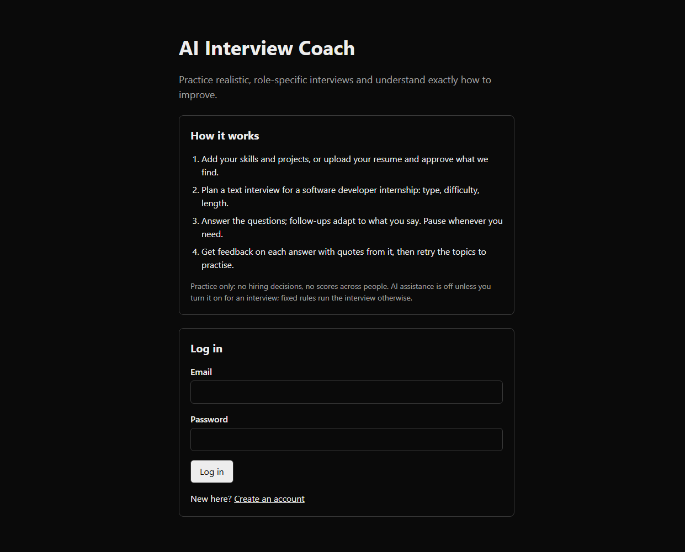
Figure B.1: Authentication and Sign-In Interface (/login)
Figure B.1 displays the clean, accessible sign-in and registration screen. The interface provides secure authentication controls with immediate client-side validation, password length bounds (8–128 characters), and clear informational guidance detailing how the coaching platform functions.
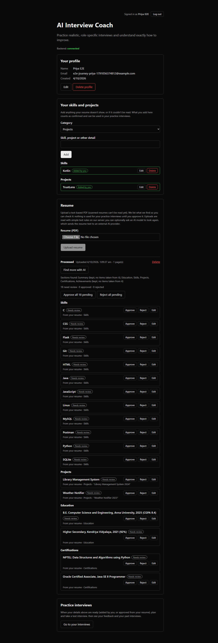
Figure B.2: Verbatim Resume Extraction and Fact Review Dashboard
Figure B.2 illustrates the human-in-the-loop fact review dashboard. Uploaded resume facts are categorized by competency (Skills, Projects, Experience, Education) with exact provenance lines. Candidates review, edit, approve, or reject items before confirming their profile.
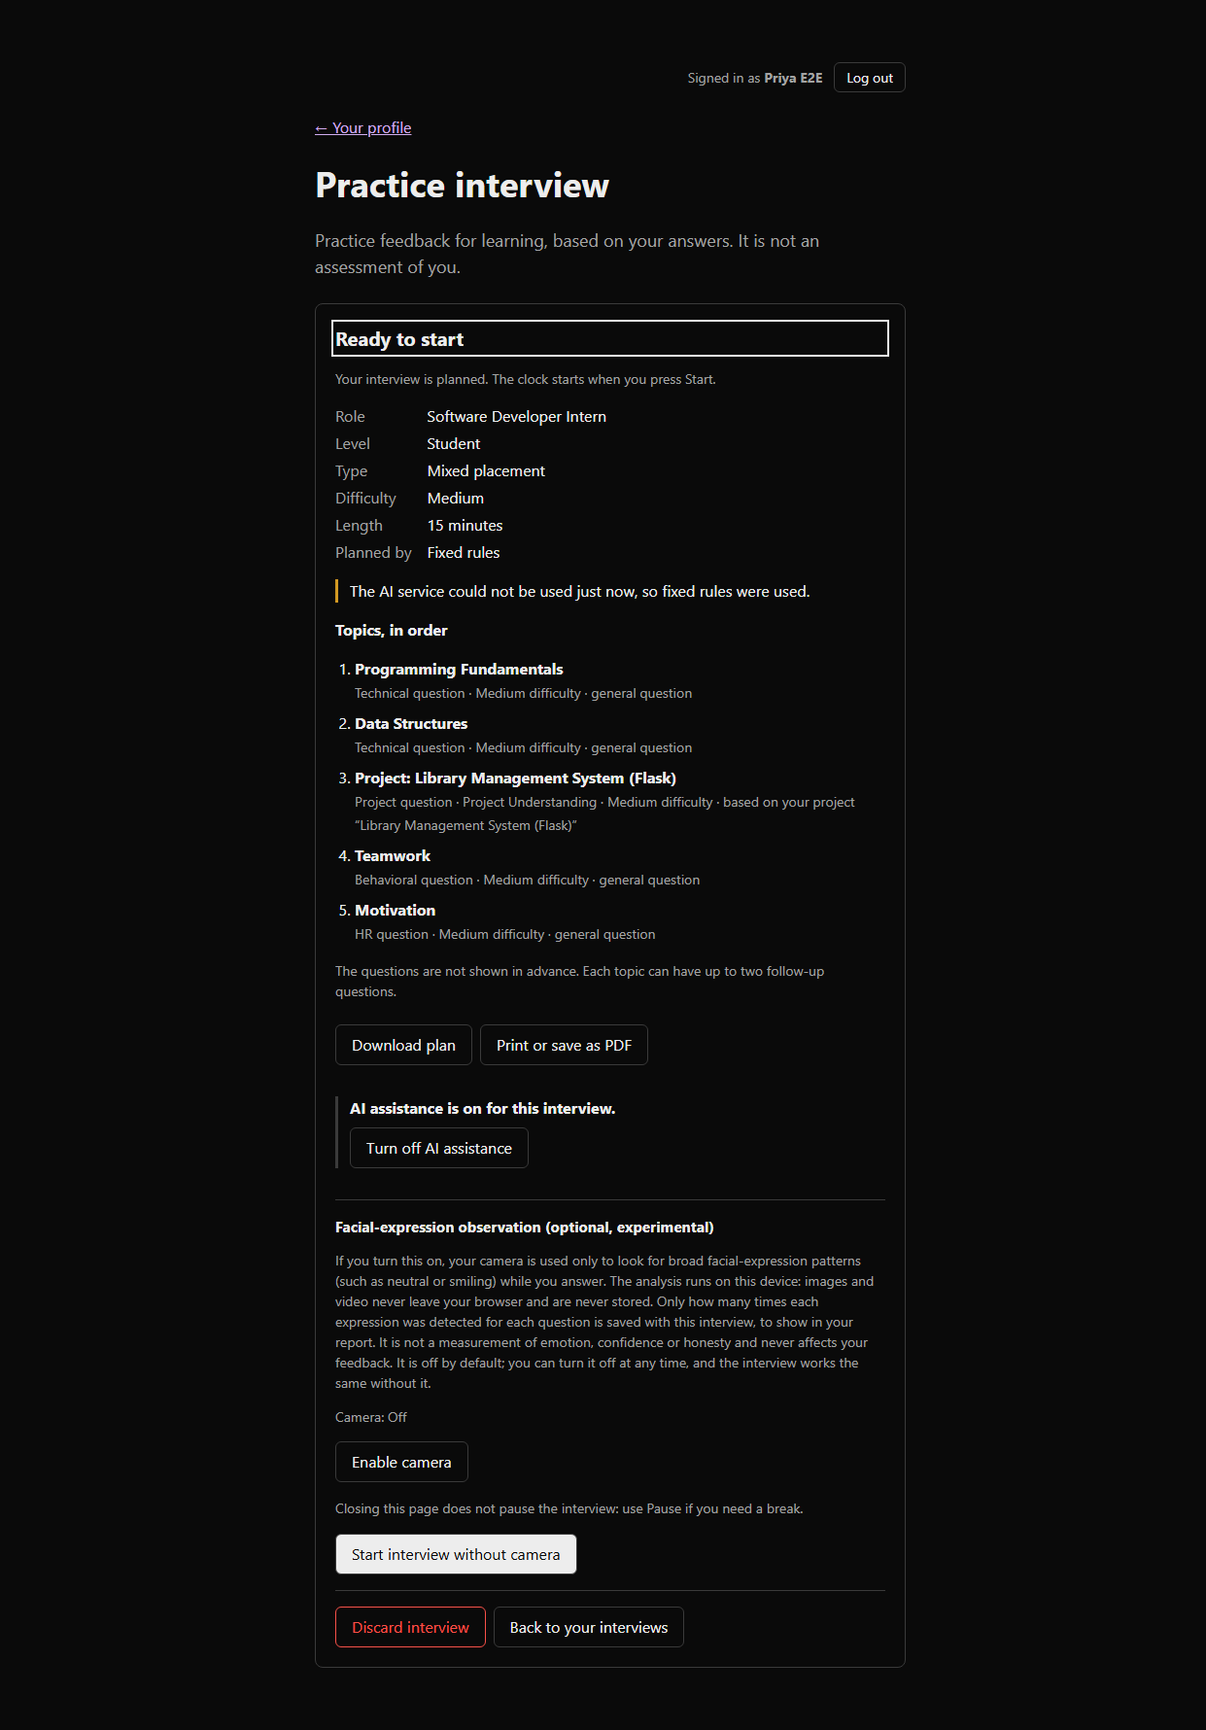
Figure B.3: Interview Configuration and Planning Screen
Figure B.3 shows the interview configuration interface. Candidates select target mode, difficulty, and duration, and toggle explicit AI consent. The generated topic sequence cites specific approved candidate facts, and offers one-click HTML/PDF export.
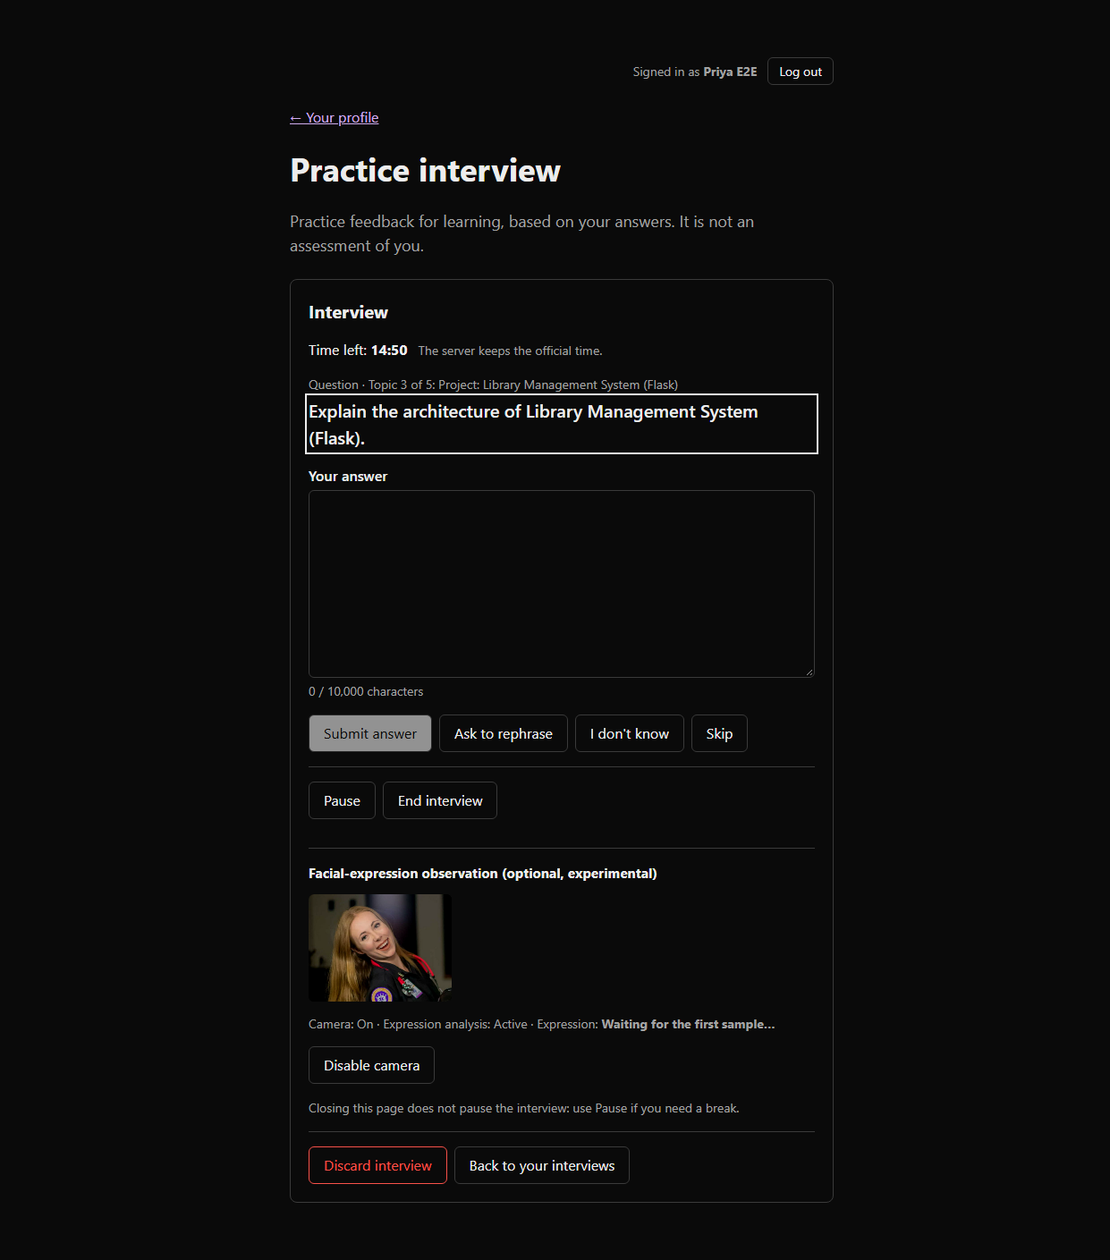
Figure B.4: In-Progress Interview Turn with Local Pacing Timer
Figure B.4 depicts an active interview turn. The interface renders the current question, candidate response textarea (with character count indicator), turn controls (Submit, Rephrase, I don't know, Skip, Pause), and active server-synchronized timer.
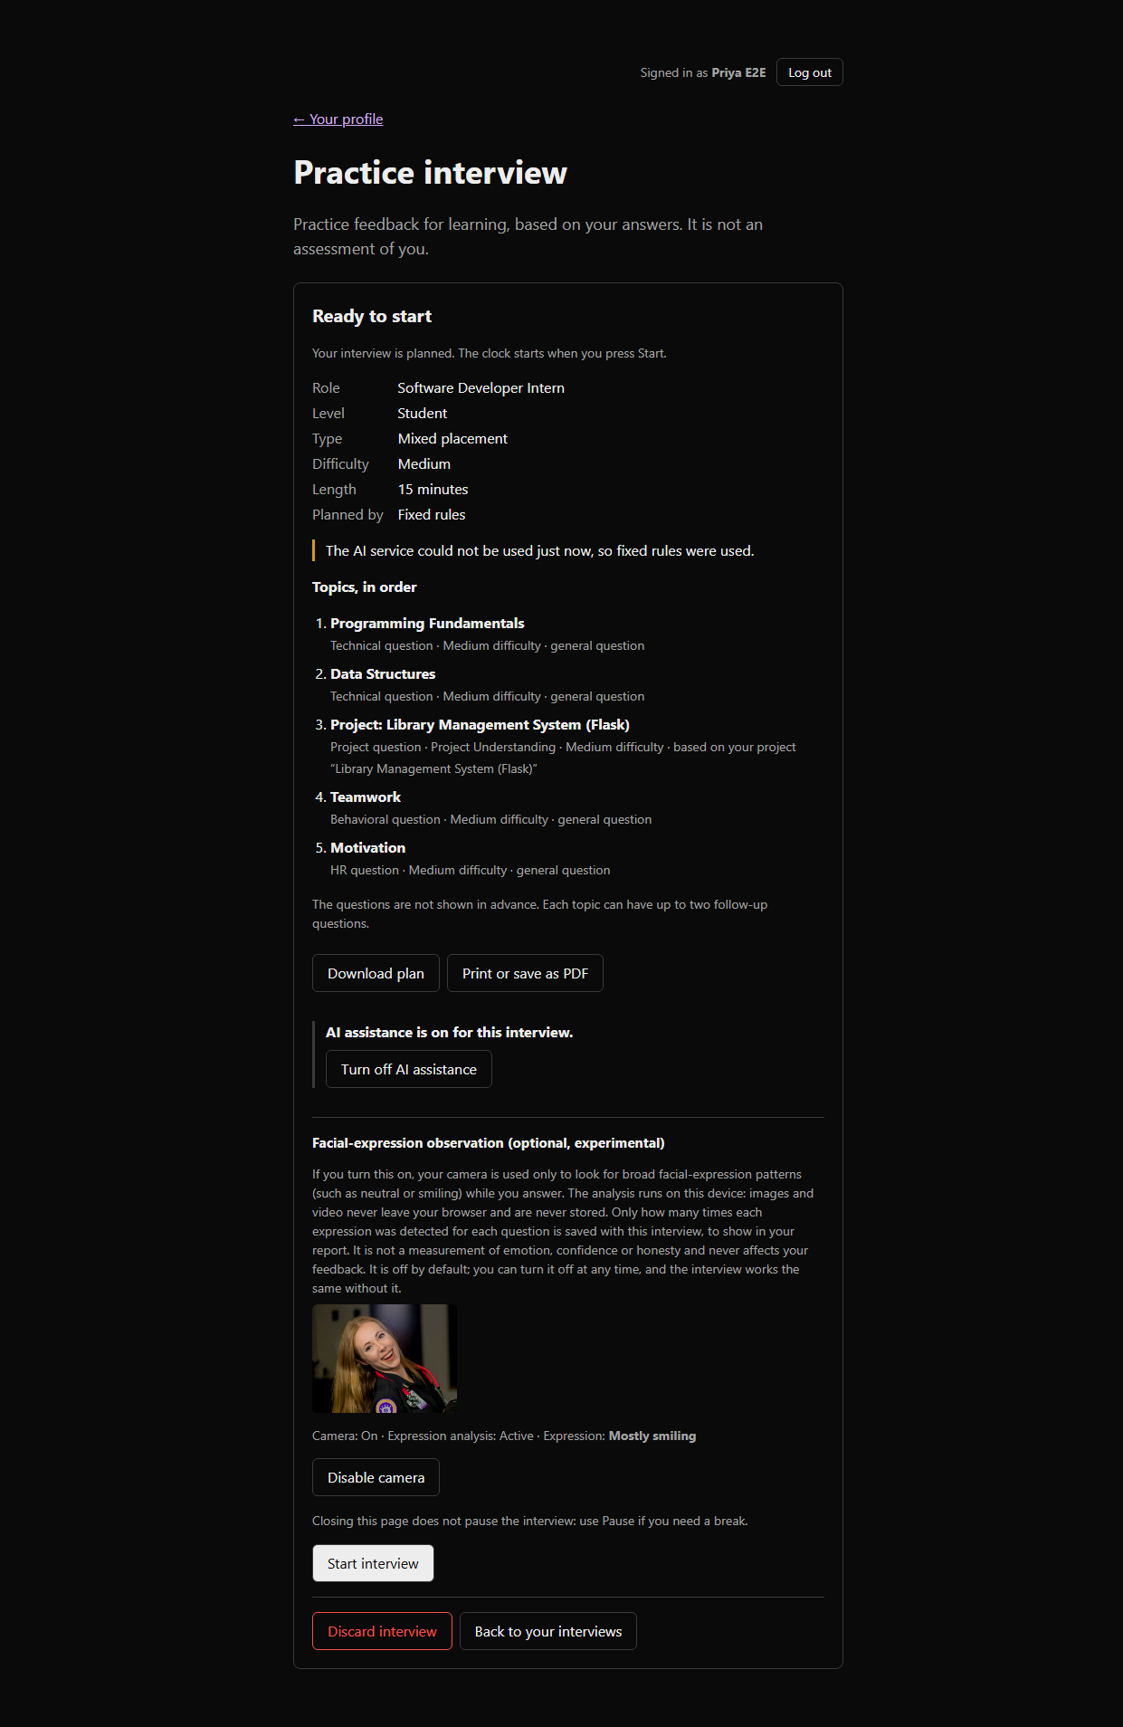
Figure B.5: On-Device Facial Expression Observation Signal Panel
Figure B.5 illustrates the optional on-device expression observation panel. Operating locally via WebGL and face-api.js, the panel displays real-time categorical signal distributions without transmitting raw camera frames or generating evaluative judgments.
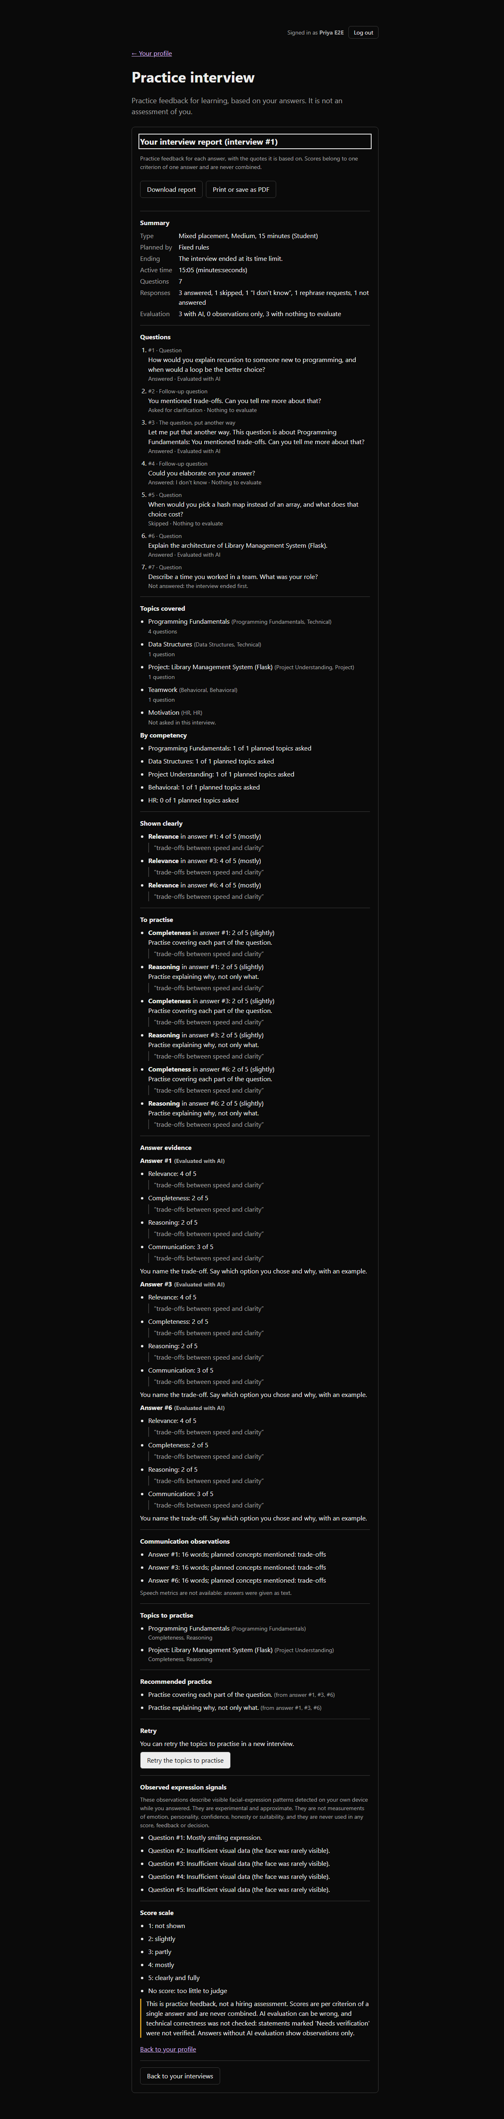
Figure B.6: Comprehensive Non-Aggregated Interview Evaluation Report
Figure B.6 presents the formative practice report. Individual criteria are scored 1–5 with exact quote evidence. The report highlights competencies shown clearly, identifies specific areas to practice, and provides an immediate retry trigger.
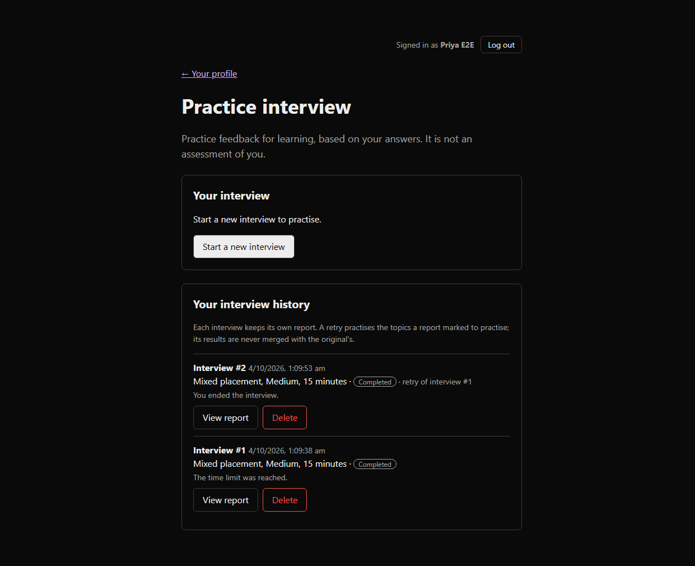
Figure B.7: Multi-Attempt Interview History and Targeted Retry Session Link
Figure B.7 shows the multi-attempt interview history dashboard. Each attempt is recorded independently with its completion status and report. Retries explicitly indicate the source interview attempt they reinforce.
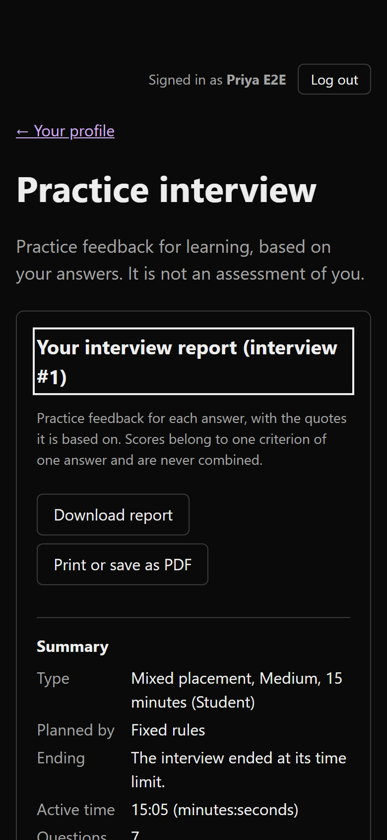
Figure B.8: Responsive Mobile View of Practice Report and Feedback
Figure B.8 confirms the mobile responsiveness of the platform on phone-sized viewports (390px width), verifying horizontal overflow prevention, readable typography, and accessible button tap targets.

REFERENCES
BOOKS:
- Bass, L., Clements, P., & Kazman, R. (2021). Software Architecture in Practice (4th ed.). Addison-Wesley Professional.
- Fowler, M. (2018). Refactoring: Improving the Design of Existing Code (2nd ed.). Addison-Wesley Professional.
- Gamma, E., Helm, R., Johnson, R., & Vlissides, J. (1994). Design Patterns: Elements of Reusable Object-Oriented Software. Addison-Wesley.
- Larman, C. (2004). Applying UML and Patterns: An Introduction to Object-Oriented Analysis and Design and Iterative Development (3rd ed.). Prentice Hall.
- Pressman, R. S., & Maxim, B. R. (2020). Software Engineering: A Practitioner's Approach (9th ed.). McGraw-Hill Education.
- Sommerville, I. (2016). Software Engineering (10th ed.). Pearson.
RESEARCH PAPERS & ARTICLES:
- Achiam, J., et al. (2023). GPT-4 Technical Report. arXiv preprint arXiv:2303.08774.
- Bommasani, R., et al. (2021). On the Opportunities and Risks of Foundation Models. arXiv preprint arXiv:2108.07258.
- Dwork, C., & Roth, A. (2014). The Algorithmic Foundations of Differential Privacy. Foundations and Trends in Theoretical Computer Science, 9(3–4), 211–407.
- Ribeiro, M. T., Singh, S., & Guestrin, C. (2016). 'Why Should I Trust You?': Explaining the Predictions of Any Classifier. ACM SIGKDD International Conference on Knowledge Discovery and Data Mining (KDD), 1135–1144.
- Vaswani, A., et al. (2017). Attention Is All You Need. Advances in Neural Information Processing Systems (NeurIPS), 30, 5998–6008.
TECHNICAL STANDARDS & DOCUMENTATION:
- ECMAScript Language Specification (ECMA-262). (2024). https://tc39.es/ecma262/
- FastAPI Framework Documentation. (2026). https://fastapi.tiangolo.com/
- Next.js App Router Documentation. (2026). https://nextjs.org/docs
- OpenAI API Specification for Structured JSON Outputs. (2024). https://platform.openai.com/docs/guides/structured-outputs
- PostgreSQL 16 Documentation. (2024). PostgreSQL Global Development Group. https://www.postgresql.org/docs/
- Pydantic V2 Documentation. (2024). https://docs.pydantic.dev/
- SQLAlchemy 2.0 Unified Documentation. (2024). https://docs.sqlalchemy.org/
- W3C Web Content Accessibility Guidelines (WCAG) 2.1. (2018). https://www.w3.org/TR/WCAG21/

