**Course: High Performance Computing Lab**

**Practical No 1**

**PRN: 23520004**

**Name: Harshad Ajit Dange**

**Batch: B4**

**Title: Introduction to OpenMP**

**Problem Statement 1 – Demonstrate Installation and Running of OpenMP code in C.**

#include <omp.h>

#include <stdio.h>

int main(){

    #pragma omp parallel

    printf("Hello world.\n");

    return 0;

}

**Output : -**

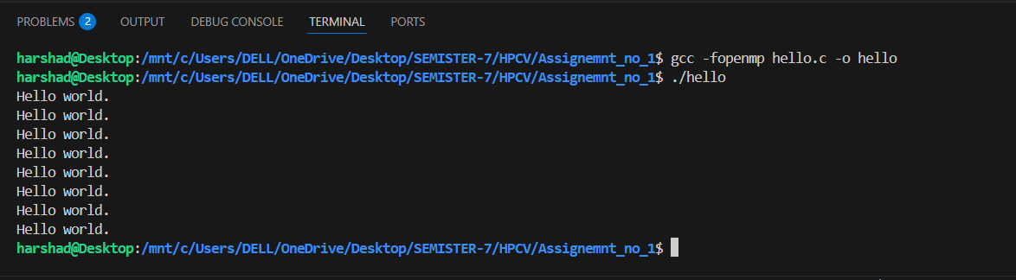

**Problem Statement 2 – Print ‘Hello, World’ in Sequential and Parallel in OpenMP**

**We first ask the user for number of threads – OpenMP allows to set the threads at runtime. Then, we print the Hello, World in sequential – number of times of threads count and then run the code in parallel in each thread.**

**Code snapshot:**

#include <stdio.h>

#include <omp.h>

int main() {

    int threads;

    printf("Entire count of thread: ");

    scanf("%d",&threads);

    omp_set_num_threads(threads);

    for (int i = 0; i < threads; i++) {

        printf("Hello World from thread %d out of %d threads (sequential).\n", i, threads);

    }

    #pragma omp parallel

    {

        int thread_id = omp_get_thread_num();

        int total_threads = omp_get_num_threads();

        printf("Hello World from thread %d out of %d threads (parallel).\n", thread_id, total_threads);

    }

    return 0;

}

**Output snapshot:**

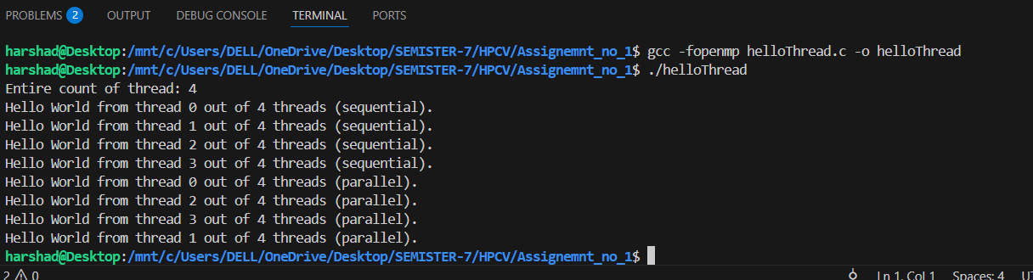

GitHub Link:

**Problem statement 3: Calculate theoretical FLOPS of your system on which you are running** **the above codes.**

**Elaborate the parameters and show calculation.**

**System Specifications:**

* **Laptop Model**: Dell Inspiron 15 3000
* **Processor**: 11th Gen Intel Core i5-1135G7
* **Base Clock Speed**: 2.4 GHz
* **Number of Physical Cores**: 4
* **FLOPs per Cycle (per core)**: 16 (with AVX2 and FMA support)

**Formula to Calculate FLOPS:**

FLOPS = Number of Cores x Clock Speed (Hz) x FLOPs per cycle

**Calculation:**

**Using Base Clock Speed (2.4 GHz):**

= 4 × 2.4 × 109 × 16 = 153.6 × 109 = 153.6 GFLOPS

**Using Turbo Boost Clock Speed (4.2 GHz):**

=4 × 4.2 × 109 × 16 = 268.8 × 109 = 268.8 GFLOPS ​

**Conclusion:**

* The **theoretical peak performance** of your system is:
  + **153.6 GFLOPS** at base clock (2.4 GHz)
  + **268.8 GFLOPS** at turbo boost (4.2 GHz)

This estimation helps in understanding the computational capacity of your system when executing parallel programs using OpenMP.