-----------------------------------------------------------------------------------------------------------------------------------------------------------------------------------------------------------------------------------------------------------------------------------------------------------------------------------------------------------------------------------------------------------------

Q1. Implementation of different searching techniques.
Ans:- 1) Linear Search
Code:-
// Java program to implement Linear Search class Linearsearch {
public static int search(int arr[], int x) { int n = arr.length;
for (int i = 0; i < n; i++) {
if (arr[i] == x) return i; } return -1;
}
public static void main(String args[]) {
int arr[] = { 2, 3, 4, 10, 40 };
int x = 10;
int result = search(arr, x); if (result == -1)
System.out.print("Element is not present in array"); else
System.out.print("Element is present" + " at index " + result);
}
}
Output:-
2) Binary Search implementation of recursive
Code:-
// Java implementation of recursive class Binarysearch {
int binarySearch(int arr[], int l, int r, int x) { if (r >= l) { int mid = l + (r - l) / 2;
if (arr[mid] == x) return mid;
if (arr[mid] > x) return binarySearch(arr, l, mid - 1, x);
return binarySearch(arr, mid + 1, r, x);
}
return -1;
}
public static void main(String args[]) {
Binarysearch ob = new Binarysearch();
int arr[] = { 2, 3, 4, 10, 40 }; int n = arr.length; int x = 10;
int result = ob.binarySearch(arr, 0, n - 1, x);
if (result == -1)
System.out.println("Element " + "not present"); else
System.out.println("Element found" + " at index " + result);
}
}
Output:-
3) Binary Search implementation of iterative
Code:-
// Java implementation of iterative class Iterbinary {
int binarySearch(int arr[], int x) {
int l = 0, r = arr.length - 1;
while (l <= r) { int m = l + (r - l) / 2;
if (arr[m] == x) return m;
if (arr[m] < x) l = m + 1;
else r = m - 1; }
return -1; }
public static void main(String args[]) {
Iterbinary ob = new Iterbinary();
int arr[] = { 2, 3, 4, 10, 40 }; int n = arr.length; int x = 10;
int result = ob.binarySearch(arr, x);
if (result == -1) System.out.println("Element not present"); else
System.out.println("Element found at index "
+ result);
}
}
Output:-
Q2. Implementation of different sorting techniques.
Ans:-
1) Bubble Sort
Code:-
import java.util.*; class Sorting {
public static void printarr(int arr[]) { for (int i = 0; i < arr.length; i++) {
System.out.print(arr[i] + " ");
}
System.out.println();
}
public static void main(String[] args) { int arr[] = { 5, 2, 3, 1, 4 };
// Bubble sort Logic
for
(int i = 0; i < arr.length - 1; i++) { for (int j = 0; j < arr.length - i - 1; j++) { if (arr[j] > arr[j + 1]) {
// swap int temp = arr[j]; arr[j] = arr[j + 1]; arr[j + 1] = temp;
}
}
}
// Printing the sorted array
printarr(arr);
}
}
Output:-
2) Selection Sort
Code:-
import java.util.*;
class Selectionsort { public static void printarr(int arr[]) { for (int i = 0; i < arr.length; i++) {
System.out.print(arr[i] + " ");
}
System.out.println();
}
public static void main(String[] args) { int arr[] = { 5, 2, 3, 1, 4 };
// Selection sort Logic for (int i = 0; i < arr.length - 1; i++) { int smallest = i; for (int j = i + 1; j < arr.length; j++) { if (arr[smallest] > arr[j]) { smallest = j;
} } int temp = arr[smallest];
arr[smallest] = arr[i]; arr[i] = temp;
}
// Printing the sorted array printarr(arr);
}
}
OutPut:-
2) Insertion Sort
Code:-
import java.util.*; class Insertionsort {
public static void printarr(int arr[]) { for (int i = 0; i < arr.length; i++) {
System.out.print(arr[i] + " ");
}
System.out.println();
}
public static void main(String[] args) { int arr[] = { 5, 2, 3, 1, 4 };
// Insertion sort Logic
for (int i = 1; i < arr.length; i++) { int current = arr[i]; int j = i - 1;
while (j >= 0 && current < arr[j]) { arr[j + 1] = arr[j]; j--;
}
// Placement arr[j + 1] = current; }
// Print the sorted array printarr(arr);
}
}
Output:-

-----------------------------------------------------------------------------------------------------------------------------------------------------------------------------------------------------------------------------------------------------------------------------------------------------------------------------------------------------------------------------------------------------------------

Q2. Using Java perform various hashing techniques with Linear Probe as collision resolution
Ans :- Code:-
package harshad;
public class HashingWithLinearProbing {
private int tableSize;
private int[] table;
public HashingWithLinearProbing(int tableSize) {
this.tableSize = tableSize;
table = new int[tableSize];
for (int i = 0; i < tableSize; i++) {
table[i] = 0;
}
}
public int hash(int key) {
return key % tableSize;
}
public void insert(int key) {
int index = hash(key);
while (table[index] != 0) {
index = (index + 1) % tableSize;
}
table[index] = key;
}
public boolean search(int key) {
int index = hash(key);
while (table[index] != 0) {
if (table[index] == key) {
return true;
}
index = (index + 1) % tableSize;
}
return false;
}
public void printTable() {
for (int i = 0; i < tableSize; i++) {
System.out.println("Index " + i + ": " + table[i]);
}
}
public static void main(String[] args) {
HashingWithLinearProbing hashTable = new HashingWithLinearProbing(10);
hashTable.insert(10);
hashTable.insert(22);
hashTable.insert(31);
hashTable.insert(4);
hashTable.insert(15);
hashTable.insert(28);
hashTable.insert(17);
hashTable.insert(88);
hashTable.insert(59);
hashTable.printTable();
System.out.println("Search for 22: " + hashTable.search(22));
System.out.println("Search for 99: " + hashTable.search(99));
}
}
Output:-

-----------------------------------------------------------------------------------------------------------------------------------------------------------------------------------------------------------------------------------------------------------------------------------------------------------------------------------------------------------------------------------------------------------------
3. Implementation of Stacks ,Ordinary Queue & Circular queue (Using arrays)
1. Implementation of stacks.
Code:
package ads; class Stack { private int[] stack; private int top; private int capacity;

public Stack(int size) { capacity = size; stack = new int[capacity]; top = -1;
}

public boolean isEmpty() { return top == -1;
}

public boolean isFull() { return top == capacity - 1;
}

public void push(int element) {
if (isFull()) {
System.out.println("Stack Overflow!");
} else {
stack[++top] = element;
System.out.println("Pushed " + element + " into stack.");
}
}

public void pop() { if (isEmpty()) {
System.out.println("Stack Underflow!");
} else {
System.out.println("Popped " + stack[top--] + " from stack.");
}
}

public void peek() { if (isEmpty()) {
System.out.println("Stack is empty!");
} else {
System.out.println("Top element is " + stack[top]);
}
}

public void display() { if (isEmpty()) {
System.out.println("Stack is empty!");
} else {
System.out.print("Stack elements: "); for (int i = top; i >= 0; i--) {
System.out.print(stack[i] + " ");
}
System.out.println();
}
}
}

public class Main { public static void main(String[] args) { Stack stack = new Stack(5); stack.push(10); stack.push(20); stack.push(30); stack.peek(); stack.display(); stack.pop(); stack.display();
}
}

Output:

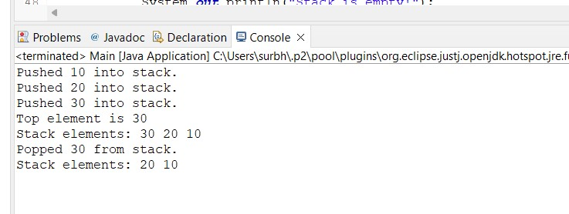
2.Ordinary Queue:

package ads;

public class Queue { private int[] queue;
private int front, rear, size, capacity;

public Queue(int capacity) { this.capacity = capacity; queue = new int[capacity]; front = 0; rear = -1; size = 0;
}

public boolean isFull() { return size == capacity;
}

public boolean isEmpty() { return size == 0;
}

public void enqueue(int element) {
if (isFull()) {
System.out.println("Queue is full! Cannot enqueue " + element); return;
}
rear = (rear + 1) % capacity; queue[rear] = element; size++;
System.out.println(element + " added to the queue");
}

public int dequeue() { if (isEmpty()) {
System.out.println("Queue is empty! Cannot dequeue"); return -1;
}
int element = queue[front];
front = (front + 1) % capacity; size--;
return element;
}

public int front() { if (isEmpty()) {
System.out.println("Queue is empty! No front element"); return -1;
}
return queue[front];
}

public int getSize() { return size;
}

public static void main(String[] args) {

Queue q = new Queue(5);

q.enqueue(10);
q.enqueue(20);
q.enqueue(30);
q.enqueue(40);
q.enqueue(50);

q.enqueue(60);

System.out.println("Dequeued element: " + q.dequeue()); System.out.println("Dequeued element: " + q.dequeue());

System.out.println("Front element: " + q.front());

q.enqueue(60);
q.enqueue(70);

System.out.println("Current size of the queue: " + q.getSize());
}

}

Output:

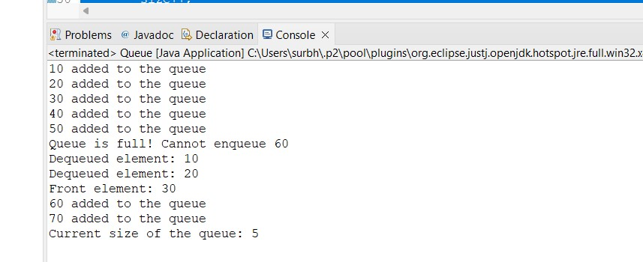
3.Circular queue (Using arrays):
package ads;

public class Circularqueue { private int[] queue;
private int front, rear, size, capacity;

public Circularqueue(int capacity) { this.capacity = capacity; queue = new int[capacity]; front = 0; rear = -1; size = 0;
}

public boolean isFull() { return size == capacity;
}

public boolean isEmpty() { return size == 0;
}

public void enqueue(int element) {
if (isFull()) {
System.out.println("Queue is full! Cannot enqueue " + element); return;
}
rear = (rear + 1) % capacity; // Move rear circularly queue[rear] = element; size++;
System.out.println(element + " added to the queue");
}

public int dequeue() { if (isEmpty()) {
System.out.println("Queue is empty! Cannot dequeue"); return -1; // Indicating queue is empty
}
int element = queue[front];
front = (front + 1) % capacity; // Move front circularly size--;
return element;
}

public int front() { if (isEmpty()) {
System.out.println("Queue is empty! No front element"); return -1;
}
return queue[front];
}

public int getSize() { return size;
}

public void display() { if (isEmpty()) {
System.out.println("Queue is empty!"); return;
}
System.out.print("Queue elements: "); for (int i = 0; i < size; i++) {
System.out.print(queue[(front + i) % capacity] + " ");
}
System.out.println();
}

public static void main(String[] args) {
Circularqueue cq = new Circularqueue(5);

cq.enqueue(10); cq.enqueue(20); cq.enqueue(30); cq.enqueue(40); cq.enqueue(50);

cq.enqueue(60); cq.display();

System.out.println("Dequeued element: " + cq.dequeue()); System.out.println("Dequeued element: " + cq.dequeue());

cq.display();

cq.enqueue(60); cq.enqueue(70); cq.display();
System.out.println("Front element: " + cq.front());
System.out.println("Final size of the queue: " + cq.getSize());

}

}
Output:

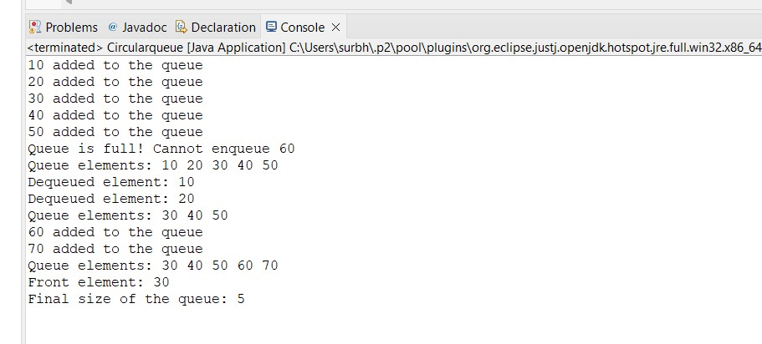

4. Implementation of Stack Applications like:
infix to postfix
Postfix evaluation
Balancing of Parenthesis
1. infix to postfix

package ads;

import java.util.Stack;

public class InfixTopostfix {

private static int precedence(char ch) { if (ch == '+' || ch == '-') { return 1;
} else if (ch == '*' || ch == '/') { return 2; } else if (ch == '^') { return 3;
}
return -1;
}

public static String infixToPostfix(String expression) {
Stack<Character> stack = new Stack<>();
StringBuilder result = new StringBuilder();

for (int i = 0; i < expression.length(); i++) { char ch = expression.charAt(i);

if (Character.isLetterOrDigit(ch)) { result.append(ch);
}

else if (ch == '(') { stack.push(ch);
}
else if (ch == ')') {
while (!stack.isEmpty() && stack.peek() != '(') { result.append(stack.pop());
}
stack.pop();
} else {
while (!stack.isEmpty() && precedence(ch) <= precedence(stack.peek()) && ch != '^') { result.append(stack.pop());
}
stack.push(ch);
}
}

while (!stack.isEmpty()) { result.append(stack.pop());
}

return result.toString();
}

public static void main(String[] args) {
String infixExpression = "A+B*(C^D-E)^(F+G*H)-I";
System.out.println("Infix Expression: " + infixExpression);
System.out.println("Postfix Expression: " + infixToPostfix(infixExpression));
}
}
Output:

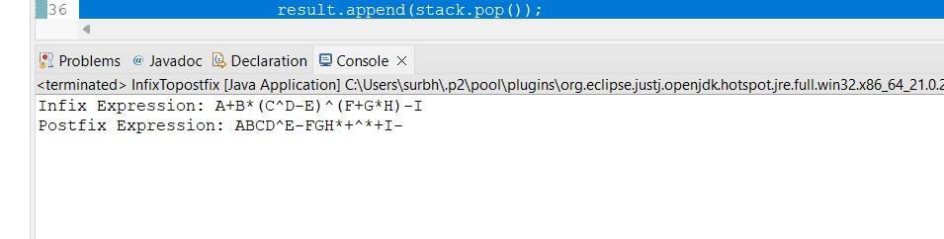
2. Postfix evaluation Code:
package ads;

import java.util.Stack;

public class Postfix {

public static int evaluatePostfix(String expression) {
Stack<Integer> stack = new Stack<>();

for (int i = 0; i < expression.length(); i++) { char ch = expression.charAt(i);

if (Character.isDigit(ch)) { stack.push(ch - '0'); }
else if (ch == '+' || ch == '-' || ch == '*' || ch == '/') { int operand2 = stack.pop(); int operand1 = stack.pop();

int result = 0; if (ch == '+') {
result = operand1 + operand2;
} else if (ch == '-') { result = operand1 - operand2;
} else if (ch == '*') { result = operand1 * operand2;
} else if (ch == '/') { result = operand1 / operand2;
}
stack.push(result);
}
}

return stack.pop();
}

public static void main(String[] args) { String postfixExpression = "23*5+"; System.out.println("Postfix Expression: " + postfixExpression);
System.out.println("Evaluation Result: " + evaluatePostfix(postfixExpression));
}
}
Output:
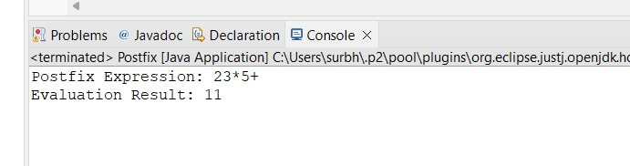
3.Balancing of Parenthesis
Code:

package ads;

import java.util.Stack;

public class ParenthesisBalancing {

public static boolean areParenthesesBalanced(String expression) {
Stack<Character> stack = new Stack<>();

for (int i = 0; i < expression.length(); i++) { char ch = expression.charAt(i);

if (ch == '(' || ch == '[' || ch == '{') {
stack.push(ch);
}
else if (ch == ')' || ch == ']' || ch == '}') { if (stack.isEmpty()) { return false;
}

char top = stack.pop(); if ((ch == ')' && top != '(') || (ch == ']' && top != '[') || (ch == '}' && top != '{')) { return false;
}
}
}

return stack.isEmpty();
}

public static void main(String[] args) {
String expression1 = "{[()]}";
String expression2 = "{[(])}";
String expression3 = "{[(";

System.out.println("Expression 1: " + expression1 + " - " +
(areParenthesesBalanced(expression1) ? "Balanced" : "Unbalanced")); System.out.println("Expression 2: " + expression2 + " - " +
(areParenthesesBalanced(expression2) ? "Balanced" : "Unbalanced"));
System.out.println("Expression 3: " + expression3 + " - " + (areParenthesesBalanced(expression3) ? "Balanced" : "Unbalanced")); Output:

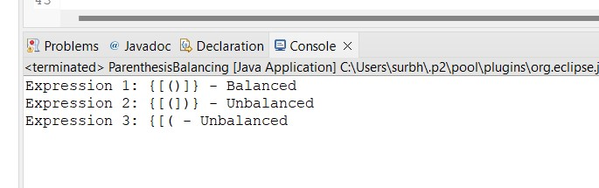

5.Implementation of all types of linked lists.
1.SinglyLinkedList Code:
class SinglyLinkedList {
// Node class to represent each node in the list static class Node { int data;
Node next;

Node(int data) { this.data = data; this.next = null;
}
}

Node head;

// Method to append a new node to the list public void append(int data) { Node newNode = new Node(data);
if (head == null) { head = newNode; return;
}
Node last = head; while (last.next != null) { last = last.next;
}
last.next = newNode;
}

// Method to delete a node by value public void delete(int key) { Node temp = head; if (temp != null && temp.data == key) { head = temp.next; return;
}
Node prev = null;
while (temp != null && temp.data != key) { prev = temp; temp = temp.next;
}
if (temp == null) return; prev.next = temp.next;
}

// Method to print the list public void printList() { Node temp = head; while (temp != null) {
System.out.print(temp.data + " -> "); temp = temp.next;
}
System.out.println("None");
}

public static void main(String[] args) { SinglyLinkedList list = new SinglyLinkedList(); list.append(10); list.append(20); list.append(30);
list.printList(); // Output: 10 -> 20 -> 30 -> None list.delete(20);
list.printList(); // Output: 10 -> 30 -> None
}
}

Output:
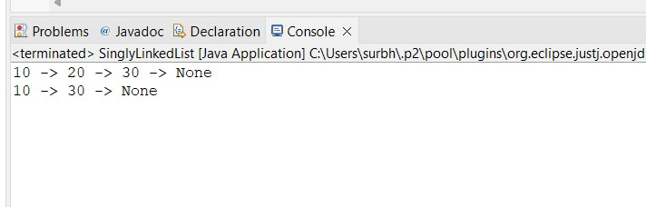
2. Doubly Linked List Code:
class DoublyLinkedList {
// Node class to represent each node in the list static class Node { int data;
Node next, prev;

Node(int data) { this.data = data; this.next = this.prev = null;
}
}

Node head;

// Method to append a new node at the end
public void append(int data) { Node newNode = new Node(data);
if (head == null) { head = newNode; return;
}
Node last = head; while (last.next != null) { last = last.next;
}
last.next = newNode; newNode.prev = last;
}
public void delete(int key) { Node temp = head;
if (temp != null && temp.data == key) { head = temp.next; if (head != null) head.prev = null; return;
}
while (temp != null && temp.data != key) { temp = temp.next;
}
if (temp == null) return;
if (temp.next != null) temp.next.prev = temp.prev; if (temp.prev != null) temp.prev.next = temp.next; }

// Method to print the list forward public void printList() { Node temp = head; while (temp != null) {
System.out.print(temp.data + " <-> "); temp = temp.next;
}
System.out.println("None");
}
public void printReverse() { Node temp = head; if (temp == null) return; while (temp.next != null) { temp = temp.next;
}
while (temp != null) {
System.out.print(temp.data + " <-> "); temp = temp.prev;
}
System.out.println("None");
}

public static void main(String[] args) {
DoublyLinkedList list = new DoublyLinkedList(); list.append(10); list.append(20); list.append(30);
list.printList(); // Output: 10 <-> 20 <-> 30 <-> None list.printReverse(); // Output: 30 <-> 20 <-> 10 <-> None list.delete(20);
list.printList(); // Output: 10 <-> 30 <-> None
}
}
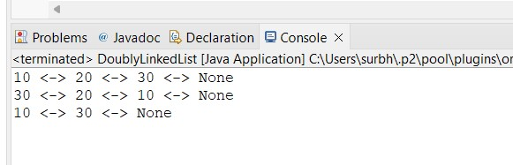

3. Circular Singly Linked List.
Code:
class CircularSinglyLinkedList { static class Node { int data;
Node next;

Node(int data) { this.data = data; this.next = null;
}
}

Node head;

// Method to append a new node to the list public void append(int data) { Node newNode = new Node(data);
if (head == null) { head = newNode; newNode.next = head; return;
}
Node last = head; while (last.next != head) { last = last.next;
}
last.next = newNode; newNode.next = head;
}
public void delete(int key) { if (head == null) return; Node temp = head; if (temp.data == key) { if (temp.next == head) { head = null; return;
}
while (temp.next != head) { temp = temp.next;
}
temp.next = head.next; head = head.next; return;
}
Node prev = null;
while (temp != null && temp.data != key) { prev = temp; temp = temp.next; if (temp == head) return;
}
if (temp == null) return; prev.next = temp.next;
}

// Method to print the list public void printList() { if (head == null) return; Node temp = head;
do {
System.out.print(temp.data + " -> "); temp = temp.next;
} while (temp != head);
System.out.println("Back to head");
}

public static void main(String[] args) {
CircularSinglyLinkedList list = new CircularSinglyLinkedList(); list.append(10); list.append(20); list.append(30);
list.printList(); // Output: 10 -> 20 -> 30 -> Back to head list.delete(20);
list.printList(); // Output: 10 -> 30 -> Back to head
}
}
Output:
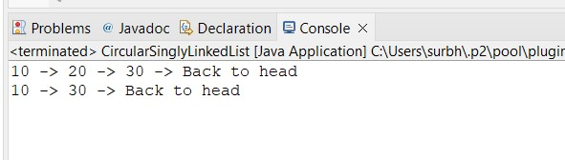

4. Circular Doubly Linked List.
Code:
class CircularDoublyLinkedList {
// Node class to represent each node in the list static class Node { int data;
Node next, prev;

Node(int data) { this.data = data; this.next = this.prev = null;
}
}

Node head;

// Method to append a new node to the list (at the end) public void append(int data) { Node newNode = new Node(data);
if (head == null) { head = newNode;
newNode.next = newNode.prev = head; // Circular link return;
}
Node last = head; while (last.next != head) { last = last.next;
}
last.next = newNode; newNode.prev = last; newNode.next = head; head.prev = newNode;
}

// Method to insert a node at the front public void insertAtFront(int data) { Node newNode = new Node(data);
if (head == null) { head = newNode;
newNode.next = newNode.prev = head; // Circular link return;
}
Node last = head.prev; // Last node (previous of head) newNode.next = head; newNode.prev = last; last.next = newNode; head.prev = newNode;
head = newNode; // New node becomes the head
}

// Method to delete a node by value public void delete(int key) { if (head == null) return; // List is empty

Node temp = head;
if (temp.data == key) { // If head is the node to be deleted if (temp.next == head) { // Only one node in the list head = null;
} else {
Node last = head.prev;
head = temp.next; last.next = head; head.prev = last;
} return;
}

// Traverse the list to find the node to delete while (temp != head && temp.data != key) { temp = temp.next;
}
if (temp == head) return; // Node not found

// Node found, remove it from the list temp.prev.next = temp.next; temp.next.prev = temp.prev;
}

// Method to print the list in forward direction public void printListForward() { if (head == null) {
System.out.println("List is empty."); return;
}
Node temp = head;
do {
System.out.print(temp.data + " <-> "); temp = temp.next;
} while (temp != head);
System.out.println("Back to head");
}

// Method to print the list in reverse direction public void printListBackward() { if (head == null) {
System.out.println("List is empty."); return;
}
Node temp = head.prev;
do {
System.out.print(temp.data + " <-> "); temp = temp.prev;
} while (temp != head.prev);
System.out.println("Back to tail");
}

public static void main(String[] args) {
CircularDoublyLinkedList list = new CircularDoublyLinkedList();

// Appending nodes list.append(10); list.append(20); list.append(30);
list.printListForward(); // Output: 10 <-> 20 <-> 30 <-> Back to head list.printListBackward(); // Output: 30 <-> 20 <-> 10 <-> Back to tail

// Inserting node at the front list.insertAtFront(5);
list.printListForward(); // Output: 5 <-> 10 <-> 20 <-> 30 <-> Back to head list.printListBackward(); // Output: 30 <-> 20 <-> 10 <-> 5 <-> Back to tail

// Deleting node with value 20 list.delete(20);
list.printListForward(); // Output: 5 <-> 10 <-> 30 <-> Back to head list.printListBackward(); // Output: 30 <-> 10 <-> 5 <-> Back to tail

// Deleting head node (5) list.delete(5);
list.printListForward(); // Output: 10 <-> 30 <-> Back to head list.printListBackward(); // Output: 30 <-> 10 <-> Back to tail
}
}
Output:
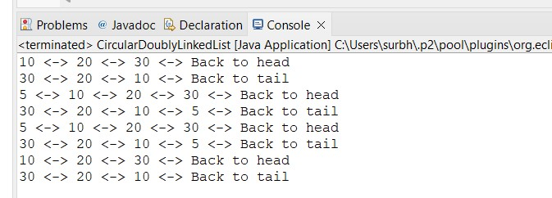

6.Demonstrate application of linked list (eg.Sparse matrix,Stack,Queue,Priority & Double ended Queue).
Code:
Sparse matrix package ads; import java.util.*;

class SparseMatrix { // Define the Node class static class Node { int row, col, value;
Node next;

Node(int row, int col, int value) { this.row = row; this.col = col; this.value = value; this.next = null;
}
}

Node head;

// Method to insert a non-zero element public void insert(int row, int col, int value) {
Node newNode = new Node(row, col, value);
if (head == null) { head = newNode; return;
}
Node temp = head; while (temp.next != null) { temp = temp.next;
}
temp.next = newNode;
}

// Method to print the Sparse Matrix public void printMatrix(int rows, int cols) {
Node temp = head;
System.out.println("Sparse Matrix:"); for (int i = 0; i < rows; i++) { for (int j = 0; j < cols; j++) { boolean printed = false; Node n = temp; while (n != null) {
if (n.row == i && n.col == j) { System.out.print(n.value + " "); temp = temp.next; printed = true; break;
} n = n.next;
} if (!printed) {
System.out.print("0 ");
}
}
System.out.println();
}
}

public static void main(String[] args) { SparseMatrix matrix = new SparseMatrix(); matrix.insert(0, 1, 5); matrix.insert(2, 3, 10); matrix.insert(1, 2, 3); matrix.printMatrix(3, 4);
}
}

Output:
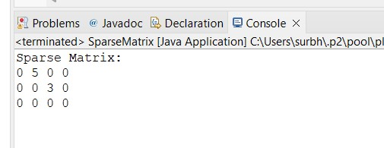

Stack Using Linked List Code: package ads;

import java.util.EmptyStackException;

class LinkedListStack { private Node top;

class Node { int data;
Node next;

Node(int data) { this.data = data; this.next = null;
}
}

public LinkedListStack() {
top = null;
}

public void push(int data) { Node newNode = new Node(data); newNode.next = top; top = newNode;
}

public int pop() { if (top == null) { throw new EmptyStackException();
}
int data = top.data; top = top.next; return data;
}

public int peek() { if (top == null) { throw new EmptyStackException();
}
return top.data;
}

public boolean isEmpty() {
return top == null;
}

public static void main(String[] args) {
LinkedListStack stack = new LinkedListStack();

stack.push(10); stack.push(20); stack.push(30);

System.out.println("Top element: " + stack.peek());

System.out.println("Popped element: " + stack.pop());

System.out.println("Top element after pop: " + stack.peek());

System.out.println("Is the stack empty? " + stack.isEmpty());

System.out.println("Popped element: " + stack.pop());

System.out.println("Is the stack empty now? " + stack.isEmpty());
}
}

Output:
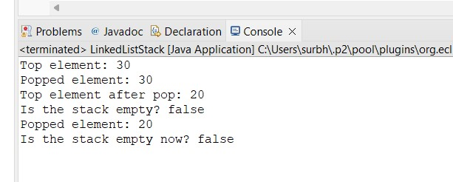
Queue Using Linked List
Code: package ads;

import java.util.NoSuchElementException;

class LinkedListQueue { private Node front, rear;

class Node { int data;
Node next;

Node(int data) { this.data = data; this.next = null;
}
}

public LinkedListQueue() {
front = rear = null;
}

public void enqueue(int data) { Node newNode = new Node(data);
if (rear == null) { front = rear = newNode; return;
}
rear.next = newNode; rear = newNode;
}

public int dequeue() {
if (front == null) throw new NoSuchElementException(); int data = front.data; front = front.next; if (front == null) rear = null; return data;
}

public boolean isEmpty() { return front == null;
}

public static void main(String[] args) {
LinkedListQueue queue = new LinkedListQueue(); queue.enqueue(10); queue.enqueue(20); queue.enqueue(30);

System.out.println("Dequeued element: " + queue.dequeue()); System.out.println("Dequeued element: " + queue.dequeue());
}
}
Output:
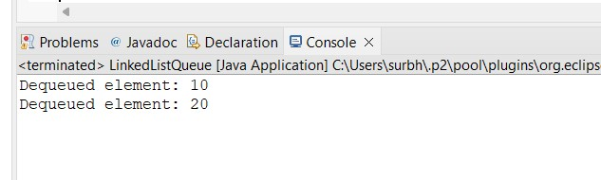

Priority Queue Using Linked List Code:
package ads;

import java.util.NoSuchElementException;

class LinkedListPriorityQueue { private Node head;

class Node { int data, priority; Node next;

Node(int data, int priority) { this.data = data; this.priority = priority; this.next = null;
}
}

public LinkedListPriorityQueue() { head = null;
}
public void enqueue(int data, int priority) { Node newNode = new Node(data, priority); if (head == null || head.priority < priority) { newNode.next = head; head = newNode;
} else {
Node current = head;
while (current.next != null && current.next.priority >= priority) { current = current.next;
}
newNode.next = current.next; current.next = newNode;
}
}

public int dequeue() {
if (head == null) throw new NoSuchElementException(); int data = head.data; head = head.next; return data;
}
public static void main(String[] args) {
LinkedListPriorityQueue queue = new LinkedListPriorityQueue(); queue.enqueue(10, 2); queue.enqueue(20, 1); queue.enqueue(30, 3);

System.out.println("Dequeued element: " + queue.dequeue()); System.out.println("Dequeued element: " + queue.dequeue());
}
}
Output:
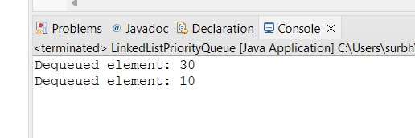
Double-ended Queue (Deque) Using Linked List Code:
package ads;

import java.util.NoSuchElementException;

class LinkedListDeque { private Node front, rear;

class Node { int data;
Node next, prev;

Node(int data) { this.data = data; this.next = this.prev = null;
}
}

public LinkedListDeque() { front = rear = null;
}

public void addFirst(int data) { Node newNode = new Node(data);
if (front == null) { front = rear = newNode;
} else { newNode.next = front; front.prev = newNode; front = newNode;
}
}

public void addLast(int data) { Node newNode = new Node(data);
if (rear == null) { front = rear = newNode;
} else {
newNode.prev = rear; rear.next = newNode; rear = newNode;
}
}

public int removeFirst() {
if (front == null) throw new NoSuchElementException("Deque is empty"); int data = front.data; front = front.next; if (front != null) { front.prev = null;
} else {
rear = null;
}
return data;
}

public int removeLast() {
if (rear == null) throw new NoSuchElementException("Deque is empty"); int data = rear.data; rear = rear.prev; if (rear != null) { rear.next = null;
} else {
front = null;
}
return data;
}
public int peekFirst() {
if (front == null) throw new NoSuchElementException("Deque is empty"); return front.data;
}
public int peekLast() {
if (rear == null) throw new NoSuchElementException("Deque is empty"); return rear.data;
}

public boolean isEmpty() { return front == null;
}

public void printDeque() {
if (front == null) {
System.out.println("Deque is empty"); return;
}
Node current = front; while (current != null) {
System.out.print(current.data + " "); current = current.next;
}
System.out.println();
}

public static void main(String[] args) {
LinkedListDeque deque = new LinkedListDeque();

deque.addFirst(10); deque.addLast(20); deque.addFirst(5); deque.addLast(25);

System.out.println("Deque after adding elements:"); deque.printDeque();
System.out.println("First element: " + deque.peekFirst());
System.out.println("Last element: " + deque.peekLast());

System.out.println("Removed from front: " + deque.removeFirst()); System.out.println("Removed from rear: " + deque.removeLast());

System.out.println("Deque after removing elements:"); deque.printDeque();
System.out.println("Is the deque empty? " + deque.isEmpty()); deque.removeFirst(); deque.removeFirst();

System.out.println("Is the deque empty now? " + deque.isEmpty());
}
}
Output:
