AIM: Write a C++ program to find the roots of a quadratic equation.
PROGRAM:
#include<iostream>
#include<cmath>
using namespace std;
int main()
{
double a,b,c,d,r1,r2; // Variable declarations
cout<<"enter a,b,c";
cin>>a>>b>>c; // Input coefficients
d=(b*b)-(4*a*c); // Calculate discriminant
// Check nature of roots based on discriminant
if(d==0)
{ // Case 1: Discriminant = 0 → roots are real and equal
cout<<"roots are real and equal"<<endl;
r1=-b/(2*a);
r2=-b/(2*a);
cout<<"r1="<<r1<<endl<<"r2"<<r2;
}
else if(d>0)
{ // Case 2: Discriminant > 0 → roots are real and distinct
cout<<"roots are real and distinct"<<endl;
r1=(-b+sqrt(d))/(2*a);
r2=(-b-sqrt(d))/(2*a);
cout<<"r1="<<r1<<endl<<"r2="<<r2;
}
else
{ // Case 3: Discriminant < 0 → roots are imaginary (no real solution)
cout<<"roots are imaginary";
}
return 0;
}

OUTPUT:
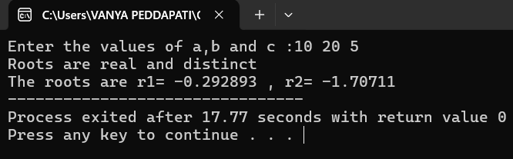

AIM: Write a C++ program to find factorial of a given number using recursion.
PROGRAM:
#include<iostream>
using namespace std;
// recursive function to find factorial
int fact(int n) {
if (n == 1) // base case
return 1;
else
return n * fact(n - 1); // recursive call
}
int main() {
int n, r;
cout << "Enter the number: ";
cin >> n;
r = fact(n); // call factorial function
cout << "The Factorial of the entered number is = " << r;

return 0;
}
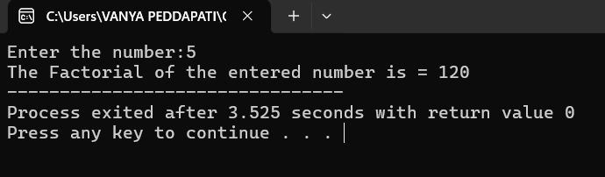
OUTPUT:

AIM: Write a C++ program to implement scope resolution operator.
PROGRAM:
#include<iostream>
using namespace std;
int a=100;//global variable
int main()
{
int a=10;//local variable
cout<<"local a="<<a<<endl;//printing local variable
cout<<"global a="<<::a;//printing global variable
return 0;
}

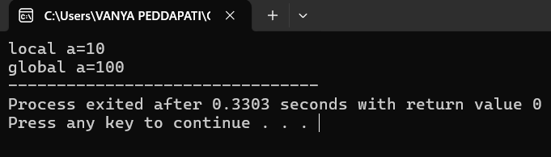
OUTPUT:

AIM: Write a C++ program to implement namespaces.
PROGRAM:
#include<iostream>
using namespace std;
namespace one {
void sample() {
int a = 10; // print integer
cout << a << endl;
}
}
namespace two {
void sample() {
string s = "ABCD"; // print string
cout << s;
}
}
int main() {
one::sample(); // call from namespace one
two::sample(); // call from namespace two
return 0;
}
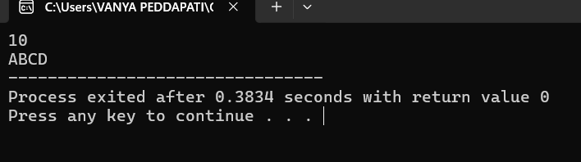
OUTPUT:

AIM: Write a C++ program to illustrate the use of default arguments
PROGRAM:
#include<iostream>
using namespace std;

class Sample {
public:
int big(int x=50, int y=30) { // return bigger of two numbers
return (x > y ? x : y);
}
};
int main() {
Sample s;
cout << "big=" << s.big(10,20) << endl; // with given values
cout << "big=" << s.big() << endl; // with default values
return 0;
}
OUTPUT:
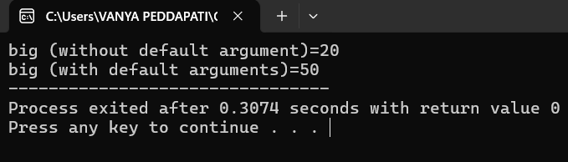

AIM: Write a C++ program to illustrate the use of access specifiers
PROGRAM:
#include <iostream>
using namespace std;
class Sample {
private:
int rollNo; // private data member
public:
string name; // public data member
// constructor
Sample(string n, int r) {
name = n;
rollNo = r;
}
// function to display roll number
void show() {
cout << "Roll No (Private using member function): " << rollNo << endl;
}
};
int main() {
Sample s("Abhinay", 101); // object creation
cout << "Student Name (public): " << s.name << endl;
s.show(); // access private via function
return 0;
}

OUTPUT:
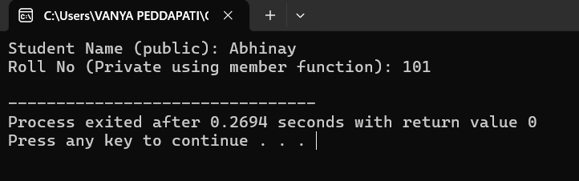

AIM: Write a C++ program to illustrate inline functions
PROGRAM:
#include<iostream>
using namespace std;
// Inline function
inline int big(int a,int b)
{
return (a>b?a:b);
}
int main()
{
cout<<"big="<<big(10,20); //printing value by calling inline function
return 0;
}

OUTPUT:
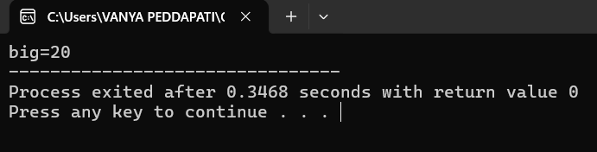

AIM: Write a C++ program to illustrate function overloading
PROGRAM:
#include<iostream>
using namespace std;

class Sum {
public:
// overloaded functions for different parameter types
void add(int a, int b) {
cout << "int Sum=" << a+b << endl;
}
void add(int a, float b) {
cout << "mixed Sum=" << a+b << endl;
}
void add(float a, float b) {
cout << "float Sum=" << a+b << endl;
}
void add(double a, double b) {
cout << "double Sum=" << a+b << endl;
}
};
int main() {
Sum s;
s.add(10, 20); // int version
s.add(10, 2.5f); // int + float version
s.add(5.9f, 4.5f); // float version
s.add(10.80, 5.9); // double version
return 0;
}
OUTPUT:
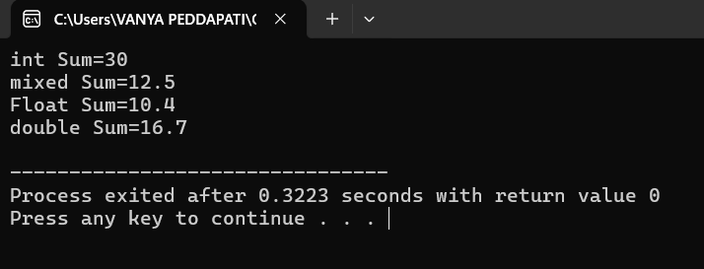

AIM: Write a C++ program to Program to illustrate friend function
PROGRAM:
#include<iostream>
using namespace std;

class Demo {
private:
int x; // private member
void get() { // private function
x = 45;
}
friend void sum(); // friend function declaration
};

// friend function definition
void sum() {
int y = 10;
Demo d;
d.get(); // allowed because sum() is a friend
cout << d.x + y; // access private member
}

int main() {
sum(); // call friend function
return 0;
}

OUTPUT:
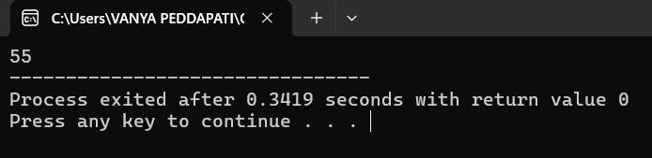

AIM: Write a C++ program to illustrate the use of Constructors and Destructors.
PROGRAM:
#include <iostream>
using namespace std;

class Sample {
private:
int rollNo;
string name;

public:
// constructor
Sample(int r, string n) {
rollNo = r;
name = n;
cout << "Constructor called for " << name << endl;
}

// member function
void show() {
cout << "Name: " << name << ", Roll No: " << rollNo << endl;
}

// destructor
~Sample() {
cout << "Destructor called for " << name << endl;
}
};

int main() {
Sample s1(101, "Abhinay"); // object creation
s1.show(); // display data
return 0;
}

OUTPUT:
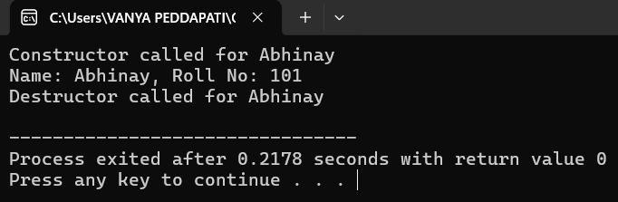
AIM: Write a C++ program illustrating Constructor overloading
PROGRAM:
#include<iostream>
using namespace std;

class Rectangle {
private:
int length, breadth;

public:
// default constructor
Rectangle() {
length = 10;
breadth = 20;
}

// parameterized constructor (square)
Rectangle(int v) {
length = v;
breadth = v;
}

// parameterized constructor (rectangle)
Rectangle(int l, int b) {
length = l;
breadth = b;
}

// function to calculate area
void area() {
cout << "Area = " << length * breadth << endl;
}
};

int main() {
Rectangle r1; // calls default constructor
Rectangle r2(5); // calls single-argument constructor
Rectangle r3(25,65); // calls two-argument constructor

r1.area();
r2.area();
r3.area();

return 0;
}
OUTPUT:
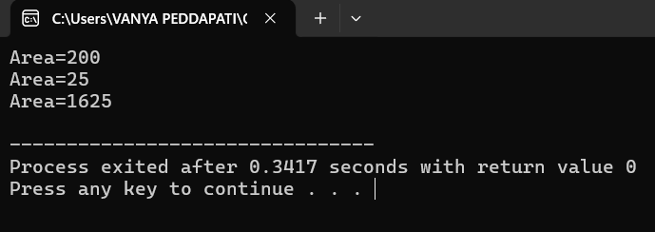

AIM: Write a C++ program illustrating Copy Constructor
PROGRAM:
#include<iostream>
using namespace std;

class sample {
private:
int x;

public:
// default constructor
sample() {
x = 45;
}

// copy constructor
sample(sample &s1) {
x = s1.x;
}

// display function
void show() {
cout << "x = " << x << endl;
}
};

int main() {
sample s1; // calls default constructor
s1.show();

sample s2(s1); // calls copy constructor
s2.show();

return 0;
}
OUTPUT:
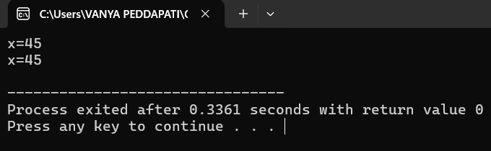

AIM: Write a C++ program to Overload Unary operator using member function.
PROGRAM:
#include<iostream>
using namespace std;

class increment {
int x, y, z;

public:
// initialize values
void get() {
x = 10;
y = 15;
z = -20;
}

// display values
void show() {
cout << "x=" << x << endl;
cout << "y=" << y << endl;
cout << "z=" << z;
}

// overload prefix ++ operator
void operator++() {
++x;
++y;
++z;
}
};

int main() {
increment i;
i.get(); // set initial values
++i; // increment all values using overloaded ++
i.show(); // display updated values
return 0;
}
OUTPUT:
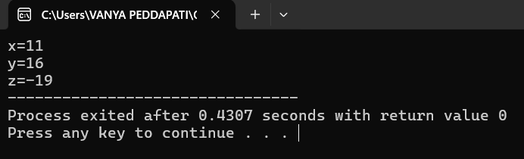

AIM: Write a C++ program to Overload Binary operator using member function.
PROGRAM:
#include<iostream>
using namespace std;

class complex {
int real, imag;

public:
// input values
void get() {
cout << "Enter real, imag values: ";
cin >> real >> imag;
}

// overload + operator to add two complex numbers
void operator+(complex c2) {
cout << real + c2.real << "+" << imag + c2.imag << "i";
}
};

int main() {
complex c1, c2;
c1.get(); // input first complex number
c2.get(); // input second complex number

c1 + c2; // calls overloaded + operator
return 0;
}
OUTPUT:
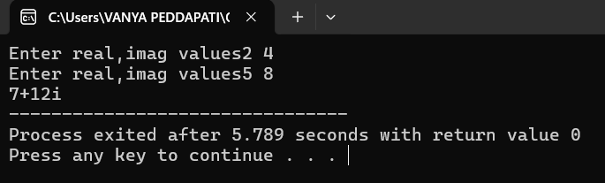

AIM: Write a C++ program to Overload Unary operator using friend function.
PROGRAM:
#include<iostream>
using namespace std;

class increment {
int x, y, z;

public:
// initialize values
void get() {
x = 10;
y = 15;
z = -20;
}

// display values
void show() {
cout << "x=" << x << endl;
cout << "y=" << y << endl;
cout << "z=" << z;
}

// friend function declaration for ++ operator
friend void operator++(increment &i);
};

// friend function definition
void operator++(increment &i) {
++i.x;
++i.y;
++i.z;
}

int main() {
increment i;
i.get(); // set initial values
++(i); //operator ++(i)
i.show(); // display updated values
return 0;
}
OUTPUT:
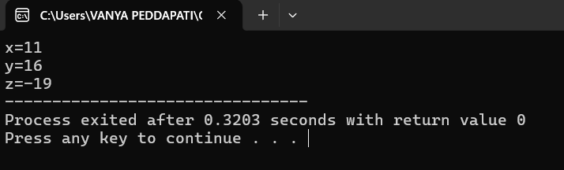

AIM: Write a C++ program to Overload Binary operator using friend function.
PROGRAM:
#include<iostream>
using namespace std;

class complex {
int real, imag;

public:
// input values
void get() {
cout << "Enter real, imag values: ";
cin >> real >> imag;
}

// friend function to overload + operator
friend void operator+(complex &c1, complex &c2);
};

// friend function definition
void operator+(complex &c1, complex &c2) {
cout << c1.real + c2.real << "+" << c1.imag + c2.imag << "i";
}

int main() {
complex c1, c2;
c1.get(); // input first complex number
c2.get(); // input second complex number

c1 + c2; // calls overloaded + operator
return 0;
}
OUTPUT:
