E-Revive E-Waste Recovery Process
Detailed process description with workflow diagram

1. Selected Process
This document selects the E-Revive e-waste second-life and resource-recovery process shown in the supplied presentation. The presentation frames E-Revive as a digital and logistics ecosystem that evaluates discarded electronics and routes each device toward the highest-value outcome: direct reuse, refurbishment, parts recovery, or responsible recycling.

2. Process Objective
The objective is to replace a conventional collect → shred/recycle pathway with a value-maximizing lifecycle hierarchy. Devices are assessed before disposal so that functional products and recoverable components can be retained for longer use.

3. Detailed Workflow
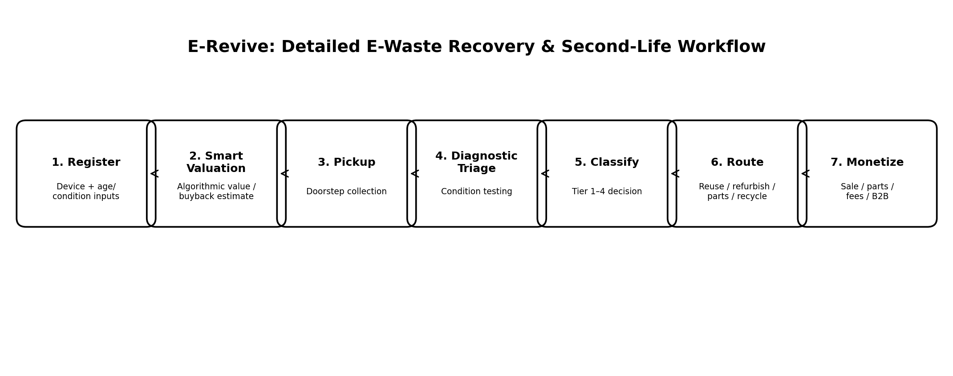

1. Device Registration
The user registers an old electronic device and provides basic information such as device type, age, condition and related inputs through the E-Revive interface.

2. Smart Valuation
An algorithmic valuation stage estimates reliability and residual/buyback value using device information and condition-related inputs.

3. Pickup
A doorstep collection service is arranged so the registered device can enter the recovery workflow conveniently.

4. Diagnostic Triage
The collected device undergoes diagnostic testing to determine its actual condition and recovery potential.

5. Tier Classification
The device is assigned to one of four routes: Tier 1 Direct Reuse, Tier 2 Refurbish, Tier 3 Parts Harvest, or Tier 4 Eco Recycling.

6. Optimal Routing
The classified device is sent to the appropriate route instead of automatically being recycled.

7. Value Recovery / Monetization
Outputs are monetized through refurbished-device sales, parts sales, recycler fees and enterprise/B2B services, as described in the presentation.

4. Four-Tier Classification
Tier | Route | Purpose
Tier 1 | Direct Reuse | Functional device; cleaned/data-wiped and directed to a second-cycle user or donation channel.
Tier 2 | Refurbish | Minor mechanical or battery repairs restore utility and improve resale value.
Tier 3 | Parts Harvest | Non-repairable devices are disassembled for usable displays, RAM modules, ICs, copper wiring and other repairable components.
Tier 4 | Eco Recycling | Remaining hazardous materials and residual material are safely handed to authorized recycling partners.

5. Why This Process Is Novel
The presentation contrasts the traditional e-waste flow, where collection is followed directly by shredding and recycling, with the E-Revive circular paradigm: Assess → Reuse → Refurbish → Parts Harvest → Recycle. Recycling is therefore treated as the final option rather than the first option.

6. Source Basis and Scope Note
Source basis: the supplied E-Revive presentation, especially the slides on the proposed idea, four-tier classification, solution workflow, and circular paradigm. The supplied presentation does not specify a particular Indian state for a state-specific e-waste signature diagram, so this document describes the E-Revive process generically rather than inventing state-specific data.

