UNIT 2 • DEVOPS MINI PROJECT
AGILE PLANNING & SCRUM IMPLEMENTATION

Name : Harshad Kashinath Ahire
PRN : 2126UDSM2576 Dept : AIDS

Enterprise Smart Library Management Platform
Completed student activity workbook + professionally structured mini-project report



SUBMISSION DETAILS | VALUE
Prepared by | Student Scrum Team | Name(s): Harshad Kashinath Ahire
Course / Subject | DevOps • Unit 2
Institute / Department | Sanjivani University AIDS
Class / Roll Number | 2126UDSM2576
Academic Year | 2026–2027
Submission Date | 10 – 10 - 2026

REPORT STATUS Planning artifacts and Scrum event outcomes are worked examples / simulations unless accompanied by actual code, repository links or test evidence.

SECTION 01 / UNIT 2 MINI PROJECT
Executive summary
━━━━━━━━━━━━━━━━━━━━━━━━━━━━━━━━━━━━━━━━━━
The Enterprise Smart Library Management Platform is a proposed library operations application intended to simplify catalog search, member management, book circulation, reminders, reporting and administration. The provided trainer guide asks student teams to apply Agile practices rather than attempt to implement every application feature in the first Sprint.
This completed workbook translates the case study into a product vision, five stakeholder groups, six business epics, 30 user stories, measurable acceptance criteria and a prioritized backlog. A first Sprint focuses on registration, login, a basic user database, repository setup, tests and documentation.
Project at a glance
Dimension | Project interpretation
Product | Enterprise Smart Library Management Platform
Approach | Agile iterative delivery using Scrum
Principal users | Librarian, member, administrator, management, IT / support
Epics | 6 – users, books, borrowing, notifications, reporting, administration
Backlog | 30 detailed user stories; top 20 prioritized for release planning
Sprint 1 focus | User authentication + basic library access foundation
Sprint 1 baseline | 8 task groups / 22 relative story points
Evidence level | Plan and classroom simulation; no production implementation asserted

Intended educational result
The report demonstrates how a Scrum Team can link real stakeholder needs to small and testable Product Backlog Items, plan realistic short-term work, make progress visible, inspect a demonstrated increment, and adapt future work from feedback.
KEY PRINCIPLE A successful Scrum mini project shows useful decision-making and traceability, not simply a collection of diagrams.

What the completed workbook demonstrates
The project is deliberately framed as a sequence of decisions. A librarian’s need for quicker member registration produces US01; that story is made testable by requiring valid field handling and duplicate-email rejection; the Product Owner then selects it for Sprint 1 because it enables later borrowing. The same trace should be repeated for catalog, circulation, reminders and reporting.
Illustrative Scrum ceremonies show how feedback changes a plan: the librarian requests a member ID during review, while the administrator requests role-based access. These suggestions become explicit backlog items instead of late additions to the Sprint. The team then identifies a practical improvement—agree the database contract earlier—to prevent the same integration delay in the next iteration.

SECTION 02 / UNIT 2 MINI PROJECT
Contents & navigation guide
━━━━━━━━━━━━━━━━━━━━━━━━━━━━━━━━━━━━━━━━━━━
PART | TOPIC | PAGE
01 | Executive summary | 3
03 | Contents & navigation | 4
04 | Background and problem statement | 5
05 | Scope, goals & success measures | 6
06 | Agile and Scrum method | 7
07 | Roles and team agreement | 8
08 | Product vision, value & personas | 9
09 | Stakeholder analysis | 10
10 | Six epics and roadmap | 11
11 | Conceptual technical architecture | 12
12 | Journeys and proposed interface | 13
13–15 | User Story Repository | 14–16
16–17 | Acceptance criteria and NFRs | 17–18
18 | Prioritized Product Backlog | 19
19 | Estimation and capacity | 20
20–21 | Sprint 1 plan and tasks | 21–22
22–23 | Scrum board and Daily Scrums | 23–24
24–25 | DevOps and test strategy | 25–26
26–27 | Sprint Review and Retrospective | 27–28
28 | Scaling, roadmap and risks | 29
29 | Conclusion, evidence checklist & references | 30

Figures used throughout the report
Agile iteration flow; stakeholder map; six-epic portfolio; conceptual architecture; book issue journey; illustrated library search interface; sample Scrum board; CI validation workflow; Sprint burndown; scaling comparison.
Terminology quick reference
Product Goal means the long-term outcome pursued by the Scrum Team. Sprint Goal describes the single objective for a particular Sprint. Product Backlog is the ordered, evolving list of desired product improvements, while Sprint Backlog includes the goal, selected items and the Developers’ plan. An Increment is integrated usable work that satisfies the Definition of Done.
Acceptance criteria are story-specific pass conditions; Definition of Done is the team-wide quality threshold applicable to completed work. Story points compare relative effort and uncertainty rather than hours. A burndown chart may help visualize forecast versus remaining effort, but Scrum does not require one and its values should not be presented as measured data without evidence.

SECTION 3 / UNIT 2 MINI PROJECT
Introduction & problem statement
━━━━━━━━━━━━━━━━━━━━━━━━━━━━━━━━━━━━━━━━━━━
Background
Libraries handle many repetitive activities: creating member records, finding titles, updating copies, tracking who borrowed each book, monitoring due dates and preparing reports. A paper register or disconnected spreadsheets can create slow searches, incorrect inventory, inconsistent return dates and limited visibility for administrators.
Problem statement
Design an Agile delivery plan for a secure and usable smart library platform that centralizes members, catalog items, loan transactions, reminders and management information, while avoiding the risk of implementing an oversized system in one release.
Current-state versus intended improvement
Current operational challenge | Proposed product improvement
Manual member records are duplicated | Single validated member profile and unique ID
Staff search separate registers | Searchable, filterable digital catalog
Issue / return errors affect availability | Transaction-based issue and return tracking
Students miss return dates | Configurable reminder and overdue alerts
Reports require manual counting | Consistent dashboards and exportable reports
Access rights are unclear | Librarian / member / administrator permissions

Why Agile is suitable
Requirements may change after librarians and members try early workflows. Incremental Sprints reduce late surprises: the Product Owner ranks what matters now, Developers create a small usable product slice, and stakeholders respond at the Sprint Review. Feedback is converted into backlog adjustments rather than ignored.
Illustrative operational scenario
Consider a student who asks for a popular textbook. In a manual workflow, the librarian may search a notebook, check the shelf, verify the student’s eligibility, write a loan entry and calculate a date by hand. Each step has an opportunity for delay or transcription error. The proposed digital journey connects search results to available copies, validates member eligibility and stores the transaction together with its due date.
This scenario also exposes the main project boundaries. A useful product must model a title separately from an individual physical copy, distinguish active from closed loans and prevent two active loans for one copy. It must protect personal data and support authorized staff corrections. These requirements can be introduced incrementally, but they should be recognized during backlog refinement before the borrowing stories are scheduled.

SECTION 04 / UNIT 2 MINI PROJECT
Project scope, objectives & success measures
━━━━━━━━━━━━━━━━━━━━━━━━━━━━━━━━━━━━━━━━━━━
Primary objective
Prepare a complete collaborative Scrum plan and simulate one Sprint around a working foundation for user authentication and basic library access, consistent with the supplied Unit 2 guide.
Specific objectives
• Identify product users, key needs, constraints and expected value.
• Create six epics and write small user stories with testable acceptance criteria.
• Order backlog items by business value, dependencies, risk and stakeholder needs.
• Estimate work using a relative 1–2–3–5–8–13 scale; create a 22-point Sprint 1 plan.
• Visualize work, conduct Scrum events and convert review feedback into future priorities.
• Describe a plausible DevOps pipeline, risks and routes for later multi-team scaling.
Scope classification
Included in overall product plan | Deferred / not asserted in Sprint 1
Registration, login, user profiles | Full fine-payment gateway
Catalog and category search | Production SMS / email integrations
Book issue, return and renew | Live deployment and load validation
Due-date reminders and reports | AI recommendations and advanced forecasting
Roles, audit logs, configuration | Completed, deployed application

Indicative success indicators
Planning quality: all six epics represented; each selected story has a clear acceptance test; Sprint 1 work fits a transparent estimated capacity. Future software quality targets: correct issue availability, valid login handling, traceable loan records and role-restricted actions. All quality targets require testing before any claim of achievement.
Measuring progress without overstating delivery
The learning outcome is assessed by the quality of planning evidence: every required artifact is present, selected stories have pass conditions, dependencies have been discussed and events produce decisions. The operational success indicators are future hypotheses. For example, search latency cannot be called satisfactory until the team defines a dataset size, network assumptions, device class and test procedure.
Scope control is equally important. It is easy to add dashboards or notifications because they sound impressive, but authentication and reliable catalog data are enabling capabilities. The team should complete one thin end-to-end slice and learn from a real stakeholder before starting several partially connected features. This prevents the Sprint from becoming a collection of isolated screens.

SECTION 05 / UNIT 2 MINI PROJECT
Agile mindset & Scrum framework
━━━━━━━━━━━━━━━━━━━━━━━━━━━━━━━━━━━━━━━━━━━
Agile emphasizes frequent delivery of value, close collaboration and response to change. Scrum implements an iterative framework with clear accountabilities, events and artifacts. A Sprint has a fixed timebox, a coherent Sprint Goal and an inspectable increment.
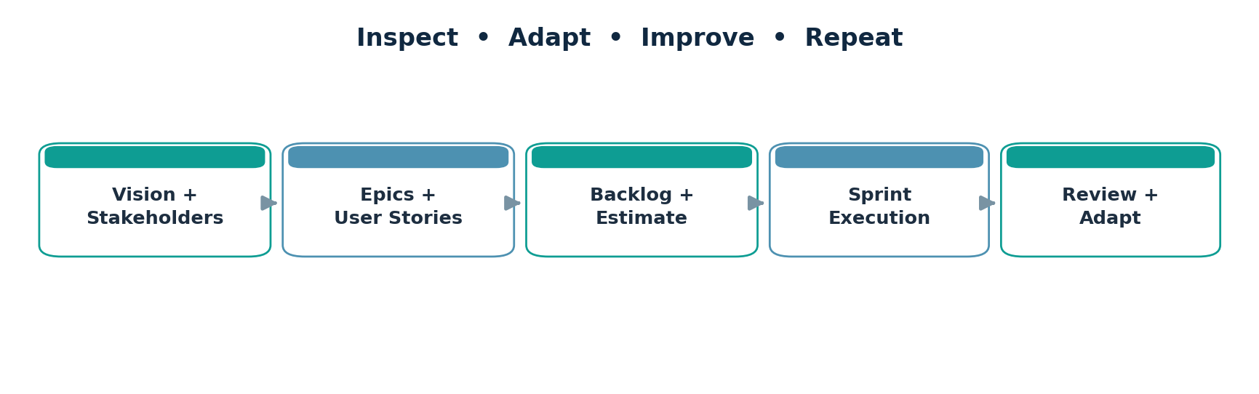
Figure 1. Agile product-planning and adaptation cycle
Core Scrum elements
Element | Application in the smart library
Product Owner | Orders Product Backlog by value and clarifies acceptance needs
Scrum Master | Coaches Scrum practice and helps resolve impediments
Developers | Build, test, document and integrate a product increment
Product Backlog | Ordered, evolving list of required improvements
Sprint Backlog | Sprint Goal, selected Product Backlog Items and delivery plan
Increment | Integrated work satisfying agreed Definition of Done
Sprint events | Planning, Daily Scrum, Review and Retrospective

Inspection and adaptation
The team inspects whether outputs genuinely meet acceptance criteria and changes the next backlog selection when new needs emerge. A task card moving to “Done” is not proof of completion unless the Definition of Done is satisfied.
Scrum events in this case study
Planning begins with the Product Goal and leads to one coherent Sprint Goal. Developers select the work they forecast they can complete and decide how to accomplish it. Daily Scrum is a short inspection of progress, with adaptation of the plan rather than formal reporting. During Sprint Review, real stakeholders should inspect the usable Increment and discuss changed needs. Retrospective focuses on the team’s effectiveness and creates manageable improvement actions.
The Scrum Master facilitates understanding and removes obstacles but does not assign implementation tasks as a project manager would. The Product Owner is accountable for maximizing value, but acceptance criteria still benefit from discussion with Developers and users. These distinctions matter because teamwork and rapid feedback are central to why Scrum can address the uncertainty of library operations.

SECTION 06 / UNIT 2 MINI PROJECT
Scrum Team roles & working agreement
━━━━━━━━━━━━━━━━━━━━━━━━━━━━━━━━━━━━━━━━━━
The trainer guide suggests teams of approximately 5–8 students: one Product Owner, one Scrum Master and the remaining members as Developers. Stakeholders support validation but are not automatically Scrum Team members.
Role | Responsible for | Sample decision
Product Owner | Value, backlog ordering, requirement clarification | Prioritizes registration before notifications
Scrum Master | Facilitation, transparency, removing impediments | Resolves ambiguous workflow ownership
Developers | Design, coding, tests, integration, docs | Choose implementation tasks and solutions
Stakeholders | Needs, review feedback, domain knowledge | Suggest member ID and role-based access

Example team agreement
• Sprint duration: 1 instructional week for the classroom simulation; real teams may choose a longer timebox.
• Daily Scrum: 15 minutes maximum; members inspect progress toward the Sprint Goal.
• Branch protection: each change is proposed through a pull request and reviewed before merging.
• Work-in-progress limit: at most two active task cards per Developer at once.
• Blocked tasks: mark and escalate within the same working day.
• Quality rule: no story is Done until acceptance conditions, review, tests and documentation are complete.
RACI-style quick view
Work product | Accountable | Contributors
Product Goal and backlog order | Product Owner | Developers + stakeholders
Sprint Goal and forecast | Whole Scrum Team | PO + Developers + SM
Solution design and tests | Developers | SM helps remove barriers
Review feedback decisions | Product Owner | Stakeholders + Scrum Team

Example of collaborative decision-making
Suppose registration requires an additional address field. The Product Owner explains why it is needed for library policy, the Developers identify required validation and database changes, and the Scrum Master ensures the dependency is discussed before the task expands. If the request appears mid-Sprint, the team assesses its relationship to the Sprint Goal and does not quietly overload an already committed plan.
A healthy agreement includes transparent impediment handling. An issue should be described with its consequence and next action: “Login is blocked because the member table schema is changing; Developer B and the database owner will agree the field contract by 2 PM.” This is more useful than simply moving a card back to To Do or blaming an individual.

SECTION 07 / UNIT 2 MINI PROJECT
Product vision, personas & value
━━━━━━━━━━━━━━━━━━━━━━━━━━━━━━━━━━━━━━━━━━━
Completed product vision
PRODUCT VISION For librarians, members and administrators, the Enterprise Smart Library Management Platform provides a secure, efficient way to manage users, books, borrowing, alerts and reports, reducing manual work and improving the library experience.

Business and user value
• Faster book discovery with clear availability and filtering.
• More accurate circulation records and automatically established return dates.
• Fewer repetitive librarian activities and easier member support.
• Better accountability through permission controls, reporting and audit records.
Three primary personas
Persona | Goal | Pain point / needed experience
Asha – Librarian | Issue and return books accurately | Needs quick member validation, copy status and transaction confirmation
Rahul – Student Member | Find relevant available books | Needs responsive search, availability and clear borrowing status
Meera – Administrator | Operate a safe, auditable system | Needs permissions, reports, backup visibility and exception handling

Product goal
Make the most frequent library journeys—identifying a member, finding a book and maintaining a loan record—simple, reliable and auditable, then expand toward notifications, reporting and advanced administration.
Value proposition translated into testable outcomes
For Asha the librarian, the highest-value result is that a new member can be registered correctly on the first attempt. For Rahul the student, it is clear information about which titles are available. For Meera the administrator, it is confidence that only approved staff can manage system settings and sensitive records. These differences help the Product Owner decide which stories belong in the first release.
A product-vision statement should remain stable enough to guide trade-offs but broad enough to permit learning. If user interviews reveal that most members search on mobile devices, the UI may change without changing the product’s goal. If auditability is more important than alerts, the backlog order may change while the product vision continues to explain the intended long-term value.

SECTION 08 / UNIT 2 MINI PROJECT
Stakeholder identification & engagement
━━━━━━━━━━━━━━━━━━━━━━━━━━━━━━━━━━━━━━━━━━━
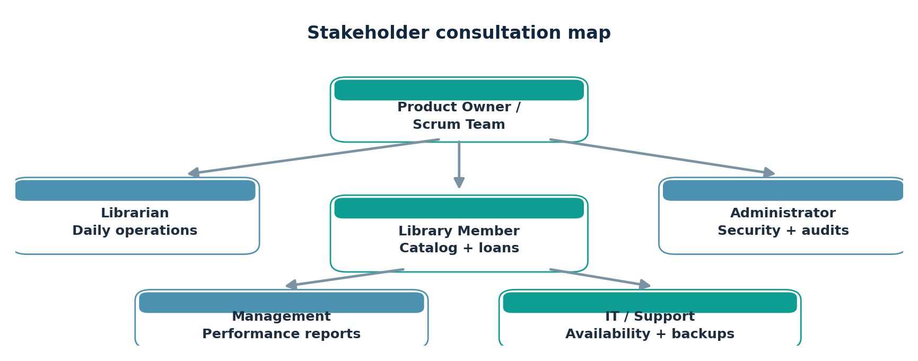
Figure 2. Stakeholders connected to the product team
Stakeholder | Influence / interest | Engagement method
Library administrator | High / high | Approval for access rules, retention and settings
Librarian | High / high | Weekly workflow demo and usability feedback
Library member | Medium / high | Catalog-search trials and survey
Management | High / medium | Review KPIs and summary reports
IT / support | High / high | Security, deployment and support review

Feedback-handling process
Capture feedback in an item with a clear request, reason, proposed acceptance criteria, priority and owner. The Product Owner evaluates it alongside the existing backlog. For example, “Add a permanent member ID field” becomes a new story, not an undocumented change in the current Sprint.
Engagement cadence and decisions
Invite librarians to inspect short workflows at the end of each Sprint because they understand the practical sequence of registration, issue and return. Ask members to try title search and report whether labels, filters and status messages are understandable. Administrators should validate access policies, retention and exceptions; IT should review deployment and recoverability before the release boundary.
The Product Owner records observations as evidence-oriented requests. Each item should include stakeholder, date, observed problem, proposed outcome, impact, and a way to confirm success. The team then judges whether it changes an existing criterion or deserves a new story. Stakeholder feedback is important, but it does not imply that every suggestion automatically becomes the next highest-ranked item.

SECTION 09 / UNIT 2 MINI PROJECT
Epic decomposition & release roadmap
━━━━━━━━━━━━━━━━━━━━━━━━━━━━━━━━━━━━━━━━━━━
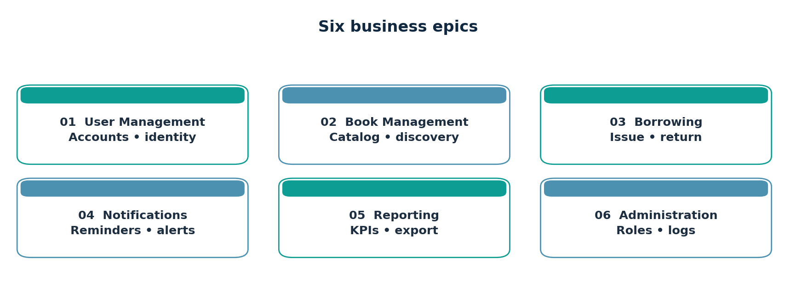
Figure 3. The six top-level functional epics preserved from the source brief
Epic ID | Epic | Representative capabilities
E1 | User Management | Registration, login/logout, password reset, profiles
E2 | Book Management | Add/edit/remove books, search, categories, availability
E3 | Borrowing Management | Issue, return, renew, due date, fine calculation
E4 | Notifications | Due-date, overdue and new-book alerts
E5 | Reporting | Issued/overdue counts, popular books, usage
E6 | Administration | Role settings, backups, audit logs, configuration

Illustrative incremental sequence
Release 0 / Sprint 1: identity foundation → Release 1: book catalog → Release 2: circulation → Release 3: alerts and reporting → Release 4: administrative hardening. This is a planning sequence, not a committed release schedule. Product Owner may reorder items after reviews.
Epic sizing and release logic
An epic is intentionally too large to treat as one Sprint-ready task. “Borrowing Management,” for example, spans issue, return, renew, due-date logic and fines. Breaking it into US12 through US16 makes progress inspectable and allows the highest-risk rules to be addressed first. In a real backlog refinement meeting, even US12 may be sliced further into eligibility validation, copy assignment and loan confirmation.
The roadmap follows enabling dependencies rather than arbitrary feature grouping. Identity makes borrowing attribution possible; catalog records establish the copies being borrowed; circulation records allow accurate reminders and reports. Operational improvements—such as backups, authorization and auditability—should be developed alongside this sequence where risk warrants, not saved entirely for the last release.

SECTION 10 / UNIT 2 MINI PROJECT
Conceptual system architecture
━━━━━━━━━━━━━━━━━━━━━━━━━━━━━━━━━━━━━━━━━━━
The source workbook depicts a web/mobile UI, application/API layer, library services, reporting/analytics, data storage and surrounding DevOps support. The diagram below reorganizes the same ideas into a legible proposed logical architecture.
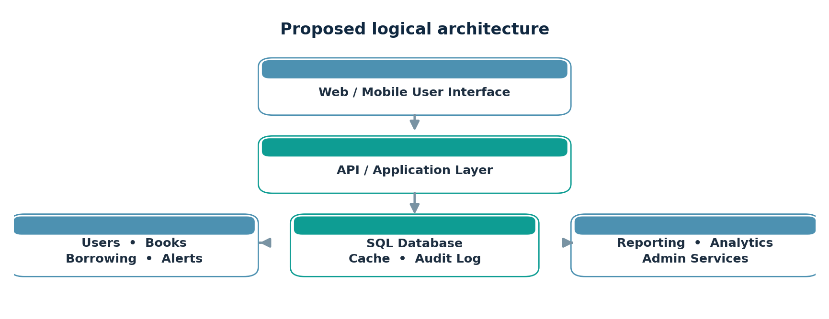
Figure 4. Planning architecture – layers are conceptual, not all Sprint 1 deliverables
Component responsibilities
Component | Example responsibilities
Web / Mobile UI | Form input, book search, member dashboard and accessible feedback
Application / API | Validation, authentication, permissions, borrowing rules
Library services | Catalog, member, circulation and notification operations
Data services | Members, copies, loans, timestamps, cached queries, audit events
Reporting | Aggregated issued / overdue / popular-book information
DevOps support | Version control, tests, release automation and monitoring

Data protection and reliability considerations
Passwords must be stored as secure hashes (never plain text). Validate inputs on the server, apply least-privilege permissions, keep an audit trail for sensitive actions, schedule recoverable backups and protect personal member information. Such controls are intended for later implementation and verification.
Example domain model and integration boundary
A minimal database could contain Member(member_id, email, password_hash, role), Book(book_id, title, author, isbn), Copy(copy_id, book_id, status), and Loan(loan_id, copy_id, member_id, issued_at, due_at, returned_at). A Book represents the shared title; a Copy represents one lendable item. Borrowing rules operate on copies to avoid confusing a title’s total holdings with the availability of a single item.
The application layer should keep these rules in services rather than directly in the user interface. When issuing a copy, it checks the account, confirms availability, creates a loan and changes copy status in one database transaction. That model can later support renewals, return history, reports and reminders without rewriting the identity foundation. The design remains illustrative until implemented and reviewed.

SECTION 11 / UNIT 2 MINI PROJECT
User journeys & interface illustration
━━━━━━━━━━━━━━━━━━━━━━━━━━━━━━━━━━━━━━━━━━━
Book issue and return workflows clarify the end-to-end value of the project beyond separate screen features. A book cannot be issued until both member eligibility and available-copy conditions pass.
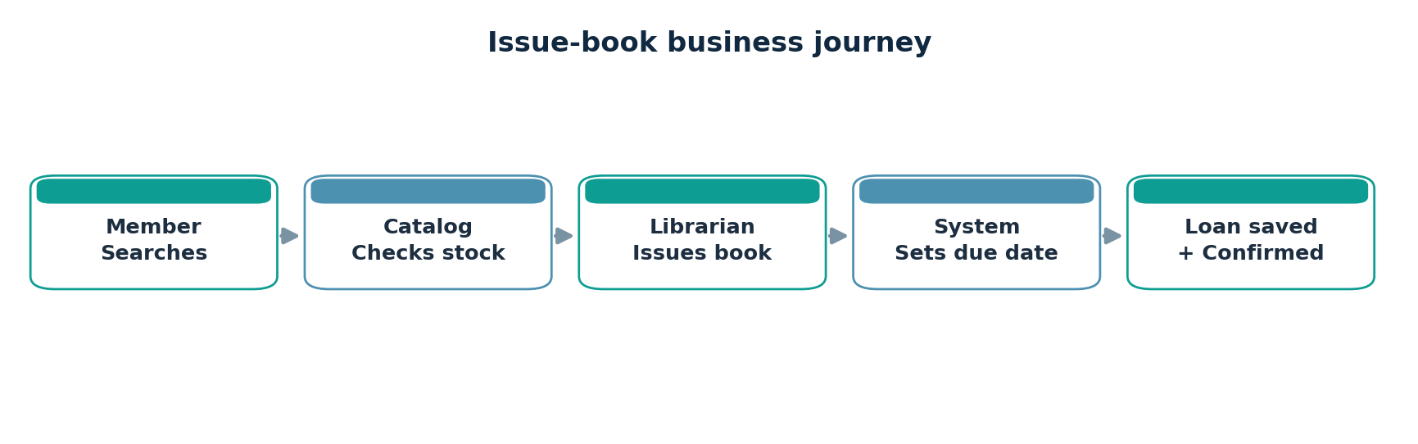
Figure 5. Proposed book issue sequence
Example member search interface
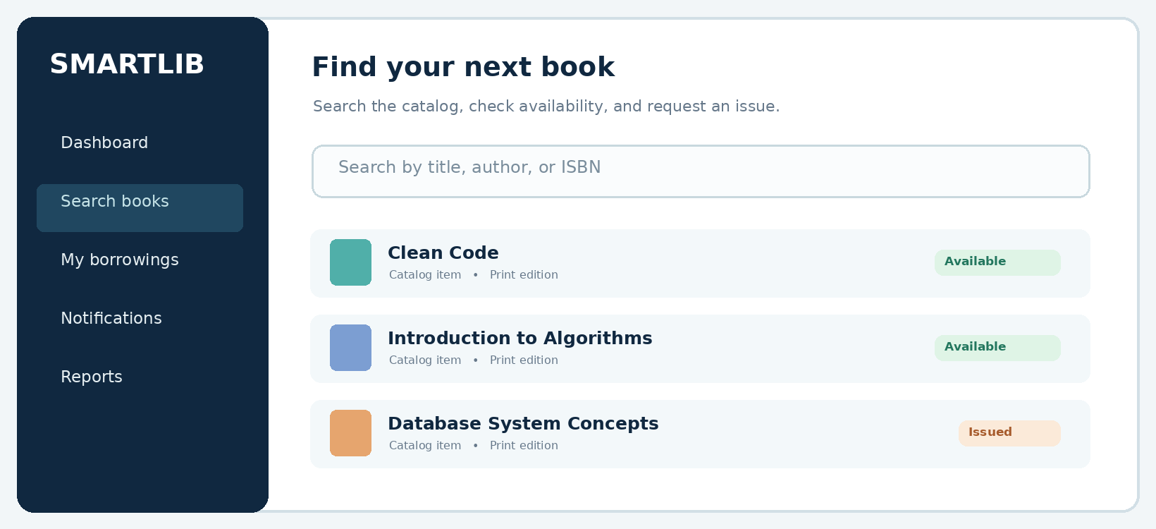
Figure 6. Original illustrative wireframe of the proposed library search screen
Business rules illustrated by the journey
• Use a unique copy identifier so multiple copies of one title can have different availability states.
• Create a loan record atomically with the availability change; reject duplicate issuance of one copy.
• Display an actionable confirmation with the calculated due date and borrower context.
Exception paths worth prototyping
A successful search and issue is only one journey. Additional screens should clarify what happens when no books match a query, an item is currently issued, a member has reached the borrowing limit or a barcode cannot be read. These are the situations in which a library application must be especially clear, because staff need a next step rather than an unexplained error.
The wireframe intentionally shows a simple search control, availability state and predictable navigation. It is not a screenshot of a deployed application. For real usability evaluation, ask at least a few students and librarians to complete the journey without coaching and record confusion around terms such as “Issued,” “Available” and “Expected return.”

SECTION 12 / UNIT 2 MINI PROJECT
User Story Repository • users & catalog
━━━━━━━━━━━━━━━━━━━━━━━━━━━━━━━━━━━━━━━━━━━
Story format: “As a [user], I want [functionality], so that [value].” Story points are relative team estimates for planning, not hours. Item IDs enable traceability across the backlog and tests.
ID / Epic | User story / desired outcome | SP
US01 / E1 | As a librarian, I want to register a member so that the member can borrow books. | 3
US02 / E1 | As a registered user, I want to log in securely so that I can access my account. | 2
US03 / E1 | As a user, I want to log out so that I can end my session safely. | 1
US04 / E1 | As a user, I want to reset a forgotten password so that I can regain access. | 5
US05 / E1 | As a member, I want to view my profile so that I can check my personal details. | 2
US06 / E2 | As a librarian, I want to add a book so that new holdings appear in the catalog. | 5
US07 / E2 | As a librarian, I want to update book details so that records remain accurate. | 3
US08 / E2 | As a librarian, I want to withdraw a book so that retired copies are not issued. | 3
US09 / E2 | As a member, I want to search by title so that I can find a book quickly. | 3
US10 / E2 | As a member, I want to filter by author, format and availability so that I see relevant items. | 5

Notes for backlog refinement
Prioritize a complete but small authentication slice in Sprint 1. Registration, login and logout have simple user outcomes; catalog features remain high-value backlog candidates for the next increments.
Story quality review – user and catalog
US01 and US02 are high-priority because all later personalized functions depend on reliable identity. US03 is small and should not be forgotten merely because logout is less visible than login. US04 is a different security workflow requiring reset verification and token expiry. US05 concerns profile display; the data shown should be limited to what the member is permitted to see.
The catalog stories are divided between staff actions (create, edit, withdraw) and member actions (search and filter). That distinction avoids an oversized “manage books” story with several different user outcomes. The team can refine each story by asking: who benefits, what observable change is expected, what inputs are required, and what important failure must be handled?

SECTION 13 / UNIT 2 MINI PROJECT
User Story Repository • circulation & alerts
━━━━━━━━━━━━━━━━━━━━━━━━━━━━━━━━━━━━━━━━━━━
Story format: “As a [user], I want [functionality], so that [value].” Story points are relative team estimates for planning, not hours. Item IDs enable traceability across the backlog and tests.
ID / Epic | User story / desired outcome | SP
US11 / E2 | As a librarian, I want to scan ISBN and review metadata so that catalog entry is faster. | 5
US12 / E3 | As a librarian, I want to issue an available copy to a valid member so that the loan is tracked. | 8
US13 / E3 | As a librarian, I want to record a return so that availability and history update. | 5
US14 / E3 | As a member, I want to renew eligible loans so that I can keep a book longer. | 5
US15 / E3 | As a librarian, I want automatic due dates so that loan policies are consistent. | 3
US16 / E3 | As a librarian, I want overdue fines calculated so that penalties are consistent. | 5
US17 / E4 | As a member, I want a due-date reminder so that I avoid late returns. | 3
US18 / E4 | As a member, I want an overdue alert so that I can act promptly. | 3
US19 / E4 | As a member, I want new-book alerts so that I can discover acquisitions. | 2
US20 / E5 | As a manager, I want a daily issue report so that I can track circulation. | 3

Notes for backlog refinement
Issue and return are high-complexity because copy state, user eligibility, due dates and history must remain consistent. A later Sprint should split these stories when finer estimates are required.
Story quality review – borrowing and notifications
US12 and US13 deserve more analysis than a typical form screen because two copies must never be considered available for one loan. The Developers should clarify whether loans may be renewed when another member has reserved the book, what date policy applies, whether fine rules vary by member group and which staff roles may override a transaction. Such policies belong in acceptance examples before coding.
Notifications depend on accurate timestamps and contact preferences. An overdue reminder should be sent only when a loan is still active and should not expose private borrowing information to another member. In a real release, the team would also add retry behavior for failed messages, log delivery attempts and allow an administrator to inspect exceptions without manual database changes.

SECTION 14 / UNIT 2 MINI PROJECT
User Story Repository • reporting & administration
━━━━━━━━━━━━━━━━━━━━━━━━━━━━━━━━━━━━━━━━━━━
Story format: “As a [user], I want [functionality], so that [value].” Story points are relative team estimates for planning, not hours. Item IDs enable traceability across the backlog and tests.
ID / Epic | User story / desired outcome | SP
US21 / E5 | As a librarian, I want an overdue list so that I can follow up with members. | 3
US22 / E5 | As a manager, I want borrowing statistics so that I can analyze demand. | 5
US23 / E5 | As a manager, I want popular-book metrics so that purchases reflect demand. | 5
US24 / E5 | As an administrator, I want user-activity reports so that I can inspect usage. | 5
US25 / E6 | As an administrator, I want role assignments so that access is controlled. | 5
US26 / E6 | As an administrator, I want audit logs so that critical changes are traceable. | 5
US27 / E6 | As IT support, I want scheduled backups so that data can be recovered. | 5
US28 / E6 | As an administrator, I want configurable loan policies so that rules match the library. | 5
US29 / E6 | As IT support, I want a health dashboard so that failures are visible. | 3
US30 / E1 | As a librarian, I want a unique member ID so that members are identified accurately. | 2

Notes for backlog refinement
Audit logs, backup and monitoring are operational needs, not optional decorations. After Sprint Review, unique member ID (US30) is an explicit refinement arising from stakeholder feedback.
Story quality review – reports and operations
Reports should define the meaning of each number. An “issued books” count might mean new loans today, active loans now or unique titles ever issued; a stakeholder must choose before the Developers design a query. Popular-book analytics should specify the observation period, and activity reports must avoid exposing unnecessary personal data.
Administrative stories support trust in the product. Access control needs a permissions matrix; audit logs need actor, action, target and timestamp fields; backups need a tested restore procedure. Monitoring should reveal failures and slow responses before users report them. These items are often deferred by feature-focused teams, so explicit backlog entries make their costs and risks visible to the Product Owner.

SECTION 15 / UNIT 2 MINI PROJECT
Acceptance criteria • key product stories
━━━━━━━━━━━━━━━━━━━━━━━━━━━━━━━━━━━━━━━━━━━
Each criterion must be observable and independently testable. The conditions below refine the core examples in the trainer guide and distinguish success paths from invalid-input handling.
US01 / Register member
• Given valid required details, when a librarian submits the form, then a unique member record is stored and a confirmation is shown.
• Given a duplicate email or missing required field, when submitted, then a clear validation error is shown and no duplicate record is saved.
US02 / User login
• Given a valid registered account, when correct credentials are submitted, then an authenticated session starts.
• Given invalid credentials, when submitted, then login is denied without revealing which credential was incorrect.
US09 / Search books
• Given books exist, when a member searches a title or keyword, then matching catalog entries with current availability are returned.
• Given no match, when submitted, then a helpful empty-state message appears; blank queries do not crash the interface.
US12 / Issue book
• Book copy is available and borrower is an eligible registered member.
• Issue action creates a single active loan, generates a due date from the configured loan policy and reduces available-copy count.
• Borrowing history is updated and a confirmation with due date is displayed.
• Unregistered, blocked or duplicate issue requests are rejected without changing data.
ACCEPTANCE RULE The issue-book requirements are based on the guide’s five core checks: availability, registration, due date, history and confirmation. Error cases are added as practical refinements.

Using Given–When–Then in team discussions
Acceptance scenarios become much clearer when three facts are separated: initial state (Given), the action (When), and the expected observable outcome (Then). For registration, a duplicate email should produce an error without creating any record. For issue-book, a blocked member or unavailable copy should leave the database unchanged. These negative examples protect the integrity of the product, not merely its user interface.
During Sprint Planning, the Product Owner confirms expected behavior while Developers decide the implementation. During testing, each criterion becomes a case that can be checked directly. An acceptance criterion should not require a specific internal library or programming language unless the technology choice is truly a stakeholder constraint.

SECTION 16 / UNIT 2 MINI PROJECT
Acceptance criteria • extensions & quality
━━━━━━━━━━━━━━━━━━━━━━━━━━━━━━━━━━━━━━━━━━━
US13 / Return book
• Given an active loan, when a librarian returns its copy, then the loan is closed and the copy becomes available.
• Returning an already closed loan gives a safe, clear response with no duplicate stock increase.
US11 / ISBN metadata-assisted entry
Given a readable ISBN, when a librarian scans or types it, then matching title, author and publisher information may be fetched from a suitable book-data API. Proposed values remain editable before saving; a failed lookup supports manual entry. External API integration is out of scope for Sprint 1.
US10 / Catalog filters
Results can be filtered by availability, author and format. An aspirational under-one-second response is stated in the source guide; its achievement would need a defined data volume, environment and measured performance tests. Unavailable books can show estimated return dates when known.
Non-functional quality targets (proposed)
Attribute | Requirement / verification approach
Security | Hash passwords, validate role checks at server endpoints, use HTTPS in deployment
Reliability | Reject invalid state transitions, commit loan and copy updates atomically
Usability | Show readable errors; support keyboard form navigation and clear labels
Performance | Search target: under 1 s in an agreed performance test environment
Recoverability | Take scheduled backups and test restore procedure before release
Maintainability | Code review, readable modules, automated tests and documented APIs

Quality gates in a real environment
Non-functional requirements become meaningful only when paired with a verification procedure. “Fast search” needs a target dataset and measured response time. “Secure login” requires checks for server-side validation, session expiry and improper authorization. “Recoverable data” requires a successful restoration test, not merely a backup folder existing.
The development team should decide how to record supporting evidence: automated test output for correctness, performance logs for response-time goals, accessibility inspection for user interface behavior and a recovery checklist for backups. Items without evidence remain proposed goals. This prevents the final report from confusing desired standards with achieved standards.

SECTION 17 / UNIT 2 MINI PROJECT
Prioritized Product Backlog
━━━━━━━━━━━━━━━━━━━━━━━━━━━━━━━━━━━━━━━━━━━
Ordered using stakeholder value, operational dependencies, risk and expected learning value. The initial source explicitly orders the first 12 listed capabilities; the working backlog expands and refines them for further planning. The Product Owner may reorder items at any time.
Rank | Story | Product Backlog Item | Pri. | Pts
1 | US01 | Registration | H | 3
2 | US02 | Login | H | 2
3 | US09 | Search book | H | 3
4 | US06 | Add book | H | 5
5 | US12 | Issue book | H | 8
6 | US13 | Return book | H | 5
7 | US04 | Password reset | H | 5
8 | US17 | Due reminder | M | 3
9 | US20 | Daily library report | M | 3
10 | US22 | Borrowing statistics | M | 5
11 | US23 | Popular-book analytics | L | 5
12 | US26 | Audit logs | L | 5
13 | US03 | Logout | H | 1
14 | US15 | Auto due dates | H | 3
15 | US25 | Role assignments | H | 5
16 | US07 | Update book | H | 3
17 | US10 | Catalog filters | M | 5
18 | US21 | Overdue list | M | 3
19 | US27 | Scheduled backups | M | 5
20 | US30 | Unique member ID | M | 2

Ordering note: items 13–20 are added for a fuller academic backlog; an actual PO would revisit whether logout, authorization and due-date rules should move earlier based on technical dependencies and security risk. US30 arises in the example Sprint Review.
Why the backlog can change
The rank table starts with the guide’s 12-item sequence so the source requirements remain recognizable. The additional stories expose operational dependencies that an actual team would likely bring forward: logout belongs close to login, automatic due-date rules support book issue, and role control helps protect sensitive workflows. Relative ordering is a Product Owner decision, not a permanent property of the story ID.
After every Review or significant stakeholder discovery, the Product Owner should reconsider priority using benefit, urgency, dependencies, uncertainty and effort. If the registration demo reveals confusion about member identity, US30 may move above some reporting items. This is healthy Product Backlog adaptation rather than poor initial planning.

SECTION 18 / UNIT 2 MINI PROJECT
Story points, dependencies & team capacity
━━━━━━━━━━━━━━━━━━━━━━━━━━━━━━━━━━━━━━━━━━━
Relative estimation approach
Use Planning Poker with a Fibonacci-like sequence 1, 2, 3, 5, 8 and 13. Points represent size, complexity and uncertainty, not exact hours. After discussion, the team chooses a shared estimate.
Reference item | Guide sample | Reasoning
User registration | 3 | Required fields, validation and persistence
User login | 2 | Credential check and session handling
Search book | 3 | Queries and availability display
Add book | 5 | Catalog forms, validation and duplicate handling
Issue book | 8 | Policy, consistency, due date and history
Return book | 5 | Loan closure, count update and history
Password reset | 5 | Verification, safe token handling and expiry

Sprint 1 capacity forecast
The guide provides eight task groups totaling 22 points. For a short simulated Sprint, the Scrum Team adopts 22 points as a planning baseline, not a statistically demonstrated velocity. In an actual Sprint, selection should also consider availability, interruptions, skill mix and empirical past throughput.
Dependencies and planning risks
Dependency | Planning implication
Repo → project structure → shared code | Establish branching and build conventions at start
User database → register/login integration | Agree schema and validation before integration
Implementation → unit tests → Done | Reserve quality time; do not defer all tests to last day
Role controls and reset flows | Explicitly deferred / tracked beyond Sprint 1

Worked estimation example
Imagine the team first votes 3, 5 and 8 points for “Add book.” The Developer choosing 8 is concerned about ISBN metadata integration, while the Developer choosing 3 expects a simple manual form. The Product Owner clarifies that external metadata is a separate story (US11). The group can then estimate the basic add-book feature at 5 points based on validation, storage and duplicate checks.
Capacity must be based on people’s real availability rather than assuming a point equals one hour. A future team with previous completed Sprints can use its observed results as one input to forecasting. For this classroom exercise, 22 points are kept as the brief’s illustrative baseline, with no assertion that the team has historically delivered that amount.

SECTION 19 / UNIT 2 MINI PROJECT
Sprint 1 Goal & selected Sprint Backlog
━━━━━━━━━━━━━━━━━━━━━━━━━━━━━━━━━━━━━━━━━━━
Sprint Goal
SPRINT GOAL Deliver a working foundation for user authentication and basic library access.

Duration: illustrative 1-week classroom Sprint. Product Goal connection: establish the member identity baseline needed before catalog and borrowing workflows can be released.
Sprint Backlog Task | Points | Definition of completion / evidence expected
Repository creation | 2 | Repo exists; README and standard structure recorded
Git workflow setup | 2 | Branch rule, PR template and review checklist documented
Project structure | 3 | UI, API and test folders organized; dependencies reproducible
User registration | 3 | Validated member form, persistence and acceptance checks
User login | 2 | Credential check, safe error feedback and session handling
User database | 5 | Members schema, uniqueness and migration / seed plan
Unit testing | 3 | Automated basic positive / negative tests passing
Documentation | 2 | Setup, API notes, test and Sprint Review notes

Commitment and forecast
Total forecast = 2 + 2 + 3 + 3 + 2 + 5 + 3 + 2 = 22 points. Completing a task group in the board simulation assumes the declared Definition of Done has been checked in the exercise; it does not verify a real application.
Sprint 1 exclusions
Search, book addition, issue/return, reminders and reporting stay in the Product Backlog. They are not quietly added to this Sprint, protecting focus and making the Sprint Goal attainable.
Selected work mapped to the Sprint Goal
The foundational technical tasks are included because registration and login cannot be safely demonstrated without a repository, project structure, persistence and tests. These tasks would normally be tracked as work supporting Product Backlog Items, rather than redefining every setup task as an independently valuable user story. This workbook preserves the instructor’s task-level Sprint table for the exercise.
The team should agree on a very small demo script at planning time: create a member, show stored identity, reject a duplicate, log in with valid credentials and reject invalid login. This avoids spending most of the Sprint assembling unrelated components that cannot be inspected as a coherent outcome.

SECTION 20 / UNIT 2 MINI PROJECT
Sprint execution tasks, timing & quality gates
━━━━━━━━━━━━━━━━━━━━━━━━━━━━━━━━━━━━━━━━━━━
Illustrative 5-day task sequence
Day | Primary activity | Review / coordination checkpoint
D1 | Kick-off; repo, Git policy; database design | Agree Sprint Goal, owners and acceptance checks
D2 | Project structure; database schema; registration | Pair-review database uniqueness and API contract
D3 | Registration integration; login; first tests | Demo registration flow internally; update board
D4 | Negative tests; error handling; docs | Review secure login behavior and coverage gaps
D5 | Final integration; Review; Retrospective | Inspect increment, record feedback and actions

Definition of Ready – for selected stories
• User benefit and acceptance criteria are understandable.
• Dependencies, constraints and data requirements are known.
• The story is small enough to complete during the Sprint.
Definition of Done – team agreement
• Code or planned artifact meets approved acceptance criteria.
• Peer review complete; relevant automated checks pass.
• Validation, security and error-handling cases assessed.
• Documentation and tests updated together with the change.
• Work integrated, demo-able and accurately reflected on the board.
Risk-management rule
A story with failing tests or missing documentation remains unfinished even if most coding is complete. Any unfinished work is returned to the Product Backlog for reordering rather than counted as a completed Increment.
Making the schedule realistic
Although the classroom timeline shows five stages, work does not have to move strictly from development into testing on the last day. Developers can prepare registration unit tests while schema and forms are being built, review small pull requests as they arrive and update setup instructions immediately after dependencies change. That reduces integration risk and makes the final demonstration easier to prepare.
The Definition of Done should be genuinely shared. If a team member marks registration complete without checking the database constraints, another member may use it as a dependency and discover a defect late. A review checklist, test evidence and accurate board movement help teams trust each other’s completed work.

SECTION 21 / UNIT 2 MINI PROJECT
Scrum board snapshot & work-in-progress
━━━━━━━━━━━━━━━━━━━━━━━━━━━━━━━━━━━━━━━━━━━
The source calls for a visible board: To Do → In Progress → Code Review → Testing → Done. Below is an original example snapshot during the middle of the classroom Sprint; card positions illustrate workflow only.
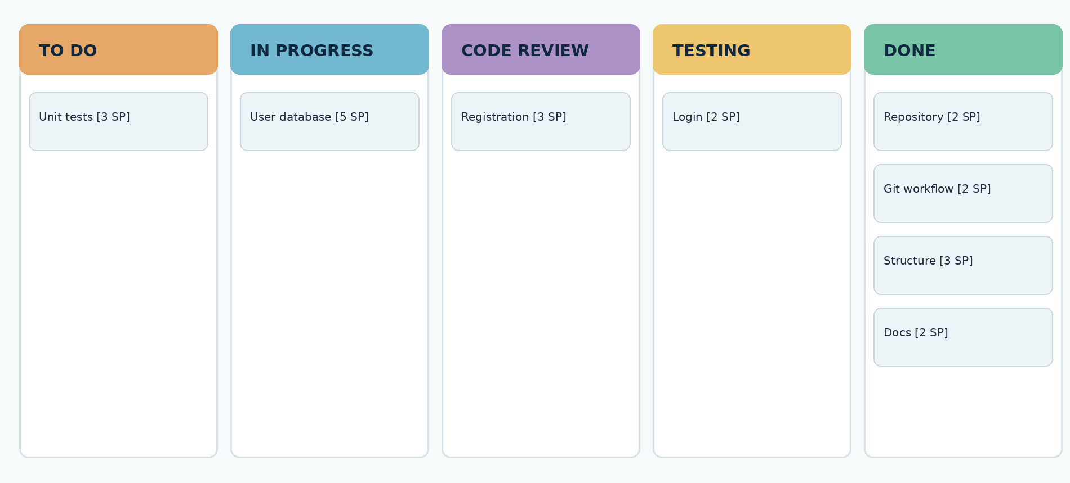
Figure 7. Illustrative Scrum board snapshot (mid-Sprint)
Column entry and exit rules
State | Meaning / movement condition
To Do | Selected work is ready but not started
In Progress | Developer is actively implementing the task
Code Review | Pull request or artifact awaits peer inspection
Testing | Functional acceptance and automated tests being checked
Done | All Definition of Done checks completed

WIP policy: maximum two active tasks per Developer; prioritize clearing reviews and tests before starting new work. If the user-database card is blocked, mark it and coordinate a dependency fix rather than hiding the delay.
Practical board-management rules
Cards should move only when their real state changes: starting a task puts it in progress; submitting a pull request puts it under review; passing review moves it into testing; and quality checks move it to Done. A card may move backward if testing uncovers a defect. Work in Progress is deliberately limited so the team finishes existing tasks instead of beginning many new ones.
The sample snapshot puts the database task in progress while registration depends on it. In a real Daily Scrum, the team would discuss whether pairing helps complete the database work sooner. The visual board is valuable because it exposes bottlenecks, not because it makes unfinished work appear advanced.

SECTION 22 / UNIT 2 MINI PROJECT
Daily Scrum meeting record • simulation
━━━━━━━━━━━━━━━━━━━━━━━━━━━━━━━━━━━━━━━━━━━
The following is a completed example meeting log, not a record of actual team attendance or software execution. Each meeting asks: What changed? What is next? What obstacle threatens the Sprint Goal?
Day | Progress and next work | Impediment / response
1 | Repo and Git policy drafted; begin schema and folder structure. | Access to repo template unclear → Scrum Master provides agreed layout.
2 | Schema prepared; begin validation and registration screens. | Duplicate-email rule ambiguous → Product Owner clarifies unique email.
3 | Registration model integrated in exercise; login and tests move forward. | Login API contract mismatch → Developers pair on shared schema.
4 | Login checks and negative test cases reviewed; documentation updated. | Test data unstable → create deterministic sample fixtures.
5 | Finish quality checklist; prepare demo and Sprint Review notes. | No new blocker; review item list before closure.

Sample stand-up dialogue summary
Developer A: “Registration acceptance checks are drafted; today I will refine duplicate-member handling.” Developer B: “The login task depends on the members schema; I will pair with the database owner.” Scrum Master: “We will resolve the dependency after this Scrum. The Sprint Goal remains unchanged.”
Inspection outcome
This format connects daily progress with blockers and decisions. Daily Scrum is for Developers to inspect their plan toward the Sprint Goal; it is not a status-report meeting for management.
Follow-through from the meeting log
Each Daily Scrum should end with a small adaptation to the Developers’ plan. Day 2’s duplicate-email ambiguity becomes a Product Owner clarification, Day 3’s API mismatch becomes a pairing session and Day 4’s unstable test data becomes a task to use repeatable fixtures. Recording those decisions is more useful than simply collecting statements about yesterday’s activities.
The meeting notes here are model outputs to support the academic exercise. They should be replaced with actual dates, attendees, decisions and card links if the students simulate these events live or implement software afterward. No invented attendance, meeting recording or real performance measurement is implied by these examples.

SECTION 23 / UNIT 2 MINI PROJECT
DevOps workflow, version control & CI concept
━━━━━━━━━━━━━━━━━━━━━━━━━━━━━━━━━━━━━━━━━━━
Scrum provides inspection and feedback; DevOps practices help deliver changes safely and repeatably. For a later implementation, the proposed workflow below integrates Git, peer review, CI tests, staging validation and controlled release.
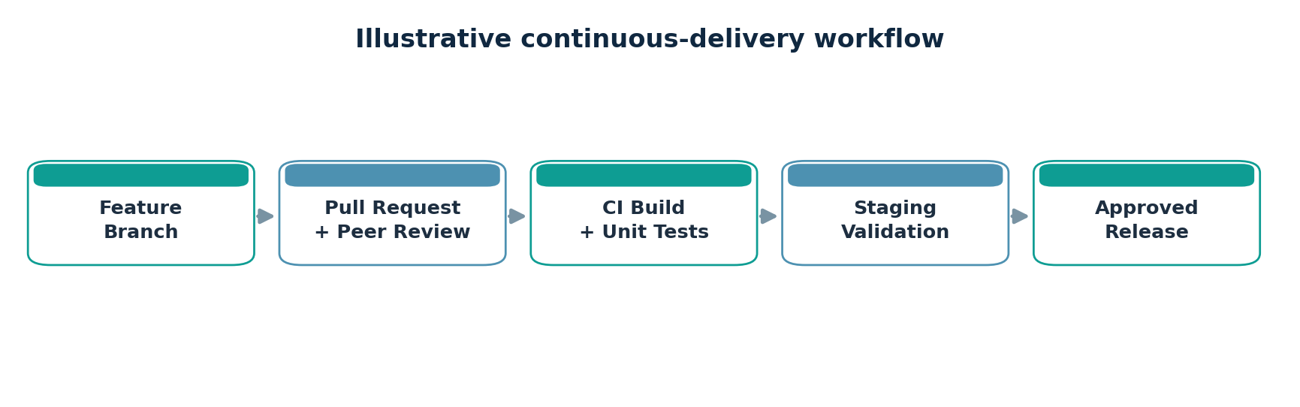
Figure 8. Proposed developer change-to-release pipeline
Suggested repository structure
Path | Purpose
frontend/ | Library screens, forms and catalog views
backend/ | Authentication, member and circulation API
database/ | Schema, migrations and local seeds
tests/ | Unit, integration and API test suites
.github/workflows/ | CI workflows for build, lint and automated tests
docs/ | Requirements, decisions, demo and release notes

Minimal quality gates (proposed)
• Feature branch and peer-reviewed pull request are mandatory for shared branches.
• CI checks format/lint, installs dependencies and runs deterministic tests.
• Secrets stay in protected environment variables; none are committed to Git.
• A successful build is promoted to staging before any production release.
IMPLEMENTATION STATUS This page documents an appropriate DevOps plan. No CI run, deployment URL or repository history was supplied, so none is claimed.

Example CI workflow in more detail
On every pull request, a CI runner could check formatting, build the frontend and backend, execute unit tests for member validation and database rules, and run API tests against an isolated test database. If a check fails, merging pauses until the team investigates. Separating test data from real member information is a practical way to keep CI safe and repeatable.
For later deployment, a versioned build can be promoted to staging, inspected by librarians and approved for a production rollout. Observability would include application errors, failed login spikes, API latency and database health. A rollback plan matters even for a small library because a broken update could interrupt circulation operations during opening hours.

SECTION 24 / UNIT 2 MINI PROJECT
Test strategy & traceability matrix
━━━━━━━━━━━━━━━━━━━━━━━━━━━━━━━━━━━━━━━━━━━
Testing translates acceptance criteria into reproducible checks. The expected results below are test designs, not measured pass/fail outcomes. Real execution should capture actual results, environment, date and evidence links.
Test ID / story | Scenario | Expected result
T01 / US01 | Register valid member | Record stored; unique ID returned
T02 / US01 | Register duplicate email | Clear error; no duplicate inserted
T03 / US02 | Correct login credentials | Authenticated session created
T04 / US02 | Incorrect login credentials | Access denied; generic error
T05 / US09 | Search existing title | Relevant books and availability shown
T06 / US09 | Search missing title | Graceful empty-state display
T07 / US12 | Issue available book | Loan + due date stored atomically
T08 / US12 | Issue unavailable copy | Rejected; state unchanged
T09 / US13 | Return active loan | Loan closed; copy available
T10 / US13 | Repeat completed return | No duplicate copy-count change
T11 / US25 | Member tries admin action | Server denies unauthorized request
T12 / US11 | ISBN lookup fails | Manual book entry remains possible

Test levels and supporting artifacts
Unit tests validate individual rules; API/integration tests verify persistence and authorization; UI acceptance tests cover member and librarian journeys. For real implementation, capture test scripts, run output, defect IDs and a traceability table linking each test to its story and criterion.
Traceability and defect handling
Test IDs deliberately include their story references so an evaluator can follow a need from its description to an expected outcome. For example, US12 links to both successful issuance and unavailable-copy rejection. The second test matters because preserving data on failure is a vital business rule and a common source of operational defects.
When a real test fails, the team should record expected behavior, observed behavior, reproduction steps, severity, environment and a related backlog or issue ID. Developers fix the defect and rerun relevant regression tests. An unchecked or failed test is never silently marked passed for a report; it remains an identified limitation until verified.

SECTION 25 / UNIT 2 MINI PROJECT
Sprint Review & feedback incorporation
━━━━━━━━━━━━━━━━━━━━━━━━━━━━━━━━━━━━━━━━━━━
Review scenario • classroom simulation
At the end of Sprint 1, the Scrum Team presents a worked demonstration scenario for registration, login and stored member details. The Source trainer guide specifically describes stakeholders asking for a member ID and role-based access option.
Agenda | Evidence / discussion
1. Sprint Goal | Foundation for identity and basic access
2. Demonstration | Walk through sample valid and invalid registration/login cases
3. Acceptance checks | Discuss expected validations and database state changes
4. Open work | Identify unresolved concerns and avoid claiming untested features
5. Stakeholder feedback | Librarian: member ID; administrator: role-based access
6. Adapt backlog | Create/refine stories US30 and US25 and reassess priorities

Captured review feedback
Feedback item | New / refined backlog action
Need permanent member identifier | US30: assign unique member ID; define uniqueness and display rule
Need different staff permissions | US25: admin controls for role assignment; add access tests
Show error messages clearly | Refine US01 / US02 acceptance criteria for recoverable errors

Review conclusion
The Review supplies input to the Product Backlog. The example scenario illustrates the feedback loop and does not establish that real code has been deployed, demonstrated or accepted by actual stakeholders.
Illustrative decision record
Decision R-01: create US30 for a permanent member ID. Rationale: librarians need an unambiguous identifier even when two members share a name. Candidate acceptance rules: each saved member receives a unique immutable identifier; authorized staff can search by it; existing members cannot be accidentally assigned the same identifier.
Decision R-02: refine US25 for role-based access. Rationale: members must not perform administrator functions. Candidate acceptance rules: role permissions are enforced by the server; denied actions return an appropriate response; changes are logged. These decisions may influence the next Sprint but are not retroactively counted in Sprint 1.

SECTION 26 / UNIT 2 MINI PROJECT
Sprint Retrospective & illustrative burndown
━━━━━━━━━━━━━━━━━━━━━━━━━━━━━━━━━━━━━━━━━━━
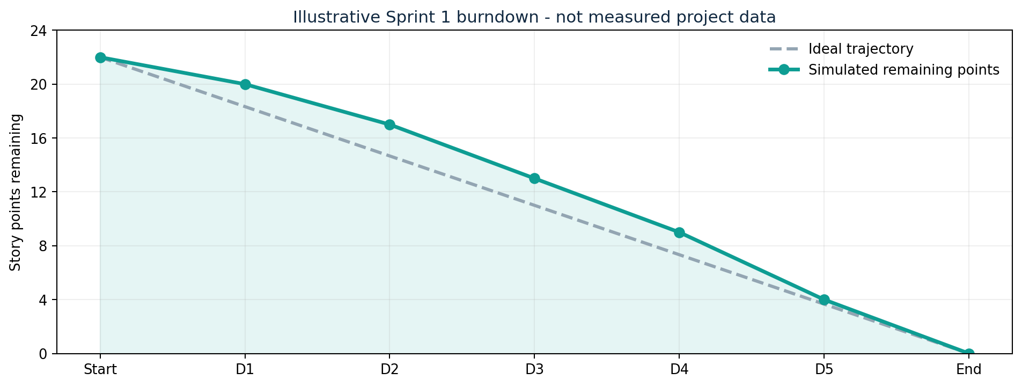
Figure 9. Classroom-example burndown using an illustrative 22-point forecast
Retrospective: observations and improvements
What worked | What should improve | Action / owner / evidence
Clear Sprint Goal | Validation rules emerged late | PO: review error paths before planning; approved criteria
Visible Scrum board | Schema dependency blocked login | Developers: contract review on Day 1; checklist
Peer review practice | Tests clustered near Sprint end | Developers: write first tests earlier; CI test report
Frequent coordination | Blocked-card labels were unclear | SM: improve blocker tracking; daily inspection

Illustrative simulation metrics
Example forecast = 22 story points; hypothetical remaining points = 22, 20, 17, 13, 9, 4, 0. This is a sample teaching data series, not measured velocity or real completion evidence. In a real project, completed points are recognized only for work satisfying the Definition of Done.
Understanding the numbers and improvement plan
The burndown is a teaching example built from the 22-point forecast. The data reaches zero by the end only because the example assumes every selected task passed its checks. Without actual code reviews, test output and a real Sprint record, this is not a measured delivery result. If any acceptance condition fails during real development, the points for that work should remain unfinished.
Retrospective improvements should be few and observable. The team can check at the next Sprint Planning whether the API schema was agreed before parallel work, and at the next Review whether automated tests ran before the final day. These are easier to act on than a vague promise to “communicate better.”

SECTION 27 / UNIT 2 MINI PROJECT
Scaling choices, next increments & risks
━━━━━━━━━━━━━━━━━━━━━━━━━━━━━━━━━━━━━━━━━━━
The original workbook asks students to explain future scaling using LeSS, SAFe or Scrum@Scale. None is necessary for a single classroom team; the comparisons below are conceptual options for a much larger initiative.
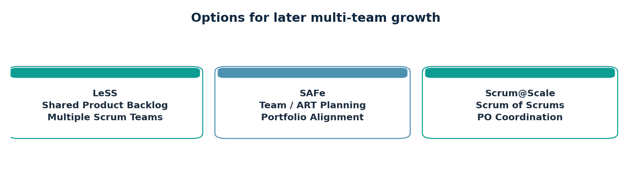
Figure 10. Three potential Agile scaling approaches
Approach | Potential fit / trade-off
LeSS | A shared product and backlog across several Scrum Teams; emphasizes simplicity, requires strong coordination.
SAFe | A wider enterprise with teams and portfolio alignment needs; adds planning structure and organizational overhead.
Scrum@Scale | Coordinates networks of Scrum Teams and Product Owners; suits a modular scaling strategy.

Indicative next Sprint candidates
After identity foundations, prioritize catalog search (US09), add book (US06), logout (US03) and role checks (US25) as dependencies warrant. Evaluate Sprint Review additions US30 and US25 before committing any new forecast.
Risks and mitigation
Key risks: expanding scope, weak user-data security, ambiguous stock rules, external API dependency, and unreliable test data. Mitigate using backlog refinement, permission checks, atomic loan transactions, API fallbacks and repeatable automated tests.
Choosing scale only when the organization needs it
Adding a scaling framework should solve a real coordination problem, such as several teams changing a shared catalog API or competing for the same Product Backlog. With one small team, extra ceremonies introduce overhead without creating more value. A practical next step is to make one team’s Definition of Done, backlog refinement and integration practice reliable before adding multiple-team structures.
When growth becomes necessary, evaluate product boundaries and technical dependencies first. A shared data model, clear ownership and a common delivery pipeline help prevent separate teams from producing incompatible modules. Whatever framework is chosen, timely integration and stakeholder inspection remain more important than the number of meetings or hierarchy labels.

SECTION 28 / UNIT 2 MINI PROJECT
Final conclusions, submission checklist & sources
━━━━━━━━━━━━━━━━━━━━━━━━━━━━━━━━━━━━━━━━━━━
Conclusion
This DevOps Unit 2 mini project demonstrates a complete Agile planning cycle for the Enterprise Smart Library Management Platform. The team begins with a product vision, identifies stakeholders, decomposes six epics, writes 30 user stories, defines observable acceptance criteria and prioritizes a product backlog. It then prepares a 22-point Sprint 1 forecast, visualizes progress using a Scrum board, simulates Daily Scrums, conducts a sample Sprint Review and records retrospective improvements.
The exercise reinforces an important DevOps principle: small, visible, testable changes create a better foundation for collaboration, integration and release automation. The next practical step is to implement the proposed stories in a real repository and replace the simulated artifacts with code, passing tests, screenshots and genuine stakeholder feedback.
Student submission checklist
Required artifact | Provided location / status
Product Vision and Stakeholder Map | Pages 9–10 • completed example
Epic List and Story Repository | Pages 11, 14–16 • 6 epics / 30 stories
Acceptance Criteria | Pages 17–18 • refined and testable
Backlog + Story Point Estimation | Pages 19–20 • ranked and estimated
Sprint Goal, Backlog, Scrum Board | Pages 21–23 • classroom simulation
Daily Scrum, Review, Retrospective | Pages 24, 27–28 • classroom simulations
Architecture diagram | Page 12 • conceptual only
Final presentation | Suggested 7-slide outline below

