ZOMATO ORDER & RESTAURANT ANALYSIS
USING POWER BI
Project Documentation

Domain: Food & Beverage · Business Analytics
Tools Used: MySQL · Power BI · DAX · SQL
Prepared by: Harshada Kardile
Date: July 2026

1. Problem Statement
Zomato generates large volumes of restaurant and order data every day. Without structured analysis, it is difficult to understand which restaurants perform best, how pricing affects customer behaviour, and how demand differs across cities and localities. This project analyses and visualizes Zomato's restaurant and order data to uncover trends in customer preferences, restaurant performance, pricing impact, and location-based insights, transforming raw transactional data into actionable business intelligence.

2. Business Objectives
- Identify top-performing restaurants based on ratings and order volume.
- Analyse how pricing impacts customer orders.
- Understand customer preferences across different cities and areas.
- Evaluate delivery time performance and identify efficiency gaps.
- Surface demand trends to support future growth planning.

3. Tools & Technologies
Tool | Purpose
MySQL | Database creation, data import, cleaning, and SQL-based analysis
SQL (DDL/DML) | Table design, constraints, deduplication, joins, view creation
Power BI Desktop | Data modeling, DAX measures, interactive dashboard visualization
Power Query | In-tool data shaping and type correction prior to modeling
DAX | Calculated measures for KPIs (Revenue, Average Order Value, etc.)

4. Approach & Methodology

4.1 Database Design
Two relational tables were created in a dedicated MySQL database (ZomatoDB):
- Zomato_Restaurants — restaurant_id (Primary Key), restaurant_name, city, area, cuisine, avg_rating, total_ratings, price_range, delivery_available.
- Zomato_Orders — order_id (Primary Key), restaurant_id (Foreign Key referencing Zomato_Restaurants), customer_id, order_date, order_time, delivery_time, total_cost, item_count, payment_method, customer_rating.
A foreign key constraint (fk_restaurant) was added on Zomato_Orders.restaurant_id, enforcing referential integrity between orders and the restaurants that fulfil them — every order must map to a valid, existing restaurant.

4.2 Data Profiling & Cleaning
Before analysis, both tables were profiled for quality issues using SQL:
- Row counts were verified for both tables (Total_Orders, Total_Restaurants).
- Duplicate key checks were run on order_id and restaurant_id using GROUP BY … HAVING COUNT(*) > 1.
- Null checks were performed across every column in both tables using conditional SUM(column IS NULL) queries.
- Text fields (payment_method, restaurant_name, city, area, cuisine) were standardized using TRIM() to remove leading/trailing whitespace inconsistencies.
- Cleaning was verified by re-aggregating payment_method and city values post-cleanup.

4.3 Data Exploration & Aggregation
With clean data in place, exploratory SQL queries were used to answer key business questions ahead of visualization:
- Restaurant count per city, ranked to reveal density (Task: restaurants per city).
- Top 5 cities by total order volume, using a JOIN between Orders and Restaurants.
- Total revenue per restaurant (SUM of total_cost), to identify top earners.
- Average order value per city (AVG of total_cost), to compare spending patterns by region.
- Top 5 restaurants by total sales, ranked in descending order.

4.4 Data Joins & View Creation
A consolidated view, vw_Zomato_Analysis, was created joining Zomato_Orders and Zomato_Restaurants on restaurant_id. This view combines order-level detail (cost, delivery time, ratings, payment method) with restaurant attributes (name, city, area, cuisine, pricing) into a single queryable structure, used for validation and ad-hoc analysis alongside the two-table Power BI model.

4.5 Power BI Data Modeling
The cleaned Zomato_Orders and Zomato_Restaurants tables were imported into Power BI and connected using a Many-to-One relationship on restaurant_id (many orders relate to one restaurant), with single-direction cross-filtering from Restaurants to Orders. This star-schema-style model allows every visual to combine order-level metrics with restaurant attributes such as city, area, cuisine, and pricing.
Key DAX measures created for the report include:
Measure | DAX Logic
Total Revenue | SUM(Zomato_Orders[total_cost])
Average Order Value | AVERAGE(Zomato_Orders[total_cost])
Total Orders | COUNTROWS(Zomato_Orders)
Total Restaurants | DISTINCTCOUNT(Zomato_Restaurants[restaurant_id])
Average Delivery Time | AVERAGE(Zomato_Orders[delivery_time])
Average Customer Rating | AVERAGE(Zomato_Orders[customer_rating])

5. Dashboard Overview
The Power BI report is organized into four pages, each targeted at a different audience need — from operational drill-down to executive summary.

5.1 Market Overview
Provides a city-level view of restaurant distribution and order behaviour: restaurant count by city, order share by city, daily sales trend over time, and scatter analyses of delivery time, order value, and ratings against customer satisfaction.
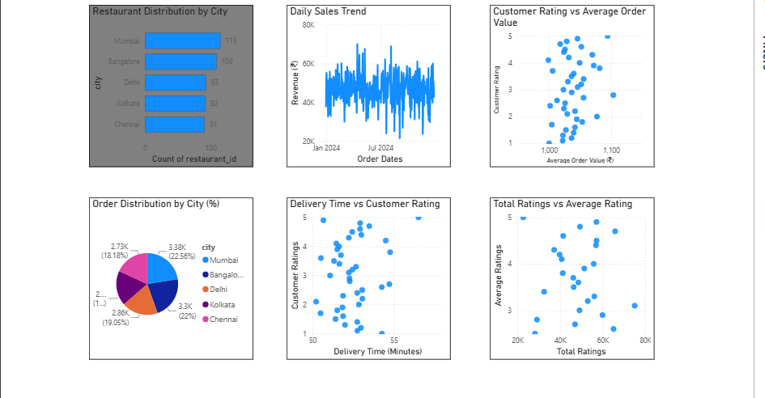
Figure 1 — Market Overview page
Key Insights:
- Bangalore has a strong restaurant presence.
- Area_B contributes significantly to revenue.
- Customer ratings vary across restaurants.

5.2 Restaurant Performance
Focuses on restaurant-level performance: top 5 restaurants by total sales, revenue contribution by area (tree map), and an order-density matrix by city with conditional-formatting heat coloring to highlight high- and low-demand cities at a glance.
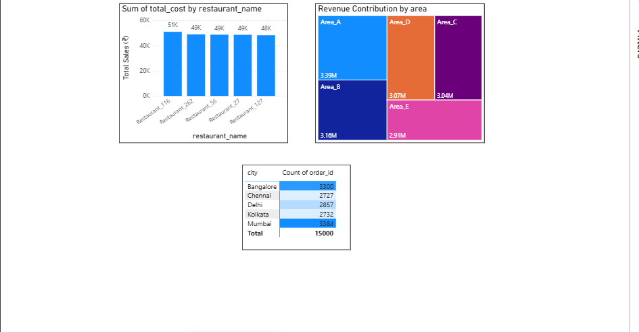
Figure 2 — Restaurant Performance page
Key Insights:
- Top restaurants contribute a large share of revenue.
- Revenue varies meaningfully by area.
- Delivery time and ratings show mixed performance across restaurants.

5.3 KPI & Restaurant Summary
A KPI-first page surfacing headline business metrics as cards, alongside a filterable, sortable restaurant-wise sales summary table (city, area, total sales, order totals, average order value) with slicers for city, area, and price range.
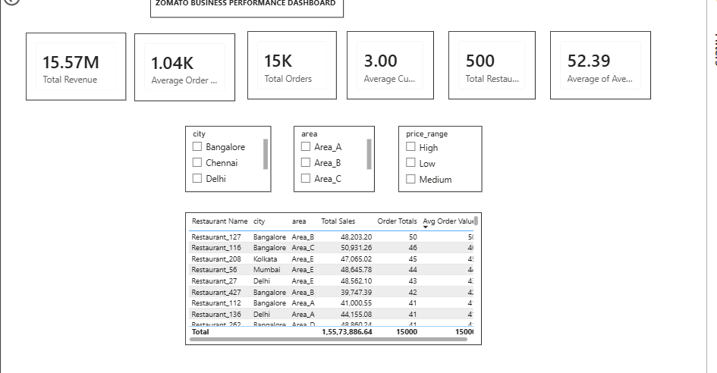
Figure 3 — KPI & Restaurant Summary page
Key Insights:
- Total Revenue: ₹15.57M
- Average Order Value: ₹1.04K
- Average Delivery Time: 52.39 minutes

5.4 Executive Dashboard
A consolidated, single-page view combining all core visuals — KPI cards, revenue by area, daily sales trend, order distribution by city, top 5 restaurants, restaurant distribution by city, and the restaurant summary table — with five synchronized slicers (city, area, price range, cuisine, payment method) for full interactive drill-down.
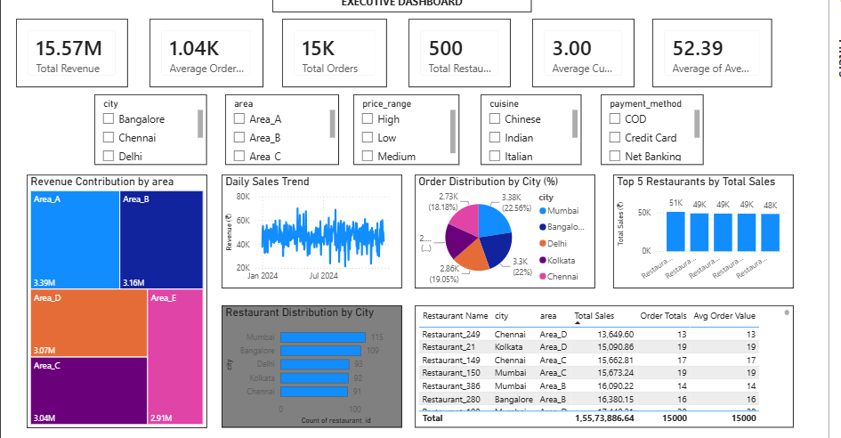
Figure 4 — Executive Dashboard page
Key Insights:
- Revenue is driven by a few top-performing restaurants.
- Average customer ratings remain around 3.0.
- Delivery performance has room for improvement.

6. Consolidated Key Insights
- Restaurant supply is concentrated in a few cities (Bangalore, Mumbai) while order demand is spread more evenly — signalling potential undersupply in high-demand, lower-density cities.
- A small group of top-performing restaurants and Area_B/Area_A localities account for a disproportionate share of total revenue.
- Average customer rating sits around 3.0 across the platform, indicating room to lift overall service quality rather than a concentration of very poor performers.
- Average delivery time (~52 minutes) is on the higher side and likely a contributing factor to rating variation — faster delivery may correlate with better ratings.
- Order value and rating do not show a strong direct relationship, suggesting price alone does not drive customer satisfaction.

7. Business Recommendations
- Prioritize restaurant onboarding and delivery-partner capacity in high-order, lower-restaurant-density cities to balance supply and demand.
- Study operational practices at top-revenue restaurants (Area_B, Area_A) and share best practices with underperforming areas.
- Investigate delivery logistics in areas with delivery times above the 52-minute average, as a targeted lever to improve customer ratings.
- Use the price-range and cuisine slicers to run targeted promotions in underrepresented, high-potential segments rather than broad discounting.
- Monitor the KPI dashboard periodically (weekly/monthly) to track whether operational changes move Average Rating and Average Delivery Time in the right direction.

8. Project Deliverables
Deliverable | Description
MySQL Database Export | Cleaned Zomato_Orders and Zomato_Restaurants tables, exported as CSV, plus SQL scripts (table creation, cleaning, exploration, aggregation, joins/view)
Power BI Report (.pbix) | 4-page interactive dashboard: Market Overview, Restaurant Performance, KPI & Restaurant Summary, Executive Dashboard
Project Documentation | This document — approach, data model, dashboard walkthrough, insights, and recommendations

9. Conclusion
This project demonstrates an end-to-end analytics workflow — from relational database design and SQL-based data cleaning through to an interactive, decision-ready Power BI dashboard. The resulting report equips stakeholders to identify high-performing restaurants, understand city- and area-level demand patterns, and target operational improvements in delivery efficiency and customer satisfaction.

