SEVA SADAN’S
R.K. TALREJA COLLEGE OF ARTS, SCIENCE & COMMERCE

Department of Computer Science



A Project Report on

Railway Reservation System

In fulfilment of the requirement for the completion of the Internal Assessment for

Data Structure

Submitted by
Name of Student: - Harshada Kene
Roll No: - 2542015

S.Y.BSc. Information Technology (NEP 2020)
SEM III A.Y. 2025 - 26

1

Table of Contents

Sr. No. | Particulars | Page No.
1. | Introduction | 3
2. | Definition | 3
3 | Objectives and Features | 3
4. | Code. | 5
5. | Output with screenshot | 11
6. | Real life Applications. | 14

2

🚆 Railway Reservation System – Project Report

📌 1. Introduction
The Railway Reservation System is a console-based C++ program designed to automate and streamline the process of booking, canceling, and managing train tickets. This project is based on fundamental data structures and object-oriented programming principles, using a linked list to manage passenger records dynamically. It demonstrates how a simple software system can effectively handle the core operations of a ticket reservation system.

📘 2. Definition
The Railway Reservation System is a computerized application that facilitates the management of railway ticket bookings. It allows passengers to book seats, cancel reservations, search ticket details, and check seat availability. In this C++ implementation, passenger data is stored in a singly linked list, allowing dynamic memory allocation and efficient record handling without the use of databases.

🎯 3. Objectives and Features
🔹 Objectives:
- To design a user-friendly and efficient reservation system.
- To implement core operations like booking, canceling, and searching tickets.
- To manage available seats and display current bookings.
- To apply linked list data structure for real-time memory allocation.

🔹 Key Features:
- Book Ticket:
  - Allows users to input their details (name, age, train name) and books a seat.
  - Automatically assigns Ticket ID and Seat Number.
- Cancel Ticket:
  - Enables passengers to cancel their booking using their Ticket ID.
  - Updates the seat count accordingly.
- Search Ticket:
  - Lets the user find ticket details using the Ticket ID.
  - Displays all relevant passenger and journey details.
- Display All Bookings:
  - Shows a list of all passengers who have booked tickets.
  - Displays ticket ID, name, age, train name, and seat number.
- Check Available Seats:
  - Displays the number of available seats out of total (100 in this case).
- Seat Limitation Logic:
  - The system does not allow booking if all 100 seats are already reserved.
- Dynamic Memory Allocation:
  - Uses a linked list to store passenger data, enabling efficient memory use and flexibility.

✒️ 4. Code
#include <iostream>
#include <string>
using namespace std;
const int TOTAL_SEATS = 100; // total seats available

// Structure for a passenger
struct Passenger {
int ticketID;
string name;
int age;
string trainName;
int seatNo;
Passenger* next;
};

// Head pointer for linked list
Passenger* head = NULL;
int nextTicketID = 1;
int bookedSeats = 0;
// Function to book a ticket
void bookTicket() {
if (bookedSeats >= TOTAL_SEATS) {
cout << "\n❌ No seats available!\n";
return;
}
Passenger* newPassenger = new Passenger;
newPassenger->ticketID = nextTicketID++;
cout << "\nEnter Passenger Name: ";
cin.ignore();
getline(cin, newPassenger->name);
cout << "Enter Age: ";
cin >> newPassenger->age;
cout << "Enter Train Name: ";
cin.ignore();
getline(cin, newPassenger->trainName);
newPassenger->seatNo = bookedSeats + 1;
newPassenger->next = NULL;

// Insert at end
if (head == NULL) {
head = newPassenger;
} else {
Passenger* temp = head;
while (temp->next != NULL) temp = temp->next;
temp->next = newPassenger;
}
bookedSeats++;
cout << "\n✅ Ticket booked successfully!";
cout << "\nTicket ID: " << newPassenger->ticketID
<< " | Seat No: " << newPassenger->seatNo << "\n";
}

// Function to cancel a ticket
void cancelTicket() {
if (head == NULL) {
cout << "\n❌ No bookings to cancel.\n";
return;
}
int id;
cout << "\nEnter Ticket ID to cancel: ";
cin >> id;
Passenger* temp = head;
Passenger* prev = NULL;
while (temp != NULL && temp->ticketID != id) {
prev = temp;
temp = temp->next;
}
if (temp == NULL) {
cout << "\n❌ Ticket ID not found.\n";
return;
}
if (prev == NULL) {
head = temp->next;
} else {
prev->next = temp->next;
}
cout << "\n✅ Ticket ID " << id << " cancelled successfully.\n";
delete temp;
bookedSeats--;
}

// Function to search for a ticket
void searchTicket() {
if (head == NULL) {
cout << "\n❌ No bookings available.\n";
return;
}
int id;
cout << "\nEnter Ticket ID to search: ";
cin >> id;
Passenger* temp = head;
while (temp != NULL) {
if (temp->ticketID == id) {
cout << "\n🎫 Ticket Found:";
cout << "\nTicket ID: " << temp->ticketID;
cout << "\nName: " << temp->name;
cout << "\nAge: " << temp->age;
cout << "\nTrain: " << temp->trainName;
cout << "\nSeat No: " << temp->seatNo << "\n";
return;
}
temp = temp->next;
}
cout << "\n❌ Ticket not found.\n";
}

// Function to display all bookings
void displayAllBookings() {
if (head == NULL) {
cout << "\n❌ No bookings available.\n";
return;
}
cout << "\n📋 All Bookings:\n";
Passenger* temp = head;
while (temp != NULL) {
cout << "Ticket ID: " << temp->ticketID
<< " | Name: " << temp->name
<< " | Age: " << temp->age
<< " | Train: " << temp->trainName
<< " | Seat No: " << temp->seatNo << "\n";
temp = temp->next;
}
}

// Function to check available seats
void checkAvailableSeats() {
cout << "\n🚉 Available Seats: " << (TOTAL_SEATS - bookedSeats)
<< " / " << TOTAL_SEATS << "\n";
}
int main() {
int choice;
do {
cout << "\n\n====== Railway Reservation System ======";
cout << "\n1. Book Ticket";
cout << "\n2. Cancel Ticket";
cout << "\n3. Search Ticket";
cout << "\n4. Display All Bookings";
cout << "\n5. Check Available Seats";
cout << "\n6. Exit";
cout << "\nEnter your choice: ";
cin >> choice;
switch (choice) {
case 1: bookTicket(); break;
case 2: cancelTicket(); break;
case 3: searchTicket(); break;
case 4: displayAllBookings(); break;
case 5: checkAvailableSeats(); break;
case 6: cout << "\nExiting... Thank you!\n";
break;
default: cout << "\n❌ Invalid choice! Try again.\n";
}
} while (choice != 6);
return 0; }

5. Output with screenshot
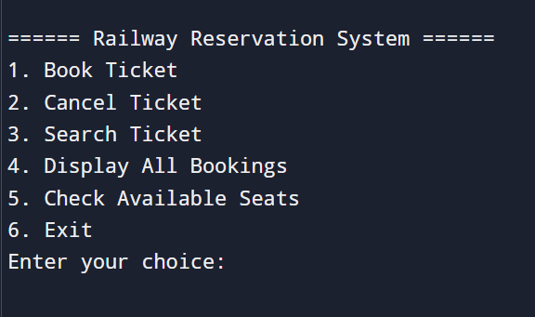

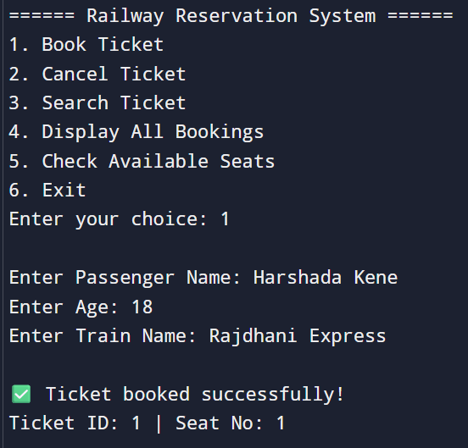
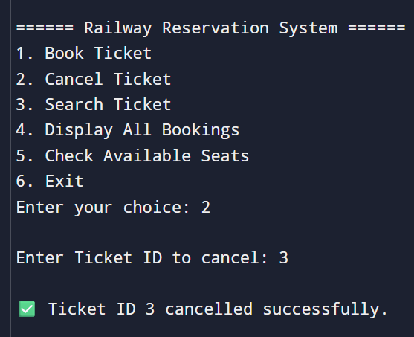
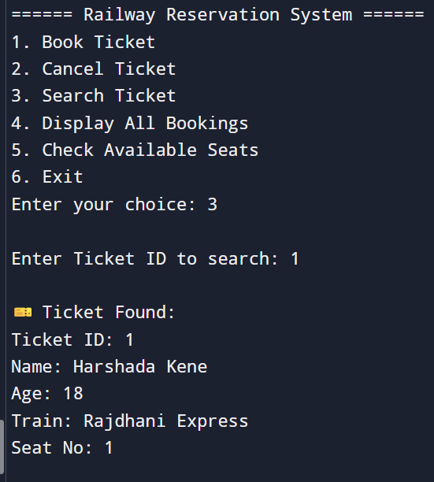
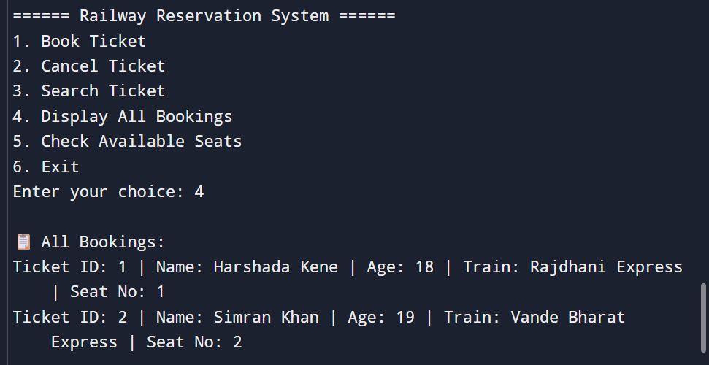
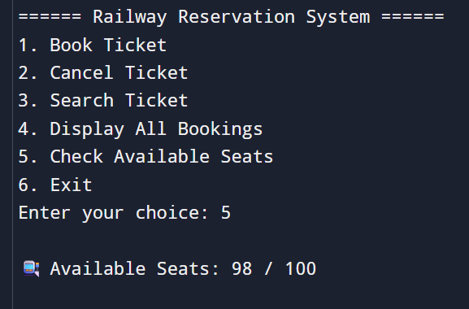
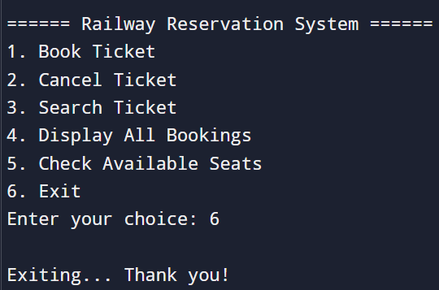
6. Real-Life Applications
A Railway Reservation System like this forms the backbone of various large-scale, real-world systems. While this implementation is simple and educational, its core logic mirrors the operations found in real railway systems, such as:
- Indian Railways Booking System (IRCTC)
- Amtrak (USA) Online Booking
- European Rail Ticketing Portals
- Rail Reservation Kiosks at Stations
✨ Real-world Applications Include:
- Online Ticket Booking Platforms
- Railway Station Booking Counters
- Mobile Reservation Apps
- Automated Customer Service Kiosks
- Passenger Management Systems
Such systems are integral to managing high volumes of passengers, reducing manual errors, and providing quick and efficient service across vast networks.

