Intorduction

Abstract

Over the past two decades, the focus of training systems has been on learners. These included Learning Management Systems (LMS) to manage the training requirements of learners and track their progress; Talent Management System to manage competency requirements and facilitate succession planning.

Training Management Systems can resolve most issues by storing operational and training requirements in a centralized relational database, that can be accessed anytime and from anywhere by all team members. Moreover, Training Management Systems can provide the necessary inputs to all learner centric systems to ensure that not only are they doing things right, but are also doing the right things!

Introduction

**Definition**

The Training Management System (TMS) is a productivity software which helps organization meet its employee competency needs.

TMS facilitates Training Management System of organizations, with its convenient, easy-to-

use, and online features allowing organizations to allocate more resources in planning and decision making than administrative work.

**Scope:**

**Managers:**

Easily ask for training for team and track it.

**HR and Training Manager and Coordinators can:**

Effectively and efficiently coordinates and communicates training activities to managers

Conveniently Plan, Implement and Monitor training activities and resources

**Objectives:**

To facilitate ease of requesting for training for the project manager.

To facilitate the process of management of training to the training coordinator or authority.

**Overview**

This System provides better solution to any indusrty for reducing workload to Training Cordinator and simplify communication between Project Manager and Project Coordinator .

**Additional Information**

The system work on internet server, so it will be operated by any end user for the buying purpose with secure platform.

This system protects the integrity of the Traininng cordinator and project manager, provides easy way to conduct the training for the employees of industry.

General Description:

The Training Management System will help to manage all the trainings of different techonolgy neded for project.

Better management system means that Industrail Training can be managed easily and less complex between Taining Coordinator and project manager .

Functional Requirement:

This section provides requirement overview of the system. Various functional modules that can be implemented by

The system will be-

**Description:**

In system there will be three different login according to role like adminstration,Training coordinator,project manager to maintain data integrity.

To Login to the system user need to provide username,password which will provided by administrator. User can change the password.

To request for new training project manager have to fill the one form which will contain all requirement related to training and can send to training cordinator.

Training cordinator will get the notificaton about the new training and according to availibility of trainer and the date time mentioned in the form corndinator will have the facility to modify the form and send back it again to project manager.

If project manager will agrree with modification he can approve it and after receiving approval of project manager then project project will approve it.Both can reject the request.

**Technical Issues:**

This system will work on client-Server architecture. It will require an internet server.

**Requirement Analysis**

**Normal Requirements**

**NR1:** The project manager should training request to the training coordinator for the particular technology for his team.

**NR2:** The training coordinator should approve or reject the training request by project manager.

**Excited Requirements**

**XR1:** The project manager should track the previous trainings using different filters.

**XR2**: The training coordinator should track the previous trainings using different filters.

**Functional Requirements**

The project manager should training request to the training manager for the particular technology for his team.

The project manager should reject the training after approval of training with some changes by training manager if he/she is not agreeing with it.

The project manager should approve back the training scheduled which is sent after approval of training manager.

The training coordinator should approve training request which is sent by training manager.

The project manager and training coordinator should track the previous trainings using different filters.

**Non Function Requirements**

The application must be reliable and not crash.

It must be free of cost inside the organization.

No one should change or delete the inserted data from the web application.

The system must be secure and reliable to use.

The system must be available for all time to the user.

It should be easily updated, modified and reused.

**Software Requirement**

The software requirements that were used for the development of the Training Management System are as follows;

Operating System: Windows 10

Programming Language: Angular, spring boot

Database: mySql

Tools: Visual Studio Code

Technologies: Java, SQLite

**Hardware Requirements**

Processor: I3 or higher

RAM: 4GB and above

System Model

**System Model**

**Agile Model**

Agile was originally developed for the software industry to streamline and improve the development process in an effort to rapidly identify and adjust for issues and defects. It provides a way for developers and teams to deliver a better product, in a faster manner, through short, iterative, interactive sessions/sprints. In the era of digital transformation, with many companies migrating to a digital workplace, agile is a perfect fit for organizations looking to transform how they manage projects and operate as a whole. Agile can help ensure company-wide process and methodological alignment.

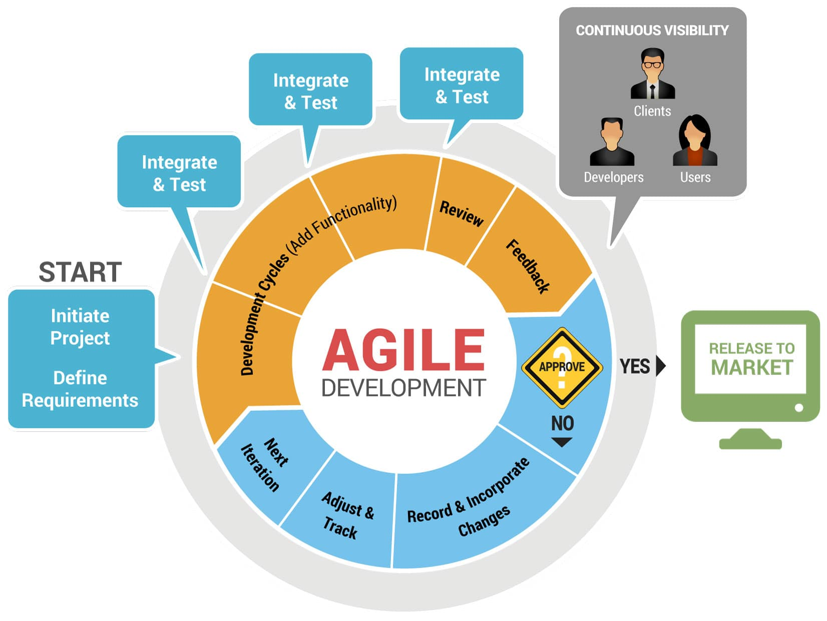

**Principles of Agile model:**

* To establish close contact with the customer during development and to gain a clear understanding of various requirements, each Agile project usually includes a customer representative on the team. At the end of each iteration stakeholders and the customer representative review, the progress made and re-evaluate the requirements.
* Agile model relies on working software deployment rather than comprehensive documentation.
* Frequent delivery of incremental versions of the software to the customer representative in intervals of few weeks.
* Requirement change requests from the customer are encouraged and efficiently incorporated.
* It emphasizes on having efficient team members and enhancing communications among them is given more importance. It is realized that enhanced communication among the development team members can be achieved through face-to-face communication rather than through the exchange of formal documents.
* It is recommended that the development team size should be kept small (5 to 9 peoples) to help the team members meaningfully engage in face-to-face communication and have collaborative work environment.
* Agile development process usually deploy Pair Programming. In Pair programming, two programmers work together at one work-station. One does coding while the other reviews the code as it is typed in. The two programmers switch their roles every hour or so.

**Advantages of agile for project management**

In the project management field, agile provides project teams, sponsors, project leaders and customers many project-specific benefits, including:

More rapid deployment of solutions

Reduced waste through minimization of resources

Increased flexibility and adaptability to change

Increased success through more focused efforts

Faster turnaround times

Faster detection of issues and defects

Optimized development processes

A lighter weight framework

Optimal project control

Increased focus on specific customer needs

Increased frequency of collaboration and feedback

**The drawbacks of agile**

As with any other methodology, agile is not well-suited for every project, and sufficient due diligence is always recommended to identify the best methodology for each unique situation. Agile may not work as intended if a customer is not clear on goals, the project manager or team is inexperienced, or if they do not function well under significant pressure.