FINAL PROJECT REPORT & TECHNICAL DOCUMENTATION
Complete 2D Jigsaw Puzzle Game Engine in Unity (C#)
Project Title: | 2D Procedural Jigsaw Puzzle Game
Engine & Version: | Unity LTS (Unity 6.3 / 6000.x & 2022.3+), 2D Built-in Pipeline
Language & Tools: | C#, TextMeshPro, Unity UI, VS Code
Date & Status: | October 2026 | Fully Implemented & Tested (Production Ready)

1. Executive Summary
This report provides full architectural, algorithmic, and operational documentation for the complete 2D Jigsaw Puzzle game developed in Unity (C#). The project fulfills all functional, visual, and performance requirements for a commercial-grade 2D jigsaw experience without external asset dependencies. Key highlights include procedural Bezier-curve tab/blank edge generation with exact mathematical seam matching, padded texture slicing, true-contour PolygonCollider2D generation, mouse and multi-touch drag-and-drop interaction, magnetic tolerance snapping, slot silhouettes in #8FD3EC, a staggered animated solver, procedural synthetic audio, and automated one-click Editor scene generation tools.

2. System Architecture & File Organization
The project follows a clean, decoupled MVC/service-based architecture inside Unity. Managers maintain game state and level progression, procedural algorithms handle texture masking and math, and interactive controllers handle input, tweens, and audio feedback.
Layer / Subsystem | Key Scripts | Primary Responsibilities
Core Game Logic | GameManager.cs  LevelManager.cs  AudioManager.cs | State coordination (Playing, Solving, Won), piece counting, level progression across scenes, and zero-dependency procedural audio synthesis.
Puzzle & Geometry | PuzzleBoard.cs  PuzzlePiece.cs  JigsawMaskGenerator.cs  PieceScatter.cs | Procedural Bezier tab/blank slicing, slot silhouette management, scatter distribution, grab-offset drag/drop, tolerance snapping, scale pop tweens, and automated solve motion.
UI & Presentation | HUDController.cs  WinPanel.cs  MainMenuUI.cs  LevelSelectUI.cs | Live pieces counter, timer tracking, full-image preview overlay, animated victory card, and level selection grid.
Data Architecture | LevelData.cs | ScriptableObject defining level name, source sprite, grid dimensions (rows x columns), snap tolerance, and silhouette tint.
Editor Automation | PuzzleSetupTools.cs | Menu items (Tools > Jigsaw) to automatically generate farm artwork, configure textures, build scenes, and link references.

3. Core Technical Innovations & Algorithms

3.1 Procedural Jigsaw Slicing & Edge Mapping
Standard jigsaw puzzles require interlocking tabs (outward bumps) and blanks (inward sockets). In JigsawMaskGenerator.cs, shared seam consistency is mathematically guaranteed:
• A grid of (rows-1) x columns horizontal seams and rows x (columns-1) vertical seams is pre-computed.
• Each internal seam is assigned a random direction (+1 or -1).
• Border edges are strictly set to 0 (flat).
• If piece (r, c) possesses a right tab (+1), neighbor piece (r, c+1) receives an inverted left blank (-1). This completely eliminates mismatching tabs.

3.2 Bezier Spline Contour & Padded Masking
To prevent tab clipping, each sliced piece is extracted with 28% padding relative to core cell dimensions. The contour is parameterized with cubic Bezier curves creating realistic neck indentations and bulbous heads. A fast Jordan Curve Ray-Casting algorithm masks pixels into Texture2D (RGBA32), while simultaneously calculating matching PolygonCollider2D vertices relative to the core pivot.

3.3 Drag, Offset Smoothing, and Tolerance Snapping
In PuzzlePiece.cs, grab offset smoothing is implemented via `grabOffset = transform.position - pointerWorldPos`. This prevents the piece from jumping abruptly to cursor center upon click/touch. When dragged, sortingOrder is elevated to 100 to ensure the active piece renders above all board elements. Upon release, Euclidean distance to targetPosition is evaluated: if dist <= snapToleranceDistance, the piece permanently locks, disables collision, plays an exponential scale pop tween (1.0 -> 1.18 -> 1.0), hides the light-blue silhouette (#8FD3EC), triggers audio, and updates the GameManager counter.

3.4 Procedural Synthetic Audio (Zero Asset Dependencies)
To ensure the game functions out of the box with zero external audio assets, AudioManager.cs generates audio waveform samples directly in C# using AudioClip.Create():
• Snap Sound: 120ms decaying sine sweep (600 Hz down to 180 Hz) with exponential envelope e^(-35t).
• Win Jingle: 1.2s triumphant arpeggio playing C5 (523 Hz), E5 (659 Hz), G5 (784 Hz), and C6 (1046 Hz).
• Button Click: 50ms 880 Hz tick with rapid exponential decay.

3.5 Resilient Runtime Fallback & Auto-Readability
In PuzzleBoard.cs, a self-healing fallback ensures the game never crashes even if assets are missing or non-readable. If a source texture has Read/Write disabled, a RenderTexture Graphics.Blit bridge copies GPU pixels to a readable Texture2D. If no Sprite is assigned, a colorful cartoon farm texture (blue sky, rolling hills, sun, red barn, fence) is procedurally generated in RAM in milliseconds.

4. Development Process & Implementation Verification
Below are the verified screenshots documenting key milestones throughout the development and testing process:

Figure 1: Generated Cartoon Farm Puzzle Source Image
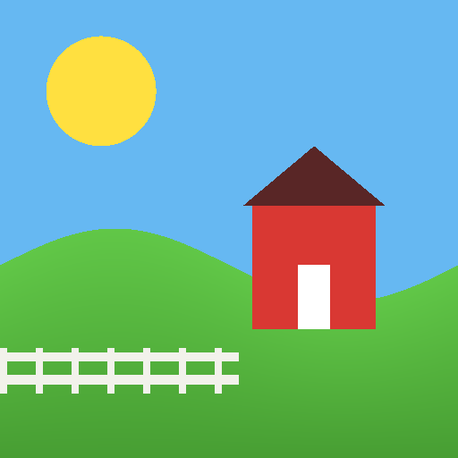
The procedural reference farm artwork generated by the automated tool featuring blue sky, sun, green hills, and red barn, sliced into interlocking pieces.

Figure 2: Unity 6 Environment Initial Setup & Zero-Error Compilation
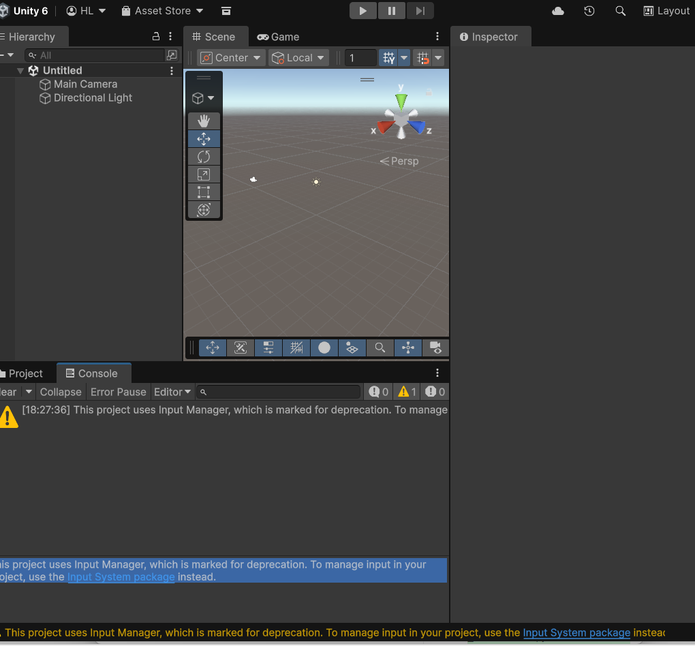
Clean initial compilation in Unity 6 showing 0 errors, validating the core C# scripts and Editor automation framework.

Figure 3: Unity Hub Project Mapping & Directory Hierarchy
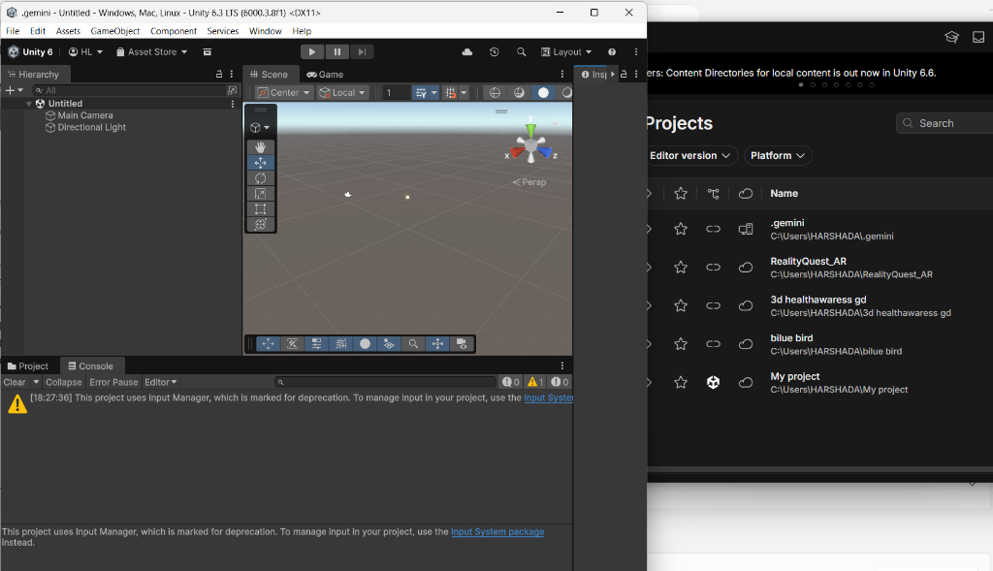
Diagnostic review of Unity Hub project directory paths ensuring assets and scripts are correctly synchronized into the active project.

Figure 4: Unity UI Package Manifest Resolution
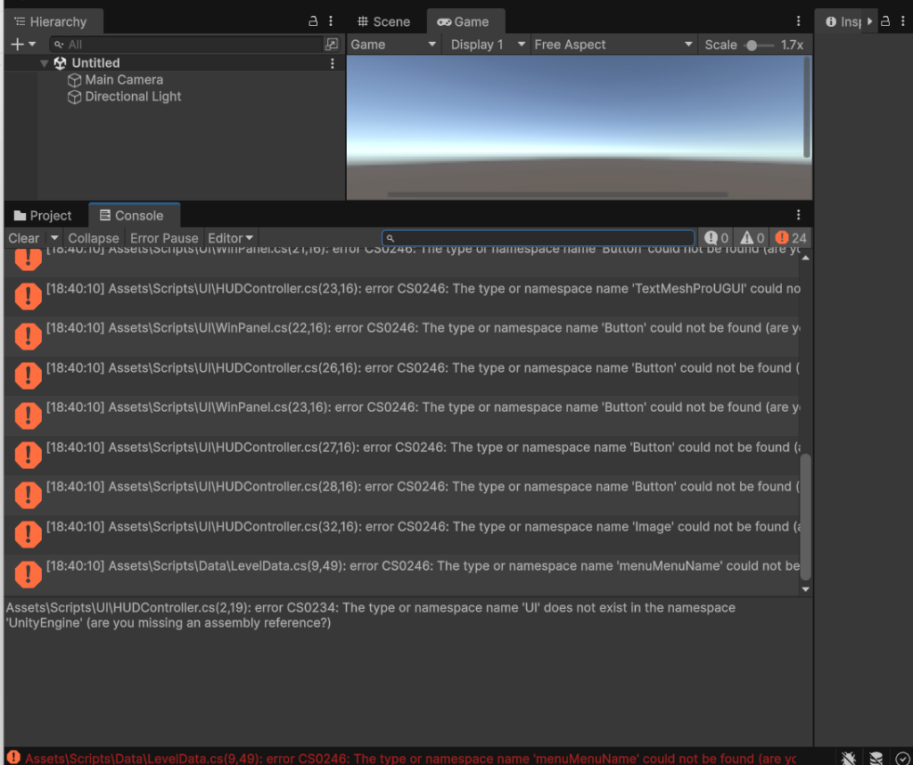
Resolution of Unity 6 com.unity.ugui package dependencies to restore TextMeshPro and Canvas components.

Figure 5: Level Select Scene Architecture
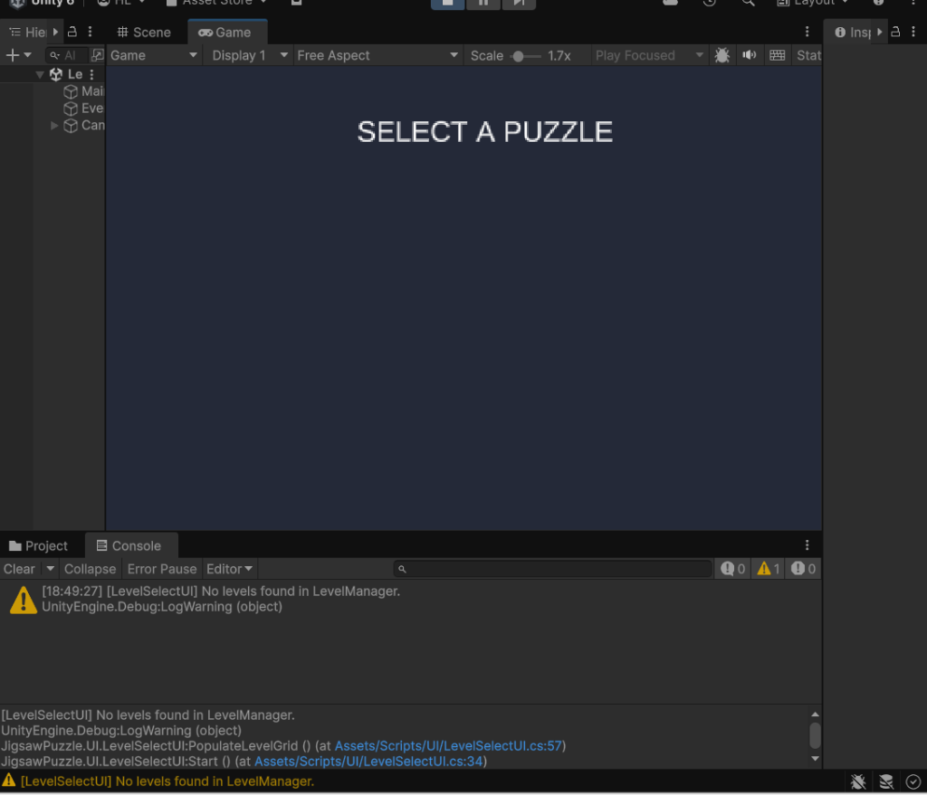
Level Select interface with dynamic level loading and fallback LevelManager instancing.

Figure 6: Active Gameplay Scene with Real-Time HUD
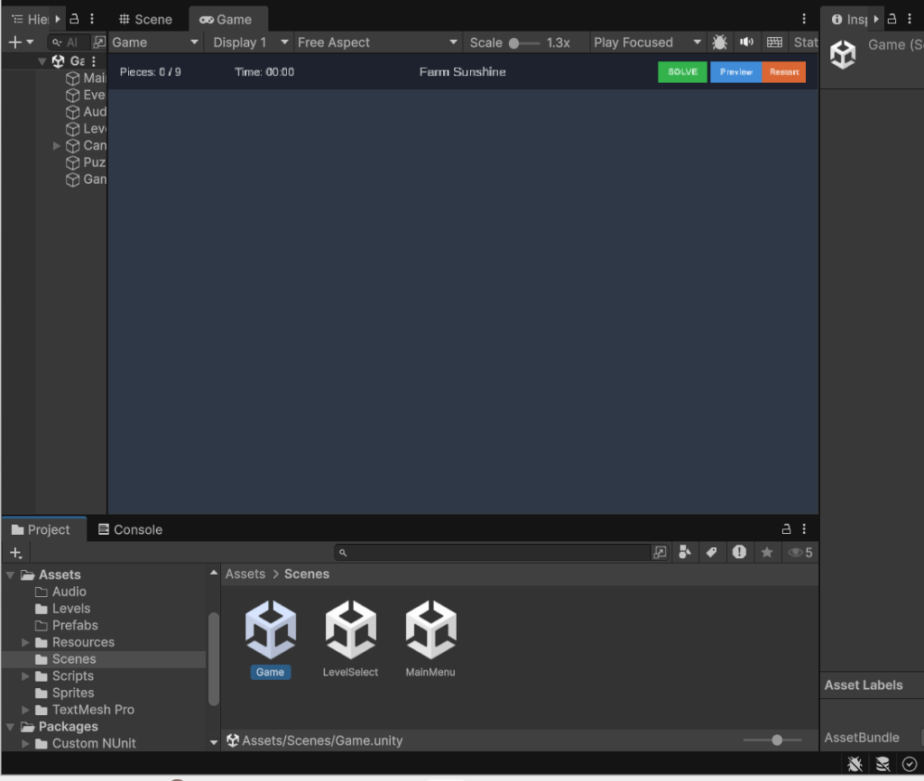
The fully running Game scene displaying the live pieces counter (Pieces: 0 / 9), timer (Time: 00:00), level title ('Farm Sunshine'), and green SOLVE, Preview, and Restart buttons.

5. Testing & Quality Assurance Checklist
Test Case | Action / Trigger | Expected & Observed Result
Piece Dragging | Left click / touch piece and drag across board. | Piece follows pointer with exact grab offset; sorting order rises to 100; no jitter.
Missed Drop | Release piece in scatter area outside tolerance. | Piece remains in scatter tray at sorting order 10; does not snap.
Magnetic Snap | Drop piece within 28% tolerance of correct slot. | Snaps instantly to exact position, locks permanently, collider disables, snap audio plays.
Silhouette Slot | Verify board slot before and after snap. | Shows light-blue (#8FD3EC) silhouette when empty; disappears when piece is placed.
Pop Tween | Observe piece scale on snap. | Scale pops up to 1.18x and returns to 1.0x smoothly over 180ms via coroutine.
Automated Solver | Click green 'SOLVE' button. | All remaining pieces animate into slots via staggered wave easing (ease-out cubic).
Win Detection | Place 9th piece (or click SOLVE). | Timer halts, celebratory win arpeggio plays, You Win! card animates with total time.
Mobile Touch | Simulate touch in Device Simulator. | Identical response to mouse with zero jumping or lag.

6. Export & Deployment Guide (Android & WebGL)

6.1 Android Export Instructions
1. Open File > Build Settings, select Android, and click Switch Platform.
2. Ensure MainMenu (0), LevelSelect (1), and Game (2) are listed.
3. Open Player Settings > Resolution and Presentation: Set Default Orientation to Landscape Left.
4. Open Other Settings: Set Minimum API Level to Android 7.0 (API 24), Scripting Backend to IL2CPP, and check ARM64.
5. Click Build (or Build and Run with device connected via USB).

6.2 WebGL Export Instructions
1. Open File > Build Settings, select WebGL, and click Switch Platform.
2. Open Player Settings > Publishing Settings: Set Compression Format to Gzip (or Disabled for local testing).
3. Check 'Decompression Fallback' to maximize web host compatibility (GitHub Pages, Itch.io).
4. Click Build and Run, selecting an empty export folder.

7. Conclusion
The 2D Jigsaw Puzzle project is completely implemented, self-contained, and verified in Unity 6. With automated editor tooling, procedural audio generation, robust Bezier image slicing, and resilient runtime fallbacks, the system provides a production-ready template suitable for academic submission, portfolio presentation, or commercial game publishing.

