MongoDB installation

Install mongodb from <https://www.mongodb.com/try/download/community>



In version 6.0 onwards u need to install mongod shell u can download from

<https://www.mongodb.com/try/download/shell>

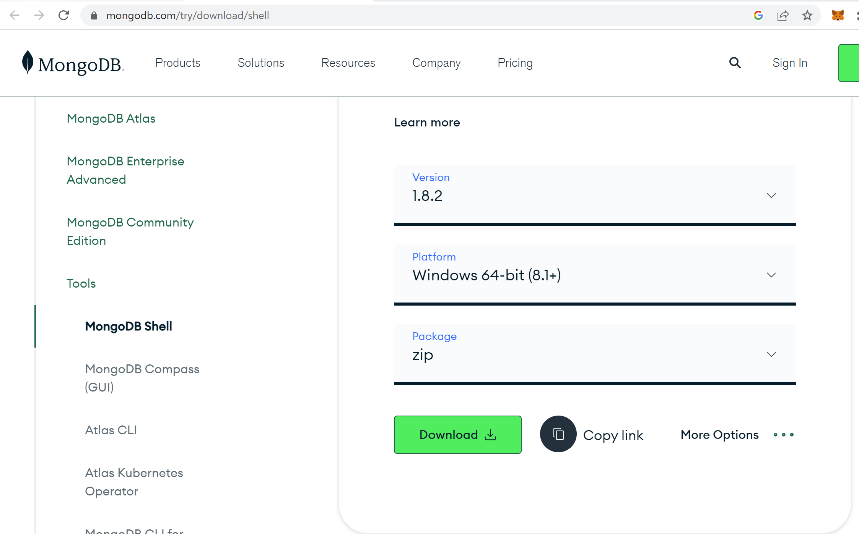

In env path need to add both folder till bin

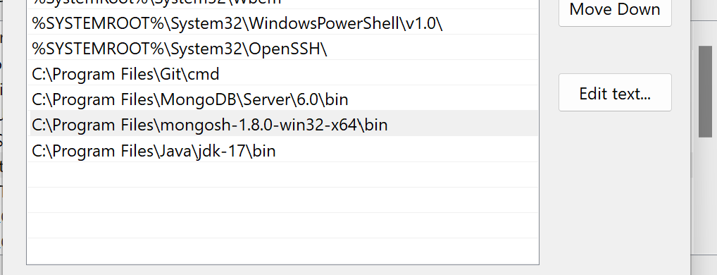

Create folder for database-> here your database will be store. While installing we give this path

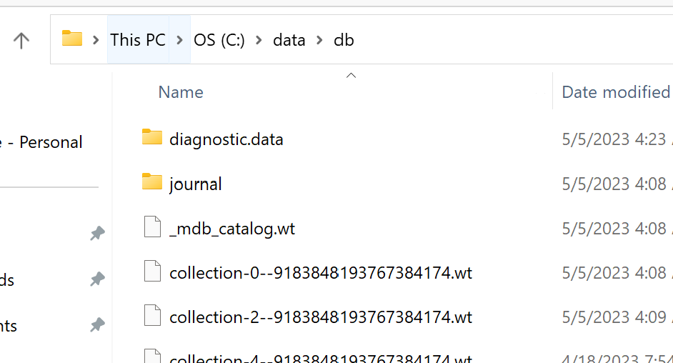

Open your command prompt and give command >mongod

For writting shell script open another command promt for writing shell scripting for mongo

Give command >mongosh

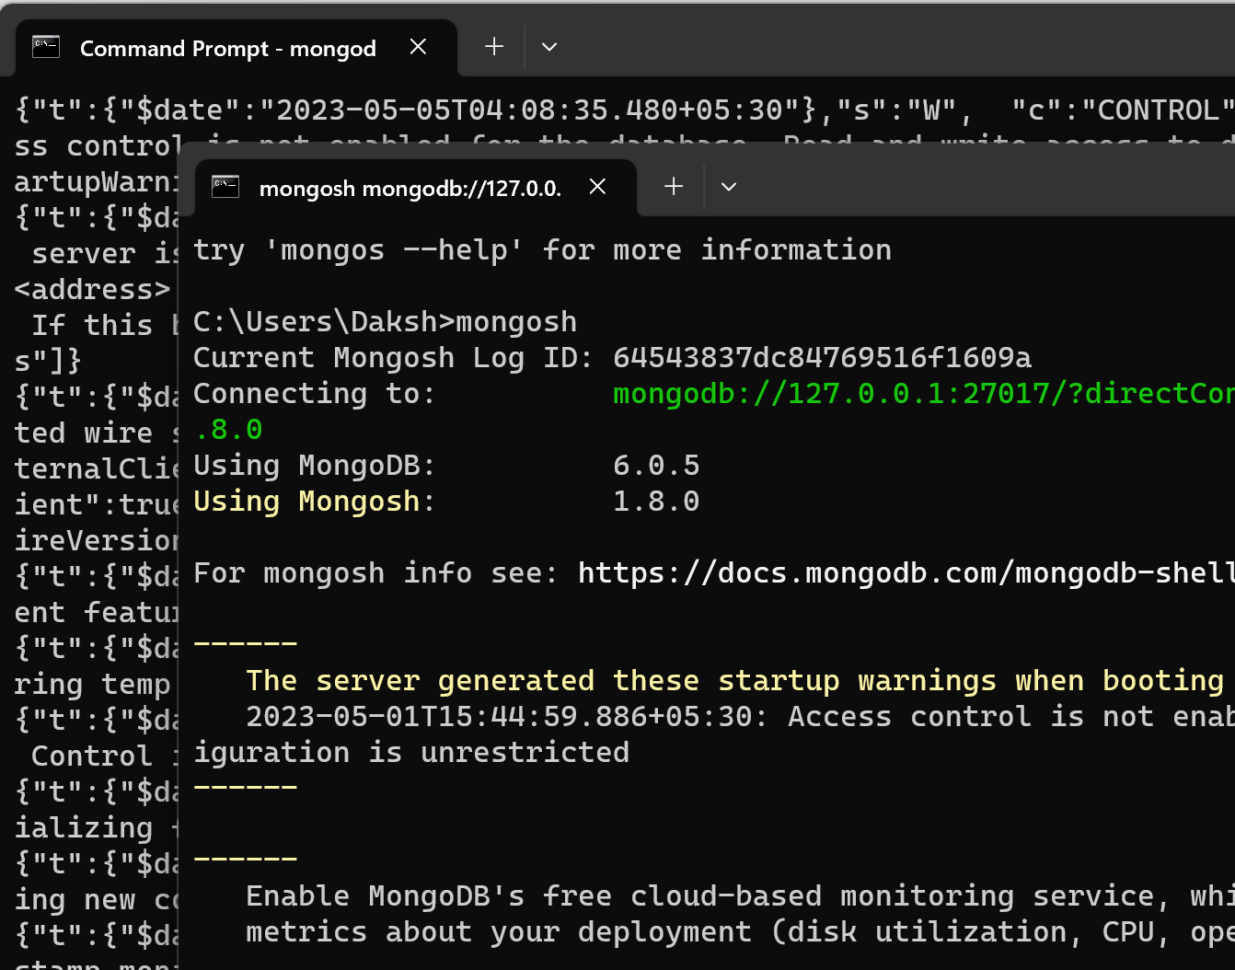

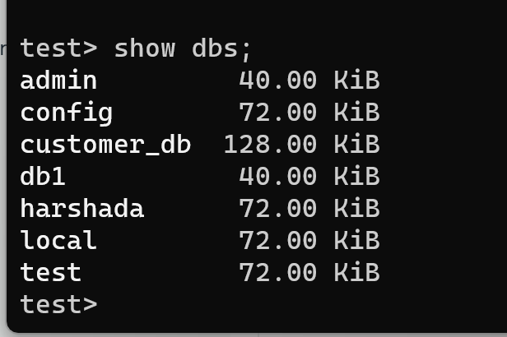

Same database we can see into mongodb compass

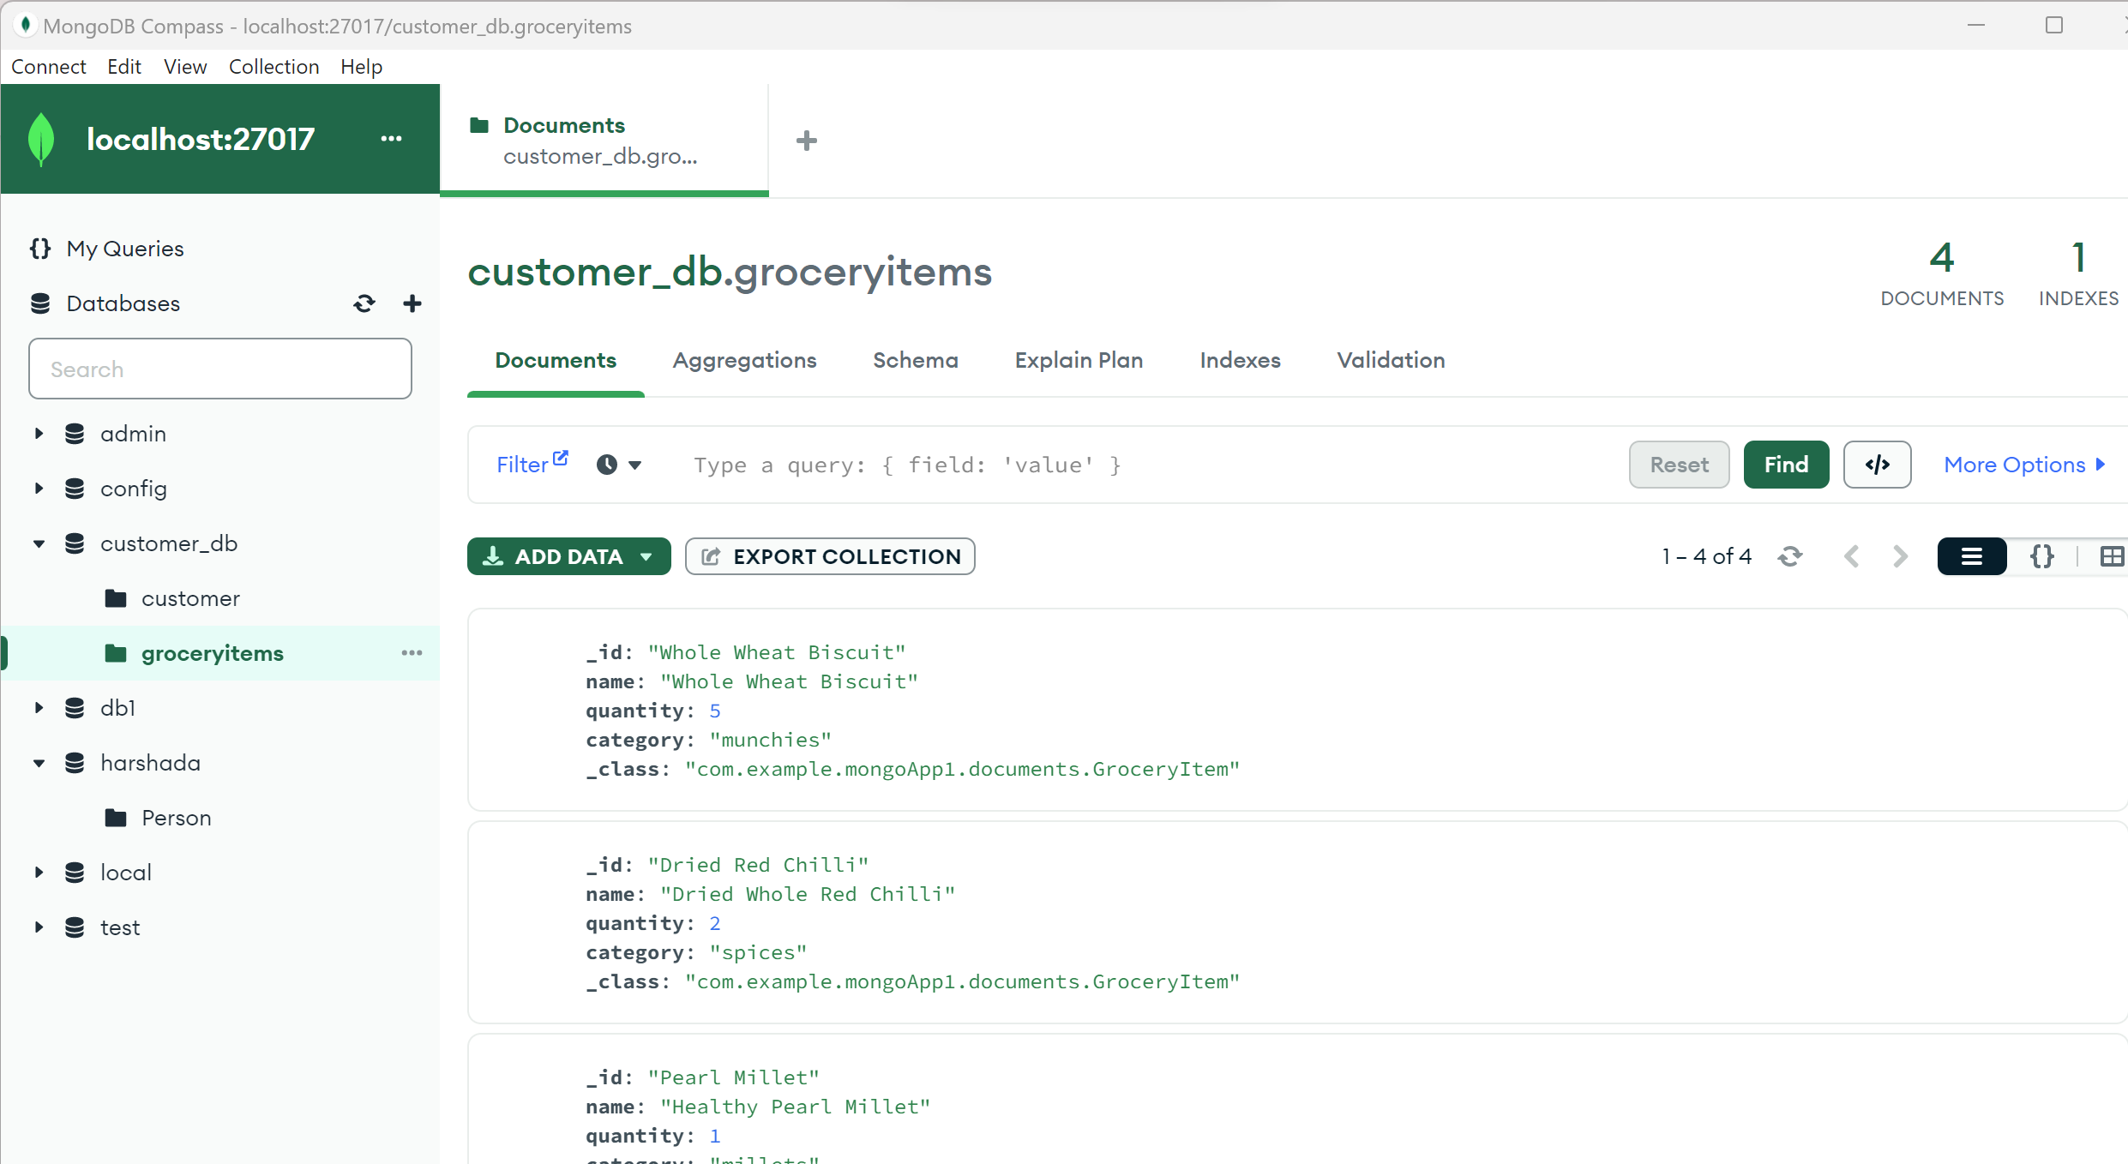

Comparisonbetween SQL to MongoDB

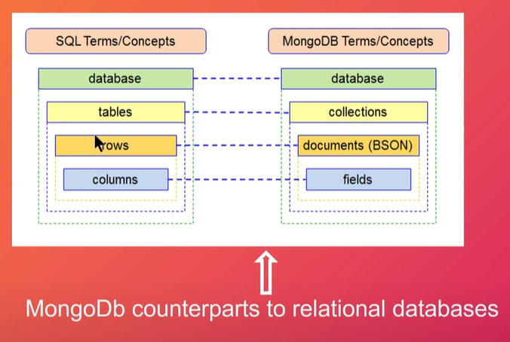

Few Commands

Use <db_name> --> witch db and if not available then create new db

Db --> show current db which you are using

db.createCollection('Person') --> Person collection or person table will be created

Show collections --> is used to check all collections or tables in side db

db.Person.drop()--> Delete Collection

db.Person.find()--> select from table or collection

db.Person.find().pretty() --> Display in proper JSON readable format

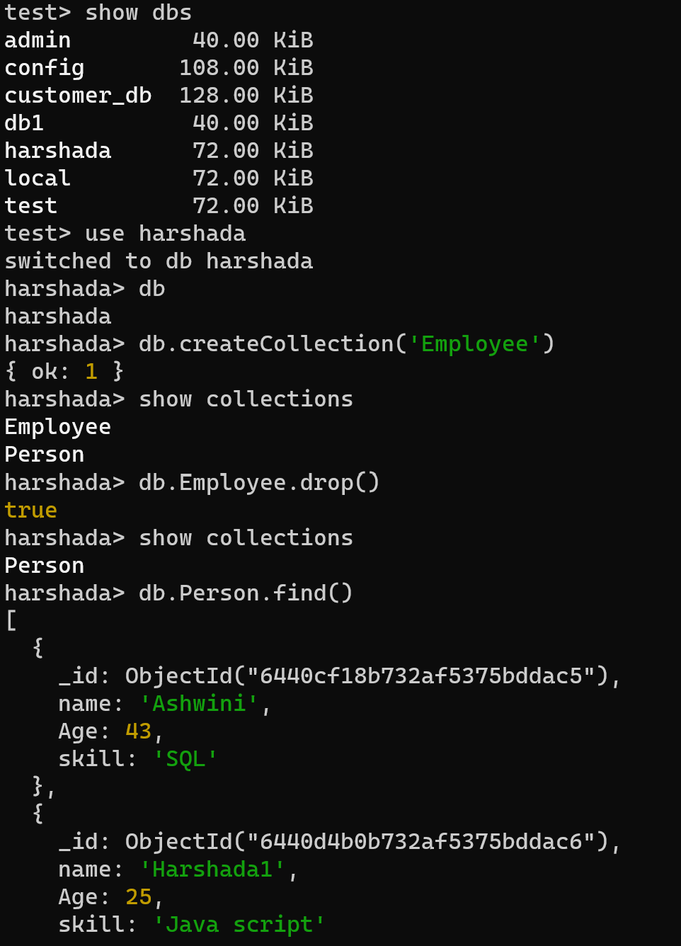

Insert Record:

db.Person.insert({'name':'Daksh','Age':10,'skill':'Scratch'})

---- Insert Many Record like Array of Objects----------

db.Person.insertMany([{'name':'Ash','Age':25,'skill':'Java script'},{'name':'Teju','Age':43,'skill':'SQL'}])

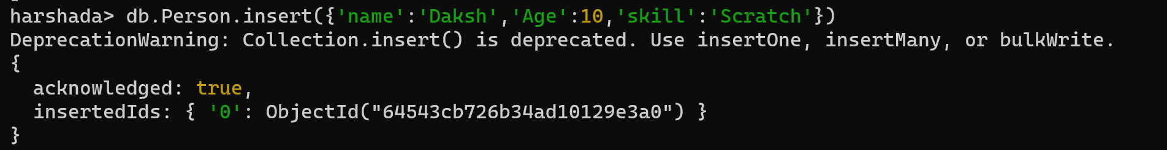

Inserting many record or array of object

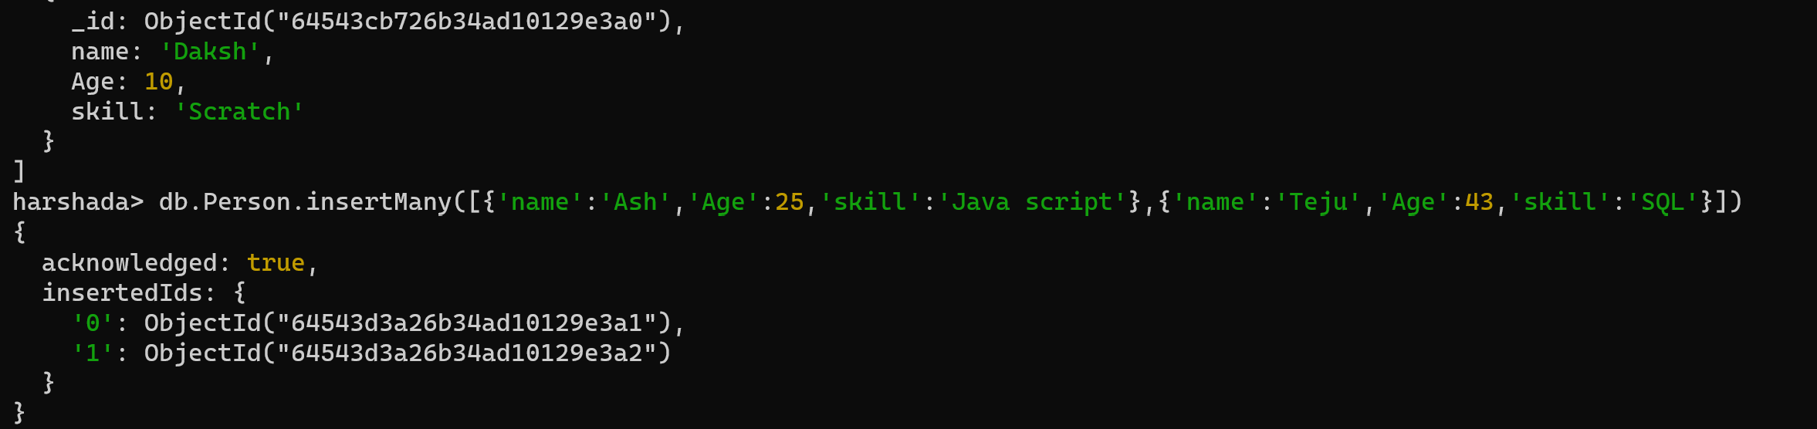

Find with where condition

db.Person.find({name:'Harshada1'})-> where name = 'Harshada1'

db.Person.find({name:'Ashwini', Age :20}) --> where condition with and

db.Person.find({name:'Ashwini'}).limit(2) --> only 2 record will display

db.Person.find().count() --> count the no of record in collection

db.Person.findOne({name:'Teju1'}) --> find first record of name=Teju1

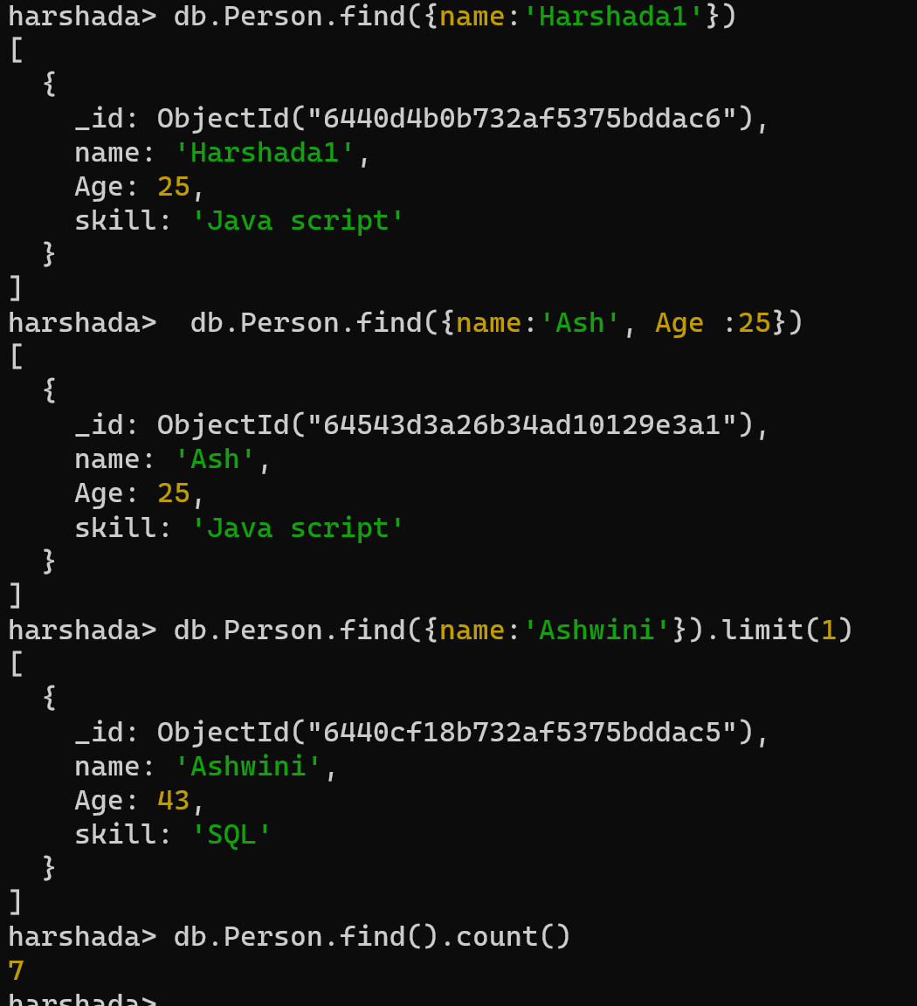

db.Person.deleteOne({name:'Ash'})

db.Person.remove({name:'Teju’})

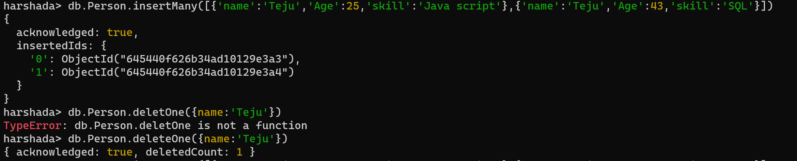



---Update Record-----------

db.Person.updateMany({ name: 'Ravi' }, {$set: { name: 'Shubham', Age: 41, Skill: 'Python' }},{upsert:true}) --> Update Many Record and {upsert:true} -> if not available then insert new record, By default value is false

db.Person.update({ name: 'Daksh' }, {$set: { name: 'Teju', Age: 23, Skill: 'Python' }},{upsert:true}) ---> Update a single record

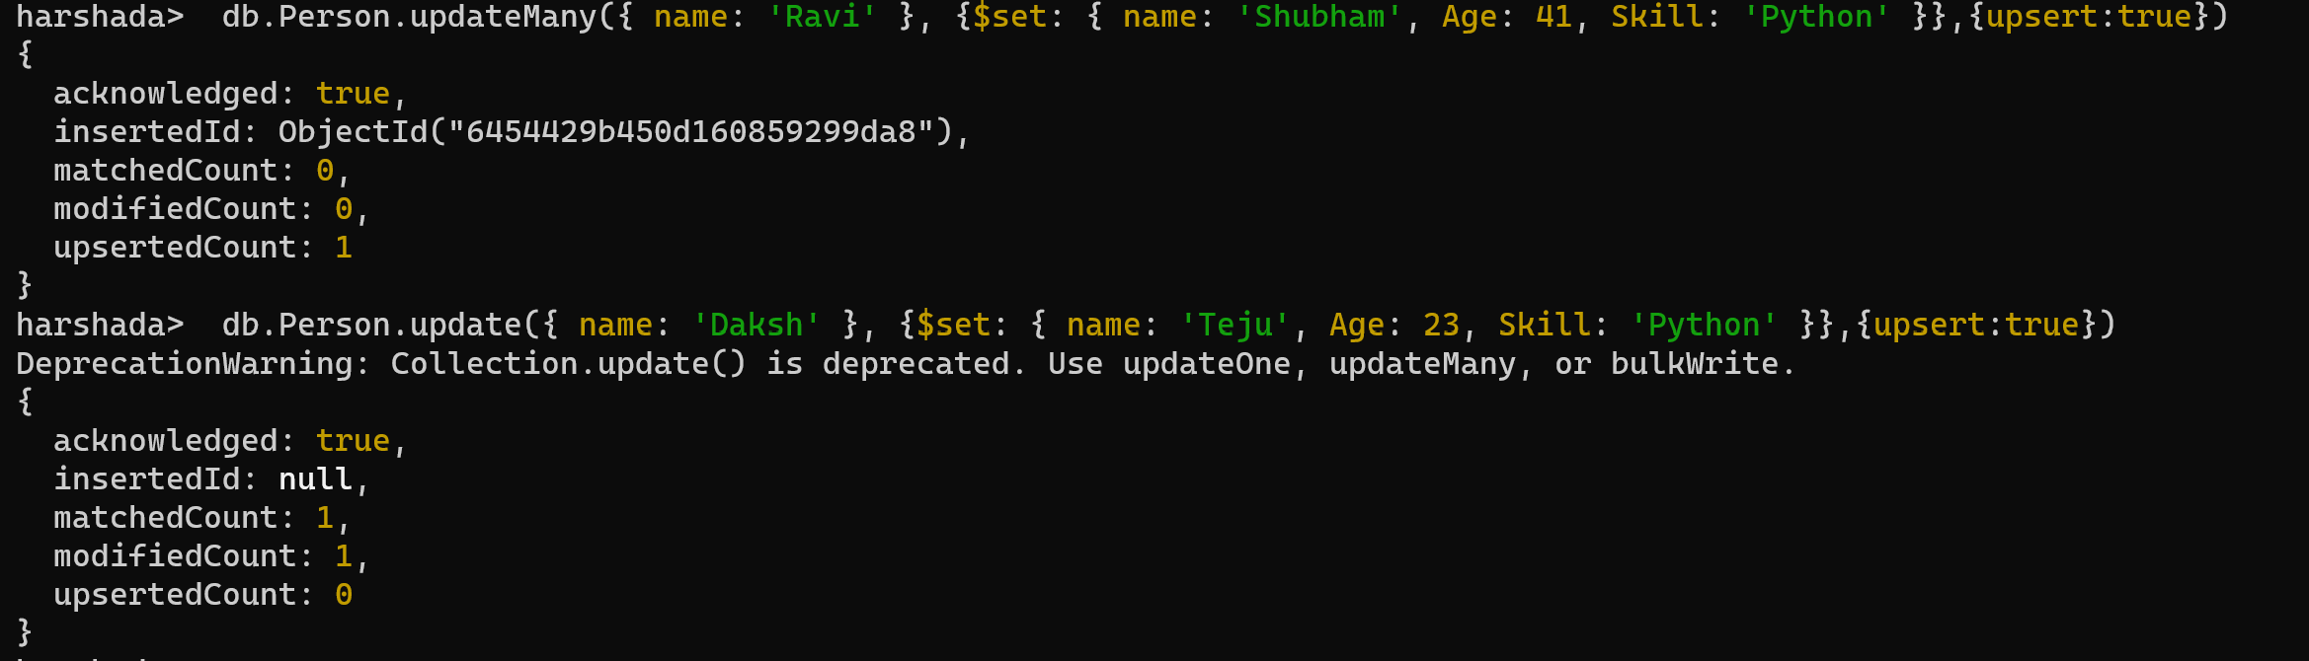

$set --> update operator

All update operators are-

<https://www.mongodb.com/docs/manual/reference/operator/update/>

db.Person.update({name:'Teju'}, {$inc:{Age:3}}) --> increment Age by 3 number.

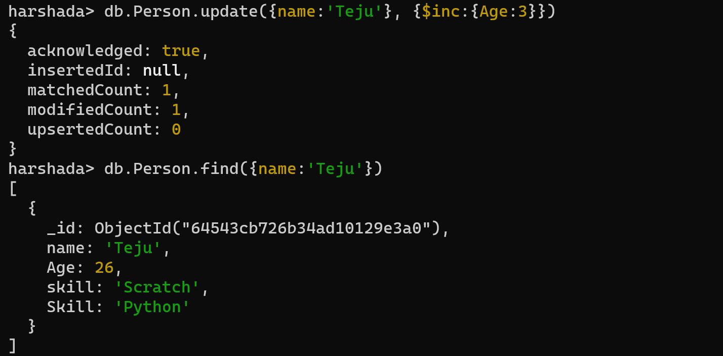

-- Operators-----

db.Person.find({Age:{$lt:26}}) --> less than 26

db.Person.find({Age:{$lte:43}}) --> less than or equal to

db.Person.find({Age:{$gt:23}}) --> greater than

db.Person.find({Age:{$gte:23}}) --> greater than or equal to

--------fetch only name and Age--------------------

db.Person.find({name:'Ashwini'},{"name":1,"Age":1})

db.Person.find({},{"name":1,"Age":1}) --> All name and Age

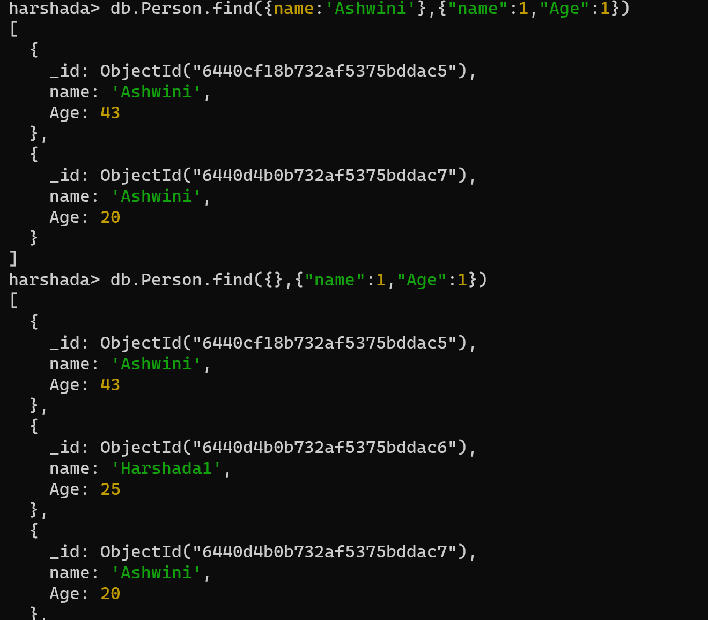

How to integrate mongodb with spring boot application

In pom.xml instead of spring data JPA we will add mongodb dependency

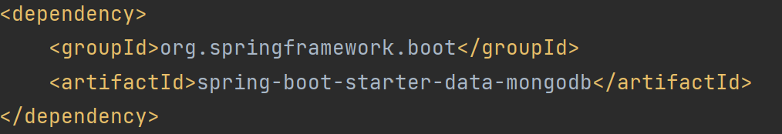

Need to mension below properties into application.properties file

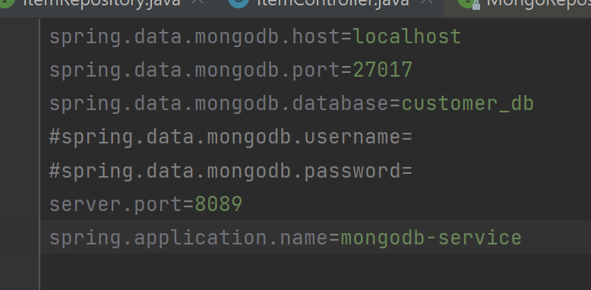

Instead of Entity will use @Document annoatation

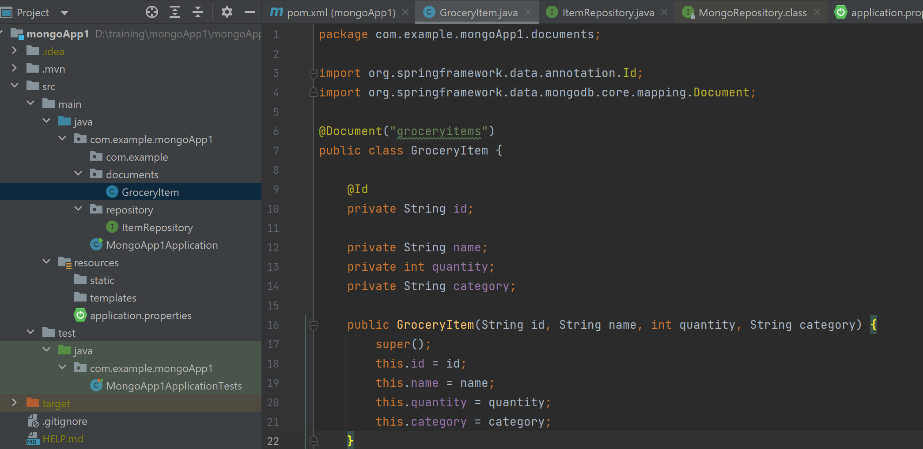

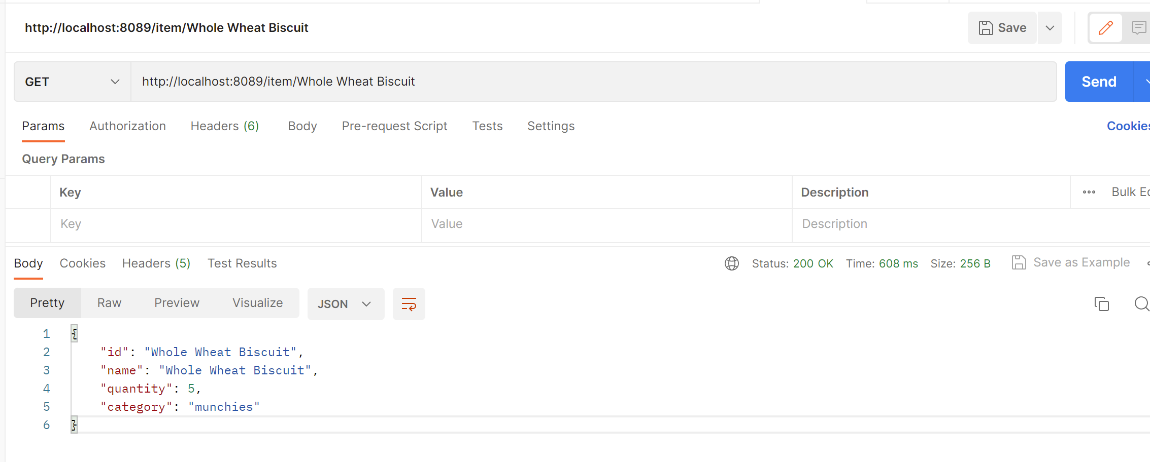

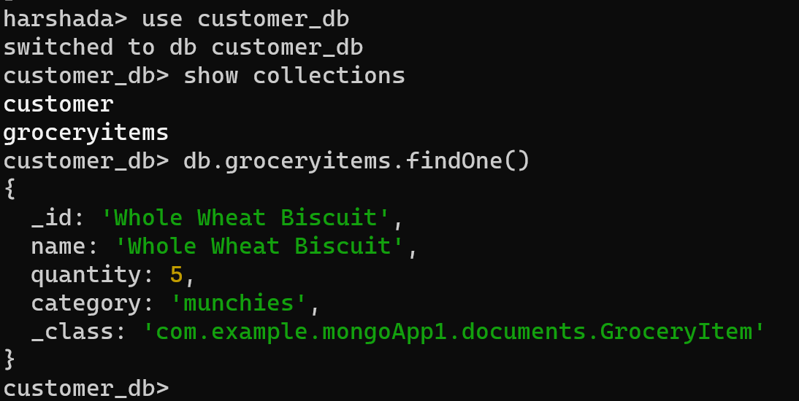

Register This Service on Eureka server.

By adding eureka server client dependency and with @EnableDiscoveryClient register this service on eureka discovery server

2 instances are running on port number 8089 and 8090

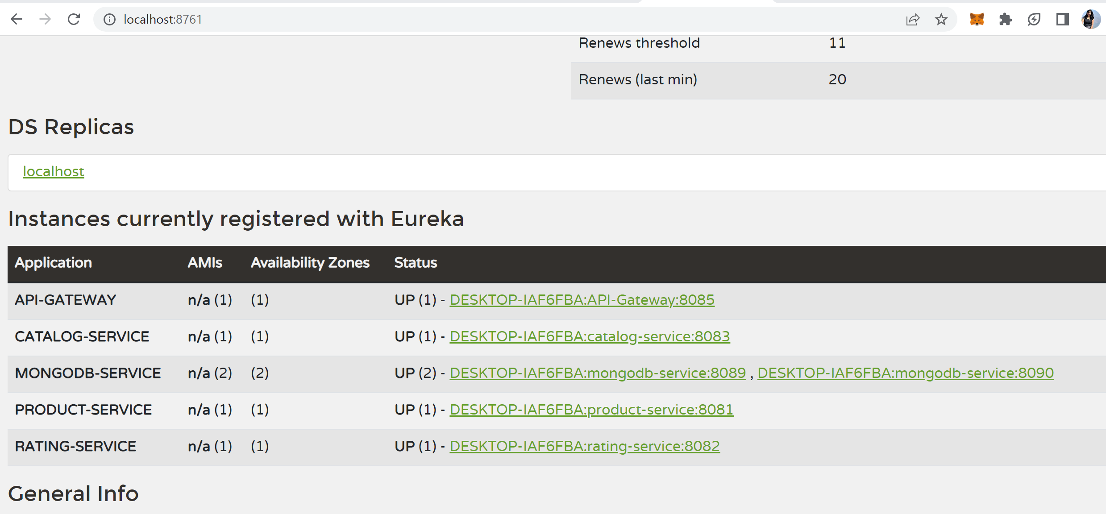

In rest template object using LoadBalancing url.

Calling this service from catalog service

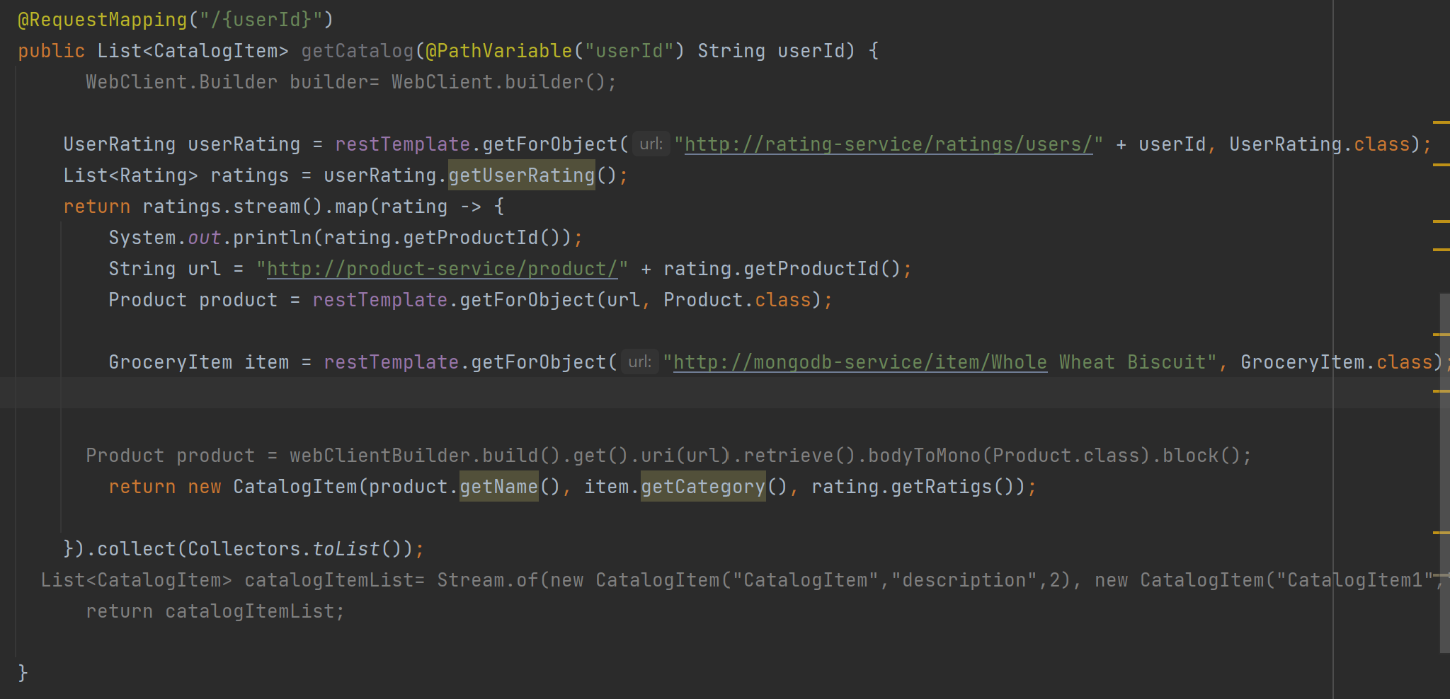

Created API Gateway project.

And in application.yml file mentioned routes

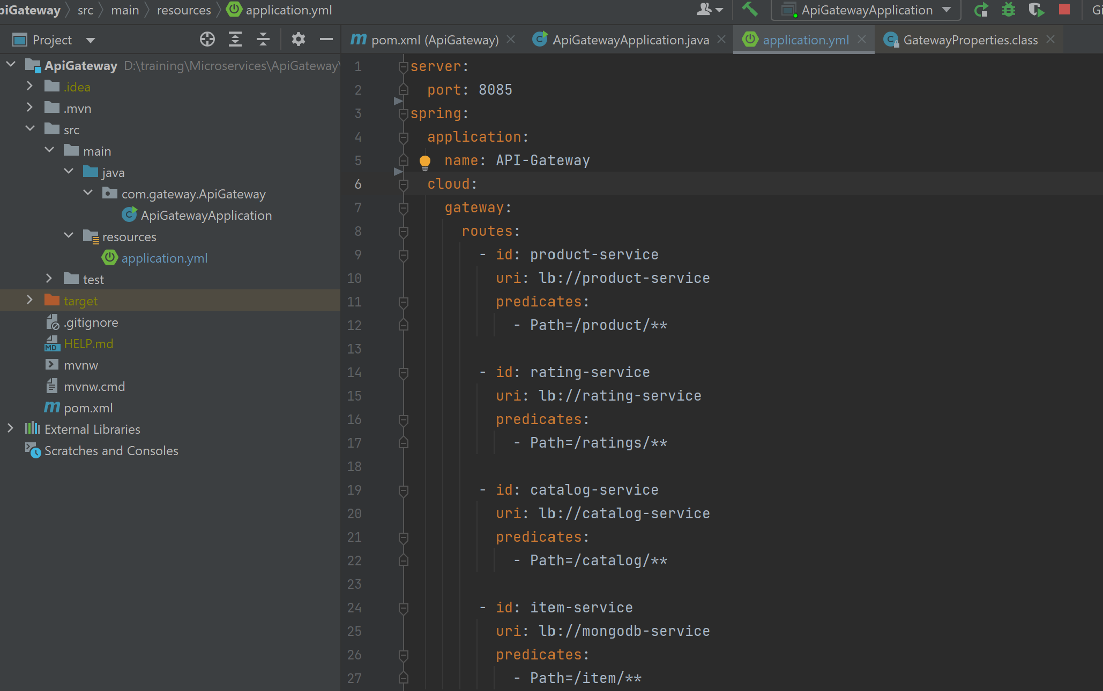

Calling this service from Catalog Service

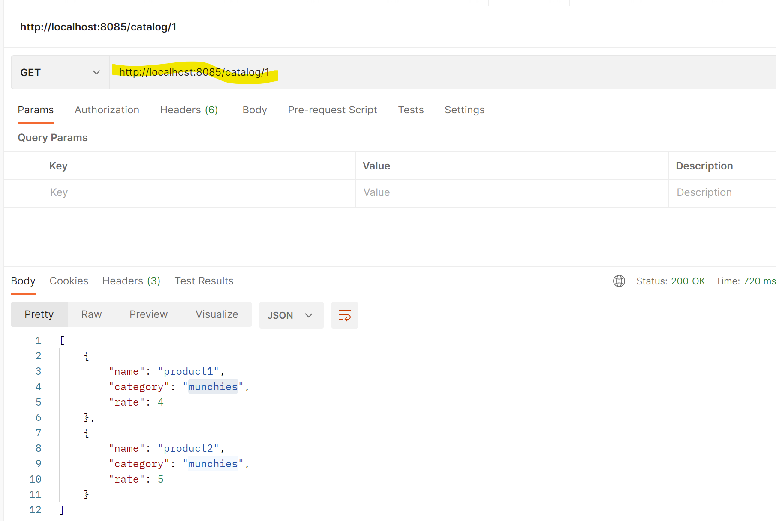

Calling below API from API Gateway route

