DEVSECOPS - PROJECT-2

NAME: Daggubati HarshaDeep COURCE:AWS,DEVOPS
EMAIL:harshadeep185@gmail.com BATH NO:B-114,8AM
MOBILE NO:9494995336 TRAINER:V.MADHUKAR REDDY

PIPELINE:
pipeline{
agent any
stages{
stage('clone'){
steps{
git branch: 'dev', url: 'https://github.com/harshadeep185/taxi-booking.git'
}
}
stage('validate'){
steps{
sh 'mvn validate'
}
}
stage('compile'){
steps{
sh 'mvn compile'
}
}
stage('test'){
steps{
sh 'mvn test'
}
}
stage('package'){
steps{
sh 'mvn package'
}
}
stage('sonarqube code quqlity'){
steps{
sh '''mvn clean verify sonar:sonar \
-Dsonar.projectKey=taxi_booking \
-Dsonar.projectName='taxi_booking' \
-Dsonar.host.url=http://3.83.125.119:9000 \
-Dsonar.token=sqp_f33fdc0c521a67ce3ac95f7e1bbe0effed65ea40'''
}
}
stage('DP check'){
steps{
dependencyCheck additionalArguments: '--scan ./ --format XML', odcInstallation: 'DP-CHECK'
dependencyCheckPublisher pattern: '**/dependency-check-report.xml'
}
}
stage('Nexus Artifact'){
steps{
nexusArtifactUploader artifacts: [[artifactId: 'maven-project', classifier: '', file: '/var/lib/jenkins/workspace/project deploying/taxi-booking/target/taxi-booking-1.0.1.war', type: 'war']], credentialsId: 'nexus', groupId: 'com.example.maven-project', nexusUrl: '54.164.50.102:8081', nexusVersion: 'nexus3', protocol: 'http', repository: 'maven-snapshots', version: '1.0-SNAPSHOT'
}
}
stage('Deploy to Tomcat'){
steps{
deploy adapters: [tomcat9(credentialsId: 'tomcat', path: '', url: 'http://3.83.125.119:8181/')], contextPath: null, war: '**/*.war'
}
}
stage ('Build and push to docker hub'){ steps{
script{
withDockerRegistry(credentialsId: 'docker-cred', toolName: 'docker') {
sh 'docker build -t bhargavi999/petshop:latest1 .'
sh 'docker push bhargavi999/petshop:latest1'

}
}

output :

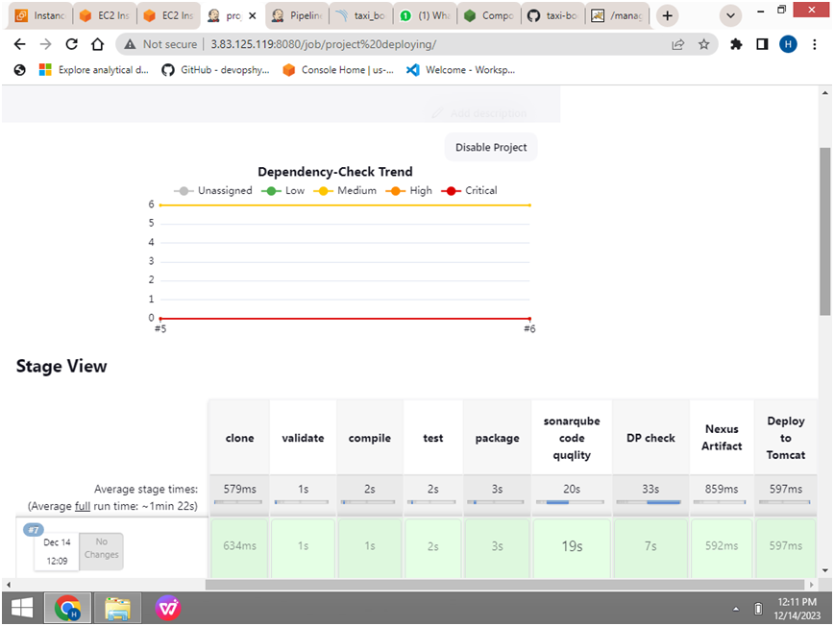

SONARCODE - ANALYSIS:

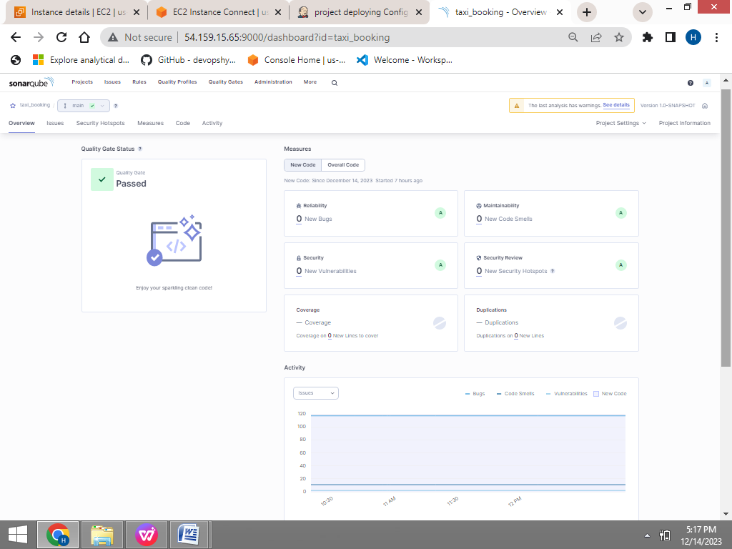

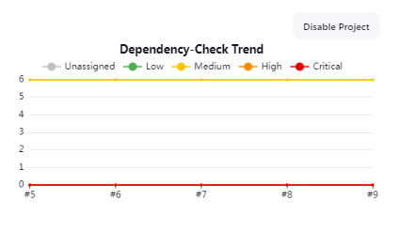

NEXUS - ARTIFACT:

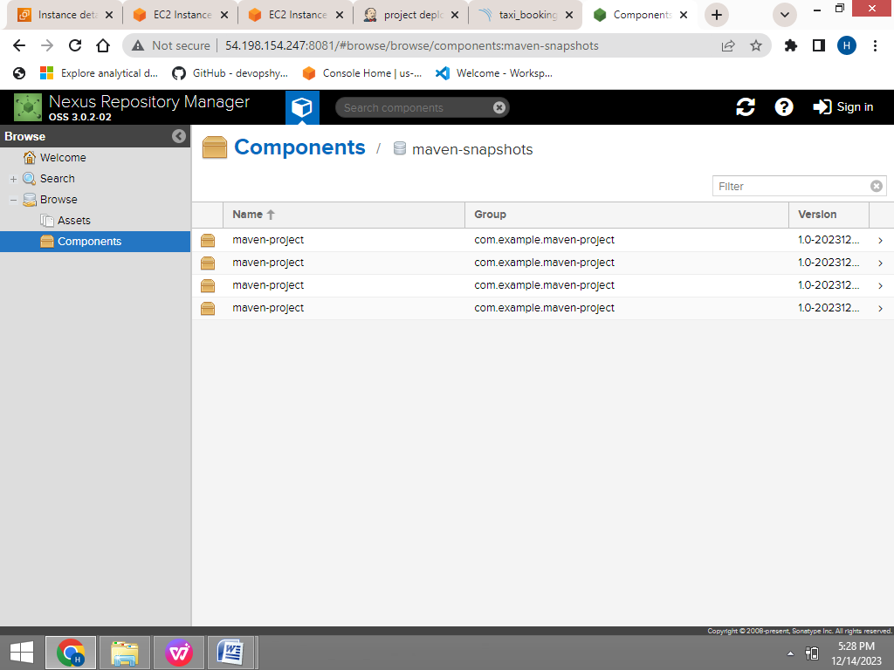

DEPLOYING TO TOMCAT:

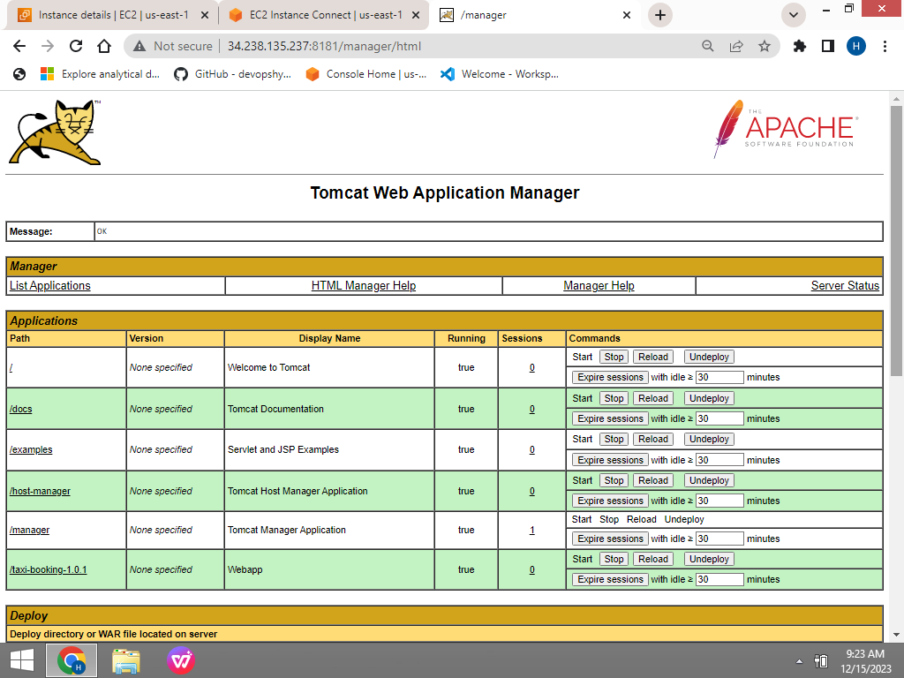

OUTPUT:

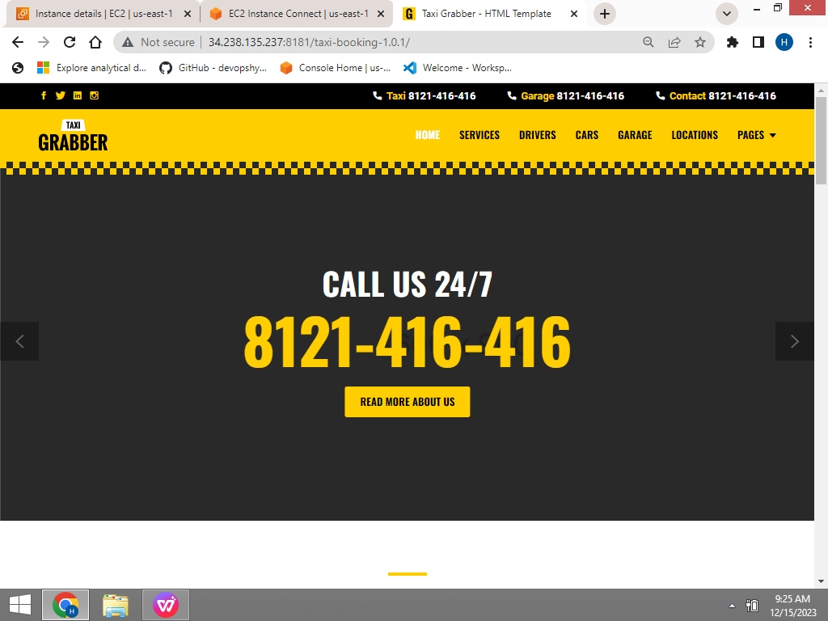

PUSHING TO GIT-HUB

