Analysis of Various Parameters Tested at Onset of Labor

Ms. Sneha Birwadkar, PG Student Dr. Sunita R. Patil Dr. Geeta Niyogi YTCEM, Bhivpuri Road, Karjat KJSIEIT, Sion K. J. Somaiya Medical College and Hospital, Sion

ersneha2489@gmail.com [spatil@somaiya.edu](mailto:spatil@somaiya.edu) niyogi@somaiya.edu

***Abstract*—In Maternity Care, a quick decision has to be made about the most suitable delivery type for the expected to be mother in labor. This study identifies obstetric and pregnancy factors that can be used to predict the most appropriate delivery technique, through the induction of data mining models using data gathered from hospital. This paper considers individual’s specific risk factors such as BP and Cervical length of expecting mother, fetus position in womb, fetal heart rate, while recommending the normal or C-section delivery. Using Naive Bayes classification algorithm, the mode of delivery can be determined in case of emergency. This paper gives monitoring and data analysis of all parameters that are tested in the normal labor delivery process and predicting complications in the normal delivery, if any.**

***Keywords—*Naive Bays Classification, Cardiotocography, Fetal Heart Rate, occiput presentation*,* Cervical length.**

# Introduction

Labor and delivery are continuously monitored to collect data set. The objective of this paper is to predict the mode of delivery based on few specific parameters identified to help women in being mentally and financially prepared with few predefined parameters related to pregnancy, based on this system determines the delivery type using Naïve Bays classification [1]. For predicting the normal delivery time and continuous monitoring of mother and fetus, few parameters are tested in medical fields [2].

*1.1 Parameters tested at the time of delivery*

Some crucial parameters are to be tested at the time of normal delivery:

1. Heartbeat of fetus
2. Blood Pressure of expecting mother
3. Cervix length of expecting mother
4. Fetus position in womb

*a. The Heartbeat of fetus*

In most cases, fetal heart rate is monitored during labor to see fetus status and to identify potential problems ahead of time. Electronic Fetal Monitoring(EFM) is currently used to monitor almost all women in hospitals. Labor and delivery are monitored electronically with sensors that measure and record maternal uterine pressure (UP) and fetal heart rate (FHR), a is referred to as cardiotocography (CTG). The standard range for a full term baby’s heart rate during labor is between 110 and 160 beats per minute (bpm). Higher or lower rates can be a sign fetus is having trouble coping with labor, depending on a number of factors. If the baseline rate is less than 110bpm, it is called bradycardia (abnormally slow heart rate) and if FHR are greater than 160bpm it is called tachycardia (abnormally high slow rate).

*b. Blood Pressure of expecting mother*

Normal blood pressure of a person is usually somewhere close to 120/80 mm Hg. Blood pressure between 140/90 and 149/99 mmHg is called Mildly high, between 150/100 and 159/109 mmHg is called Moderately high and of 160/110 mmHg or higher is called severely high blood pressure. If the BP of mother is not in normal range then there are various risks to mother as well as fetus. Few risks to mother are as follows:

a. An increased chance of having a stroke. b. Damage to kidneys and liver. c. An increased risk of blood clotting problems. d. An increased risk of severe bleeding from placenta.

If developed pre-eclampsia, then it can cause serious damage to organs, including brain and kidneys.

The risks to fetus are as follows: a. An increased chance of poor growth. b. An increased chance of premature birth.

*c. Cervix length of expecting mother*

Normal cervical length measures 4 to 5 cm when woman is not pregnant. During a normal pregnancy, the cervix remains firm, long, and closed until late in the third trimester. It usually starts to soften, shorten (efface) and open up (dilate) as body prepares itself for labor. Normally, in the late second and early third trimester the cervical length measures anywhere between 3 cm to 3.5 cm (30-35mm) and decreases progressively as the pregnancy advances, in preparation for labor. When cervical length is less than 2.2 cm (abnormal), women are not in progress to deliver normally. Normal cervix length should be10 cm at the time of delivery.

*d. Fetus position in womb* The most common and abnormal combination of fetus position are as follows: a. Cephalic Presentation b. Occiput-posterior Presentation: c. Brow Presentation d. Breech Presentation e. Shoulder Presentation *a. Cephalic presentation* The normal position of a fetus is facing rearward (toward the woman’s back) with the face and body angled to one side and the neck flexed, and presentation is head first. Figure 1 shows the normal position of fetus in mother’s womb.

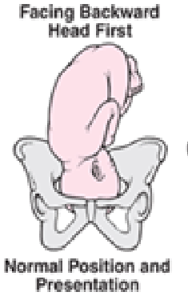

Fig. 1 Normal Fetus Positions

Figure 2 shows the abnormal position and presentation of fetus in mother’s womb.

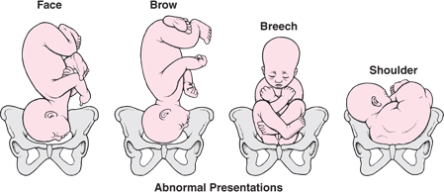

Fig. 2 Abnormal Fetus Presentation

### b. Occiput posterior presentation

In the occiput posterior presentation (sunny-side up), the fetus is head first but is facing up (toward the mother's abdomen). It is the most common abnormal position or presentation. When a fetus faces forward, the neck is often straightened rather than bent, and the head requires more space to pass through the birth canal. Delivery by a vacuum extractor or forceps or cesarean delivery may be necessary.

*c. Brow Presentation*

If your baby is in a brow presentation, this means the largest area of head will be trying to fit through your pelvis during birth. Brow presentation usually happens when baby's neck and head are slightly extended (deflexed), as if baby is looking up.   
  
d. *Breech presentation*

The buttocks or sometimes the feet present first. Breech presentation occurs in 3 to 4% of full-term deliveries. When delivered vaginally, babies that present buttocks first are more likely to be injured than those that present head first. Such injuries may find before, during, or after birth. The baby may even die. Complications are less likely when breech presentation is detected before labor or delivery .Sometimes the doctor can turn the fetus to present head first by pressing on the woman’s abdomen before labor begins, usually after 36 weeks of pregnancy. However, if labor begins and the fetus is in breech presentation, problems may occur.

*e. Shoulder Presentation*

Shoulder presentation is an abnormal position of the fetus at the time of delivery. In this, the fetus lies transversely so that its vertebral column lies perpendicular to the maternal position of spine. So, the part that enters the birth canal will be the trunk or shoulder. In spite of some deviations in the positioning of the fetus, the doctor may try for vaginal birth only if the baby’s head, or buttock, or feet are at the bottom. Hence, the vaginal birth will be unthinkable for the mother and she has unquestionably to undergo a C-section.

The decision for usage of forceps or a vacuum assistance is guided by the indication for an instrumented delivery and the clinician’s experience [3].

# Literature Survey

*2.1 Pregnancy period tests & devices*

Various devices are used to monitor the wellness of fetus and mother as listed & explained below:

*a. Ultra scan*

As shown in Figure 3, an [ultrasound scan](http://www.babycentre.co.uk/a1014487/are-ultrasound-scans-safe) sends sound waves through womb (uterus). These waves bounce off the baby as echoes. The echoes are turned into an image on a screen that shows fetal position and [movements](http://www.babycentre.co.uk/a549375/your-babys-movements-in-pregnancy). Hard tissues such as bone, reflect the sound waves and make the biggest echoes. It includes white in the image and soft tissues as grey. Fluids such as the [amniotic fluid](http://www.babycentre.co.uk/a568740/low-amniotic-fluid) surrounding the baby appear as black. This is because the sound waves go through with no echoes. A first-trimester scan will test that baby's heart is beating and also look at the basic examination of baby’s head, abdominal wall, and limbs.

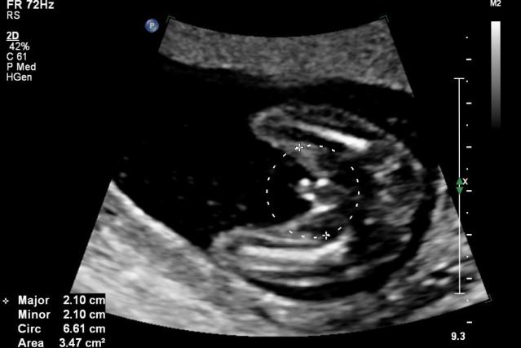

Fig.3 Ultrasound Scan

. b. *Doppler Ultrasound*

A Doppler is a form of [ultrasound](http://www.babycentre.co.uk/a329/pregnancy-ultrasound-scans-an-overview) scan that helps to assess baby's health [4]. It measures the blood flow in different parts of fetal body, such as [umbilical cord](http://www.babycentre.co.uk/x543058/can-i-store-my-babys-umbilical-cord-blood-for-medical-purposes), brain, and heart. This helps to show whether fetal is getting all the oxygen and nutrients needs via the placenta. The transducer sends out sound waves, which bounces off the blood flow to fetal body through the cord as well as his blood circulation system. This creates an image on a display which shows how the blood is flowing. This is shown in Figure 3.

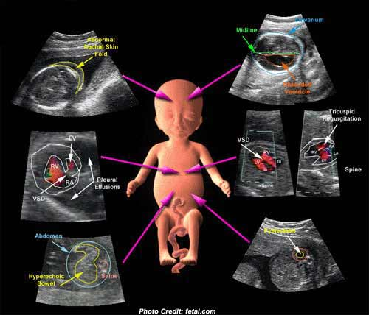

Fig.3 Doppler Ultra Scan

*c. CT Scan*

A doctor or physician may order a Computerized tomography (CT) scan of the fetus to formulate detailed pictures and analyze the internal structure. Computerized Tomography (CT) scanning is useful to get a very detailed 3D image of certain parts of the body. The same is shown in Figure 4.

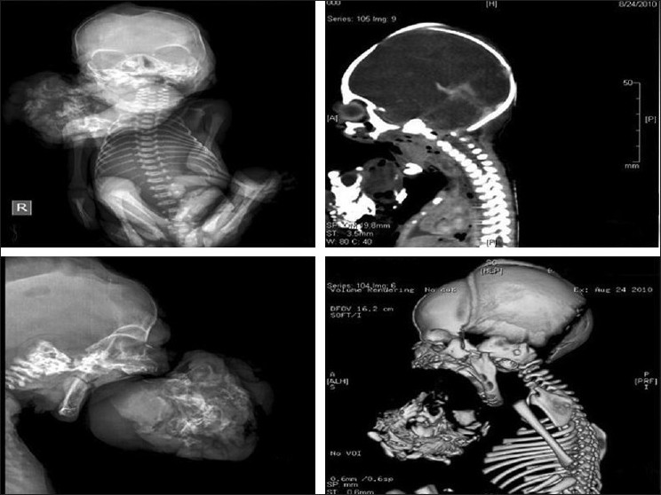

Fig. 4 CT Scan

*d. Stethoscope*

External Electronic Fetal monitoring can be done by listening to baby's heartbeat with a special stethoscope. External monitoring is done using two flat devices known as sensors held in place with elastic belts on belly. One sensor makes use of reflected sound waves i.e. [ultrasound](http://www.webmd.com/a-to-z-guides/what-is-an-ultrasound) to keep track of fetal heart rate. The other sensor measures the strength and duration of uterine contractions. The sensors are connected to a machine to keep the track of information. External monitoring is used for a non-stress test which records baby's heart rate while baby is moving and not moving. A non-stress test may be combined with a fetal ultrasound to evaluate the amount of amniotic fluid. External monitoring is also made for a contraction stress test, which records changes in baby's heart rate when to have uterine contractions. It may be done to check on fetal health during a non-stress test. It may help to predict whether the baby can handle the stress of labor and vaginal delivery.

*e. Telemetry*

External monitoring can also be done remotely called as telemetry, without need to be connected by wires to a machine. At some places, the sensors send the information about the fetal heart rate and uterine contractions to a remote monitor. Remote monitoring allows to walk around freely. The position of the heart rate monitor changes periodically to adjust to the movement of baby. For a non-stress test, the sensors are placed on belly of the labor. It is asked to push a button on the machine every time baby moves or have a contraction. Fetal heart rate is recorded and compared to the record of movement or contractions.

*f. Electrode with a wire & tube*

Internal fetal monitoring is done only after cervix has dilated to at least 2 centimeters (cm) and amniotic sac has ruptured. Once started, internal monitoring is done continuously. A thin wire (electrode) is guided through vagina and cervix and attached to baby's scalp. A small tube is also inserted through vagina to attach a device to monitors the contractions inside uterus. The electrode and the tube are attached with wires to a recording device to record of fetal heart rate as well as the strength and duration of uterine contractions.

*g.. Monitors*

Monitors are used to detect the baby's heart rate and length and frequency of the contractions. There are even monitors that allow patients to walk around while it keeps track of the heart rate and contractions. Figure 5 shows the same.

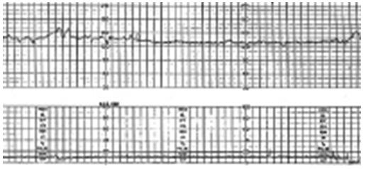

Fig. 5 Monitor

*h. Delivery assistance (operative vaginal delivery)* It is hand held metal instrument with blade extensions that are applied to each side of the fetal head part for delivery process. The traction force of the blades helps to aids in neonate delivery as shown in Figure 6.



Fig. 6 Operative Vaginal Delivery

*i. Forceps* The Use of forceps has decreased over the past several decades. The indications for forceps are included in prolonged second stage of labor or ineffective maternal push power. The presenting part needs to be at +2 station part before forceps should be applied to the labor for the delivery [5]. If the presenting part is at higher station, abdominal delivery should be chosen into consideration of the labor for the process. Forceps use is mainly associated with less fetal hematoma formation and quick delivery times are compared with vacuum assist lacerations. Forceps is associated with lower risk of maternal bleeding condition and better choice that the mother is able to deliver vaginally in subsequent pregnancies. The device is shown in Figure 7.

# **http://www.bumpshull.co.uk/wp-content/uploads/Forceps.jpg**

Fig. 7 Forcep

*j. Vacuum*

Vacuum consists of a suction cup that is attached to the fetal head part to assist with extraction. Tractional pressure is updated by a negative pressure handle system. Types include metal cup vacuums, plastic cup vacuums, and a mushroom-shaped vacuum cup that uses the advantages of the metal and plastic designs. It is used during emergency delivery because of fetal distress, poor maternal push power, or checks for maternal medical conditions that contraindicate strong pushing. The same is shown in Figure 8.

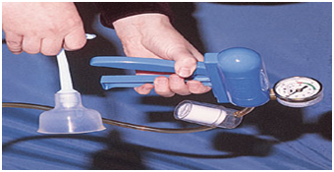

Fig. 8 Vacuum

*k. Axis traction device for delivery forceps*

This device is light, simple in construction, having only three parts, and very easy to apply to any forceps handle when axis traction is required. It prevents the lock of the forceps from slipping and at the same time does not hinder the forceps blades from being opened or closed at the wish of the operator. The handle alone is sufficient for most of the axis traction cases, but when a great amount of traction is required a "T" or cross-bar can be attached through the slot in the lower end. The same is shown in Figure 9

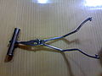

Fig. 9 Axis Traction for Delivery Forceps

*l. Cusco's self-retaining bivalve vaginal speculum*

Cusco vaginal speculum can be used to carry out an endoscopy. The speculum is placed inside the vaginal opening of the woman which helps the surgeon to perform the required endoscopic process**.** This process usually involves the female reproductive system and the genitourinary system which is why the vaginal opening must be expanded for the process to be conducted efficiently. The same is shown in Figure 10.

# 

Fig.10 Cusco self-retaining bivalve vaginal speculum

# SYSTEM DESIGN AND IMPLEMENTATION

Our system deals with predicting the mode of delivery for a woman in labor depending on various parameters. The system then determines the delivery mode whether normal or c-section using Naive Bayes classification [4,5,6]. The system architecture is shown in Figure 11.



Fig.11 System Architecture

Various module of System architecture are as follows:

*i. Selection of Classifier*

The prediction of normal or c-section will be done with the help of data mining classification technique based on naive bayes theorem. The set of all classes (C) available, , and the item with attributes so using Naive Bayes classification algorithm, we can predict the class C to which X belongs, based on the similarity of the attributes of X and items of that class. For this, the posterior probability P (C|X) is given by equation i. below.

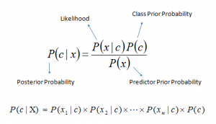

*where P(X|C) is the conditional probability of X given C.*

Equation I

*ii. Pre-Processing and Cleaning of the input data set*

After eliminating some record for which the parameters are

missing or incorrect values, the ultimate data set should obtained each containing 4 parameters. After selecting the parameters, the numeric values were converted into categories like – LOW, HIGH, and NORMAL for simplifying the classification process.

*iii. Classification and Prediction*

Classification is a two step-model. First step is division of data into training set used for predicting relations and testing data set used for assessing the strength and accuracy of the relations predicted. In the next step, the training set is used to build the classifier model and the testing set is used to validate the model built. The goal is to classify the mode of delivery as NORMAL or NOT_NORMAL based on the known attributes. The second class consists of all other delivery types like Caesarean (C-section), vacuum delivery, forceps delivery etc. The user inputs values of all the 4 parameters to the classification algorithm. After processing, the predictor determines whether a normal delivery is possible or not.

1. RESULT

Result of parameter comparison is shown using various tables below. The normal and abnormal values of all required parameters to be tested for verifying expected mother status in labor and fetus condition, exactly before delivery process are shown in tables Ibelow. It also discusses the necessary action to be taken by expecting mother in labor and expert doctor opinion. Table II to Table VI shows comparison of various parameters against each other for predicting normal or caesarean delivery depending on the complications involved. Computing the results with naïve bayes classifier the system acts like a predictor tool, allowing the users to enter values of the specified parameters and giving the most likely mode of delivery as the output.

IV. CONCLUSION

The proposed system helps to monitor the health condition of pregnant women at regular intervals. The sensor-based hand held device predicts the mode of delivery as normal or c-section. It also determines the mode of delivery by monitoring values of various parameters need to be tested against each other to decide on normal or c-section delivery.

# future scope

In future the device can be improved by allowing users to contribute to all medically relevant parameter values. The device can be made full proof to work on many more parameters giving accurate result and early prediction for delivery mode. The system would also be modified further to obtain associations and possible anomalies for better analysis and medical care of the fetus & expected mother.

REFERENCES

[1] K. Ming Leung, “Naïve Bayes Classifier”, Polytechnic University Department of Computer Science / Finance and Risk Engineering.

[2] ] Maria Elisabete Teixeira da silva, Marco Paulo Lages Parente, Renato Manuel Natal Jorge, “Biomechanical study of fetus during vaginal delivery”, Bioengineering(ENBENG) 2013 ,Braga, Portugal.

[3] Yavar Naddaf, Mojdeh Jalali Heravi and Amit Satsangi, “Predicting Preterm Birth Based on Maternal and Fetal Data”, 2008.

[4] R. Levy, S. Zakas, A. Ben-Arie, S. Perlman, Z. Hagay and E. Vaisbuch: “Can angle of progression in pregnant women before onset of labor predict mode of delivery?” Ultrasound Obstet Gynecol 2012; 40: 332–337 Published online in Wiley Online Library (wileyonlinelibrary.com)

[5] CA Kalu, OU Umeora, EV Egwuatu, A Okwor: “Predicting mode of delivery using mid pregnancy ultrasonographic measurement” Vol 15

[6] Shamsa, A., Bai, J., Raviraj, P. and Gyaneshwar, R. (2013) “Mode of delivery and its associated maternal and neonatal outcomes”. *Open* *Journal of Obstetrics and Gynecology*.

[7] Quinlan, J.R. . “Induction of decision trees Machine Learning” Centre for Advanced Computing Sciences, New South Wales Institute of Technology, Sydney 2007, Australia

[8] Harleen Kaur and Siri Krishan Wasan: “Empirical Study on Applications of Data Mining Techniques in Healthcare”, Journal of Computer Science 2

TABLE I Parameter Values

|  |  |  |  |  |  |  |  |
| --- | --- | --- | --- | --- | --- | --- | --- |
| **BP of mother** (**mm Hg)** | | **Fetus Heart Rate(bpm)** | | **Cervix length of mother(cm)** | | **Position of fetus in womb** | |
|  | Classifier Prediction |  | Classifier Prediction |  | Classifier Prediction |  | Classifier Prediction |
| 115/75 (Accurate value) | Need not to worry | 110-160 (Normal ) | Need not to worry | 10cm | Fully dilated | Cephalic presentation | Best position. Can wait for normal delivery |
| 140/90 to 149/99 (**Mildly High BP)** | Doctor try to maintain normal BP of mother | <110 Bradycardia | It is not usually a problem | 0cm | Closed | **Occipito-posterior** | labor may be long and slow, with bouts of contractions starting and stopping |
| 150/100 to 159/109 (Moderately high BP) | Doctor try to maintain normal BP of mother otherwise preeclampsia | <100 Bradycardia | Sign of fetal distress. | <2.2cm | Short cervix length. | Breech | Not ideal for delivery. |
| Above 160/110 (Severely high BP) | Preeclampsia which is at high risk of placental abruption | >160 Tachycardia | It is not always a sign of fatal distress | <1.5cm | C-section is necessary | **Left Shoulder Presentation** | Chance for a prolapsed cord |
| 90/60 (Borderline low BP) | The normal drop in BP typically does not cause any problems | >180 Tachycardia | Sign of foetus distress. | 3.0 cm  to 3.5 cm | Normal | **Back Down Position** | Baby can be pushed into the right position. |
| 60/40  (Mild low BP) | Greater risk of stillbirth relative to normotensive pregnancies. Need close care and treatment | +FHR >15 bpm, lasting >15s but <10 min Accelerations | Doctor may need to induce accelerations. | 4-5 | Anterior position | **Right shoulder presentation** | Require a C-section. |
| 50/33 (Extremely low BP) | A severe drop in blood pressure can result in organ damage. | -FHR >15 bpm, lasting >15 s but <10 min Deceleration | It can be a problem C-section is needed | 5+ | Baby is ready to come out | **Brow Presentation** | Doctor may recommend caesarean |

Table II shows the comparison of BP of mother with cervical length of mother and the prediction accordingly

TABLE II BP of Mother with Cervical Length of Mother

|  |  |  |
| --- | --- | --- |
| **BP of mother** | **Cervix length of mother** | **Classifier Prediction** |
| 115/75(normal) | 10cm | Cervix is fully dilated |
| 115/75(normal) | 5+ | Baby is ready to come out |
| 115/75(normal) | >2.2 cm | Doctors try to open the cervix |
| >140/90 (mild high BP) | 10cm | Need not to worry. Continuous monitoring is required |
| >140/90 (mild high BP) | 5+ | Need not to worry. Continuous monitoring is required |
| >140/90 (mild high BP) | >2.2 cm | Doctors try to open the cervix |
| 150/100 to 159/109(Moderate high BP) | 10cm | Need not to worry but careful attention is needed to BP |
| 150/100 to 159/109(Moderate high BP) | 5+ | Need not to worry but careful attention is needed to BP |
| 150/100 to 159/109(Moderate high BP) | >2.2 cm | Doctor may advised to go under c-section |
| Above 160/110(Severely high BP) | 10cm | Doctor tries everything possible to maintain normal BP. If not controlled then caesarean |
| Above 160/110(Severely high BP) | 5+ | Doctor tries everything possible to maintain normal BP. If not controlled then caesarean |
| Above 160/110(Severely high BP) | >2.2 cm | Probably caesarean |
| 50/33 (Extremely low BP) | 10cm | Doctor tries everything possible to maintain normal BP. If not controlled then caesarean |
| 50/33 (Extremely low BP) | 5+ | Doctor tries everything possible to maintain normal BP. If not controlled then caesarean |
| 50/33 (Extremely low BP) | >2.2 cm | Probably caesarean |

Table III shows the comparison of Blood pressure (BP) of mother with Heart Beat of fetus(FHR) and prediction accordingly.

TABLE III BP of Mother with FHR of Fetus

|  |  |  |
| --- | --- | --- |
| **BP of mother** | **Heartbeat of fetus** | **Classifier Prediction** |
| 115/75(normal) | 110-160 (normal) | Happy outcome for both expect other risk factors. |
| 115/75(normal) | <110 (bradycardia) | Healthcare provider will run further tests and take any appropriate action necessary to regulate FHR. |
| 115/75(normal) | >160 (tachycardia) | If the baby’s heart rate is consistently high, your doctor may prescribe you [medication](http://americanpregnancy.org/medication/) that is passed through the placenta to the baby to help regulate the heartbeat. |
| >140/90 (mild high BP) | 110-160 (normal) | If your blood pressure remains mildly to moderately raised and you do not develop pre-eclampsia then the risk is low |
| >140/90(mild high BP) | <110  bradycardia | If your blood pressure remains mildly to moderately raised and you do not develop pre-eclampsia then the risk is low but bradycardia may be a problem it is below 100 BPM, especially if there are other abnormal heart rate patterns, such as poor beat-to-beat variability. continuously assess expectant mothers with preeclampsia and monitor FHR. |
| >140/90(mild high BP) | >160 tachycardia | High blood pressure and tachycardia can be dangerous. Continuously assess expectant mothers with preeclampsia and monitor FHR. |
| 150/100 to 159/109(Moderate high BP) | 110-160(normal) | A woman with mild-to-moderate hypertension could develop severe hypertension if not managed correctly |
| 150/100 to 159/109(Moderate high BP) | <110 bradycardia | If your blood pressure remains mildly to moderately raised and you do not develop pre-eclampsia then the risk is low but bradycardia may be a problem it is below 100 BPM , especially if there are other abnormal heart rate patterns, such as poor beat-to-beat variability. continuously assess expectant mothers with preeclampsia and monitor FHR. |
| 150/100 to 159/109(Moderate high BP) | >160 (tachycardia) | If your blood pressure remains mildly to moderately raised and you do not develop pre-eclampsia then the risk is low but tachycardia may be a problem if it is greater than 180. |
| Above 160/110(Severely high BP) | 110-160(normal) | It may develop Preeclampsia which can cause serious complications both in the mother and the baby if left untreated. |
| Above 160/110(Severely high BP) | <110  bradycardia | Doctor may preferred to go under caesarean |
| Above160/110  (Severely high BP) | >160 tachycardia | Doctor may preferred to go under caesarean |
| 50/33 (Extremely low BP) | 110-160(normal) | The normal drop in BP typically does not cause any problems but a severe drop in blood pressure can result in organ damage such as [stroke](https://www.medicinenet.com/stroke_symptoms_and_treatment/article.htm), [kidney failure](https://www.medicinenet.com/kidney_failure/article.htm), and [heart attack](https://www.medicinenet.com/heart_attack/article.htm) |
| 50/33 (Extremely low BP) | <110  bradycardia | Doctor may preferred to go under caesarean |
| 50/33 (Extremely low BP) | >160 tachycardia | Doctor may preferred to go under caesarean |

Table IV shows BP of mother with fetus position in womb and prediction accordingly

TABLE IV BP of Mother with Fetus Position

|  |  |  |
| --- | --- | --- |
| **BP of mother** | **Fetus position in womb** | **Classifier Prediction** |
| 115/75(normal) | cephalic presentation | Both are safe |
| 115/75(normal) | occipito-posterior, Brow presentation | Delivery by a vacuum extractor or forceps or caesarean delivery may be necessary. |
| 115/75(normal) | Breech presentation, Shoulder presentation | Sometimes the doctor can turn the Fetus to present head first by pressing on the woman’s abdomen otherwise caesarean delivery is preferred |
| >140/90 (mild high BP) | cephalic presentation | Doctor tries to control BP |
| >140/90 (mild high BP) | occipital-posterior, Brow presentation | Delivery by a vacuum extractor or forceps or caesarean delivery may be necessary |
| >140/90 (mild high BP) | Breech presentation, Shoulder presentation | Sometimes the doctor can turn the fetus to present head first by pressing on the woman’s abdomen otherwise caesarean delivery is preferred |
| 150/100 to 159/109(Moderate high BP) | cephalic presentation | Doctor tries to control BP |
| 150/100 to 159/109(Moderate high BP) | occipital-posterior, Brow presentation | Delivery by a vacuum extractor or forceps or caesarean delivery |
| 150/100 to 159/109(Moderate high BP) | Breech presentation, Shoulder presentation | Sometimes the doctor can turn the Fetus to present head first by pressing on the woman’s abdomen otherwise caesarean delivery is preferred |
| Above 160/110(Severely high BP) | cephalic presentation | Doctor tries to control BP otherwise caesarean is preferred |
| Above 160/110(Severely high BP) | occipital-posterior, Brow presentation | Delivery by a vacuum extractor or forceps or caesarean delivery may be necessary |
| Above 160/110(Severely high BP) | Breech presentation, Shoulder presentation | Sometimes the doctor can turn the fetus to present head first by pressing on the woman’s abdomen otherwise caesarean delivery is preferred |
| 50/33 (Extremely low BP) | cephalic presentation | Doctor tries to control BP otherwise caesarean is preferred |
| 50/33 (Extremely low BP) | occipital-posterior, Brow presentation | Delivery by a vacuum extractor or forceps or caesarean delivery may be necessary |
| 50/33 (Extremely low BP) | Breech presentation, Shoulder presentation | Sometimes the doctor can turn the fetus to present head first by pressing on the woman’s abdomen otherwise caesarean delivery is preferred |

Table V shows comparison of BP of mother ,cervix length of mother and Fetal heart rate and prediction accordingly.

TABLE V BP of Mother, Fetus Position in Womb and Cervix Length

|  |  |  |  |
| --- | --- | --- | --- |
| **BP of Mother** | **FHR** | **Cervix length** | **Classifier Prediction** |
| 115/75(normal) | 110-160 (normal) | 10cm | Both are safe. normal delivery is possible |
| 115/75(normal) | <110 (bradycardia) | 5+ | FHR need to be monitored continuously |
| 115/75(normal) | >160 (tachycardia) | >2.2 cm | FHR need to be monitored continuously and doctors try to open the cervix. If not managed then caesarean is possible |
| **>140/90 (mild high BP)** | **110-160 (normal)** | **10cm** | **Both are safe. normal delivery is possible** |
| >140/90 (mild high BP) | <110 (bradycardia) | 5+ | FHR need to be monitored continuously |
| >140/90 (mild high BP) | >160 (tachycardia) | >2.2 cm | FHR need to be monitored continuously and doctors try to open the cervix. If not managed then caesarean is possible |
| 150/100 to 159/109(Moderate high BP) | 110-160 (normal) | 10cm | Both are safe. normal delivery is possible |
| 150/100 to 159/109(Moderate high BP) | <110 (bradycardia) | 5+ | FHR need to be monitored continuously |
| 150/100 to 159/109(Moderate high BP) | >160 (tachycardia) | >2.2 cm | FHR need to be monitored continuously and doctors try to open the cervix. If not managed then caesarean is possible |
| Above 160/110(Severely high BP) | 110-160 (normal) | 10cm | Doctor tries to control BP otherwise caesarean is preferred |
| Above 160/110(Severely high BP) | <110 (bradycardia) | 5+ | Doctor tries to control BP otherwise caesarean is preferred |
| Above 160/110(Severely high BP) | >160 (tachycardia) | >2.2 cm | Doctor advised to go under c-section |
| 50/33 (Extremely low BP) | 110-160 (normal) | 10cm | Doctor tries to control BP otherwise caesarean is preferred |
| 50/33 (Extremely low BP) | <110 (bradycardia) | 5+ | Doctor tries to control BP otherwise caesarean is preferred |
| 50/33 (Extremely low BP) | >160 (tachycardia) | >2.2 cm | Doctor advised to go under c-section |

Table VI shows comparison of BP of mother, Fetal heart rate, Cervix length of mother and Fetus position in womb and prediction accordingly.

TABLE VI BP of Mother, FHR ,Cervix Length of Mother and Fetus Position in Womb

|  |  |  |  |  |
| --- | --- | --- | --- | --- |
| **BP of Mother** | **FHR** | **Cervix length** | **Fetes position in womb** | **Classifier Prediction** |
| 115/75(normal) | 110-160 (normal) | 10cm | cephalic presentation | Baby is ready to come out |
| 115/75(normal) | <110 (bradycardia) | 5+ | occipito-posterior, Brow presentation | Delivery by a vacuum extractor or forceps or caesarean |
| 115/75(normal) | >160 (tachycardia) | >2.2 cm | Breech presentation, Shoulder presentation | Doctor can turn the fetus to present head first by pressing on the woman’s abdomen otherwise caesarean delivery |
| >140/90 (mild high BP) | 110-160 (normal) | 10cm | cephalic presentation | Doctor tries to control BP |
| >140/90 (mild high BP) | <110 (bradycardia) | 5+ | occipito-posterior, Brow presentation | Delivery by a vacuum extractor or forceps or caesarean delivery |
| >140/90 (mild high BP) | >160 (tachycardia) | >2.2 cm | Breech presentation, Shoulder presentation | Doctor can turn the fetus to present head first by pressing on the woman’s abdomen otherwise caesarean delivery |
| 150/100 to 159/109(Moderate high BP) | 110-160 (normal) | 10cm | cephalic presentation | Doctor tries to control BP |
| 150/100 to 159/109(Moderate high BP) | <110 (bradycardia) | 5+ | occipito-posterior, Brow presentation | Delivery by a vacuum extractor or forceps or caesarean delivery |
| 150/100 to 159/109(Moderate high BP) | >160 (tachycardia) | >2.2 cm | Breech presentation, Shoulder presentation | Doctor can turn the fetus to present head first by pressing on the woman’s abdomen otherwise caesarean delivery |
| Above 160/110(Severely high BP) | 110-160 (normal) | 10cm | cephalic presentation | Doctor tries to control BP |
| Above 160/110(Severely high BP) | <110 (bradycardia) | 5+ | occipito-posterior, Brow presentation | Delivery by a vacuum extractor or forceps or caesarean delivery may be necessary |
| Above 160/110(Severely high BP) | >160 (tachycardia) | >2.2 cm | Breech presentation, Shoulder presentation | Doctor can turn the fetus to present head first by pressing on the woman’s abdomen otherwise caesarean |
| 50/33 (Extremely low BP) | 110-160 (normal) | 10cm | cephalic presentation | Doctor tries to control BP |
| 50/33 (Extremely low BP) | <110 (bradycardia) | 5+ | occipito-posterior, Brow presentation | Delivery by a vacuum extractor or forceps or caesarean delivery |
| 50/33 (Extremely low BP) | >160 (tachycardia) | >2.2 cm | Breech presentation, Shoulder presentation | Doctor can turn the fetus to present head first by pressing on the woman’s abdomen otherwise caesarean delivery |