S H E I K S U D H E E R H A R S H A D H

FRESHER

# CAREER OBJECTIVE

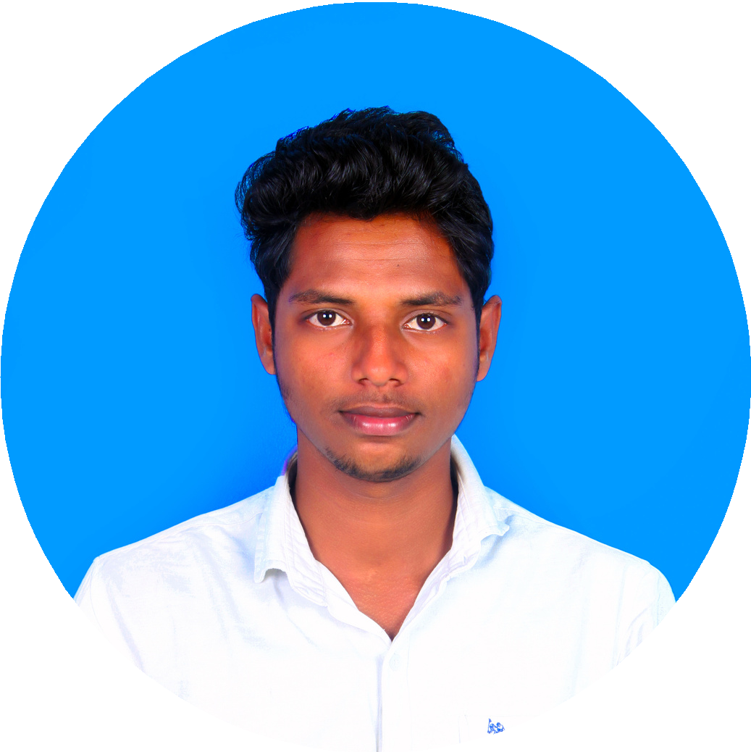

"Self-motivated, Highly Passionate and Hardworking fresher looking for an opportunity to work in a challenging Organization to utilize my Skills and Knowledge to work for the growth of the Organization".

EDUCATION

### S.R.K.R Engineering College (Andhra University), (2016-2020)

Bachelor of Technology in Mechanical Engineering

Enrolled from June 2016 to Oct 2020 Graduated with 7.34 CGPA (73.4%)

### Sri Surya Jr College (BIEAP) , Narsapur (2014- 2016)

Intermediate in M.P.C

Attended from June 2014 to March 2016 Completed with 977/1000 marks (97.7%)

Pratibha High School (BSEAP), Mogalthur Attended from June 2013 to March 2014 Completed with 9.2 CGPA (92%)

# HOW TO REACH ME

Phone: +91 8790316639

Email: [sudheer01sk@gmail.com](mailto:sudheer01sk@gmail.com) Address: 8-116, Dayaldaspeta Street, Mogalthur, Andhra Pradesh - 534281 LinkedIn: @sheikharshadh

SKILLS

**Key Skills**

Structured Query Language (SQL), Oracle Database, Java , HTML/CSS , Testing, Manual testing , Quality Assurance / Code Testing,

Adobe Photoshop, Microsoft Office

**Soft Skills**

Flexibility, Leadership, Effective communication, Team work , Critical Thinking, Adaptability, Analytical skills, Problem-solving, Presentation Skills , Self-Driven, solution-oriented attitude,Evaluation skills

# PROJECTS

Fabrication of Self powered drive Vehicle for Physically Handicapped using steering column propulsion.

Automatic Automobile Turn Indicator using Google Maps.

Fabrication of effortless Bicycle.

# WORKSHOPS

Participated in RC AIRCRAFT workshop in SRKR Engineering college, conducted by AME in SANKETA 2K17.

Bagged the best design award for the designed all terrain vehicle in ISIE Karting Competition in KLU Vijayawada.

# ORGANIZATIONS

Association Of Mechanical Engineering Students (06/2018 - 10/2020)

S*ecretary, Executive Body Member, Senior Body Member*

SRKR Hobby Club (2016-2020)

*Member, Head of hobby club* SRKR Karting Club (2019-2020) *Member,Maintenance team*

EXTRA CURRICULAR ACTIVITIES

**Secretary**

## Association Of Mechanical Engineering Students(2018- 2019)

Roles /Responsibilities/Activities:

Planning and organizing various technical and non technical events to the students with in the

campus.

Assigning works to the team mates and also ensure that the work is in the right path.

Reporting the status of work to the senior body members during daily meetings.

Taking approvals and permissions from concerned departments at various point of time.

Planned and organized a national level technical symposium 'SANKETA'.

Worked as the photoshop designing lead for the department.

Senior Body Member

Association Of Mechanical Engineering Students(2019- 2020)

Roles /Responsibilities/Activities:

selecting executive body members by conducting tests and interviews.

assigning works to the executive body members and reviewing the work assigned to them.

Reporting the work status to head of the mechanical engineering department and the principal of the college.

Presiding over the general meetings.

AWARDS AND ACHIEVEMENTS

Runner up in the inter state quiz competition by reliance in kakinada. Awarded Pratibha award for outstanding performance in the ssc results.

Secured State 13th Rank in the Intermediate results.

Awarded Best student in the intermediate.

Cleared Jee Mains,Eamcet,BITSAT Exams.

Cleared several competitive exams like UPSC CDS,AFCAT etc..

# HOBBIES & INTERESTS

Writing

Arithmetic & Reasoning Travel

Sports Music

# LANGUAGES

### English

*Bilingual Proficiency*

***Telugu*** *Native* ***Hindi***

*Full professional Proficiency*

# DECLARATION

I hereby declare that the above written details are true to the best of my knowledge and belief.