Power BI Assignment -
Name: Harsha Hiralal Dhunde
Subject: Data Analytics
Tool: Power BI Desktop

QUESTION 1
Install Power BI Desktop and explain the interface.
Answer:
Power BI Desktop is a Business Intelligence tool used to connect, clean, model, and visualize data.
Main Components:
- Get Data: Connect to various data sources like Excel, CSV, databases, and APIs.
- Report View: Create charts, tables, and dashboards.
- Data View (Table View): View and validate loaded data, create calculated columns.
- Model View: Manage relationships between multiple tables.
- Publish Button: Publish reports to Power BI Service.

QUESTION 2
Data Cleaning using Sales Data.
Answer:
The Sales dataset was loaded in Power BI. Data cleaning steps performed:
- Order Date column converted from Text to Date format.
- Columns renamed for readability: DateKey → Order Date, ProductKey → Product ID, CustomerKey → Customer ID.
- Numeric data types validated: SalesAmount and Quantity are Whole Number.
- Checked duplicates and missing values: No duplicates or nulls found.
- Derived columns created: Year, Month, Month Name from Order Date.
Purpose:
- Enables time-based, product-wise, category-wise, and region-wise analysis.

QUESTION 3
Explain three data connectors besides Excel/CSV.
Answer:
- SQL Server: Connects to enterprise databases for large-scale business data.
- MySQL Database: Connects Power BI to MySQL tables (like Customers, Products).
- Web API: Fetches live data in JSON format for real-time analysis.
Each requires server details, credentials, or API keys.

QUESTION 4
Connect to MySQL database and load data.
Answer:
A local MySQL database with Customers table (CustomerID, Name, City) was created. MySQL ODBC connector installed. Using Get Data → MySQL, the table was loaded successfully into Power BI Data View.

QUESTION 5
Compare Import, DirectQuery, and Live Connection modes.
Answer:
- Import Mode: Stores data in Power BI, fast performance, supports transformations.
- DirectQuery Mode: Data remains in source, real-time queries.
- Live Connection: Used with Analysis Services or Power BI datasets.
Recommendation:
- Small/medium data → Import Mode
- Large/real-time data → DirectQuery / Live Connection

QUESTION 6
Connect to public API and create visualization.
Answer:
A public JSON API was connected using Web connector. Data was loaded in Power Query, columns renamed, data types corrected. Visualizations like Bar Chart and Table were created.
Purpose:
Enables real-time analysis and interactive visualization.

Sales Data Specific Explanation
Dataset Columns:
- Order Date, Product, Category, Region, Quantity, Sales, Year, Month, Month Name
Cleaning Steps:
- Order Date converted to Date type.
- Columns renamed for clarity.
- Quantity and Sales numeric types verified.
- No duplicates or missing values found.
- Derived columns: Year, Month, Month Name for time analysis.
Visualizations Panel:
- Left: Charts available (bar, column, line, pie, table, matrix).
- Right: Cleaned columns and measures visible (Total Sales, Total Quantity).
Conclusion:
Sales Data cleaned and transformed enables time-based, product-wise, category-wise, and region-wise analysis using Power BI visualizations.
*******************************************************************************************
Question 1 to 6
Complete the following questions for self-evaluation

1 Install Power BI Desktop on your system (Windows preferred, or a VM with Windows for Mac/Linux users). Explore the interface and identify the location of the following: 'Get Data' options, 'Report View', 'Table View', 'Model View', and the 'Publish' button. Take a screenshot of the Power BI Desktop interface with these elements clearly indicated and submit it with a brief explanation of each element's function.
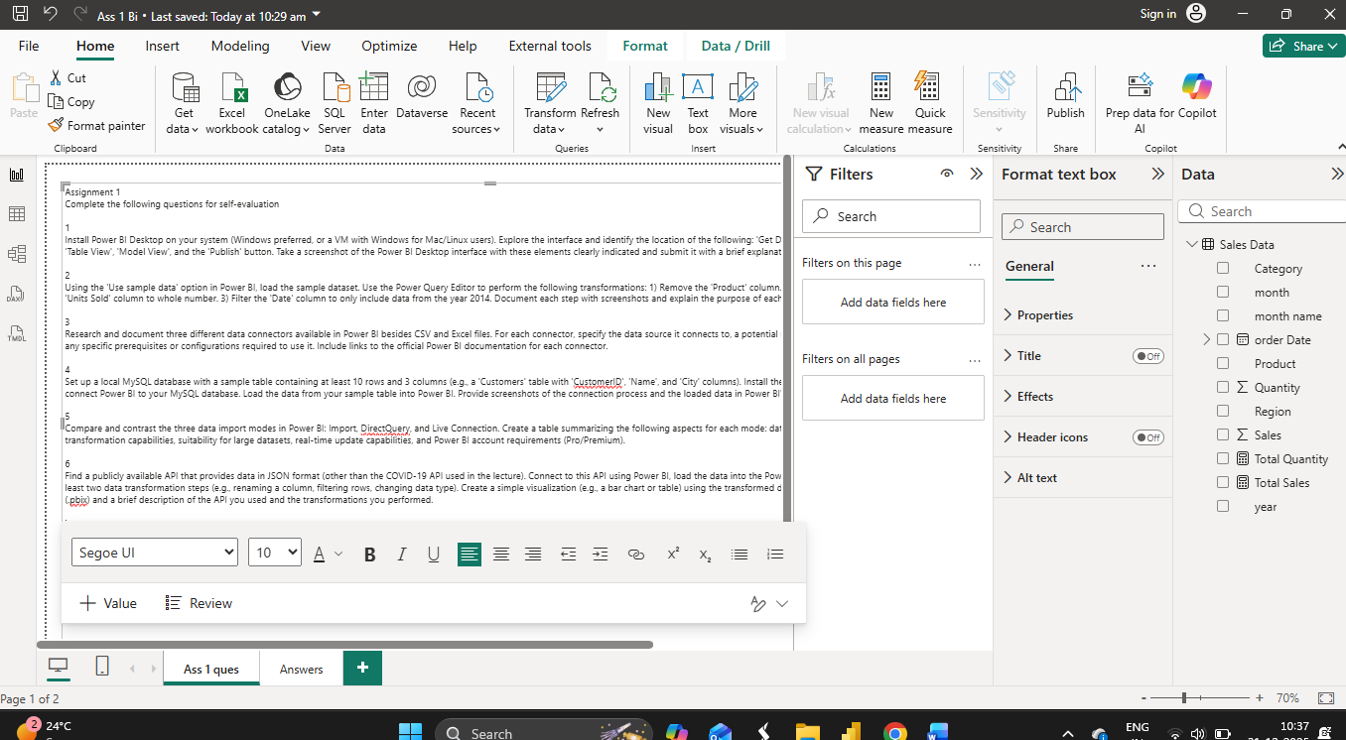

2
Using the 'Use sample data' option in Power BI, load the sample dataset. Use the Power Query Editor to perform the following transformations: 1) Remove the 'Product' column. 2) Change the data type of the 'Units Sold' column to whole number. 3) Filter the 'Date' column to only include data from the year 2014. Document each step with screenshots and explain the purpose of each transformation.
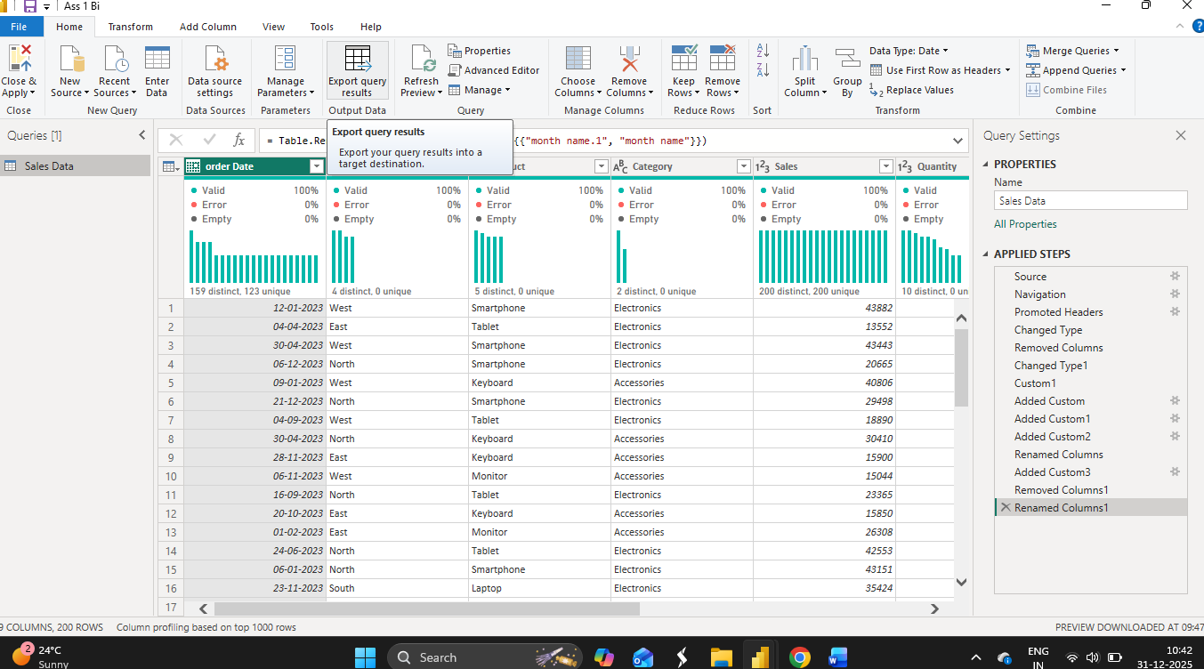
3
Research and document three different data connectors available in Power BI besides CSV and Excel files. For each connector, specify the data source it connects to, a potential use case for that connector, and any specific prerequisites or configurations required to use it. Include links to the official Power BI documentation for each connector.

4
Set up a local MySQL database with a sample table containing at least 10 rows and 3 columns (e.g., a 'Customers' table with 'CustomerID', 'Name', and 'City' columns). Install the MySQL ODBC connector and connect Power BI to your MySQL database. Load the data from your sample table into Power BI. Provide screenshots of the connection process and the loaded data in Power BI's Data View.
5
Compare and contrast the three data import modes in Power BI: Import, DirectQuery, and Live Connection. Create a table summarizing the following aspects for each mode: data storage location, data transformation capabilities, suitability for large datasets, real-time update capabilities, and Power BI account requirements (Pro/Premium).
6
Find a publicly available API that provides data in JSON format (other than the COVID-19 API used in the lecture). Connect to this API using Power BI, load the data into the Power Query Editor, and perform at least two data transformation steps (e.g., renaming a column, filtering rows, changing data type). Create a simple visualization (e.g., a bar chart or table) using the transformed data. Submit the Power BI file (.pbix) and a brief description of the API you used and the transformations you performed.

