**Email Id – harshadkhedekar123@gmail.com**

**Power BI Assignment 3**

1. List and explain different PowerBi products?

Ans.

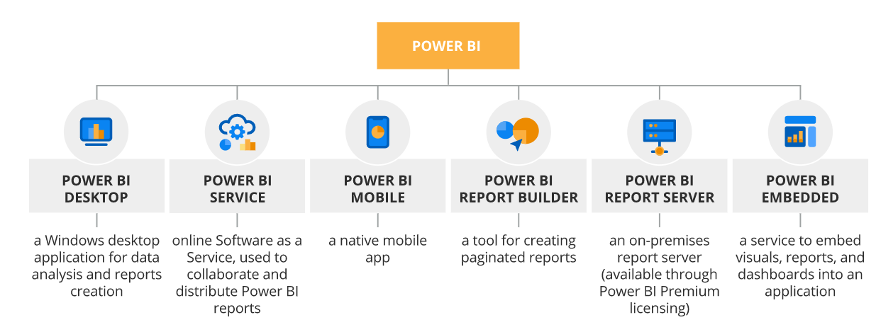

1. What limitations of Excel, Microsoft solved by PowerBi?

Ans.

* **Excel has limitations in the amount of data it can work with. In contrast, Power BI can handle much larger amounts of data.**
* **Power BI can connect to a large number of data sources, while Excel's connectivity capacity is limited. Also, unlike Excel, Power BI can be easily used from mobile devices.**
* **Power BI has faster processing than Excel.**
* **Power BI dashboards are more visually appealing, interactive and customizable than those in Excel.**
* **Power BI is a more powerful tool than Excel in terms of comparison between tables, reports or data files.**
* **Power BI is more user friendly and easy to use than Excel.**

1. Explain PowerQuery?

Ans.

* **Power Query is a data transformation and data preparation engine.**
* **Power Query comes with a graphical interface for getting data from sources and a Power Query Editor for applying transformations. Because the engine is available in many products and services, the destination where the data will be stored depends on where Power Query was used.**
* **Using Power Query, you can perform the extract, transform, and load (ETL) processing of data.**

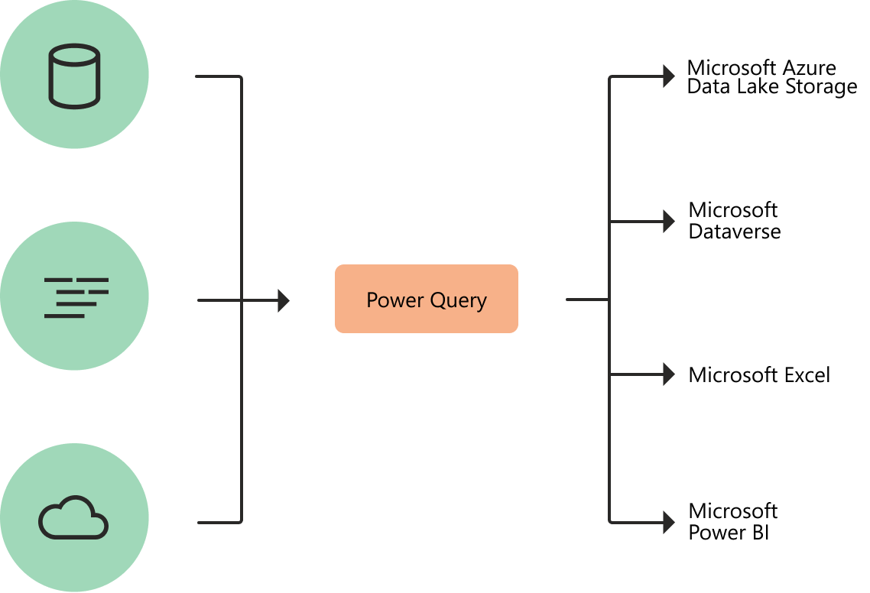

1. Explain PowerMap?

Ans.

* **Microsoft Power Map for Excel is a three-dimensional (3-D) data visualization tool that lets you look at information in new ways. A power map lets you discover insights you might not see in traditional two-dimensional (2-D) tables and charts.**
* **With Power Map, you can plot geographic and temporal data on a 3-D globe or custom map, show it over time, and create visual tours you can share with other people. You’ll want to use Power Map to:**
* **Map data - Plot more than a million rows of data visually on Bing maps in 3-D format from an Excel table or Data Model in Excel.**
* **Discover insights - Gain new understandings by viewing your data in geographic space and seeing time-stamped data change over time.**
* **Share stories - Capture screenshots and build cinematic, guided video tours you can share broadly, engaging audiences like never before. Or export tours to video and share them that way as well.**

1. How powerBi eliminated the need to host SharePoint Server on premises?

Ans.

1. Explain the updates done in Power Bi Service(power BI 2.0) as compared to older version ?

Ans.

**The following updates are new to the Power BI service**

* **Datasets hub improvements**
* **Power BI Goals enhancements**
* **Quickly create reports from SharePoint document libraries**
* **Changing the default Power BI Home layout**