**Aim: Write a small batch program and save as .bat extension and execute in**

**victim machine.**

**How to create virus using notepad**

1. Just Copy/paste all the code in notepad.
2. Save the file with extension .bat (like practice.bat)
3. Send it to the victim by mail or by Pen Drive.
4. When the victim will click on it, it will start working.
5. You can also check these codes on your own PC.
6. These codes only work in Windows.

**What is the Virus we are creating?**

**Application Bomber** It will start to open different applications repeatedly which will affect the system’s performance.

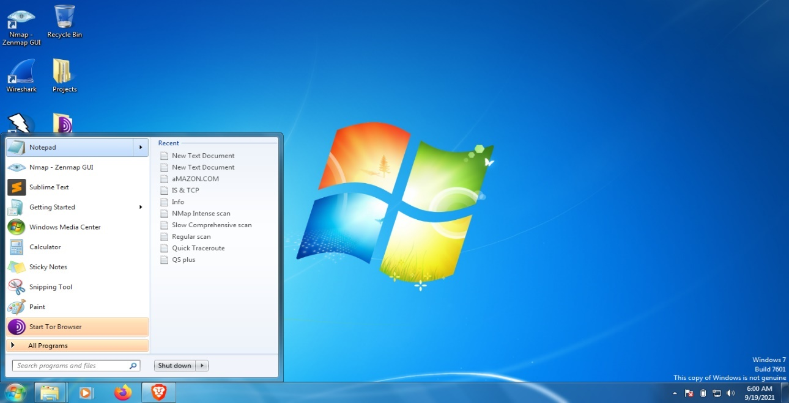

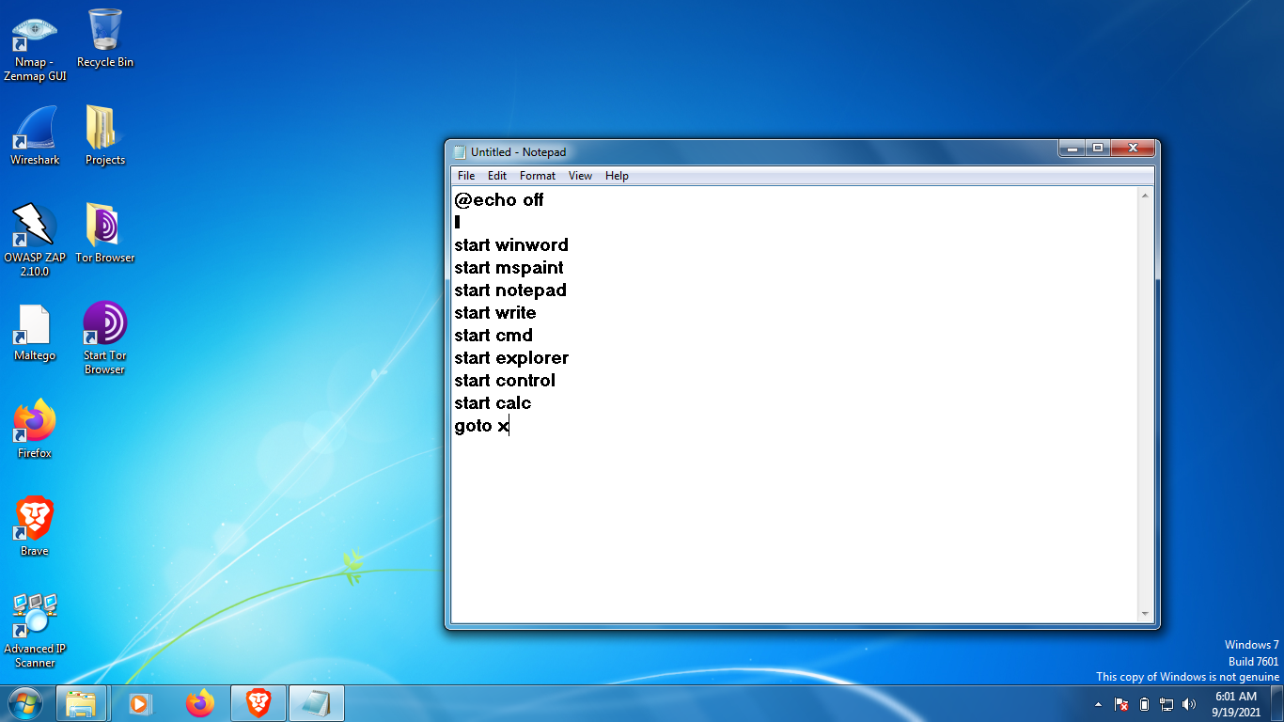

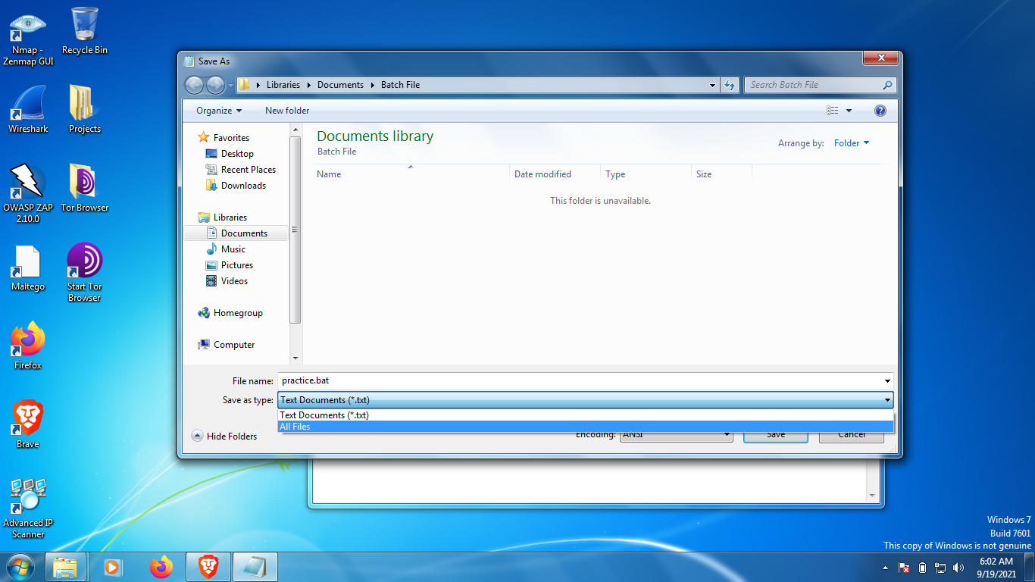

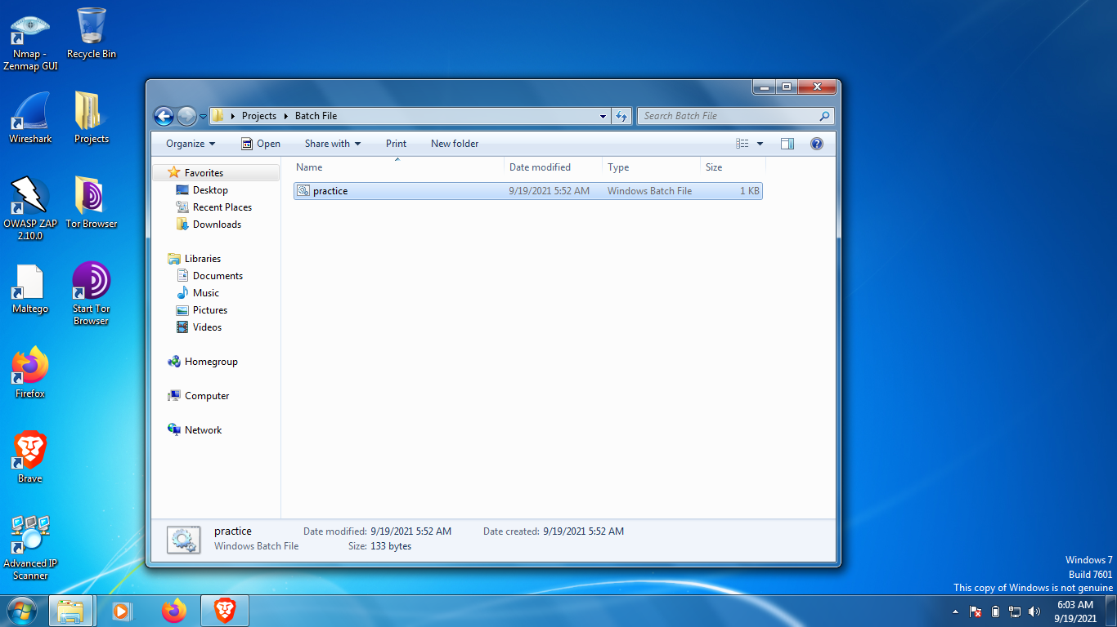

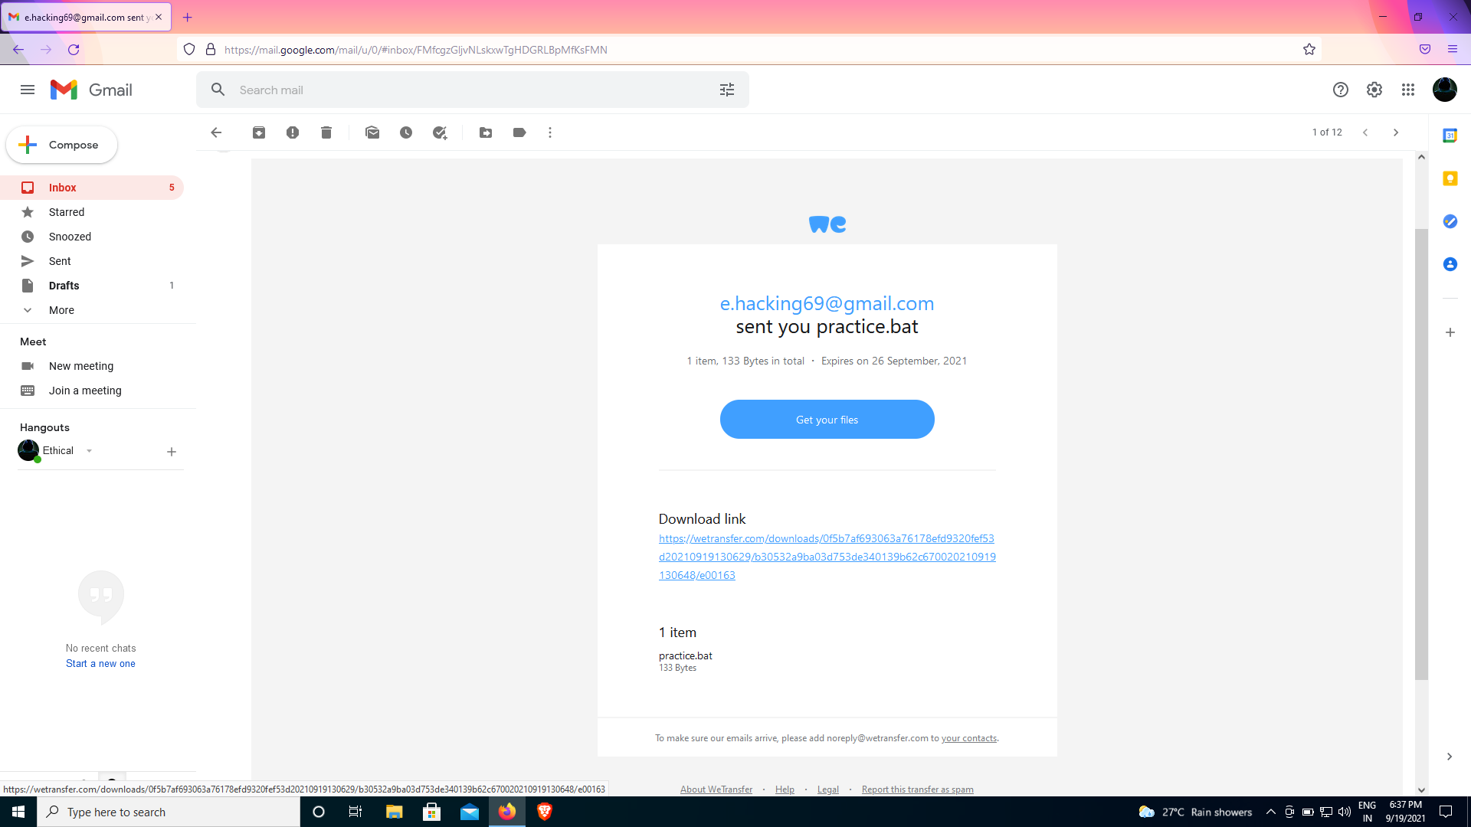

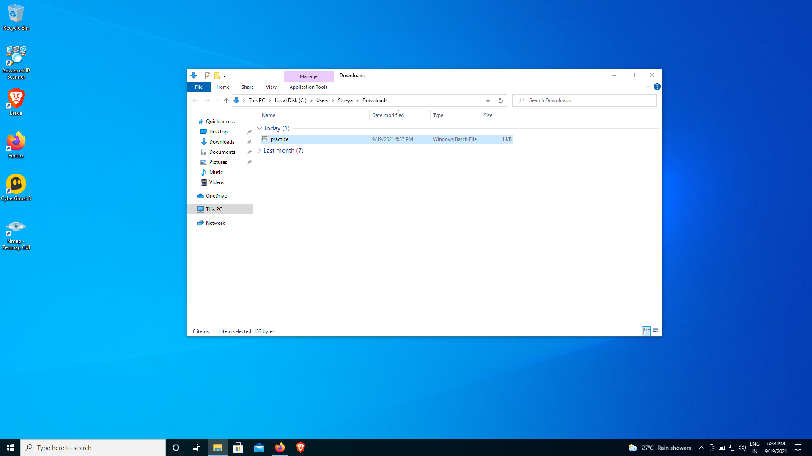

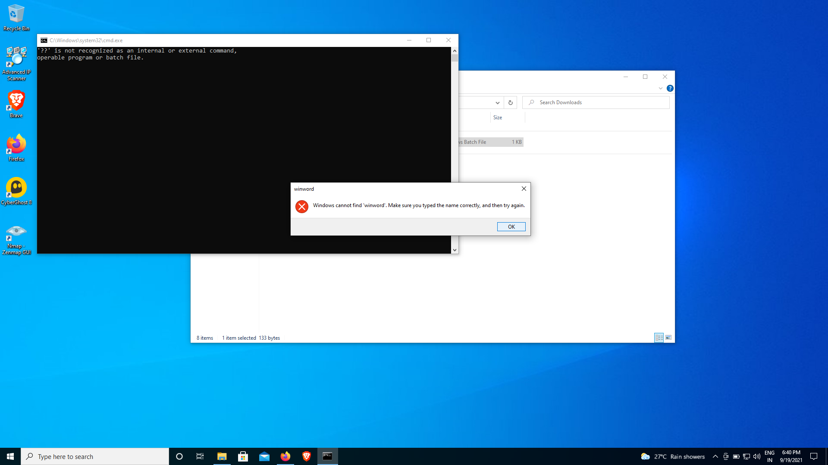

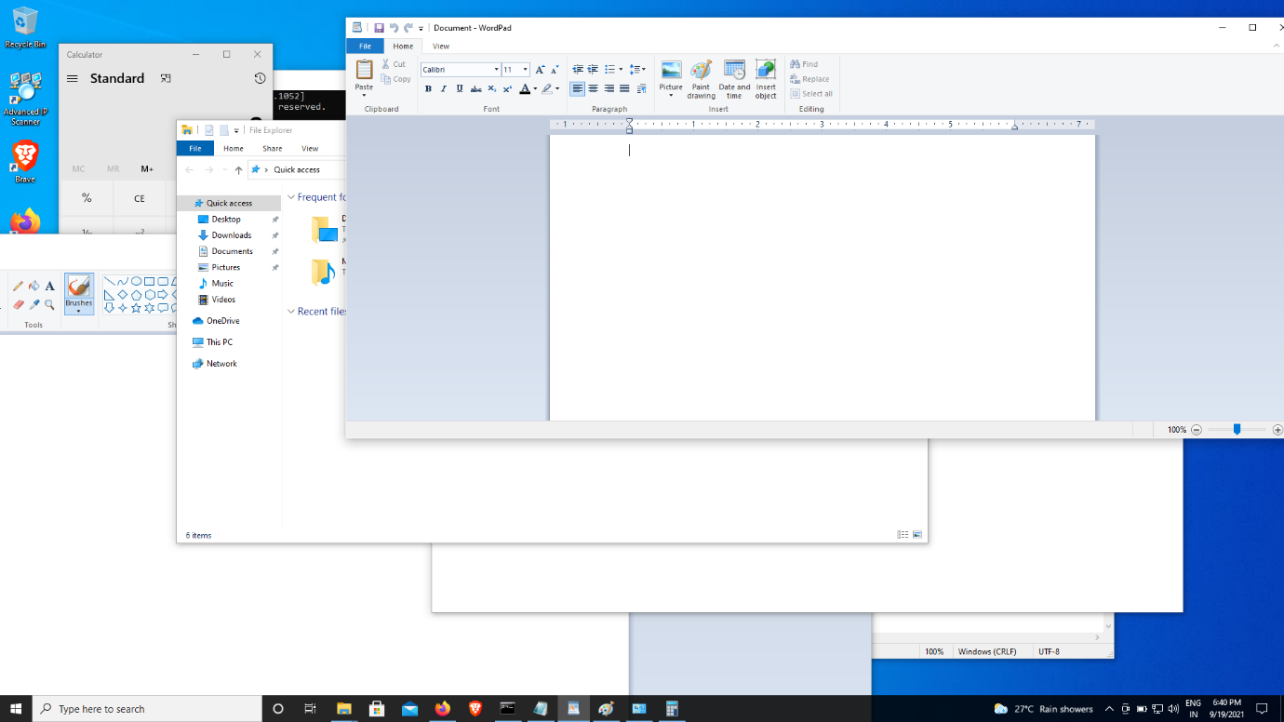

**To defend against these types of viruses:**

1. Enforce strict policies. Downloading executables or documents from the Internet is unacceptable, and anything that runs in your organization should be virus-checked and approved first. Unsolicited executables, documents, spreadsheets and such shouldn't be run inside any organization. If you don't know that something is virus-free, assume it isn't. Ideally, employees and staff shouldn't be allowed to have anything they don't actually need.

2. Block any unwanted file types at the e-mail gateway. Viruses often use file types such as .vbs, .shs, .exe, .scr, .chm and .bat to spread. It's unlikely that your organization will ever need to receive files of these types from the outside.

3. Block any file that has "double extensions" from entering your organization. Some viruses attempt to disguise their true executable nature by using double extensions. Files with names such as love-letter-for-you.txt.vbs or annakournikova.jpg.vbs may appear at first to be harmless graphic or ASCII text files.

4. Set a firm policy on hoaxes. Hoax virus warnings and chain letter e-mails can be as disruptive as viruses themselves. Not only do hoaxes spread misinformation and waste staff time and resources, but they can also be embarrassing to organizations whose employees forward them to contacts or customers. Here's a sample hoax policy:

"You shall not forward any virus warnings of any kind to anyone other than [insert name of the department or staff member who looks after antivirus issues]. It doesn't matter if the virus warnings have come from an antivirus vendor or been confirmed by any large computer company or your best friend. All virus warnings should be sent to [insert name] and [insert name] only. It is [insert name]'s job to send all virus warnings, and a virus warning that comes from any other source should be ignored."

5. Change the CMOS bootup sequence so that, rather than booting from drive A: if you leave a floppy in your machine, you boot by default from drive C:. This should stop all pure boot-sector viruses (like Form, CMOS4, AntiCMOS and Monkey) from infecting your systems. Should you need to boot from a floppy disk, the CMOS can easily be switched back.

6. Make regular backups of important work and data, and check that the backups were successful.

7. Subscribe to an e-mail alert service that warns you about new, in-the-wild viruses. There are many antivirus vendors and security sources that regularly publish alerts of new virus threats [)](http://computerworld.com/services/buyersguide/cat/0,4846,KEY73_SUB4,00.html).

8. Keep an eye on [Microsoft's security bulletins](http://www.microsoft.com/security). These warn of new security loopholes and issues with Microsoft's software.

9. Produce a set of guidelines and policies for safe computing, and distribute them among employees. Make sure that every employee has read and understood them and that they know whom to contact if they have questions.

10. Keep your antivirus software up to date across the enterprise.

**LINKS USED:**

[**https://seofreetips.medium.com/notepad-virus-script-a6d60a8174a5**](https://seofreetips.medium.com/notepad-virus-script-a6d60a8174a5)

**https://www.computerworld.com/article/2571475/ten-ways-to-defend-against-viruses.html**

**Conclusion:**

We can make a number of batch programs using notepad.