1 Create one IAM user and assign EC2 and S3 full access roles.
Go to IAM Click create user Give user name and give access according to the request in the question
Created a user and added the policy required
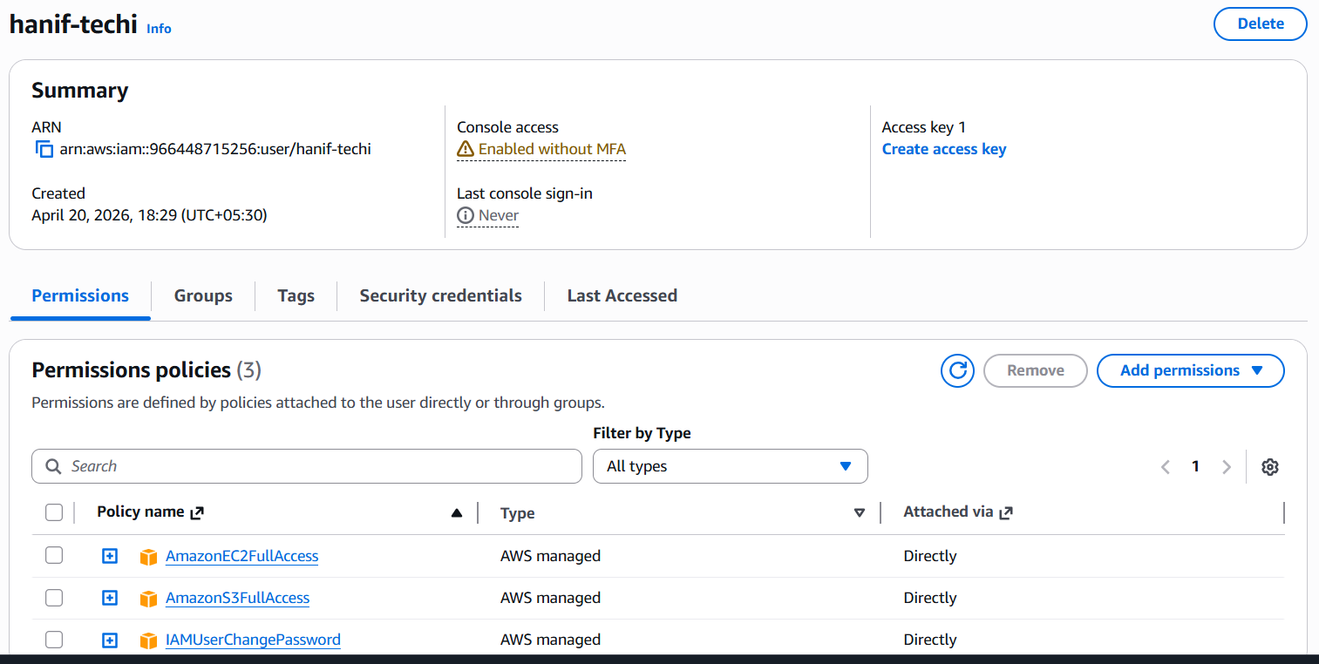
2 Create one group in IAM and assign read access for EC2.
Create a Group in IAM and gave specific permission
Ec2 read only permission and attach user to it
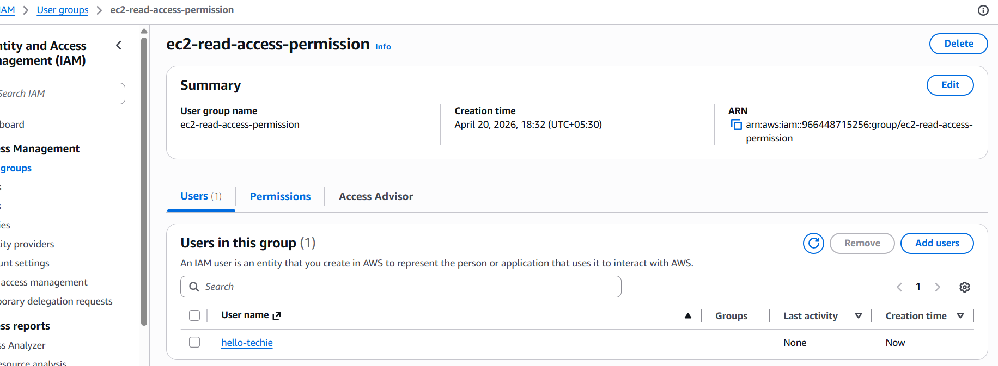
Read only permission
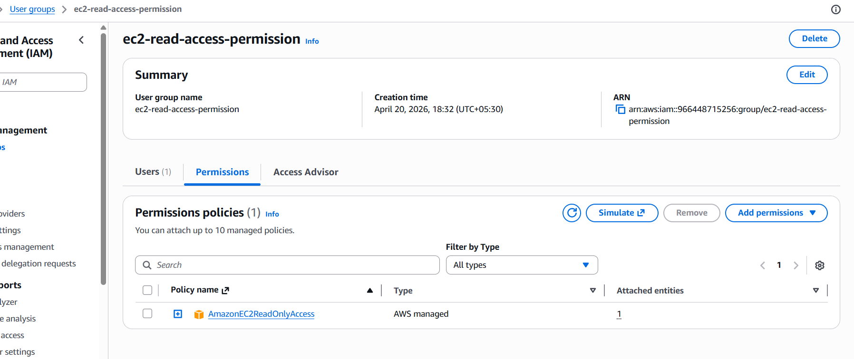
3 Create a new user named "Devops" and add to the group created in task 2.
Created new user and attached to that Group
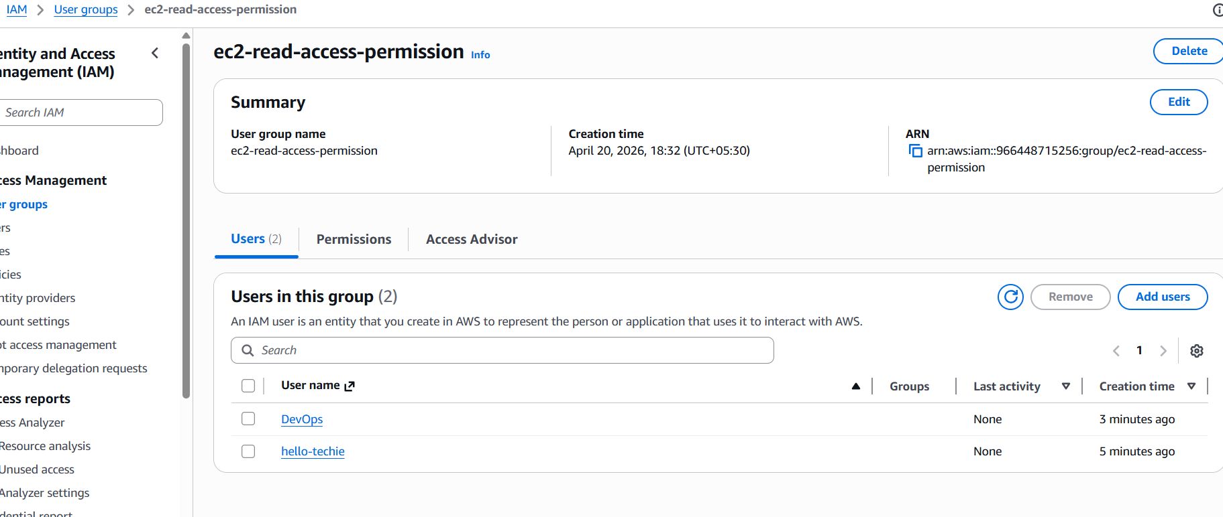
4 Write a bash script to create an IAM user with VPC full access.
Created a script to give access to the user name vpc
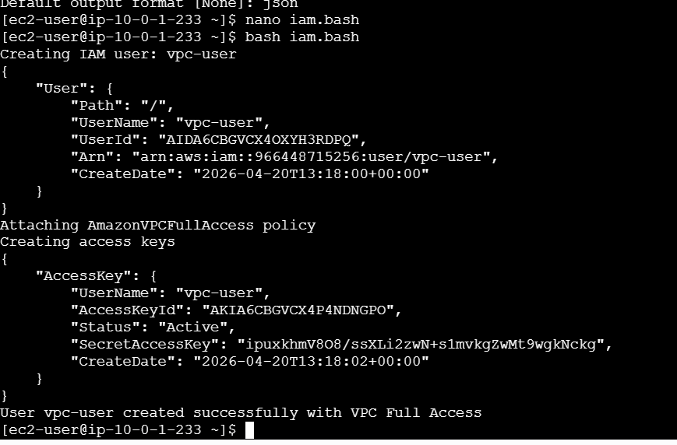
Now in GUI you will have the user with vpc access
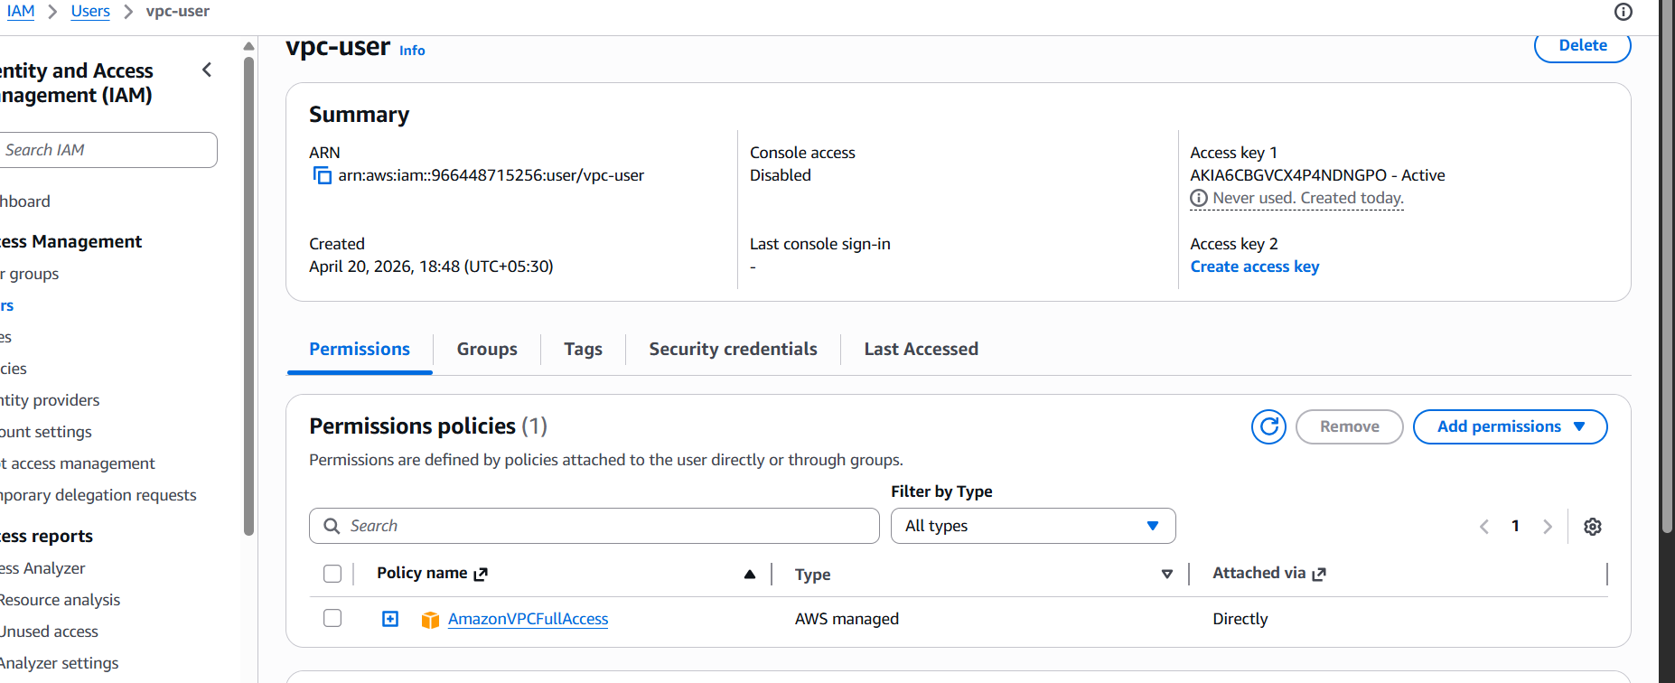
Created the user with full access of vpc
5 Create an IAM policy to allow EC2 access for a specific user in specific regions only.
Written a Json to restrict specific region only
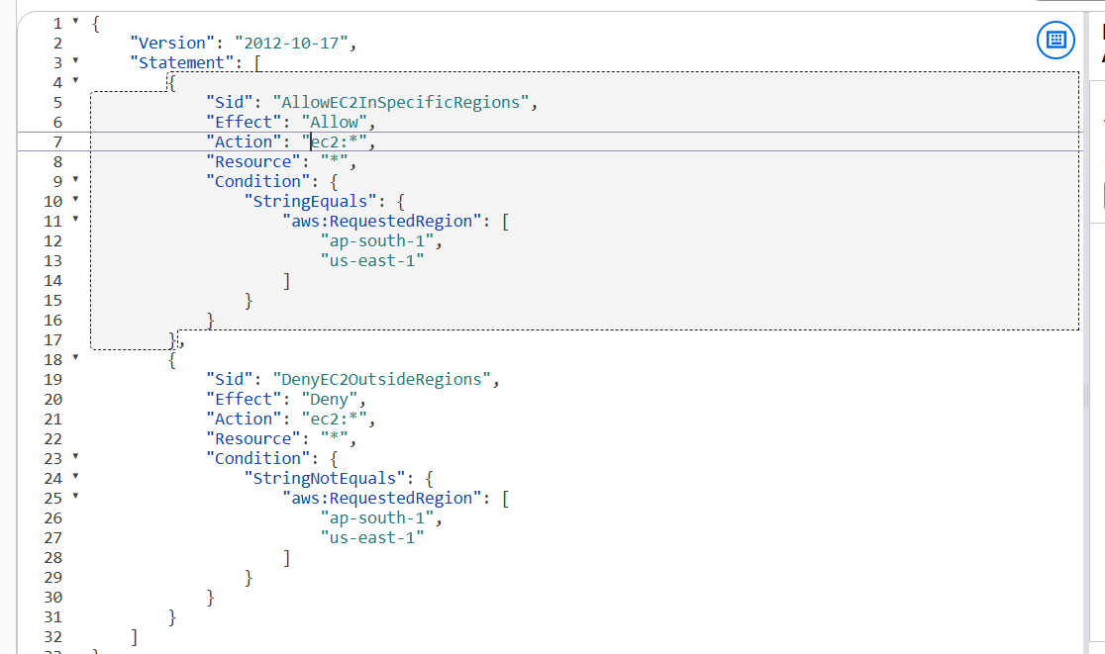
Attached the access to user
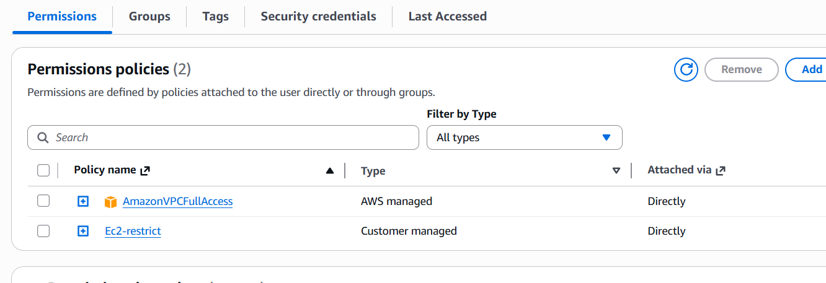
6 We have two accounts: Account A and Account B. Account A user should access an S3 bucket in Account B.
(Collaborate with a team member and execute this. This is mostly asked in every interview.)
Create a bucket policy to your bucket which I have attached below and use your college s3 bucket and work on that
{
"Version": "2012-10-17",
"Statement": [
{
"Effect": "Allow",
"Principal": {
"AWS": "arn:aws:iam::966448715256:user/Syed"
},
"Action": [
"s3:ListBucket",
"s3:GetObject",
"s3:PutObject"
],
"Resource": [
"arn:aws:s3:::s3-cross-demo",
"arn:aws:s3:::s3-cross-demo/*"
]
}
]
}
[8:24 PM]
s3-cross-demo
Now use cli command to get configure the and get the data from your college bucket
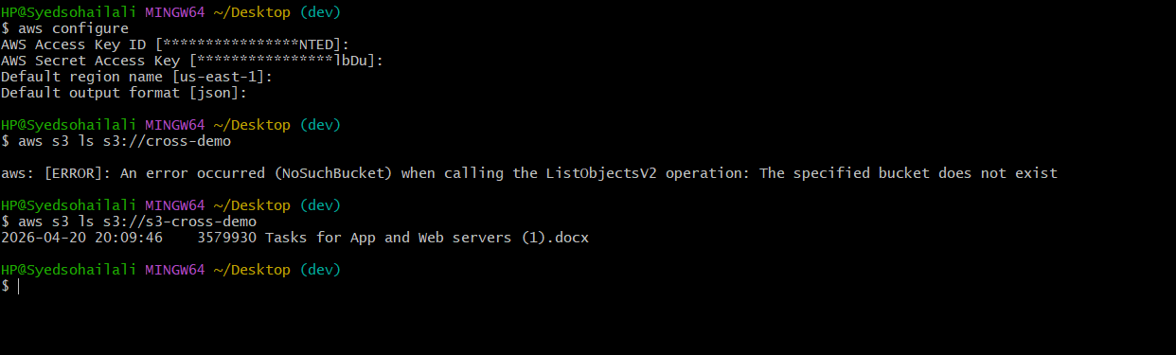
This is how you need fetch the data from another bucket Using the following policy and command

