- To install Docker Steps used to install docker in amazon-linux-ec2-machine command used is
Steps:
sudo yum install docker -y
It will install the latest docker version in our ec2-machine
Use this commands to start the docker
systemctl start docker and systemctl status docker
to check the docker version use command
docker -v
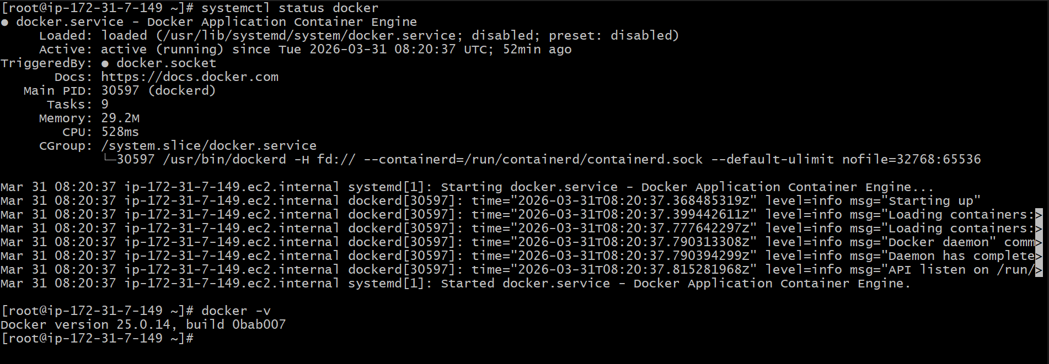
This are steps used to install docker
let’s pull one base image nginx and run that in port 82 using docker
docker pull nginx:latest this command is used pull base image nginx
docker run -itd -p 82:80 nginx:latest to run docker file in port 82
docker ps to check the image is running or not
- To install Jenkins we need to follow few steps
(I) For Jenkins java is the most used prerequisite first of all try to install java using the command = sudo yum install java (install the latest version of java)
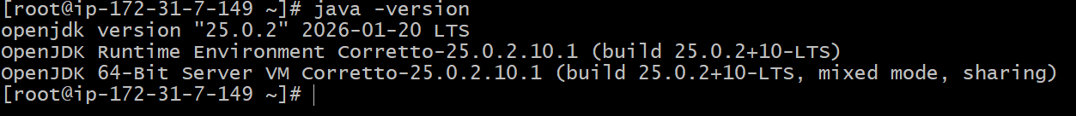
(ii) Second step is
Go to Google search for Jenkins DownloadSelect the link which I have attached below
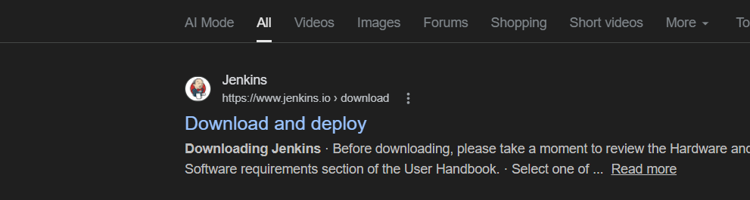
After going inside the link select os which is redhat I have attached the Image below
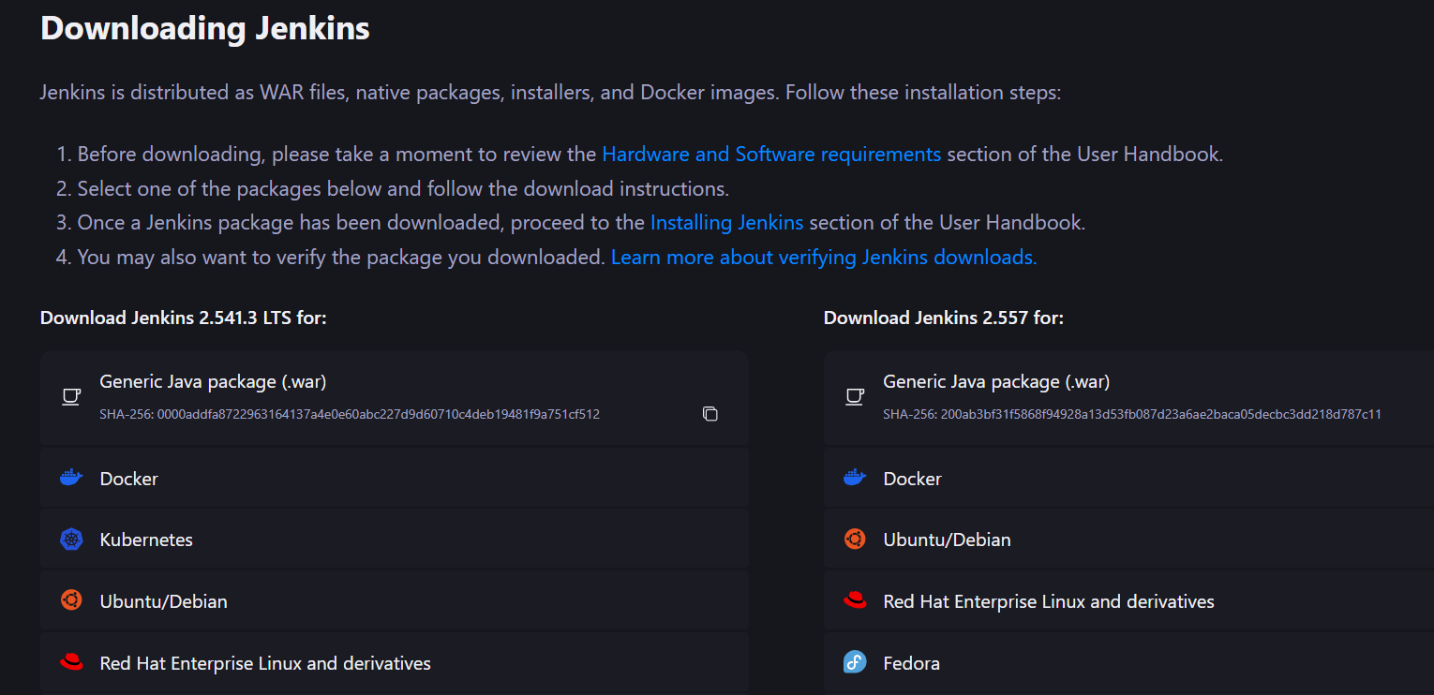
Now use this commands to install Jenkins
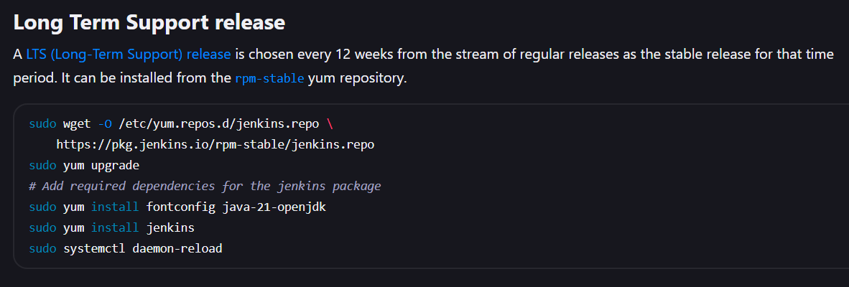
Attached the link below
https://www.jenkins.io/doc/book/installing/linux/#red-hat-centos
(iii) Now do this things in server
you wiil install Jenkins now check the status using systemctl command
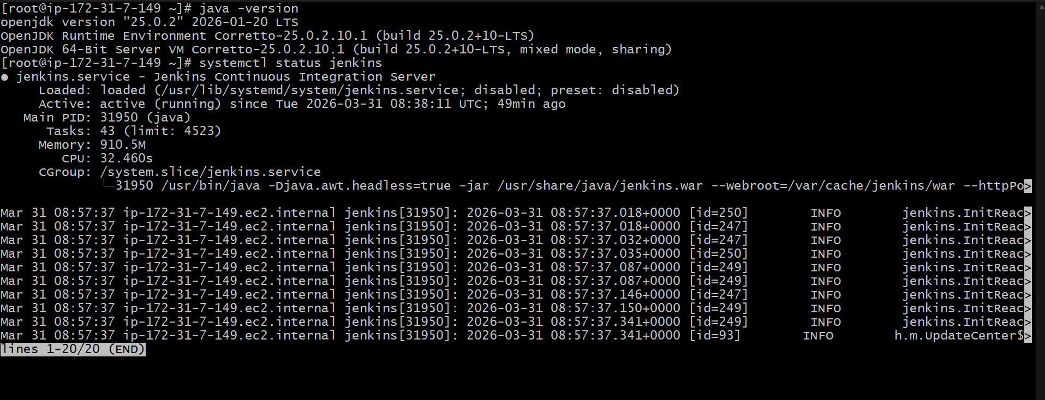
(iv)Now out Jenkins is running in the port number 8080
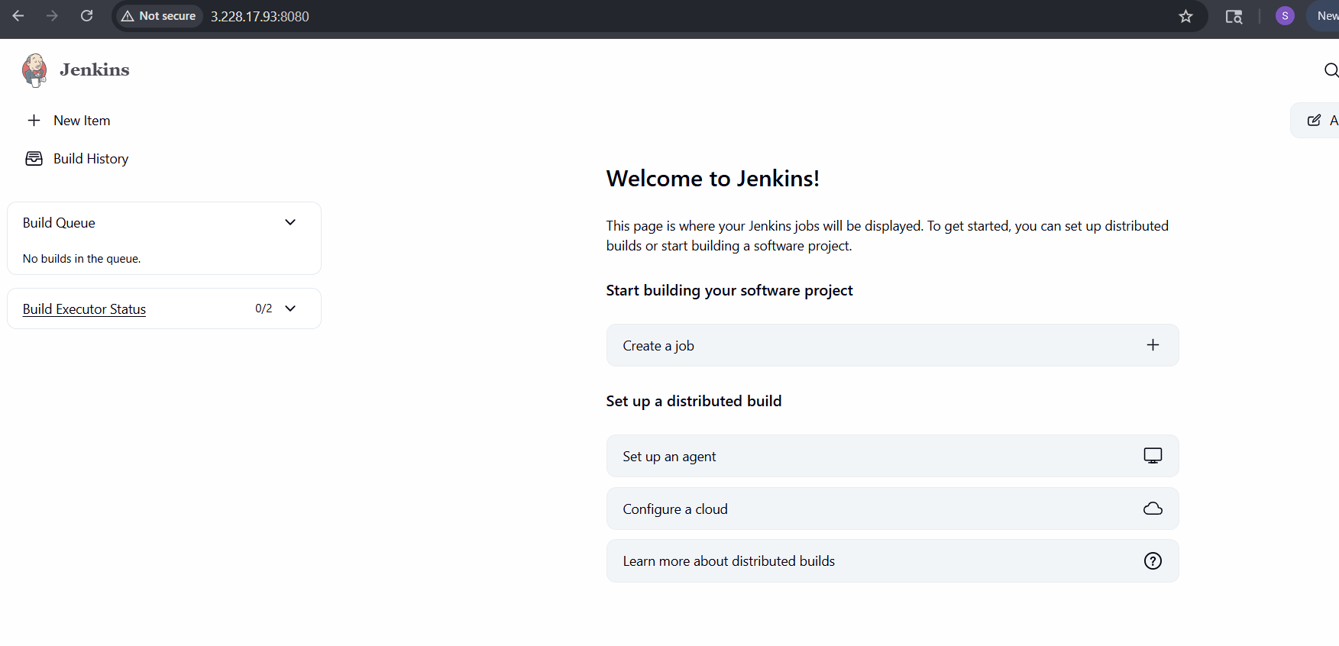
- Install apache (httpd)
To install httpd in our ec2-server use this below command
sudo yum install httpd
It will install now start the service using command
Systemctl start httpd and systemctl status httpd
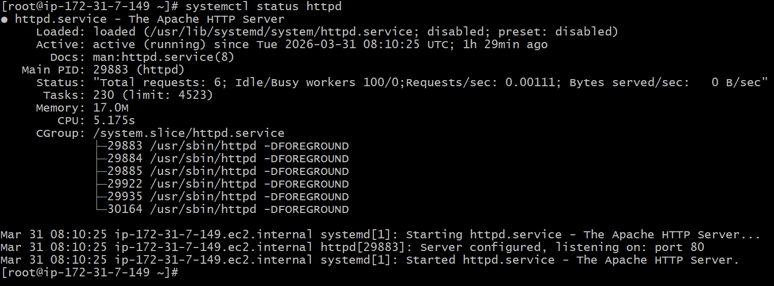
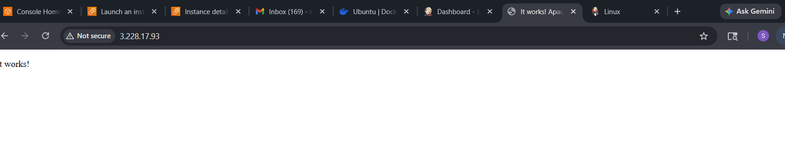
Now httpd is up and working

4 Install Nginx and change it’s port number
To install nginx use the below
sudo yum install nginx -y
Systemctl start nginx and systemctl status nginx
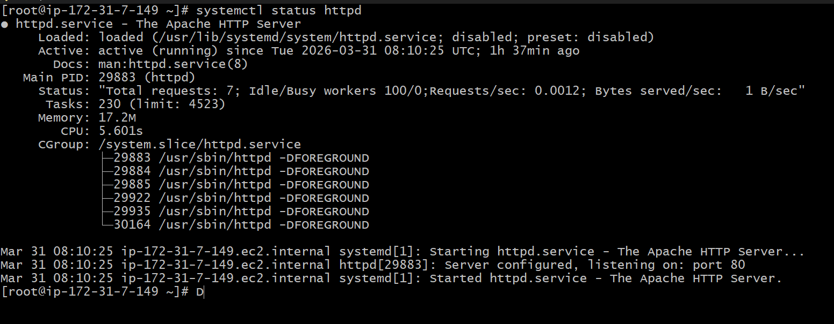
Now since we are using apache and nginx since both are running in same port
Now we need to change the port by going to location nano /etc/nginx/nginx.conf
And edit the port as mention below image
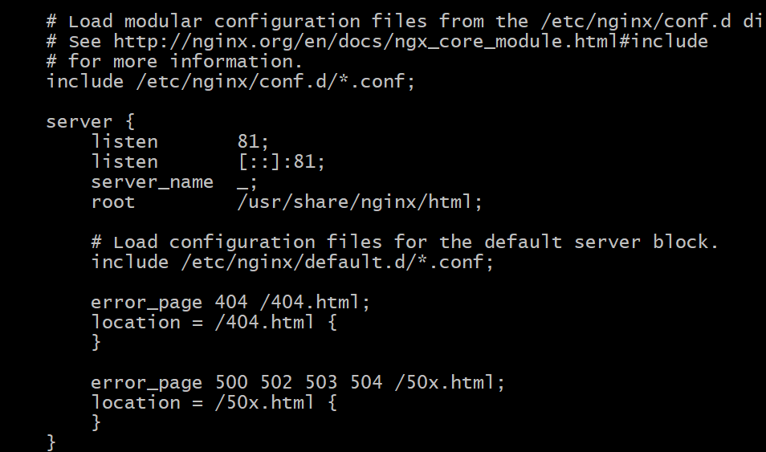
After changing the port the nginx will run on port 81 as mentioned in the image
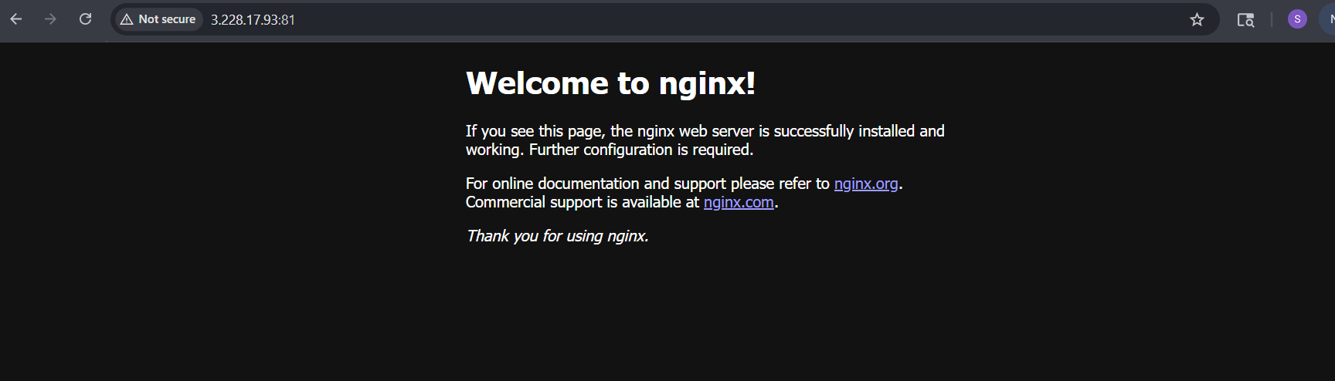
5 Install Tomcat
To use the following command
first use wget command to get download the package
wget https://dlcdn.apache.org/tomcat/tomcat-9/v9.0.116/bin/apache-tomcat-9.0.116.tar.gz
use the command to download tomcat
Now tar xvf apache and go to bin and use sh startup,sh to run the tomcat command so the server will start
(ii) Since we are using Jenkins and tomcat on same server and port need to change the port number in tomcat using this location
Go To tomcat cd conf nano server.xml and change the connector port to 8081
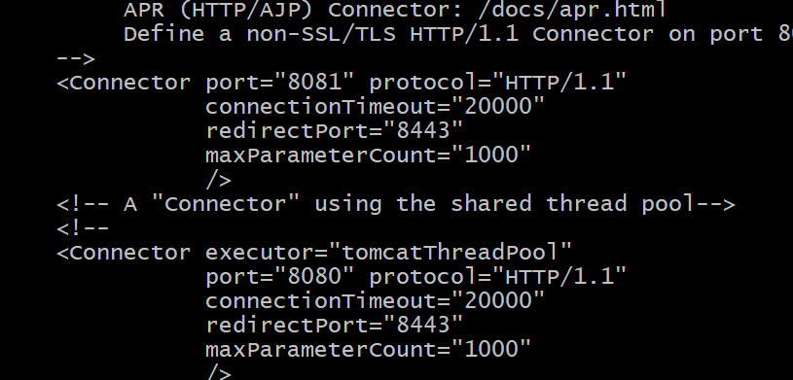
Now since we changed the port number restart using command sh shutdown.sh and start shutdown.sh

