- Install nginx and run nginx on port number 81.
To Install Nginx in ec2-server- we can use the command = sudo yum install nginx
After installing use command = systemctl start nginx and to check the status used command = systemctl status nginx
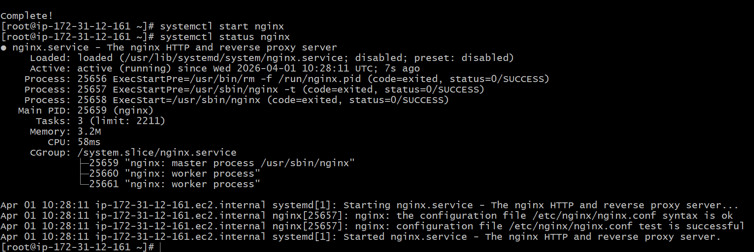
No we need to change the port number for nginx
use this command to change nano /etc/nginx/nginx.conf
change the port to 81

Now the nginx is running in port 81
2) Let’s deploy Deploy a sample index.html file on nginx.
Use the path = /usr/share/nginx/html we will have a index.htmk page remove that to deploy the sample webapp in that
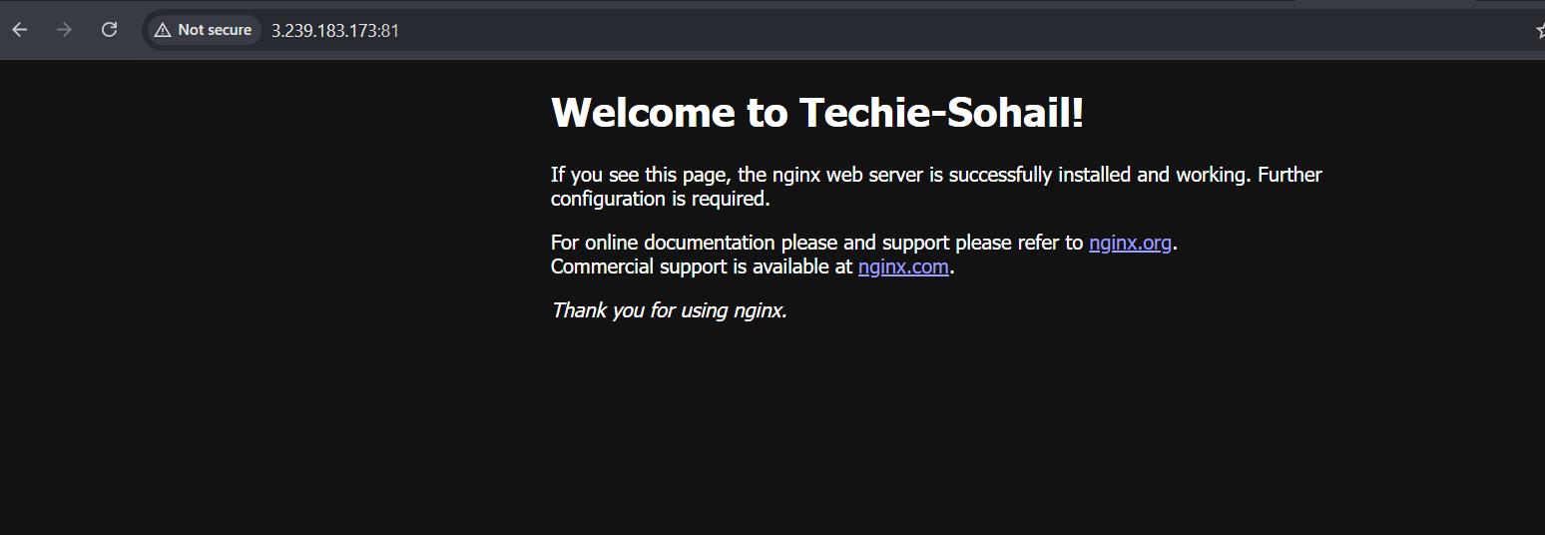
3 Install Apache and run Apache on port number 82
To install apache use command = yum install nginx . After installing use command = systemctl start httpd and to check the status used command = systemctl status httpd
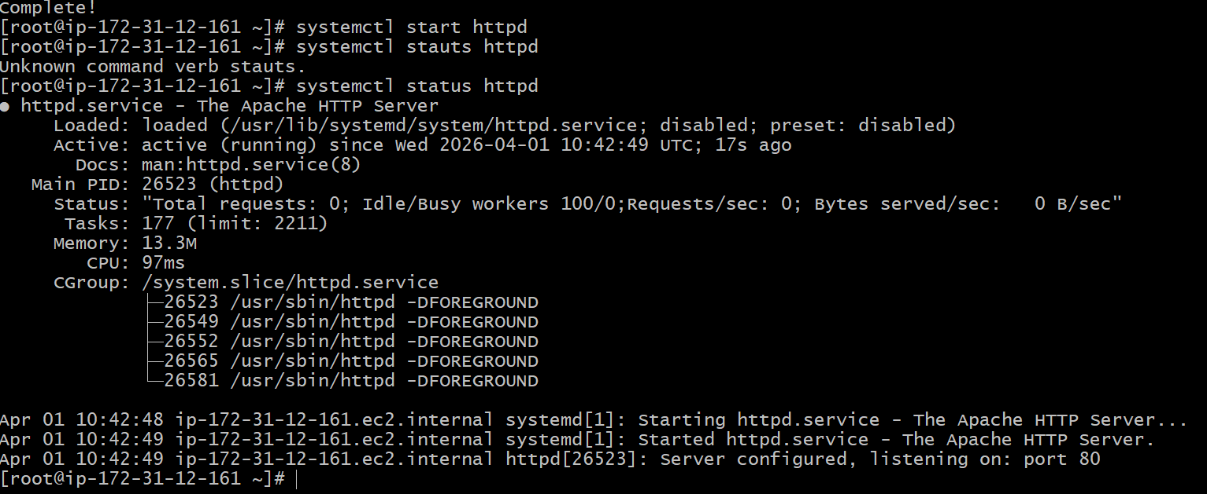
Now to change the port number in https use this location
sudo nano /etc/httpd/conf/httpd.conf here create a index.html file and restart httpd
4 Deploy a sample index.html file on Apache.
To deploy a sample we application used this path and create a index.html file
Cd /var/www/html and add index.html file

5 Install Apache tomcat on port number 8082
To use the following command
first use wget command to get download the package
wget https://dlcdn.apache.org/tomcat/tomcat-9/v9.0.116/bin/apache-tomcat-9.0.116.tar.gz
use the command to download tomcat
Now tar xvf apache and go to bin and use sh startup,sh to run the tomcat command so the server will start
(ii) To change the port in tomcat using this location
Go To tomcat cd conf nano server.xml and change the connector port to 8082
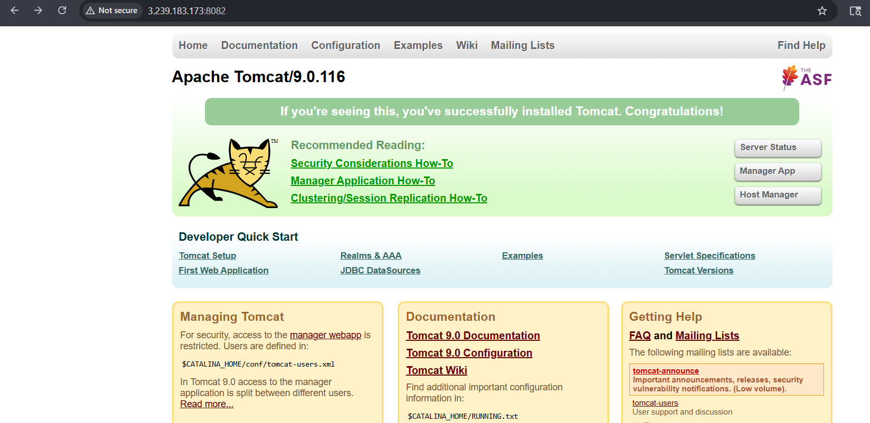

6 Deploy a sample app on webapps
To deploy the webapp we need to go to location cd /webapps and download the sample.war packer using wget command
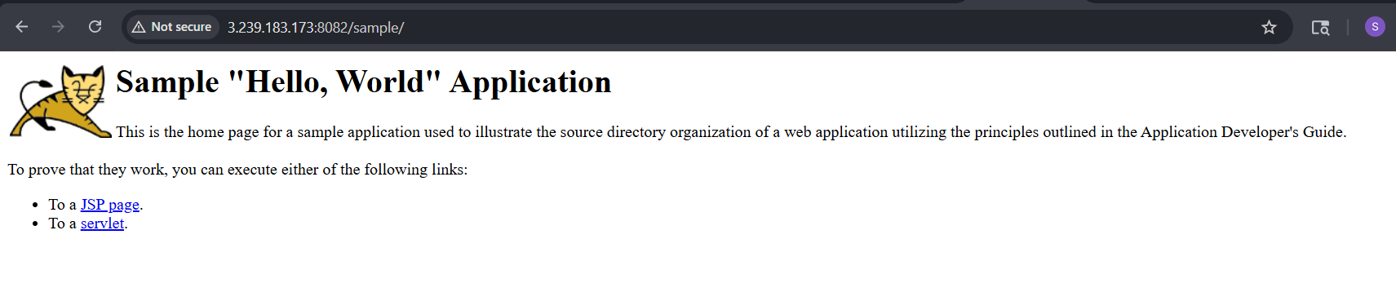
7 Create a tomcat.service file for tomcat.
for that create a tomcat.service file used the command = sudo nano /etc/systemd/system/tomcat.service to create file and copy service file related commands
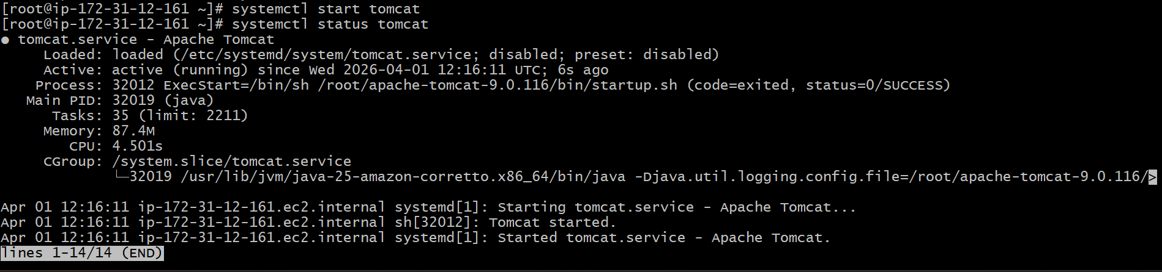
8) Configure HA Proxy server
To configure Ha Proxy I have followed the steps given in the documentation
and and created the hA proxy I have attached the images below
Running using Httpd with HAProxy public ip

Runnig Using nginx with Ha proxy public ip

============================================================

