Shell = Shell is a program which takes input and gives output.
Terminal = Terminal is a tool to execute the shell commands, is also called as CLI (Command line interface).
===========================================================
Commands that I have worked on after seeing the class. And have attached the screenshot below for your reference
echo $0 = Command is used to check which type shell you are using
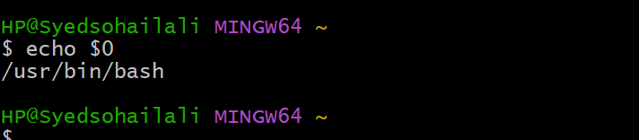
/ = Is the working root directory in which all the other directory will comes in
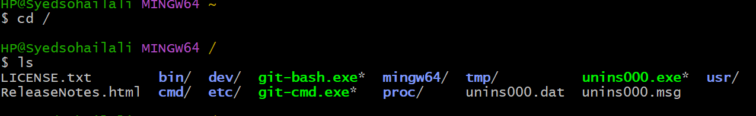
PWD = Will show the present working directory of the file or folder
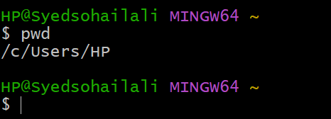
~ = Is basically a home directory for a user
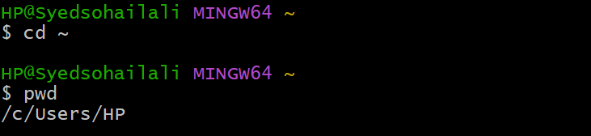
cd = is basically used to switch from one directory to another
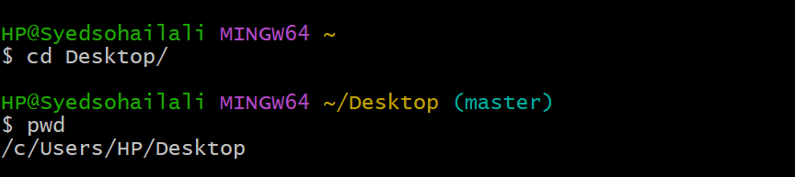
cd.. = this command is used to get back one step behind from the working
Directory
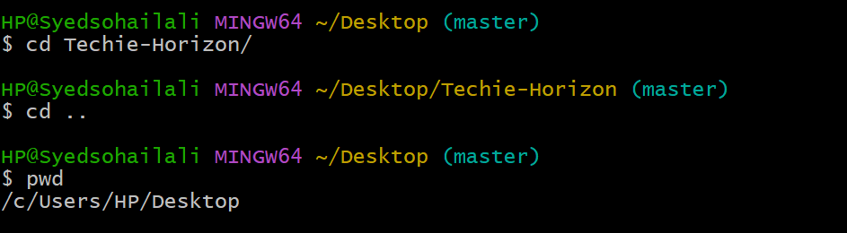
Cd ../.. = This is command is used to get back two steps
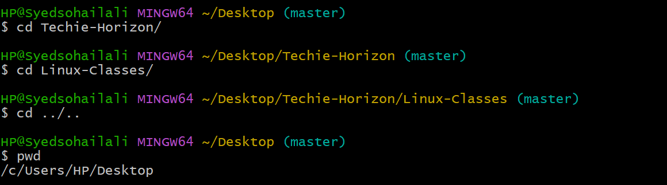
ls = Command used to list of file
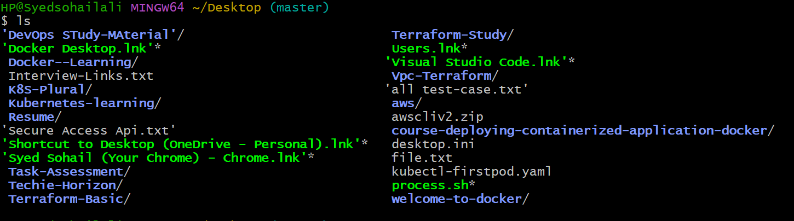
ll = Command used to display file and folder in long list which include
file permission and creation date the file has been created
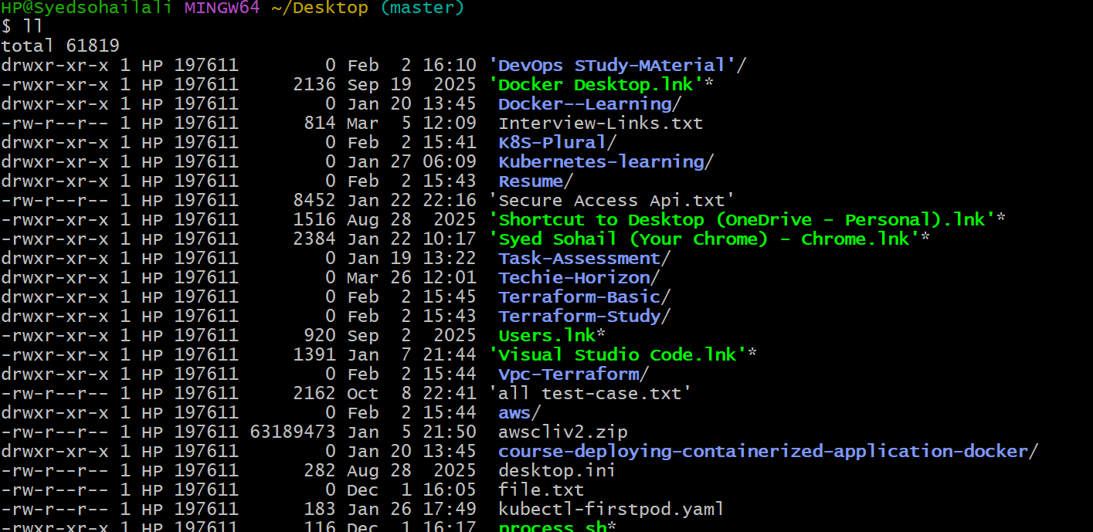
ls -ltr = This command is also used to long list the file permission and creation date. -l → Long listing format. - t → Sort by time. -r → Reverse order
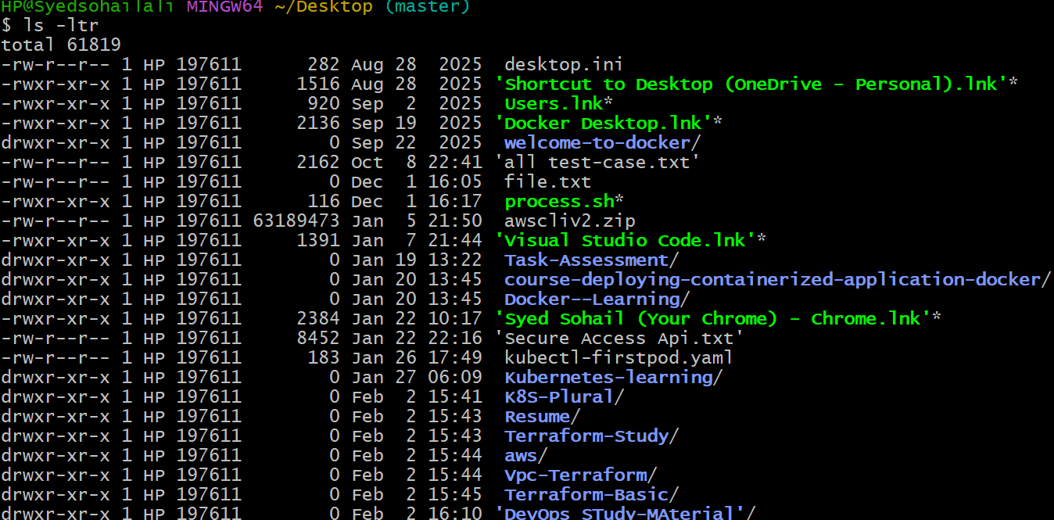
ls -a = This command is used to show the hidden files
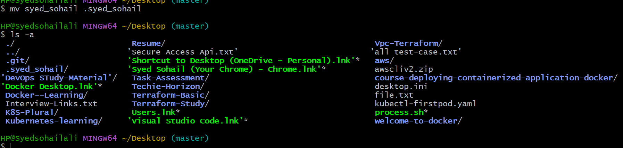
mkdir = This command is used to create the directory for user
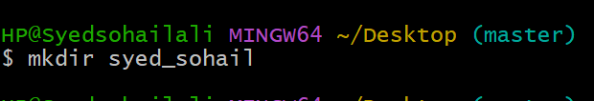
mv = This command is used for two type one is for rename the file. And another one is you move your specific file to specific location
Here I have rename the file name
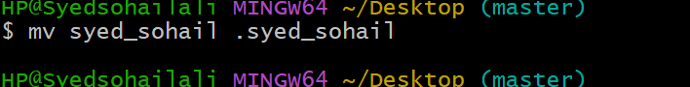
Here I have moved the file/folder to another location
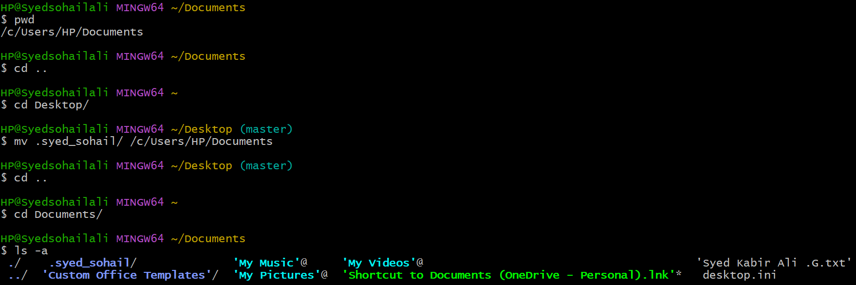
rm -rf = This command is used to delete the folders and file
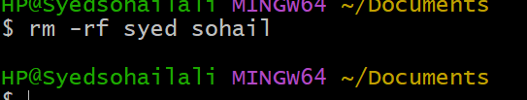
Touch = This command is used to create a zero byte file
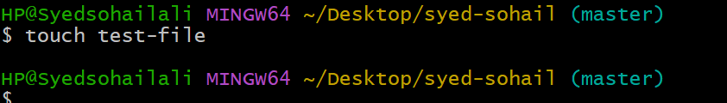
Vi = this command is used the edit the file and write content in that
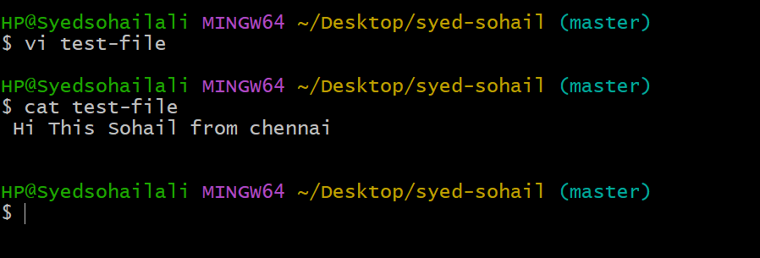
Cat = Command is used to cat the content in the file
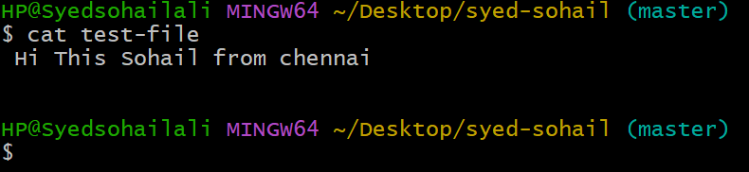
wc = Command is used to count the letters and string in the text file
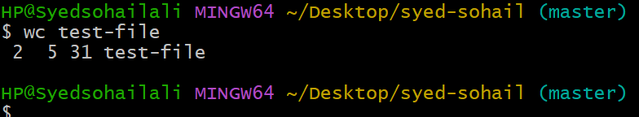
This are command which I have practiced with hands on in Git-Bash
=======================================================

