- Install git.
To install git in our server we can use command
yum install git if you are working in local use command git init in git bash to initialize .git folder in localTo check if it’s installed or not use command git –version
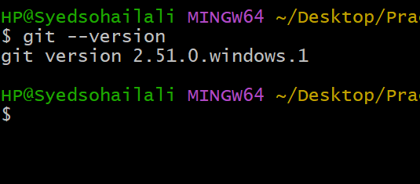
Now git has been installed
2. Create a repo in GitHub with README.md and .ignore file.
To create a empty repository and .ignore file Go to GitHub accountGo to RepositoryClick add new repository
Now give the name to the repositoryEnable Add Readme.fileselect no ignore file click create
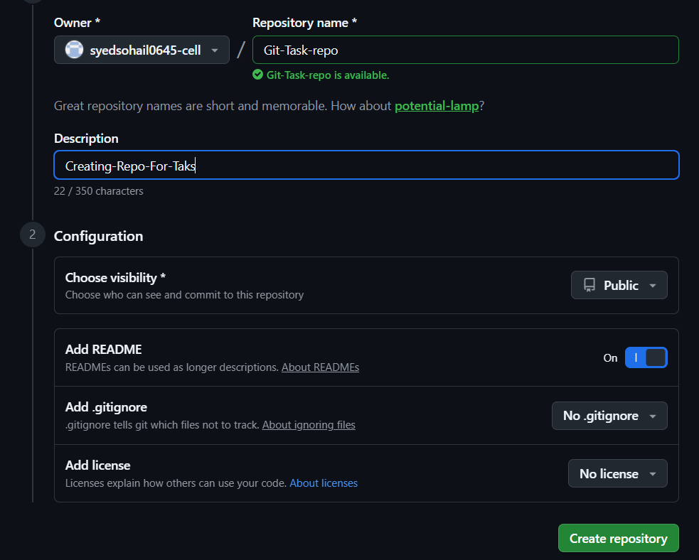
This how we need to create a repository
- Clone the created repo to local.
To clone the created repository to localuse the following command Git clone https://repo-url copy the url and clone it using git clone command
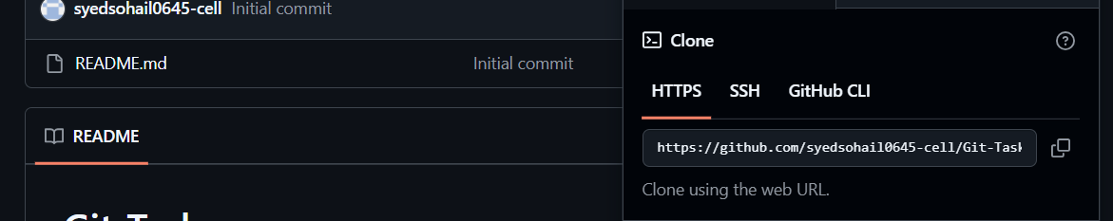
Copy the url and use like the below image you will able to clone the repository
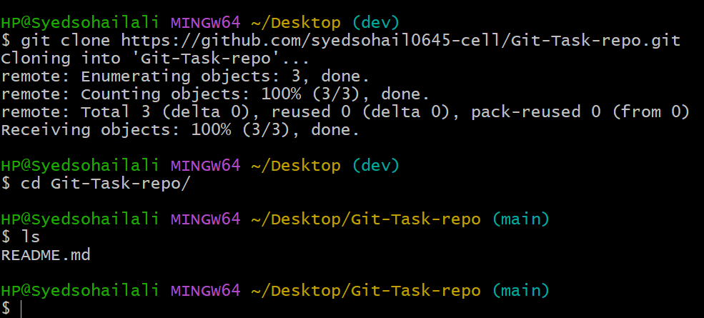
4. Create two files in local repo.
To create two files in local repo we need to use the command touch and create two file in local repo Image attached below
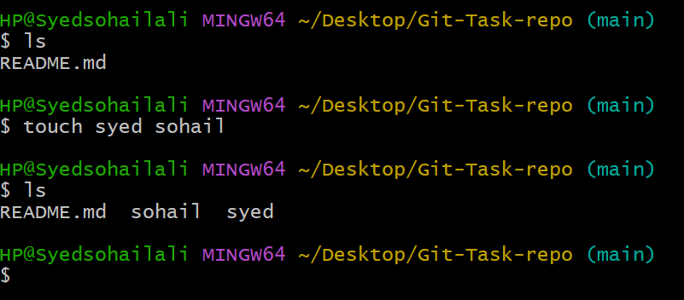
5. Commit two files and push to central Repository.
To commit two file and push to central repo First we need to add those two file to git using the command called git add . for multiple files if single file use command git add (file-name) after that check the status and the push to central repository
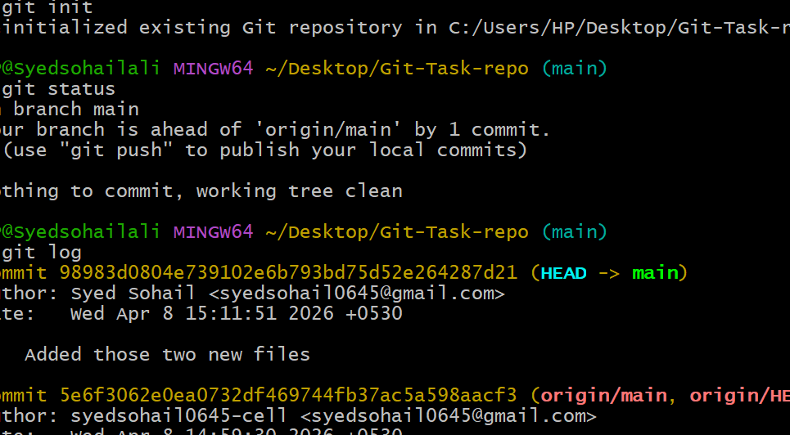
Added two file and committed now Need to push it using command git push origin -u main
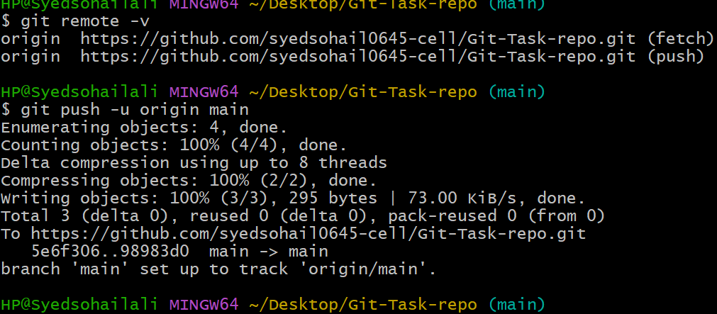
Now the committed file are pushed
6. Create a branch in local and create a sample file and push to central.
To do this Create a branch From the copy of base Branch main Use command git branch (New Branch Name)Now switch to the new branch using command git checkout (Branch-name) Create a new file using touch command and add it using git add command and commit it using git commit -m command and use git push command to psuh to central Follow the steps mentioned in the image
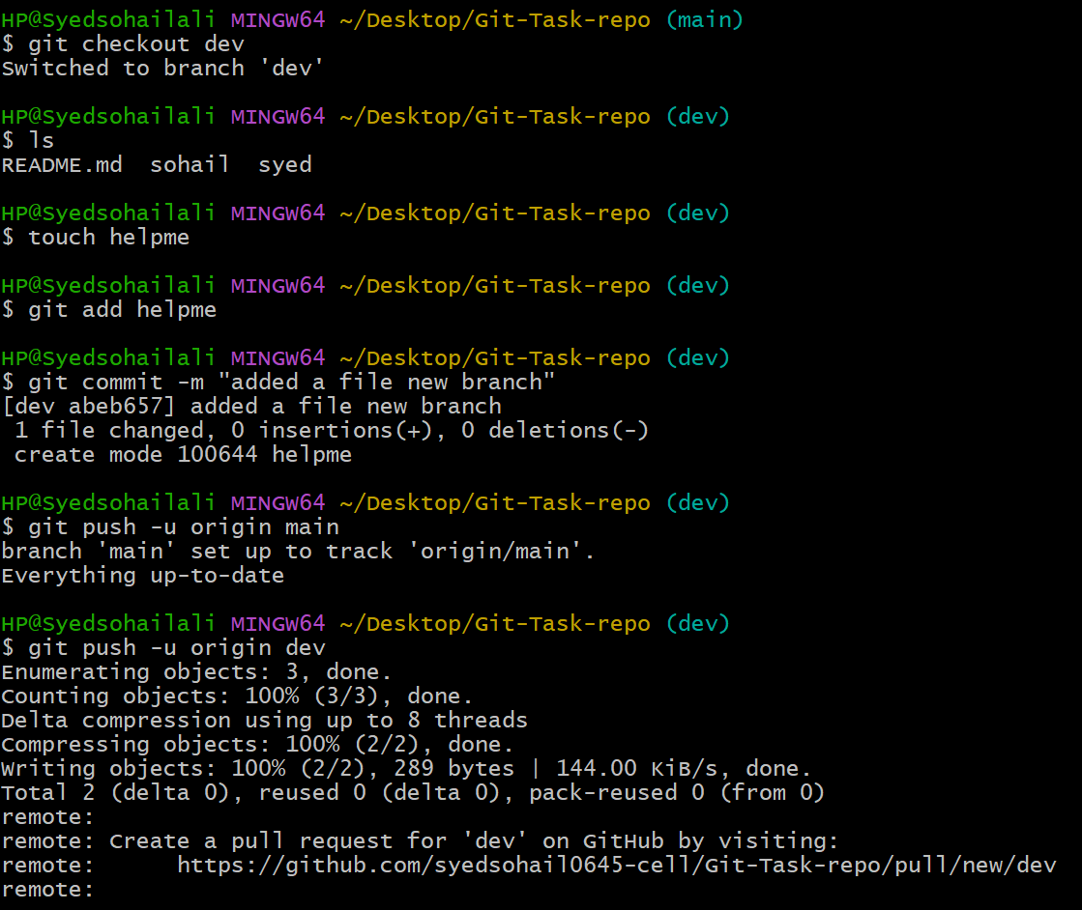
7. Create a branch in github and clone that to local.
Create a new Branch in GitHubMentioned below in the image
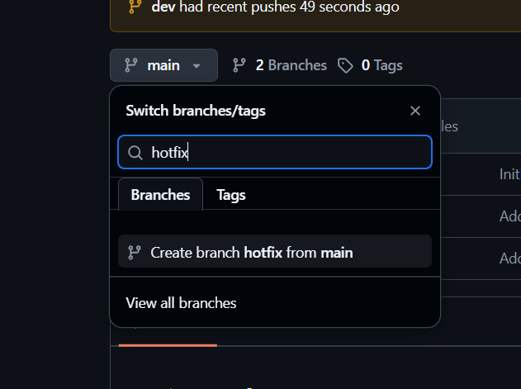
Click Create a new branch will be created now
Now to clone the new branch from central to local use git clone command and the url If it does not worked means use command called git fetch
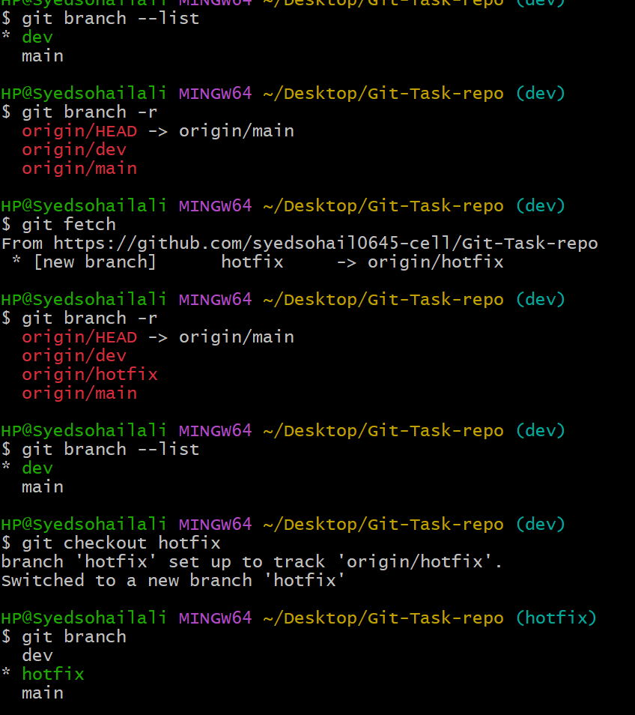
This are the steps needed to follow for the result
8 Merge the created branch with master in git local.
To merge two different branch in localuse git merge and the branch you are going to merge with
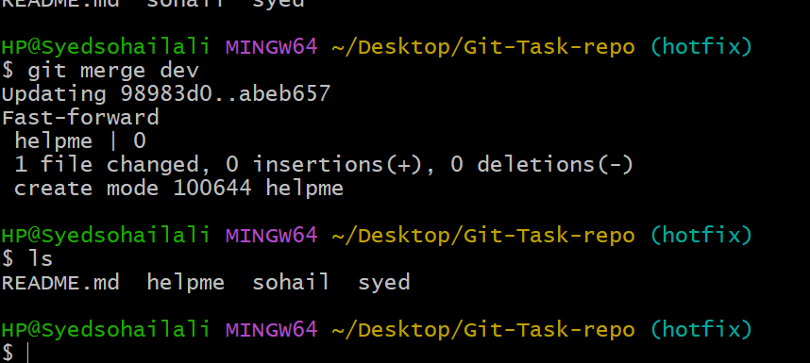
This is the process to merge two different
9. Merge the created branch with master in github by sending a pull request.
To do the following steps use Github GUIClick on compare and pull request it will pop like image below
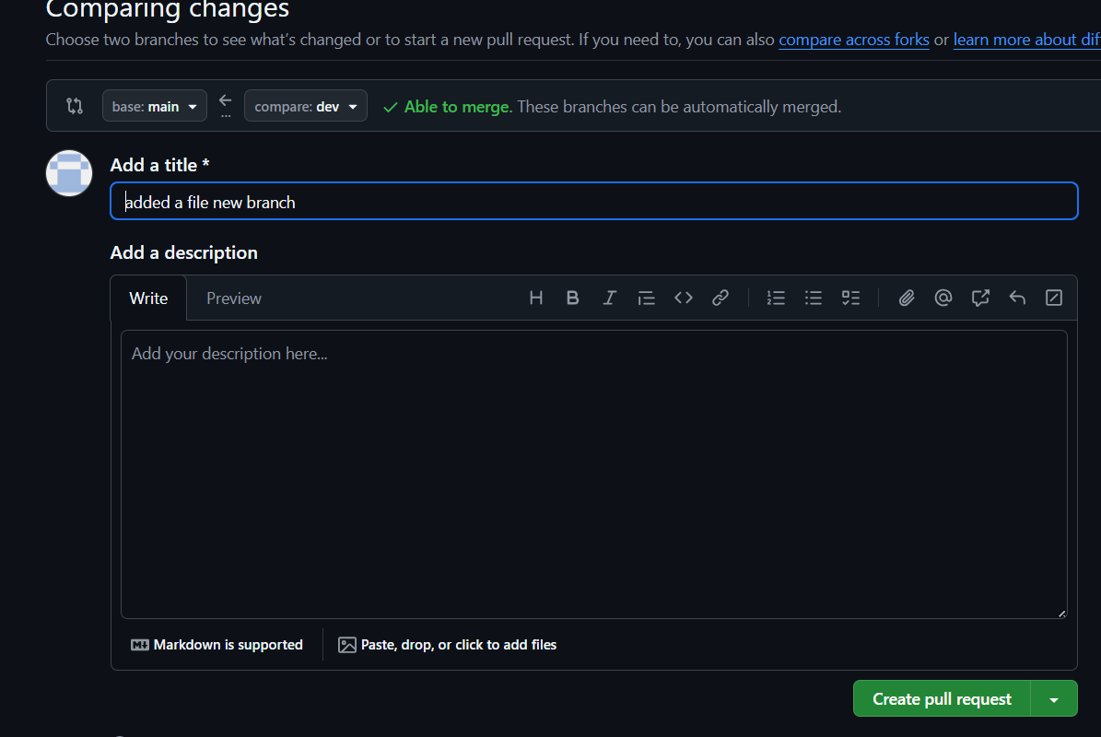
Now base branch the branch we are going to merge and Pull request from dev branch Give the name and create pull request
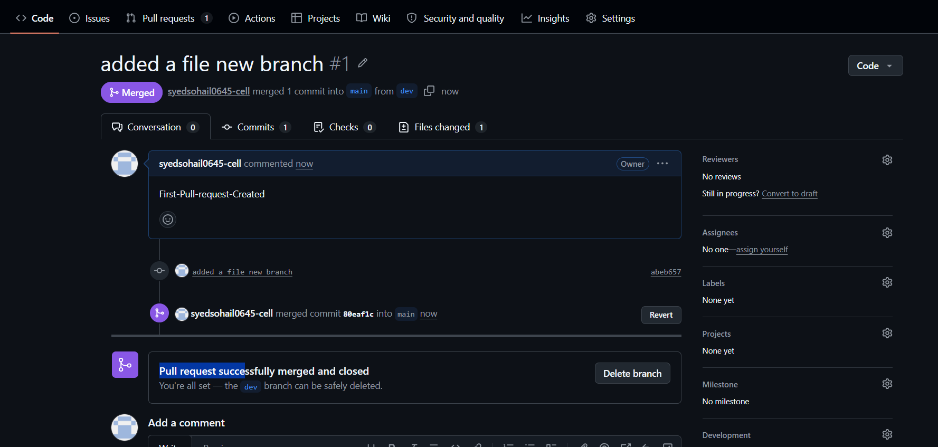
Now go to Pull request and accept the merge request it will done now check the changes in main branch dev branch
10. Create a file in local and send that to branch in github.
To create a file and send that to GitHub First create a file using touch command the use git add (file name) command then use git commit -m and message inside quotes
Then push it to the branch using git push command and branch you want to push the file
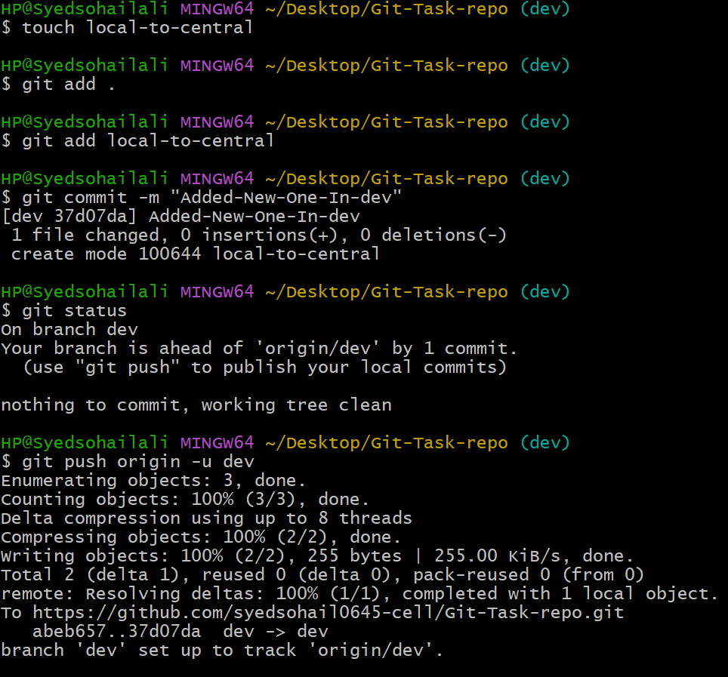
Now the files are pushed from local to central
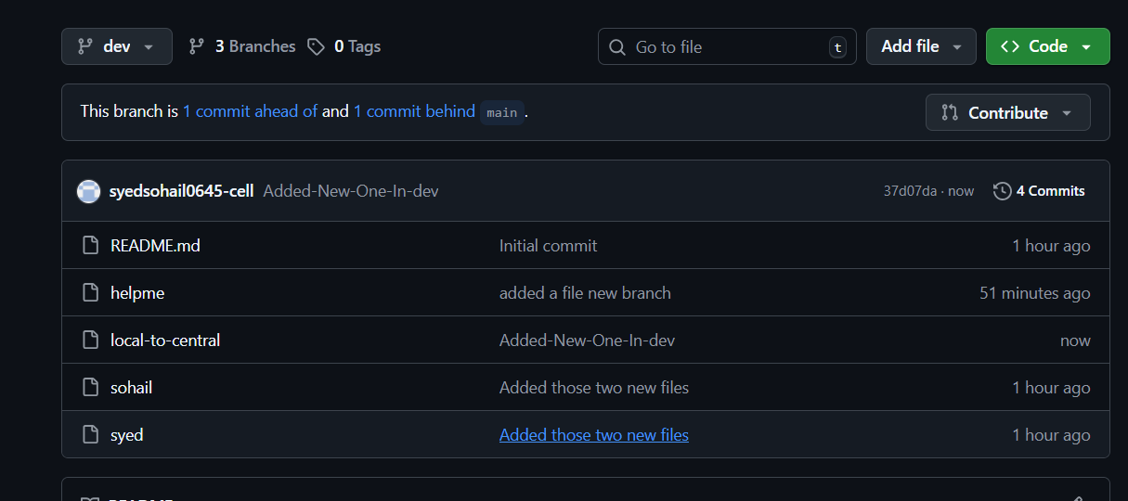

11. Clone only a branch from github to local.
Again use git fetch command it will clone newly created repository and the switch to the specific branch
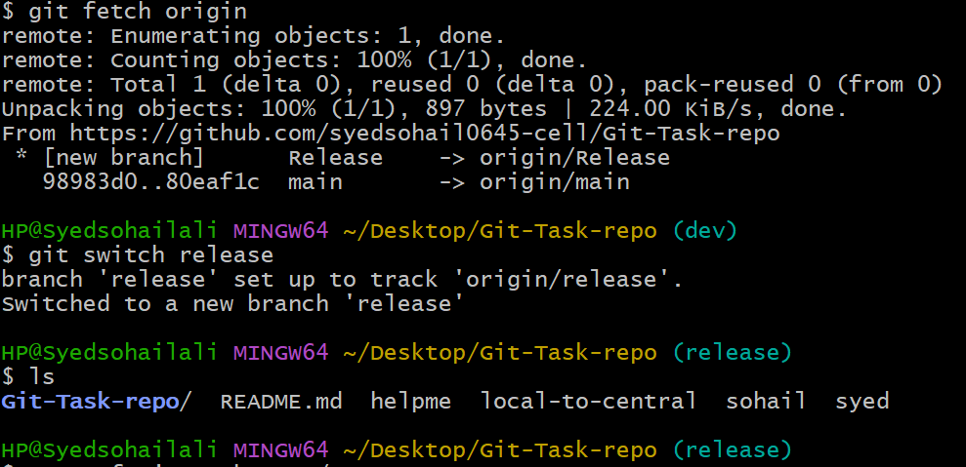
12. Create a file with all passwords and make that untrackable with git.
SO to do all this steps follow the image attached below
Create file and added content to it nano .gitignor file and add password.txt so that our file will be untackable with git
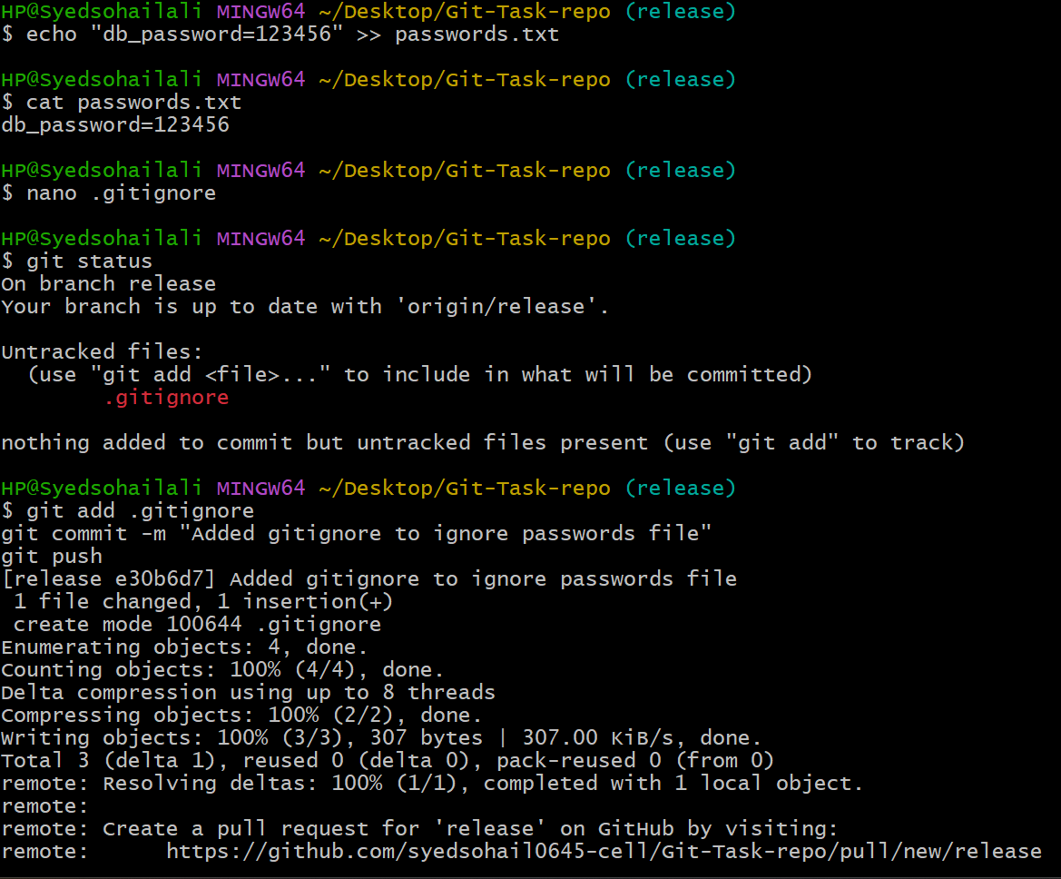
If you check git status it will not track password.txt. file

13 Make a commit and make that commit reset without savings changes.
To do the following reset use the command git reset --hard HEAD~1 This command is used revert and rest the previous commit and help you to without saving changes
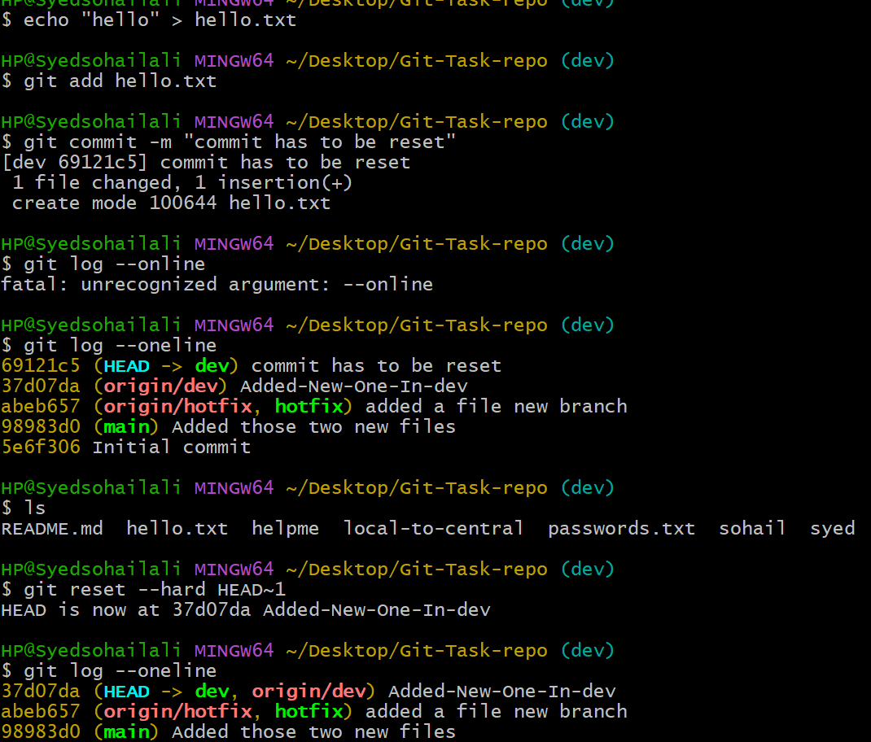
This are steps to be done for the following task
14. Revert a commited commit to the older version.
To do the following Create a File add a content in that file add the file and commit it Again change the content to version02 add and commit the content Use command git revert HEAD
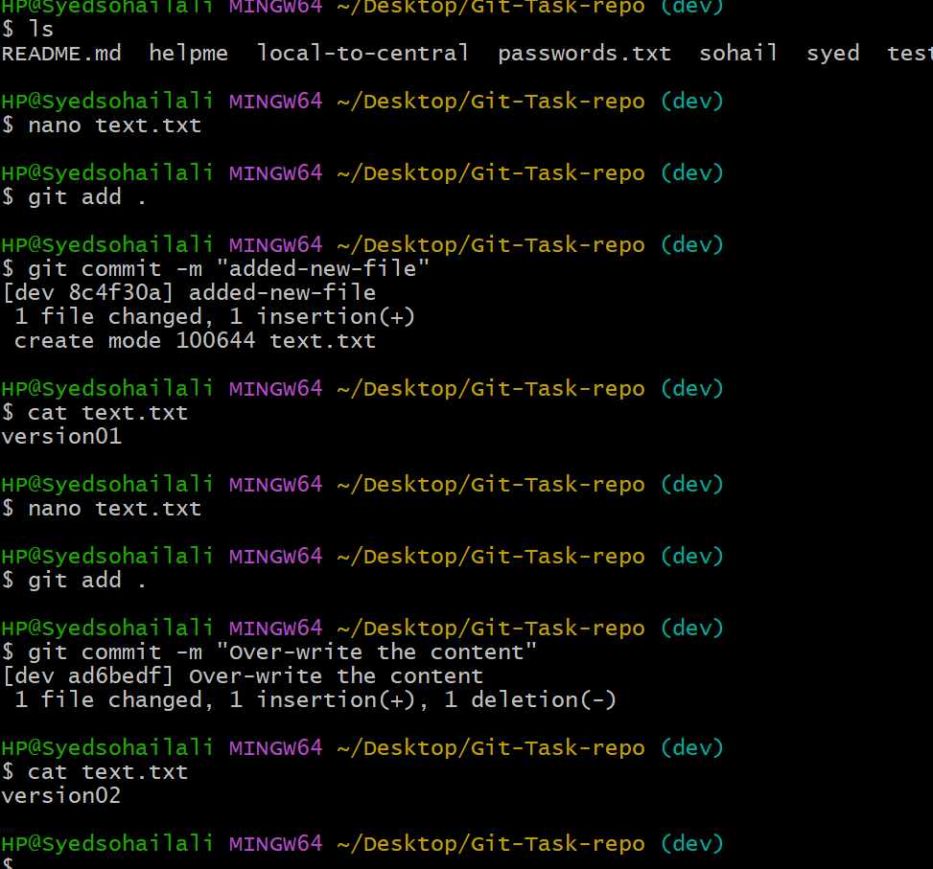
Now use Git revert HEAD command to revert the file to pervious content version01
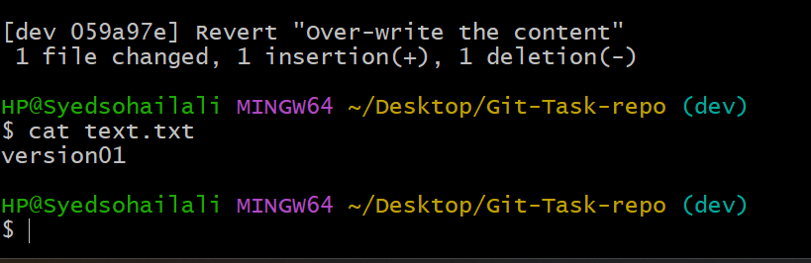
15. Push a file to stash without savings the changes and work on another file.
First create file and work on that now you got task to work on another task or file until that push the file to git stash -u and give git status you will see nothing to commit working tree clean
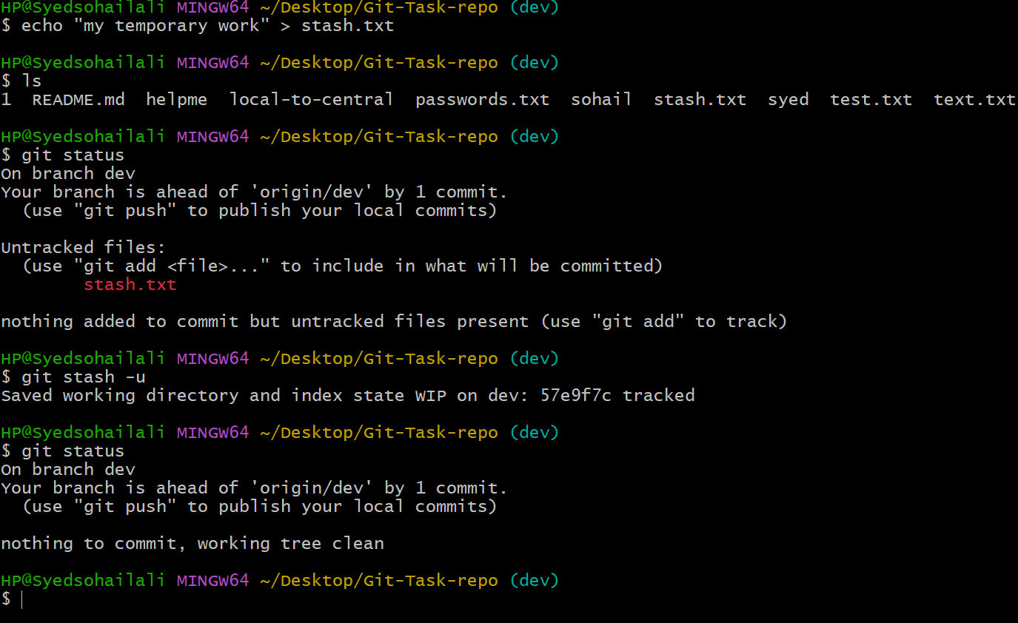
After working on this main file I will work on old file again
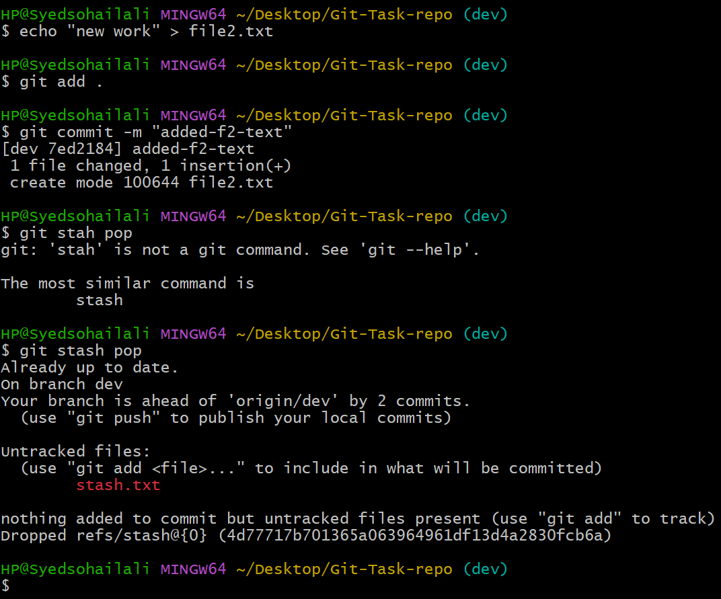
16. Undo the stash file and start working on that again.
To do this create a file work on that and use git stash -u command to the working file to stash memory then once your finished move that to stash after you finished your work use git stash pop command it will help you keep file back on track in below image
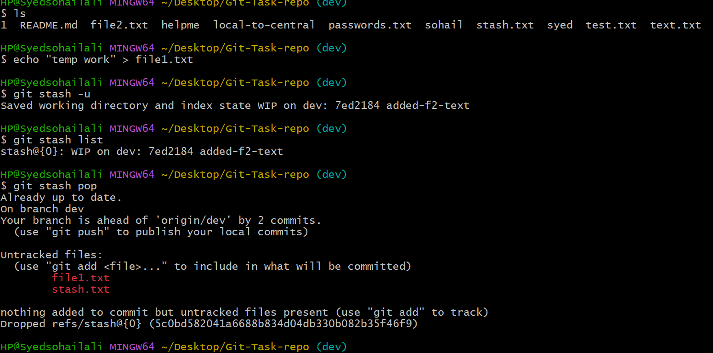
17 Generate a ssh-keygen and configure into github.
First create a public key using ssh-keygen command copy the public key
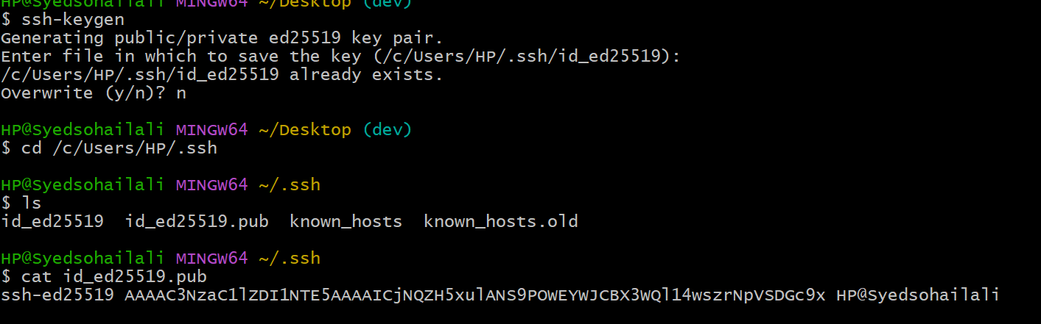
Now go to GitHub user profile settings go to ssh key add your ssh-key here like mentioned in the image
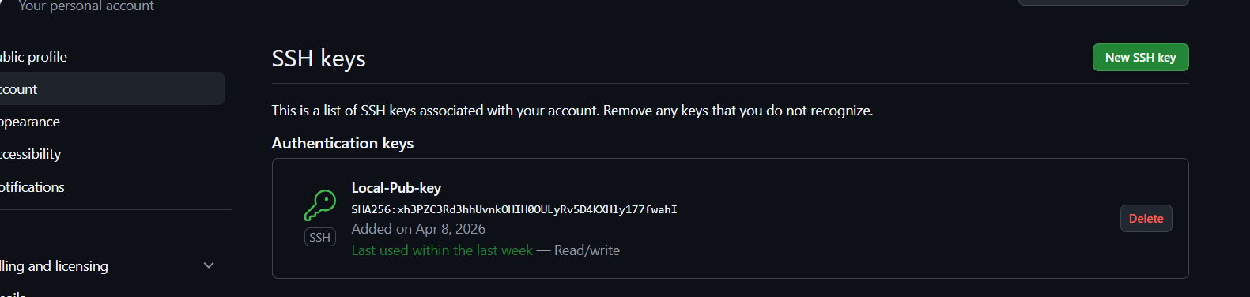
You will recive a mail now use that code form the mail and paste It
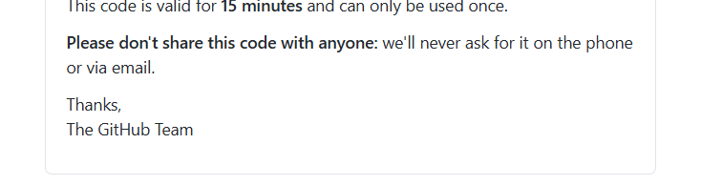
18.Configure webhooks to GitHub.
To do this Go to repository settings you will webhooks over there click webhooks add webhooks
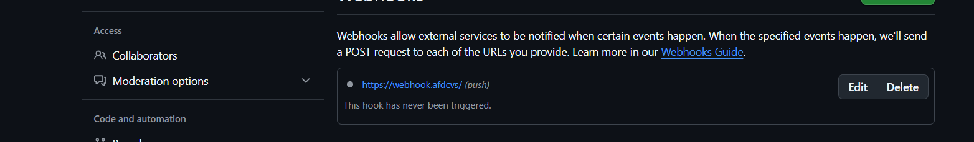
19 Basic understanding of .git file.
.git folder stores all the information about your repository like commits, branches, and history
20 Check all the logs of git.
We can use git log command to check all the logs
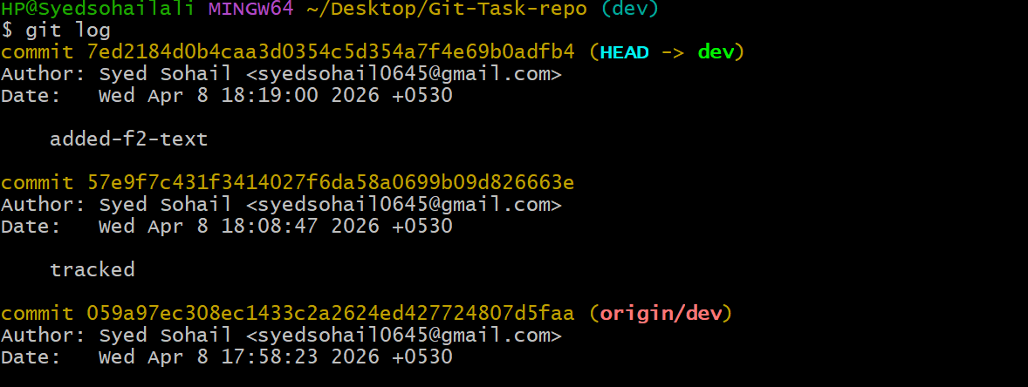
21 Rename the commit message.
To change the last commit message we can use command
git commit --amend -m "New commit message"
this is before changing
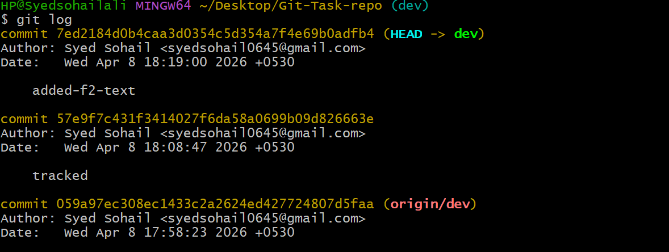
After changing
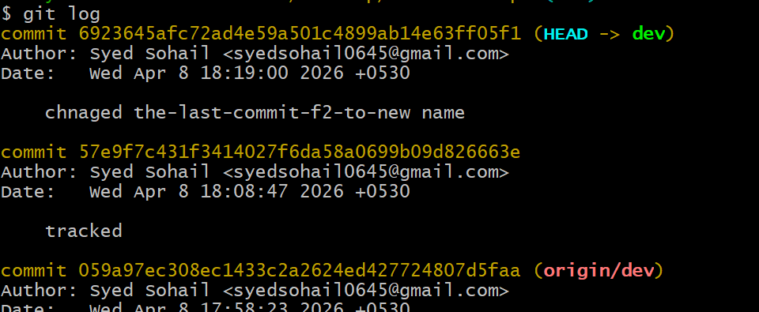
22. Merge multiple commits into single commit
To merge multiple commit into single commit
First use git log -4 command to see first 4 commits
now use the command git rebase -i HEAD~4 to enter the vi mode 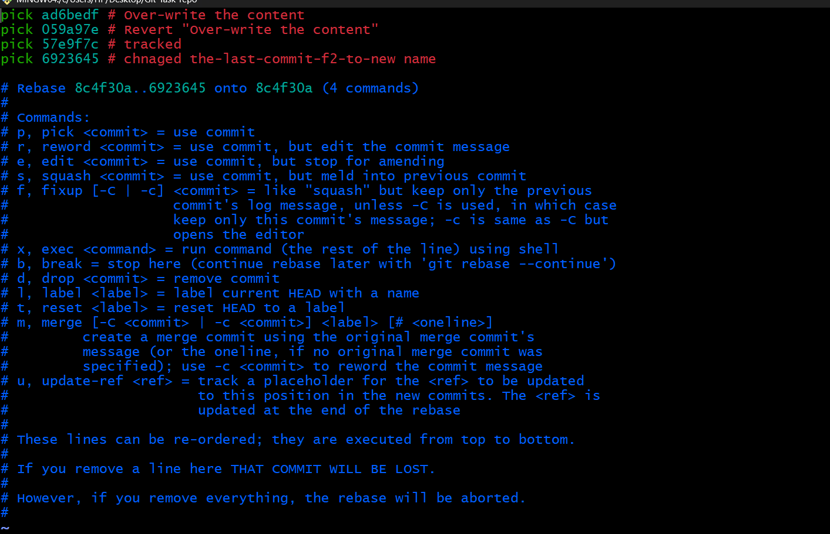
Change the first 3 line pick to squash and save it
and now it’s merged multiple commit into single commit
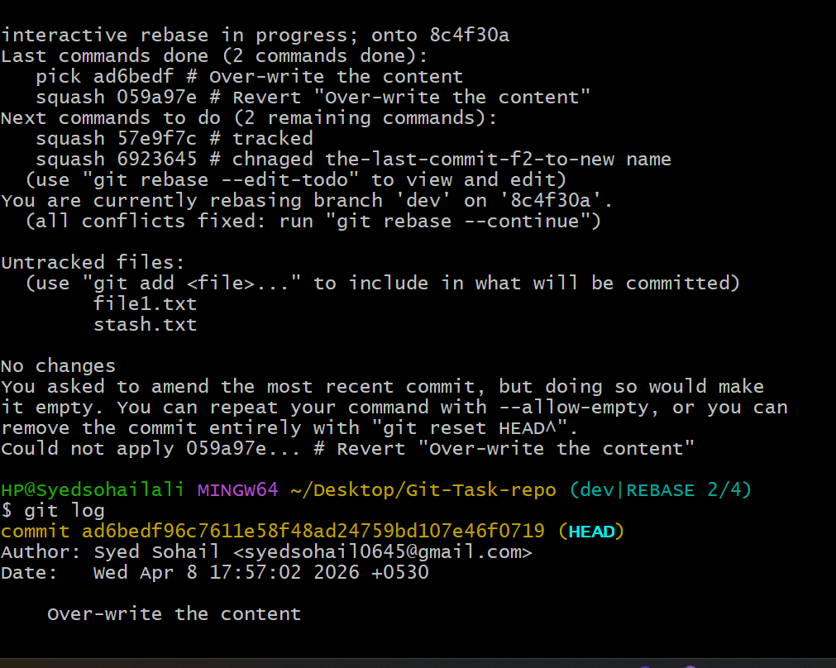
It’s done now

