Data Base Management System(DBMS)
23/10/2026
Name : Harshad Sanjay Teli.
Roll No : 15
Batch : B1
Practical Assignment 8
Practical: Transaction Control Commands (COMMIT, ROLLBACK, SAVEPOINT)
Question: A college maintains student fee payment details in a table named StudentFees(StudentID, StudentName, TotalFees, PaidFees, PendingFees).
Perform the following operations using MySQL TCL commands:
- Create the StudentFees table and insert records for five students.

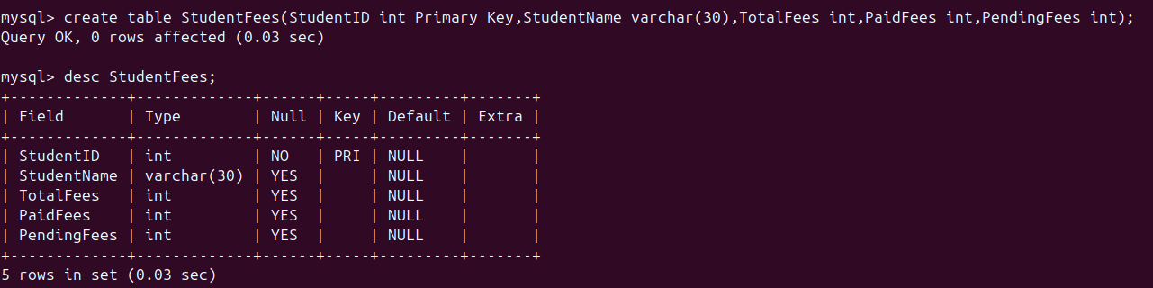
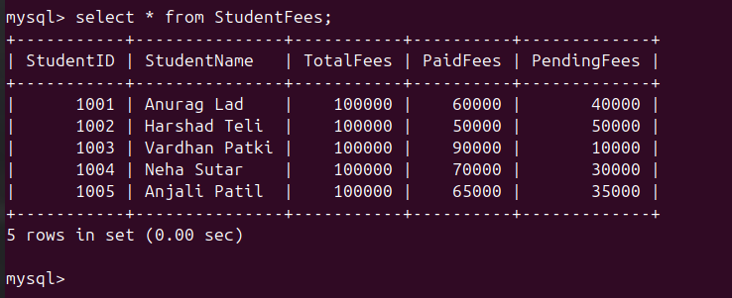

- Start a transaction and update the fee payment of the first student by ₹10,000.
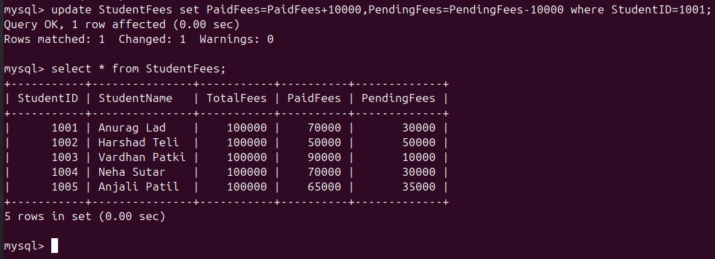

- Create a savepoint named SP1.

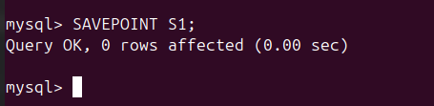

- Update the fee payment of the second student by ₹15,000.
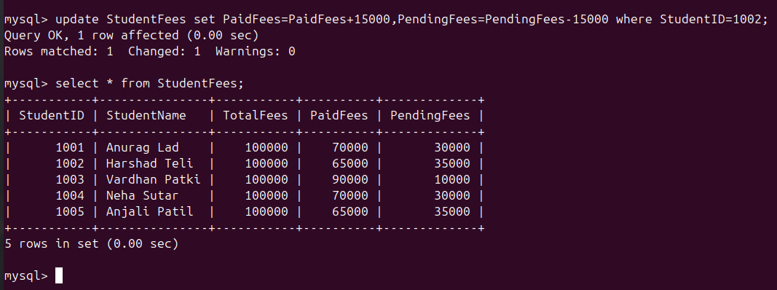
- Create another savepoint named SP2.
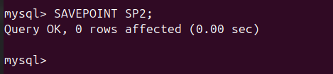

- Update the fee payment of the third student by ₹20,000.

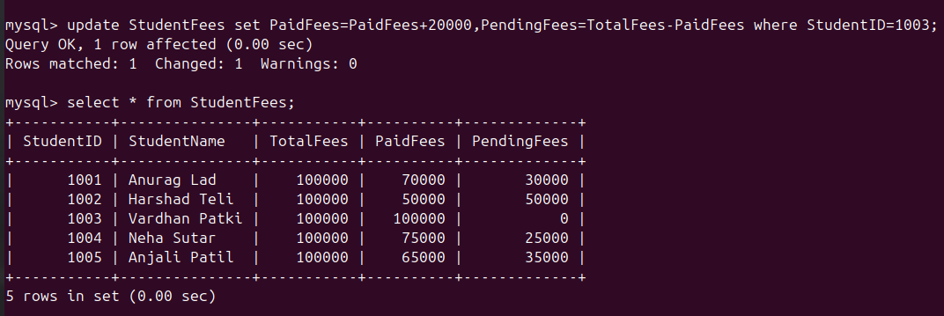

- Roll back to savepoint SP1 to cancel the changes made after it.


- Update the fee payment of the fourth student by ₹5,000.
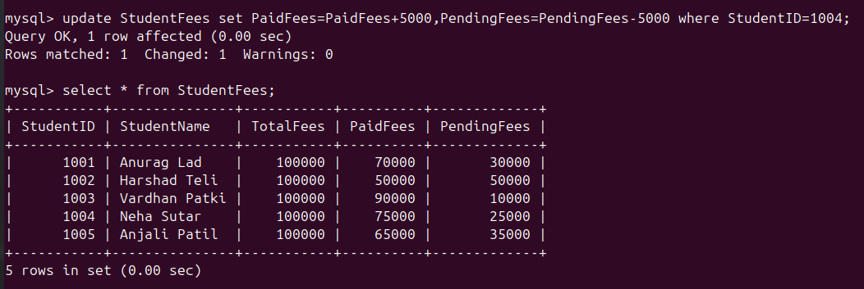
- Display the updated fee payment records.
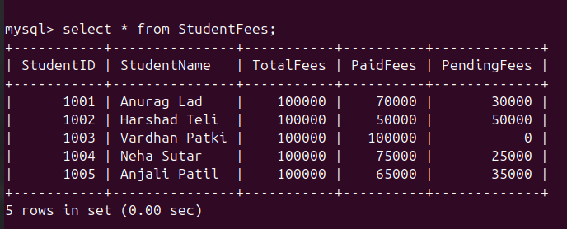

- Use COMMIT to permanently save the remaining changes.

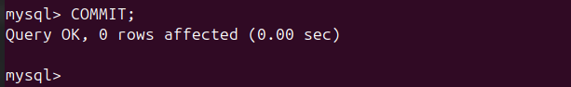

- Start a new transaction and update the fee payment of the fifth student by ₹8,000.

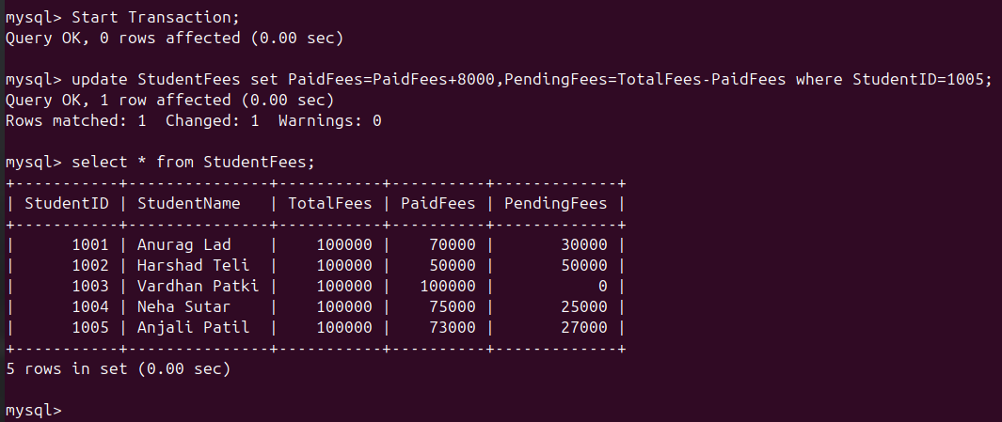

- Use ROLLBACK to cancel the last transaction.
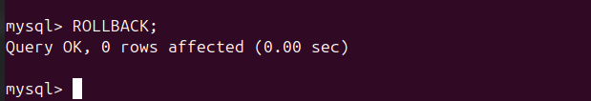

- Display all records and verify which changes were saved and which were cancelled.

