Data Base Management System (DBMS) 2/09/2026
Name : Harshad Sanjay Teli.
Roll No : 15
Batch : B1
Assignment No 1 – Constraints in SQL
Question 1: Employee Management

Table Structure:
Employee(EmpID, EmpName, Department, Salary, City)
Perform the following SQL operations:

Constraints:
- Create the Employee table with EmpID as the PRIMARY KEY.

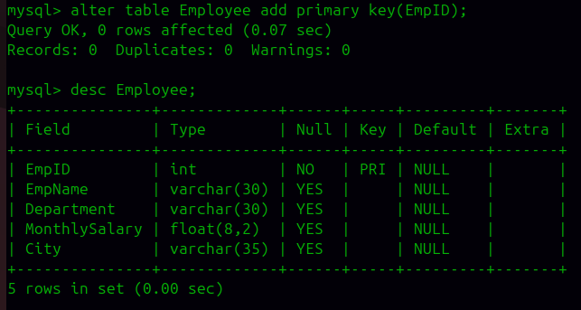

- Apply NOT NULL constraint to EmpName and Department

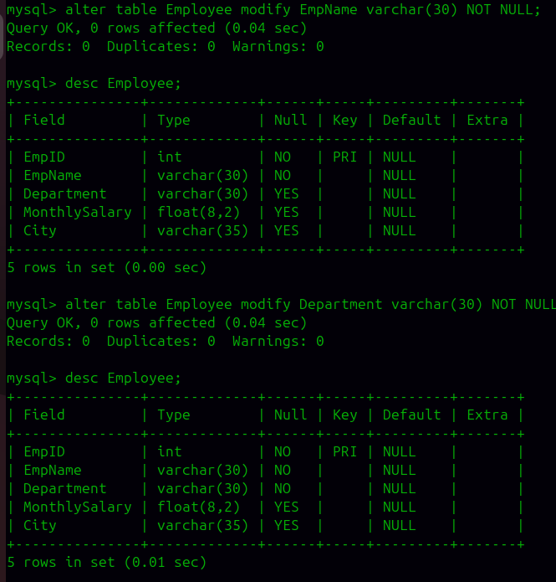
.

- Apply UNIQUE constraint to EmpName

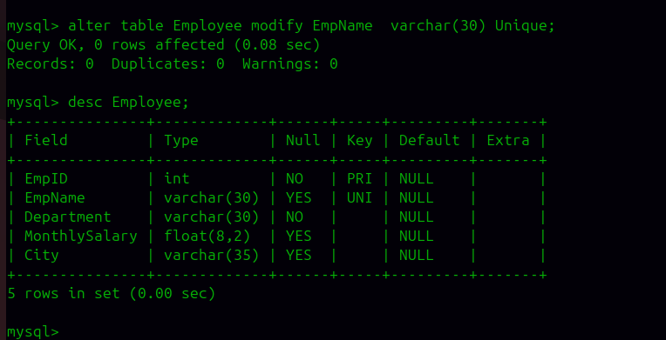

- Apply CHECK constraint to ensure that Salary is greater than 10000.
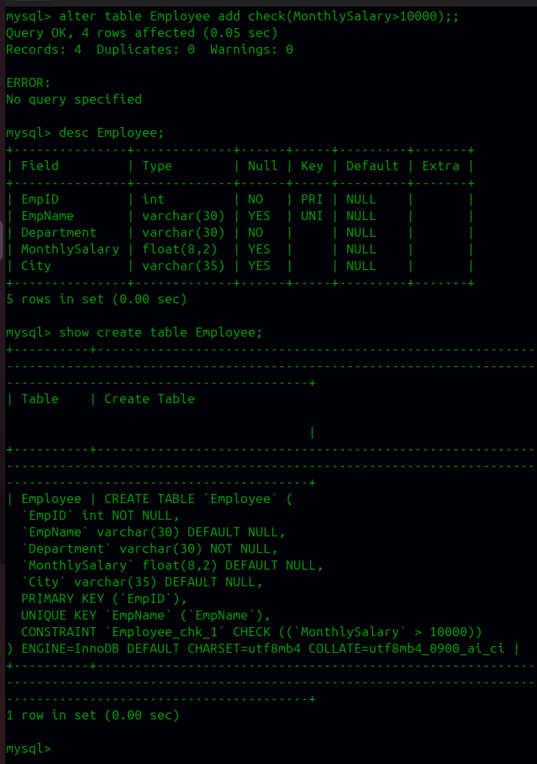
e) Apply CHECK constraint to ensure that Department is one of the following: HR, IT, Finance, Sales.
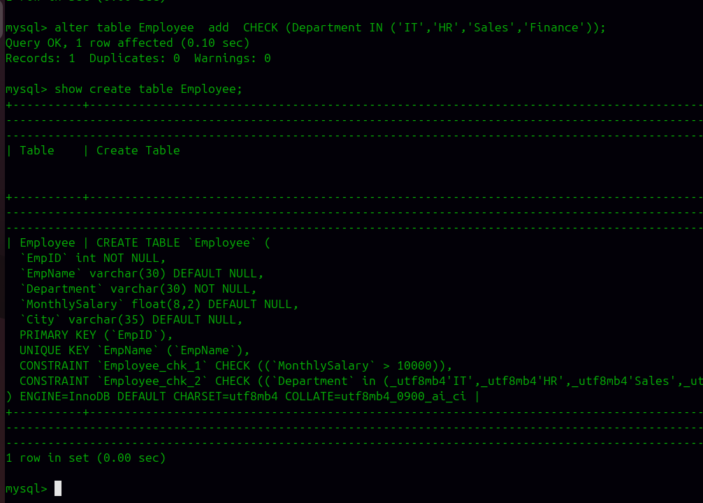
f) Insert at least 5 employee records satisfying all the constraints.
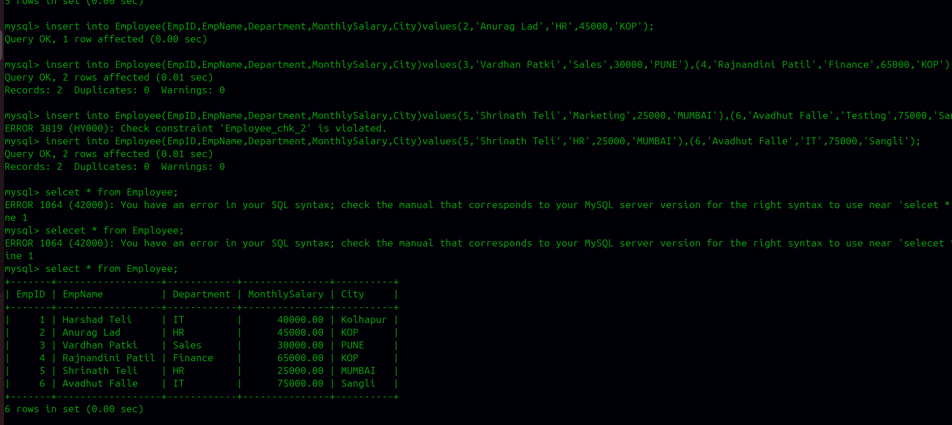

g) Display all employee records.
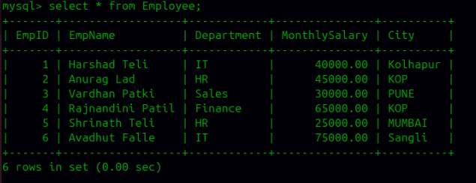
h) Try to insert an employee record with a duplicate EmpID and observe the result.
i) Try to insert an employee record with a duplicate EmpName and observe the result..
j) Try to insert an employee record with Salary less than or equal to 10000 and observe the result.
k) Try to insert an employee record without providing EmpName and observe the result.

l) Display the table structure and verify the constraints applied.
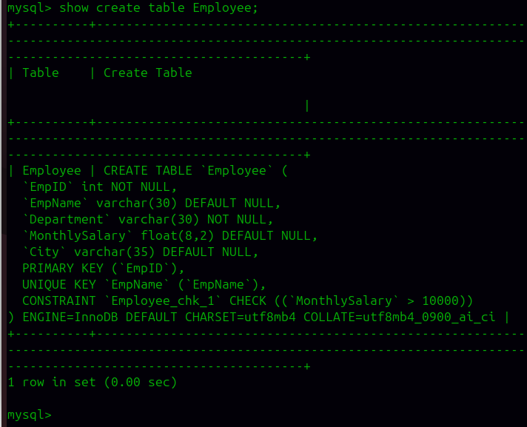

Question 2: Student Management

Table Structure:
Student(StudentID, StudentName, Course, Age, Email)
Perform the following SQL operations:

Constraints:
a) Create the Student table with StudentID as the PRIMARY KEY.
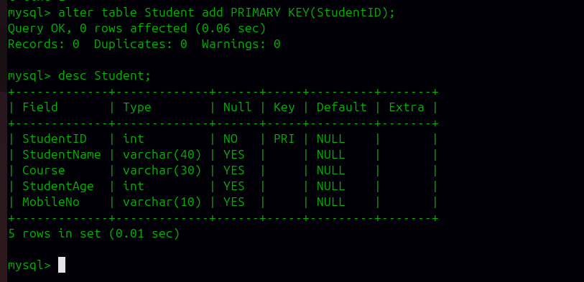
b) Apply NOT NULL constraint to StudentName and Course.
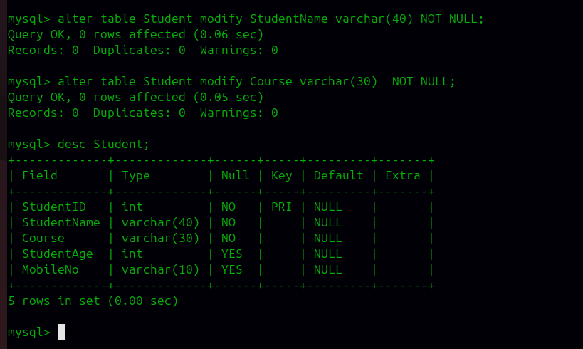
c) Apply UNIQUE constraint to Email.
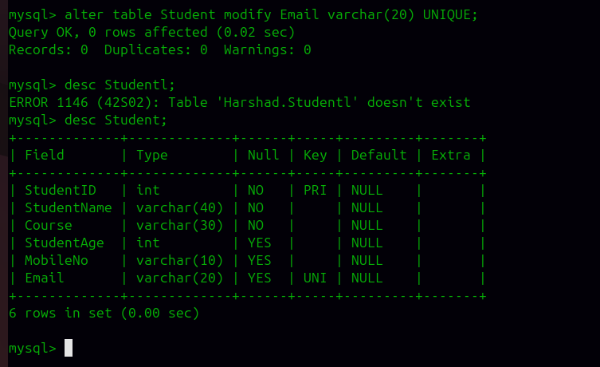
d) Apply CHECK constraint to ensure that Age is greater than or equal to 18.
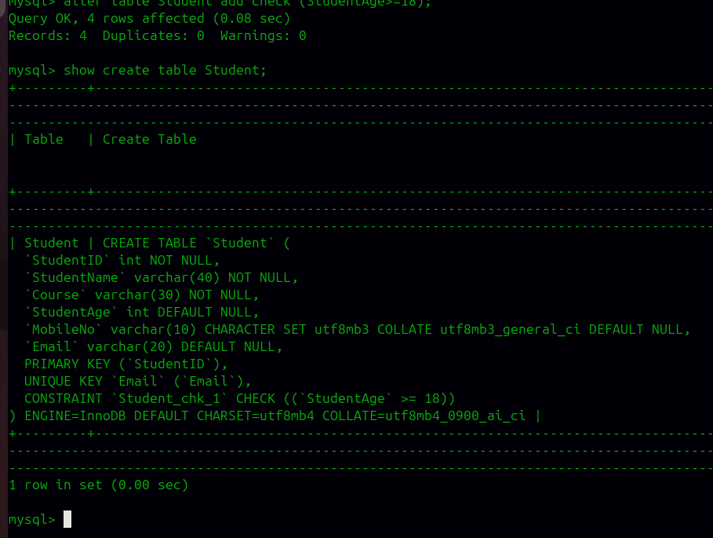
e) Apply CHECK constraint to ensure that Course is one of the following: MCA, MBA, BCA, MSc.
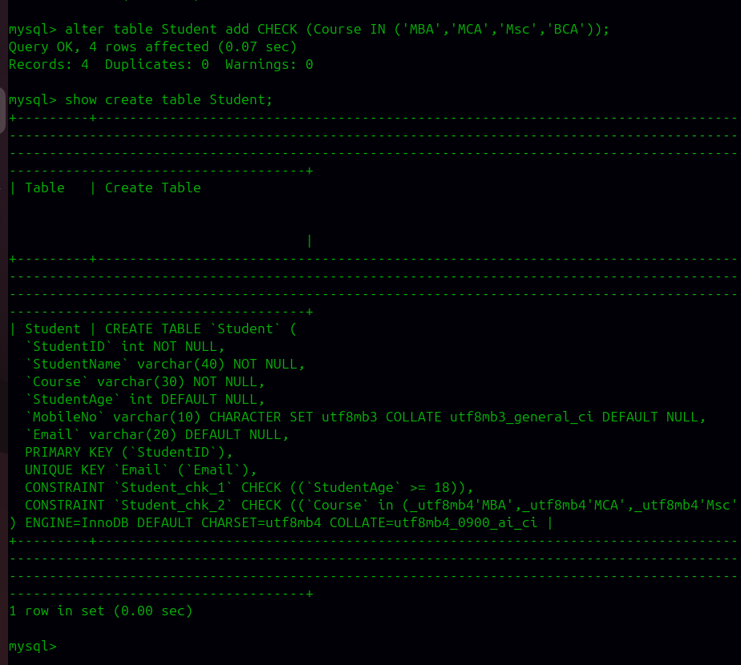
f) Insert at least 5 student records satisfying all the constraints.
(From old Data in the Student Table will be Display)
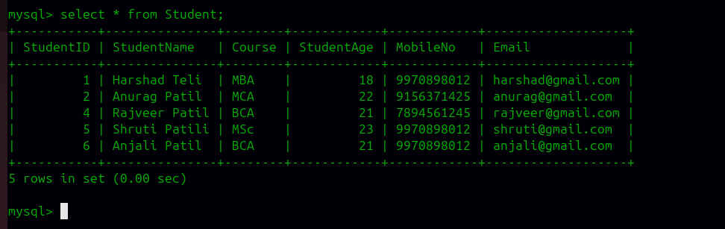
g) Display all student records.

h) Try to insert a student record with a duplicate StudentID and observe the result.
i) Try to insert a student record with a duplicate Email and observe the result.
j) Try to insert a student record with Age less than 18 and observe the result.
k) Try to insert a student record without providing StudentName and observe the result.
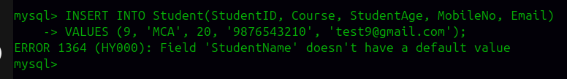

l) Display the table structure and verify the constraints applied.
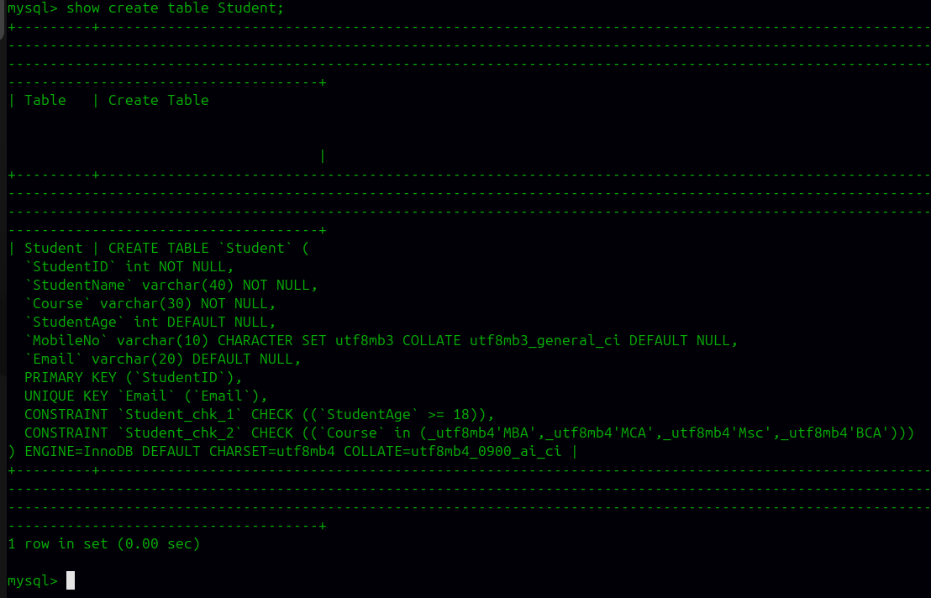

.

c) Add a new column MobileNo.
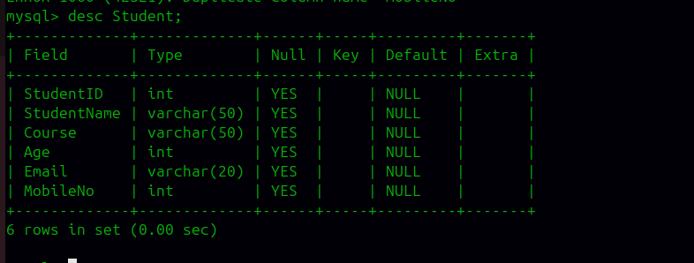
d) Modify the size of the Course column.
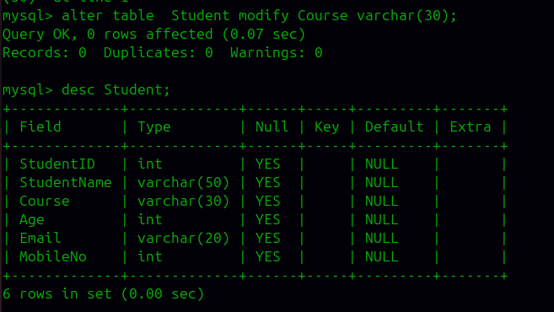

e) Modify the size of the StudentName column.
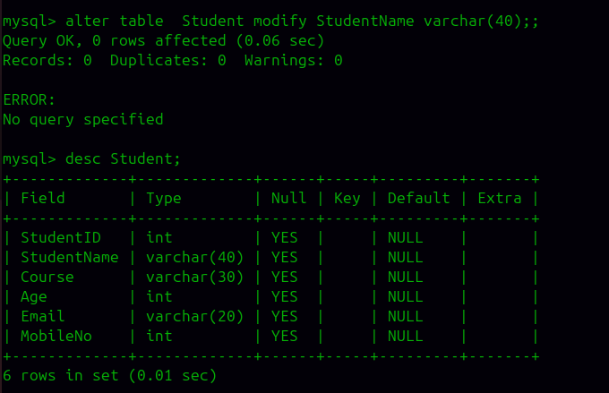
f) Rename the column Age to StudentAge.
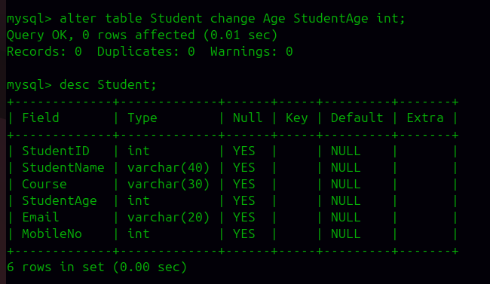

g) Drop the Email column
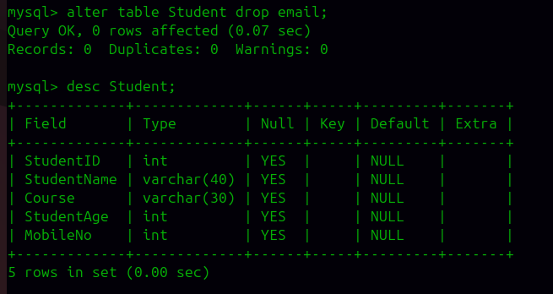
.
h) Rename the table Student to StudentMaster.
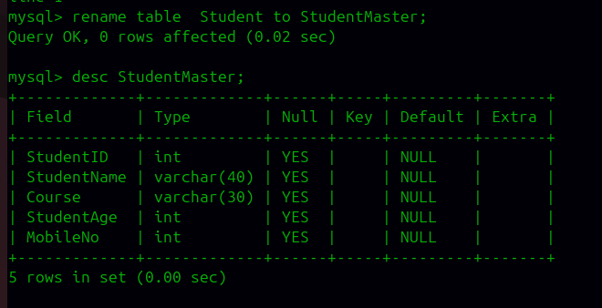

DML Commands:
i) Insert at least 5 student records into the table.
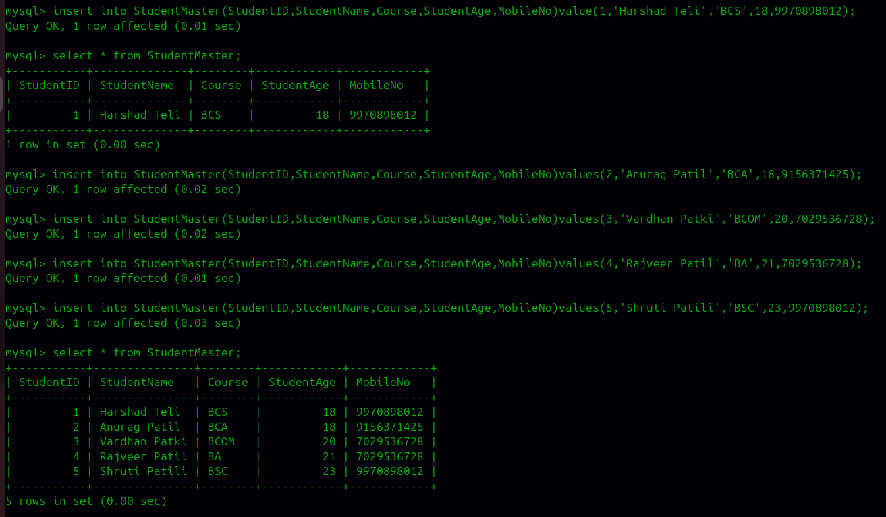
j) Display all records from the table.
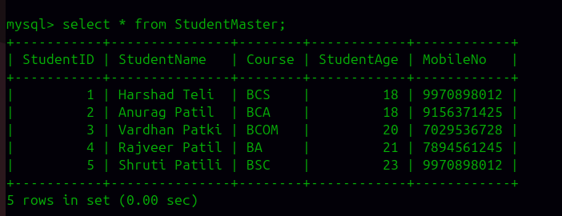

k) Update the Course of a student using StudentID.
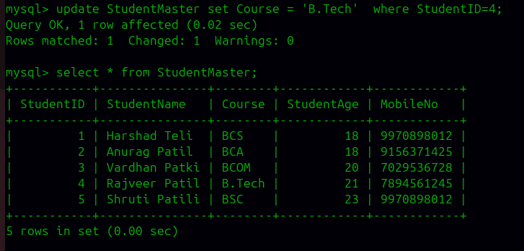
l) Update the StudentAge of a student using StudentID.
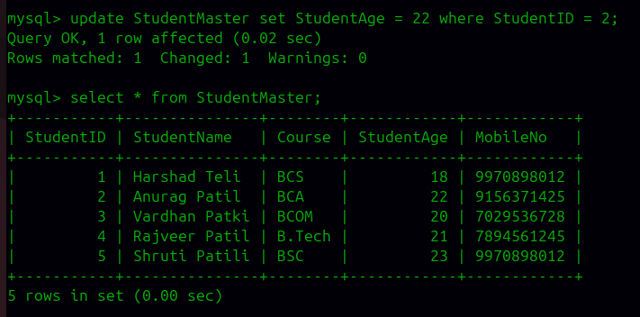

m) Update the MobileNo of a student using StudentID.
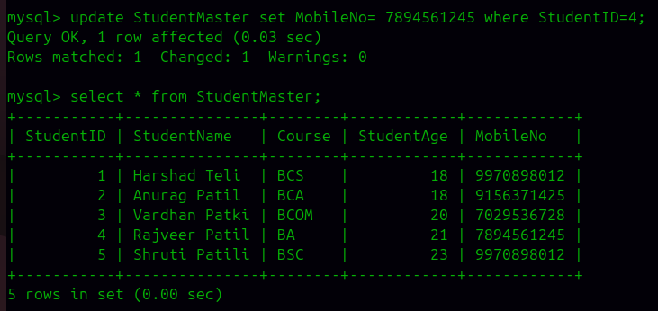
n) Delete one student record using StudentID.
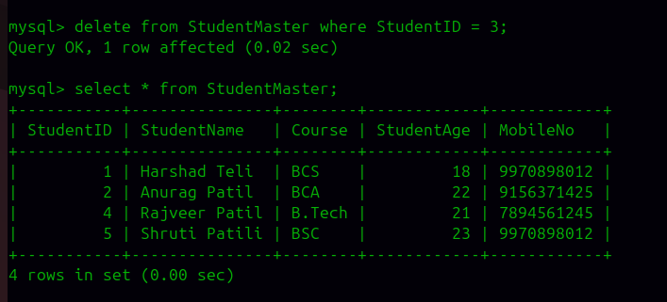
o) Display the records after performing the update and delete operations.
