Data Base Management System (DBMS) 2/09/2026
Name : Harshad Sanjay Teli.
Roll No : 15
Batch : B1
Assignment No 3 – SQL Operators
Question 1: Employee Management

Table Structure:
EmployeeDetails(EmpID, EmpName, MonthlySalary, City)
Perform the following SQL queries

Queries:
- Display the EmpID, EmpName, and MonthlySalary of all employees.

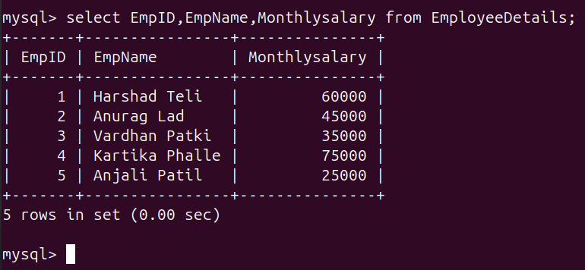

- Display employees whose MonthlySalary is greater than 30000.

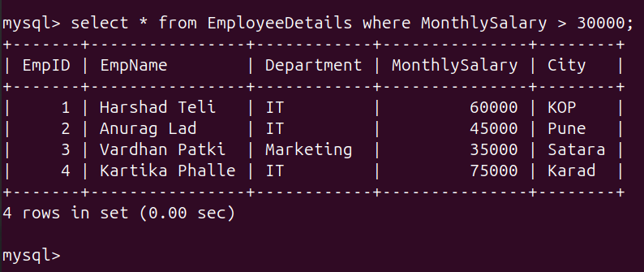

- Display employees whose MonthlySalary is less than or equal to 50000.

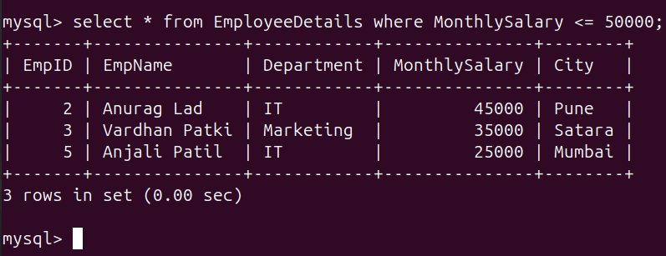
- Display employees who belong to the IT department and have a MonthlySalary greater than 30000.
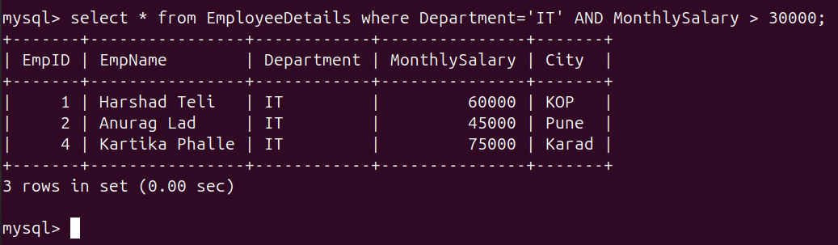
e) Display employees who belong to either the HR department or IT department.
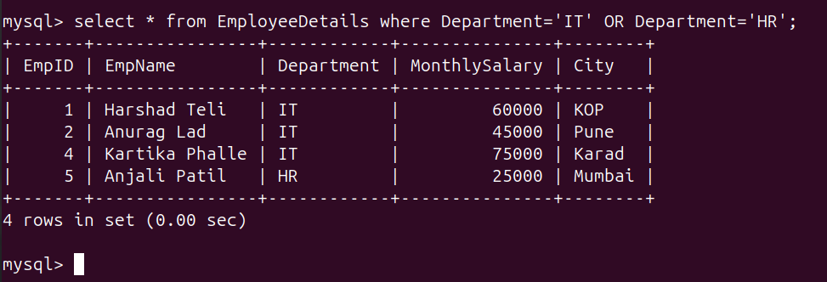
f) IDisplay employees whose Department is IT, HR, or Finance.
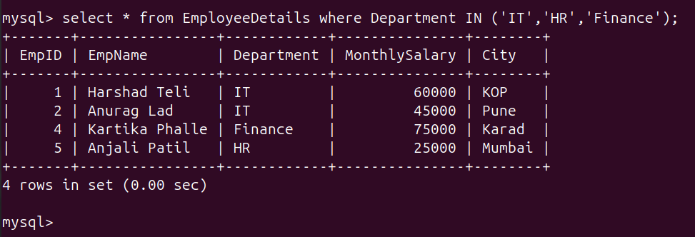
g) Display employees whose MonthlySalary is between 25000 and 50000.
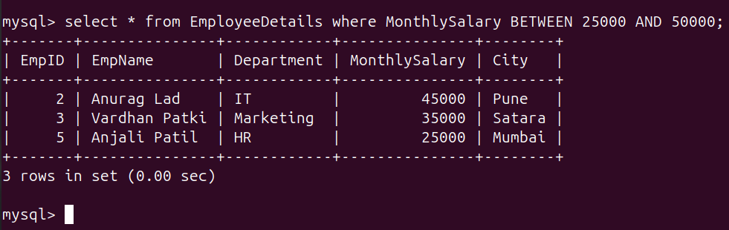
h) Display employees whose EmpName starts with the letter 'A'.
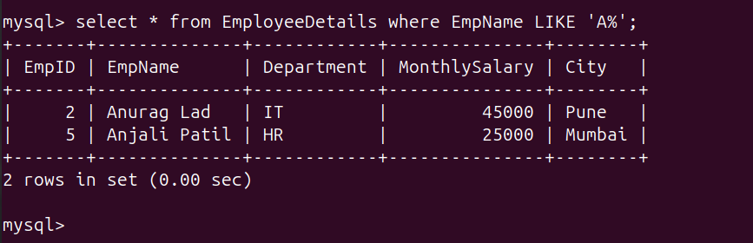
i) Display employees who are not from the IT department.
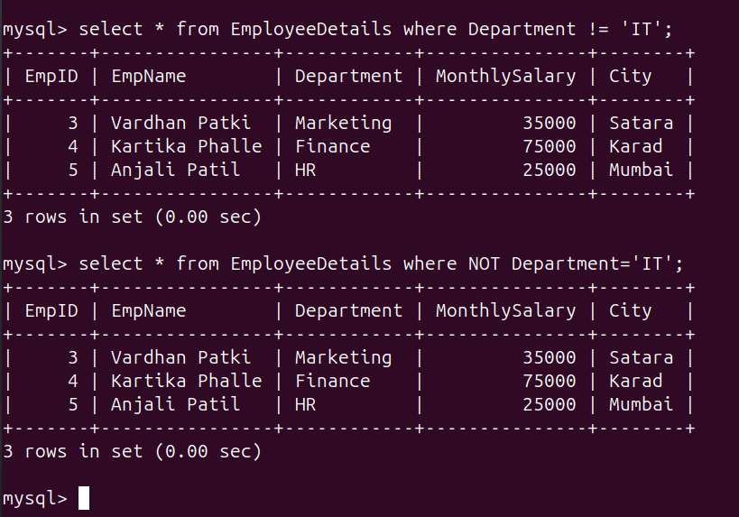
j) Display EmpID, EmpName, MonthlySalary, and calculate the Annual Salary.
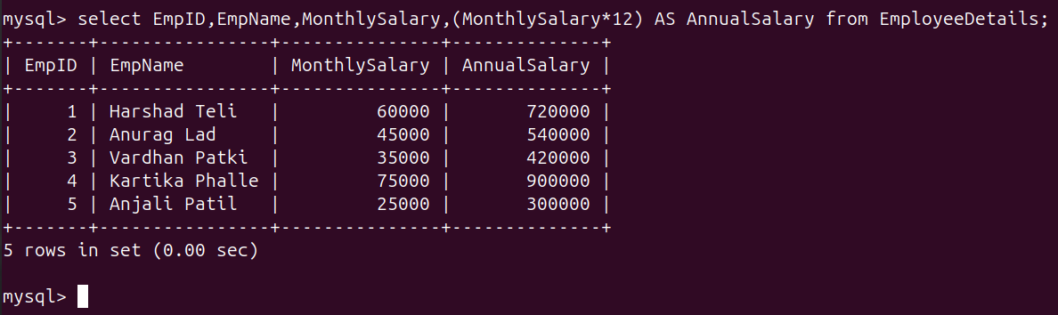

Question 2: Student Management

Table Structure:
StudentMaster(StudentID, StudentName, Course, Age, Email)
Perform the following SQL operations:

Queries:
a) Display the StudentID, StudentName, and Course of all students.
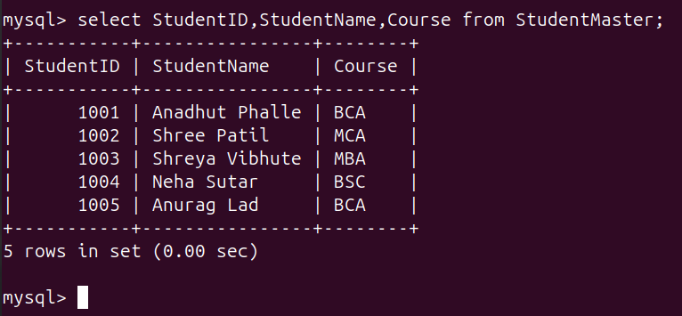
b) Display students whose StudentAge is greater than 20.
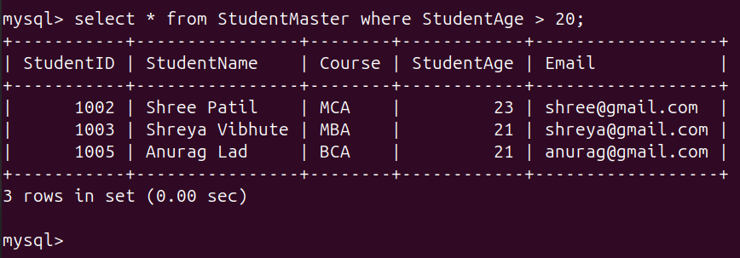

c) Display students whose StudentAge is less than or equal to 25.
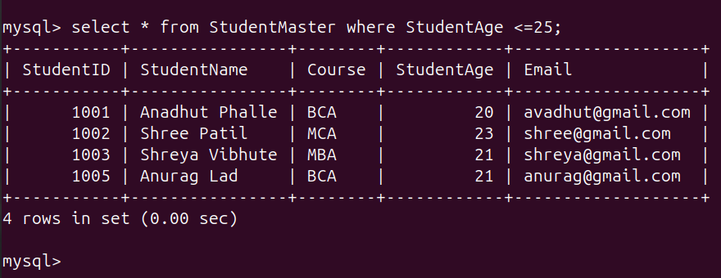
d) Display students who are studying MCA and whose StudentAge is greater than 20.
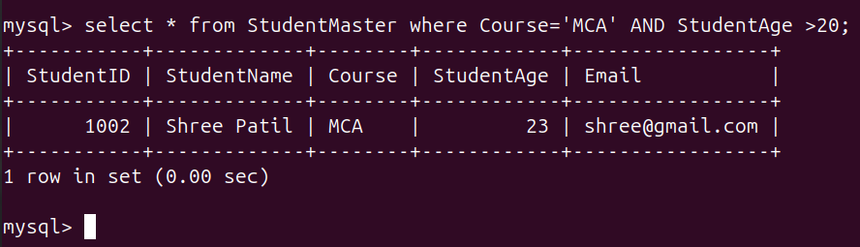
e) Display students who are studying either MCA or BCA.
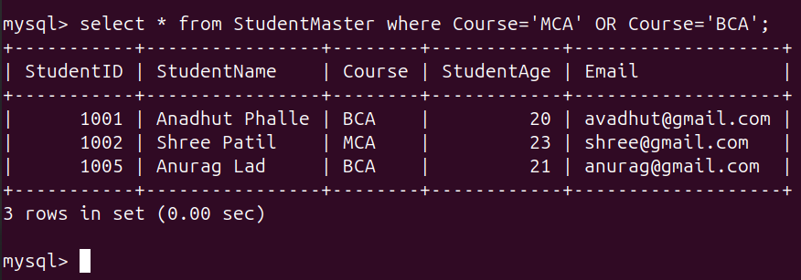

f) Display students whose Course is MCA, BCA, or MBA.
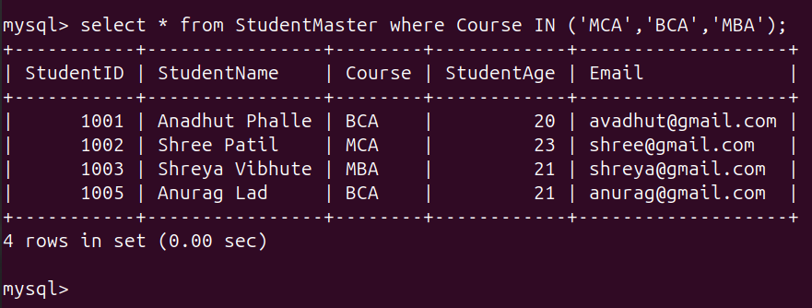
g) Display students whose StudentAge is between 18 and 25.
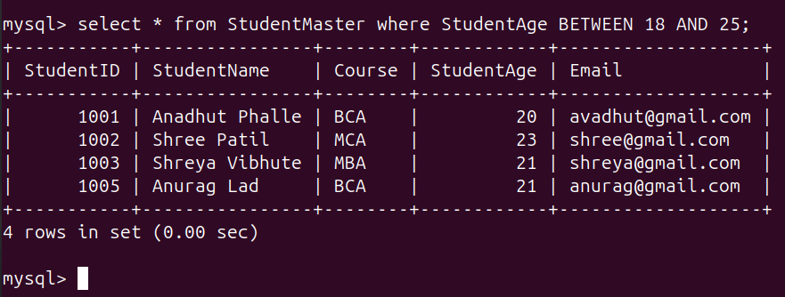
h) Display students whose StudentName starts with the letter 'S'.
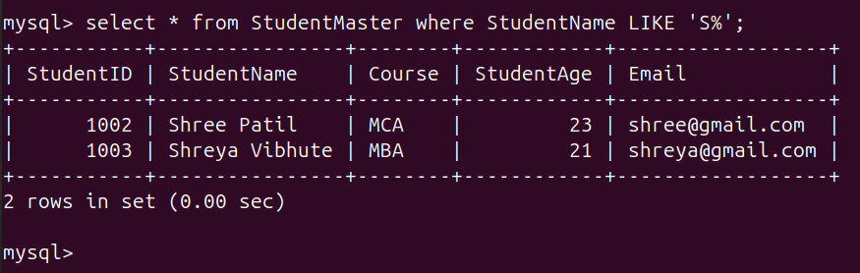

i) Display students who are not studying MCA.
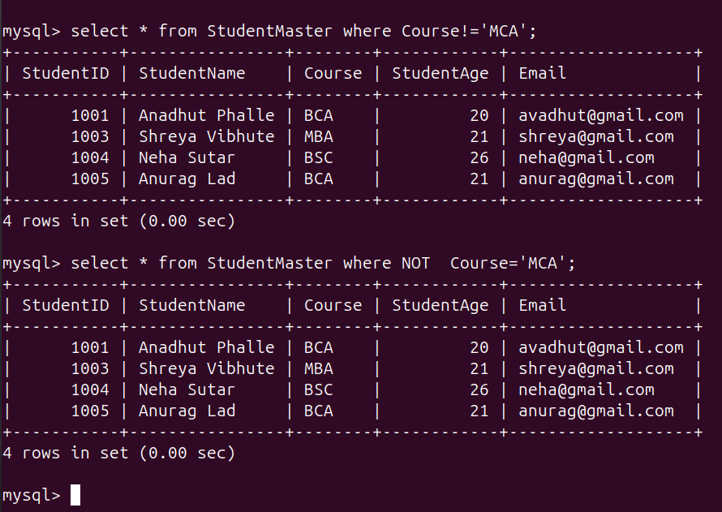
j) Display students whose StudentName contains the letter 'a' and whose StudentAge is greater than 20.
