Internet Programming 03/09/2026
Name : Harshad Sanjay Teli.
Roll No : 15
Batch : B1
Assignment No 4
Image with Image Map.

Q1. Image with Image Map
Insert an image (for example, a world map or campus map) and define two clickable areas using <map> and <area> tags.
Each area should link to a different website or internal page.
Example:
- Click on India → opens https://www.india.gov.in
- Click on USA → opens https://www.usa.gov
Input:
<!DOCTYPE html>
<html>
<head>
<title>Image Map Example</title>
</head>
<body>
<h2>Click on India or USA on the Map</h2>

<img src="https://www.shutterstock.com/image-vector/usa-india-on-world-map-260nw-2428470365.jpg"
alt="World Map"
usemap="#worldmap"
width="800" height="400">
<map name="worldmap">
<area shape="rect"
coords="530,165,580,230"
href="https://www.india.gov.in"
alt="India"
title="Click to go to India.gov.in"
target="_blank">

<area shape="rect"
coords="100,90,230,190"
href="https://www.usa.gov"
alt="USA"
title="Click to go to USA.gov"
target="_blank">
</map>
</body>
</html>

Output:
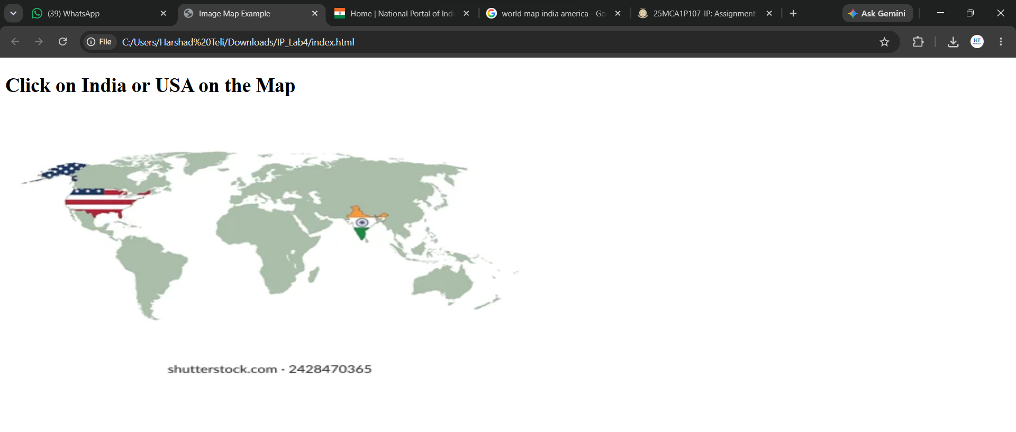
When the user click on the India in the above World Map

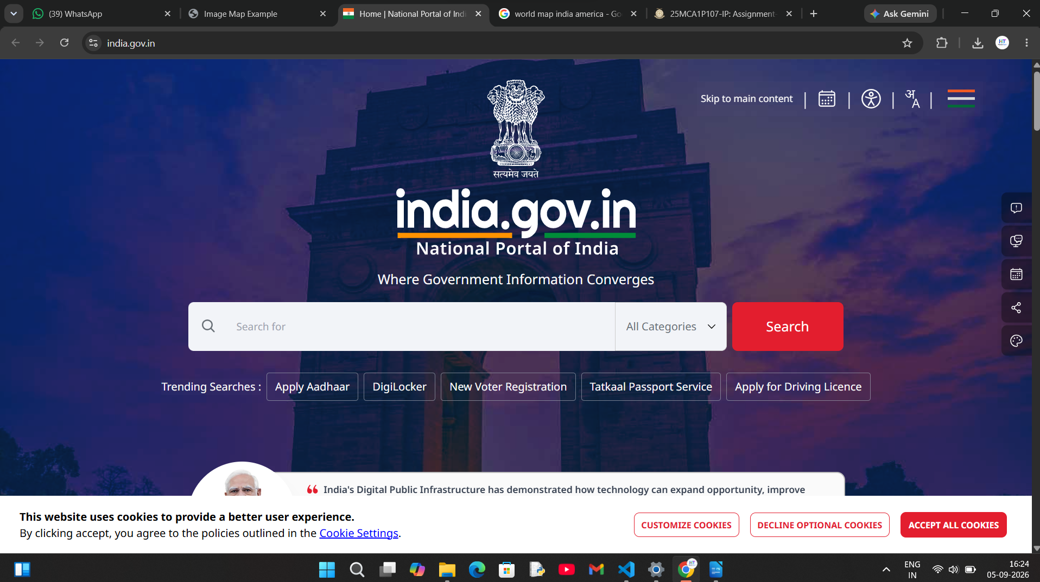
When the user click on the America then the

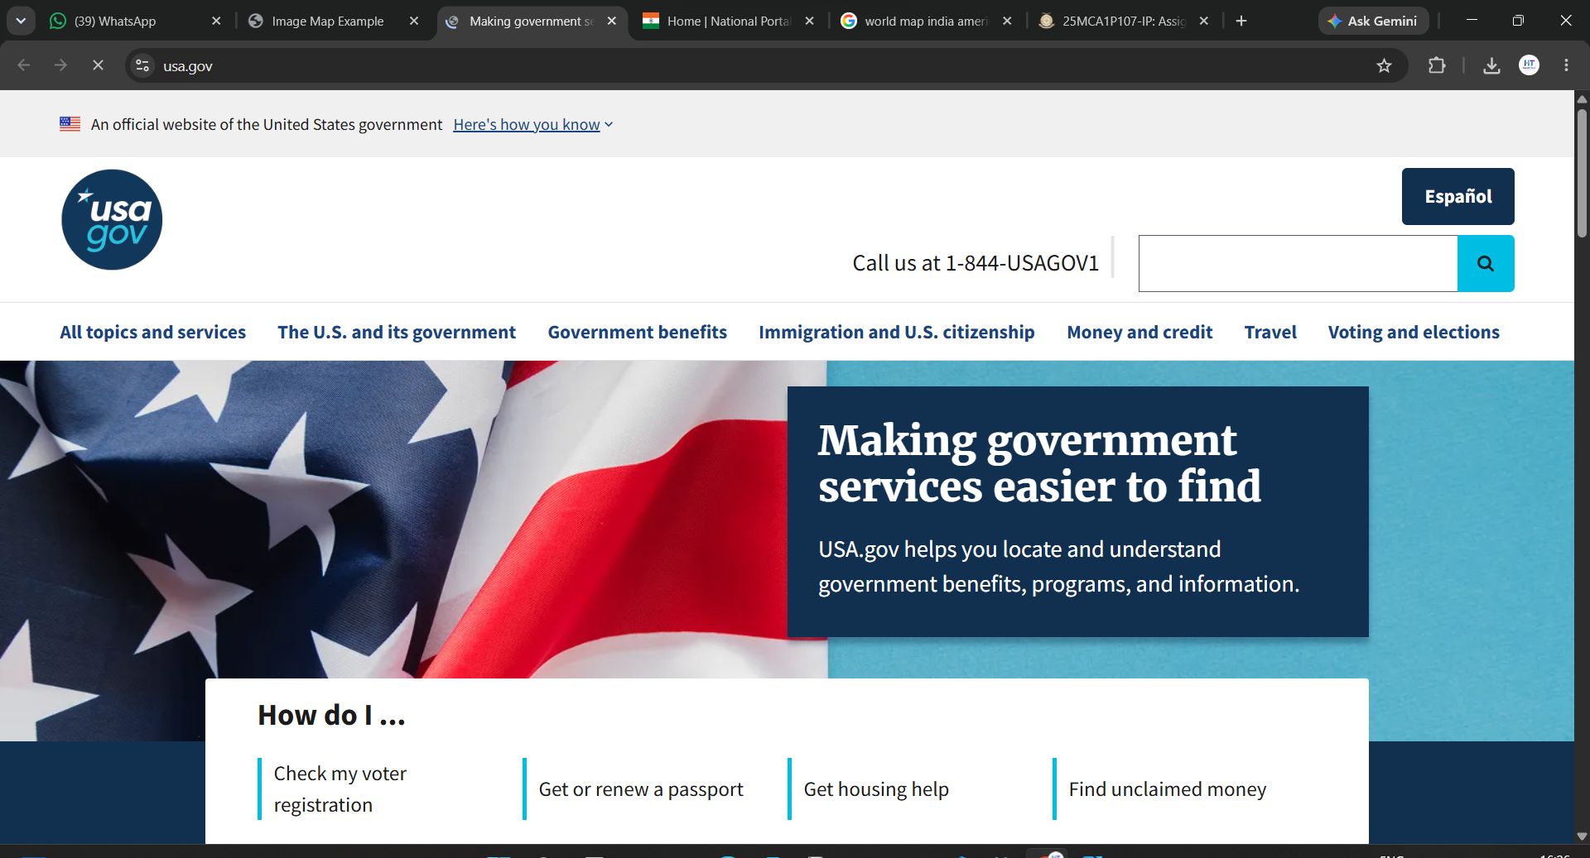

Q2. Interactive Flower Garden
Insert an image of a flower garden containing different flowers. Using <map> and <area>, create three clickable areas.
Each clickable area should open a different data:text/html page containing information about the selected flower.
- Click on Rose → display information about Rose.
- Click on Sunflower → display information about Sunflower.
- Click on Jasmine → display information about Jasmine.

Input:
<!DOCTYPE html>
<html>
<head>
<title>Garden Image Map</title>
</head>
<body>
<h2>Click on Flowers in the Garden</h2>

<img src="garder.jpeg"
alt="Garden Image"
usemap="#flowermap"
width="800" height="400">

<map name="flowermap">
<!-- 1. Rose -->
<area shape="rect"
coords="50,50,250,300"
href="data:text/html;charset=utf-8,%3Ch1%3E%F0%9F%8C%B9%20Rose%3C%2Fh1%3E%3Cp%3E%3Cb%3EScientific%20Name%3A%3C%2Fb%3E%20Rosa%3Cbr%3E%3Cb%3EFamily%3A%3C%2Fb%3E%20Rosaceae%3Cbr%3E%3Cbr%3EKnown%20as%20the%20King%20of%20Flowers.%20Symbol%20of%20love%20and%20beauty.%20Used%20for%20perfume%20and%20rose%20water.%3C%2Fp%3E"
alt="Rose"
title="Click for Rose Info"
target="_blank">

<area shape="rect"
coords="300,50,500,300"
href="data:text/html;charset=utf-8,%3Ch1%3E%F0%9F%8C%BB%20Sunflower%3C%2Fh1%3E%3Cp%3E%3Cb%3EScientific%20Name%3A%3C%2Fb%3E%20Helianthus%3Cbr%3E%3Cb%3EFamily%3A%3C%2Fb%3E%20Asteraceae%3Cbr%3E%3Cbr%3EAlways%20faces%20the%20sun.%20Gives%20sunflower%20oil%20and%20seeds.%20Symbol%20of%20happiness.%3C%2Fp%3E"
alt="Sunflower"
title="Click for Sunflower Info"
target="_blank">

<area shape="rect"
coords="550,50,750,300"
href="data:text/html;charset=utf-8,%3Ch1%3E%F0%9F%8C%B8%20Jasmine%3C%2Fh1%3E%3Cp%3E%3Cb%3EScientific%20Name%3A%3C%2Fb%3E%20Jasminum%3Cbr%3E%3Cb%3EFamily%3A%3C%2Fb%3E%20Oleaceae%3Cbr%3E%3Cbr%3EWhite%20flower%20with%20sweet%20fragrance.%20Blooms%20at%20night.%20Used%20in%20garlands%20and%20tea.%3C%2Fp%3E"
alt="Jasmine"
title="Click for Jasmine Info"
target="_blank">
</map>
</body>
</html>

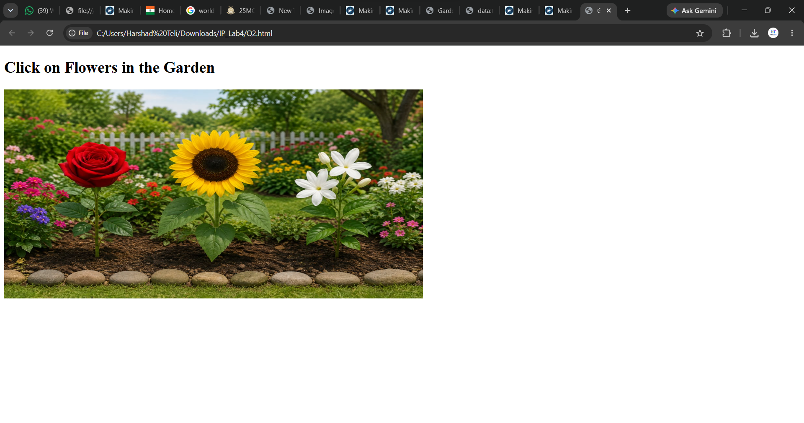
Whe we click on the Rose then the following infotmation will be c

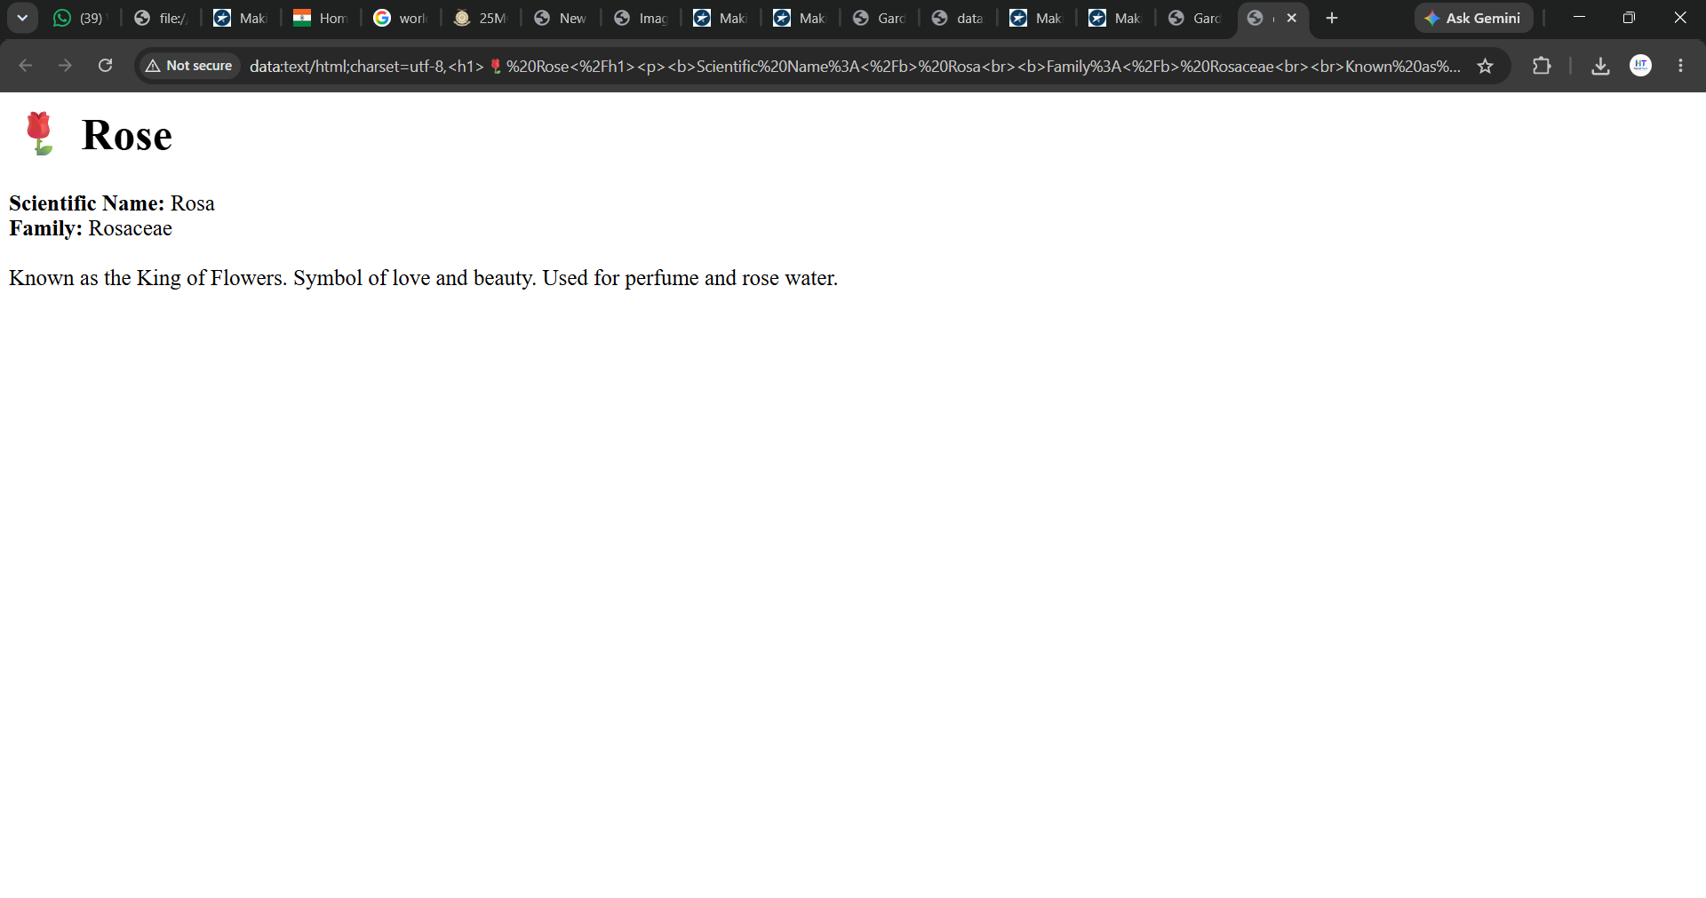
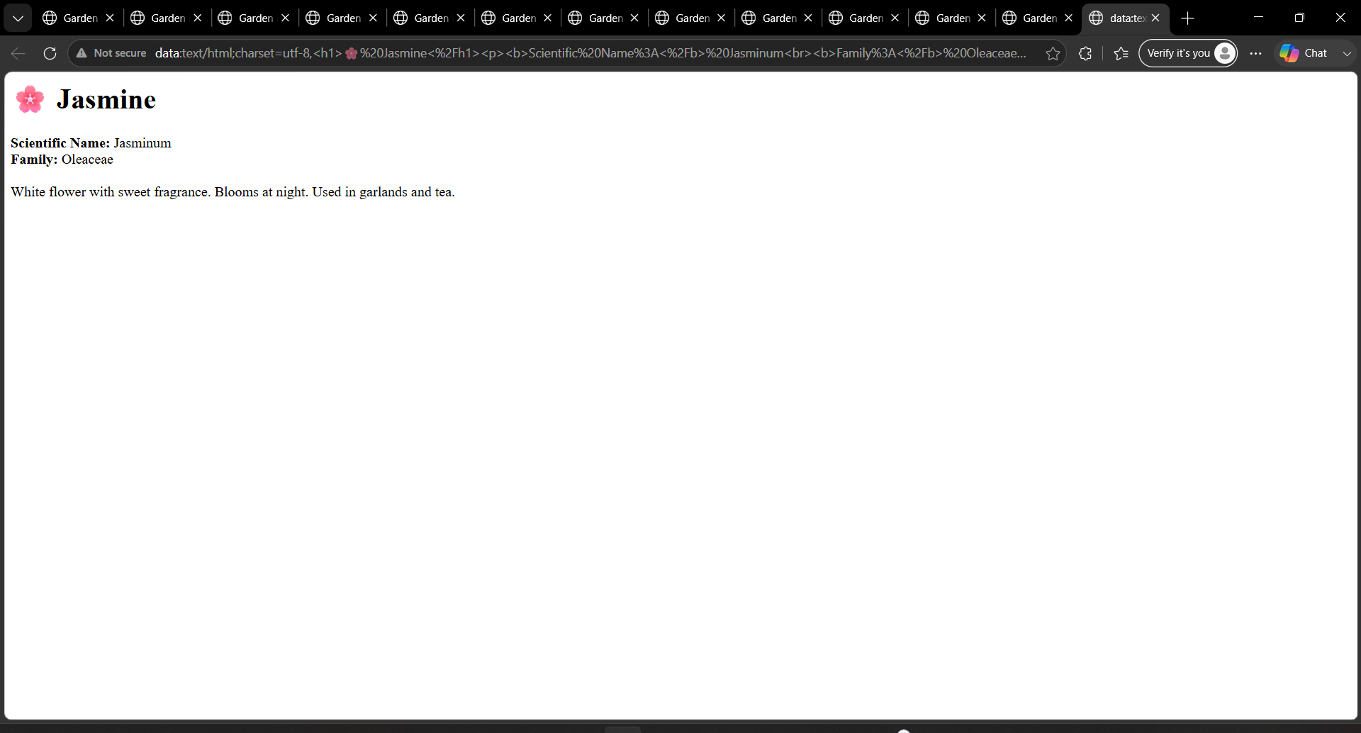

Q3. Interactive Vehicle Image
Insert an image containing different vehicles, such as a Car, Bus, and Motorcycle.
Define two clickable areas using <map> and <area>.
- Click on Car → display its basic features and uses.
- Click on Motorcycle → display its basic features and uses.
Use data:text/html to display the information.
Input:

<!DOCTYPE html>
<html>
<head>
<title>Interactive Vehicle Image</title>
</head>
<body>
<h2>My Garage - Click on Car or Motorcycle</h2>

<img src="garage.jpeg"
alt="Car and Motorcycle in Garage"
usemap="#vehiclemap"
width="800" height="500">

<map name="vehiclemap">

<area shape="rect"
coords="98,315,450,770"
href="data:text/html;charset=utf-8,<body style='font-family:Arial; padding:20px; background:%23ffe9e9'><h1>🚗 Car</h1><h3>Basic Features:</h3><ul><li>4 Wheels, 5 Seater Sedan</li><li>Engine: 1200cc Petrol</li><li>Features: AC, Airbags, Touchscreen</li><li>Top Speed: 180 km/h, Mileage 20 kmpl</li></ul><h3>Uses:</h3><ul><li>Family travel and long trips</li><li>Comfortable and safe in all weather</li><li>Luggage carrying capacity</li></ul></body>"
alt="Car"
title="Click for Car Info"
target="_blank">

<area shape="rect"
coords="450,365,705,795"
href="data:text/html;charset=utf-8,<body style='font-family:Arial; padding:20px; background:%23e6f0ff'><h1>🏍️ Motorcycle</h1><h3>Basic Features:</h3><ul><li>2 Wheels, 2 Seater Sports Bike</li><li>Engine: 150cc-300cc Petrol</li><li>Features: Disc Brakes, LED Headlights</li><li>Top Speed: 140 km/h, Mileage 45 kmpl</li></ul><h3>Uses:</h3><ul><li>Fast commuting in city traffic</li><li>Low fuel cost and easy parking</li><li>Thrill and adventure riding</li></ul></body>"
alt="Motorcycle"
title="Click for Motorcycle Info"
target="_blank">
</map>
</body>
</html>

Output:
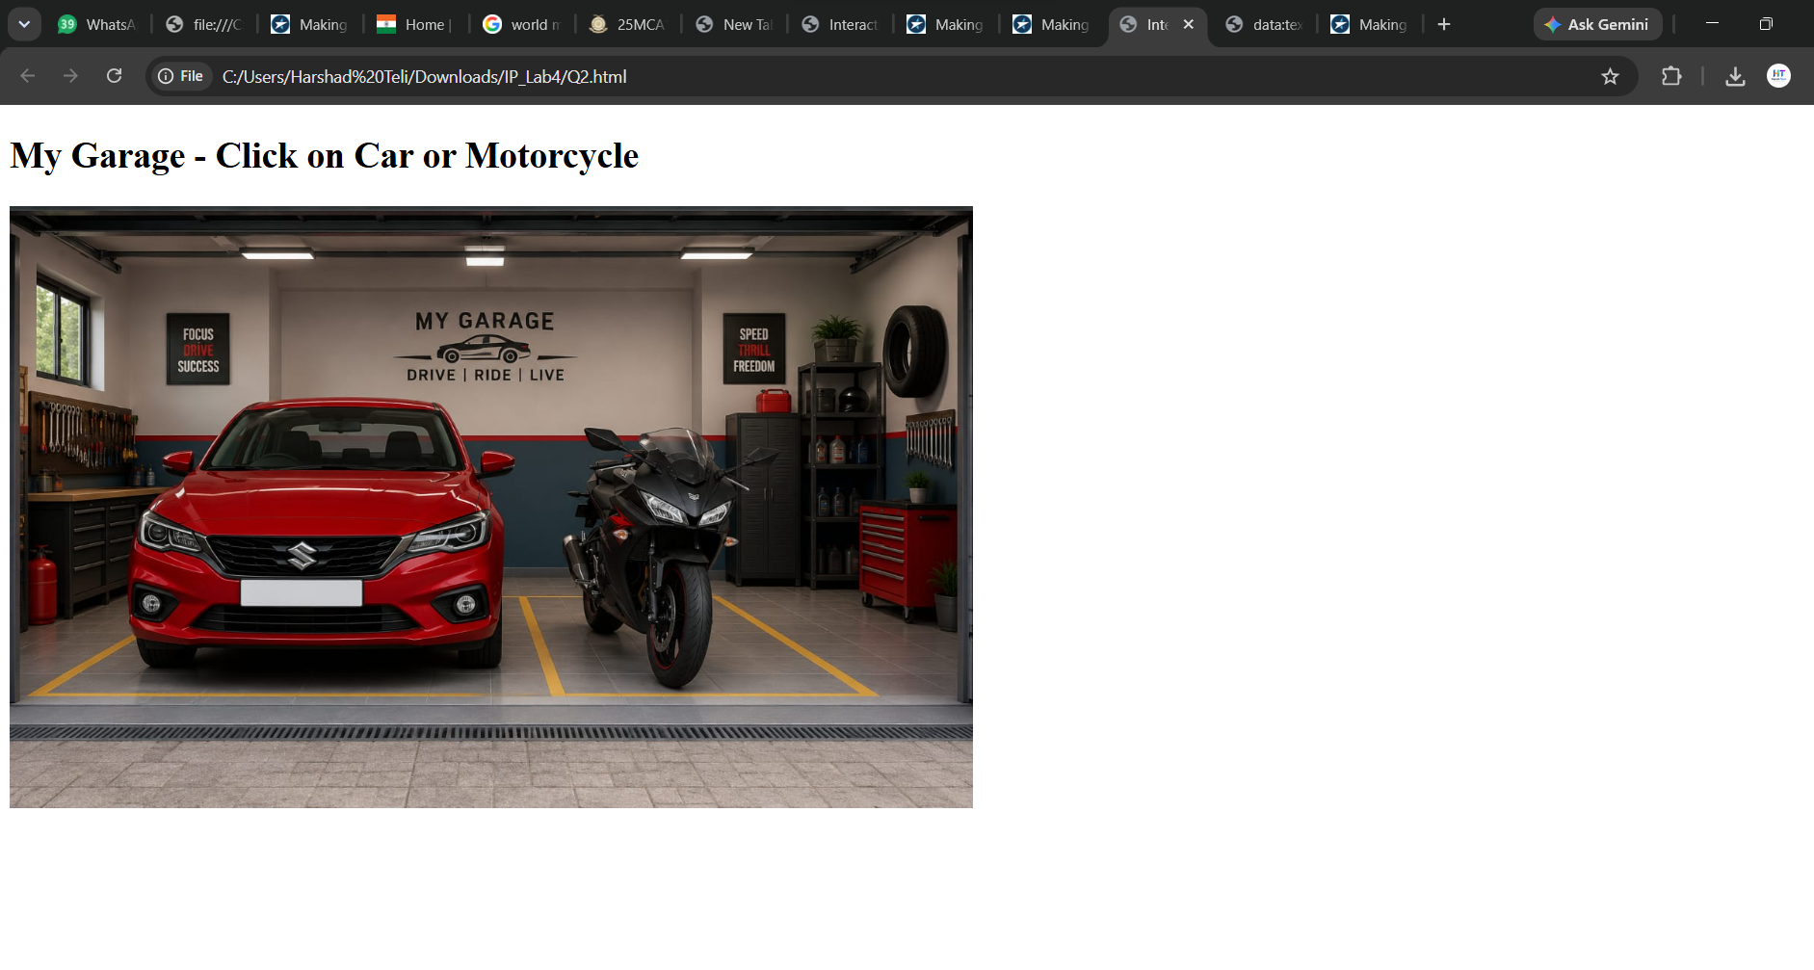
When the User click on the car then to display the information:
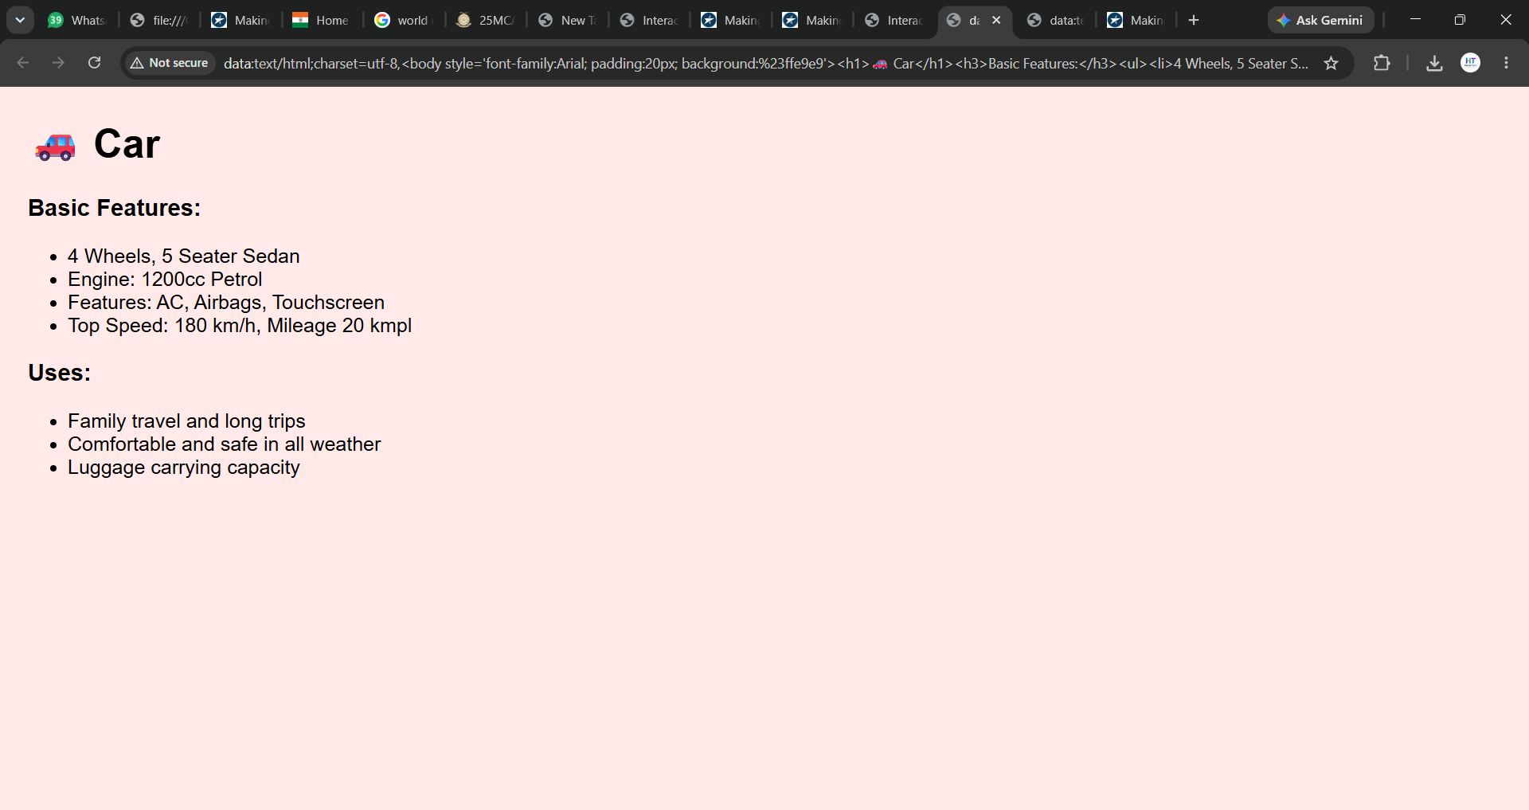
Whne the user click on the Bike then the show information
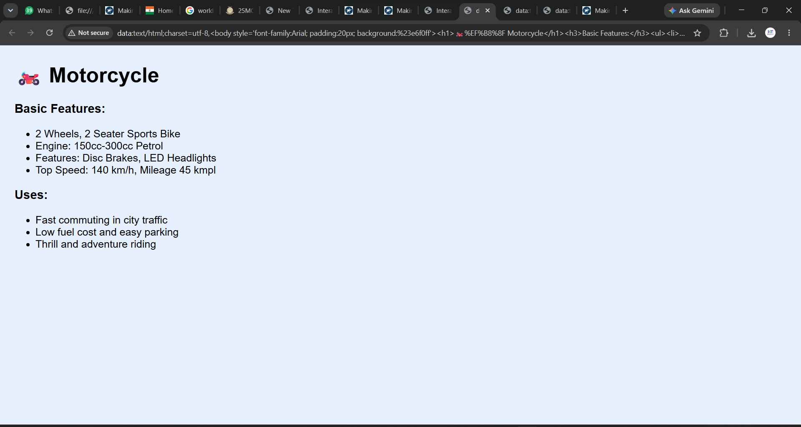

Q4. Student Registration Form
Create a Student Registration Form using basic HTML form elements. The form should contain the following fields:
- Student Name – Text box
- Password – Password input
- Email ID – Email input
- Age – Number input
- Date of Birth – Date input
- Gender – Radio buttons (Male/Female/Other)
- Hobbies – Checkboxes (Reading, Sports, Music)
- Upload Photo – File input
- Favorite Color – Color input
- Submit button
- Reset button
Use appropriate <label>, <input>, and <form> tags. Do not use CSS or JavaScript.
Input:

<!DOCTYPE html>
<html>
<head>
<title>Student Registration Form</title>
</head>
<body>

<h2>Student Registration Form</h2>

<form>

<label for="name">Student Name:</label>
<input type="text" name="sname"><br><br>

<label for="password">Password:</label>
<input type="password" name="password"><br><br>

<label for="email">Email ID:</label>
<input type="email" name="email"><br><br>

<label for="age">Age:</label>
<input type="number" name="age"><br><br>

<label for="date">DOB:</label>
<input type="date" name="dob"><br><br>

<label for="gender">Gender:</label>
<input type="radio" name="gender" value="Male"> Male
<input type="radio" name="gender" value="Female"> Female
<input type="radio" name="gender" value="Other"> Other
<br><br>

<label for="hobbies">Hobbies:</label>
<input type="checkbox" name="hobby1" value="Reading"> Reading
<input type="checkbox" name="hobby2" value="Sports"> Sports
<input type="checkbox" name="hobby3" value="Music"> Music
<br><br>

<label for="photo">Upload Photo:</label>
<input type="file" name="photo"><br><br>

<label for="favcolor">Favorite Color:</label>
<input type="color" name="favcolor"><br><br>

<input type="submit" value="Submit">
<input type="reset" value="Reset">

</form>
</body>
</html>

Output:
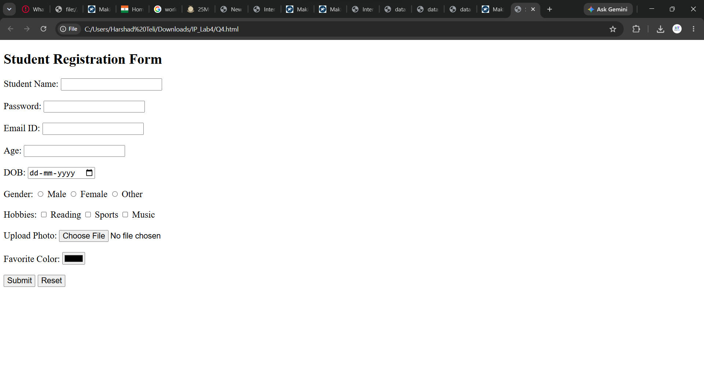

Q5. Online Course Registration Form
Create an Online Course Registration Form using only HTML form elements. The form should contain:
Full Name – Text box
Username – Text box
Password – Password input
Email – Email input
Mobile Number – Number input
Date of Birth – Date input
Gender – Radio buttons (Male/Female)
Select Course – Checkboxes (HTML, CSS, JavaScript, Python)
Upload Certificate – File input
Preferred Color – Color input
Submit Form button
Reset Form button
Use suitable HTML input types for each field. Do not use CSS or JavaScript.

Input:
<!DOCTYPE html>
<html lang="en">

<head>
<meta charset="UTF-8">
<meta name="viewport" content="width=device-width, initial-scale=1.0">
<title>Document</title>

<body>
<h2>Online Course Registration Form</h2>
<form action="">
<label for="fname">Full Name:</label>
<input type="text"><br>
<label for="uname">User Name:</label>
<input type="text"><br>
<label for="password">Password:</label>
<input type="password"><br>
<label for="email">Email:</label>
<input type="email"><br>
<label for="mnumber">Mobile Number:</label>
<input type="number"><br>
<label for="dob">DOB:</label>
<input type="date"><br>
<label for="gender">Gender:</label>
<input type="radio" name="Male" value="Male">Male
<input type="radio" name="Female" value="Female">Female<br>
<label for="courses">Select Courses:</label>
<input type="checkbox" name="HTML" value="HTML">HTML
<input type="checkbox" name="CSS" value="CSS">CSS
<input type="checkbox" name="JAVASCRIPT" value="JAVASCRIPT">JAVASCRIPT
<br><label for="certificate">Upload Certificate:</label>
<input type="file"><br>
<input type="color"><br>
<input type="submit" value="Submit">
<input type="Reset" value="Reset">
</form>
</body>
</html>

Output:
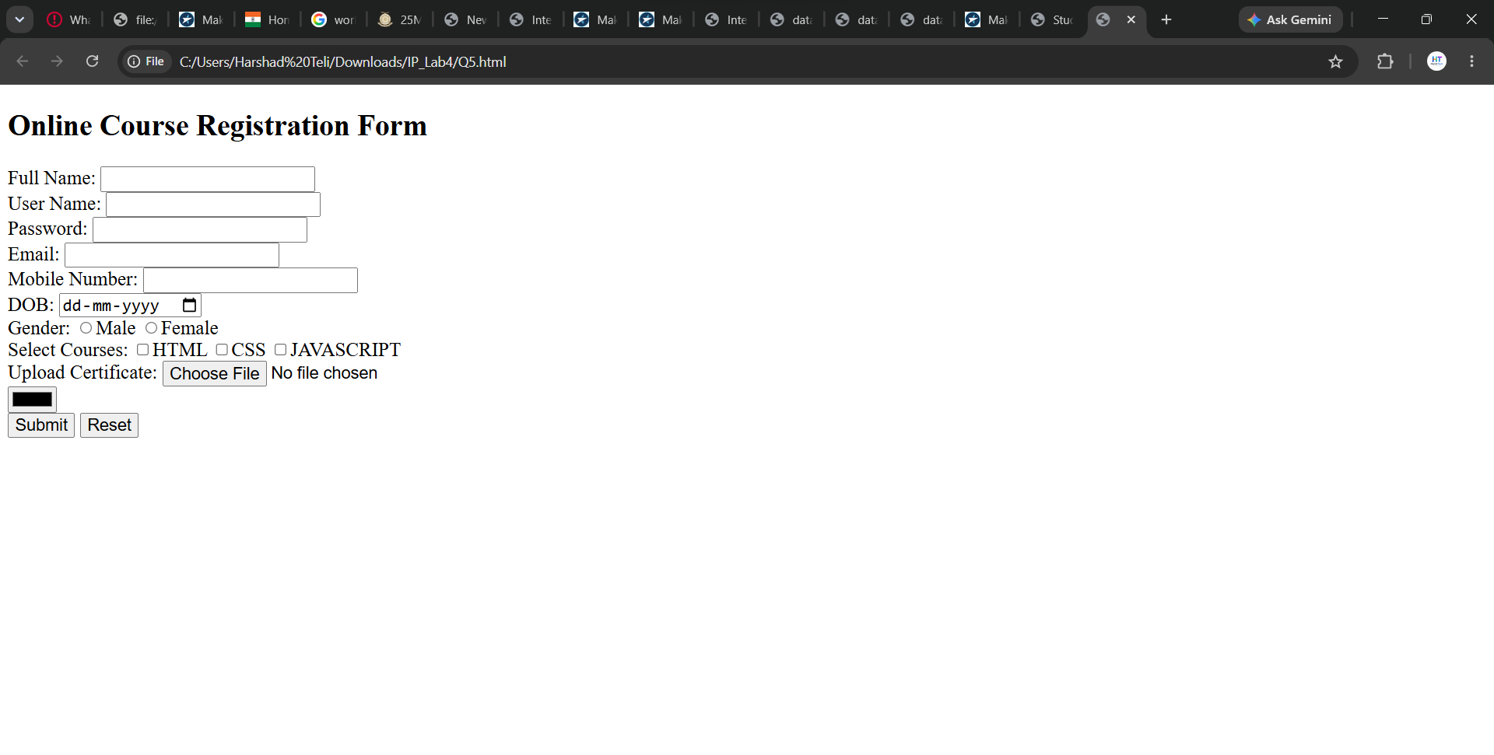

Q6. Importing Audio and Video
- Insert an audio file using the <audio> tag with controls and autoplay.
- Insert a video file using the <video> tag with controls and width/height set.

Input:
<!DOCTYPE html>
<html lang="en">
<head>
<meta charset="UTF-8">
<meta name="viewport" content="width=device-width, initial-scale=1.0">
<title>Audio and Video Tags</title>
</head>
<body>
<audio controls>
<source src="harsh.mpeg" type="audio/mp3">
</audio>
<video controls muted autoplay loop width="320" height="240">
<source src="dyptemsih.mp4" type="video/mp4">
</video>
</body>
</html>

Output:
