Data Structure (C Programming) 25/08/2026
Name : Harshad Sanjay Teli.
Roll No : 15
Batch : B1
Prerequisite
Based on Array.

Q1. Write a C program to find the largest and smallest element in an array of integers.
Input:
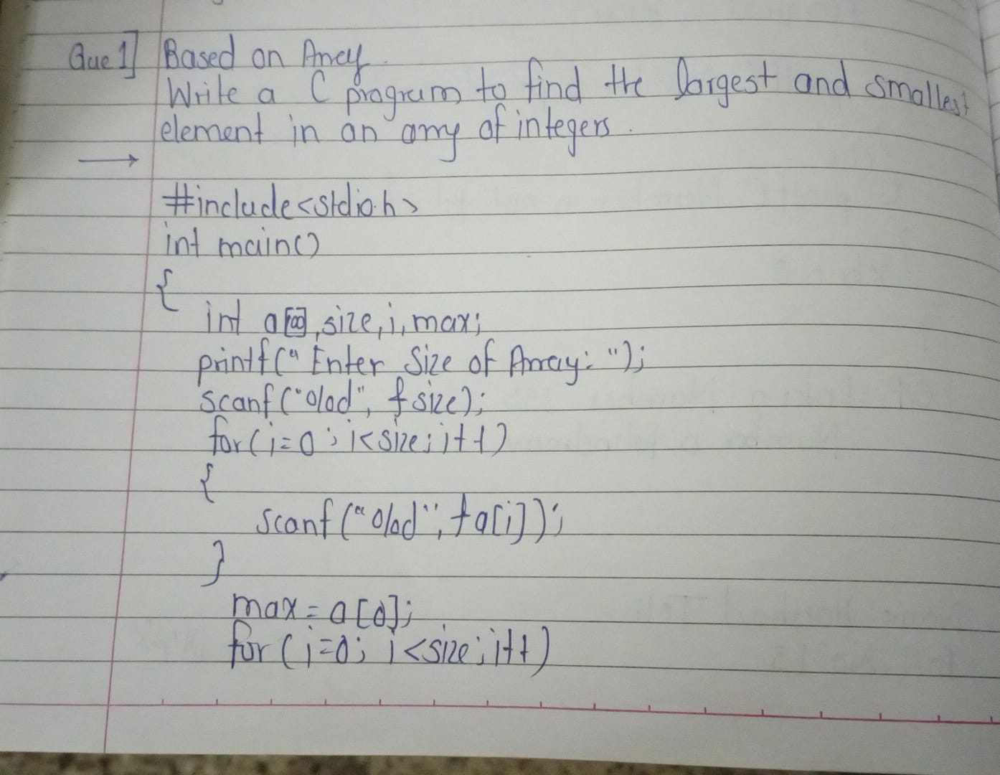

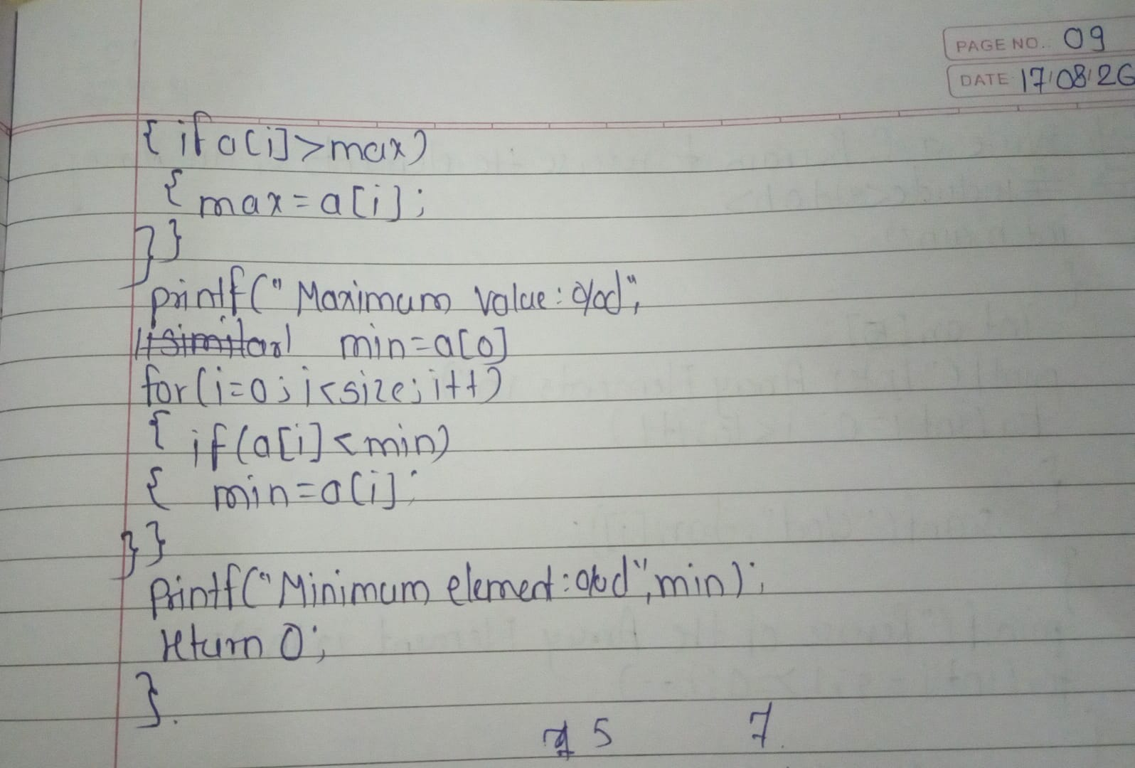

Output:
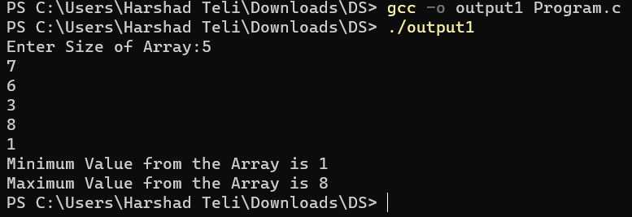

Q2. Write a C program to reverse the elements of an array.
Input:
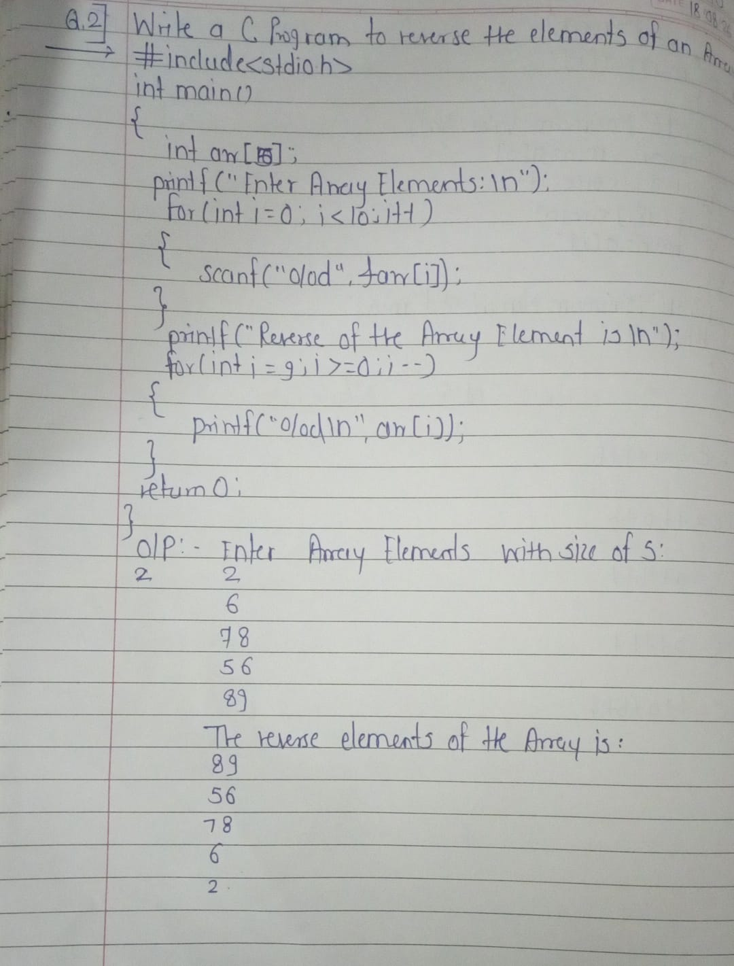

Output:
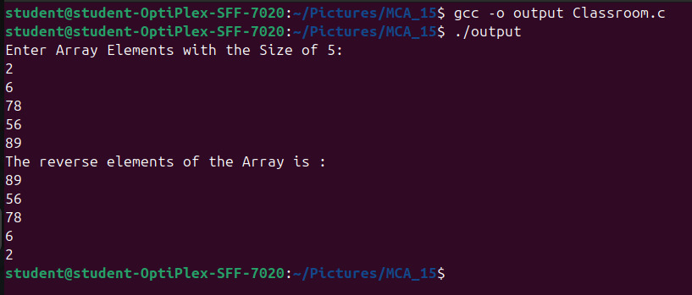

Q3. Write a C program to perform the addition of two matrices (2D arrays) of size 3×3.
Input:
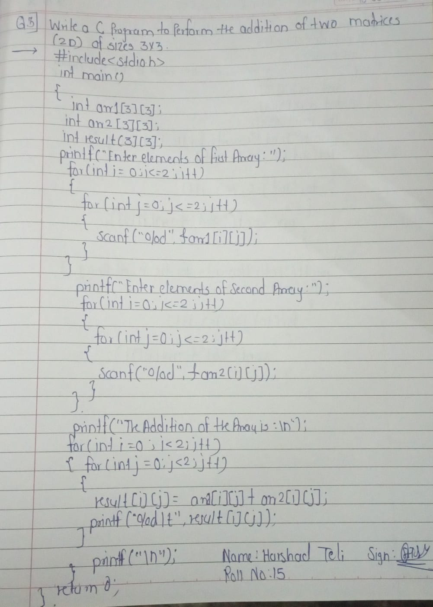

Output:
